Phase 3

CASS PROGRAM OVERVIEW AND QUARTERLY REPORT Update Q2 2026

Point of Contact: Uwe Sonnewald,
Program Director, University of Erlangen-Nuremberg, uwe.sonnewald@fau.de

Business Point of Contact: Wolfgang Zierer
CASS Scientific Program Manager, University of Erlangen-Nuremberg, wolfgang.zierer@fau.de

Date report submitted: July 17th 2026

Investment ID: 58147
Start date: May 1, 2024
End date: April 30, 2029

CASS’s Mission: To achieve a significant increase in the yield of high-quality cassava storage roots under low-input farming conditions in smallholder farmer fields by optimizing cassava physiology.

HOW CASS QUARTERLY REPORTS ARE STRUCTURED

This report lays out the Team Objectives and Key Results, the measurable and time-bound metrics for assessing progression in the project. It provides two scores, a Percent Complete and Progress Score for each key result, along with a justification overview for the scores that have been given, challenges that have been identified in the objective and a brief overview of the action plan for the next quarter.

1. Percent Complete: We look at the Key Result (metric) and estimate the percentage of work that has been completed by dividing the accomplished tasks by the total tasks assigned for that objective. This score can be low early in the project and even zero for a Team Objective that does not start until later in the programme. We are not expecting this score to necessarily show linear progress over the five years of the project.

2. Progress Score: This is a score indicates, independently of the Percent Complete, if we are still on track to deliver the Key Results by the target date. We are expecting this to be green (0.7 - 0.9) for most objectives until significant risk to delivery by the target date is anticipated. A completed Key Result can be scored 1 and a dropped Key Result can be scored 0. To interpret the scores, use the following guidelines:
♦ 0.9: Excellent progress with delivery assured by the target date.
♦ 0.7: On track and likely to deliver by the target date.
♦ 0.5: Lower than anticipated progress with some challenges or delays.
♦ 0.3: Low progress with significant challenges or delays.
♦ 0.1: Very low progress or no progress at all.

3. Justification Statements
- Progress Update: A brief update on the progress made toward each objective. This includes key accomplishments and milestones achieved during the quarter.
- Challenges and Mitigations: The challenges or obstacles encountered during the quarter that affected progress. We explain the steps taken or strategies implemented to mitigate these challenges and minimize their impact on the project.
- Next Steps in the Action Plan: Provides an outline of the planned activities or next steps that will be undertaken in the upcoming quarter to continue progress toward the objective. It includes specific tasks, milestones, or experiments that will be conducted.
CASS PROGRAM OVERVIEW AND QUARTERLY REPORT Update Q4 2024

Use the links below to access sections of the report document:

HOW CASS QUARTERLY REPORTS ARE STRUCTURED 2
CASS Reporting and Quarterly Meeting timetable 2024-2029 5
Module reporting leaders 6
CASS Stage Gate Grid 7
EM1: Optimizing assimilate allocation to storage roots 8
EM1.1_Manipulating shoot architecture 9
EM1.2_Limiting lateral transport losses through active phloem (re-)loading 36
EM1.3_Transport and allocation modelling 65
EM2: Increasing sink strength by optimizing xylem parenchyma cell formation in storage roots 71
EM2.1_Manipulation of OVAC and cytokinin metabolism or signaling 72
EM2.2_Manipulation of downstream factors involved in xylem parenchyma cell formation 86
EM3: Increasing sink strength by optimizing metabolic flux in storage roots 92
EM3.1_Optimization of sucrolytic cleavage and glycolysis 93
EM3.2: Optimization of starch-precursor delivery to amyloplasts 99
EM3.3: Starch granule initiation and growth 107
EM3.4: Model-based predictions 120
TM1: Project management and central services 125
TM1_Project management and central services 126
TM1_Project management and central services 127
TM2: Cassava Transformation 132
TM2.1_Routine transformation 133
TM2.2_Chemical and genetic boosters 140
TM2.3_Transformation of farmer-preferred genotypes 150
TM3_Expanding the cassava expression toolbox 156
TM3.1_Testing of already identified tissue-specific promoter candidates 157
TM3.2_Identification of genes and promoter candidates involved in formation of xylem parenchyma 169
TM4_Cassava confined field testing 173
TM4.1_Pre-testing of transgenic lines outside Africa 174
TM4.2_Testing of transgenic lines in Africa and transgenic crossing activities 189
TM4.2_Testing of transgenic lines in Africa and transgenic crossing activities 192
TM5_Cassava plant and field phenotyping 203
TM5_Cassava plant and field phenotyping 204
TM6_Research data management 214
TM6.1_Research data management 215

CASS Reporting and Quarterly Meeting timetable 2024-2029

Reporting Period | Start | End | DEADLINE: Report from Partners | DEADLINE: Report to Gates Ag One | CASS Quarterly Meeting
Q3 2024 | July 1, 2024 | September 30, 2045 | September 16, 2024 | September 20, 2024 | September 30th, 2024
Q4 2024 | Oct 1, 2024 | Dec 31, 2024 | February 10th, 2025 | February 14, 2025 | February 27th, 2025
Q1 2025 | January 1, 2025 | March 30, 2025 | April 11, 2025 | April 18, 2025 | April 25, 2025
Q2 2025 | April 1, 2025 | June 30, 2025 | July 11, 2025 | July 18, 2025 (Annual Report) | July 25, 2025
Q3 2025 | July 1, 2025 | September 30, 2025 | September 15, 2025 | September 19, 2025 | September 29th, 2025
Q4 2025 | Oct 1, 2025 | Dec 31, 2025 | February 9th, 2026 | February 13, 2026 | February 26th, 2026
Q1 2026 | January 1, 2026 | March 30, 2026 | April 10, 2026 | April 17, 2026 | April 24, 2026
Q2 2026 | April 1, 2026 | June 30, 2026 | July 17, 2026 | July 24, 2026 (Annual Report) | July 31, 2026
Q3 2026 | July 1, 2026 | September 30, 2026 | September 14, 2026 | September 18, 2026 | September 28th, 2026
Q4 2026 | Oct 1, 2026 | Dec 31, 2026 | February 8th, 2027 | February 12, 2027 | February 25th, 2027
Q1 2027 | January 1, 2027 | March 30, 2027 | April 16, 2027 | April 23, 2027 | April 30, 2027
Q2 2027 | April 1, 2027 | June 30, 2027 | July 16, 2027 | July 23, 2025 (Annual Report) | July 30, 2027
Q3 2027 | July 1, 2027 | September 30, 2027 | September 13, 2027 | September 17, 2027 | September 27th, 2027
Q4 2027 | Oct 1, 2027 | Dec 31, 2027 | February 7th, 2028 | February 11, 2028 | February 24th, 2028
Q1 2028 | January 1, 2028 | March 30, 2028 | April 14, 2028 | April 21, 2028 | April 28, 2028
Q2 2028 | April 1, 2028 | June 30, 2028 | July 14, 2028 | July 21, 2025 (Annual Report) | July 28, 2028
Q3 2028 | July 1, 2028 | September 30, 2028 | September 12, 2028 | September 16, 2028 | September 26th, 2028
Q4 2028 | Oct 1, 2028 | Dec 31, 2028 | February 6th, 2029 | February 10, 2029 | February 23th, 2029
Q1 2029 | January 1, 2029 | March 30, 2029 | April 13, 2026 | April 20, 2029 | April 27, 2029

Module reporting leaders
 | EM1: Optimizing assimilate allocation to storage roots
Uwe Sonnewald, FAU | EM1.1_Manipulating shoot architecture
Ekkehardt Neuhaus, RPTU with MPI-MPP. | EM1.2_Limiting lateral transport losses through active phloem (re-)loading
Lee Sweetlove, UO with RPTU, MPI-MPP and ETH. | EM1.3_Transport and allocation modelling
 | EM2: Increasing sink strength by optimizing xylem parenchyma cell formation in storage roots
Yka Helariutta, HU with FAU and ETH. | EM2.1_Manipulation of OVAC and cytokinin metabolism or signalling
Ari-Pekka Mähönen, HU with FAU and ETH. | EM2.2_Manipulation of downstream factors involved in xylem parenchyma cell formation
 | EM3_Increasing sink strength by optimizing metabolic flux in storage roots
Alisdair Fernie, MPI-MPP with FAU and Oxford | EM3.1_Optimization of sucrolytic cleavage and glycolysis
Wolfgang Zierer, FAU with ETH. | EM3.2_Optimization of starch-precursor delivery to amyloplasts
Sam Zeeman, ETH with FAU. | EM3.3_Starch granule initiation and growth
Lee Sweetlove, OU with RPTU, MPI-MPP and ETH. | EM3.4_Model-based predictions
Wolfgang Zierer and Uwe Sonnewald, FAU | TM1_Project management and central services
 | TM2_Cassava transformation
Simon Bull, ETH | TM2.1_Routine transformation
Christian Lamm, FAU. | TM2.2_Chemical and genetic boosters
Ihuoma Okwuonu, NRCRI. | TM2.3_Transformation of farmer-preferred genotypes
 | TM3_Expanding the cassava expression toolbox
Wolfgang Zierer, FAU. | TM3.1_Testing of already identified tissue-specific promoter candidates
Ari Pekka Mähönen, HU | TM3.2_Identification of genes and promoter candidates involved in formation of xylem parenchyma
 | TM4_Cassava confined field testing
Wilhelm Gruissem, NCHU with FAU and FZJ. | TM4.1_Pre-testing of transgenic lines outside Africa
Ismail Rabbi, IITA. | TM4.2_Testing of transgenic lines in Africa and transgenic crossing activities
Uwe Rascher, FZJ with Robert Koller, FZJ | TM5_Cassava plant and field phenotyping
Lukas Mueller, BTI. | TM6_Research data management

CASS Stage Gate Grid
The progression of CASS engineering targets through glasshouse and CFT testing indicating team objectives and the timing of Go/No-go discussions points.
 | Cloning | Transformation | Glasshouse Analysis | Go/No-go | CFT Taichung 1 | Phenotyping 1 | Sample Analysis 1 | Go/No-go | CFT Taichung 2 | Phenotyping 2 | Sample Analysis 2 | Go/No-go | Transformation FPV | CFT SSA
EM1.1: Cassava lines expressing GA2ox and DELLA. | 1.1.1 | T2.1.1 | 1.1.2 | Q4 2025 | T4.1 | T4.1 | 1.1.3 | Q2 2027 | T4.1 | T4.1 | 1.1.4 | Q2 2028 | T2.2/  T2.3 | T4.2
EM1.2: Existing cassava lines expressing AKT2/AAP1/SUC2. | - | - | 1.2.1 | Q4 2024 | T4.1 | T4.1 | 1.2.2 | Q3 2025 | T4.1 | T4.1 | 1.2.3 | Q3 2027 | T2.2/  T2.3 | T4.2
EM1.2: New AKT2/AAP1/SUC2 construct versions and/or synergistic combinations. | 1.2.4 | T2.1.1 | 1.2.5 | Q3 2026 | T4.1 | T4.1 | 1.2.6 | Q3 2028 | T4.1 | T4.1 | 1.2.7 | Q2 2029 | T2.2/  T2.3 | T4.2
EM2.1: Cassava lines with alterations in OVAC and storage root-specific cytokinin overexpression. | 2.1.1 | T2.1.1 | 2.1.2 | Q4 2025 | T4.1 | T4.1 | 2.1.3 | Q2 2027 | T4.1 | T4.1 | 2.1.4 | Q2 2029 | T2.2/  T2.3 | T4.2
EM2.2: Cassava lines with storage root-specific overexpression of transcription factors involved in xylem parenchyma cell formation. | 2.2.1 | T2.1.1 | 2.2.2 | Q4 2025 | T4.1 | T4.1 | 2.2.3 | Q2 2027 | T4.1 | T4.1 | 2.2.4 | Q2 2028 | T2.2/  T2.3 | T4.2
EM2.2: Transgenic cassava lines single-cell RNA-Seq-derived candidates for five promoter-reporter constructs and 5 storage (xylem) parenchyma formation gene candidates. | 2.2.5 | T2.1.1 | 2.2.6 | Q4 2027 | T4.1 | T4.1 | 2.2.7 | Q2 2029 | T4.1 | T4.1 | - | - | - | -
EM3.1: Transgenic cassava lines with new constructs aimed at improved sucrose cleavage/glycolysis. | 3.1.1 | T2.1.1 | 3.1.2 | Q3 2026 | T4.1 | T4.1 | 3.1.3 | Q2 2027 | T4.1 | T4.1 | 3.1.4 | Q2 2028 | T2.2/  T2.3 | T4.2
EM3.1: Transgenic cassava lines with three model-prediction constructs (to be nominated later). | 3.1.5 | T2.1.1 | 3.1.6 | Q3 2027 | T4.1 | T4.1 | 3.1.7 | Q2 2029 | T4.1 | T4.1 | - | - | - | -
EM3.2: Transgenic cassava lines with PPase/GPT/NTT/PGM/glgC constructs and combinations. | 3.2.1 | T2.1.1 | 3.2.2 | Q3 2025 | T4.1 | T4.1 | 3.2.3 | Q2 2027 | T4.1 | T4.1 | 3.2.4 | Q2 2029 | T2.2/  T2.3 | T4.2
EM3.3: Single and multigene constructs with PTST2, MFP1, MRC, SS4, ESV1 and LESV1. | 3.3.1 | T2.1.1 | 3.3.2 | Q4 2025 | T4.1 | T4.1 | 3.3.3 | Q2 2027 | T4.1 | T4.1 | 3.3.4 | Q2 2028 | T2.2/  T2.3 | T4.2
EM3.3: Second generation constructs: Best performing constructs from EM3.2 (Starch-precursory delivery) and EM3.3 (Starch granule initiation and growth) combined. | 3.3.5 | T2.1.1 | 3.3.6 | Q3 2028 | - | - | - | - | - | - | - | - | - | -

EM1: Optimizing assimilate allocation to storage roots

EM1.3_Transport and allocation modelling
1.3
EM1.2_Limiting lateral transport losses through active phloem (re-)loading
1.2
EM1.1_Manipulating shoot architecture
1.1

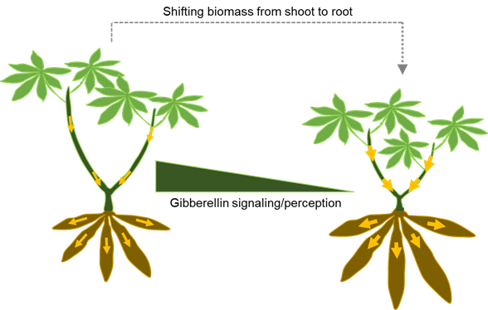
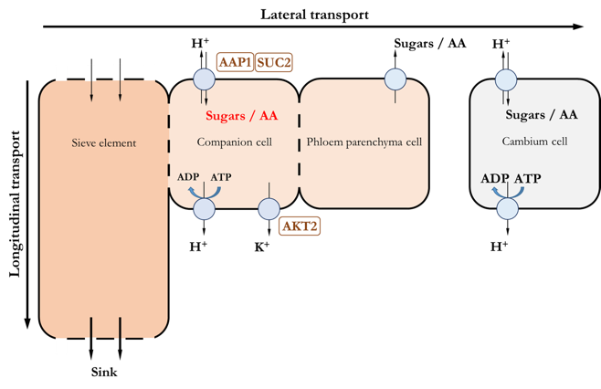
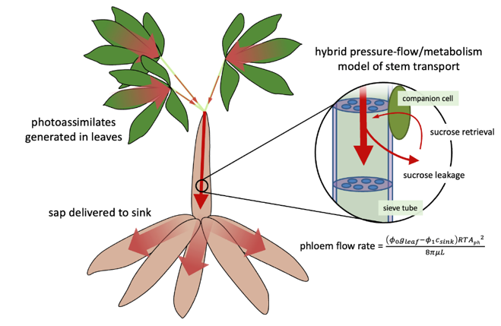
Module EM1: Optimizing Assimilate Allocation to Storage Roots

Summary of Goals and Impact
The primary goal of EM1 is to enhance cassava yield by optimizing the allocation of photoassimilates, the energy-rich products of photosynthesis, towards the storage roots. This module seeks to reduce the resources invested in aboveground parts like stems and direct more to the roots, where cassava stores its valuable starch. By fine-tuning gibberellin signalling specifically in stems and improving the efficiency of nutrient transport within the plant, EM1 aims to maximize the storage root yield without compromising the plant's ability to propagate.
This research holds significant potential for creating impactful products for smallholder farmers. By increasing the efficiency of how cassava plants use their resources, this module could lead to higher yields even under low-input farming conditions, directly benefiting farmers who rely on cassava as a staple crop. Furthermore, the computational model developed in this module could serve as a predictive tool, helping breeders and farmers optimize harvests with greater precision. The success of this module could pave the way for innovations that ensure food security and improve livelihoods for smallholder farmers, aligning with the mission of CASS and Gates Ag One.

EM1.1_Manipulating shoot architecture

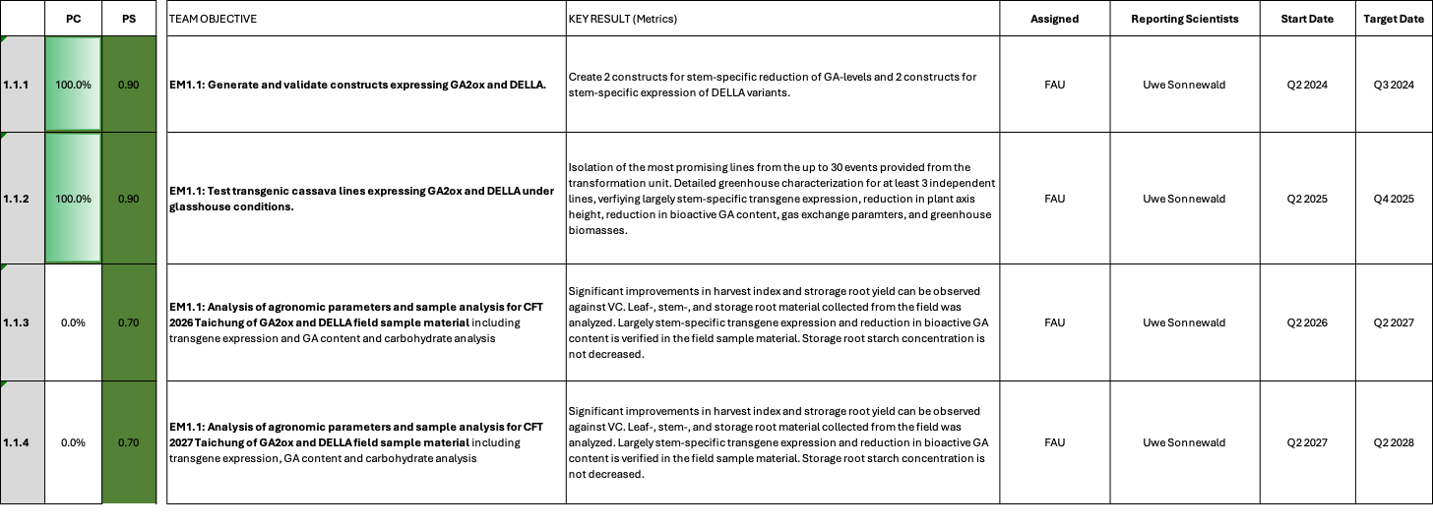

EM1.1_Manipulating shoot architecture

Reporting module leader: Uwe Sonnewald, FAU

Progress Update:

1.1.1. Generate and validate constructs expressing GA2ox and DELLA. Based on RNASeq data (published in Rüscher et al., 2024; https://doi.org/10.1093/plphys/kiae298), two genes have been selected for isolation of stem-specific promoters, Manes.09G047609 (encoding a chloroplastic theronine dehaydratase (OMR1)) and Manes.17G027300 (encoding a homeobox protein (SBH1)). The OMR1 gene is expressed strongly in upper stems and weaker in petioles and middle and lower stem parts. It is not expressed in leaves and roots. The SBH1 gene is more or less homogenously expressed in all tested stem tissues but not in leaves and roots. Using these promoters, as well as the already validated Arabidopsis AtCAB1 promoter (Zierer et al., 2022), five target gene constructs have been designed and cloned. Target genes are (i) Arabidopsis GA2-oxidase (AtGA2ox) and (ii) Arabidopsis GAI_D17. GA2ox is involved in the degradation of bioactive gibberellins and should decrease GA levels. The GAI_D17 protein acts as a GA-independent repressor and should decrease GA responses. The constructs are shown in Table 1. To validate the promoter specificity of the new promoters used, promoter:reporter gene constructs have been designed and cloned. Details are shown in Table 2.

Table 1_Summary of the gene constructs.
Construct number | Gene cassette | Database link
C2-92 | pManes.09G047609::AtGAI_Δ17 CDS-6xHA::tHsp18.2 | https://cassbase.org/stock/462041/view
C2-94 | pManes.09G047609::AtGA2ox1-6xHA::tHsp18.2 | https://cassbase.org/stock/462043/view
C2-93 | pManes.17G027300::AtGAI_Δ17 CDS-6xHA::tHsp18.2 | https://cassbase.org/stock/462042/view
C2-95 | pManes.17G027300::AtGA2ox1-6xHA::tHsp18.2 | https://cassbase.org/stock/462044/view
C2-113 | pAtCAB1::AtGA2ox1::6xHA::tHsp18.2 | https://cassbase.org/stock/462045/view

Table 2_Summary of promoter:reporter gene constructs.
Construct number | Gene cassette | Database link
C1-70 | pManes.09G047609::GUS⁺ CDS::Ter + pManes.09G047609::ER-tdTomato::Ter | https://cassbase.org/stock/462039/view
C1-71 | pManes.17G027300::GUS⁺ CDS::Ter + pManes.17G027300::ER-tdTomato::Ter | https://cassbase.org/stock/462040/view

Challenges and Mitigations:
No unforeseen challenges have been encountered.

Next Steps in the Action Plan:
- Concluded
1.1.2. Test transgenic cassava lines expressing GA2ox and DELLA under glasshouse conditions.
Please see previous reports for the reporting history.
An update results section containing a summary of the most relevant data is presented below:
Transgenic cassava plants from pMeOMR1::AtGAIΔ17 (C2-92) (lines 836, 880, and 883), together with the corresponding vector controls (lines 887,888, 889 and 890) and wild-type (WT) plants, as well as C2-93 (lines 826, 827, 833, 834, 865, 867, 868, 938, 829, and 932), together with the corresponding VC lines (887, 888, 889, and 890) and WT plants, were transferred to the greenhouse on 28 January 2026.
Plants from the C2-92 experiment were harvested on 25 May 2026, and those from the C2-93 experiment on 1 June 2026. At harvest, plant growth and biomass-related traits were recorded, including plant height, petiole length of the 6th leaves (used as a representative measurement of petiole length), total node number, leaf number, stem diameter, leaf fresh weight, stem fresh weight, total green biomass, and storage root fresh weight. To determine the dry matter content of storage roots, storage roots were separated into peel and core tissues. The fresh weight of each tissue fraction was recorded, after which samples were dried at 60°C until a constant weight was reached. Dry matter content was calculated as the percentage of dry weight relative to fresh weight. For subsequent molecular and biochemical analyses, tissue samples were collected from different plant organs. Leaf samples were harvested from the sixth fully expanded leaf from the apex at 1:00 pm. Petiole samples were collected from the 6th, 7th, and 8th leaves. Internodes from the middle portion of the stem were dissected into xylem and phloem tissues. Storage root samples were collected from the middle region of the roots and separated into peel and core tissues. All samples were immediately frozen in liquid nitrogen and stored at −80°C until further analysis.
To investigate the spatial distribution of carbohydrates within storage roots, additional samples were collected from two C2-93 (pMeSBH1::AtGAIΔ17) lines (834 and 938), together with VC line 889 and WT plants. Storage roots were divided into 2-cm sections representing the proximal, middle, and distal regions. Each section was further separated into peel and core tissues, immediately frozen in liquid nitrogen, and stored at −80°C for subsequent biochemical analyses.

AtGAIΔ17 improved the agronomic performance of greenhouse-grown cassava
Plant height and petiole length were reduced in all examined pMeSBH1::AtGAIΔ17 lines and in two pMeOMR1::AtGAIΔ17 lines (883 and 836) (Fig. 1A,B and Fig. 2). This phenotype is consistent with the function of AtGAIΔ17, a stabilized DELLA protein that cannot be degraded by GA, thereby suppressing GA signalling and inhibiting cell elongation, resulting in reduced plant growth. In addition, differences in the reduction of plant height level among pMeSBH1::AtGAIΔ17 (ranging from 21% to 77%) and pMeOMR1::AtGAIΔ17 (25% for 883 and 49% for 836) lines may be associated with variation in AtGAIΔ17 expression levels. The reduction in plant height in pMeSBH1::AtGAIΔ17 lines was accompanied by increased stem diameter in most lines (Fig. 1C), suggesting that enhanced DELLA activity may suppress longitudinal cell elongation while promoting radial stem growth. This effect was observed in pMeOMR1::AtGAIΔ17 lines (883 and 836) (Fig. 1C).

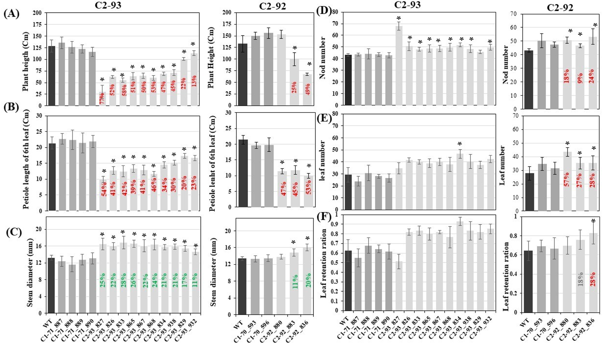
Fig. 1. Plant height (A), petiole length of the 6th leaf (B), stem diameter (C), nod number (D), leaf number (E), and leaf retention ratio (F) were measured in WT and transgenic cassava lines. The number of biological replicates was for C2-93/pMeSBH1::AtGAIΔ17 construct: n = 10 for WT, n = 10 for VC-887, n = 11 for VC-888, n = 10 for VC-889, n = 10 for VC-890, n = 7 for line 826, n = 10 for line 827, n = 6 for line 833, n = 9 for line 834, n = 12 for line 865, n = 9 for line 867, n = 6 for line 868, n=6 for lone 829, and n = 11 for line 938; and for C2-92/pMeOMR1::AtGAIΔ17 construct: n = 10 for WT, n = 5 for VC-953, n = 6 for VC-596, n = 8 for line 880, n = 8 for line 883, and n = 8 for line 836. Asterisks indicate significant differences compared with WT (*P < 0.05). Values represent means ± SD

Representative pictures of the shoot phenotypes are shown in Fig. 2. The reduction in plant height is obvious for lines of C2-92 and C2-93 compared to WT and vector control.
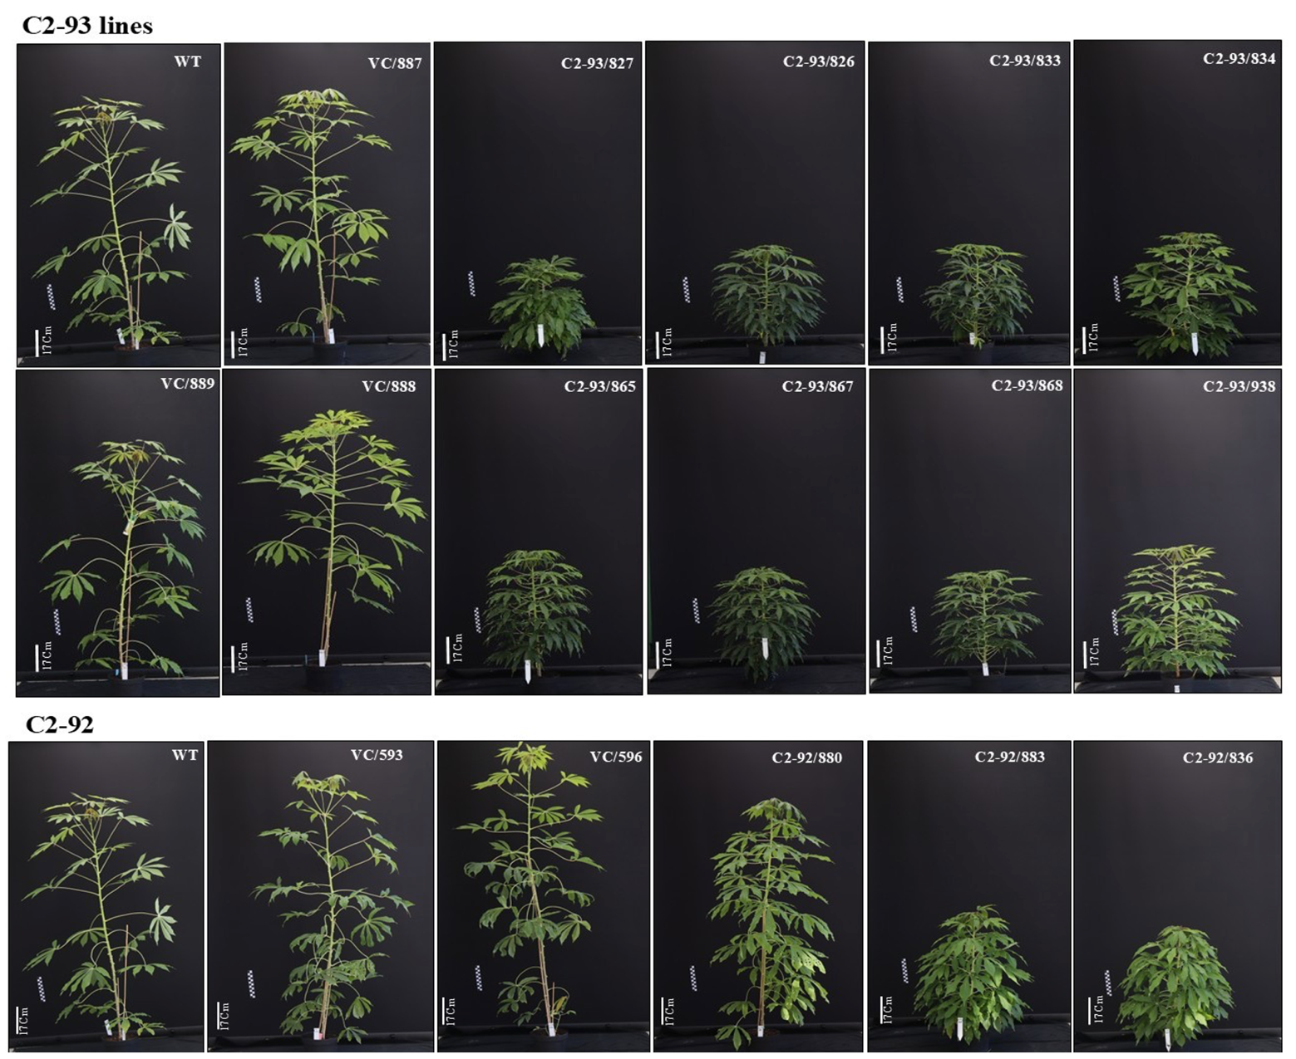
Fig. 2. Representative images of 17-week-old cassava plants from WT, C2-93/pMeSBH1::AtGAIΔ17 (VC-887, VC-888, VC-889, 826, 827, 833, 834, 865,867,868 and 938) and C2-92/pMeOMR1::AtGAIΔ17 (VC-953, VC-596, 880, 883 and 836) lines

An increase in total storage root fresh biomass was observed in all pMeSBH1::AtGAIΔ17 lines, except line 827, which exhibited a severe dwarf phenotype. The most pronounced increases were detected in lines 834 (137%), 938 (188%), 829 (99%), and 932 (102%) compared with wild-type plants (Fig. 3A). Consistently, pMeSBH1::AtGAIΔ17 lines, except line 827, showed higher harvest index values, with the highest values detected in lines 834 and 938 (54% and 69%, respectively) (Fig. 3B), which may indicate enhanced allocation of assimilates toward storage root development. However, the reduced performance of line 827 may indicate that excessive growth inhibition caused by strong AtGAIΔ17 activity can negatively affect overall biomass production and yield formation. Among the examined pMeOMR1::AtGAIΔ17 lines, line 836 exhibited a 66% increase in storage root fresh biomass and a 44% increase in harvest index compared with WT plants (Fig. 3A). Dry matter content in the peel of storage roots of pMeSBH1::AtGAIΔ17 lines was generally stable across transgenic lines, ranging roughly between ~14–20%, except for 834, which significantly increased. Dry matter content in the core of the storage root was stable except for 868, 867, 833, and 827, which showed a significant decrease compared to WT (Fig. 3C,D). Node number and leaf number analyses, together with the reduced leaf retention ratio (leaf number per node number), indicated that WT and VC lines exhibited greater leaf loss during the growth period compared with pMeSBH1::AtGAIΔ17 lines (Fig. 1D,E,F). This suggests that AtGAIΔ17 expression may contribute to maintaining leaf retention by delaying leaf senescence and/or abscission, resulting in prolonged canopy maintenance during plant development. However, because naturally abscised leaves were not collected and quantified during the growth period, the shoot biomass measured at harvest likely does not represent the total aboveground biomass produced by each genotype. The greater leaf loss observed in WT and VC plants may have led to an underestimation of their cumulative shoot biomass, potentially overestimating the calculated harvest index in these control plants. Therefore, the actual improvement in biomass partitioning and storage root yield associated with AtGAIΔ17 expression may be even more pronounced than estimated from harvest measurements alone.
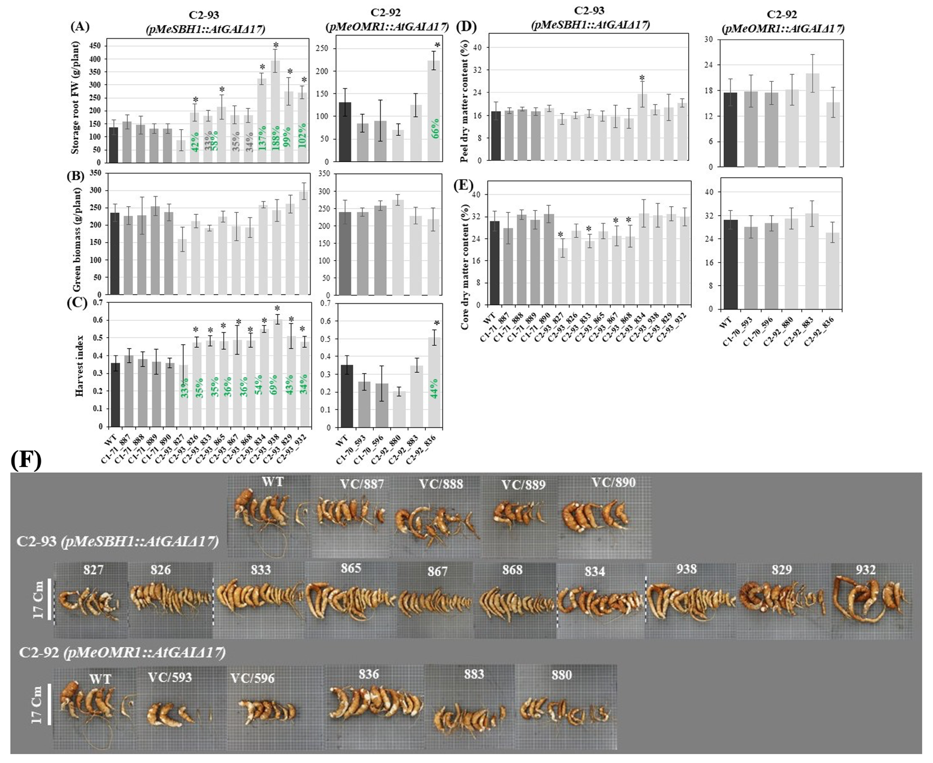
Fig. 3. Storage root fresh weight (A) and green biomass (B) were measured in WT and transgenic cassava lines. Harvest index (C) was calculated as the ratio of storage root fresh weight to total green biomass. Dry matter content of storage root peel (D) and core (E) tissues. Representative images of storage root for C2-93 and C2-93 (F). The number of biological replicates was for pMeSBH1::AtGAIΔ17 construct: n = 10 for WT, n = 10 for VC-887, n = 11 for VC-888, n = 10 for VC-889, n = 10 for VC-890, n = 7 for line 826, n = 10 for line 827, n = 6 for line 833, n = 9 for line 834, n = 12 for line 865, n = 9 for line 867, n = 6 for line 868, n=6 for lone 829, and n = 11 for line 938; and for pMeOMR1::AtGAIΔ17 construct: n = 10 for WT, n = 5 for VC-953, n = 6 for VC-596, n = 8 for line 880, n = 8 for line 883, and n = 8 for line 836. Asterisks indicate significant differences compared with WT (*P < 0.05). Values represent means ± SD

AtGAIΔ17 increased photosynthetic capacity
CO₂ assimilation rates in 7-week-old pMeSBH1::AtGAIΔ17 plants were significantly increased only in line 827, while the remaining transgenic lines showed no significant differences compared with WT plants. In contrast, 11-week-old pMeSBH1::AtGAIΔ17 plants exhibited enhanced CO₂ assimilation rates across most transgenic lines, indicating that the impact of AtGAIΔ17 expression on photosynthetic performance becomes more pronounced during later developmental stages. 11-week-old pMeOMR1::AtGAIΔ17 plants showed no significant changes in CO₂ assimilation rates compared with WT plants, suggesting that promoter-dependent regulation of AtGAIΔ17 expression influences the extent of photosynthetic responses (Fig. 4). Analysis of additional photosynthetic parameters, including Vmax (maximum carboxylation rate of Rubisco) and Jmax (maximum electron transport rate), revealed that a subset of pMeSBH1::AtGAIΔ17 lines exhibited significant increases compared with WT plants, whereas pMeOMR1::AtGAIΔ17 lines showed limited changes. Notably, the enhancement of Vmax and Jmax was more pronounced in 11-week-old plants than in 7-week-old plants (Fig. 4), indicating that the positive effect of AtGAIΔ17 expression on photosynthetic biochemical capacity becomes stronger as plants progress to later developmental stages. The increase in Vmax suggests enhanced Rubisco activity and/or abundance, reflecting greater capacity for CO₂ fixation via the Calvin–Benson cycle. Similarly, elevated Jmax indicates improved photosynthetic electron transport efficiency, which may enhance RuBP regeneration and support higher carbon assimilation under light-saturated conditions. Together, these changes indicate an overall improvement in photosynthetic capacity that may increase assimilate production and promote greater carbon allocation toward storage organ development in pMeSBH1::AtGAIΔ17 transgenic lines.

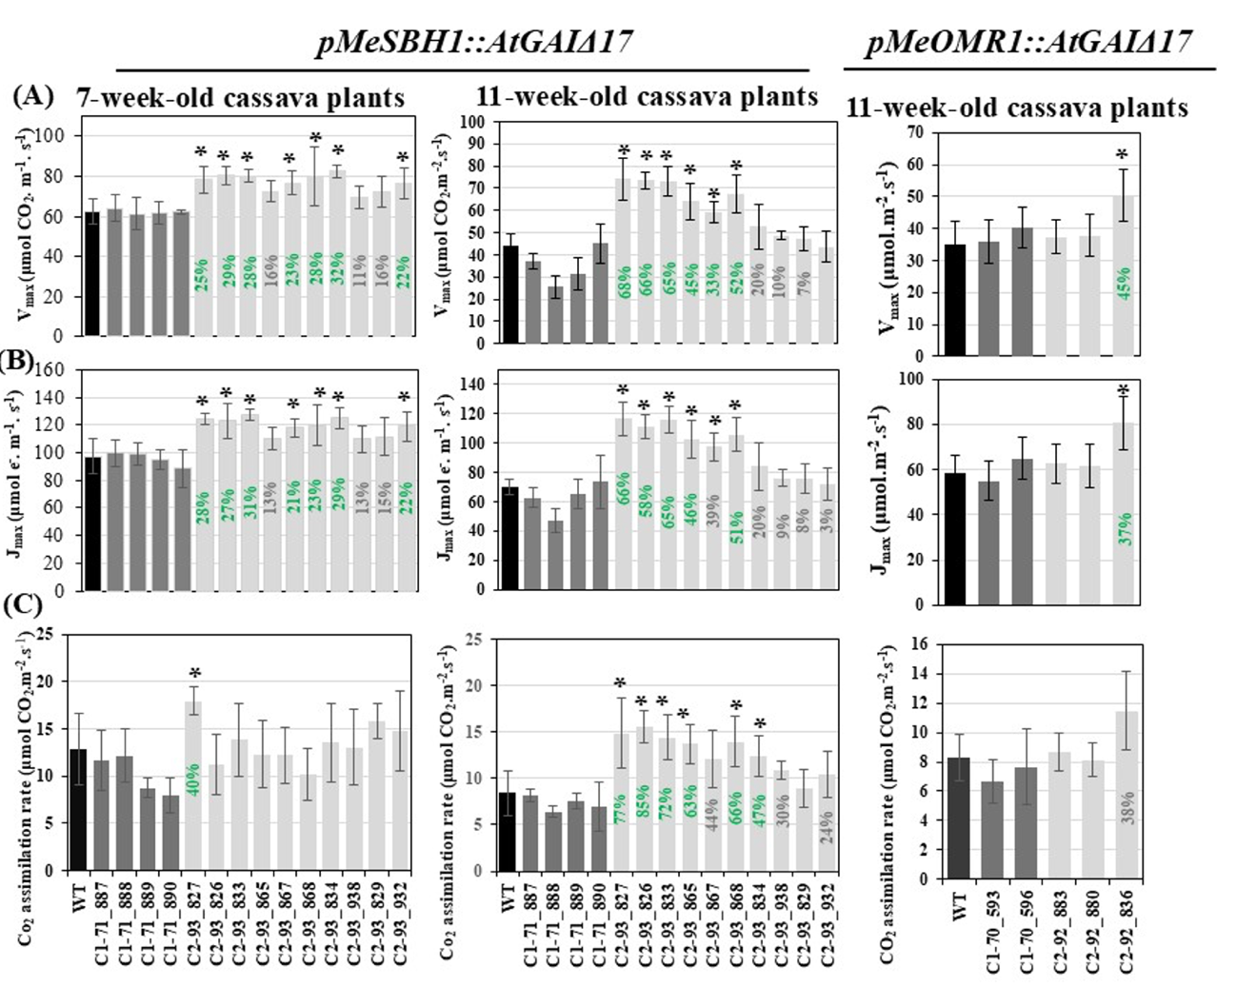
Fig. 4. Photosynthetic performance of C2-93/pMeSBH1::AtGAIΔ17 and C2-92/pMeOMR1::AtGAIΔ17 transgenic cassava lines. The maximum rate of Rubisco carboxylation (Vmax), maximum electron transport rate (Jmax), and CO₂ assimilation rate were measured in 7- and 11-week-old pMeSBH1::AtGAIΔ17 lines and 11-week-old pMeOMR1::AtGAIΔ17 lines using a LI-6800 Portable Photosynthesis System. Measurements were performed on fully expanded leaves under controlled light and CO₂ conditions. The number of biological replicates was for pMeSBH1::AtGAIΔ17 construct: n = 5 for WT, n = 4 for VC-887, n = 5 for VC-888, n = 5 for VC-889, n = 4 for VC-890, n = 5 for line 826, n = 5 for line 827, n = 5 for line 833, n = 5 for line 834, 5 = 12 for line 865, n =5 for line 867, n = 5 for line 868, and n = 5 for line 938; and for pMeOMR1::AtGAIΔ17 construct: n = 9 for WT, n = 4 for VC-953, n = 6 for VC-596, n = 8 for line 880, n = 6 for line 883, and n = 7 for line 836. Asterisks indicate significant differences compared with WT (*P < 0.05). Values represent means ± SD

Impact of AtGAIΔ17 on starch and sugar contents in proximal, middle, and distal regions of storage roots in transgenic cassava lines.
Starch and sugar content were analysed in peel and core tissues from the proximal, middle, and distal regions of storage roots in C2-93/pMeSBH1::AtGAIΔ17 and in peel and core tissues from the middle region of storage roots in C2-92/pMeOMR1::AtGAIΔ17 transgenic lines (Fig. 5). Starch content varied significantly among different storage root regions in pMeSBH1::AtGAIΔ17 transgenic plants compared with WT (Fig. 5A). In pMeSBH1::AtGAIΔ17 lines, starch accumulation in the peel was significantly increased compared with WT, particularly in the distal region, where increases of approximately 143% and 176% were observed in lines 834 and 938, respectively (Fig. 5A). A similar but less pronounced increase was observed in the distal core tissue, with starch content increasing by approximately 38% and 35% in lines 834 and 938, respectively. In contrast, starch levels in the core tissues of the proximal and middle regions remained unchanged compared with WT (Fig. 5A). In pMeSBH1::AtGAIΔ17 transgenic lines, the spatial pattern of starch accumulation along the storage root axis reveals a clear gradient in carbon storage, with the highest levels observed in the distal region. This pattern suggests that expression of AtGAIΔ17 may enhance sink activity in storage roots, thereby promoting preferential carbon allocation to specific root regions rather than uniformly across the organ. The pronounced increase in starch accumulation in the distal region, particularly in the peel, may suggest higher sink activity and a greater capacity for carbon deposition in this tissue under AtGAIΔ17 expression. In contrast, the relatively lower starch accumulation in the proximal and middle regions suggests either a more limited capacity for starch storage or a preferential redistribution of incoming carbon toward distal tissues with higher sink strength.
Overall, these results suggest a dynamic pattern of carbon partitioning, in which sucrose transport and starch biosynthesis are preferentially enhanced in distal storage root tissues. This spatial regulation may also be influenced by region-specific differences in AtGAIΔ17 expression levels. Although GUS staining confirmed strong promoter activity in storage roots, the absence of spatially resolved expression data prevents conclusions regarding uniform expression across proximal, middle, and distal regions. Therefore, variation in local AtGAIΔ17 expression may contribute, at least in part, to the observed differences in starch accumulation along the storage root axis.
Sucrose content was also analysed in peel and core tissues along the proximal–middle–distal axis of the storage root. Sucrose content showed a tissue- and region-dependent response in pMeSBH1::AtGAIΔ17 transgenic lines. In peel tissues, line 834 showed a significant increase in sucrose content in the proximal region, while changes in the middle and distal regions were not significant (Fig. 5B). In contrast, line 938 did not show a significant change in the proximal region and showed a non-significant reduction in sucrose content in the middle and distal regions. Despite these differences in sucrose levels, both transgenic lines exhibited increased starch accumulation in peel tissues across the storage root regions, particularly in the distal region. Therefore, differences in sucrose turnover or conversion efficiency into starch may contribute to the observed pattern. In contrast, pMeOMR1::AtGAIΔ17 lines showed no consistent or significant changes in starch content in either the peel or core tissues of the middle storage root region compared with WT. However, sucrose levels were increased in the middle region in line 883 (Fig. 5B).
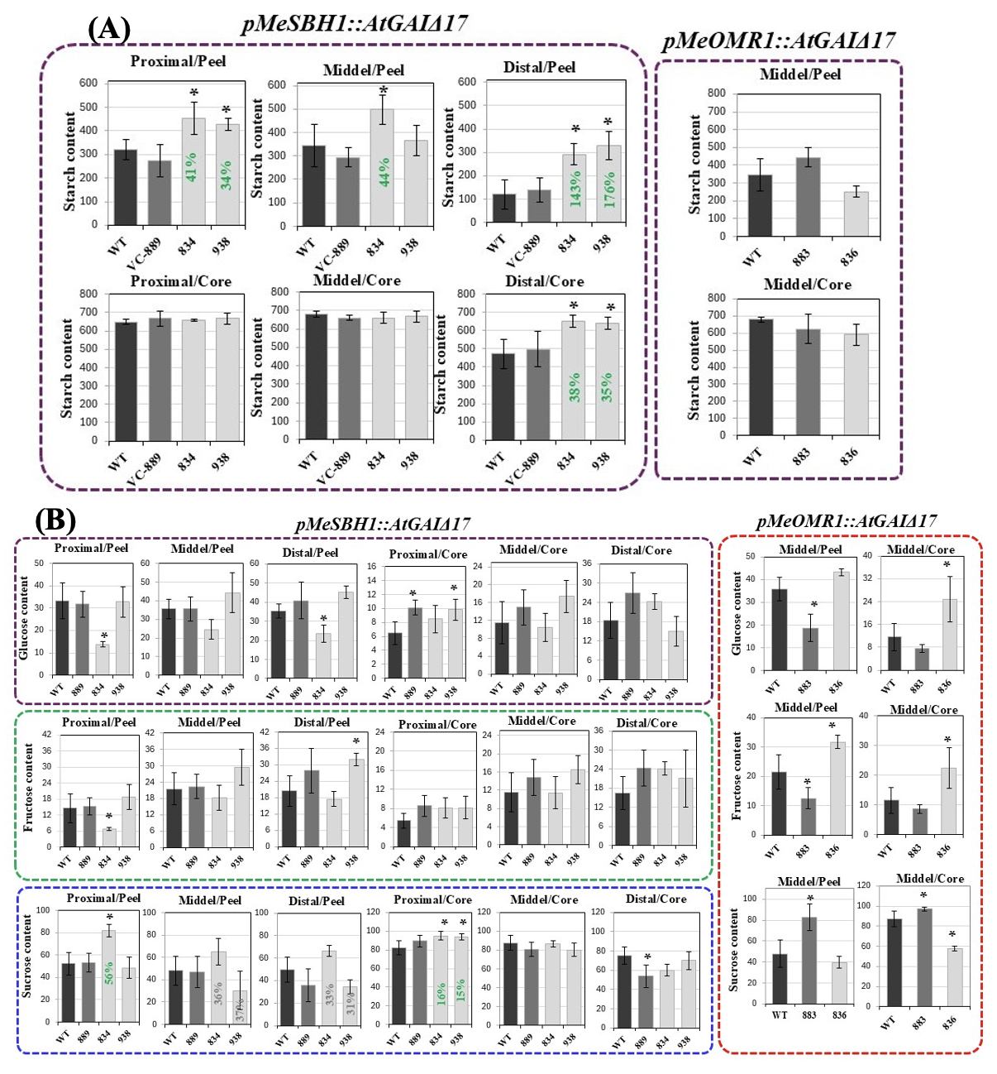
Fig. 5. The contents of starch (A) and sugars (B) in the proximal, middle, and distal regions of storage roots in C2-93/pMeSBH1::AtGAIΔ17 transgenic cassava lines, and in the middle region of storage roots in C2-92/pMeOMR1::AtGAIΔ17 transgenic cassava lines. The number of biological replicates was n = 4. Asterisks indicate significant differences compared with WT (*P < 0.05). Values represent means ± SD
Overall, the combined sucrose and starch data suggest that both pMeSBH1::AtGAIΔ17 lines enhance carbohydrate storage, but through potentially different metabolic strategies. Line 834 appears to promote increased carbon availability and storage capacity through higher sucrose accumulation accompanied by starch deposition, whereas line 938 may favor more efficient conversion of soluble sugars into starch, resulting in increased starch accumulation despite limited sucrose accumulation. In addition, histological analysis of pMeSBH1::AtGAIΔ17 storage roots indicated that lignin accumulation in the transgenic lines was not increased compared with the WT (Fig. 6).

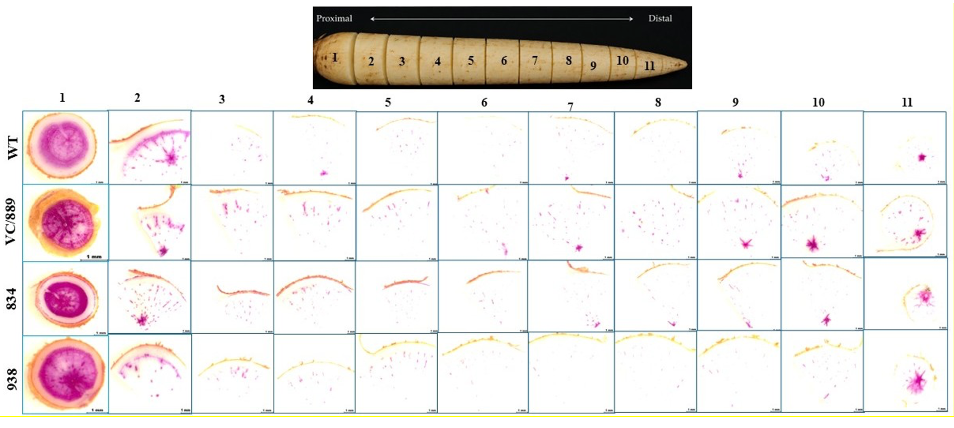
Fig. 6. Histological analysis of cassava storage roots from C2-93/pMeSBH1::AtGAIΔ17, VC/889, and WT plants was performed on transverse sections collected at 1 cm intervals along the proximal-to-distal axis. Sections were stained with phloroglucinol–HCl to visualize starch deposition and lignification patterns in the storage root tissues.
AtGAIΔ17 expression in the proximal, middle, and distal regions of storage roots
Relative expression of AtGAIΔ17 was analyzed in peel and core tissues from the proximal, middle, and distal regions of storage roots in the C2-93 (pMeSBH1::AtGAIΔ17) lines (834 and 938), and in the middle region of storage roots in the C2-92 (pMeOMR1::AtGAIΔ17) lines (836 and 883) (Fig. 7). in the C2-93 lines, AtGAIΔ17 transcript level showed no clear differences between peel and core tissues across the proximal, middle, and distal regions of the storage root. However, a tendency toward lower transcript levels of AtGAIΔ17 was observed in the distal region compared with the proximal and middle regions. Overall, AtGAIΔ17 expression in C2-93 appeared relatively uniform along tissues, but with a slight reduction in the distal portion of the storage root (Fig. 7). In the C2-92 lines, AtGAIΔ17 expression was detected in both peel and core tissues of the middle storage root region, with line 836 showing higher transcript abundance than line 883, particularly in the peel tissue. Notably, AtGAIΔ17 transcript levels in the peel were higher than in the core, indicating a stronger accumulation of AtGAIΔ17 transcripts in the outer tissue layers. However, GUS staining primarily indicated expression in the outer layers of the storage root (Included in the Q2-2025 CASS report), whereas a weaker but detectable signal in the core may not have been fully captured by the staining assay, suggesting that low-level internal expression could be below the detection threshold of GUS analysis. Overall, AtGAIΔ17 transcript levels were higher in C2-93 lines compared with C2-92 lines (Fig. 7).

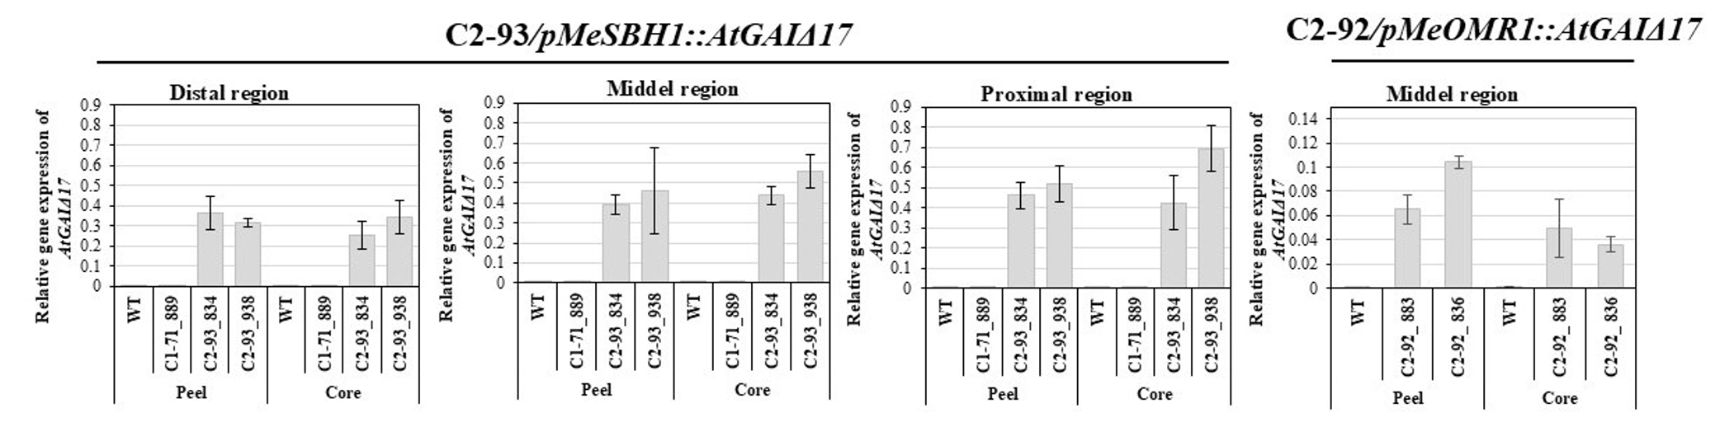
Fig. 7. Quantitative real-time PCR measurements of AtGAIΔ17 expression levels in the proximal, middle, and distal regions of storage roots in C2-93/pMeSBH1::AtGAIΔ17 transgenic cassava lines, and in the middle region of storage roots in C2-92/pMeOMR1::AtGAIΔ17 transgenic cassava lines. The number of biological replicates was n = 4.

Challenges and Mitigations:

Update Q2 2026
No challenges to report at this point.

Next Steps in the Action Plan:

Update Q2 2026

- Measurement of hormones for proximal, middle, and distal regions of the storage root

- Measurement of total protein content in the 1st, 5th, 10th, and 15th leaves from the top

- Performing RNA-seq for proximal, middle, and distal regions of the storage root

- qPCR for AtGAIΔ17 in different tissues (storage root, leaf, petiole, stem, and fibrous root)

Additional AtGAIΔ17 and GA2ox1-based constructs utilizing different promoters have arrived from the transformation team (EM2.1) for further analyses. The constructs and available lines are summarized in Table 3. These lines are being prepared for the greenhouse and a subset of constructs and lines will be selected for further analyses.

Table 3_Summary of additional AtGAIΔ17 and GA2ox1 constructs.
Construct number | Gene cassette | Number of lines | Database link
C2-141 | pMeKS1::GUS + pMeKS1::GA2ox1 genomic | ETH6029 – ETH6050 (22 lines) | https://cassbase.org/stock/475424/view
C2-142 | pMeKS1::GUS + pMeKS1::AtGAIΔ17 | ETH6052 – ETH6067 (17 lines) | https://cassbase.org/stock/475425/view
C2-144 | pCaMV35S::GUS + pCaMV35S::GA2ox1 genomic | ETH6068 – ETH6094 (27 lines) | https://cassbase.org/stock/475429/view
p134GG | Corresponding vector control for C2-141, C2-142, and C2-144 | ETH6095 – ETH6112 (17 lines) | https://cassbase.org/stock/368701/view

EM1.2_Limiting lateral transport losses through active phloem (re-)loading
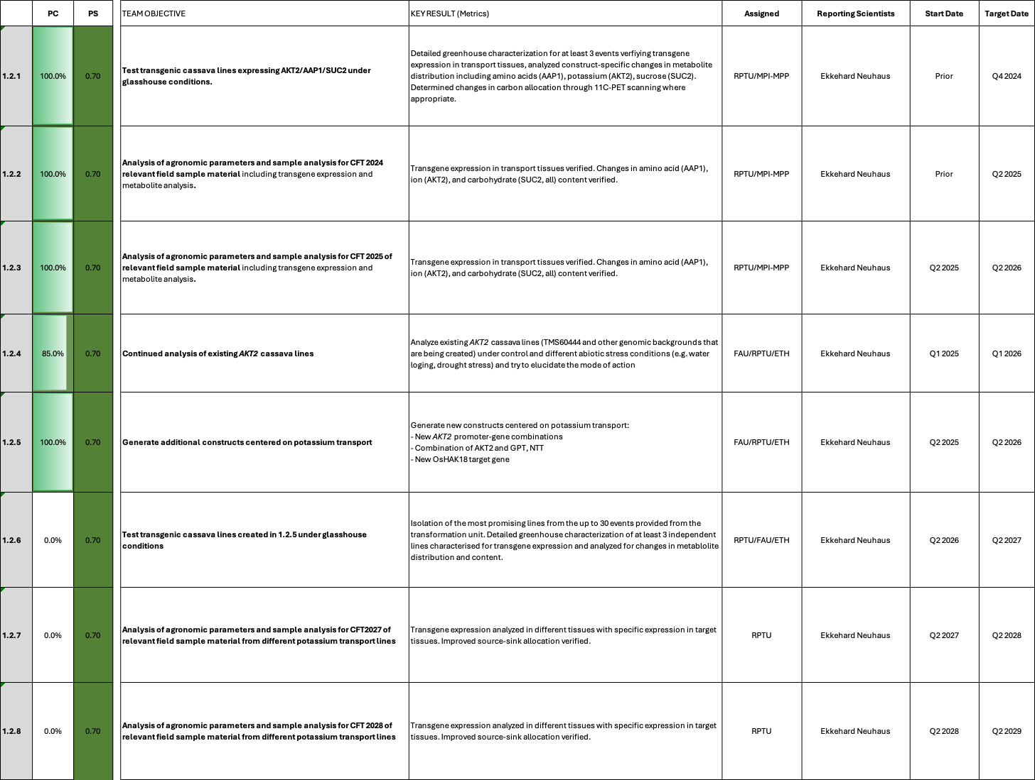

EM1.2_Limiting lateral transport losses through active phloem (re-)loading

Reporting module leader: Ekkehardt Neuhaus, RPTU with MPI-MPP.

Progress Update:
1.2.1. Test transgenic cassava lines expressing AKT2/AAP1/SUC2 under glasshouse conditions
Concluded. Please see previous reports for reporting history.

1.2.2. Analysis of agronomic parameters and sample analysis for CFT 2024 relevant field sample material including transgene expression and metabolite analysis.
Concluded. Please see previous reports for reporting history.

1.2.3 Analysis of agronomic parameters and sample analysis for CFT 2025 of relevant field sample material including transgene expression and metabolite analysis.
Concluded. Please see previous reports for reporting history.

1.2.4 Continued analysis of existing AKT2_{var} cassava lines (& perform additional Arabidopsis experiments)
This point is ongoing. In contrast to the initial projection for target date Q1 2026, more time is required to properly analyze the existing AtAKT2_{var} cassava lines for their drought resistance, as well as the added Arabidopsis experiments with many different AKT2_{var} variants that were agreed upon previously. Please see previous reports for reporting history.
In this reporting period a hydroponic cultivation system was established for Arabidopsis plants in the RPTU lab to enable a more detailed analysis of the drought stress response. Compared with plate-based assays, the hydroponic setup provides larger amounts of plant material and allows rosette and root tissues to be harvested and analyzed separately. This enables tissue-specific investigation of physiological and molecular responses to drought stress. The implementation of this system was motivated by the promising results obtained in the plate-based drought experiments, in which the AtAKT2_{var} lines consistently showed a tendency to maintain higher biomass and increased lateral root formation under PEG-induced drought stress. At present, the hydroponic system has been successfully established, and the first cultivation cycle and subsequent physiological (Fig. 1) and molecular analyses are currently running.
The first hydroponic cultivation experiment, including the WT and the akt2-1 knockout mutant, has been completed and harvested (Fig. 1). Preliminary analyses revealed that, at the beginning of the experiment (T1), WT plants exhibited a higher fresh weight for both rosettes and roots compared with the akt2-1 mutant under control conditions (Fig. 1A). At the second harvest time point (T2), two days after transfer to PEG-induced drought stress, plants maintained under control conditions (without PEG) still displayed a slight difference in root fresh weight, with WT roots being approximately 22% heavier than those of the akt2-1 knockout mutant (Fig. 1B). Compared with T1, however, this difference was less pronounced, indicating that the initial developmental difference between the genotypes became smaller over time under control conditions. In contrast, under PEG-induced drought stress, the difference remained pronounced, with WT plants exhibiting a significantly higher root fresh weight of approximately 31% compared with the akt2-1 mutant (Fig. 1C). A similar pattern was observed for rosette fresh weight, where the initial difference between the genotypes decreased over time under control conditions but remained more pronounced under PEG treatment.

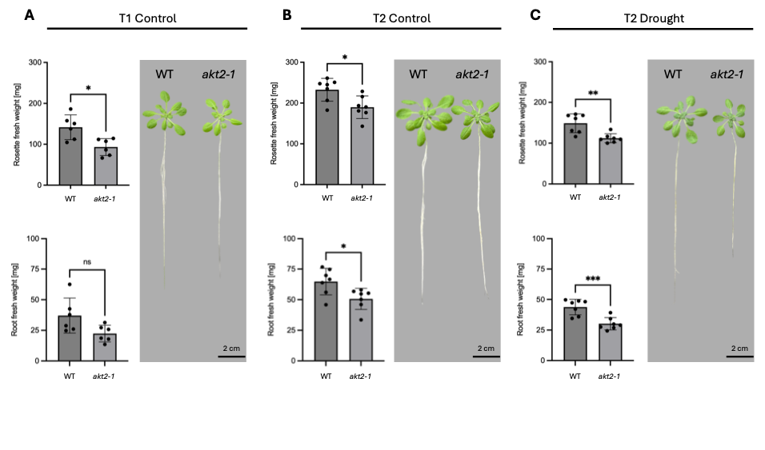
Fig. 1_ Fresh weight analysis of WT and the akt2-1 knockout mutant grown in a hydroponic system under control and PEG-induced drought stress conditions. (A) Rosette and root fresh weight at the beginning of the experiment (T1) for 4-week-old plants grown under control conditions. (B) Rosette and root fresh weight at the second harvest time point (T2) under control conditions. (C) Rosette and root fresh weight after two days of PEG-induced drought stress harvested at T2. Data represent the mean of n=6-8 biological replicates ± SD. For comparison of WT and akt2-1 unpaired students t-test was performed (p < 0.001 ** and p < 0.0001 ***).

This experimental setup will help to elucidate the phenotypic and molecular differences of the different AKT2_{var} construct version, particularly in their root growth and drought stress response. Additional measurements on various experiments were performed. However, no comprehensive picture is yet available. A comprehensive overview of the obtained Arabidopsis and cassava results will be shared with the next quarterly report.

1.2.5 Generate additional constructs centered on potassium transport
As agreed upon previously, new constructs centered on potassium transport have been generate. Constructs have successfully been created and transformation has been initiated. Table 1 summarizes the current status of these constructs.

Table 1_Summary of EM1.2 gene constructs in preparation for cassava transformation
Construct number | Gene cassette | Database link | Current status
C2-122 | pAtSUC2::AtAKT2 CDS_S210N-S329N::Ter (companion cell-specific expression) | https://cassbase.org/stock/470120/view | Transformed in April, regeneration media
C2-131 | pMeAKT2a::AtAKT2_{var} (Endogenous AKT2a specificity) | https://cassbase.org/stock/470133/view | Awaiting rooting test analysis
C2-143 | pMeAKT2b::AtAKT2_{var} (Endogenous AKT2b specificity) | https://cassbase.org/stock/475426/view | Awaiting rooting test analysis
C127 | AKT2_{var} + GPT2 + NTT1 | https://cassbase.org/stock/470119/view | Transformed in April, regeneration media
C2-129 | pAtSUC2::OsHAK18 | https://cassbase.org/stock/471878/view | Awaiting rooting test analysis
C2-130 | pMeSUS1::MeSWEET10 RNAi | https://cassbase.org/stock/471879/view | Awaiting rooting test analysis

Constructs C2-122 (pAtSUC2::AtAKT2_{var}) and C127 (AKT2_{var} + PsPGT2 + AtNTT1) were transformed in April and are currently on regeneration meida. Constructs C2-131 (pMeAKT2a::AtAKT2var), C2-143 (pMeAKT2b::AtAKT2var), C2-129 (pAtSUC2::OsHAK18), and C2-130 (pMeSUS1::MeSWEET10 RNAi) are ahead in the transformation and isolated shoots are awaiting rooting test analysis.

1.2.6 Test transgenic cassava lines created in 1.2.5 under glasshouse conditions
Not started yet

1.2.7 Analysis of agronomic paramters and sample analysis for CFT2027 of relevant field sample material from different potassium transport lines
Not started yet

1.2.8 Analysis of agronomic paramters and sample analysis for CFT2028 of relevant field sample material from different potassium transport lines
Not started yet
Challenges and Mitigations:
Despite the ongoing limitation in growing capacity at RPTU, no new limitations have been reported.

Next Steps in the Action Plan:
- Detailed analysis of the different At/MeAKT2(_{var}) lines (Ongoing)
- Evaluation of AKT2_{var} control vs. drought stress RNA-Seq and design of further experiments to reveal the AKT2_{var} mechanism (Ongoing)
- Transformation of new EM1.2 constructs (Ongoing)

EM1.3_Transport and allocation modelling

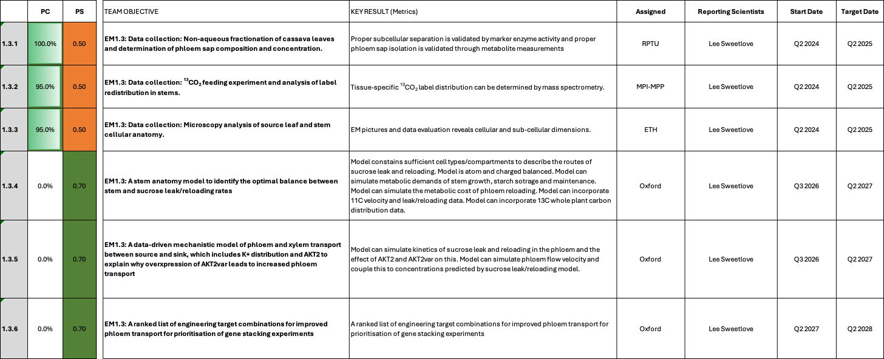

EM1.3_Transport and allocation modelling

Reporting module leader: Lee Sweetlove, UO with RPTU, MPI-MPP and ETH.

Progress Update:

1.3.1. Data collection: Non-aqueous fractionation of cassava leaves and determination of phloem sap composition and concentration.
See previous reports for reporting history. All required data was collected.
1.3.2. Data collection: ¹³CO₂ feeding experiment and analysis of label redistribution in stems.
See previous reports for reporting history. All required data was collected with the exception of 13C labelling data. The labelling experiment has been performed and the samples have been generated. However, they need to be sent of to an isotope ratio mass spectrometry analysis group (external). Results are not yet available.
1.3.3. Data collection: Microscopy analysis of source leaf and stem cellular anatomy.
See previous reports for reporting history. All required data was collected with the exeption of the numeric stem anatomy data. High quality light microscopy images of stem sections have been generated. However, segmentation and data analysis is still ongoing.
1.3.4 A stem anatomy model to identify the optimal balance between stem and sucrose leak/reloading rates
We agreed on these new targets for EM1.3. Updates will be shared in future reports.

1.3.5 A data-driven mechanistic model of phloem and xylem transport between source and sink, which includes K+ distribution and AKT2 to explain why overxpression of AKT2_{var} leads to increased phloem transport
We agreed on these new targets for EM1.3. Updates will be shared in future reports.

1.3.6 A ranked list of engineering target combinations for improved phloem transport for prioritisation of gene stacking experiments
We agree on these new targets for EM1.3. Updates will be shared in future reports.

Challenges and Mitigations:
See previous reports for reporting history. Due to the previously reported delays in the modelling work, we decided to cancel the construction of source leaf / phloem loading models, as well as trying to construct full source-sink models and focus this work on establishing good stem models and to predict target genes for improved phloem transport. The reporting documents were updated accordingly (new points 1.3.4 / 1.3.5 / 1.3.6).

Next Steps in the Action Plan:
Stem model construction is now planned to begin in Q3 2026 with initial model versions completed by the end of period 3 (Q2 2027). Stem models will then be used in an ongoing basis in period 4 for interpretation and analysis of transgenic plants.

EM2: Increasing sink strength by optimizing xylem parenchyma cell formation in storage roots
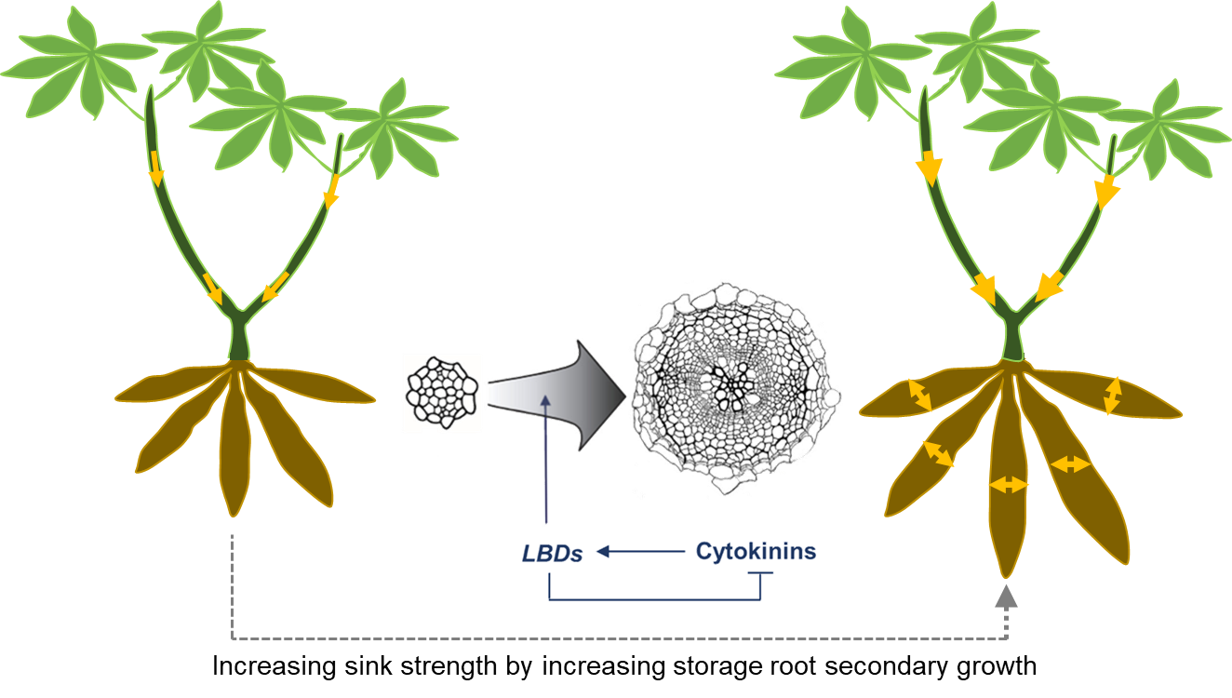

EM2.2_Manipulation of downstream factors involved in xylem parenchyma cell formation

2.2
EM2.1_Manipulation of OVAC and cytokinin metabolism or signaling
2.1
Summary of Goals and Impact
The goal of EM2 is to enhance the sink strength of cassava storage roots by promoting the formation of xylem parenchyma cells, which are crucial for starch storage. By stimulating the vascular cambium, the tissue responsible for radial growth, through targeted manipulation of cytokinin (CK) signalling pathways and other secondary growth regulators, this module aims to significantly increase the radial growth and starch-storing capacity of cassava roots.

For smallholder farmers, the impact of this research could be transformative. By boosting the storage root yield through an increase in the number of starch-storing cells, EM2 has the potential to deliver higher yields with minimal additional inputs. This approach could lead to more productive and resilient cassava plants, directly improving food security and livelihoods in regions where cassava is a staple crop. The innovative use of tissue-specific gene expression to control and enhance storage root growth could set a new standard for biotechnological interventions in root crops, offering scalable solutions for sustainable agriculture.

EM2.1_Manipulation of OVAC and cytokinin metabolism or signalling

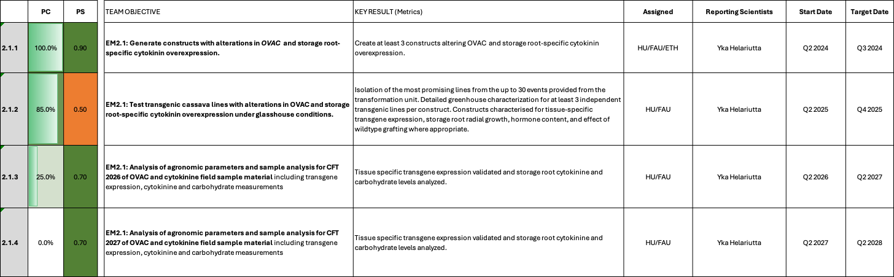

EM2.1_Manipulation of OVAC and cytokinin metabolism or signalling

Reporting module leader: Yka Helariutta, HU with FAU and ETH.

Progress Update:

2.1.1. Generate constructs with alterations in OVAC and storage root-specific cytokinin overexpression.
See previous reports for reporting history. Constructs have been successfully generated. Current analyses are focussed on the meovac Crispr/Cas9 KO lines at Helsinki University and on the IPT7/LOG1 lines at FAU Erlangen.

2.1.1. Test transgenic cassava lines with alterations in OVAC and storage root-specific cytokinin overexpression under glasshouse conditions.
See previous reports for reporting history.
Q2 2026 Update from HU
We performed anatomical characterization of AtOVAC OE lines (construct C2-51) and measured storage root yield as well as stem thickness after growth period extending over winter season in the greenhouse conditions. There seems no obvious variation in the histological samples (Fig. 1A) indicating that vascular patterning is unaffected in the transgenic lines as compared to WT. Final harvest of storage roots is not increased in the AtOVAC OE lines (Fig. 1B), which confirms our earlier take on this material. Also, secondary growth based on stem diameter measurements did not exceed WT. Thus, we conclude that cassava productivity does not seem to improve by over-expression of AtOVAC. Based on our recent unpublished observations in Arabidopsis, ribosomal methylation levels may in fact decrease rather than increase in ectopic over-expressors of AtOVAC (Helariutta group, in collaboration with F. Kirpekar); such an obverse outcome may realize in AtOVAC OE cassava as well. We are establishing a method to estimate the level of OVAC-dependent ribosomal methylation in meovac lines (construct CC1_MeOVAC), and in that context consider testing methylation levels of C2-51 lines too. Nevertheless, we may not prioritize further analyses of the C2-51 lines.

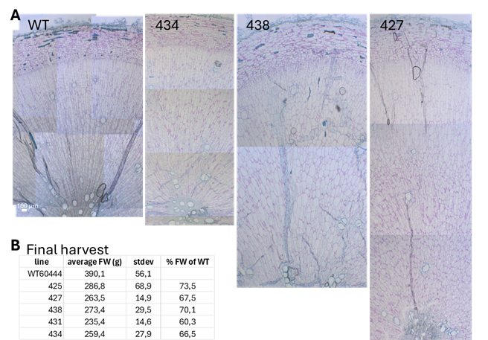
Fig. 1_Characterization of storage roots of wild type (WT) and transgenic lines carrying the construct C2-51 (pCaMV35S::AtOVAC). Histological sections were prepared from 8-wk old plants (A) and final harvest fresh weight measured after 9 months of growth in the greenhouse conditions (n=4-5) (B).

In this reporting period, HU has further optimized their grafting workflow for cassava. Preliminary results of the first set of cassava grafts meovac/WT, WT/WT, WT/meovac and meovac/meovac are shown in Fig. 2. We consider this dataset rather inconclusive and the experiment terminated prematurely, as the plants were growing poorly under suboptimal conditions during midwinter and the grafting technique was still improved at the time. We did observe that the meovac storage root phenotype (vessel differentiation) may be enhanced in WT/meovac graft (Fig. 2H). However, during the timeframe of this experiment it is premature to evaluate a possible stimulatory effect on storage organogenesis in meovac/WT (Fig. 2B and C). We have repeated the graftings in May-June 2026 and currently grow the plants in the greenhouse. Alongside the most recent grafts, we are also growing non-grafted WT and meovac lines to confirm previously observed phenotypes and characterize the meovac CRISPR lines (construct CC1_MeOVAC) in further detail.
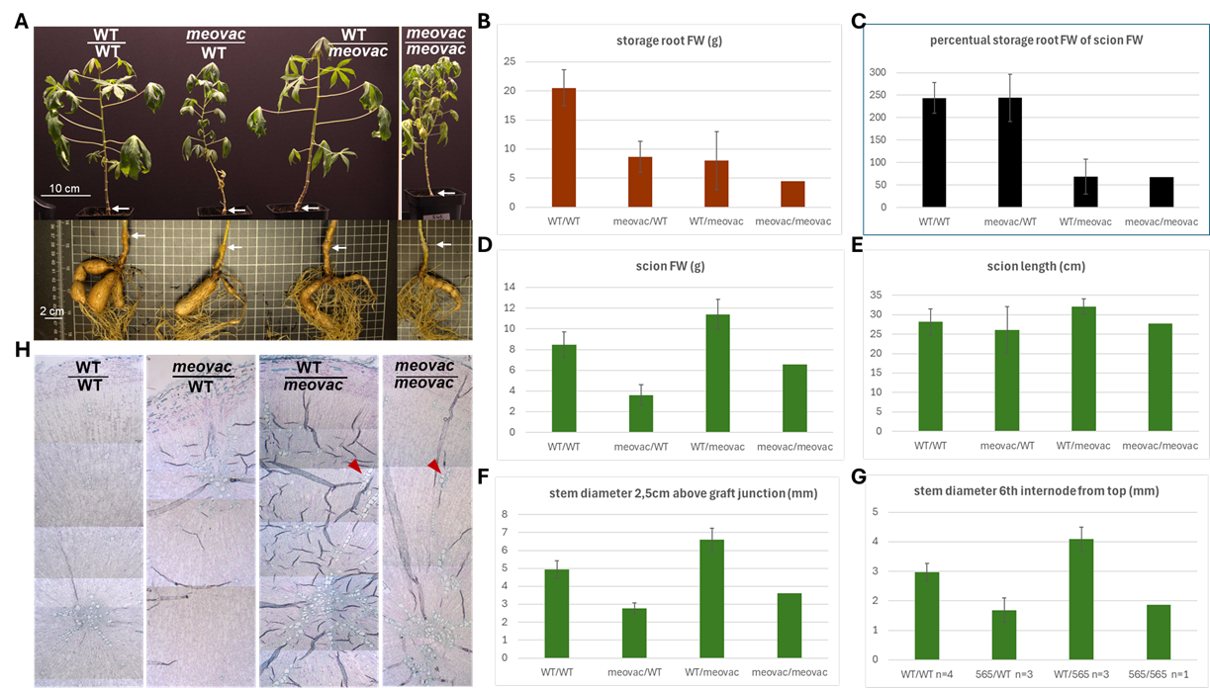

Fig. 2_Optimization of grafting technique with the following scion/rootstock combinations: WT/WT, meovac/WT, WT/meovac, and meovac/meovac. (A) Overview of representative individuals, with arrows pointing at graft junctions. (B-G) Various growth parameters as indicated in each panel, measured approximately 3.5 months after grafting. At the time of harvesting, we recorded the largest storage root biomass in WT/WT combination (B), Interestingly, meovac/WT eqúals the storage root fresh weight (FW) in relation to scion biomass (panel C-D). Therefore, experiments are ongoing to observe storage root organogenesis and its biomass gain at a later stage. (H) Anatomical cross sections of storage roots of each graft combination. Arrowheads point at vessel clusters. n=3-4 in meovac/WT, WT/WT and WT/meovac, and n=1 in meovac/meovac. Mean values ±stdev are shown in B-G. meovac corresponds to meovac CRISPR line 565.

Q2 2026 Update from FAU
We previously reported that IPT7/LOG1-based lines showed accelerated storage root induction. Detailed histological and molecular analysis of the first cultivation is ongoing and we are currently preparing the repetition of this greenhouse experiment. We will be able to share a more comprehensive summary of results with the Q3 2026 report.
Due to the accelerated storage root bulking observed in the greenhouse, we decided to dedicate 5 replicates of the ongoing CFT experiment at NCHU Taichung, Taiwan for an early harvest to see if early induction of storage roots might indeed translate to field conditions. Despite the low number of replicates, the IPT7/LOG1 constructs tended to have higher storage root biomass at this early harvest timepoint (approx. 3-4 month of field growth). The IPT7+LOG1 construct even displayed a significant increase over the vector controls (Fig. 3). These findings suggest that the accelerated bulking behaviour observed in the greenhouse also translates to field conditions.

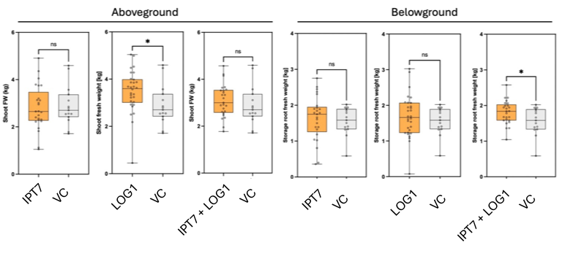
Fig. 3_Intermediate harvest data of pStPatatin::AtIPT7 (C2-56), pStPatatin::AtLOG1 (C2-59), pStPatatin::AtIPT7 + pStPatatin::AtLOG1 (C75). Plants were grown in the CFT Taichung, Taiwan in 2026 from end of March to end of June. Summarized results (all lines) per construct vs vector control. (*) Welch test, p < 0.05.

We will keep focusing our analyses efforts on these constructs.

Challenges and Mitigations:
See previous report for reporting history. No new challenges to report.

Next Steps in the Action Plan:
- Continued analyses with the meovac KO material through different grafting combinations
- Continued analyses with the IPT7/LOG1 material (second cultivation, histology, hormone analysis, RNA-Seq, etc.)

EM2.2_Manipulation of downstream factors involved in xylem parenchyma cell formation

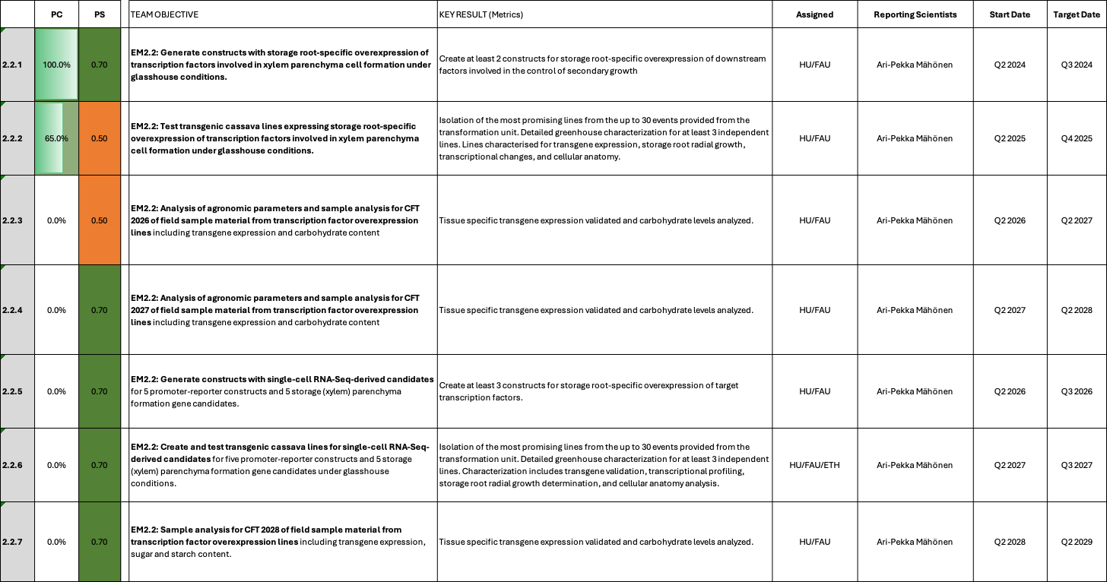

EM2.2_Manipulation of downstream factors involved in xylem parenchyma cell formation

Reporting module leader: Ari Pekka Mähönen, HU with FAU and ETH.

Progress Update:

2.2.1. Generate constructs with storage root-specific overexpression of transcription factors involved in xylem parenchyma cell formation under glasshouse conditions.
Cloning was concluded. See previous reports for details.

2.2.2. Test transgenic cassava lines expressing storage root-specific overexpression of transcription factors involved in xylem parenchyma cell formation under glasshouse conditions.
See previous reports for details. We have concluded the initial screening of these lines. No deeper analyses has taken place so far. However, our initial impression was that MeLBD4 overexpression lines appeared WT-like and MeLBD11 overexpression lines even had problems with storage root formation. Analysis of the GFP-marked expression domains indicated that the transgenes are not expressed in the vascular cambium, but rather close to xylem vessels. Since we selected these genes based on homology to Arabidopsis LBDs, it is possible that we are not targeting the correct gene variants. Therefore, we prioritized the analyses of IPT7/LOG1 plants.

However, Arabidiopsis LBD11 was already demonstrated to boost cassava secondary growth when expressed from the cambium/xylem promoter pMX5, but lacked specific expression in storage roots. If a storage root cambium/xylem promoter could be isolated, expression of AtLBD11 would have a high chance to boost secondary growth specificially in storage roots. Recently, promoter discovery efforts have indeed identified a gene that shows storage root cambium-specific expression, MeFANTA4. MeFANTA4 (Manes.02G156700) only shows expression in bulking storage root and is specific to the cambium and xylem area (Fig. 1).

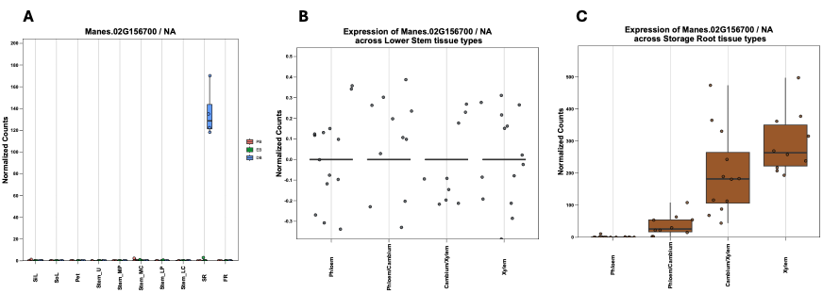
Fig. 1_Expression data in different tissues for Manes.02G156700 (MeFANTA4). (A) Expression in different tissues. Expression is specific to bulking storage roots (SR). (B) No expression is found in stems. (C) Expression is located to the cambium and cambium/xylem area within the storage root.

We are currently cloning a pMeFANTA4::GUS + pMeFANTA4::AtLBD11 construct and will transform it as soon as possible.

Challenges and Mitigations:
Although deeper analysis is so far lacking, initial results suggest that MeLBD4 and MeLBD11 overexpression lines do not result in promising outcomes concerning storage root formation. Expression of the well-described Arabidopsis homolog AtLBD11 via the putative storage root cambium-specific promoter pMeFANTA4 is being persued.

Next Steps in the Action Plan:
- Finalize cloning of pMeFANTA4::GUS + pMeFANTA4::AtLBD11 and initiate transformation

EM3: Increasing sink strength by optimizing metabolic flux in storage roots
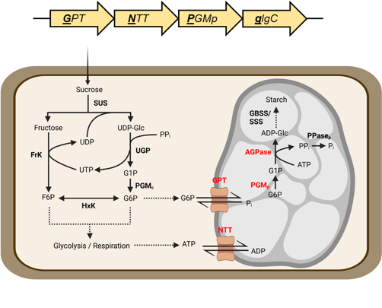
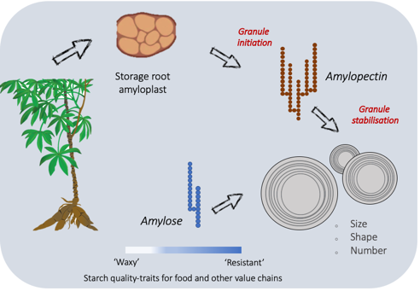
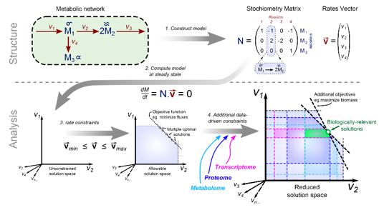
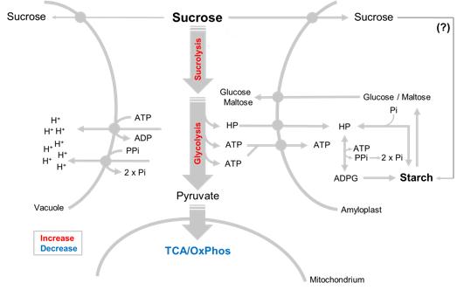
EM3.1: Optimization of sucrolytic cleavage and glycolysis
3.1
EM3.4: Model-based predictions
3.4
EM3.3: Starch granule initiation
and growth
3.3
EM3.2: Optimization of starch-precursor delivery to amyloplasts
3.2
Summary of Goals and Impact
The objective of EM3 is to enhance the sink strength of cassava storage roots by optimizing the metabolic processes that drive starch biosynthesis. Many African cassava varieties struggle with low starch production, leading to storage roots with excessive sugar and water content. This module seeks to address these limitations by focusing on key metabolic areas: sugar cleavage and glycolysis (EM3.1), the delivery of starch precursors to amyloplasts (EM3.2), and the initiation and growth of starch granules (EM3.3). Additionally, a computational model of storage root metabolism (EM3.4) will be developed to guide the engineering efforts and predict effective gene targets for improving starch synthesis.

This research holds great promise for creating tangible benefits for smallholder farmers. By boosting the starch content and overall yield of cassava, EM3 could lead to more productive crops that offer higher nutritional and economic value. The success of this module would not only increase food security but also support sustainable agricultural practices under low-input conditions, making a significant impact on the lives of farmers who rely on cassava as a staple crop.

EM3.1_Optimization of sucrolytic cleavage and glycolysis

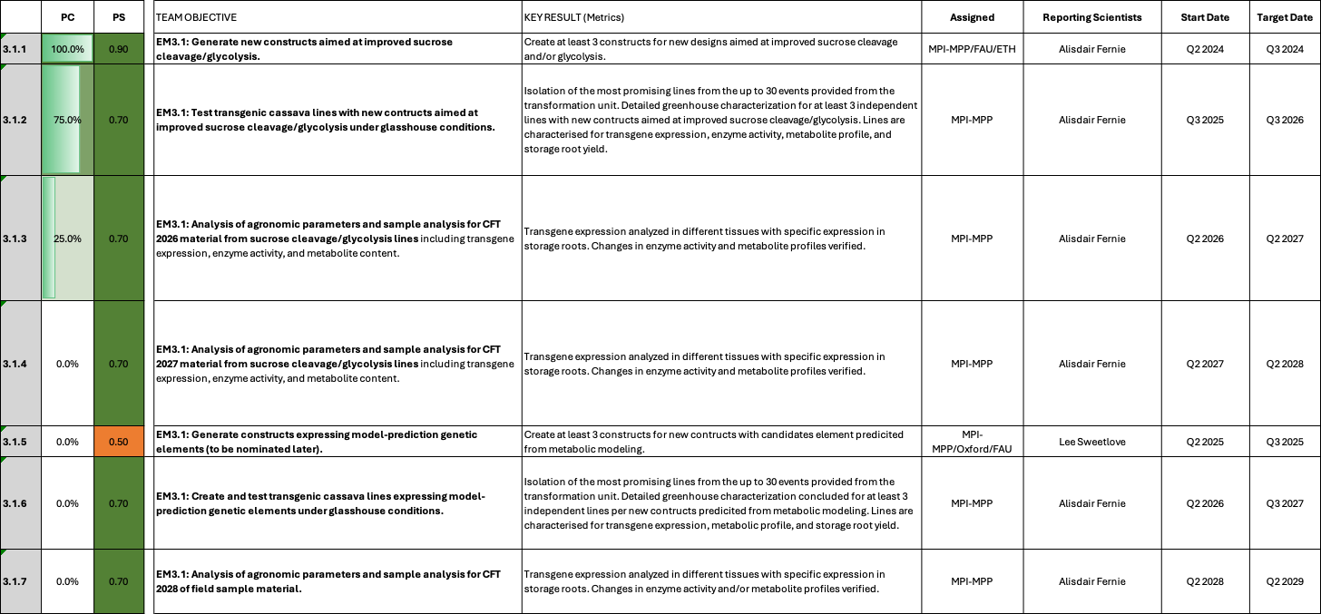

EM3.1: Optimization of sucrolytic cleavage and glycolysis

Reporting module leader: Alisdair Fernie, MPI-MPP with Oxford and FAU.

Progress Update:

3.1.1. Generate new constructs aimed at improved sucrose cleavage/glycolysis.
Construct cloning has been concluded. See previous reports for details.

3.1.2. Test transgenic cassava lines with new constructs aimed at improved sucrose cleavage/glycolysis under glasshouse conditions.
Screening of lines has been concluded. See previous reports for details.

Recently, pre-screened transgenic lines for constructs C2-100 (pMeGPT2::MePFP1beta_ACU), C2-101 (pMeGPT2::MeGAPC_ACU), and C2-112 (pMeGPT2::PGAM-ENO-PK) were sent to MPI-MPP for in detail analysis. The plants are currently being prepared for transfer to the greenhouse. More results will be available in future reports.

3.1.3. Analysis of agronomic parameters and sample analysis for CFT 2026 material from sucrose cleavage/glycolysis lines including transgene expression, enzyme activity, and metabolite content.
Leaf, stem, and storage root material has been obtained for constructs C2-100 and C2-101 from 3-4 month-old cassava plants during the intermediate harvest CFT Taichung, Taiwan 2026. C2-112 was unfortunately not yet part of the CFT and has to be included in the CFT 2027. The material will be forwarded to the MPI-MPP team for metabolite profiling once the samples are transferred from Taichung to Erlangen.

3.1.4. Analysis of agronomic parameters and sample analysis for CFT 2027 material from sucrose cleavage/glycolysis lines including transgene expression, enzyme activity, and metabolite content.
Not started yet.

3.1.5. Generate constructs expressing model-prediction genetic elements
Due to delays in the storage root metabolic model construction, no targets have yet been nominated.

3.1.6. Create and test transgenic cassava lines expressing model-prediction genetic elements under glasshouse conditions.
Not started yet.

3.1.7 Analysis of agronomic parameters and sample analysis for CFT 2028 of field sample material.
Not started yet.

Challenges and Mitigations:
No new challenges reported.

Next Steps in the Action Plan:
- Detailed analyses of C2-100, C2-101, and C2-112 cassava lines.

EM3.2: Optimization of starch-precursor delivery to amyloplasts

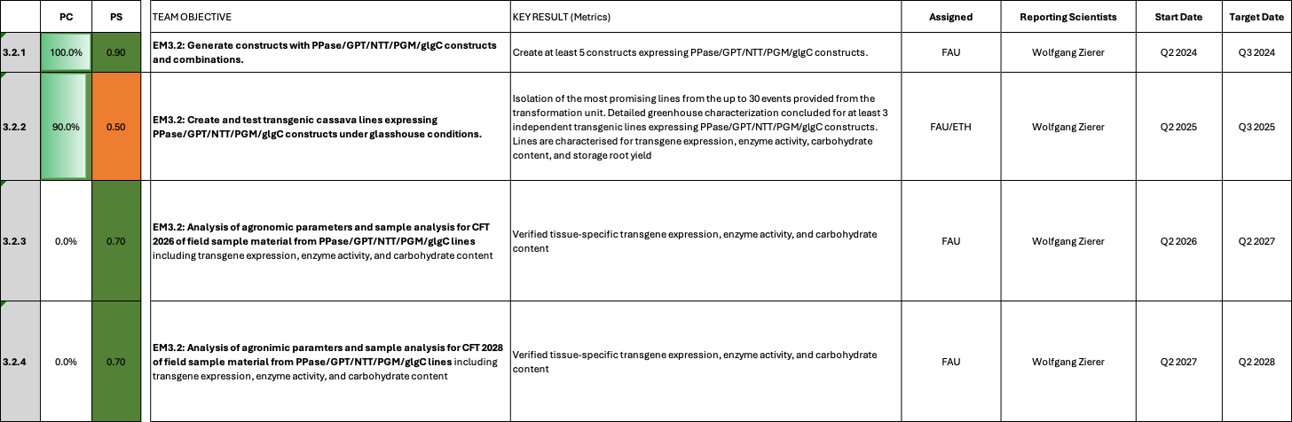

EM3.2: Optimization of starch-precursor delivery to amyloplasts

Reporting module leader: Wolfgang Zierer, FAU with ETH.

Progress Update:

3.2.1. Generate constructs with PPase/GPT/NTT/PGM/glgC constructs and combinations.
Cloning of constructs has been concluded. See previous reports for details.

EM3.2. Create and test transgenic cassava lines expressing PPase/GPT/NTT/PGM/glgC constructs under glasshouse conditions.
As previously reported analyses of the PsGPT2/AtNTT1 construct version (C56) is currently being concluded and the results summarized in a manuscript. The manuscript will be circulated in the coming weeks among the co-authors and be prepared for submission. In summary, PsGPT2/AtNTT1 expression diverts the metabolism towards plastidic starch synthesis as expected and results in biomass and starch level increases in the greenhouse. However, the current iteration is not able to improve yield in the field. We are currently cloning several new construct versions that aim to improve the PsGPT2/AtNTT1 concept by adding either source improvements, starch breakdown inhibition, and/or more specific expression of the transporters in the main starch synthesis domain. Table 1 gives an overview of the constructs currently being created.

Table 1_Summary of new PsGPT2/AtNTT1 constructs
Construct number | Gene cassette | Rational | Database link
C127 | pStGBSS1::PsGPT2 + pStB33::AtNTT1 + pAtAKT2::AKT2_{var} | Adding source improvement (via AKT2_{var}) to PsGPT2/AtNTT1 | https://cassbase.org/stock/470119/view
NA | pStGBSS1::PsGPT2 + pStB33::AtNTT1 + pAtAKT2::AKT2_{var} + pStPatatin::MeGWD RNAi | Adding starch breakdown inhibition to C127 | In construction
NA | pMeAPL3a::PsGPT2 + pMeAPL3a::AtNTT1 | More specific expression of PsGPT2/AtNTT1 in the main starch synthesis domain | In construction
NA | pStGBSS1::PsGPT2 + pStB33::AtNTT1 + pAtAKT2::AKT2_{var} + pStPatatin::MeGWD RNAi | Adding source improvement and starch breakdown inhibition to the more cell specific expression of PsGPT2/AtNTT1 | In construction
NA | pStGBSS1::PsGPT2 + pStB33::AtNTT1 + pMeSTM::GAIdelta17 | Adding source improvement (via GAIdelta17) to PsGPT2/AtNTT1 | In construction
NA | pStGBSS1::PsGPT2 + pStB33::AtNTT1 + pManes.01G013100::PPase + pManes.01G013100::GUS | Adding source improvement (via putative source leaf-specific expression of PPase) to PsGPT2/AtNTT1 | In construction
NA | pStGBSS1::PsGPT2 + pStB33::AtNTT1 + pMSTR.2603::PPase + pMSTR.2603::GUS | Adding source improvement (via putative source leaf-specific expression of PPase) to PsGPT2/AtNTT1 | In construction
NA | pStGBSS1::PsGPT2 + pStB33::AtNTT1 + pAtCAB1::PPase-siRNA + pAtCAB1::GUS-siRNA | Adding source improvement (via putative source leaf-specific expression of PPase) to PsGPT2/AtNTT1 | In construction

Constructs that have been built with the start of CASSIII and were based on the endogenous versions of MeGPT2/MeNTT1/MePGMp (as well as bacterial glgC16) have shown problems with transgene expression as previously reported. However, the single gene construct versions of MePGMp and glgC16 did display transgene expression and were analyzed further. Some of the results are summarized in Fig. 1 and Fig. 2 below.

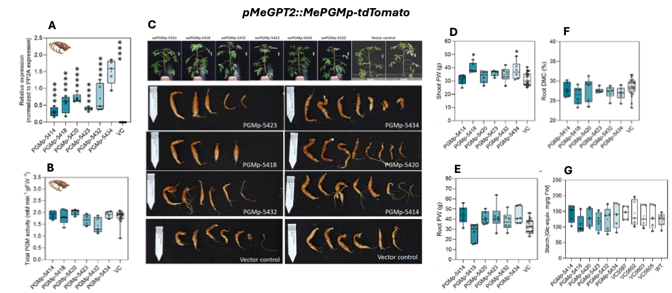
Fig. 1_Result summary of pMeGPT2::MePGMp-tdTomato cassava lines. (A) Transgene expression normalized against MePP2A expression. (B) Total PGMp enzyme activity. (C) Representative pictures of transgenic lines and corresponding controls. (D) Shoot fresh weight of transgenic MePGMp lines and vector controls. (E) Storage root fresh weight of transgenic MePGMp lines and vector controls. (F) Storage root dry matter content of transgenic MePGMp lines and vector controls. (G) Starch levels of of transgenic MePGMp lines and vector controls.

The analysis of MePGMp cassava lines revealed that despite good transgene expression (Fig. 1A), the total PGMp activity (Fig. 1B) does not seem increased. While it is possible that the increase in plastidic PGM activity is masked in the overall activity, the transgenic lines also did not display a phenotype consistent with the transgene. Overall plant habitus was WT-like (Fig. 1C), storage root fresh weight was not significantly altered (Fig. 1E). Some lines did display slight increases in shoot fresh weight though (Fig. 1D). Neither dry matter content (Fig. 1F) nor starch levels (Fig. 1G) were altered.
While no final conclusion has yet been reached, these lines don´t seem to display a lot of potential for yield improvement.

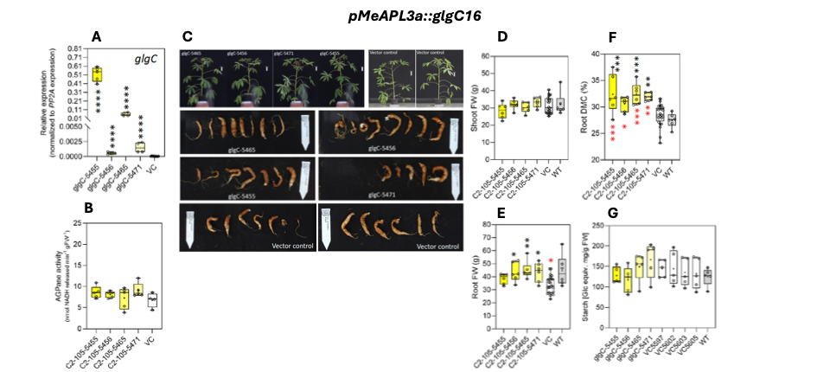
Fig. 2_Result summary of pMeAPL3a::glgC16 cassava lines. (A) Transgene expression normalized against MePP2A expression. (B) Total AGPase enzyme activity. (C) Representative pictures of transgenic lines and corresponding controls. (D) Shoot fresh weight of transgenic glgC16 lines and vector controls. (E) Storage root fresh weight of transgenic glgC16 lines and vector controls. (F) Storage root dry matter content of transgenic glgC16 lines and vector controls. (G) Starch levels of of transgenic glgC16 lines and vector controls.

The glgC16 transgene (bacterial AGPase) is driven by the MeAPL3a promoter in this construct, which expresses the transgene in the main starch synthesis domain according to the pMeAPL3a::GUS lines. According to our current thinking this is the optimal place for glgC16 expression. Indeed, the transgenic lines display good transgene expression (Fig. 2A). However, according to the current AGPase activity measurements, the overall activity does not seem to be increased in the transgenic lines (Fig. 2B). Representative pictures don´t show obvious changes to the vector controls (Fig. 2C), but the quantification of storage root fresh weight shows significant increases of glgC16 lines compared to vector controls (Fig. 2E). Shoot fresh weight was unaltered (Fig. 2D). Importantly, large increases in storage root dry matter content were recorded for this construct (Fig. 2F). Yet again, no increases for starch levels could be demonstrated so far (Fig. 2G).

While the increased dry matter content for the glgC16 lines is promising, the overall results are conflicting. While dry matter is increased, starch is not, begging the question if the roots are indeed more woody or if the dry matter content/starch measurement results are incorrect. In addition, there is currently no connection between the observed dry matter phenotype and the actual enzyme function. A new cultivation and repeated experiments are necessary to resolve this issue. However, if pMeAPL3a::glgC16 could indeed boost starch levels, it would be a great gene to combine with PsGPT2/AtNTT1 for potentially improved effect on starch synthesis.

Another one of our approaches is the source leaf-specific expression of the E.coli pyrophophorylase to increase the production and export of sucrose. We previously reported on constructs C2-76 and C2-91, which were unfortunately not suitable to achieve the desired expression. However, two new construct versions have arrived at FAU from the transformation team and are currently being prepared for the greenhouse. We hope that the promoters tested in constructs C2-139 and C2-140 will be able to direct specific expression of the PPase transgene in source leaves.

Table 2_Summary of additional PPase constructs
Construct number | Gene cassette | Number of lines | Database link
C2-139 | pMe01g239100-GUS + pMe01g239100-PPase | 26 | https://cassbase.org/stock/475427/view
C2-140 | pMe15g171200-GUS + pMe15g171200-PPase | 34 | https://cassbase.org/stock/475427/view

Challenges and Mitigations:
No new challenges to report.

Next Steps in the Action Plan:
- Continue cloning of new PsGPT2/AtNTT1 construct variants
- Repeat the experiments for glgC16
- Initiate new experiments for newly-delivered PPase variants

EM3.3: Starch granule initiation and growth

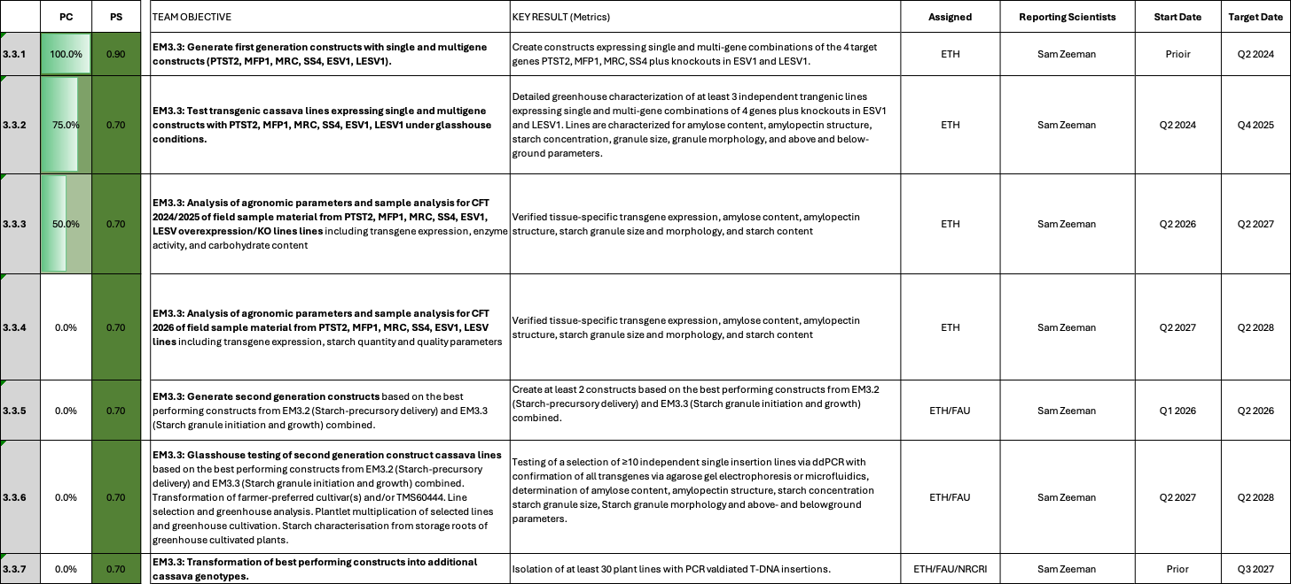

EM3.3: Starch granule initiation and growth

Reporting module leader: Sam Zeeman, ETH with FAU.

Progress Update:

3.3.1. Generate first generation constructs with single and multigene constructs (PTST2, MFP1, MRC, SS4, ESV1, LESV1).
Most of the PTST2, MFP1, MRC, SS4, ESV1, and LESV1 constructs have been cloned at this point. See previous reports for details.
However, 6 additional LESV Crispr/Cas9 and overexpression constructs have recently been added (Table 1).

Table 1_Newly-added EM3.3 constructs
Construct number | Gene cassette | Database link | Overall status
ETH37579 | pMeYCE1::Cas9-eGFP::tHSP + pU6::LESVsg958::tRNAPol | https://cassbase.org/stock/493373/view | Transformed Q2 2026, shoots emerging
ETH37593 | pMeYCE1::Cas9-eGFP::tHSP + pU6::LESVsg500::tRNAPol | https://cassbase.org/stock/493374/view | Transformed Q2 2026, shoots emerging
ETH37581 | pMeYCE1::Cas9-eGFP::tHSP + pU6::LESVsg1025::tRNAPol | https://cassbase.org/stock/493375/view | Transformed Q2 2026, shoots emerging
ETH37580 | pMeYCE1::Cas9-eGFP::tHSP + pU6::LESVsg958::tRNAPol + pU6::LESVsg500::tRNAPol | https://cassbase.org/stock/493376/view | Transformed Q2 2026, shoots emerging
ETH37582 | pMeYCE1::Cas9-eGFP::tHSP + pU6::LESVsg958::tRNAPol + pU6::LESVsg1025::tRNAPol | https://cassbase.org/stock/493377/view | Transformed Q2 2026, shoots emerging
ETH37594 | pMeGBSS::HbLESV-tHSP | https://cassbase.org/stock/493378/view | Transformed Q2 2026, shoots emerging

The modified CRISPR and OE LESV-based construct are regenerating and some producing juvenile shoots. Preliminary indications suggests some variation in the numbers of regenerating tissue, with constructs containing a single sgRNA being more recalcitrant than those with two sgRNAs or the OE construct. It is unclear to date whether this is a construct-based phenomena, but emerging shoots will be assessed for transgenes and editing events. We are also investigating the expression of the pYCE1 promoter (reportedly callus specific) driving Cas9 expression to minimise continuous expression of Cas9 (i.e. by a 35SCaMV promoter).

3.3.2. Test transgenic cassava lines expressing single and multigene constructs with PTST2, MFP1, MRC, SS4, ESV1, LESV1 under glasshouse conditions.
See previous reports for the reporting history. In the current reporting period the following updates are reported:
ESV1
To determine the extent to which starch degradation/sugar mobilisation occurs in storage roots of ESV1 and CRISPR-ESV1 plants, in vitro plants were propagated and cultivated in the glasshouse in Q1. A sub-section of plants were ratooned (canopy removed) and after 10 days tissue was sampled and growth performance data collected (Q2). This is similar to the experimental approach used in the recent Laure et al., 2026 AMY3 publication, whereby starch content was less negatively impacted in the RNAi transgenic lines compared to the WT following canopy loss/damage. Tissue is being processed and data measurements will be performed in Q3/Q4.

PTST2/MFP1/MRC/SS4 stacks
Further progress has been made on analysing starch granule initiation in the cell layers and amyloplasts of the developing storage root. For example, in line 37501-21 (OE MFP1+MRC) we observed very rounded starch granule morphologies in the SEM images. By assessing starch granule number/distribution it is evident that this line tends to produce only one starch granule per amyloplast, which probably explains why they are round i.e. the granules are not packed together (Fig. 1). In comparison, line ETH37493-14 (OX: SS4/PTST2/MRC) had an increase in granule number compared to the wildtype (Fig. 2).

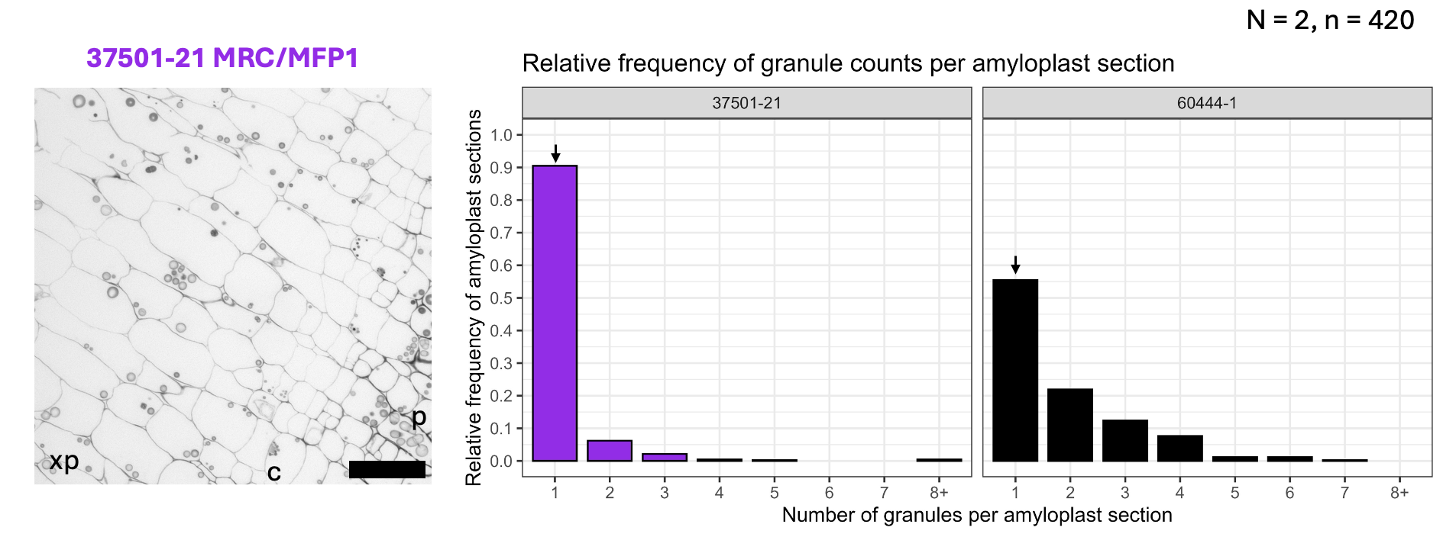
Fig. 1_ Starch granules per amyloplast in line ETH37501-21. Granule number in amyloplasts of transgenic line ETH37501-21 (MRC/MFP1) and wildtype 60444 sections. N=2 (two biological replicates each of transgenic line and WT. n=420 (210 amyloplasts counted per biological replicate).

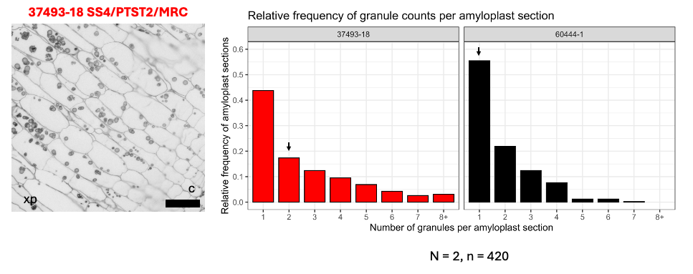
Fig. 2_Starch granules per amyloplast in line ETH37493-18. Granule number in amyloplasts of transgenic line ETH37493-18 (OX: SS4/PTST2/MRC) and wildtype 60444 sections. 763 and 1085 granules counted in the transgenic and WT lines, respectively. N=2 (two biological replicates each of transgenic line and WT. n=420 (210 amyloplasts counted per biological replicate).

Moreover, it was observed that granule number increased greater than WT from the 5th cell layer (Fig. 3). These results are preliminary and need further investigation and interpretation, but provide new and interesting insights to starch granule initation in cassava roots.

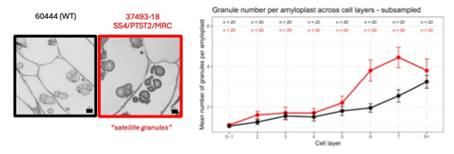
Fig. 3_ Starch granules per amyloplast in line ETH37501-21. Granule number in amyloplasts of transgenic line ETH37501-21 (MRC/MFP1) and wildtype 60444 sections. N=2 (two biological replicates each of transgenic line and WT. n=420 (210 amyloplasts counted per biological replicate).

In addition with advancing with the image analyses, in Q2 2026 we harvested plant lines (ETH37494 (SS4), ETH37503 (MFP1), ETH37505 (MRC/PTST2) and controls) from the glasshouses at ETH Zurich. No significant difference were measured between the shoot fresh weight of the transgenic lines and the control plants (Fig. 4). Two lines underperformed in root fresh weight (ETH37505-12 and 30), but all other lines were statistically similar to the controls (Fig. 5). Some differences were measured in the dry matter content (Fig. 6), but this may be a reflection of the relatively small sized sample, and more informative data should come from the CFT2026 field-grown material.

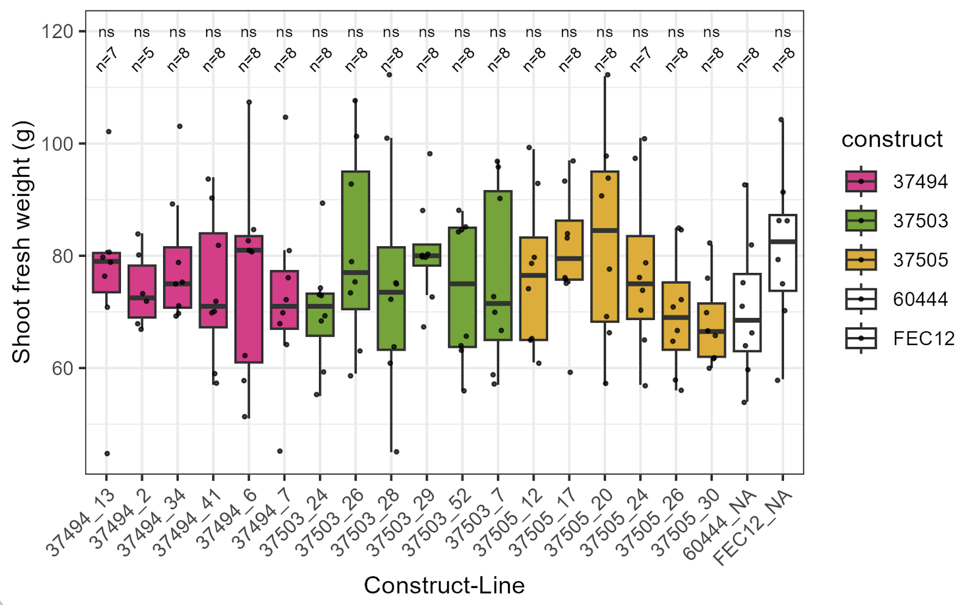
Fig. 4_Shoot fresh weight of glasshouse cultivated plants. Six transgenic lines per construct: ETH37494 (SS4), ETH37503 (MFP1), ETH37505 (MRC/PTST2). WT control (60444) and tissue culture control (FEC12). 5-8 biological replicates per line. Statistics - Wilcoxon Rank Sum non-parametric test. ns, not significant.

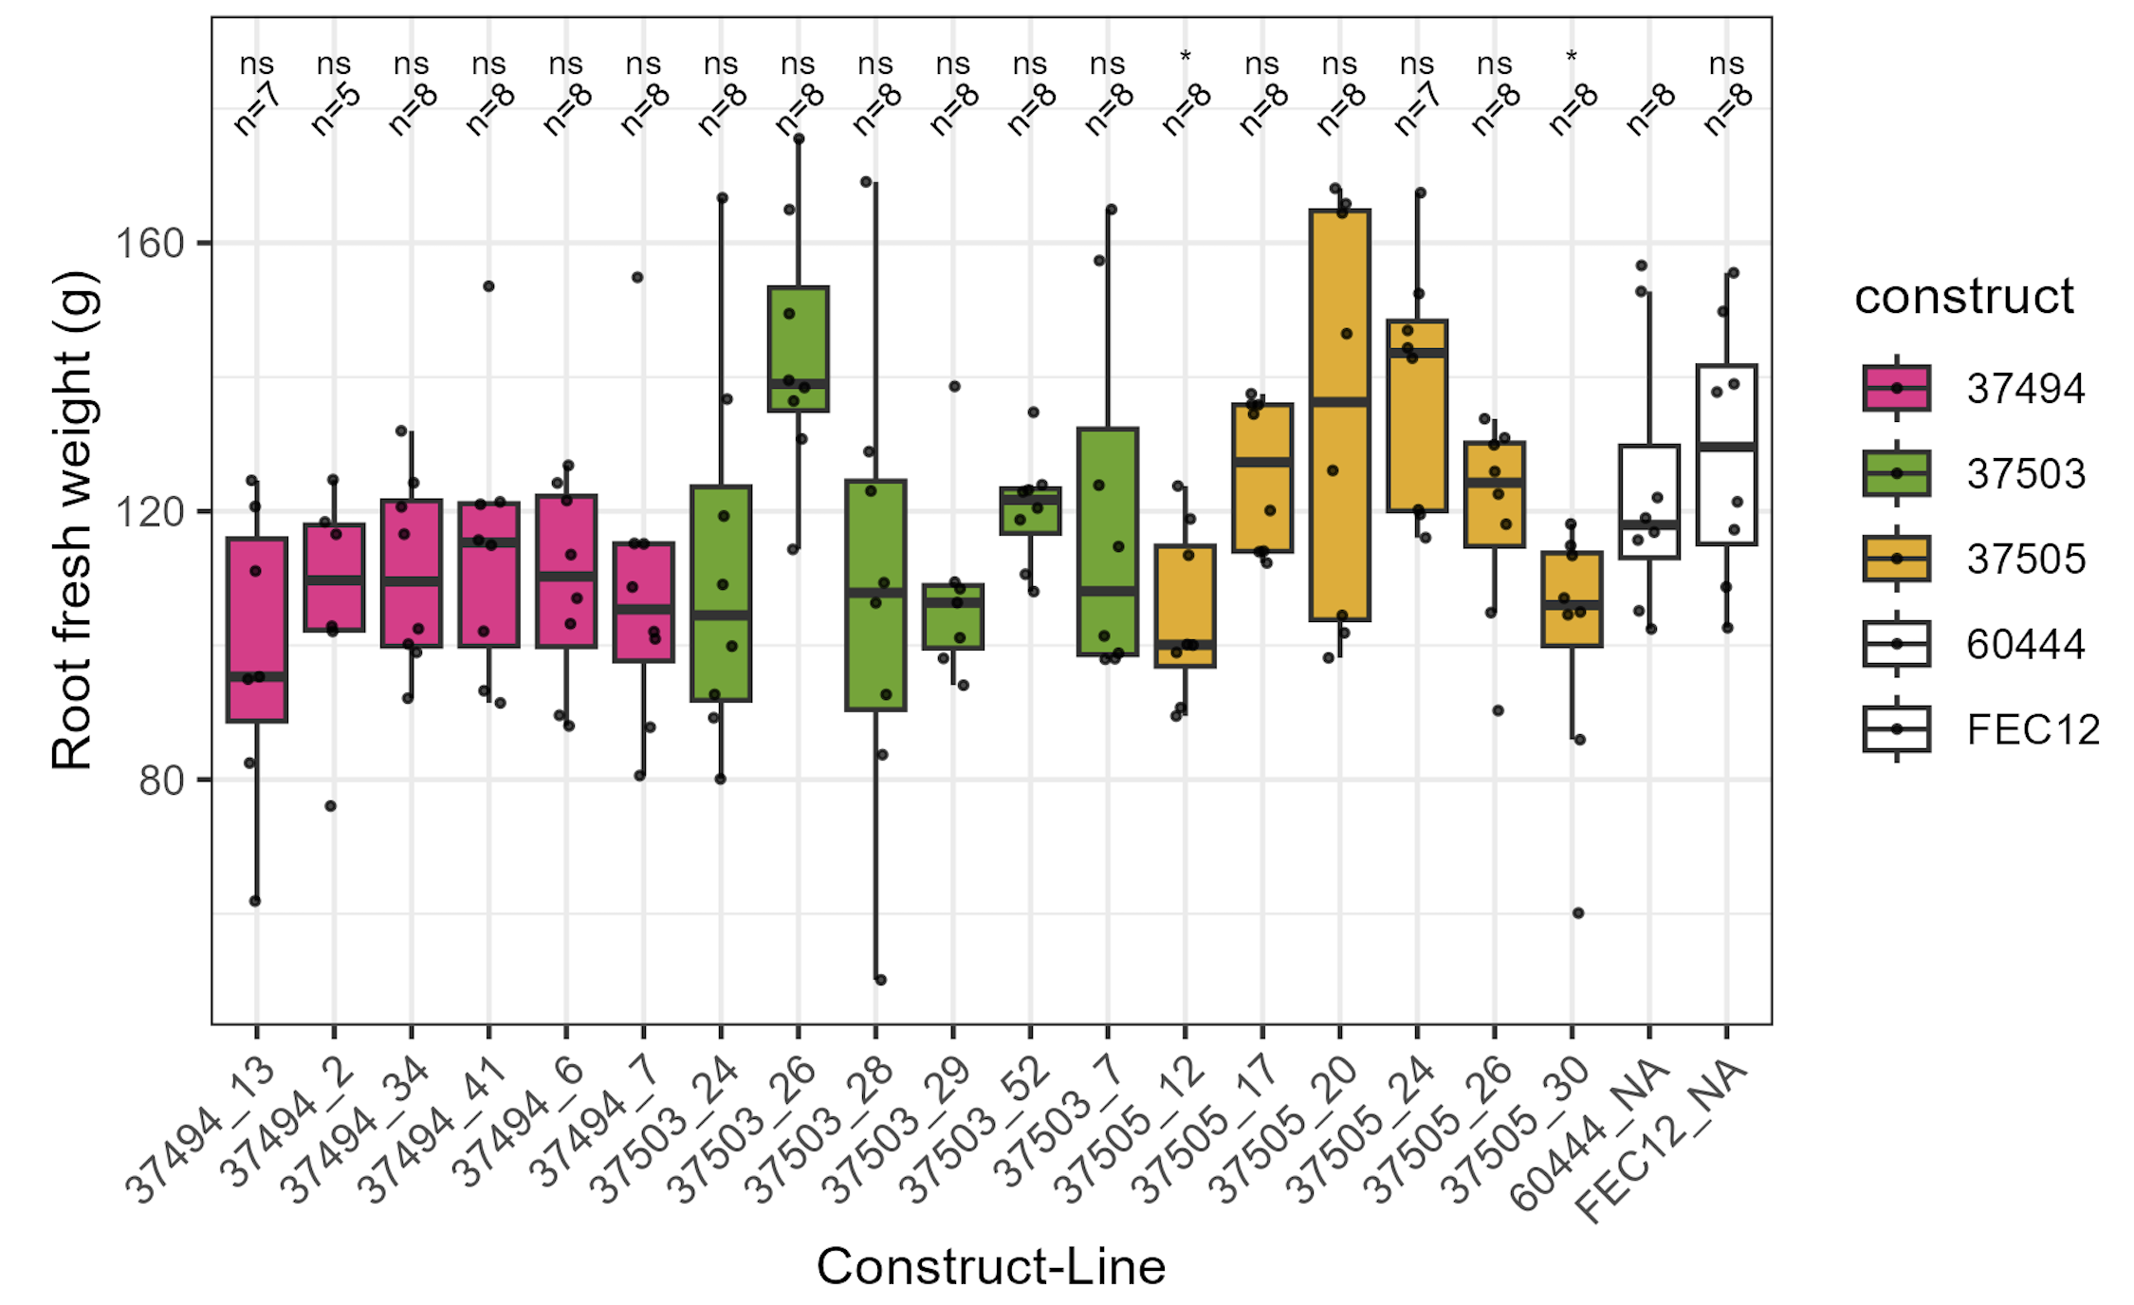
Fig. 5_Root fresh weight of glasshouse cultivated plants. Six transgenic lines per construct: ETH37494 (SS4), ETH37503 (MFP1), ETH37505 (MRC/PTST2). WT control (60444) and tissue culture control (FEC12). 5-8 biological replicates per line. Statistics - Wilcoxon Rank Sum non-parametric test. ns, not significant.

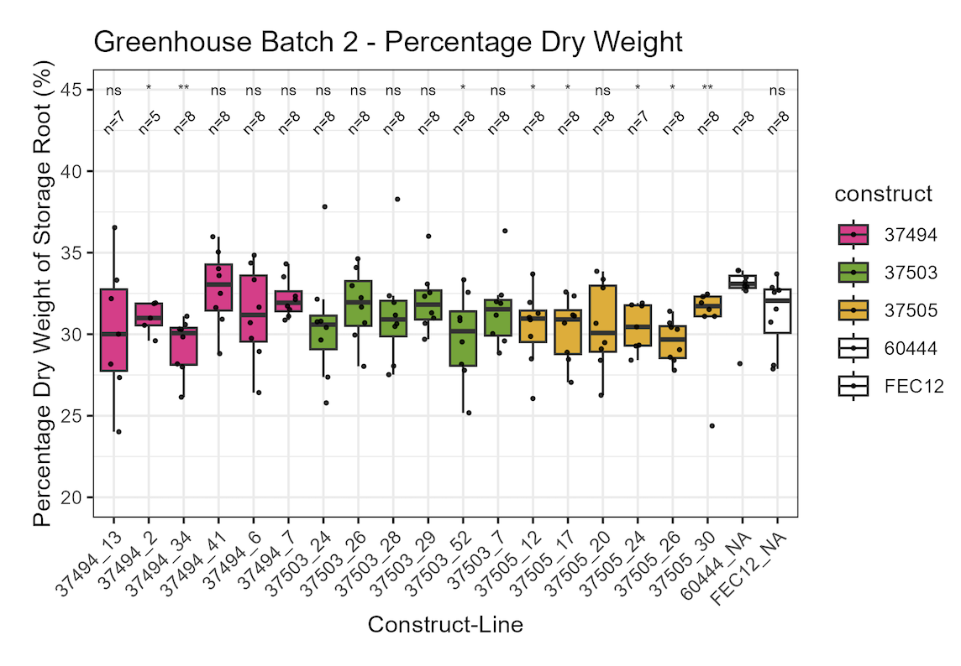
Fig. 6_Dry matter content of fresh, glasshouse cultivated, harvested storage roots. Six transgenic lines per construct: ETH37494 (SS4), ETH37503 (MFP1), ETH37505 (MRC/PTST2). WT control (60444) and tissue culture control (FEC12). 5-8 biological replicates per line. Statistics - Wilcoxon Rank Sum non-parametric test. ns, not significant.

3.3.3 Analysis of agronomic parameters and sample analysis for CFT 2024/2025 of field sample material from PTST2, MFP1, MRC, SS4, ESV1, LESV overexpression/KO lines
See previous report for details

Challenges and Mitigations:
No new challenges to report

Next Steps in the Action Plan:
- Process the tissue samples (ETH37494 (SS4), ETH37503 (MFP) and ETH37505 (PTST2:MRC) from the recent glasshouse harvest for further analyses (i.e. SEM, flow cyt, amylose content, etc).
- Intermediate harvest of selected lines scheduled for Q3. Isabel Williams (PhD student at ETH), will join the Tawain team to facilitate with the harvest. Shipping of material to ETH for analysing.
- Pre-screen LESV emerging material to check for transgenesis and edits in the target LESV sites. If results are promising, this will become a project for a undergraduate student in Q4 2026.
- Continue with the starch and sugar profiling of glasshouse cultivated lines from 2025 glasshouse harvest.

EM3.4: Model-based predictions

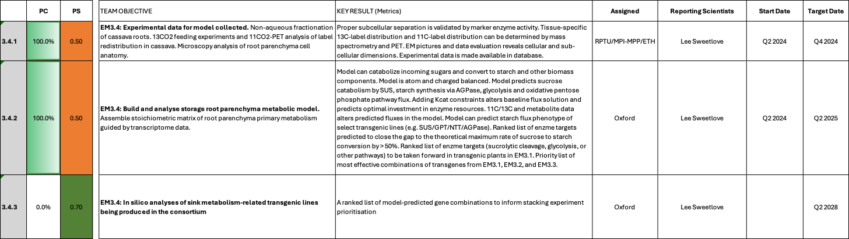

EM3.4: Model-based predictions

Reporting module leader: Lee Sweetlove, OU with RPTU, MPI-MPP and ETH.

Progress Update:

3.4.1. Experimental data for model collected.
Experimental data collection for constructing the basic metabolic model for the storage root has been concluded. See previous reports for details.

3.4.2. Build and analyse storage root parenchyma metabolic model.
The basic metabolic model has successfully been constructed. See previous reports for details.
Root modelling work in this quarter has focused on iterating the model based on discussion meetings. Improvements to the root model were made to account for constraints on sucrolysis via invertase which highlighted a potential limitation in cytosolic pyrophosphate supply. Additionally, GPT/NTT transgenic plants were analysed using the model. The model predictions confirmed the theoretical benefit of overexpressing GPT and NTT and identified potential strategies for further improvement of target performance. Specifically, the importance of balancing expression of GPT and NTT was identified, as well as hypotheses for the observed decrease in stress tolerance of GPT/NTT lines. The model predicted the optimal combination of GPT/NTT with other root metabolism targets with AGPase (glgC16), UGPase and Fructokinase as the top three combinations. Further iteration of the model following discussions can continue next quarter.
A manuscript on the root modelling work has been drafted with the aim of publication by Q4 2026. This will incorporate the contributions of the other consortium parters who collected data and performed analysis essential for building the model.

EM3.4.3. In silico analyses of sink metabolism-related transgenic lines being produced in the consortium
Goging forward the storage root model will be used to predict favorable gene combinations, as well as an analysis tool to try and understand the observed behaviour of transgenic cassava lines. Iterative and ongoing use of the root model is working well and regular meeting with other PIs in the CASS project are planned to continue. The focus of these meetings is in making use of the root model to explore biological questions and help prioritise transformation targets or target combinations.

Challenges and Mitigations:
No new challenges to report

Next Steps in the Action Plan:

Progress the storage root metabolic model manuscript
- Providing modeling support to the project through regular modeling meetings that enable the users to ask questions to the model.

TM1: Project management and central services
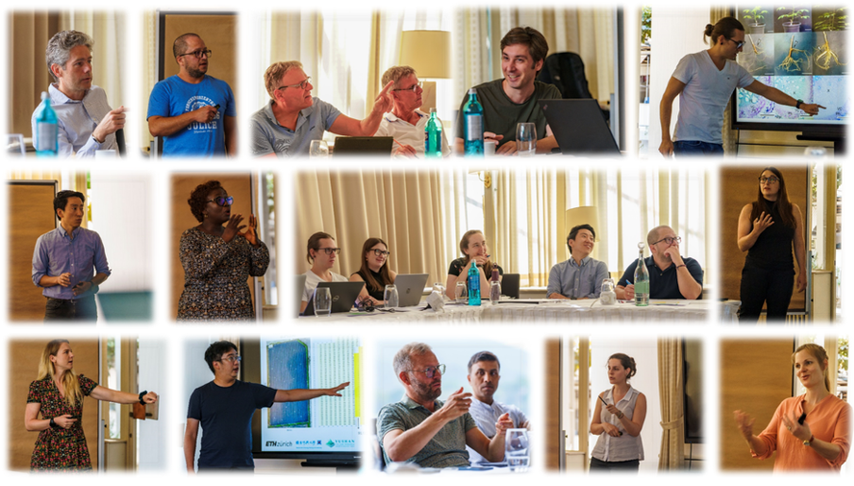
1.1

TM1_Project management and central services

Summary of Goals and Impact
The primary goal of TM1 is to ensure the efficient management and coordination of the Cassava Source-Sink Project (CASS) across all its components. This module is responsible for organizing, reporting, and communicating the progress of the project, as well as managing finances, intellectual property, and stakeholder interactions. Through regular meetings, detailed reporting, and strategic management, TM1 supports the seamless execution of the scientific and engineering goals of CASS, ensuring that all modules work in harmony towards the mission of increasing cassava yields under low-input farming conditions.

The impact of TM1 extends beyond administrative support; it facilitates the successful integration of cutting-edge research with practical agricultural applications. By ensuring that the project runs smoothly and efficiently, TM1 enables the delivery of tangible benefits to smallholder farmers, aligning with the broader goals of enhancing food security and improving livelihoods through innovative agricultural biotechnology.

TM1_Project management and central services

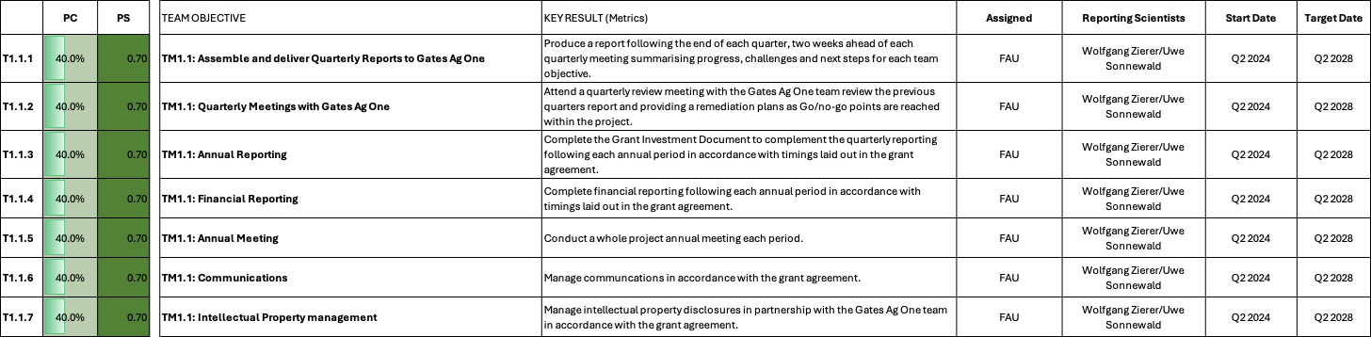

TM1: Project management and central services

Reporting module leaders: Wolfgang Zierer and Uwe Sonnewald, FAU.

Progress Update:

T1.1.1 Assembly and delivery of Quaterly Reports to Gates Ag One
With the support of Christian Rogers and Catherine Espinoza, a quarterly reporting structure similar to the ENSA project has been established. The present document represents the core of the first quarterly report (parts of Q2 and entire Q3) submitted to Gates Ag One within the agreed upon timeframe.
Q4 2024 report was submitted on February 14th 2025 as agreed.
Q1 2025 report was submitted on April 14th 2025 as agreed.
Q2 2025 report was submitted on July 18th 2025 as agreed.
Q3 2025 report was submitted on Sep 12th 2025 as agreed.
Q4 2025 report was submitted on Feb 13th 2026 as agreed.
Q1 2026 report was submitted on April 17th 2026 as agreed.
Q2 2026 report was submitted on July 17th 2026 as agreed.

T.1.1.2 Quaterly Meetings with Gates Ag One
The first quarterly meeting for CASS Phase 3 is scheduled for September 30.
Q4 2024 quaterly meeting was held on Feb 27th 2025.
Q1 2025 quaterly meeting was held on May 2nd 2025.
Q2 2025 quaterly meeting was held on July 25th 2025.
Q3 2025 quaterly meeting coincided with the annual meeting, which was held on Sep 24-25th at IITA, Ibadan.
Q4 2025 quarterly meeting was held on Feb 26th 2026.
Q1 2026 quarterly meeting was held on April 24th 2026.
Q2 2026 quarterly meeting is scheduled for July 17th 2026.

T1.1.5 Annual Meeting
The CASS Phase 2/CASS Phase 3 “Kick-off” meeting was conducted in Zurich, in April 2024. A first CASS Phase 3 annual meeting is scheduled for October 6-8 2024 in Taichung Taiwan. The agenda is fixed and the meeting organized. The next annual meeting will likely be conducted in Europe or Africa around a similar time in October 2025, but is not yet organized.
The next annual meeting is scheduled for the week of 22-26. October 2025 at IITA Ibadan, Nigeria. I have contacted Ismail to begin the planning for this event. Due to the requirements for visa and specific vaccinations, it will be important to communicate meeting details in a timely manner.
No feedback from IITA so far. A meeting with Ismail Rabbi has been initiated.
Preparations for the annual meeting at IITA are under way. Participants have been asked to make travel plans and to contact IITA for invitation letters and hotel reservations. An additional planning meeting is scheduled for July 22nd 2025 to advance the meeting planning.
The annual meeting at IITA, Ibadan is organized. Let´s hope it will be a good one (it was)!
The annual meeting 2026 is scheduled for Sept 15-18 in Helsinki. We are currently finalizing the meeting agenda, collecting attendance, booking rooms, preparing invitation letters, booking flights etc.

T1.1.6 Communication
Please see previous communication efforts in previous reports.
During this reporting period, communication activities focused on supporting project visibility and stakeholder engagement. Regular LinkedIn content was developed and published to communicate CASS research, consortium activities and project progress. Preparations also began for the World Cassava Week 2026 campaign, including the development of a coordinated series of social media posts and communication materials. In addition, communication materials were further developed, website content was updated, and dissemination activities were coordinated with consortium partners. These efforts support the project’s objective of increasing awareness of CASS and communicating research progress to scientific and wider stakeholder audiences.

T1.1.7 Intellectual Property Management
Please see previous IP efforts in previous reports. The CASS IP portal is received well and in regular use.

Challenges and Mitigations:
No new challenges to report

Next Steps in the Action Plan:
- Continue planning the CASS annual meeting in Helsinki September 15-18 in Helsinki
- Receive and distribute CASS Period 3 funds (hopefully soon)

TM2: Cassava Transformation
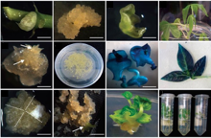
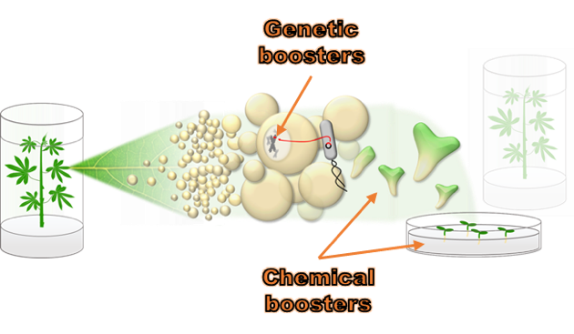
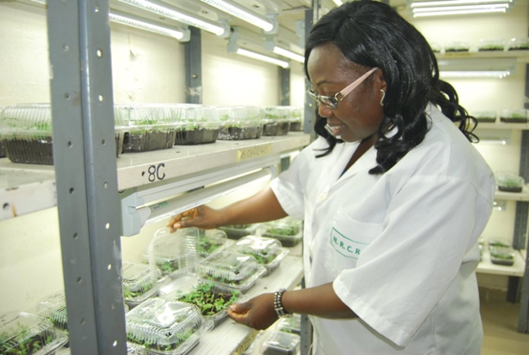
TM2.3_Transformation of farmer-preferred genotypes
2.3
TM2.2_Chemical and genetic boosters
2.2
TM2.1_Routine transformation
2.1
Summary of Goals and Impact

The primary goal of TM2 is to provide the transformation capacity essential for the success of the Cassava Source-Sink Project (CASS). This module focuses on transforming cassava genotypes, particularly the model genotype TMS60444, and optimizing transformation protocols to achieve higher efficiency, especially in farmer-preferred varieties. TM2 aims to develop genotype-independent transformation protocols, ensuring that the advances made in the engineering modules (EM1 to EM3) can be effectively applied to a range of useful cassava cultivars.

The activities within TM2 are critical for enabling the deployment of genetic innovations that can significantly boost cassava yields. By optimizing transformation protocols and ensuring the delivery of high-quality, transformed plantlets for further analysis and field testing, TM2 plays a central role in translating research into practical outcomes. This work has the potential to make a profound impact on the livelihoods of smallholder farmers by improving the productivity and resilience of cassava, a staple crop in many regions.

TM2.1_Routine transformation

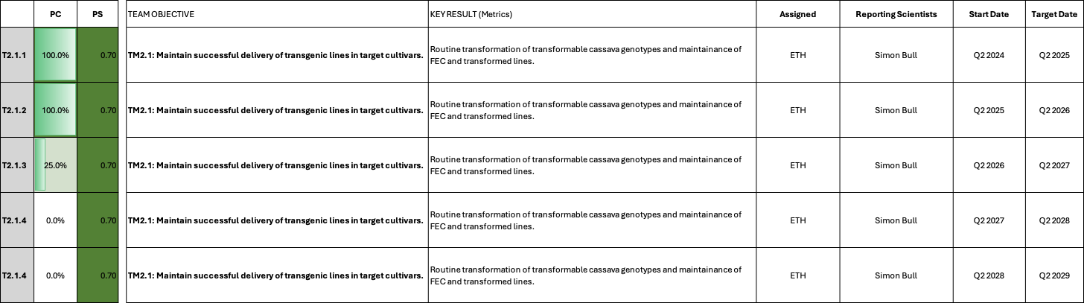

TM2.1_Routine transformation

Reporting module leader: Simon Bull, ETH.

Progress Update:

T2.1.1. Maintain successful delivery of transgenic lines in target cultivars.
See previous reports for reporting history. Table 1 summarizes the status of ongoing/recent material.
Table 1_Status of recent transformation constructs at ETH
Construct number | Gene cassette | Database link | Next steps
C2-132 | pMeACL5::GUS + pMeACL5::AtBUD2 | https://cassbase.org/stock/471880/view | Awaiting rooting test analysis
C2-133 | pStPat::AtTPS1 | https://cassbase.org/stock/471881/view | Awaiting rooting test analysis
C2-134 | pSlRBCS2::GUS + pSlRBCS2::IntronGA2ox1 | https://cassbase.org/stock/471877/view | Awaiting rooting test analysis
C2-136 | pSlRBCS2::GUS + pSlRBCS2::AtGAIdelta17 | https://cassbase.org/stock/475422/view | Awaiting rooting test analysis
C2-139 | pMe01g239100::GUS + pMe01g239100::PPase | https://cassbase.org/stock/475427/view | 26 plants sent to FAU (Q2)
C2-140 | pMe15g171200::GUS + pMe15g171200::PPase | https://cassbase.org/stock/475428/view | 34 plants sent to FAU (Q2)
C2-144 | pCaMV35S::GUS + pCaMV35S::IntronGA2ox1 | https://cassbase.org/stock/475429/view | 27 plants sent to FAU (Q2)
C126 | pKNAT1::GUS + pKNAT1::GAL4 + UAS::KNAT1 + UAS::ER-GFP | https://cassbase.org/stock/475430/view | Awaiting rooting test analysis
C2-141 | pKS1::GUS + pKS1::IntronGA2ox1 | https://cassbase.org/stock/475424/view | 22 plants sent to FAU (Q2)
C2-142 | pKS1::GUS + pKS1::AtGAIdelta17 | https://cassbase.org/stock/475429/view | 17 plants sent to FAU (Q2)
C2-129 | pAtSUC2::OsHAK18 | https://cassbase.org/stock/471878/view | Awaiting rooting test analysis
C2-130 | pMeSUS1::MeSWEET10 RNAi | https://cassbase.org/stock/471879/view | Awaiting rooting test analysis
C2-131 | pMeAKT2a::AtAKT2var | https://cassbase.org/stock/475431/view | Awaiting rooting test analysis
C2-143 | pMeAKT2b::AtAKT2var | https://cassbase.org/stock/475426/view | Awaiting rooting test analysis
C2-96 | bZIP-TF11 | https://cassbase.org/stock/470121/view | Awaiting rooting test analysis
C2-97 | bZIP-TF53 | https://cassbase.org/stock/470122/view | Awaiting rooting test analysis
C2-122 | pAtSUC2::AtAKT2 CDS_S210N-S329N::Ter (companion cell-specific expression) | https://cassbase.org/stock/470120/view | Transformed in April 2026, regeneration media
C127 | PsGPT2 + AtNTT1 + AtAKT2_{var} | https://cassbase.org/stock/470119/view | Transformed in April 2026, regeneration media

Plantlets transformed with C2-139, C2-140, C2-141, C2-142, and C2-144 including VC (see Table 1 above) were successfully shipped to FAU for further analyses. Other constructs (11 in total) from transformations performed in Q1 are awaiting rooting test analysis (expected Q3).

Challenges and Mitigations:
No new challenges to report.

Next Steps in the Action Plan:
- Proceed current transformations (Table 1)
- Prepare for upcoming additional 12 transformations

TM2.2_Chemical and genetic boosters

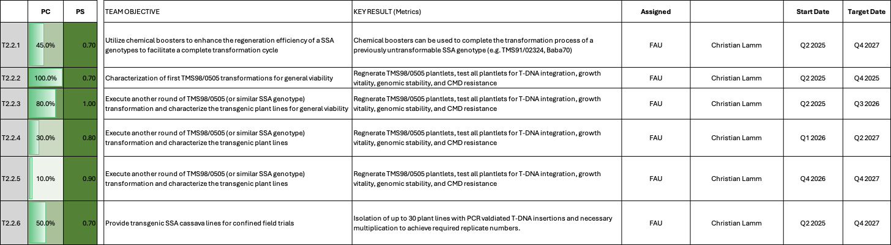

TM2.2_Chemical and genetic boosters
Reporting module leader: Christian Lamm, FAU.

Progress Update:

TM2.2.1. Utilize chemical boosters to enhance the regeneration efficiency of a SSA genotypes to facilitate a complete transformation cycle
See previous reports for reporting history.
On 9 June, approximately 65 transgenic BABA70 plantlets were transferred from tissue culture to the greenhouse. About 30 days after transplanting, the plants are now established in soil. Although it is still too early to assess all lines conclusively, many transgenic plants exhibit off-type phenotypes, while several are currently comparable to the wild-type controls. We will continue growing the plants for another 3-4 weeks before making a final evaluation. Having retained the information on which plant was derived from which medium type (i.e. the type and concentration of chemical booster), we will pay special attention to these associations.

TM2.2.2. Characterization of first TMS98/0505 transformations for general viability
See previous reports for reporting history.
Unfortunately, initial attempts to infect susceptible wildtype cassava plants with ACMV using a particle-gun–based method were unsuccessful: the plants showed no symptoms of infection after several weeks. We are reevaluating the particle‑gun setup and will use not only susceptible cassava plants but also, for example, Nicotiana benthamiana to propagate the virus.

TM2.2.3. Execute another round of TMS98/0505 (or similar SSA genotype) transformation and characterize the transgenic plant lines for general viability
See previous reports for reporting history.
Plant regeneration has now been completed. Digital PCR (dPCR) analysis confirmed successful T-DNA integration in the transgenic lines and enabled the identification of single-, double-, and multiple-copy insertion events for most of the lines (Fig. 1).
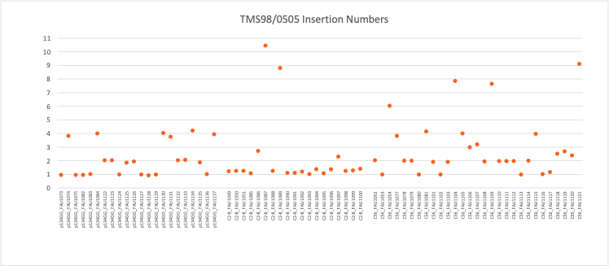
Fig. 1_T-DNA insertion numbers of TMS98/0505 transgenic cassava lines.

The first batch of eight transgenic plants (C56 only) was transferred to the greenhouse as soon as quality tissue culture plants were available for transplanting (18 May, approximately eight weeks ago). Since transfer, these plants have established well and continue to show a mostly healthy, vigorous growth habit. Phenotypically, they are largely indistinguishable from wild-type plants, with no obvious abnormalities observed so far.
A second, larger batch, consisting of 25 C56 plants, 26 empty-vector controls, 22 C2-8 plants, and a number of wild-type controls, was moved to the greenhouse on 25 June. While it is still early to draw firm conclusions, initial observations suggest that a small proportion of the plants may exhibit obvious off-type phenotypes. However, many of the individuals appear normal at the current stage and are developing as expected.
Based on the overall quality and performance of the current material, we are confident that this generation represents a significant improvement compared with the first batch and will provide a robust population for downstream analyses. Plant propagation is currently ongoing to generate sufficient material for further characterization and experimentation.

TM2.2.4 Execute another round of TMS98/0505 (or similar SSA genotype) transformation and characterize the transgenic plant lines for general viability
This set of transformations contains the AtGAIdelta17 constructs and corresponding controls as reported previously. Selection has been completed and the regenerated material is currently progressing through the regeneration phase. The first rooting test positive plants have been obtained, confirming the presence of the transgenes. Regeneration efforts are ongoing with the aim of producing a sufficient number of independent lines for the next round of greenhouse evaluation.
TM2.2.5 Execute another round of TMS98/0505 (or similar SSA genotype) transformation and characterize the transgenic plant lines for general viability
A new batch of TMS98/0505 FEC is currently being prepared and is expected to be ready for transformation within the next few weeks. Discussions are ongoing regarding construct selection to ensure alignment with AgOne SOPs concerning plasmid design requirements prior to transformation.

Challenges and Mitigations:
No new challenges to report

Next Steps in the Action Plan:
- Molecular characterization and agronomic parameters for the Baba70 material
- Complete the greenhouse experiment, record agronomic traits, and perform transgene expression analyses in stem and root tissues for the TMS98/0505 material.
- Define constructs for new round of TMS98/0505 transformations

TM2.3_Transformation of farmer-preferred genotypes

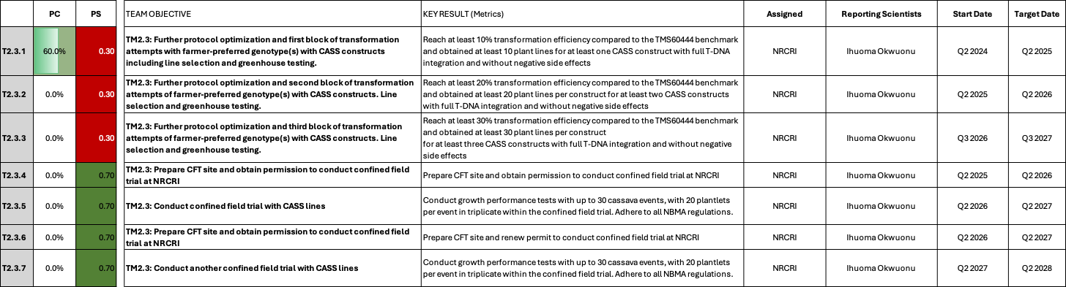

TM2.3_Transformation of farmer-preferred genotypes

Reporting module leader: Ihuoma Okwuonu, NRCRI.

Progress Update:

Following our Q4 2024 change request and subsequent discussion during the Q1 2025 quarterly meeting, we agreed to add field testing activities to this work package.

T2.3.1. Further protocol optimization and first block of transformation attempts with farmer-preferred genotype(s) with CASS constructs including line selection and greenhouse testing.
See previous reports for reporting history. The following updates for Q2 2026 are reported:
Agrobacterium overgrowth with the new constructs C2-124 (pAtAKT2::AKT2_{var} without tag), C127 (PsGPT2+AtNTT1+AKT2_{var} without tag), and empty vector control have been resolved with 8 lines of new transformations in 980505, CR 36-5 and IBA 070536 genetic background at different stages of selection and regeneration. Twelve embryos have been harvested from IBA 070536 at the moment and are being tested for rooting, while the rest are yet to produce embryos. The transgenic lines on hygromycin selection for all the cultivars used in transformation are slower to produce embryos compared to the untransformed controls. To check for the possible delay in regeneration of transgenic events on hygromycin selection, we plan to established regeneration experiment using different concentrations of hygromycin as well as different sources. The transformed events are on selection media and will be moved to regeneration by the end of the month.
Ten transgenic events in 4 genetic background TMS 980505 (4), CR 24-16 (4) and IBA 070536 (2) which have been fully confirmed positive with integration of AtAKT2_{var} are being propagated for greenhouse texting. Unfortunately, the first batch of materials weaned in SAH boxes did not survive. It seems that the materials were not very vigorous at the time of weaning thus their survival was affected. The lines were re-subculture and will be ready for weaning by mid-September hopefully.
Second batch of transformation with the new construct C2-124 (pAtAKT2::AKT2_{var} without tag), C127 (PsGPT2+AtNTT1+AKT2_{var} without tag), and empty vector control are on schedule for the rest of the year with constant pipeline of target tissues in place. Efforts are also in place to derive FECs from newly released farmer preferred cassava cultivar to increase our chances of selecting the best genetic background for the expression the CASS construct.

TM2.3.2. Further protocol optimization and second block of transformation attempts of farmer-preferred genotype(s) with CASS constructs. Line selection and greenhouse testing.
While a few transgenic lines have been produced so far, the transformation efficiency is yet low and needs to be improved further.

TM2.3.3. Further protocol optimization and second block of transformation attempts of farmer-preferred genotype(s) with CASS constructs. Line selection and greenhouse testing.
While a few transgenic lines have been produced so far, the transformation efficiency is yet low and needs to be improved further.
TM2.3.4. Prepare CFT site and obtain permission to conduct confined field trial at NRCRI
Lines for field experiments at NRCRI can now be nominated and necessary steps can be prepared.
Challenges and Mitigations:
Transformation efficiency continues to be low at NRCRI, but work packages have been shifted to field testing according to previous discussions.
Next Steps in the Action Plan:
- To carry out alteast two more batches of transformation with the new construct to generate transgenic events and further analysis in the screenhouse
- To wean and evaluate the first set of events in the screenhouse for viability and gene expression.
- Nominate lines and prepare NBMA application in coordination with IITA and FAU

TM3_Expanding the cassava expression toolbox

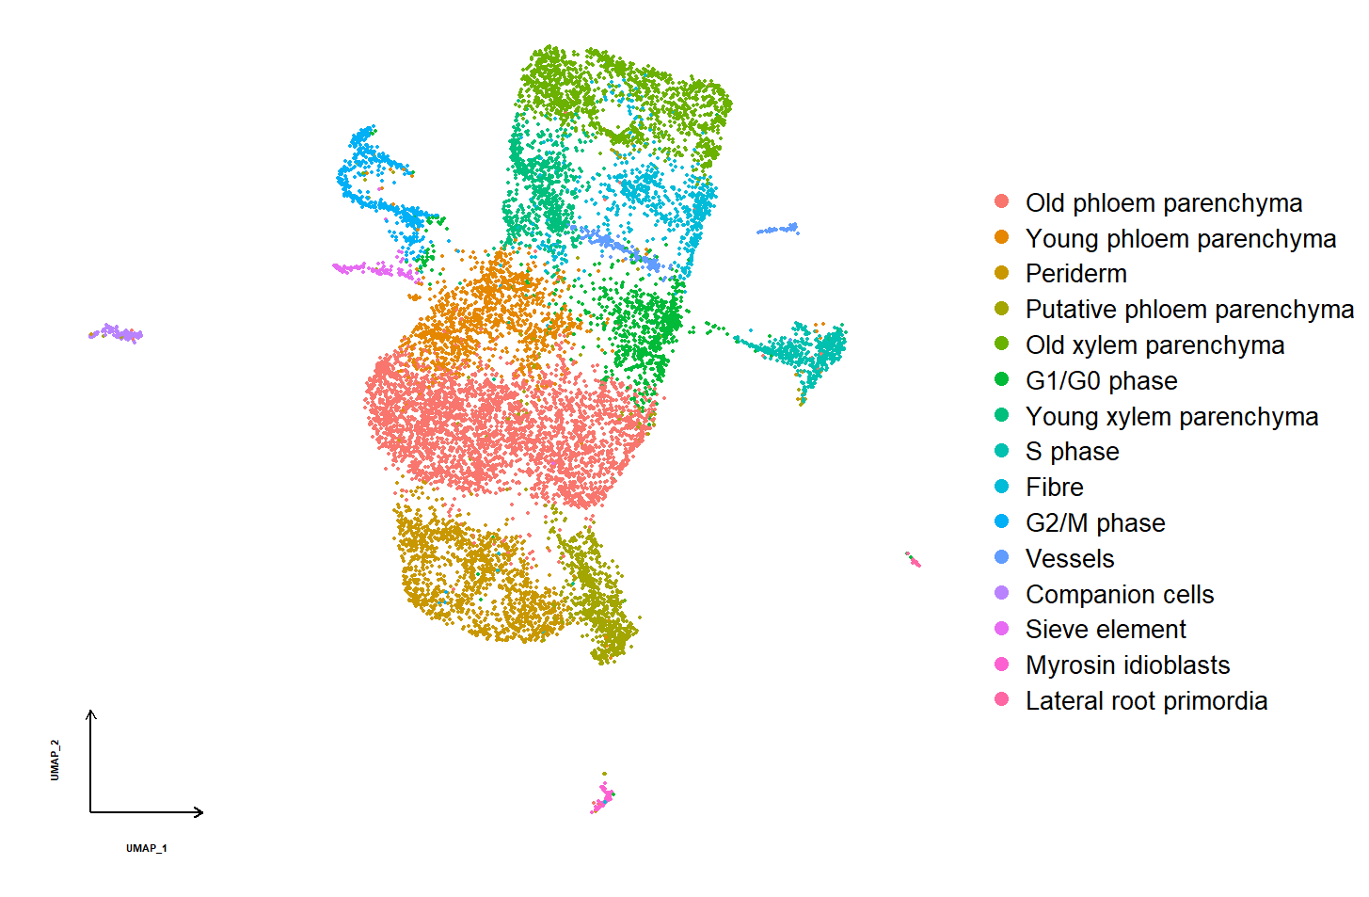
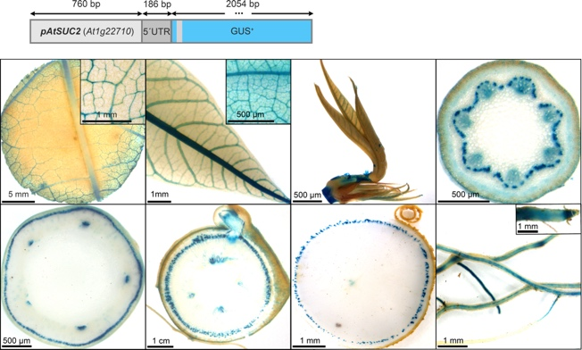
TM3.2_Identification of genes and promoter candidates involved in formation of xylem parenchyma
3.2
TM3.1_Testing of already identified tissue-specific promoter candidates

3.1
Summary of Goals and Impact
The primary goal of TM3 is to develop a robust and versatile promoter toolbox that allows for tissue- and cell-specific expression of target genes in cassava. By expanding the range of available promoters, TM3 aims to enable more precise control over gene expression, which is crucial for optimizing the physiological traits of cassava plants. This module will leverage RNA sequencing and single-cell transcriptomics to identify and validate promoters that can drive expression in specific tissues or cells, particularly those involved in storage root development and growth.

The activities in TM3 are pivotal for enhancing the effectiveness of genetic engineering efforts across the CASS project. By enabling targeted gene expression, TM3 supports the development of cassava varieties with improved yield, resilience, and overall productivity. This work is essential for creating cassava plants that can meet the needs of smallholder farmers in diverse environments, ultimately contributing to food security and economic stability in regions where cassava is a key crop.

TM3.1_Testing of already identified tissue-specific promoter candidates

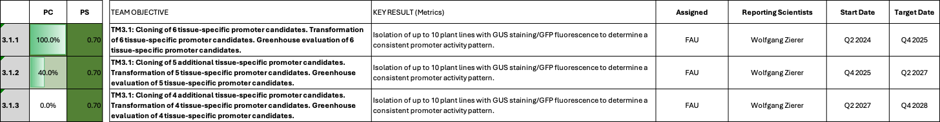

TM3.1_Testing of already identified tissue-specific promoter candidates

Reporting module leader: Wolfgang Zierer, FAU.

Progress Update:

T3.1.1. – T3.1.3. Cloning, transformation and greenhouse testing of 6 tissue-specific promoter candidates.
See previous reports for reporting history.
Many promoters are tested to facilitate the succesful implementation of various target genes. The overall focus is on isolating a source leaf-specific promoter, a storage root cambium promoter, as well as stem-specific promoters. Table 1 summarizes the tested and ongoing promoter-reporter lines.
Table1_Overview on promoter-reporter constructs
Promoter tested | Target tissue | Conclusion | Context | Cassbase
C1-65_pManes03G182100 | Source leaf (SoL) | Not sufficiently active in SoL | General discovery | https://cassbase.org/stock/462063/view
C1-67_pManes05G048400 | Storage root cambium | Not specific | Developmental targets (EM2) | https://cassbase.org/stock/462064/view
C1-68_pManes09G126100 | Storage root cambium | Not specific for cambium, but seems specific for particular phloem/cortex cells in the storage root | Developmental targets (EM2) | https://cassbase.org/stock/462065/view
C1-69_pManes03G057900 | Fibrous root | Not specific | General discovery | https://cassbase.org/stock/462066/view
C1-70_pManes09G047609 | Stem | Specific but only in certain cell layers; led to a working implementation of GAIdelta17 in the first iteration | GAIdelta17 implementation (EM1.1) | https://cassbase.org/stock/462039/view
C1-71_pManes17G027300 | Stem | Not entirely specific; led to a working implementation of GAIdelta17 in the first iteration | GAIdelta17 implementation (EM1.1) | https://cassbase.org/stock/462040/view
C1-72_pManes11G085500 | Storage root | Specific for storage root; most active in young xylem parenchyma cells | Metabolic targets (EM3.1-3.3) | https://cassbase.org/stock/462067/view
C1-73_pManes12G037900 | Storage root cambium | Not specific | Developmental targets (EM2) | https://cassbase.org/stock/462068/view
C2-76_pManes.09G045900 | Source leaf | Not specific | PPase (EM3.2) | https://cassbase.org/stock/462058/view
C2-91_pManes.05G118300 | Source leaf | Not active | PPase (EM3.2) | https://cassbase.org/stock/462059/view
C2-141/C2-142_pManes.16G068951 | Stem | Ongoing; More specific implementation of GAIdelta17 | GAIdelta17 implementation (EM1.1) | https://cassbase.org/stock/475424/view  https://cassbase.org/stock/475425/view
NA_pManes.02G156700 | Storage root cambium | Ongloing; More specific implementation of LBDs | Developmental targets (EM2) | NA
C2-139_pManes.01g239100 | Source leaf | Ongoing | PPase (EM3.2) | https://cassbase.org/stock/475427/view
C2-140_pManes.15g171200 | Source leaf | Ongoing | PPase (EM3.2) | https://cassbase.org/stock/475428/view
NA_pManes.01G013100 | Source leaf | Ongoing | PPase (EM3.2) | NA
NA_pMSTR2603 | Source leaf | Ongoing | PPase (EM3.2) | NA
C2-131_pMeAKT2a | Phloem-sided | Ongoing | Transport targets (EM1.2) | https://cassbase.org/stock/475431/view
C2-143_pMeAKT2b | Xylem-sided | Ongoing | Transport targets (EM1.2) | https://cassbase.org/stock/475426/view
C2-132_pMeACL5 | Storage root | Ongoing | Developmental targets (EM2) | https://cassbase.org/stock/471880/view
C126_pMeKNAT1 | Storage root cambium | Ongoing | Developmental targets (EM2) | https://cassbase.org/stock/475430/view

As previously reported, we also further extended our sequencing data to also include non-coding RNA species (Fig. 1). We are currently preparing the sequencing data for a ressource paper, including an easy to use, visual, expression analysis tool, which we intent to publish in the near future. This dataset also enables the identification of tissue-specific small RNAs, including putative miRNAs, which can be use to optimize the expression domain of existing promoters.

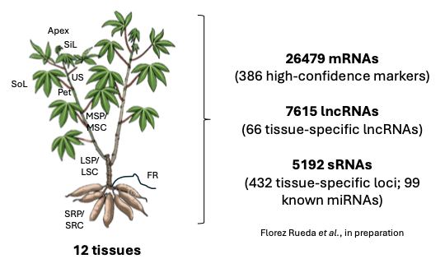
Fig. 1_Overview of the mRNA, lncRNA, and sRNA datasets. Data from these three RNA species is available for 12 cassava tissues. Data was generated on TME7 plants.
We are currently exploring this concept by adding a miRNA target site from a miRNA that seems to be active in all green tissues besides the source leaf (Fig. 2) to the photosynthetic pAtCAB1 promoter. Our hope is that the target mRNA (e.g. PPase) driven by pAtCAB1 will be suppressed in all green tissues besides the source leaves. The miRNA is homolog to a known miRNA called miR2118.

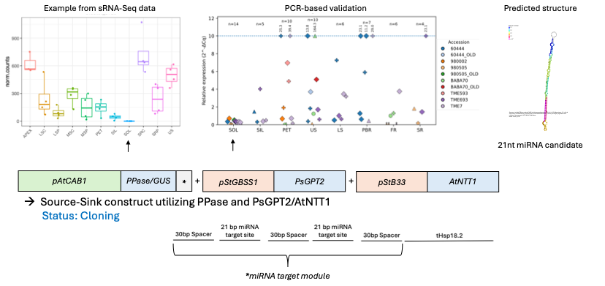
Fig. 2_miRNA candidate active in various tissues besides the source leaves (SoL). Left plot shows the prediction obtained from the sequencing data. No detection in SoL, but detection in all other tissues. Middle plot shows the wet-lab validation on independent material. No detection in SoL, but detection in other tissues tested. Right pannel shows the predicted structure of the miRNA. Below is the design of the testing construct. GUS will be used to visualize to expression domain of “pAtCAB1::GUS-miRNA target” and “pAtCAB1::PPase-miRNA target” will be added on an independent expression cassette.

Challenges and Mitigations:
No new challenges to report

Next Steps in the Action Plan:
- Analyze C2-139 and C2-140 (source leaf-specific promoter candidates) cassava lines recently received from Zurich
- Proceed with cloning of ongoing reporter constructs

TM3.2_Identification of genes and promoter candidates involved in formation of xylem parenchyma

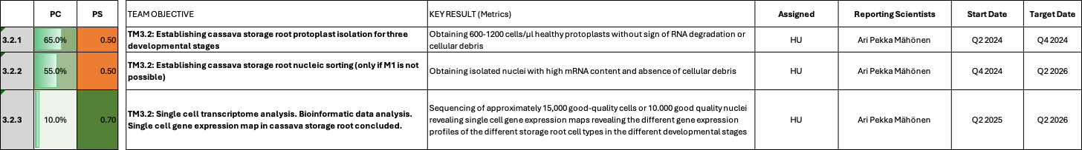

TM3.2_Identification of genes and promoter candidates involved in formation of xylem parenchyma

Reporting module leader: Ari Pekka Mähönen, HU

Progress Update:

T3.2.1. Establishing cassava storage root protoplast isolation for three developmental stages
See previous reports for reporting history.
Initial analysis of scRNA data obtained from the first trial of protoplasting has confirmed that the data quality is suboptimal. However, the dataset still retains a biological signal that can be used for screening genes that would be expressed in storage root xylem specifically. When comparing our single cell RNA sequencing data to RNAseq data obtained from cryosections of different positions of Manihot esculenta cambium (Rüscher et al. 2025), a simple DEG analysis revealed that 4 out of 6 high ranking candidates for storage organ-specific expression, showed also upregulation in the cryosection data set obtained from storage organ (Fig. 1). In addition, the scRNA data clusters correlate well with the cryosectioning data and well-known Arabidopsis orthologs with the initial tissue type annotation confirming the dataset is consistent – but still likely lacking the lower count cell types to make high confidence predictions. The integrated dataset of both storage root and fibrous root cells clustered together with similar annotations and seemed to contain an early divergence from cambial stem cell type to fibrous root cells and to storage root cells.
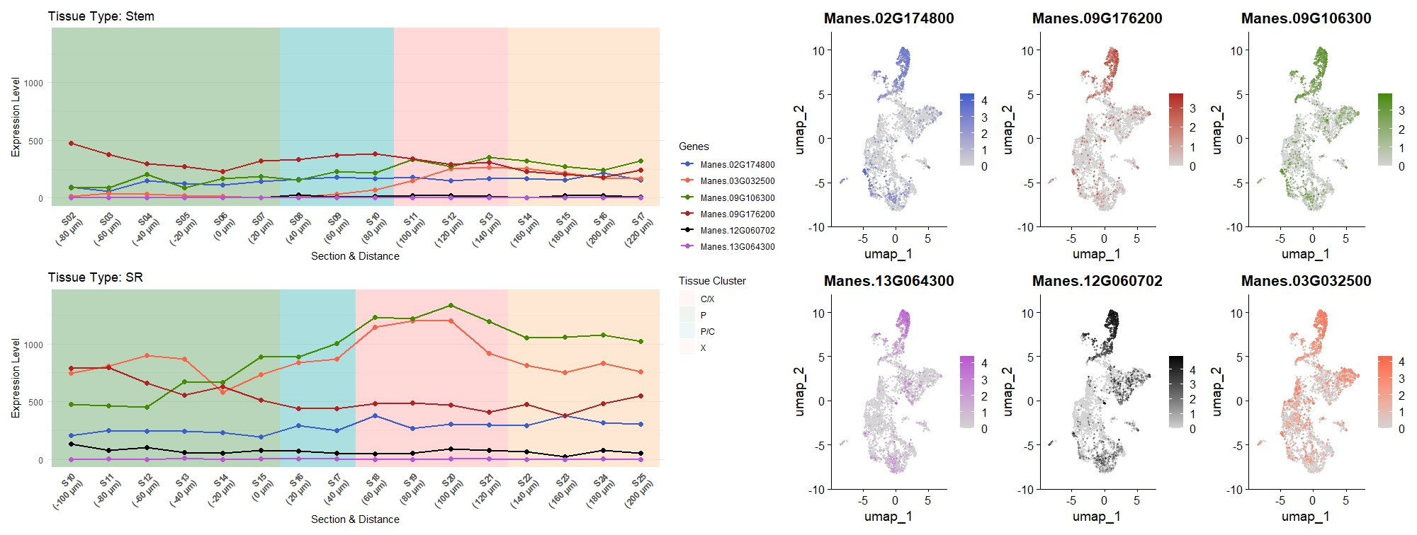
Fig. 1_High ranking genes from scRNA data from early xylem cluster (Cluster 1) DEGs between storage and non-storage roots show storage organ specific expression in cryosections. Left panel cryosections from Rüscher et al., 2025, right panel scRNA U-maps.

Challenges and Mitigations:
The starch granules are still a challenge, but density gradients are showing promise in data acquisition phase. In case OptiPrep is not helping cell viability or starch granule separation, the issue is possible to circumvent by choosing the material in the transition phase from fibrous root to storage root. We have established that we can obtain single cell data from fibrous roots and obtaining data from the transition phase could capture the cells in early trajectory to storage xylem parenchyma could reveal early transcription factors and/or metabolism changes required to storage organ formation.

In parallell FAU has increased its efforts to obtain single cell expression data. A single nuclei-based method is currently being established and we are collaborating with BMKGene in an effort to conduct spatial transcriptomics on transitioning/young cassava storage roots. However, both efforts are still in the establishment phase and no results are available at this point.

Next Steps in the Action Plan:
- HU: Continue efforts to establish clean protoplast isolations via density gradients and other optimizations
- FAU: Continue to establish single nuclei isolation and sequencing
- FAU: Continue to work with BMKGene to establish spatial transcriptomics for cassava

TM4_Cassava confined field testing

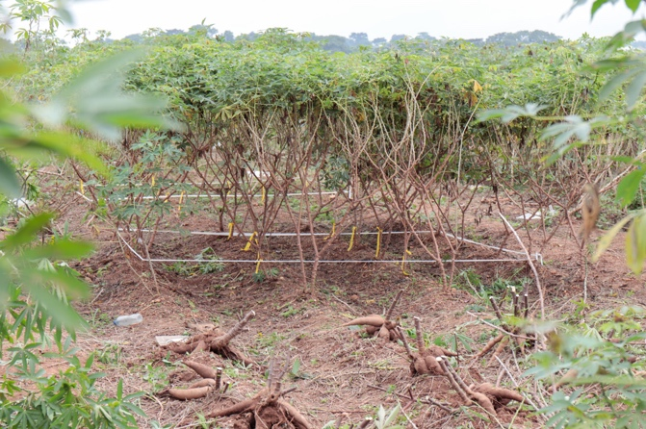
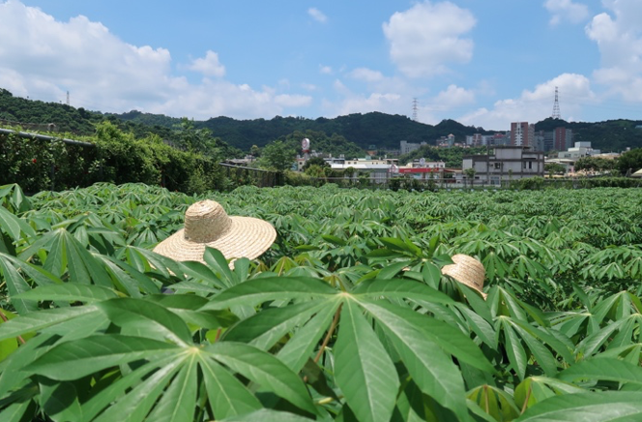
TM4.2_Testing of transgenic lines in Africa and transgenic crossing activities
4.2
TM4.1_Pre-testing of transgenic lines outside Africa
4.1
Summary of Goals and Impact
The goal of TM4 is to conduct confined field tests (CFTs) of transgenic cassava plants, crucial for evaluating the agronomic performance of the genetically modified plants developed in the CASS project. This module includes field testing in Taiwan and Nigeria, focusing on generating reliable data on the performance of transgenic cassava lines. These tests are essential for validating the strategies developed in the engineering modules (EM1-3) aimed at increasing storage root yield.

TM4 also involves ensuring regulatory compliance in Nigeria, conducting pilot crossing experiments with farmer-preferred genotypes, and phenotypically validating transgenic plants in these backgrounds. By expanding field testing capacity and validating transgenic lines in real-world agricultural settings, TM4 directly contributes to the development of high-yielding, resilient cassava varieties that can significantly benefit smallholder farmers. The outcomes from this module will be pivotal in advancing cassava as a staple crop, enhancing food security, and supporting sustainable agricultural practices in regions dependent on cassava cultivation.

TM4.1_Pre-testing of transgenic lines outside Africa
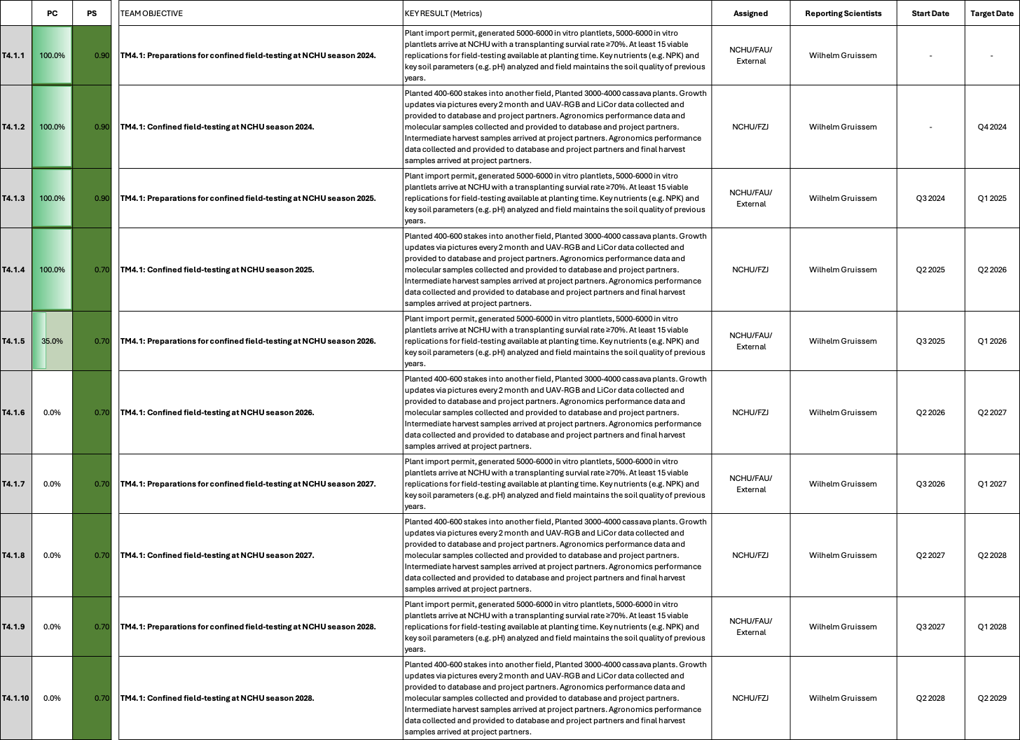

TM4.1_Pre-testing of transgenic lines outside Africa

Reporting module leader: Wilhelm Gruissem, NCHU with FAU and FZJ.

Progress Update:

4.1.1. Preparations for confined field-testing at NCHU season 2024.
Concluded. See previous reports for details.

4.1.2. Confined field-testing at NCHU season 2024.
Concluded. See previous reports for details.

4.1.3. Preparations for confined field-testing at NCHU season 2025
Concluded. See previous reports for details.

4.1.4. Confined field-testing at NCHU season 2025
Concluded. See previous reports for details.

Challenges and Mitigations – Season 2024:
Concluded. See previous reports for details.

Next Steps in the Action Plan – Season 2024:
Concluded. See previous reports for details.

Challenges and Mitigations – Season 2025:
Concluded. See previous reports for details.

Next Steps in the Action Plan – Season 2025:
Concluded. See previous reports for details.

4.1.5. Preparations for confined field-testing at NCHU season 2026

Concluded. See previous reports for details.

4.1.6. Confined field-testing at NCHU season 2026

- The 2026 field experiment is organized based on the source of the plant materials. Field layouts for WF1, WF2 and EF2 were created and deposited in CASSBASE. Lines from FAU were planted in WF1 and EF2, while those from ETH were planted in WF2. This arrangement was necessary because some FAU-derived lines (DELLA constructs) are expected to exhibit dwarf and semi-dwarf phenotypes. Planting them alongside normal-height lines could result in shading, affecting their growth and accurate phenotypic assessment. WF1 is divided into three sections. The first section consists of DELLA constructs arranged in a block design of 4 X 4 plants. The second section includes metabolic lines planted in a random serpentine arrangement for final harvest, and the third section contains metabolic lines in a random serpentine arrangement for intermediate harvest. Similarly, WF2 is divided into three sections: the first small section for intermediate harvest, the second section for final harvest, and third small section with DELLA lines for intermediate harvest. All plants in WF2 and EF2 are planted in a random serpentine arrangement. All planting activities were completed within four days: EF2 on March 16, 2026; WF2 on March 17, 2026; WF1 on March 18, 2026; and EF3 (stakes from 2025) on March 19, 2026. The planting dates were kept close across all fields to ensure uniform crop establishment and synchronized growth, enabling consistent comparison and analysis. EF1, which was used for growing in vitro plants in 2025, will be conditioned with soybean to improve nutrient status.

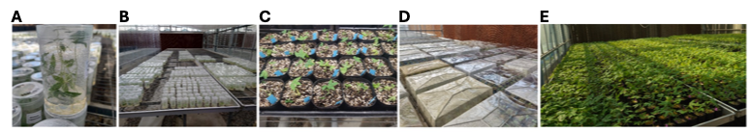

Figure 1_(A) In vitro plants as received from FAU via Zurich. (B) Jars containing in vitro plants maintained under controlled conditions for 3–4 days for acclimatization. (C) In vitro plants after transfer to pots. (D) Potted plants covered with lids to reduce dehydration and limit excess light exposure. (E) Hardened plants arranged across greenhouse tables to ensure adequate spacing for growth.

- The first round of replacing dead plants was carried out on March 30, 2026 across all fields (EF2, WF2, and WF1). In EF2, two plants of the same original construct were replaced. In WF2, a total of 22 plants were replaced, including two with the same construct and 20 with different lines. In WF1, 10 plants were replaced, of which six were from the same construct lines and four from different constructs. As agreed, all plants from this first round of replacement will be included in the study, as their planting time remains close to the main batch. A second round of replacement is planned for mid-April. These plants will not be included in any analysis because they will be nearly one month behind than the rest, which could affect comparability. The purpose of this second replacement is to maintain a similar plant density and crowding effect across the field, ensuring consistent field conditions. All replaced constructs have been shared with the CASS data manager for updating in CASSBASE. For the stake field (EF3), about 75% of the stakes have sprouted. Stakes that have not sprouted by mid-April will be replaced.
- The second round of plant replacement was carried out on April 13, 2026, across all fields. In WF1, two plants were replaced, while six plants were replaced in WF2. As noted earlier, these replacement plants will not be included in any measurements or analyses because they were planted nearly one month later than the rest of the population. Replacement of the unsprouted stakes (approximately 20%) in EF3 was also completed on April 13, 2026. The positions of all replacement plants, together with their corresponding original positions, were shared with the teams at FAU and ETH, as well as the data manager, who recorded the changes and updated them in the CASSBASE.
- Photosynthetic parameters of the C2-93 DELLA lines, and the wildtype were measured using the LI-6800 portable photosynthesis system. The results have been shared with the FAU team, and a detailed summary is included later in this report. In addition, a MoniPAM system was installed in the field by Dr. Juan Quiros to monitor diurnal and seasonal changes in photosynthetic performance. The MoniPAM sensor head is regularly repositioned among selected plants and routinely monitored to ensure continuous and reliable measurements throughout the growing season.
- The dwarf and semi-dwarf DELLA lines have received particular attention from both the FAU and the Gates Foundation teams. To document their growth and phenotypic development, representative photographs of each line were taken regularly and shared with FAU team. On June 23, 2026, a requested video highlighting the transgenic field with the DELLA lines and the photosynthesis measurement equipment was recorded for the Gates Foundation team. The NCHU Experiment Station field site is unique and currently the only field site available to the CASS proejct that can accommodate more than 4,000 transgenic cassava plants for agronomic performance evaluation at a single location.
- To monitor plant growth during the main growing phase, UAV flights capturing RGB images are being conducted using drones. Since planting, flights were recorded on April 9, April 29, May 27, June 10, and June 23, and they will continue every 14 days until later in the growth season. The collected data are shared with the FZJ team in Germany for further analysis. In addition, a wildlife camera has been installed to capture plant-level growth and phenological dynamics during the growth season. This camera captures several images per day until the plants reach the harvest stage, providing a continuous visual record of growth progression.
Early phenotype assessment
- In the greenhouse, most plants showed a similar growth phenotype at approximately one month of age. However, one construct, C2-93 carrying the AtGAI_Δ17 gene under control of the pManes17G027300 promoter, showed a distinct phenotype even at this early stage. Among the seven independent lines, C2-93_FAU865, C2-93_FAU827, C2-93_FAU868, C2-93_FAU834, C2-93_FAU867, and C2-93_FAU833 exhibited a dwarf phenotype, while lines C2-93_FAU838 and C2-93_FAU826 appeared similar to the wild type.

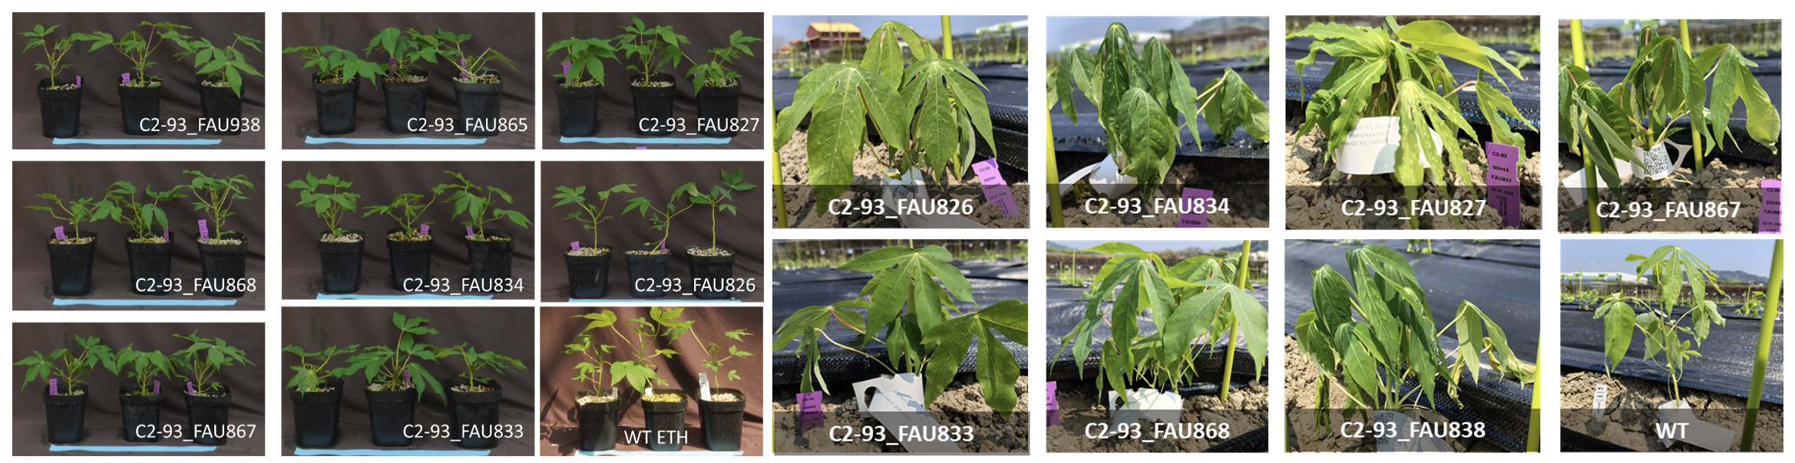

Figure 2_ Phenotype of C2-93 construct in the greenhouse and after one week of planting them in the field

The dwarf phenotype was also observed in the field after transplantation (Fig. 2). To prevent these shorter plants from being shaded by lines with normal growth height, the WF1 field was designed in blocks, allowing better exposure and more accurate phenotypic assessment.
After three months of growth in the field, the wild-type plants reached an average height of approximately 120 cm (Fig. 3). In contrast, all DELLA lines remained below 100 cm (Fig. 3). Among them, C2-93-FAU827 exhibited the strongest dwarf phenotype, reaching only about 55 cm in height, less than half the height of the wild type. This pronounced reduction in plant height was consistent with the phenotype observed during the greenhouse stage.

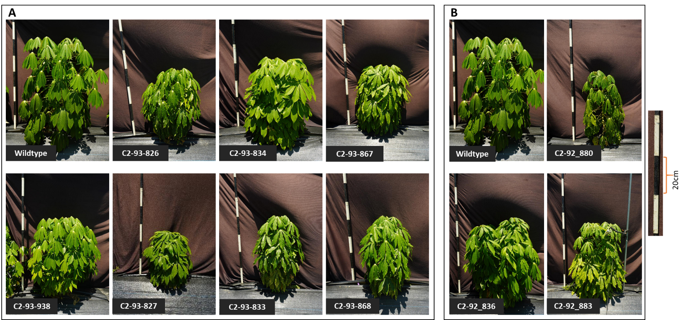
Fig. 3_ Phenotype of A) C2-93 and B) C2-92 DELLA lines after three months of planting them in the field.

Standardization of photosynthesis measurements using LI-6800

Photosynthesis measurements were standardized to ensure reliable estimation of photosynthetic parameters using LI-6800 under field conditions. Beginning in June, ambient air temperatures in the confined field trial (CFT) station frequently exceeded 35°C, while the perceived ("real feel") temperature often exceeds 40°C. The use of black tarp for weed control likely intensified the microclimate around the plants by reflecting heat. Under these conditions, the LI-6800 required several hours to reduce leaf temperature (Tleaf) to the target temperature of 30°C, substantially increasing measurement time and making it difficult to obtain stable readings. To determine whether reliable estimates of VC_{max} and J_{max} could still be obtained at different measurement temperatures, gas exchange measurements were conducted on stake plants that had reached a suitable developmental stage in April, before the onset of peak summer temperatures. Measurements were performed at leaf temperatures of 28°C, 30°C, and 32°C.
A light response curve was first generated to identify the light saturation point for cassava (Fig. 4A). Determining this point is essential to ensure that light does not limit photosynthesis during subsequent ACi measurements while avoiding photoinhibition. The results showed that a photosynthetically active radiation (PAR) level of 1500 µmol m⁻² s⁻¹ was sufficient to saturate photosynthesis. Electron transport rate (ETR) reached a plateau at this light intensity, and in some cases declined at higher irradiance levels (Fig. 4B). Therefore, a saturating light intensity of 1500 µmol m⁻² s⁻¹ was adopted for all subsequent gas exchange measurements.
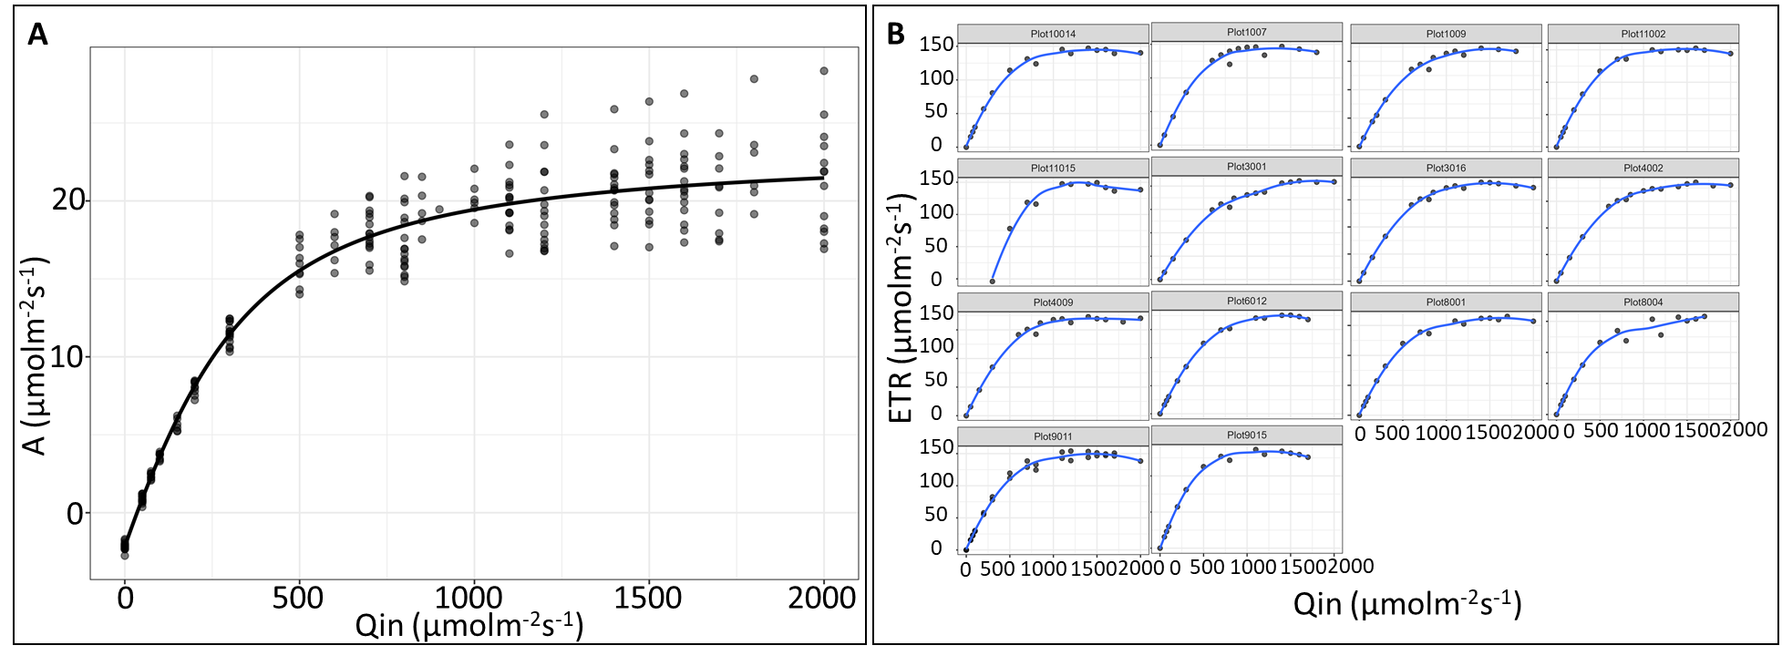
Fig. 4_Light response curve to estimate the saturation light intensity in cassava. Number of replicates (n) = 14
Net CO₂ assimilation increased with increasing leaf temperature, demonstrating the strong influence of measurement temperature on photosynthetic rates (Fig. 5). Therefore, temperature normalization was required to enable meaningful comparison of photosynthetic parameters across experiments. Normalizing VC_{max} and J_{max} to the reference temperature of 25°C removes the direct influence of measurement temperature, allowing differences among samples to reflect physiological variation rather than temperature-induced changes. Although stomatal conductance generally declines with increasing temperature, cassava showed relatively stable conductance between leaf temperatures of 28°C to 32°C. Throughout the experiments, a stomatal conductance value of 0.1 mol m⁻² s⁻¹ was established as the minimum acceptable threshold for valid gas exchange measurements (Fig. 5B and C).
The VC_{max} and J_{max} values calculated at the actual measurement temperatures increased with increasing leaf temperature. However, after normalization to 25°C, both parameters were highly comparable regardless of whether measurements were done at 28°C, 30°C, or 32°C (Fig. 5D). This result confirms that temperature normalization effectively compensates for temperature-dependent variation and provides consistent estimates of photosynthetic capacity.

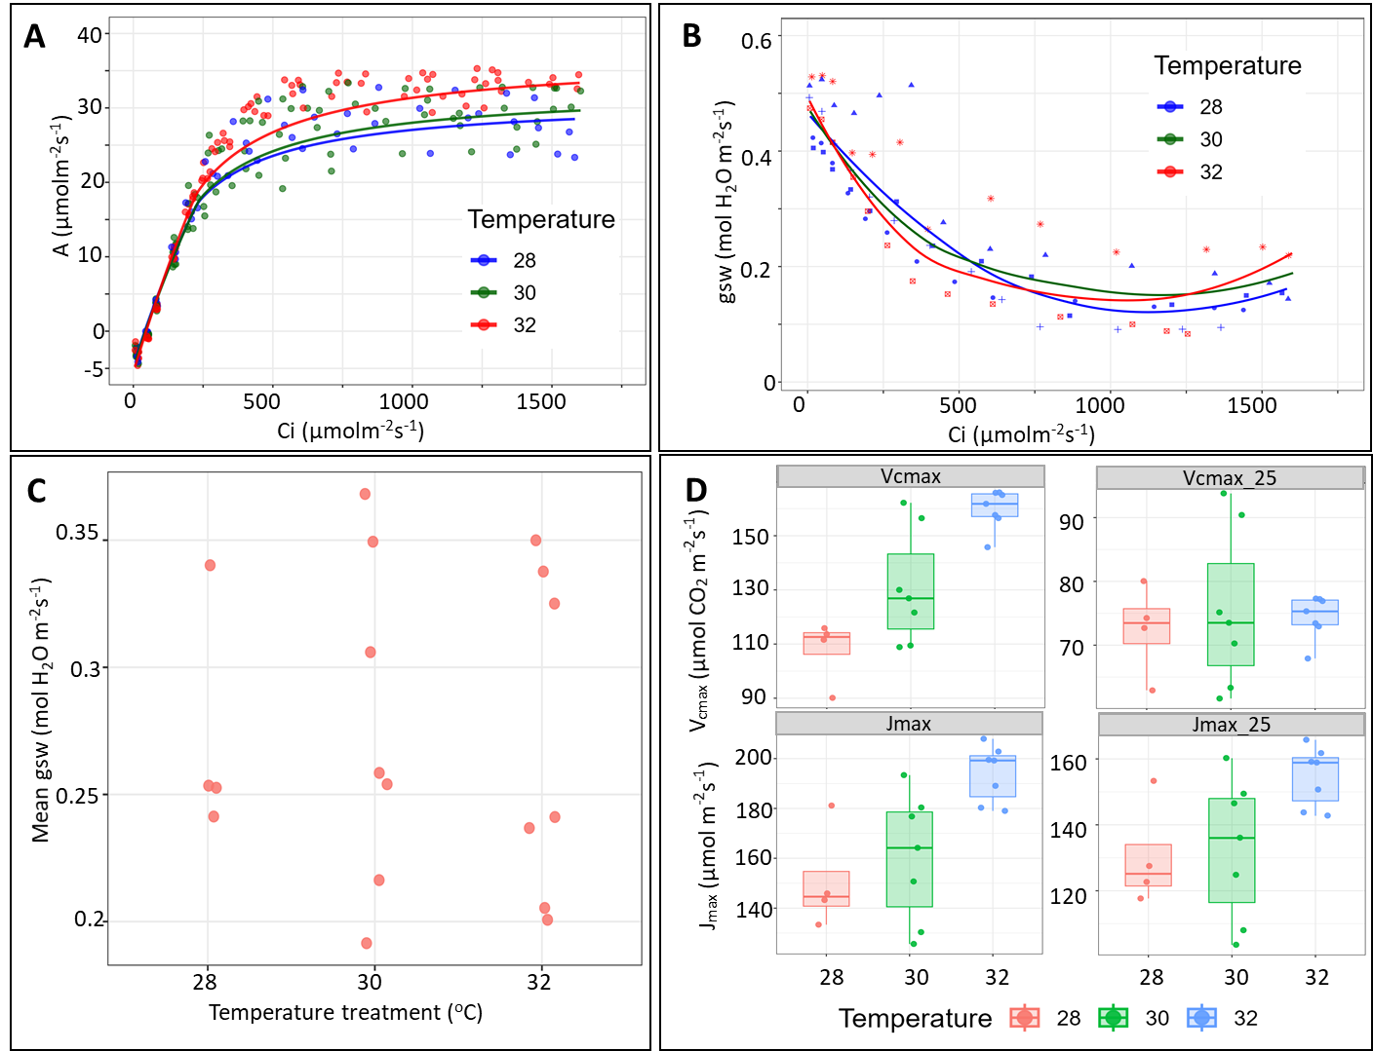
Fig. 5_CO₂ response curve of cassava under different temperature to measure its Net CO₂ assimilation (A), stomatal conductance (gsw), maximum rate of RuBisCO carboxylation (VCmax), and maximum rate of RuBP regeneration (Jmax). Number of measured replicates (n) = 4 at 28ºC and 7 each at 30 ºC and 32ºC.
These findings are particularly important for summer field measurements, where maintaining Tleaf below 30°C is often not feasible. During individual ACi measurements, leaf temperature frequently increased from the target 30°C to approximately 34°C despite instrument temperature control (discussed in the next section). The successful normalization of Vc_{max} and J_{max} provides confidence that reliable comparisons can still be made under these challenging environmental conditions

Gas exchange analysis of C2-93 DELLA lines

Gas exchange measurements were conducted to estimate VC_{max} and J_{max} in selected C2-93-FAU (DELLA lines) transgenic cassava lines that has the over expression of promoter AtGAI_delta17 with the pManes.17G027300. Based on preliminary greenhouse results obtained in Germany, three transgenic lines, C2-93-FAU834, C2-93-FAU827, and C2-93-FAU938, were selected for the field gas exchange measurements and compared to the wildtype (Fig. 6A). All ACi measurements were performed with a target leaf temperature of 30°C. However, due to extremely high field temperatures, leaf temperature gradually increased during measurements and occasionally reached approximately 34°C (Fig. 6B). Despite these conditions, stomatal conductance remained well above the minimum acceptable threshold, averaging approximately 0.15 mol m⁻² s⁻¹ and never declining below 0.05 mol m⁻² s⁻¹ during the measurements (Fig. 6C).

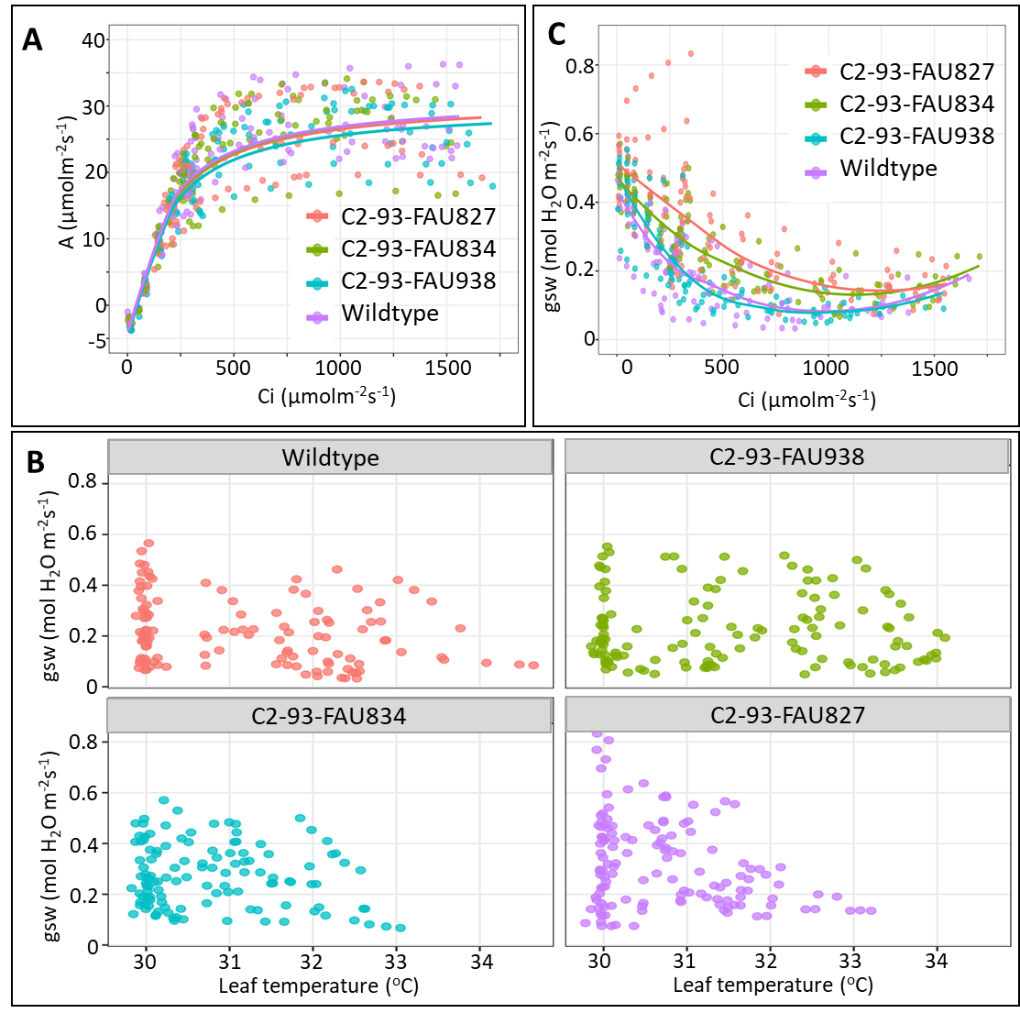
Fig. 6_CO₂ response curve of C2-93 DELLA lines. Number of replicates (n) = 8 for C2-93-FAU827 and 9 each for C2-93-FAU938 and C2-93-FAU834.
The CO₂ response curves indicated that the DELLA lines and the wildtype exhibited similar net CO₂ assimilation rates across the range of intercellular CO₂ concentrations (Fig. 6A). Consistent with these observations, analysis of the fitted ACi curves showed no statistically significant differences in either VCmax or Jmax between the DELLA transgenic lines and the wildtype (Fig. 7A and B).
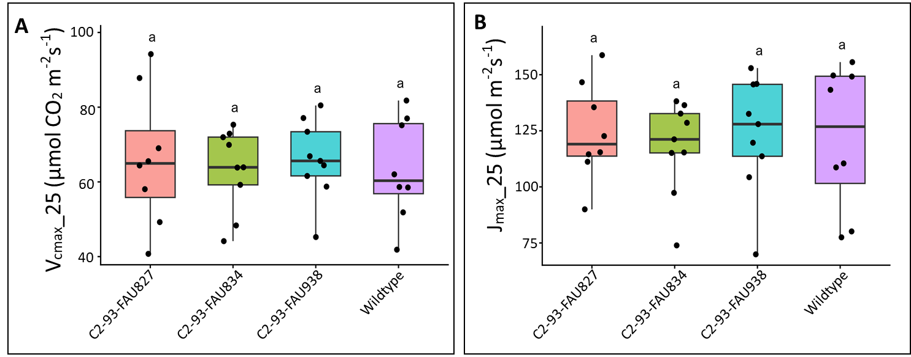
Fig. 7_VC_{max} and J_{max} of C2-93 DELLA lines. Number of replicates (n) = 8 for C2-93-FAU827 and 9 each for C2-93-FAU938 and C2-93-FAU834.
Overall, the field measurements indicate that the selected DELLA lines did not exhibit enhanced photosynthetic performance relative to the wildtype. Despite the elevated temperatures experienced during measurements, the standardized measurement protocol and temperature normalization ensured that the derived photosynthetic parameters remained robust and comparable across genotypes. These field observations differ from the preliminary greenhouse results and suggest that the enhanced photosynthetic characteristics observed under controlled conditions were not expressed under the field environment.
Challenges and Mitigations - Season 2026:

- After reporting the survival rate and receiving the field map from the CASS team, all plants were tagged prior to planting to ensure proper identification and tracking. However, due to damage and loss of replicas of some constructs, replacements were required. In some cases, replicas from different lines of the same constructs were used for replacement, while in others cases replicas from different constructs were used for replacement. All changes were communicated to the CASS data manager for updating in CASSBASE.
- In WF1, the construction of a single vertical trench caused a shift in planting positions relative to the original field map. This was reported to the FAU team, and a revised map was prepared to avoid confusion during field monitoring and data collection, particularly for aerial drone imaging where spatial accuracy is critical.
- Following planting, the weather in Taiwan has been predominantly hot and dry, which is not ideal for the transplanted in vitro plants due to their sensitivity to water stress. To support establishment and reduce transplant shock, the team has been regularly irrigating the plants using hoses, including during weekends. This consistent watering is important to maintain plant survival and ensure uniform early growth across the field.
- Taichung received about 890 mm of rainfall between April and June. In April alone, the NCHU Experiment Station had approximately 160 mm of rainfall within just five days, with short but intense rainfall events. In June, rainfall increased substantially, reaching a total of 638 mm, with major peak events recorded on June 9 (145 mm), June 15 (55 mm), and June 27 (195 mm). These high-intensity rainfall episodes created strong pressure on field drainage capacity. Despite these challenging conditions, the constructed trench systems together with the installed pumping infrastructure functioned effectively throughout the period. Excess water was efficiently drained from the experimental plots, preventing waterlogging and minimizing potential damage to cassava plants. This ensured that plant growth conditions remained stable even under fluctuating and heavy rainfall patterns.
- To prevent the spread of spider mites and whiteflies, insecticides were applied twice across all fields during April and May. The treatments included Diafenthiuron (1.1 L/ha), Spiromesifen (0.41 L/ha), and Cyenopyrafen (0.66 L/ha). These applications were carried out as preventive measures to minimize pest infestation and maintain healthy plant growth throughout the experiment.
Next Steps in the Action Plan – Season 2026:
- To train the NCHU team in gas exchange measurements using the LI-6800 instrument in the field, the postdoctoral researcher Silas Wungrampha will visit Forschungszentrum Jülich, Germany, for one month starting January 10, 2026. This hands-on training will provide practical experience in instrument handling, experimental design, and data interpretation. The training will also help in optimizing gas exchange protocols for future experiments and in improving the integration of gas exchange data with chlorophyll fluorescence measurements obtained from the MicroPAM. This combined approach will enhance the physiological interpretation of photosynthetic performance and strengthen the robustness of our experimental analyses.
- Immediately after harvest, WF1, WF2 and EF1 were ploughed and sown with a legume cover crop to increase soil nitrogen and organic matter (the EF2 and EF3 fields were planted with soybean earlier in 2025). In early February 2026, the fields will be ploughed again and flooded in preparation for fine ploughing in the second half of February 2026. This will be followed ridge building and covering of the fields with black tarpaulin in early March, prior to layout and mapping for cassava planting. In addition, digital soil mapping is planned after field preparation to assess spatial variation in soil properties. In particular, soil electrical conductivity will be evaluated to determine whether it contributes to the observed heterogeneity in cassava growth across the fields.
- To monitor plant growth, UAV-based RGB and multispectral imaging of WF1, WF2, EF2, and EF3 will be conducted twice per month until final harvest. The first UAV flight is scheduled for April 8, 2026, followed by the second on April 23, 2026. Thereafter, subsequent flights will be conducted at 15-day intervals.
- To better understand the heterogeneity in plant growth, particularly in WF1 and WF2, soil electromagnetic induction (EMI) is being measured using the EM38 (Genomics) instrument by Dr. Juan Quiros. In addition, field topography is being mapped using GPS coordinate points. These datasets will be integrated to examine potential correlations between EMI and soil topography. Based on the analysis, detailed soil sampling will be conducted at locations showing the highest and lowest EMI values. This will help determine whether variations in soil properties are contributing to the observed differences in plant growth across the field.
- The intermediate harvest is scheduled in two phases. The first phase is planned from June 29 and will be carried out in WF1 and EF2, where FAU-originated plants are grown. The second phase is scheduled from July 27 and will focus on WF2, which contains plants originating from ETH. Srujan Kumar Talasila from FAU and Isabel Williams from ETH will participate in the intermediate harvest activities.

TM4.2_Testing of transgenic lines in Africa and transgenic crossing activities

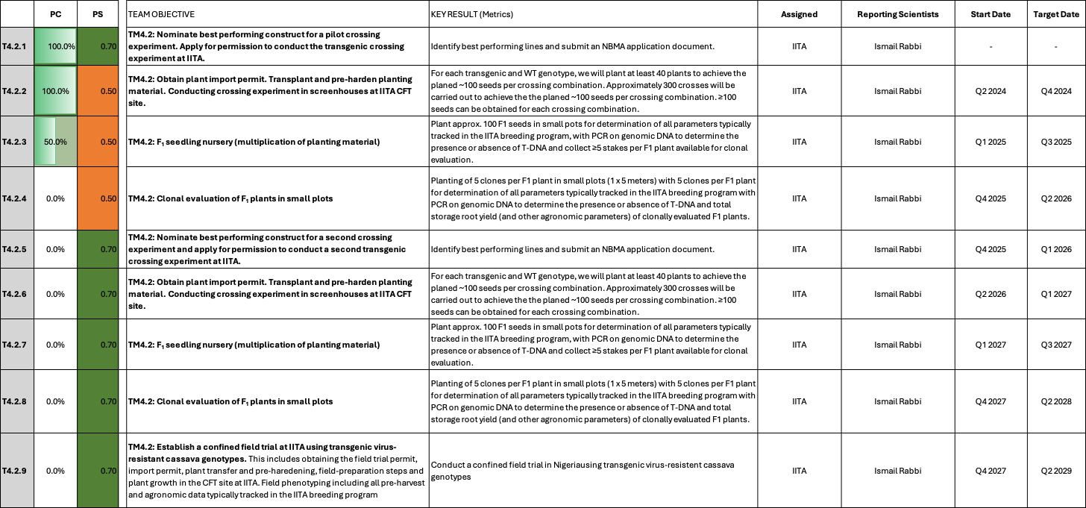

TM4.2_Testing of transgenic lines in Africa and transgenic crossing activities

Reporting module leader: Ismail Rabbi, IITA.

Progress Update:

4.2.1. Nominate best performing construct for a pilot crossing experiment. Apply for permission to conduct the transgenic crossing experiment at IITA.
Concluded. See previous report for details.

4.2.2. Obtain plant import permit. Transplant and pre-harden planting material. Conducting crossing experiment in screenhouses at IITA CFT site.
Concluded. See previous report for details.

4.2.3. F₁ seedling nursery (multiplication of planting material)
Seedling nursery was established. See previous reports for reporting history.

4.2.4. Clonal evaluation of F1 plants in small pots
Not yet started

Field testing updates

During Q2, the first confined field trial conducted under NBMA Permit No. NBMA/CFT/016 was successfully completed and harvested. Comprehensive agronomic measurements were collected on all experimental plots, including fresh root yield, root number, root weight, shoot biomass, harvest index, root size, dry matter content, and dry root yield. Statistical analyses were subsequently completed to evaluate the performance of the three AKT2_{var} transgenic events relative to the wild-type (TMS60444) and empty-vector (EV4234) controls.

The trial generated high-quality data with good experimental precision. Entry-mean broad-sense heritability was high for the principal productivity traits, including fresh root yield (H² = 0.90), fresh root weight (H² = 0.83), dry matter content (H² = 0.92), dry root yield (H² = 0.92), and harvest index (H² = 0.94), with corresponding prediction accuracies ranging from 0.91 to 0.97. Coefficients of variation were within acceptable ranges for cassava field experiments, ranging from 8.4% for dry matter content to 23.3% for shoot weight, while the key productivity trait, fresh root yield, recorded a CV of 14.7%, indicating good experimental precision. Collectively, these metrics demonstrate that the trial was sufficiently robust to reliably discriminate among the transgenic events and control genotypes, providing confidence that the observed performance differences largely reflect true biological variation rather than experimental error.

The wild-type control (TMS60444) remained the highest-yielding genotype overall. However, among the transgenic events, ETH4266 consistently exhibited superior performance and emerged as the most promising AKT2 event for continued evaluation. Compared with the empty-vector control (EV4234), ETH4266 produced:

- 10.8% higher fresh root yield

- 11.4% greater fresh root weight

- 15.9% more storage roots

- 3.7% higher harvest index

These results suggest that the AKT2_{var} construct may positively influence assimilate partitioning towards storage roots relative to the transformed background. The improved performance of ETH4266 appeared to result primarily from increased storage root number and improved harvest index rather than increased individual root size. A detailed statistical analysis of the trial is provided in the accompanying harvest report.

2. Establishment of the Second-Season Confined Field Trial
Immediately following harvest, stem cuttings obtained from the first-season trial were replanted to establish the second confined field evaluation. The objective of the second season is to confirm the performance, stability, and reproducibility of the most promising AKT2_{var} events over an additional cropping cycle under confined conditions. The planting will also allow us to carry out further crosses to generate new F1s for transgene effect testing in adapted genetic backgrounds.

3. Screenhouse Activities and Maintenance of Transgenic Materials
Maintenance of backup transgenic materials continued throughout the reporting period within the confined screenhouse and Semi-Autotrophic Hydroponics (SAH) facilities. Routine propagation, hardening, irrigation, sanitation, and plant health monitoring ensured the continuous availability of healthy planting materials for the second field cycle and future evaluations. No significant plant health issues or biosafety concerns were observed during routine monitoring.

4. NBMA Inspection and Regulatory Compliance
Officials of the National Biosafety Management Agency (NBMA) conducted a regulatory inspection of the confined field trial and associated containment facilities from 12–14 June 2026. The inspection covered the confined field site, screenhouse facilities, biosafety procedures, inventory and record keeping, traceability systems, and overall compliance with the conditions of NBMA Permit No. NBMA/CFT/016. The project remained fully compliant with all permit conditions throughout the reporting period. No biosafety incidents, containment breaches, or regulatory non-compliances were recorded. During the quarter, IITA also submitted a formal progress update to NBMA and informed the Agency of the successful completion of the first confined field trial and the establishment of the second-season evaluation.

Challenges and Mitigations:
No new challenges to report.

Next Steps in the Action Plan:
- Monitor the growth and performance of the second-season confined field trial.
- Continue agronomic, physiological and biosafety assessments of all transgenic events.
- Generate further F₁ crosses
- Maintain and propagate backup transgenic materials in the screenhouse.
- Continue regulatory reporting and compliance with NBMA requirements.

TM5_Cassava plant and field phenotyping

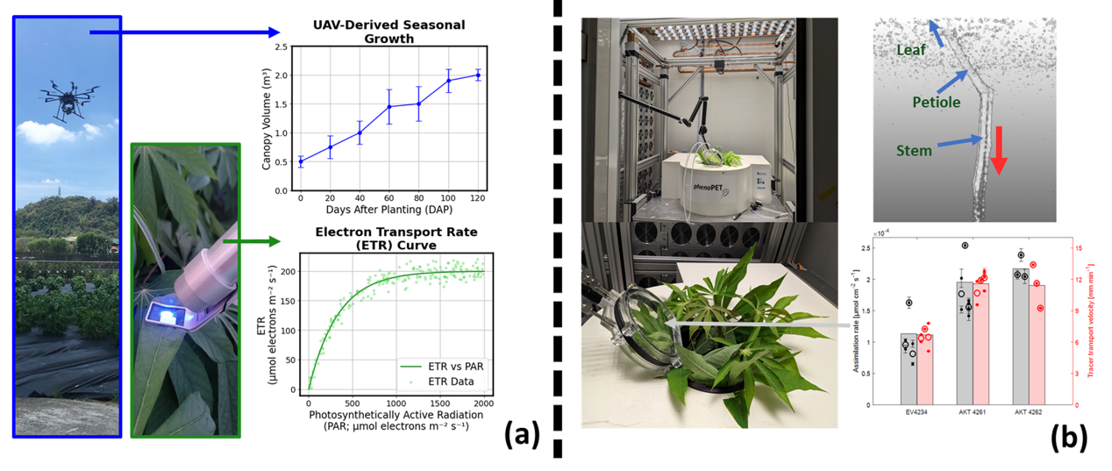
TM5.1_Cassava plant and field phenotyping
5.1
Summary of Goals and Impact
The goal of TM5 is to conduct comprehensive phenotyping of cassava plants, both in controlled environments and in the field, to assess the impact of genetic modifications on plant performance and yield. This module employs advanced techniques, including ¹¹CO₂-PET measurements, UAV-based imaging, and ground-based sensor systems, to monitor carbon transport, photosynthesis, and growth dynamics in both wild-type and transgenic cassava plants. By gathering detailed quantitative data on these physiological traits, TM5 aims to identify the most promising genetic lines for increased storage root yield and overall plant performance.

The activities in TM5 are critical for translating genetic modifications into tangible agronomic improvements. By providing precise and high-resolution data on how transgenic cassava plants grow and function in real-world conditions, this module ensures that only the most effective traits are carried forward into large-scale testing and deployment. The insights gained from TM5 will guide the development of cassava varieties that are more productive and resilient, directly benefiting smallholder farmers by enhancing food security and agricultural sustainability.

TM5_Cassava plant and field phenotyping

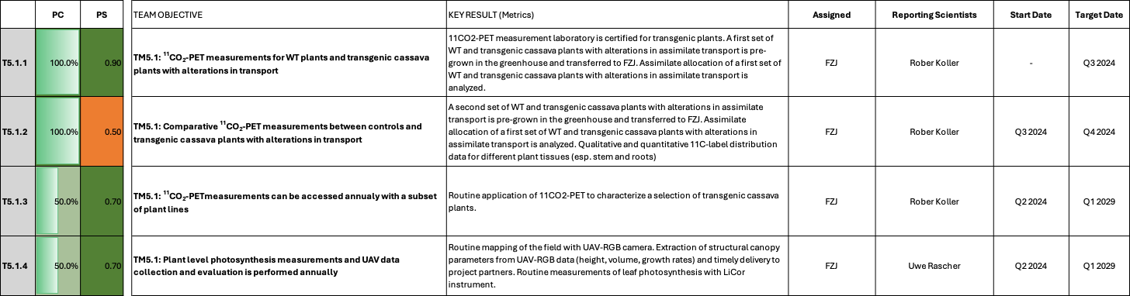

TM5.1: Cassava plant and field phenotyping

Reporting module leader: Uwe Rascher, FZJ.

Progress Update:

5.1.1. ¹¹CO₂-PET measurements for WT plants and transgenic cassava plants with alterations in transport
Concluded. See previous reports for details.

5.1.2. Comparative ¹¹CO₂-PET measurements between controls and transgenic cassava plants with alterations in transport
Concluded. See previous reports for details.

5.1.3. ¹¹CO₂-PET measurements can be accessed annually with a subset of plant lines
See previous reports for reporting history. In this quarter the following activities were performed:
  - ¹¹CO₂-PET measurements on 2 MeAPS1 RNAi and 2 PPase lines and Vector Control from FAU (24 Plants in total) was performed. Data analysis showed a tendency for slower transport in the transgenic lines compared to VC, but data quality was not sufficient for unambiguous conclusions. Further adjustments to the newly established measurement device are necessary to generate higher quality data.
  - Repetition of the experiment with the most promising line is currently being discussed with FAU
  - Measurements with GAIdelta17 lines are being discussed with FAU
5.1.4. Plant level photosynthesis measurements and UAV data collection and evaluation is performed annually
Season 2024
Concluded. See previous reports for details.
Season 2025
Concluded. See previous reports for details.
Season 2026
See previous reports for reporting history. In this reporting period the following activities were performed:
During this reporting period, activities focused on expanding the characterization of the environment where CASS genotypes are evaluated in the confined field trial in Taiwan, providing an increasingly robust basis for disentangling environmental and genetic sources of phenotypic variation.

- As part of our objective to better understand the sources of spatial heterogeneity within the experimental fields and improve the disentanglement of environmental and genetic sources of phenotypic variation, the apparent electrical conductivity (ECa) maps derived from the electromagnetic induction (EMI) survey were integrated with historical plant growth data to identify strategic sampling locations. The planned soil sampling campaign has now been completed (Fig. 1A).
- To strengthen the temporal characterization of the field experiment, a wildlife camera has been deployed to provide continuous visual monitoring of crop development throughout the growing season from a perspective that cannot be captured by aerial imagery. An automated processing pipeline has been set up to generate time-lapse animations in which the image sequence is synchronized with key environmental variables, including 5-hourly air temperature (recorded by the camera), growing degree days (GDD; calculated from daily temperature obtained from the CODIS weather service - https://codis.cwa.gov.tw/-), and cumulative precipitation (also obtained from CODIS), facilitating the interpretation of crop development under changing environmental conditions (Fig. 1C-D).

- The MicroPAM experiment established to monitor photosynthetic performance throughout the growing season is operational. Sensors were installed on selected plants in the main field experiment (DELLA, C2-16, VC and WT) on mid-May. A period of persistent rainfall during June complicated the continuity of field measurements and the retrieval of data for remote monitoring in Germany. During our ongoing (June 29 to July 14) visit to the field, the monitoring system was serviced and measurements were resumed on July 6th (Fig. 1E).

- Wireless cloud-based data transfer was established for the MicroPAM monitoring system (Fig. 1F), enabling the automatic transmission of photosynthetic measurements from the field to a cloud platform. The objective of this development is not to replace the established exchange of experimental datasets between project partners. Rather, it represents an important step towards the development of a remote phenotyping facility by enabling the near real-time assessment of seasonal photosynthetic dynamics and their response to changing environmental conditions.

- Leaf expansion data were collected from selected plants in the field to support the development and evaluation of leaf growth models in collaboration with the modelling team. A representative cassava leaf template was additionally used to support image segmentation and area extraction. Using this approach, leaf area was quantified for three leaves from each of three plants (total of 9 leaves), providing an initial insight into leaf expansion dynamics (Fig. 1I-J).

- The manuscript titled: “Repeatability and Heritability of UAV-Derived Canopy Traits in a Cassava Breeding Population Using Time-Series Data from Two Consecutive Growing Seasons” has been published as a bioRxiv preprint in accordance with Gates AgOne requirements. Following minor revisions to align the manuscript with the requirements of the target journal, The Plant Phenome Journal, the updated version has been resubmitted to the Gates AgOne for IP clearance prior to journal submission.

- To support scientific dissemination of the project outcomes, the abstract titled: “Temporal Dynamics of Heritability for UAV-Derived Growth Traits in Cassava Across Multiple Growing Seasons” has been submitted for consideration as a poster presentation at the 9th International Plant Phenotyping Symposium (IPPS9). This is a work in collaboration with IITA colleagues (Ismail Rabbi and Chike Ugoji).

- In coordination with the CASSbase team (Mercedes Thieme, FAU Erlangen, and Lukas Mueller, BTI), the historical UAV phenotyping datasets (2022-2025), together with orthomosaic maps from all available flights, were reorganized and provided to support the update and completion of the CASSbase repository.

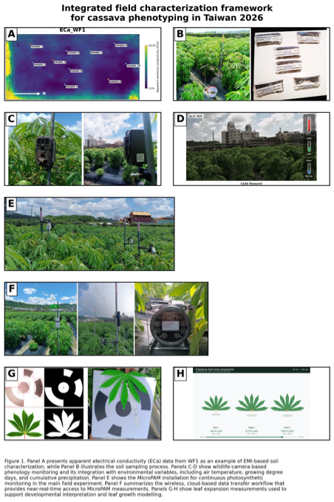

Challenges and Mitigations:
The main challenge during this reporting period has been the interpretation of the complex spatial heterogeneity observed across the experimental fields. While the EMI-derived apparent electrical conductivity (ECa) maps provide valuable information on field variability, they do not directly reveal the underlying causes. Addressing this challenge has required the integration of ECa with complementary datasets, including historical vegetation performance and field observations, together with close collaboration between experts from different disciplines. This integrative approach has resulted in progress towards the identification of the key factors driving spatial variability and provides a strong foundation for the ongoing soil analyses.
Ensuring a continuous flow of photosynthetic measurements throughout the growing season has been a key challenge during this reporting period. To improve the robustness of the monitoring workflow, a dedicated field router was successfully integrated with the MicroPAM system and a cloud-based data transfer platform was established, enabling automatic synchronization of photosynthetic measurements and remote access to field data from Germany. This successful implementation provides a more robust framework for continuous seasonal monitoring and represents an important step towards the development of a remote phenotyping facility capable of supporting the near real-time assessment of photosynthetic dynamics under changing field conditions.

Next Steps in the Action Plan:
5.1.3
- Planning for next ¹¹CO₂-PET measurements on DELLA lines with FAU is currently ongoing and measurements are planned for later in Q3 2026.
5.1.4
- Continue the routine processing and analysis of UAV, MicroPAM and wildlife camera information.
- Integrate the results of the ongoing soil physical and chemical analyses with the EMI-derived apparent electrical conductivity (ECa) data and historical phenotyping information to further investigate the underlying causes of spatial heterogeneity within the experimental fields.
- Continue the peer-review process of the manuscript Repeatability and Heritability of UAV-Derived Canopy Traits in a Cassava Breeding Population Using Time-Series Data from Two Consecutive Growing Seasons and address reviewer comments as they become available.
- Process and analyze the UAV time-series data required for the study submitted for presentation at the 9th International Plant Phenotyping Symposium (IPPS9).
- Continue collaborating with the CASSbase team by providing additional UAV phenotyping data and related information as required to support the maintenance and expansion of the database.
- Monitor the long-term performance and reliability of the wireless cloud-based MicroPAM data transfer system, identifying potential limitations and optimizing the workflow for continuous remote field monitoring.

TM6_Research data management
6.1
TM6.1_Research data management

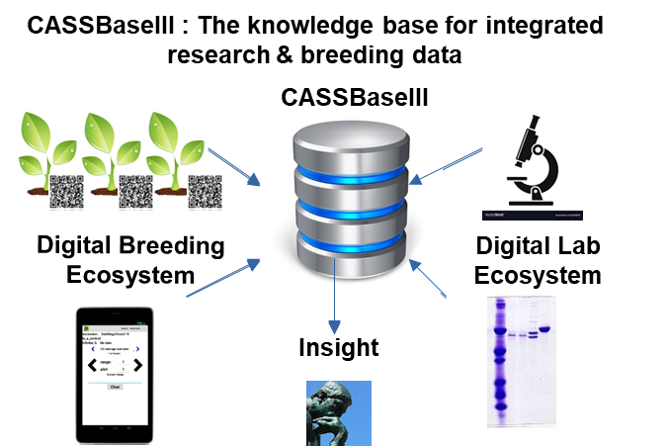
Summary of Goals and Impact
The goal of TM6 is to facilitate the data management of the project and is therefore an important component for success of the CASS program.

By instituting the use of a modern central digital ecosystem for breeding and scientific data on the project level through the use of CASSbase, the module will result in high quality, comprehensive, queryable, and actionable information, generating feedback loops for new queries and hypotheses, that will help produce a higher impact and improved outcomes for the project and the farmer.

TM6_Research data management

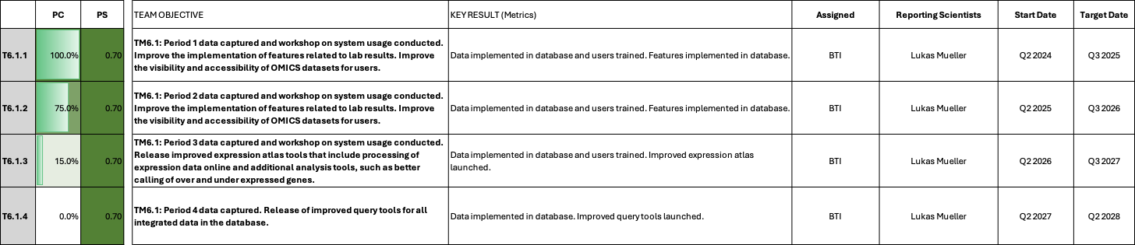

Progress Update: TM6_Research data management

Reporting module leader: Lukas Mueller, BTI.

6.1.1. Period 1 data captured and workshop on system usage conducted. Improve the implementation of features related to lab results. Improve the visibility and accessibility of OMICS datasets for users.
See previous reports for reporting history. Capture of constructs, transgenic lines, and field data complete.

6.1.2. Period 2 data captured and workshop on system usage conducted. Improve the implementation of features related to lab results. Improve the visibility and accessibility of OMICS datasets for users.
See previous reports for reporting history. Capture of constructs, transgenic lines, and field data complete.

6.1.2. Period 3 data captured and workshop on system usage conducted. Improve the implementation of features related to lab results. Improve the visibility and accessibility of OMICS datasets for users.
- New 2026 trials have been designed for Taiwan and are tracked in the system; an intermediate harvest is scheduled for the very near future.
- BTI continues to work on new features and optimizations related to the transformation protocols that the CASS project relies upon. CASSbase allows transformation processes to be tracked using special identifiers created for transformation experiments, which can be printed as barcode labels. The barcodes can be scanned directly with a tablet and the status of the tracked samples adjusted on a special CASSbase webpage. In the previous reporting periods, improvements to the system were made, for example, how certain samples can be obsoleted, with obsoleted lines being listed in supplementary table from which they can be un-obsoleted if necessary, and how data can be associated with obsoleted materials, which is sometimes required during the workflow. In this reporting period, this process has been refined by bug fixes and other improvements. In total, 84 pull requests (PR’s) were merged in reporting period. For example, the option to add parental information to the trial and phenotype download has been added (see PR #6172, https://github.com/solgenomics/sgn/pull/6172), which is important for transformants, as the vector appears as one of the parents. This allows the data to be more easily managed by vector. Improvements were also made to the label designer, where more options were added to print the labels in custom orders were added (see PR #6174, https://github.com/solgenomics/sgn/pull/6174). All PR’s can be seen at https://github.com/solgenomics/sgn/pulls.
- A new tool has been added that allows trials to be managed in the context of larger fields. The trials can be designed as before, and then placed onto a field with several other trials, and planting and harvesting orders retrieved for the entire field (see PR#6078, https://github.com/solgenomics/sgn/pull/6078 ).
- Another new tool has been added to visualize the geographic differences in performance, called the “environment stratification tool”. The tool allows users to select a dataset and trait, run environment stratification analysis, and review compatible environment groups based on genotype-by-environment interaction (see PR#6093, https://github.com/solgenomics/sgn/pull/6093 ).
- The Breedbase ordering system has been opened for FAU ordering of transgenic lines. The system allows users to log in and generate lists of stock requests, which can then be processed and managed by the FAU transformation lab. A pull request is in preparation that optionally allows all available accessions to be added to the catalog automatically, and improves the user interface flow for creating orders by eliminating a pop up window and other changes.
- A wiki system has been implemented recently as reported previously, to replace the somewhat pricey Confluence system. This system is now in production use and all pages have been migrated to the new system (https://cassbase.org/wiki [login required]). Pages can also include images and videos.
- The recent influx of new expression data has renewed the interest in the Expression Atlas, for which several instances have been created for CASS over the years. The older, publicly available data is shown on https://cea.sgn.cornell.edu/, whereas for the newer data, a private instance was created at https://cessea.sgn.cornell.edu/, where the new datasets are being uploaded. Some design changes have been requested, including a better summary display for each selected gene, and simplified data uploads (for current PR’s see https://github.com/solgenomics/TEA/issues/). The expression atlas has recently been dockerized (https://github.com/solgenomics/tea_dockerfile/), making deployment and creation of new instances much easier to implement.
Data upload summary
- At FAU and ETH, experiments now get routinely designed in Cassbase, with labels printed and data collected using tablets (Field Book). In total, 21 new trials were designed in the reporting period. Under the CASS breeding program, 7 trials were uploaded, under the FAU breeding program, 1 trials was uploaded, ETH uploaded 8 and MPI-MP entered 5 . Digital collection tools are now also routinely used, with 455,247 phenotypes being uploaded in the reporting period. These included some re-uploads and corrections to older drone-based experiments.
- In total, 439 new accessions created in the system, which are being tracked in regeneration using the Cassbase tracking tool.
- 113 new trait variables were added to the CASS trait ontology, mostly for new metabolic compounds.
- The database content stats can be viewed by date range at https://cassbase.org/breeders/dbstats .
Challenges and Mitigations:
  - Participation in the digital ecosystem of Cassbase has vastly improved since the beginning of the project, especially at FAU, ETH, and in Taiwan, with improvements at other sites. The system is now routinely used for the vast majority of trial related data management.

Next Steps in the Action Plan:
- Mueller started a sabbatical ETH Zurich at the end of March 2026 and work hands-on on software to improve use cases identified in the Zeeman lab. During the time in Zurich, Mueller visited Erlangen and helped the ETH lab improve their use of CASSbase.
- A major focus is still on the transformation tracking tool, with UI improvements and developing the necessary descriptive ontologies for the transformation and regeneration processes. Naming schemes can now be defined on a per breeding program level, improving the automation of generating new accessions with standardized names.
- Many improvements are being worked on or in the pipeline for Breedbase (see tickets at https://github.com/solgenomics/sgn/issues), such as architectural changes for large uploads and downloads, an authorization system with finer grained permissions, and support for high dimensionality phenotypes (such as expression data, metabolimic data, NIRS data, etc).
- The Expression Atlas will be improved with a number of features, including more intuitive displays and simplified data uploads.

CASS Reporting and Quarterly Meeting timetable 2024-2029

Reporting Period | Start | End | DEADLINE: Report from Partners | DEADLINE: Report to Gates Ag One | CASS Quarterly Meeting
Q3 2024 | July 1, 2024 | September 30, 2045 | September 16, 2024 | September 20, 2024 | September 30th, 2024
Q4 2024 | Oct 1, 2024 | Dec 31, 2024 | February 10th, 2025 | February 14, 2025 | February 27th, 2025
Q1 2025 | January 1, 2025 | March 30, 2025 | April 11, 2025 | April 18, 2025 | April 25, 2025
Q2 2025 | April 1, 2025 | June 30, 2025 | July 11, 2025 | July 18, 2025 (Annual Report) | July 25, 2025
Q3 2025 | July 1, 2025 | September 30, 2025 | September 15, 2025 | September 19, 2025 | September 29th, 2025
Q4 2025 | Oct 1, 2025 | Dec 31, 2025 | February 9th, 2026 | February 13, 2026 | February 26th, 2026
Q1 2026 | January 1, 2026 | March 30, 2026 | April 10, 2026 | April 17, 2026 | April 24, 2026
Q2 2026 | April 1, 2026 | June 30, 2026 | July 17, 2026 | July 24, 2025 (Annual Report) | July 31, 2026
Q3 2026 | July 1, 2026 | September 30, 2026 | September 14, 2026 | September 18, 2026 | September 28th, 2026
Q4 2026 | Oct 1, 2026 | Dec 31, 2026 | February 8th, 2027 | February 12, 2027 | February 25th, 2027
Q1 2027 | January 1, 2027 | March 30, 2027 | April 16, 2027 | April 23, 2027 | April 30, 2027
Q2 2027 | April 1, 2027 | June 30, 2027 | July 16, 2027 | July 23, 2025 (Annual Report) | July 30, 2027
Q3 2027 | July 1, 2027 | September 30, 2027 | September 13, 2027 | September 17, 2027 | September 27th, 2027
Q4 2027 | Oct 1, 2027 | Dec 31, 2027 | February 7th, 2028 | February 11, 2028 | February 24th, 2028
Q1 2028 | January 1, 2028 | March 30, 2028 | April 14, 2028 | April 21, 2028 | April 28, 2028
Q2 2028 | April 1, 2028 | June 30, 2028 | July 14, 2028 | July 21, 2025 (Annual Report) | July 28, 2028
Q3 2028 | July 1, 2028 | September 30, 2028 | September 12, 2028 | September 16, 2028 | September 26th, 2028
Q4 2028 | Oct 1, 2028 | Dec 31, 2028 | February 6th, 2029 | February 10, 2029 | February 23th, 2029
Q1 2029 | January 1, 2029 | March 30, 2029 | April 13, 2026 | April 20, 2029 | April 27, 2029

Module reporting leader | CASS Module
 | EM1: Optimizing assimilate allocation to storage roots
Uwe Sonnewald, FAU | EM1.1_Manipulating shoot architecture
Ekkehardt Neuhaus, RPTU with MPI-MPP. | EM1.2_Limiting lateral transport losses through active phloem (re-)loading
Lee Sweetlove, UO with RPTU, MPI-MPP and ETH. | EM1.3_Transport and allocation modelling
 | EM2: Increasing sink strength by optimizing xylem parenchyma cell formation in storage roots
Yka Helariutta, HU with FAU and ETH. | EM2.1_Manipulation of OVAC and cytokinin metabolism or signalling
Ari Pekka Mähönen, HU with FAU and ETH. | EM2.2_Manipulation of downstream factors involved in xylem parenchyma cell formation
 | EM3_Increasing sink strength by optimizing metabolic flux in storage roots
Alisdair Fernie, MPI-MPP with Oxford and FAU | EM3.1_Optimization of sucrolytic cleavage and glycolysis
Wolfgang Zierer, FAU with ETH. | EM3.2_Optimization of starch-precursor delivery to amyloplasts
Sam Zeeman, ETH with FAU. | EM3.3_Starch granule initiation and growth
Lee Sweetlove, OU with RPTU, MPI-MPP and ETH. | EM3.4_Model-based predictions
Wolfgang Zierer and Uwe Sonnewald, FAU | TM1_Project management and central services
 | TM2_Cassava transformation
Simon Bull, ETH | TM2.1_Routine transformation
Christian Lamm, FAU. | TM2.2_Chemical and genetic boosters
Ihuoma Okwuonu, NRCRI. | TM2.3_Transformation of farmer-preferred genotypes
 | Objective TM3_Expanding the cassava expression toolbox
Wolfgang Zierer, FAU. | TM3.1_Testing of already identified tissue-specific promoter candidates
Ari Pekka Mähönen, HU | TM3.2_Identification of genes and promoter candidates involved in formation of xylem parenchyma
 | Objective TM4_Cassava confined field testing
Wilhelm Gruissem, NCHU with FAU and FZJ. | TM4.1_Pre-testing of transgenic lines outside Africa
Ismail Rabbi, IITA. | TM4.2_Testing of transgenic lines in Africa and transgenic crossing activities
Robert Koller, FZJ | TM5_Cassava plant and field phenotyping
Lukas Mueller, BTI. | TM6_Research data management

