Phase 3

CASS PROGRAM OVERVIEW AND QUARTERLY REPORT Update Q1 2026

Point of Contact: Uwe Sonnewald,
Program Director, University of Erlangen-Nuremberg, uwe.sonnewald@fau.de

Business Point of Contact: Wolfgang Zierer
CASS Scientific Program Manager, University of Erlangen-Nuremberg, wolfgang.zierer@fau.de

Date report submitted: Friday 14th 2025

Investment ID: 58147
Start date: May 1, 2024
End date: April 30, 2029

CASS’s Mission: To achieve a significant increase in the yield of high-quality cassava storage roots under low-input farming conditions in smallholder farmer fields by optimizing cassava physiology.

HOW CASS QUARTERLY REPORTS ARE STRUCTURED

This report lays out the Team Objectives and Key Results, the measurable and time-bound metrics for assessing progression in the project. It provides two scores, a Percent Complete and Progress Score for each key result, along with a justification overview for the scores that have been given, challenges that have been identified in the objective and a brief overview of the action plan for the next quarter.

1. Percent Complete: We look at the Key Result (metric) and estimate the percentage of work that has been completed by dividing the accomplished tasks by the total tasks assigned for that objective. This score can be low early in the project and even zero for a Team Objective that does not start until later in the programme. We are not expecting this score to necessarily show linear progress over the five years of the project.

2. Progress Score: This is a score indicates, independently of the Percent Complete, if we are still on track to deliver the Key Results by the target date. We are expecting this to be green (0.7 - 0.9) for most objectives until significant risk to delivery by the target date is anticipated. A completed Key Result can be scored 1 and a dropped Key Result can be scored 0. To interpret the scores, use the following guidelines:
♦ 0.9: Excellent progress with delivery assured by the target date.
♦ 0.7: On track and likely to deliver by the target date.
♦ 0.5: Lower than anticipated progress with some challenges or delays.
♦ 0.3: Low progress with significant challenges or delays.
♦ 0.1: Very low progress or no progress at all.

3. Justification Statements
- Progress Update: A brief update on the progress made toward each objective. This includes key accomplishments and milestones achieved during the quarter.
- Challenges and Mitigations: The challenges or obstacles encountered during the quarter that affected progress. We explain the steps taken or strategies implemented to mitigate these challenges and minimize their impact on the project.
- Next Steps in the Action Plan: Provides an outline of the planned activities or next steps that will be undertaken in the upcoming quarter to continue progress toward the objective. It includes specific tasks, milestones, or experiments that will be conducted.

CASS PROGRAM OVERVIEW AND QUARTERLY REPORT Update Q4 2024

Use the links below to access sections of the report document:

HOW CASS QUARTERLY REPORTS ARE STRUCTURED 2
CASS Reporting and Quarterly Meeting timetable 2024-2029 5
Module reporting leaders 6
CASS Stage Gate Grid 7
EM1: Optimizing assimilate allocation to storage roots 8
EM1.1_Manipulating shoot architecture 9
EM1.2_Limiting lateral transport losses through active phloem (re-)loading 36
EM1.3_Transport and allocation modelling 65
EM2: Increasing sink strength by optimizing xylem parenchyma cell formation in storage roots 71
EM2.1_Manipulation of OVAC and cytokinin metabolism or signaling 72
EM2.2_Manipulation of downstream factors involved in xylem parenchyma cell formation 86
EM3: Increasing sink strength by optimizing metabolic flux in storage roots 92
EM3.1_Optimization of sucrolytic cleavage and glycolysis 93
EM3.2: Optimization of starch-precursor delivery to amyloplasts 99
EM3.3: Starch granule initiation and growth 107
EM3.4: Model-based predictions 120
TM1: Project management and central services 125
TM1_Project management and central services 126
TM1_Project management and central services 127
TM2: Cassava Transformation 132
TM2.1_Routine transformation 133
TM2.2_Chemical and genetic boosters 140
TM2.3_Transformation of farmer-preferred genotypes 150
TM3_Expanding the cassava expression toolbox 156
TM3.1_Testing of already identified tissue-specific promoter candidates 157
TM3.2_Identification of genes and promoter candidates involved in formation of xylem parenchyma 169
TM4_Cassava confined field testing 173
TM4.1_Pre-testing of transgenic lines outside Africa 174
TM4.2_Testing of transgenic lines in Africa and transgenic crossing activities 189
TM4.2_Testing of transgenic lines in Africa and transgenic crossing activities 192
TM5_Cassava plant and field phenotyping 203
TM5_Cassava plant and field phenotyping 204
TM6_Research data management 214
TM6.1_Research data management 215

CASS Reporting and Quarterly Meeting timetable 2024-2029

Reporting Period | Start | End | DEADLINE: Report from Partners | DEADLINE: Report to Gates Ag One | CASS Quarterly Meeting
Q3 2024 | July 1, 2024 | September 30, 2045 | September 16, 2024 | September 20, 2024 | September 30th, 2024
Q4 2024 | Oct 1, 2024 | Dec 31, 2024 | February 10th, 2025 | February 14, 2025 | February 27th, 2025
Q1 2025 | January 1, 2025 | March 30, 2025 | April 11, 2025 | April 18, 2025 | April 25, 2025
Q2 2025 | April 1, 2025 | June 30, 2025 | July 11, 2025 | July 18, 2025 (Annual Report) | July 25, 2025
Q3 2025 | July 1, 2025 | September 30, 2025 | September 15, 2025 | September 19, 2025 | September 29th, 2025
Q4 2025 | Oct 1, 2025 | Dec 31, 2025 | February 9th, 2026 | February 13, 2026 | February 26th, 2026
Q1 2026 | January 1, 2026 | March 30, 2026 | April 10, 2026 | April 17, 2026 | April 24, 2026
Q2 2026 | April 1, 2026 | June 30, 2026 | July 17, 2026 | July 24, 2025 (Annual Report) | July 31, 2026
Q3 2026 | July 1, 2026 | September 30, 2026 | September 14, 2026 | September 18, 2026 | September 28th, 2026
Q4 2026 | Oct 1, 2026 | Dec 31, 2026 | February 8th, 2027 | February 12, 2027 | February 25th, 2027
Q1 2027 | January 1, 2027 | March 30, 2027 | April 16, 2027 | April 23, 2027 | April 30, 2027
Q2 2027 | April 1, 2027 | June 30, 2027 | July 16, 2027 | July 23, 2025 (Annual Report) | July 30, 2027
Q3 2027 | July 1, 2027 | September 30, 2027 | September 13, 2027 | September 17, 2027 | September 27th, 2027
Q4 2027 | Oct 1, 2027 | Dec 31, 2027 | February 7th, 2028 | February 11, 2028 | February 24th, 2028
Q1 2028 | January 1, 2028 | March 30, 2028 | April 14, 2028 | April 21, 2028 | April 28, 2028
Q2 2028 | April 1, 2028 | June 30, 2028 | July 14, 2028 | July 21, 2025 (Annual Report) | July 28, 2028
Q3 2028 | July 1, 2028 | September 30, 2028 | September 12, 2028 | September 16, 2028 | September 26th, 2028
Q4 2028 | Oct 1, 2028 | Dec 31, 2028 | February 6th, 2029 | February 10, 2029 | February 23th, 2029
Q1 2029 | January 1, 2029 | March 30, 2029 | April 13, 2026 | April 20, 2029 | April 27, 2029

Module reporting leaders
 | EM1: Optimizing assimilate allocation to storage roots
Uwe Sonnewald, FAU | EM1.1_Manipulating shoot architecture
Ekkehardt Neuhaus, RPTU with MPI-MPP. | EM1.2_Limiting lateral transport losses through active phloem (re-)loading
Lee Sweetlove, UO with RPTU, MPI-MPP and ETH. | EM1.3_Transport and allocation modelling
 | EM2: Increasing sink strength by optimizing xylem parenchyma cell formation in storage roots
Yka Helariutta, HU with FAU and ETH. | EM2.1_Manipulation of OVAC and cytokinin metabolism or signalling
Ari-Pekka Mähönen, HU with FAU and ETH. | EM2.2_Manipulation of downstream factors involved in xylem parenchyma cell formation
 | EM3_Increasing sink strength by optimizing metabolic flux in storage roots
Alisdair Fernie, MPI-MPP with FAU and Oxford | EM3.1_Optimization of sucrolytic cleavage and glycolysis
Wolfgang Zierer, FAU with ETH. | EM3.2_Optimization of starch-precursor delivery to amyloplasts
Sam Zeeman, ETH with FAU. | EM3.3_Starch granule initiation and growth
Lee Sweetlove, OU with RPTU, MPI-MPP and ETH. | EM3.4_Model-based predictions
Wolfgang Zierer and Uwe Sonnewald, FAU | TM1_Project management and central services
 | TM2_Cassava transformation
Simon Bull, ETH | TM2.1_Routine transformation
Christian Lamm, FAU. | TM2.2_Chemical and genetic boosters
Ihuoma Okwuonu, NRCRI. | TM2.3_Transformation of farmer-preferred genotypes
 | TM3_Expanding the cassava expression toolbox
Wolfgang Zierer, FAU. | TM3.1_Testing of already identified tissue-specific promoter candidates
Ari Pekka Mähönen, HU | TM3.2_Identification of genes and promoter candidates involved in formation of xylem parenchyma
 | TM4_Cassava confined field testing
Wilhelm Gruissem, NCHU with FAU and FZJ. | TM4.1_Pre-testing of transgenic lines outside Africa
Ismail Rabbi, IITA. | TM4.2_Testing of transgenic lines in Africa and transgenic crossing activities
Uwe Rascher, FZJ with Robert Koller, FZJ | TM5_Cassava plant and field phenotyping
Lukas Mueller, BTI. | TM6_Research data management

CASS Stage Gate Grid
The progression of CASS engineering targets through glasshouse and CFT testing indicating team objectives and the timing of Go/No-go discussions points.
 | Cloning | Transformation | Glasshouse Analysis | Go/No-go | CFT Taichung 1 | Phenotyping 1 | Sample Analysis 1 | Go/No-go | CFT Taichung 2 | Phenotyping 2 | Sample Analysis 2 | Go/No-go | Transformation FPV | CFT SSA
EM1.1: Cassava lines expressing GA2ox and DELLA. | 1.1.1 | T2.1.1 | 1.1.2 | Q4 2025 | T4.1 | T4.1 | 1.1.3 | Q2 2027 | T4.1 | T4.1 | 1.1.4 | Q2 2028 | T2.2/  T2.3 | T4.2
EM1.2: Existing cassava lines expressing AKT2/AAP1/SUC2. | - | - | 1.2.1 | Q4 2024 | T4.1 | T4.1 | 1.2.2 | Q3 2025 | T4.1 | T4.1 | 1.2.3 | Q3 2027 | T2.2/  T2.3 | T4.2
EM1.2: New AKT2/AAP1/SUC2 construct versions and/or synergistic combinations. | 1.2.4 | T2.1.1 | 1.2.5 | Q3 2026 | T4.1 | T4.1 | 1.2.6 | Q3 2028 | T4.1 | T4.1 | 1.2.7 | Q2 2029 | T2.2/  T2.3 | T4.2
EM2.1: Cassava lines with alterations in OVAC and storage root-specific cytokinin overexpression. | 2.1.1 | T2.1.1 | 2.1.2 | Q4 2025 | T4.1 | T4.1 | 2.1.3 | Q2 2027 | T4.1 | T4.1 | 2.1.4 | Q2 2029 | T2.2/  T2.3 | T4.2
EM2.2: Cassava lines with storage root-specific overexpression of transcription factors involved in xylem parenchyma cell formation. | 2.2.1 | T2.1.1 | 2.2.2 | Q4 2025 | T4.1 | T4.1 | 2.2.3 | Q2 2027 | T4.1 | T4.1 | 2.2.4 | Q2 2028 | T2.2/  T2.3 | T4.2
EM2.2: Transgenic cassava lines single-cell RNA-Seq-derived candidates for five promoter-reporter constructs and 5 storage (xylem) parenchyma formation gene candidates. | 2.2.5 | T2.1.1 | 2.2.6 | Q4 2027 | T4.1 | T4.1 | 2.2.7 | Q2 2029 | T4.1 | T4.1 | - | - | - | -
EM3.1: Transgenic cassava lines with new constructs aimed at improved sucrose cleavage/glycolysis. | 3.1.1 | T2.1.1 | 3.1.2 | Q3 2026 | T4.1 | T4.1 | 3.1.3 | Q2 2027 | T4.1 | T4.1 | 3.1.4 | Q2 2028 | T2.2/  T2.3 | T4.2
EM3.1: Transgenic cassava lines with three model-prediction constructs (to be nominated later). | 3.1.5 | T2.1.1 | 3.1.6 | Q3 2027 | T4.1 | T4.1 | 3.1.7 | Q2 2029 | T4.1 | T4.1 | - | - | - | -
EM3.2: Transgenic cassava lines with PPase/GPT/NTT/PGM/glgC constructs and combinations. | 3.2.1 | T2.1.1 | 3.2.2 | Q3 2025 | T4.1 | T4.1 | 3.2.3 | Q2 2027 | T4.1 | T4.1 | 3.2.4 | Q2 2029 | T2.2/  T2.3 | T4.2
EM3.3: Single and multigene constructs with PTST2, MFP1, MRC, SS4, ESV1 and LESV1. | 3.3.1 | T2.1.1 | 3.3.2 | Q4 2025 | T4.1 | T4.1 | 3.3.3 | Q2 2027 | T4.1 | T4.1 | 3.3.4 | Q2 2028 | T2.2/  T2.3 | T4.2
EM3.3: Second generation constructs: Best performing constructs from EM3.2 (Starch-precursory delivery) and EM3.3 (Starch granule initiation and growth) combined. | 3.3.5 | T2.1.1 | 3.3.6 | Q3 2028 | - | - | - | - | - | - | - | - | - | -

EM1: Optimizing assimilate allocation to storage roots

EM1.3_Transport and allocation modelling
1.3
EM1.2_Limiting lateral transport losses through active phloem (re-)loading
1.2
EM1.1_Manipulating shoot architecture
1.1

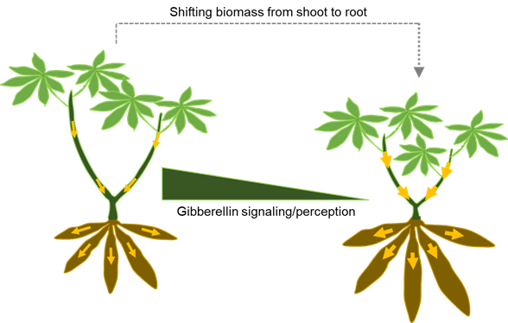
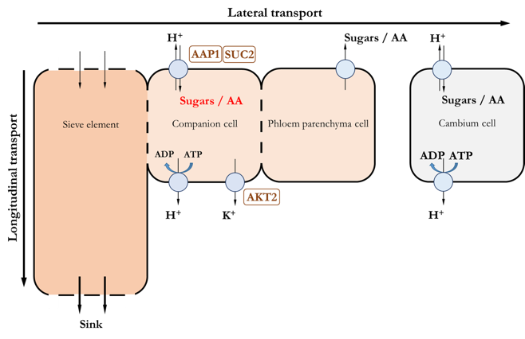
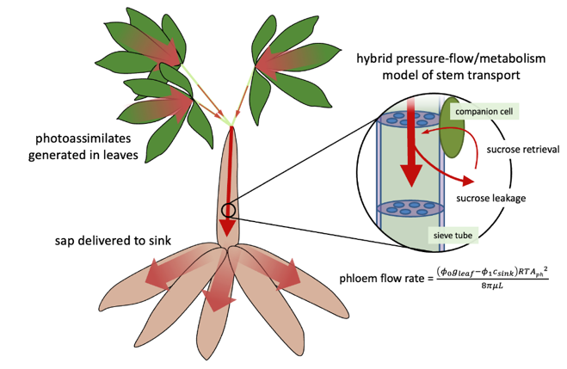
Module EM1: Optimizing Assimilate Allocation to Storage Roots

Summary of Goals and Impact
The primary goal of EM1 is to enhance cassava yield by optimizing the allocation of photoassimilates, the energy-rich products of photosynthesis, towards the storage roots. This module seeks to reduce the resources invested in aboveground parts like stems and direct more to the roots, where cassava stores its valuable starch. By fine-tuning gibberellin signalling specifically in stems and improving the efficiency of nutrient transport within the plant, EM1 aims to maximize the storage root yield without compromising the plant's ability to propagate.
This research holds significant potential for creating impactful products for smallholder farmers. By increasing the efficiency of how cassava plants use their resources, this module could lead to higher yields even under low-input farming conditions, directly benefiting farmers who rely on cassava as a staple crop. Furthermore, the computational model developed in this module could serve as a predictive tool, helping breeders and farmers optimize harvests with greater precision. The success of this module could pave the way for innovations that ensure food security and improve livelihoods for smallholder farmers, aligning with the mission of CASS and Gates Ag One.

EM1.1_Manipulating shoot architecture

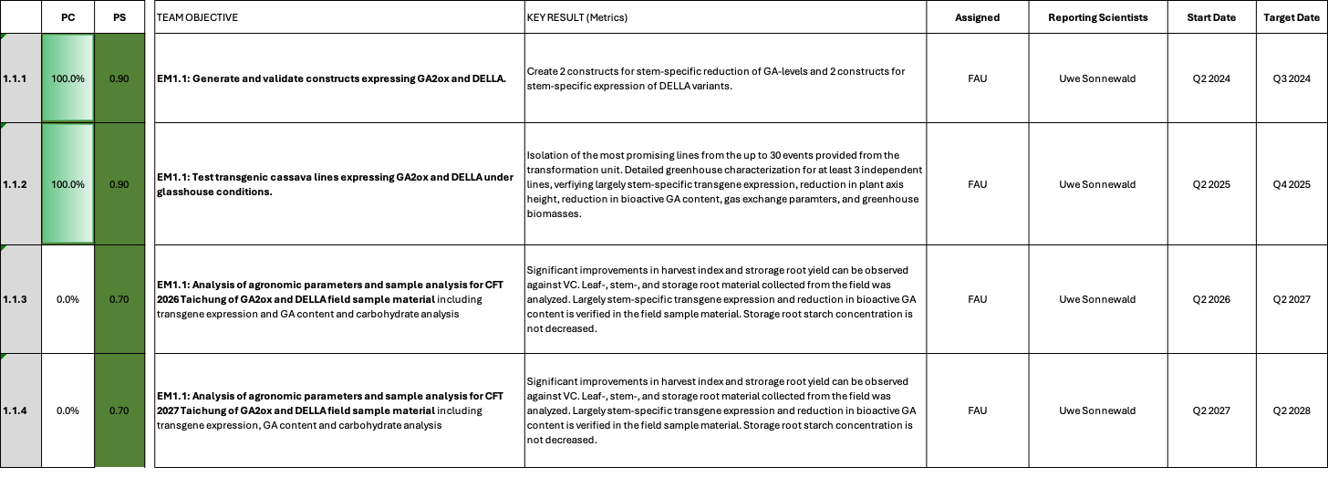

EM1.1_Manipulating shoot architecture

Reporting module leader: Uwe Sonnewald, FAU

Progress Update:

1.1.1. Generate and validate constructs expressing GA2ox and DELLA. Based on RNASeq data (published in Rüscher et al., 2024; https://doi.org/10.1093/plphys/kiae298), two genes have been selected for isolation of stem-specific promoters, Manes.09G047609 (encoding a chloroplastic theronine dehaydratase (OMR1)) and Manes.17G027300 (encoding a homeobox protein (SBH1)). The OMR1 gene is expressed strongly in upper stems and weaker in petioles and middle and lower stem parts. It is not expressed in leaves and roots. The SBH1 gene is more or less homogenously expressed in all tested stem tissues but not in leaves and roots. Using these promoters, as well as the already validated Arabidopsis AtCAB1 promoter (Zierer et al., 2022), five target gene constructs have been designed and cloned. Target genes are (i) Arabidopsis GA2-oxidase (AtGA2ox) and (ii) Arabidopsis GAI_D17. GA2ox is involved in the degradation of bioactive gibberellins and should decrease GA levels. The GAI_D17 protein acts as a GA-independent repressor and should decrease GA responses. The constructs are shown in Table 1. To validate the promoter specificity of the new promoters used, promoter:reporter gene constructs have been designed and cloned. Details are shown in Table 2.

Table 1_Summary of the gene constructs.
Construct number | Gene cassette | Database link
C2-92 | pManes.09G047609::AtGAI_Δ17 CDS-6xHA::tHsp18.2 | https://cassbase.org/stock/462041/view
C2-94 | pManes.09G047609::AtGA2ox1-6xHA::tHsp18.2 | https://cassbase.org/stock/462043/view
C2-93 | pManes.17G027300::AtGAI_Δ17 CDS-6xHA::tHsp18.2 | https://cassbase.org/stock/462042/view
C2-95 | pManes.17G027300::AtGA2ox1-6xHA::tHsp18.2 | https://cassbase.org/stock/462044/view
C2-113 | pAtCAB1::AtGA2ox1::6xHA::tHsp18.2 | https://cassbase.org/stock/462045/view

Table 2_Summary of promoter:reporter gene constructs.
Construct number | Gene cassette | Database link
C1-70 | pManes.09G047609::GUS⁺ CDS::Ter + pManes.09G047609::ER-tdTomato::Ter | https://cassbase.org/stock/462039/view
C1-71 | pManes.17G027300::GUS⁺ CDS::Ter + pManes.17G027300::ER-tdTomato::Ter | https://cassbase.org/stock/462040/view

Challenges and Mitigations:
No unforeseen challenges have been encountered.

Next Steps in the Action Plan:
- Concluded

1.1.2. Test transgenic cassava lines expressing GA2ox and DELLA under glasshouse conditions. Agrobacterium tumefaciens mediated transformation of cassava genotype TMS60444 of all target constructs (Table 1 and Table 2) was started on August 8th latest. Transformed cultures have been selected and regeneration has been initiated.
Table 3 shows the respective transformation progress. The regeneration and testing of events is a continues process that happens over several weeks. Therefore, the number of regenerated and confirmed events is not final and still subject to change. However, the transformation is nearing the end of the regeneration cycle and total event numbers will likely not increase dramatically anymore. We are projecting 15 confirmed events for the promoter-GUS constructs C1-70 and C1-71 and 20 confirmed events each for all other EM1-1 constructs. Confirmed events were tested for their hygromycin resistance and the presence of T-DNA in the plant genome.

Table 3_Transformation status of EM1-1 plants
Construct number | Gene cassette | Database link | Current transformation status
C2-92 | pManes.09G047609::AtGAI_Δ17 CDS-6xHA::tHsp18.2 | https://cassbase.org/stock/462041/view | No problems reported; 14 PCR-positive events
C2-94 | pManes.09G047609::AtGA2ox1-6xHA::tHsp18.2 | https://cassbase.org/stock/462043/view | No problems reported; 40 PCR-positive events
C2-93 | pManes.17G027300::AtGAI_Δ17 CDS-6xHA::tHsp18.2 | https://cassbase.org/stock/462042/view | No problems reported; 26 PCR-positive events
C2-95 | pManes.17G027300::AtGA2ox1-6xHA::tHsp18.2 | https://cassbase.org/stock/462044/view | No problems reported; 40 PCR-positive events
C2-113 | pAtCAB1::AtGA2ox1::6xHA::tHsp18.2 | https://cassbase.org/stock/462045/view | No problems reported; 35 PCR positive events
C1-70 | pManes.09G047609::GUS⁺ CDS::Ter + pManes.09G047609::ER-tdTomato::Ter | https://cassbase.org/stock/462039/view | Transformation finished; 15 events isolated
C1-71 | pManes.17G027300::GUS⁺ CDS::Ter + pManes.17G027300::ER-tdTomato::Ter | https://cassbase.org/stock/462040/view | Transformation finished; 15 events isolated

The first batch of plants from construct C1-70 and C1-71 is currently growing in the greenhouse. First GUS stainings indicate that pManes.09G047609 (C1-70) has activity in sink leaf, petiole-, stem-, and storage root cortex, but no activity in source leaf, storage root xylem core, or fibrous roots. Therefore, the promoter seems to be close to the desired activity. First GUS stainings performed with young plants for pManes.17G027300 indicate less specific activity, with staining visible in leaves and fibrous roots. However, both promoters still need a more detailed characterization and a characterization of different events to generate a robust picture, which will be possible in a few weeks once the plants have formed storage roots. Please also see the updated results for C1-70 and C1-71 under TM3.1. In brief, C1-70 displays stem-specific expression, however, the activity is limited to the outermost layers of the tissues. If this localized activity is sufficient to achieve a sufficient GA2/GAI effect, remains to be seen. C1-71 has more homogenous activity in stem tissues, however this promoter is not specific. If this unspecific expression results in unwanted effects upon GA2/GAI expression remains to be seen.

Figure 1 below shows the updated results for C1-70 and C1-71.

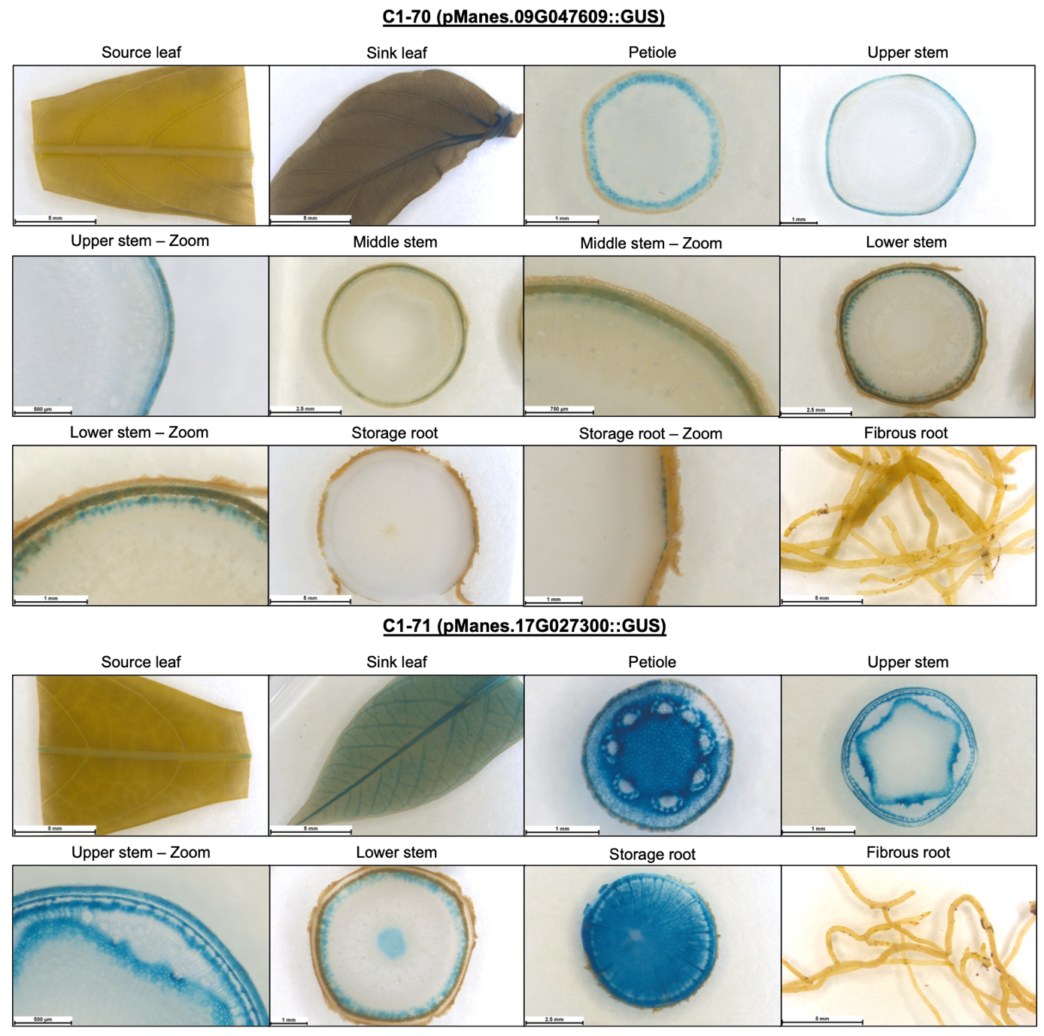
Fig. 1_GUS staining results for C1-70 (pManes.09G047609) and C1-71 (pManes.17G027300::GUS)

Detailed GUS staining analysis shows that pManes.09G047609 (used in C2-92 and C2-94) is mostly active in petiole, stem, and storage root tissues, with no clear staining in leaves, and fibrous roots. However, overall promoter activity is clearly limited to the outer tissue layers (likely representing cortex tissue). The overall activity of the promoter seemed weaker compared to pManes.17G027300 during the GUS stainings, an observation that is also reflected in the qPCR expression data of the AtGAI constructs (C2-92 and C2-93; see below). pManes.17G027300 (used in C2-93 and C2-95) is active in petiole, stem, and storage root tissues, with slight staining in sink leaves. No clear activity was found in source leaves and fibrous roots. Within the tissues with activity, staining seems to be present in all living cell types (mostly excluding woody xylem).

PCR positive lines for all other constructs were transferred to the greenhouse and are currently growing. However, it is still to early to see phenotypic differences.

Greenhouse characterization has progressed and the current status is summarized in Table 4 below.

Table 4_Summary of the current status of transgenic lines.
Construct number | Gene cassette | Number of lines in the greenhouse | Number of lines tested so far for AtGA2ox1 or AtGAI_Δ17 transgene expression | Number of lines with positive transgene expression for AtGA2ox1 or AtGAI_Δ17
C2-92 | pManes.09G047609::AtGAI_Δ17 CDS-6xHA::tHsp18.2 | 14 | 7 | 4
C2-94 | pManes.09G047609::AtGA2ox1-6xHA::tHsp18.2 | 37 | 11 | 0
C2-93 | pManes.17G027300::AtGAI_Δ17 CDS-6xHA::tHsp18.2 | 15 | 4 | 4
C2-95 | pManes.17G027300::AtGA2ox1-6xHA::tHsp18.2 | 39 | 11 | 0
C2-113 | pAtCAB1::AtGA2ox1::6xHA::tHsp18.2 | 18 | 8 | 0 in stem and 8 in leaf

To verify expression of the transgenes, qPCR analysis was carried out using stem cuttings. Unfortunately, for all of the transgenic lines carrying AtGA2ox1, under the control of the three different promoters, no transgene-specific mRNA was detectable. Since the failure to detect AtGA2ox transcripts for constructs C2-94 and C2-95 was associated with the absence of any visible phenotype deviating from untransformed control plants, further analysis of these transgenic lines was stopped. Since the promoter-gus results confirm promoter activity, the problem likely is caused by the AtGA2ox1 coding sequence.

In case of construct C2-113, expression of AtGA2ox1 was further tested in leaves. Here, a very weak expression could be detected. Results of the preliminary screening for C2-113 are shown in Figure 2. Therefore, the remaining untested lines have been transferred to the greenhouse and will be tested in the next two months.

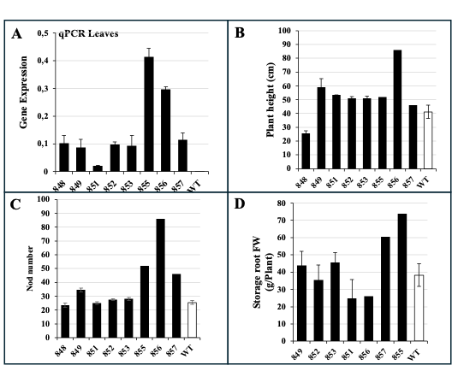
Fig. 2_Summary of the preliminary characterization of transgenic lines carrying construc C2-113. A) Transgene expression in leaves. B) Plant height. C) Nod number. D) Storage root fresh weight.

Constructs C2-92 and C2-93 carry the AtGAI_Δ17 transgene under control of pManes.09G047609 and pManes.17G027300 promoters. In both cases, expression could be found in stem (data not included), petioles and storage roots. Figure 3 summarizes preliminary results that we have collected for construct C2-92.

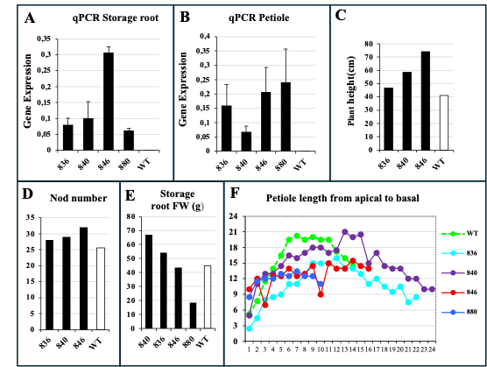
Fig. 3_Summary of the preliminary characterization of transgenic lines carrying construc C2-92. A) Transgene expression in storage roots. B) Transgene expression in petioles. C) Plant height. D) Nod number. E) Storage root fresh weight. F) Petiole length.

While plant height, in contrast to expectations, was slightly increased, petiole length for three of the four positive lines was decreased, indicating activity of the introduced DELLA protein. Storage root yield was highly variable. More reliable data will be generated, once the screening is complete and the chosen lines can be tested with sufficient replications. The remaining untested lines have been transferred to the greenhouse and will be characterized in the next two months.

First results of construct C2-93 are summarized in Figure 4.

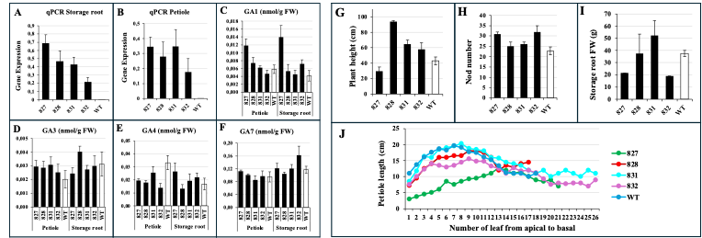
Fig. 4_Summary of the preliminary characterization of transgenic lines carrying construc C2-93. A) Transgene expression in storage roots. B) Transgene expression in petioles. C-F) GA levels in petioles and storage roots. G) Plant height. H) Nod number. I) Storage root fresh weight. J) Petiole lenght

With exception of line 827, AtGAI_Δ17 expressing plants show increased shoot growth. This result is unexpected since overexpression of AtGAI_Δ17 should result in dwarf plants. Similar to construct C2-92, AtGAI_Δ17 expressing plants show reduced petiole length. To obtain first insights into the possible mechanism, accumulation of GA was analyzed in petioles and storage roots of transgenic and control plants. This analysis suggests a slight increase in the levels of GA1 and GA3 in petioles of transgenic plants. The remaining untested lines have been transferred to the greenhouse and will be characterized in the next two months.

A second batch of plants was recently analyzed in the glasshouse. This batch contained additional lines from the constructs C2-92, C2-93, and C2-113 (see Table 5).

Table 5.
Construct number | Line number
C2-92 | 838,841,843,862,863,879
C2-93 | 825, 826, 827, 829, 830, 833, 834, 865, 866, 867, 868
C2-113 | 850, 859, 860, 869, 871, 872, 873, 875, 877

Constructs C2-92 and C2-93 carry the AtGAI_Δ17 transgene under control of pManes.09G047609 and pManes.17G027300 promoters, respectively. To verify AtGAI_Δ17 overexpression in transgenic lines of constructs C2-92 and C2-93, qPCR analysis was carried out using petiole tissue. The results of qPCR for AtGAI_Δ17 in petioles from the second batch of transgenic lines carrying constructs C2-93 and C2-92 are summarized in Figure 5.

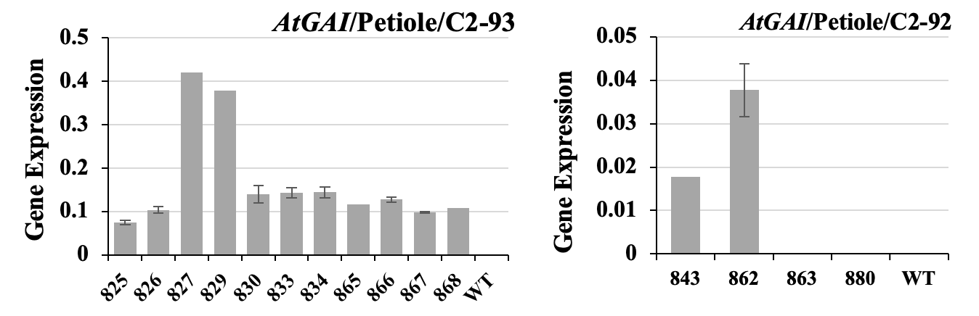
Fig. 5_ qPCR analysis of AtGAI_Δ17 expression in petiole cuttings from transgenic lines carrying constructs C2-92 and C2-93.

Phenotypic parameters, including plant height, stem diameter, node number, and petiole length, were assessed for C2-93 and C2-92 lines on August 28, 2025. Xylem, phloem of internodes, and storage roots were also collected to evaluate AtGAI expression, to perform western blotting, to measure GA levels, and to conduct RNA-seq.

Based on plant height measurements of C2-93 lines, three distinct phenotypes were identified: dwarf phenotype (line 827), semi-dwarf phenotypes (lines 826, 829, 833, 834, 865, 866, 867, and 868), and slender phenotypes (ines 825 and 830). Petiole length was reduced in dwarf and semi-dwarf lines (826, 829, 833, 834, 865, 866, 867, and 868), whereas it remained similar to the WT in lines with a slender phenotype (825 and 830) (Figure 6A).

With the exception of lines 825 and 830, which displayed a slender phenotype, node number was increased and petiole length was decreased for all lines with dwarf and semi-dwarf phenotypes (Figure 6B-C).
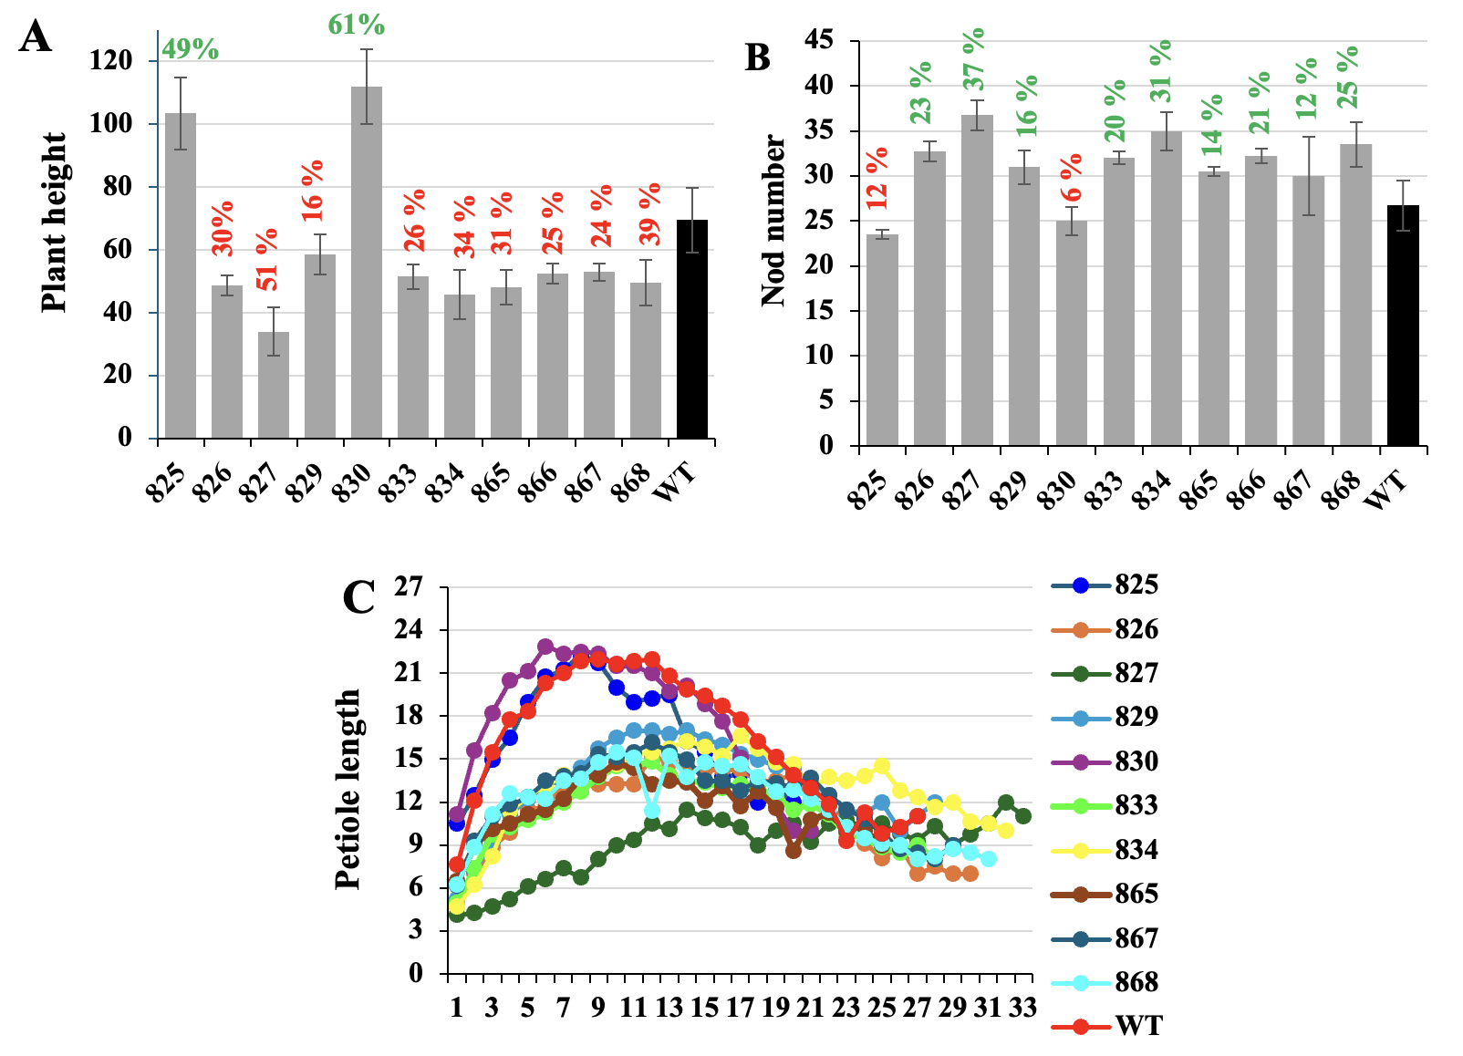
Fig. 6_ Summary of the preliminary characterization of second-batch transgenic lines carrying construct C2-93. (A) Plant height. (B) Nod number. (C) Petiole length from apical to basal

Importantly, our preliminary analysis revealed that C2-93 transgenic lines produced storage root on a similar of potentially even better level as the WT, despite the expression of the truncated DELLA protein also in storage roots. Considering these findings, we recommend transferring the semi-dwarf lines to field trials for further evaluation under natural growth conditions. Field-based studies will allow us to assess their performance in terms of yield stability, adaptability, and overall agronomic value.

In case of construct C2-92, only two lines (843 and 862) showed detectable albeit very low expression of AtGAI in petioles. This low expression is accompanied by wildtype-like phenotypes as shown in (Figure 7). Based on these results the lines will not be included in further analysis.

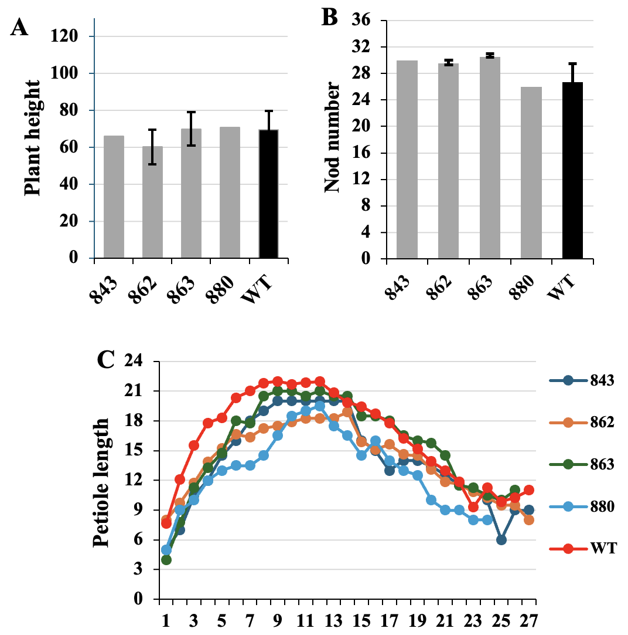
Fig. 7_ Summary of the preliminary characterization of second-batch transgenic lines carrying construct C2-92. (A) Plant height. (B) Nod number. (C) Petiole length from apical to basal.

In case of construct C2-113, expression of AtGA2ox1 was tested in leaves of second batch plants. Here, a very weak expression could be detected (Figure 8A). Results of the preliminary screening for C2-113 are shown in Figure 8B-D. Based on these results the lines will not be included in further analysis.

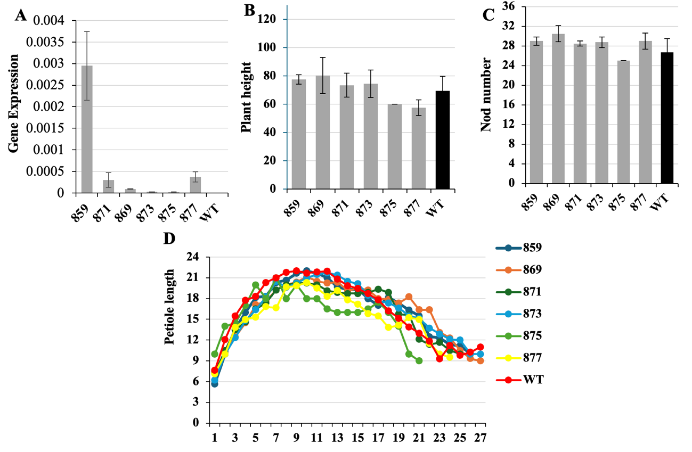
Fig. 8_ Summary of the preliminary characterization of second-batch transgenic lines carrying construct C2-113. A) Transgene expression in leaves. B) Plant height. C) Nod number. D) Petiole length from apical to basal.

As reported above, C2-93 revealed draft and semidwarf cassava plants as proposed. Plant height was reduced between 51-16% compared to wildtype plants. Under greenhouse conditions, this did not have negative effects on storage root bulking, or photosynthesis. Expression was not restricted to stem tissues, but is also found in storage roots. Whether this will have negative impacts on storage root development will be studied under field conditions as planned. More detailed characterization of the plant lines in the greenhouse will be done in parallel.

Q4 2025 – An updated summary of the results for C2-93 (pManes.17G027300::AtGAI_Δ17 CDS-6xHA-tHsp18.2)

Based on greenhouse testing of C2-92, C2-93, C2-94, C2-95, and C2-113 constructs, the C2-93 construct exhibited the best performance, as reported in the Q3 2025 CASS quarterly report. Consequently, subsequent research focused on C2-93 lines, and the findings for this construct are presented in this report. Different lines carrying the C2-93 construct were transferred to the greenhouse, and their growth parameters were measured (Table 5).

Table 5_Transgenic lines carrying the C2-93 construct transferred to the Greenhouse
Construct number | Gene cassette | Line number | Transferred date to the Greenhouse | Harvesting time
C2-93 | pManes.17G027300::AtGAI_Δ17 CDS-6xHA::tHsp18.2 | 825, 826, 827, 829, 830, 833, 834, 865, 866, 867, 868 | May 30, 2025 | - First harvesting: August 21, 2025 (measuring growth parameters and sampling for further analyses)  -Second harvesting: October 23, 2025  (measuring storage root fresh weight)
C2-93 | pManes.17G027300::AtGAI_Δ17 CDS-6xHA::tHsp18.2 | 824, 931, 932, 935, 938 | July 21, 2025 | November 6, 2025 (measuring growth parameters)

AtGAI_Δ17 overexpression in transgenic lines carrying the C2-93 construct was verified using petiole samplings by qPCR analysis. The updated results of qPCR for AtGAI_Δ17 in petiole transgenic lines carrying construct C2-93 are summarized in Fig. 9.
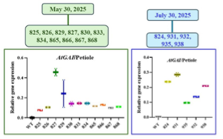

Fig. 9_ qPCR analysis of AtGAI_Δ17 expression in petiole samples from transgenic lines carrying constructs C2-93

Plant height in transgenic lines carrying the C2-93 construct varied considerably compared to the wild type. A marked reduction in height ranging from 16% to 51% was observed in lines 829, 867, 866, 833, 868, 932, 826, 865, 834, 938, 931, 935, 827, and 824, whereas lines 830 and 825 exhibited increased plant height compared to WT (Fig. 10A,D). Except for lines 825 and 830, which displayed a slender phenotype, node number increased, and petiole length was decreased for all lines with dwarf and semi-dwarf phenotypes (Fig. 10B-C).
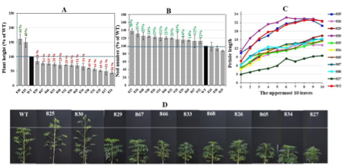

Fig. 10_Summary of growth parameters for transgenic lines carrying construct C2-93. (A) plant height, (B) nod number, (C) petiole length, and (D) images of select transgenic lines carrying the C2-93 construct

Our analysis of transgenic cassava plants carrying construct C2-93 demonstrated that storage root production was enhanced in plants with a semi-dwarf phenotype compared with control plants (Fig. 11). This improvement suggests that the semi-dwarf architecture may contribute to a more favourable allocation of assimilates toward root development. Considering these findings, we recommend transferring the transgenic lines (827, 833, 868, 867, 865, 834, 826, and 938) to field trials for further evaluation under natural growth conditions. Field-based studies will allow us to assess their performance in terms of yield stability, adaptability, and overall agronomic value. This construct may represent a promising candidate construct for future breeding programs and for improving cassava productivity.

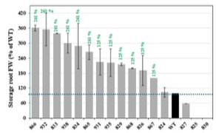
Fig. 11_ Changes in storage root fresh weight in transgenic lines carrying the C2-93 construct compared with WT

To determine whether the morphological alterations observed in lines carrying the C2-93 construct represent stable, heritable genetic changes introduced during transformation, growth parameters were assessed in plants regenerated from stem cuttings of lines 827, 826, 866, 868, 867, 865, 833, 834, 829, 825, and 830. Lines that had previously exhibited a dwarf or semi-dwarf phenotype maintained this phenotype in plants regenerated from stem cuttings (Fig. 12). A notable increase in fresh storage root weight was observed for lines 829 and 834. For the other lines exhibiting a dwarf/semi-dwarf phenotype, no significant increase in storage root fresh weight was detected compared to WT (Fig. 12D,E). It is worth noting that these plants were exposed to sudden and severe stress at two time points, including nighttime temperature drops and reduced humidity. We therefore hypothesize that, if these unexpected stress events had not occurred, storage root fresh weight in the other lines with dwarf/semi-dwarf phenotype might also have increased.

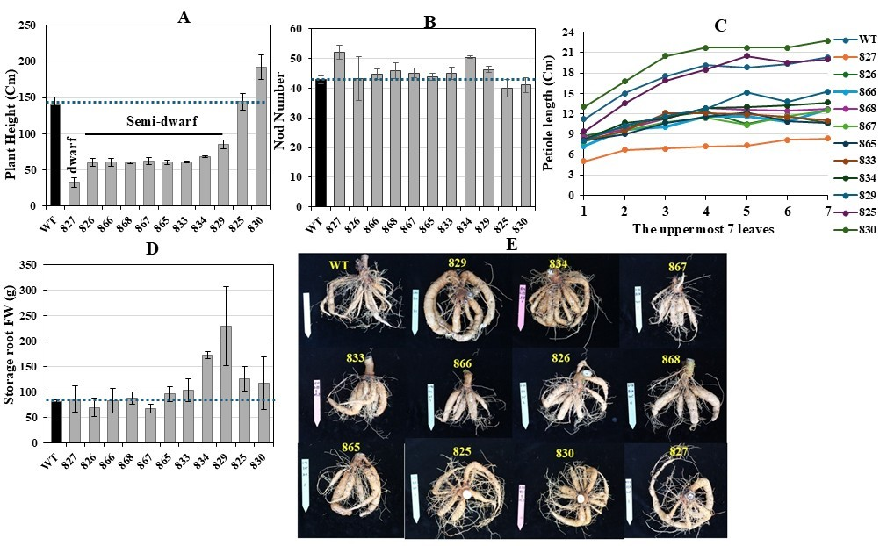
Fig. 12_Summary of growth parameters for transgenic lines carrying construct C2-93 generated from stem cuttings. (A) plant height, (B) nod number, (C) petiole length, (D) storage root fresh weight, and (E) images of storage roots. (09.09.025-07.01.2026)

Expression analysis of AtGAI_Δ17 and GA levels in stem tissues (phloem and xylem), and storage roots
Xylem and phloem tissues from internodes, as well as storage roots, were collected from 3-month-old transgenic plants exhibiting dwarf (827), semi-dwarf (834, 865), and slender (825, 830) phenotypes. These samples were used to evaluate tissue-specific expression patterns of AtGAI_Δ17, quantify GA levels, and perform RNA-seq analyses to investigate why expression of AtGAI_Δ17 under the control of the pManes.17G027300 promoter results in slender and dwarf phenotypes. In line 827, which exhibits a pronounced dwarf phenotype, AtGAI_Δ17 expression was markedly upregulated in both xylem and phloem tissues (Fig. 13A). Interestingly, this increase in DELLA transcripts was accompanied by strong accumulation of bioactive GAs (GA₁ and GA₄) and jasmonic acid (JA) in the same vascular tissues (Fig. 13B-F). At first glance, the coexistence of high DELLA expression and elevated GA levels may seem contradictory, given that GA typically promotes stem elongation. However, DELLA proteins act as repressors of GA signaling by inhibiting downstream growth responses. Thus, despite the accumulation of GAs, the high DELLA activity prevents effective GA signaling, resulting in the observed dwarf phenotype.

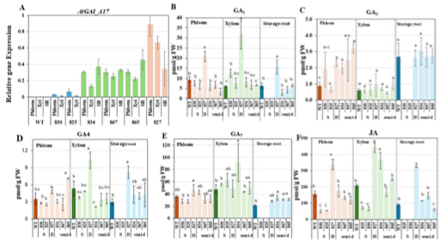
Fig. 13_Gene expression level of AtGAI_Δ17 (A), GA and JA levels (B-F) in xylem and phloem in lines carrying the C2-93 construct. S: slender; D: dwarf; semi-D: semi-dwarf

In lines exhibiting a semi-dwarf phenotype (834 and 867), a moderate increase in AtGAI_Δ17 expression was detected in the xylem and phloem relative to its expression in line 827 (Fig. 13A), while the pronounced elevation of GA1 and GA4 observed in the dwarf line was not detected in semi-dwarf lines (Fig. 13B-E). This suggests that the extent of AtGAI_Δ17 overexpression directly influences the strength of the feedback regulation on GA biosynthesis. In the semi-dwarf lines, the relatively lower DELLA accumulation may only partially repress GA signaling, leading to a weaker compensatory activation of GA biosynthetic pathways compared to the dwarf 827-line. Such dosage-dependent effects of DELLA expression on plant stature show that moderate DELLA accumulation leads to semi-dwarfism, while strong overexpression results in severe growth inhibition. Therefore, the phenotypic gradient from semi-dwarf to dwarf among the AtGAI_Δ17 transgenic lines likely reflects differential DELLA-mediated modulation of GA signaling and feedback regulation in vascular tissues. Interestingly, JA levels showed tissue- and phenotype-specific patterns. In dwarf 827-line, JA accumulated strongly in both xylem and phloem, whereas in the semi-dwarf lines, JA levels remained largely unchanged in the phloem but were elevated in the xylem of lines 834 and 865 (Fig. 13F).

In the lines with slender phenotype, stem elongation exceeded that of the wild type, despite very mild AtGAI_Δ17 overexpression in the xylem and phloem (Fig. 13A) and no corresponding increase in free bioactive GA levels (Fig. 13B-E). Moreover, the slender phenotype was characterized by a significant reduction in JA levels in both xylem and phloem (Fig. 13F). Given the well-established antagonism between JA and GA pathways, the decline in JA concentration likely alleviates JA-mediated repression of growth and further enhances GA sensitivity in these lines. Therefore, the combined effect of weak AtGAI_Δ17 overexpression, increased GA sensitivity, and reduced JA accumulation likely acts synergistically to promote the enhanced stem elongation observed in the slender transgenic plants. Overexpression of AtGAI_Δ17 was detected in the storage roots of both dwarf and semi-dwarf transgenic lines (Fig. 13A). This enhanced DELLA accumulation coincided with increased GA₇ levels in both dwarf and semi-dwarf plants (Fig. 13D), while bioactive GA₁ and GA₄ concentrations were significantly elevated only in the dwarf line (Fig. 13B,C). Interestingly, storage root fresh weight was greater in the semi-dwarf lines than in the wild type (Fig. 11).

RNA-seq-based identification and comparative profiling of DELLA-regulated genes in dwarf, semidwarf, and slender genotypes
Given the clear phenotypic distinctions in AtGAI-Δ17 transgenic plants, the transcriptomes of xylem, phloem, and storage root tissues from dwarf (827), semi-dwarf (834 and 865), and slender (825 and 830) lines were analyzed by RNA-seq to identify DELLA-regulated genes and uncover tissue- and genotype-specific transcriptional responses. A comparative analysis of differentially expressed genes (DEGs) across phloem, xylem, and storage roots in dwarf, semi-dwarf, and slender genotypes revealed distinct, phenotype-specific responses. Notably, the dwarf-phenotype 827 line exhibited the highest number of DEGs in each tissue, with 1,873 in phloem, 1,871 in xylem, and 930 in storage root (Fig. 14A).

Among the DELLA-regulated genes identified in the dwarf 827-line, one GA receptor-encoding gene (Manes.05G070500/GID1B) and four genes associated with GA biosynthesis, (Manes.18G084300/GA20ox2, Manes.06G141200/GA20ox1, Manes.16G067700/GA3ox1, and Manes.11G050500/GA3ox1) were identified in phloem tissue. In the xylem tissue of the dwarf 827-line, three GA receptor-encoding genes (Manes.05G070500/GID1B, Manes.01G212300/GID1B, and Manes.09G161600/GID1C) and one GA biosynthesis gene (Manes.18G084300/GA20ox2) were upregulated. Notably, Manes.05G070500/GID1B and Manes.01G212300/GID1B are homologous to the Arabidopsis GA receptor gene At3g63010/AtGID1B, which was previously reported to be upregulated in RGA-Δ17 mutant Arabidopsis plants (Zentella et al. 2007). Likewise, Manes.16G067700/GA3ox1 and Manes.11G050500/GA3ox1 share homology with At1g15550/GA3ox1, and Manes.18G084300/GA20ox2 is homologous to At5g51810/GA20ox2, all of which were also reported to be upregulated in the RGA-Δ17 transcriptome dataset (Fig. 14B). This finding suggests that DELLA stabilization may trigger transcriptional feedback on GA perception and biosynthesis machinery in cassava, similar to what has been observed in Arabidopsis (Zentella et al. 2007). Importantly, no upregulation of GID1 genes was detected in cassava lines exhibiting semi-dwarf (834, 865) or slender (825, 830) phenotypes, indicating that this response is specific to the strongly dwarf genotype. Such genotype-specific activation of genes related to GID1, GA20ox, and GA3ox implies that elevated expression of these genes may require a threshold level of DELLA activity or DELLA stability, and, therefore, could represent a compensatory mechanism to enhance GA sensitivity under severe DELLA repression. This interpretation is consistent with the hypothesis that overexpression of AtGAI-Δ17 in the dwarf 827-line triggers a stronger DELLA signaling output that promotes transcriptional activation of GID1 genes. A significant upregulation was observed for genes linked to GA biosynthesis (GA 20OX and GA 3OX) in storage roots of dwarf line-827. Transcript level of Manes.18G084300/GA 20OX2, Manes.06G141200/GA 20OX1, Manes.16G067700/GA 3OX1 and Manes.11G050500/GA 3OX1 increased in storage roots of dwarf plants (Fig. 14B). DELLA-imposed repression of growth is often associated with DELLA interactions with specific TFs, resulting in the sequestration of these transcription regulators away from their target promoters. GRFs (GROWTH-REGULATING FACTORS), as DELLA-regulated TFs, are transcriptional activators with a role in growth control. The transcript abundance of six GRF-encoding genes in the phloem (Manes.01G041800/GRF7, Manes.03G039500/GRF5, Manes.05G043700/GRF9, Manes.08G022300/GRF3, Manes.09G058720/GRF3, Manes.18G049600/GRF1), and two in the xylem (Manes.09G058720/GRF3, Manes.18G049600/GRF1) of the dwarf line 827, was increased (Fig. 14B).

Collectively, these results demonstrate that strong DELLA stabilization in the dwarf cassava line-827 induces a coordinated, tissue-specific transcriptional response affecting GA perception, GA biosynthesis, and downstream growth-related transcription factors. The genotype-specific upregulation of GID1 genes together with GA20ox and GA3ox biosynthetic genes in phloem, xylem, and storage roots suggests the activation of a conserved transcriptional feedback mechanism aimed at compensating for severe DELLA-mediated growth repression. The absence of this response in semi-dwarf and slender lines indicates that a threshold level of DELLA activity or stability is required to trigger this feedback regulation. Furthermore, the increased expression of multiple GRF transcription factors, known DELLA-regulated growth activators, suggests that DELLA signaling in the dwarf 827-line not only represses growth but also reshapes the transcriptional landscape to partially counterbalance growth inhibition. Together, these findings support a model in which overexpression of AtGAI-Δ17 generates a strong DELLA signaling output that activates GA-related biosynthetic and perception pathways, as well as growth-promoting transcription factors, in an attempt to restore GA sensitivity under conditions of severe DELLA repression.

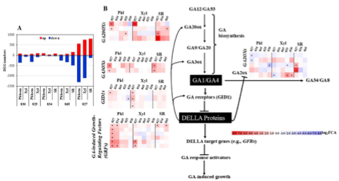
Fig. 14_(A) Differentially expressed genes (DEGs) in lines 827, 834, 865, 825, and 830 across phloem, xylem, and storage root tissues. Genes were considered significantly upregulated (log₂ fold change ≥ 1, P ≤ 0.05) or downregulated (log₂ fold change ≤ −1, P ≤ 0.05), (B) Changes in the expression of genes related to GA20ox, GA3ox, GA2ox, GID1, and GRFs in lines 827, 834, 865, 825, and 830 across phloem, xylem, and storage root tissues.

Update Q1 – 2026
Based on greenhouse testing of C2-92, C2-93, C2-94, C2-95, and C2-113 constructs, the C2-93 construct exhibited the best performance, as reported in the Q3-2025 CASS report. Consequently, subsequent research focused on C2-93 lines, and the findings for this construct are presented in this report.

Updated findings from RNA-seq data of DELLA-regulated genes in dwarf, semi-dwarf, and slender genotypes
Expression analysis of AtGAI-Δ17 and endogenous MeGAI in different cassava tissues
AtGAI-Δ17 transcript levels varied considerably among the transgenic C2-93 lines. In the phloem and xylem tissues, line 827 exhibited the highest expression level, whereas lines 825 and 830 showed very low expression. Moderate expression levels were observed in lines 865 and 834 (Figure 1). In the storage root, similar overexpression of AtGAI-Δ17 was observed in lines 827, 834, and 865. As expected, no AtGAI-Δ17 expression was detected in WT plants (Figure 1A). The observed variation in AtGAI-Δ17 overexpression among C2-93 lines was accompanied by changes in the transcript levels of the endogenous MeGAI gene (Figure 1B). In lines 825 and 830, which displayed a slender phenotype, MeGAI transcript levels increased significantly in xylem and phloem. It may reflect a feedback response to enhanced GA signalling activity, ultimately contributing to the slender growth phenotype in these lines. In contrast, line 827, which exhibited a dwarf phenotype, showed a significant decrease in MeGAI transcript levels in the xylem, likely in response to increased levels of bioactive GA and DELLA accumulation observed in this line (Figure 1A). Therefore, elevated AtGAI-Δ17 transcript levels may trigger feedback regulation within the GA signalling pathway, altering endogenous MeGAI transcript levels. Similarly, lines 834 and 865, which displayed a semi-dwarf phenotype, showed a reduction (but non-significant) in MeGAI expression in response to the increased levels of accumulation DELLA and bioactive GAs (Figure 1B).

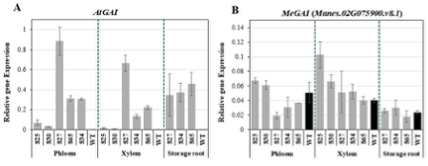
Figure 1. Relative expression of (A) AtGAI and endogenous (B) MeGAI in phloem, xylem, and storage root tissues of transgenic cassava lines carrying AtGAI-Δ17

qPCR Validation of Upregulated Genes Associated with GA Biosynthesis, GA Receptors, and GRF Transcription Factors Identified by RNA-seq Following AtGAI-Δ17 Overexpression

RNA-seq data showed that among the DELLA-regulated genes identified in the dwarf 827-line, one GA receptor-encoding gene (Manes.05G070500/GID1B) and four genes associated with GA biosynthesis (Manes.18G084300/GA20ox2, Manes.06G141200/GA20ox1, Manes.16G067700/GA3ox1, and Manes.11G050500/GA3ox1) were identified in phloem tissue. In the xylem tissue of the dwarf 827-line, three GA receptor-encoding genes (Manes.05G070500/GID1B, Manes.01G212300/GID1B, and Manes.09G161600/GID1C) and one GA biosynthesis gene (Manes.18G084300/GA20ox2) were upregulated. However, RNA-seq data did not reveal significant upregulation of GID1-, GA20OX-, and GA3OX-related genes in the phloem, xylem, or storage roots of lines 834 and 865, which exhibited a semi-dwarf phenotype. The expression of GA20OX1 (Manes.06G141200.v8.1), GA20OX2 (Manes.18G084300.v8.1), GID1B (Manes.05G070500.v8.1), GA3OX1 (Manes.11G050500.v8.1), and ent-kaurene synthase (Manes.16G065800.v8.1 and Manes.16G067901.v8.1) was subsequently examined by qPCR (Figure 2). qPCR results indicated that nearly all of these genes were significantly upregulated in the xylem, phloem, and storage roots of lines 827, 865, and 834, which exhibited dwarf and semi-dwarf phenotypes (Figure 2). In accordance with these data, increased levels of GAs were detected for xylem and/or phloem of 827 (GA₁, GA_{3,} and GA₄), 834 (GA₃), and 865 (GA₃ and GA₄) lines (Included in the Q4-2025 CASS report). Higher expression levels of GID1B, GA3OX, and GA20OX1 were detected for storage roots of 827, 865, and 834 lines. Consistent with these data, increased levels of GA7 were observed in the storage roots of 827, 865, and 834 (Included in the Q4-2025 CASS report). These findings suggest activation of feedback mechanisms in GA biosynthesis (upstream GA signalling pathway) due to the stabilization of DELLA proteins in the xylem, phloem, and storage roots. Despite elevated GA levels, shoot elongation remains inhibited because the AtGAI-Δ17 mutant protein cannot be degraded in response to GA. In contrast, RNA-seq and qPCR analyses revealed no detectable changes in the transcript levels of genes associated with GA biosynthesis or GA receptor signalling in the tissues of line 830, which exhibits a stable and heritable slender phenotype (Figure 2), suggesting that the slender growth arises from complex regulatory interactions within the GA signalling pathway rather than from changes in GA levels themselves. Therefore, DELLA stabilization may trigger transcriptional feedback on the upstream of the GA signalling pathway (GA perception and biosynthesis machinery) in cassava carrying AtGIA-Δ17, similar to what has been observed in Arabidopsis (Zentella et al. 2007).
The accumulation of DELLA proteins in transgenic plants carrying AtGIA-Δ17 appears to enhance interaction between DELLA and JAZ1, a key repressor of the JA signalling pathway. This interaction likely activates JA biosynthesis by promoting MYC2 release, thereby enabling the transcription of JA-responsive genes. In agreement with this mechanism, elevated JA levels were observed in these transgenic lines (Included in the Q4-2025 CASS report). Interestingly, a reduction in MeMYC2/Manes.02G002400.v8.1 transcript levels was also detected, which may represent a negative feedback response to increased JA accumulation. Such feedback regulation is consistent with the fine-tuning of JA signalling observed in other systems. Moreover, JAZ-DELLA interaction may partially sequester DELLA repressors, thereby relieving their inhibitory effect on the DELLA–PIF3 module (Yang et al. 2012). This could facilitate PIF3 binding to the promoter of GA-responsive genes to active growth program.
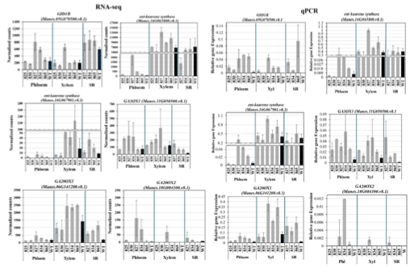
Figure 2. Expression analysis of GID1, ent-kaurene synthase, GA3OX1, GA20OX1, and GA20OX2 genes in phloem, xylem, and storage root tissues of transgenic cassava lines carrying AtGAI-Δ17 by RNA-seq and qPCR

DELLA-imposed repression of growth is often associated with DELLA interactions with specific TFs, resulting in the sequestration of these transcription regulators away from their target promoters (Lu et al. 2022). GRFs (GROWTH-REGULATING FACTORS), as GA-regulated TFs, are transcriptional activators with a role in growth control (Liu et al. 2023). RNA-seq data showed that the transcript abundance of six GRF-encoding genes in the phloem (Manes.01G041800/GRF7, Manes.03G039500/GRF5, Manes.05G043700/GRF9, Manes.08G022300/GRF3, Manes.09G058720/GRF3, Manes.18G049600/GRF1), and two in the xylem (Manes.09G058720/GRF3, Manes.18G049600/GRF1) of the dwarf line 827, was increased. qPCR confirmed upregulation of GRF6 and GRF9 for lines 827, 834, and 865 (Figure 3). The upregulation of GRFs in stem and storage root tissues was accompanied by increased GA levels, particularly in line 827. This enhanced expression of GRFs is likely part of a GA-responsive mechanism that attenuates DELLA-mediated growth inhibition in transgenic plants with a dwarf phenotype. However, the growth-promoting effects of GRFs appear to be constrained by impaired DELLA-mediated GA signaling in the dwarf line. Consequently, in transgenic cassava lines expressing AtGAI-Δ17, the upregulation of GRFs likely represents a compensatory response to DELLA-mediated growth repression and may be considered part of the GA signalling feedback network. In agreement with these findings, Tang et al. (2018) found that OsGRF6 regulates plant architecture by modulating GA signalling and biosynthesis.

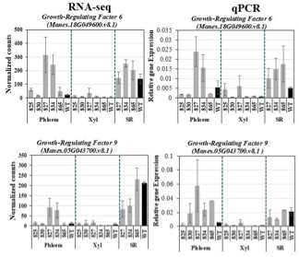

Figure 3. Expression analysis of GRF6 and GRF9 in phloem, xylem, and storage root tissues of transgenic cassava lines carrying AtGAI-Δ17 by RNA-seq and qPCR

DELLA proteins, in addition to serving as key negative regulators of gibberellin signalling, also promote the expression of positive regulators such as GA20-oxidase, the GA receptor, and the transcription factor SCARECROW-LIKE3 (SCL3), thereby contributing to GA feedback regulation. Since DELLAs lack a DNA-binding domain, they depend on interacting transcription factors, particularly INDETERMINATE DOMAIN (IDD) proteins, which act as transcriptional scaffolds to mediate their regulatory activity (Yoshida and Ueguchi-Tanaka 2014; Yoshida et al. 2014). Therefore, the balance between DELLA and SCL3 proteins, both members of the GRAS family, regulates downstream gene expression through IDD-mediated DNA binding. RNA-seq data showed increased transcript levels of MeSCL3 genes in cassava plants expressing AtGAI-Δ17, particularly in the strongly dwarf line 827 (Figure 4). DELLA proteins interact with IDD transcription factors to promote SCL3 expression, which in turn attenuates DELLA activity, forming a negative feedback loop within the GA signalling pathway. Consistent with this regulatory mechanism, RNA-seq data revealed strong upregulation of four IDD5 genes and one SCL3 gene, particularly in the storage root, suggesting activation of the IDD–SCL3 module in this tissue. Therefore, the accumulation of DELLA proteins in cassava plants carrying AtGAI-Δ17 also initiated a secondary layer of feedback regulation through activation of the IDD–SCL3 module.
Taken together, the upregulation of genes associated with GA biosynthesis (e.g., GA20ox), GA perception (e.g., GA receptors), and downstream regulatory components such as SCL3 suggests that these plants attempt to enhance GA signalling in response to constitutive DELLA accumulation. This coordinated transcriptional response likely reflects a feedback-driven effort to restore hormonal balance and mitigate the growth-inhibitory effects of DELLA proteins.

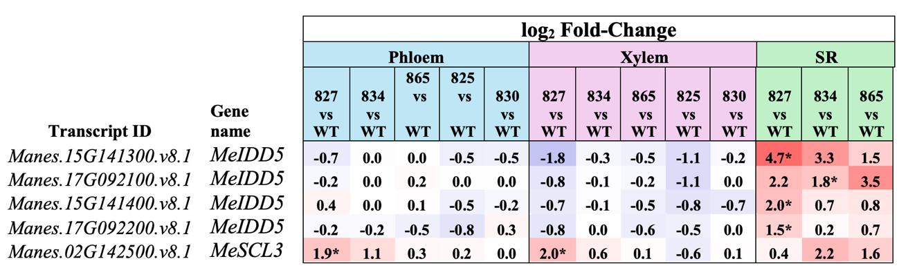
Figure 4. Expression analysis of INDETERMINATE DOMAIN5 (IDD5) and SCARECROW-LIKE3 (SCL3) in phloem, xylem, and storage root tissues of transgenic cassava lines carrying AtGAI-Δ17 by RNA-seq

Hormonal regulation of storage root development in C2-93 carrying GAI-Δ17
Auxin plays a central role in cambium development (Smetana et al. 2019), and mutations in components of its signalling pathway, including those involved in hormone perception and polar transport, result in defects in cambial activity, vascular patterning, and xylem and phloem formation in planta and during vascular regeneration (Brackmann et al. 2018). GA has been shown to promote secondary xylem formation in both Arabidopsis (Ragni et al. 2011) and poplar (Mauriat and Moritz 2009). In Arabidopsis roots, GA promotes the preferential differentiation of stem cell daughters into xylem cells and, in extreme cases, can even induce the respecification of stem cells from a phloem to a xylem identity (Mäkilä et al. 2023). In addition, in Arabidopsis roots, the interaction between GA and auxin has been shown to play a crucial role in cambial activity and the promotion of secondary xylem formation, highlighting the importance of hormonal crosstalk in vascular development (Mäkilä et al. 2023).
The positioning of an auxin signalling maximum within the cambium plays a critical role in determining the fate of stem cell daughters. This spatial pattern is regulated by gibberellin-dependent, PIN1-mediated polar auxin transport, whereby gibberellin treatment expands the auxin maximum from the xylem side toward the phloem. The observed upregulation of auxin-responsive genes, including ARF2, SAUR family members, and GH3-related genes, in the storage roots of transgenic cassava plants (Figure 5A) suggests activation of auxin signalling pathways alongside GA-related responses. Consistent with this, hormone quantification revealed elevated auxin (Figure 5B) and GA levels (Included in the Q4-2025 CASS report) in the storage roots of transgenic plants.

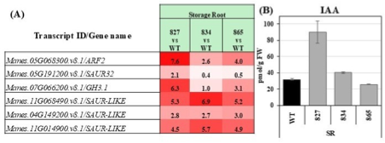
Figure 5. Expression analysis of auxin-related genes (A) and auxin level (B) in the storage root tissues of transgenic cassava lines carrying AtGAI-Δ17 by RNA-seq

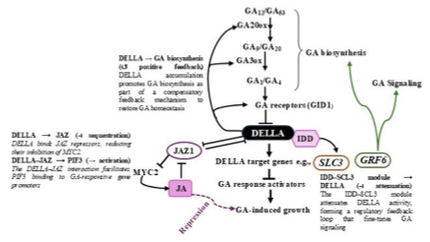

Proposed model of GA–DELLA signalling in cassava lines carrying AtGAI-Δ17: DELLA proteins exert dual regulatory roles in GA signalling by modulating both upstream and downstream components. On the one hand, DELLA accumulation promotes GA biosynthesis and potentially GA perception as part of a compensatory feedback mechanism. Simultaneously, DELLA activates the IDD–SCL3 module and DELLA-JAZ interaction, which act to attenuate DELLA activity.
New Greenhouse Experiment for In-Depth Analysis of C2-92 and C2-93 Lines

A new greenhouse experiment was initiated on January 28, 2026, including:
- C2-93 lines: 826, 827, 833, 834, 865, 867, 868, and 938 (nominated for field trials); as well as 829, 932, and 934, along with vector control (VC) lines (887, 888, 889, and 890) and wild type (WT)
- C2-92 lines: 836, 880, and 883 (nominated for field trials) as well as 846 and 862, together with VC lines (956 and 953) and WT.

Plant height measurements were initiated on March 6, 2026, and conducted weekly thereafter. Photosynthetic parameters were assessed in seven-week-old plants of the C2-93 lines. Both Vmax and Jmax were increased in the C2-93 lines (Figure 6). In addition, leaf samples were collected at 6:00 AM, 2:00 PM, and 10:00 PM for the determination of soluble sugars and starch content. Photosynthetic measurements will be repeated in 12-week-old plants, and leaf samples will again be collected at 6:00 AM, 2:00 PM, and 10:00 PM for the determination of soluble sugars.
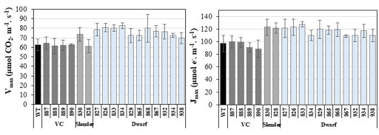
Figure 6 Assessment of photosynthetic parameters (V_{max} and J_{max}) in seven-week-old C2-93 lines expressing AtGAI-Δ17
Due to the increase in greenhouse photosynthesis, 3 transgenic lines were selected for photosynthetic characterization during the CFT 2026 Taichung field experiments.

Challenges and Mitigations: No unforeseen challenges have been encountered. First results from chosen promoters for implementation of GA2ox and GAI might not result in optimal expression. Further attempts might be necessary. However, evaluation of C2-92, C2-93, C2-94, C2-95, and C-113 will result in more clarity.

A first set of transgenic lines for all constructs has been transferred to the greenhouse and tested for transgene expression. This analysis revealed that transcripts of GA2ox1 are not detectable in stem tissues of C2-94 and C2-95 lines, and only to a very low amount in leaves of transgenic plants carrying the strong AtCAB1 promoter. Therefore, constructs C2-94 and C2-95 have been terminated. A possible reason for the low level of detectable AtGA2ox1 transcripts is the use of a cDNA clone lacking intron sequences. In earlier studies, the use of a genomic AtGA2ox1 sequence enabled high expression in tobacco and potato plants. The genomic DNA contains two introns which enabled high expression levels of AtGA2ox. Using an intron-less pea GA2ox cDNA also failed to express to reasonable RNA levels in earlier studies. Therefore, we suggest to design new AtGA2ox1 constructs using the previously successful genomic fragment from Arabidopsis. As promoters, we suggest to use three different ones: (1) SlRBCS2 for strong leaf-specific expression, (2) MeKS1 (Manes.16G065800) for stem-specific expression and (3) 35S for constitutive expression.

Expression of AtGAI_Δ17 revealed very unexpected results. While it seems that the reduced petiole length is in agreement with AtGAI_Δ17 expression, the observed slender phenotype of several transgenic lines was not expected. This opens the question why expression of AtGAI_Δ17 leads to increased shoot growth. One possible explanation is based on the cell-specific expression of the dominant repressor protein. As summarized in Zentella et al., 2007 (https://doi.org/10.1105/tpc.107.0549999), DELLA proteins not only down-regulated GA-responsive genes, but also upregulate GA biosynthetic and GA receptor genes. In wildtype plants this feedback regulation is thought to control GA homeostasis. In transgenic plants showing cell-specifc expression of AtGAI_Δ17, GA biosynthesis could be stimulated in transgene expressing cells. However, in these cells, the DELLA mutation would abolish GA-activation of gene expression. Since GA is a mobile phytohormone, newly produced GA could move cell-to-cell and reach neighboring cells not expressing AtGAI_Δ17. In these cells, GA would activate gene expression which could lead to the observed slender phenotype. The current working hypothesis is summarized in Figure 5. Whether this working hypothesis is true will be tested in selected transgenic lines.

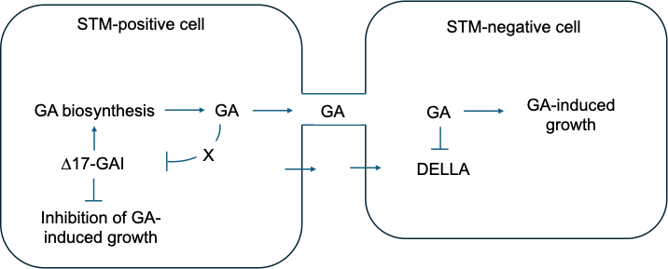
Fig.5_Working hypothesis for observed shoot elongation in AtGAI_Δ17 transgeneic plants.

If true, cell-specific expression of AtGAI_Δ17 might be problematic. To further elucidate the usability of the DELLA concept, we suggest to design two new constructs carrying the AtGAI_Δ17 gene under control of the SlRBCS2 and MeKS1 promoter, respectively. Alternatively, genome editing approaches could be followed.
In summary, we suggest five new constructs to further elucidate the effect of AtGA2ox1 and AtGAI_ Δ17 transgene expression. The planned constructs are summarized in Table 5.

Despite the more promising results for the second batch of C2-93, we are still constructing several new constructs to better implement the AtGAI_Δ17, and especially the AtGA2ox1 approach (Table 6). Cloning and quality control (whole plasmid sequencing) of all constructs has now been finished and transformation will be inititated soon.

Based on the latest results for C2-93, the construct might be quite viable for researching the GA/DELLA concept and its potential for yield improvement. Most lines of C2-93 seem to produce a (semi-)dwarf phenotype and the few slender lines don´t represent a problem. Even if the tissue specific expression and GA mobility turns out to be problemeatic, other constructs with different expression patterns are already in transformation.

Table 6_Planned gene constructs currently under construction
Construct number | Gene cassette | Database link | Current status
C2-142 | pMeKS1::GUS + pMeKS1::AtGAI_Δ17 CDS-6xHA::tHsp18.2 | https://cassbase.org/stock/475425/view | Transformed Nov 25 / Emerging shoots
C2-136 | pSlRBCS2::GUS + pSlRBCS2:: AtGAI_Δ17 CDS-6xHA::tHsp18.2 | https://cassbase.org/stock/475422/view | Transformed Jan 26
C2-141 | pMeKS1::GUS + pMeKS1::AtGA2ox1 genomic-tHsp18.2 | https://cassbase.org/stock/475424/view | Transformed Nov 25 / Emerging shoots
C2-134 | pSlRBCS2::GUS + pSlRBCS2::AtGA2ox1 genomic-tHsp18.2 | https://cassbase.org/stock/471877/view | Transformed Jan 26
C2-137 | pCaMV35S::GUS + pCaMV35S::AtGA2ox1 genomic-tHsp18.2 | https://cassbase.org/stock/475423/view | Transformed Nov 25 / Emerging shoots

Q1 2026 Update
No challenges, Greenhouse characterization proceeding as planned, Field trial proceeding as planned

Next Steps in the Action Plan:
- Plants regenerated on selection medium will be tested for the presence of the transgenes (PCR). (Concluded)
- Transgenic events now exiting the transformation pipeline will be multiplied and transferred to the greenhouse as soon as possible. Primary characterization (especially phenotyping and expression screening) can commence once the lines have established in the greenhouse. (Concluded)
- Analyze greenhouse-grown plants for phenotyptic differences and transgene expression (Concluded)
- Continue expression screening of C2-113, C2-92, and C2-93 (Concluded)
- Perform more detailed analyses with select plant lines using sufficient replications (Concluded)
- Cloning of new transformation constructs outlined in Table 6 (Concluded)
- Physiological, biochemical and molecular characterization of C2-93 lines will be continued in the greenhouse to understand why expression of AtGAI under control of the pManes.17G027300 promoter results in slender and dwarf phenotypes. (Concluded
- The third batch of transgenic lines will be screened in the greenhouse to potentially nominate additional lines (Concluded)
- Nominate lines for CFTs (Concluded)

Organize field sampling for CFT 2026 and evaluate field data (Ongoing)

Detailed greenhouse characterization of these lines will continue parallel to field trials (Ongoing)

Southern blot for lines C2-93 in the greenhouse (Ongoing)

Measuring photosynthesis for 12-week-old-C2-92 and C2-93 (Ongoing)

Measuring sugars and starch for C2-92 and C2-93 lines (Ongoing)

C2-93 and C2-92 lines are expected to be harvested in late May or June 2026, at which time phenotypic parameters (plant height, node number, petiole length, green biomass weight, and storage root fresh and dry weight) will be measured, and samples will be collected from leaves, petioles, various stem sections, fibrous roots, and storage roots for subsequent detailed analyses (Ongoing)

EM1.2_Limiting lateral transport losses through active phloem (re-)loading
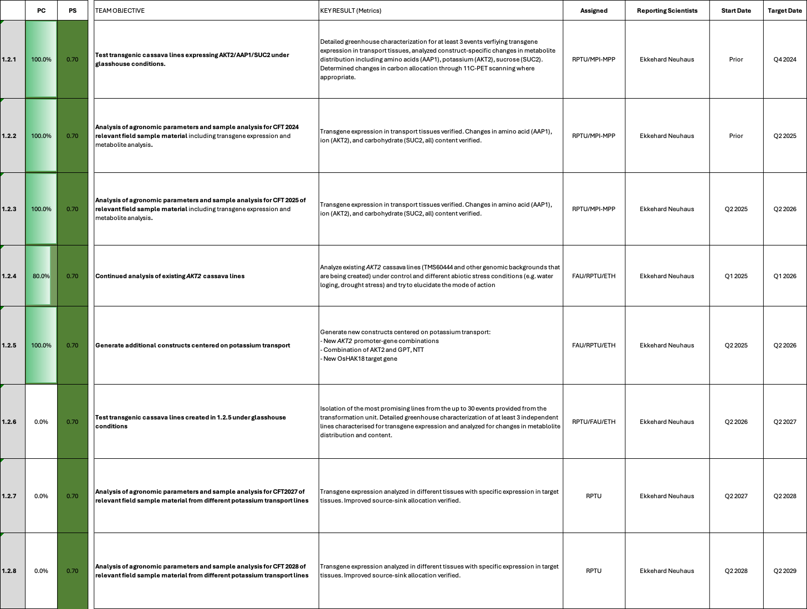

EM1.2_Limiting lateral transport losses through active phloem (re-)loading

Reporting module leader: Ekkehardt Neuhaus, RPTU with MPI-MPP.

Progress Update:
1.2.1. Test transgenic cassava lines expressing AKT2/AAP1/SUC2 under glasshouse conditions &
1.2.2. Analysis of agronomic parameters and sample analysis for CFT 2024 relevant field sample material including transgene expression and metabolite analysis.
AKT2 project (RPTU): Cultivation of AKT2 cassava plants alongside appropriate controls has already been carried out five times under greenhouse conditions. In addition, two further drought stress experiments (with positive outcome) have already been carried out for the ongoing patent application. The processing of the samples will continue until the beginning of December. In collaboration with Ralf Metzner and Robert Koller (FZJ), initial investigations using ¹¹C-PET scan analyses of phloem flow velocity were successfully carried out (T5.1.2).
Several additional control and drought stress treatments were analyzed in detail for the preparation of the “AKT2_{var}” manuscript. The analysis included measurements of sugar and starch content, ion concentrations (both cations and anions), and amino acid composition in various segments of the plant. These assessments aimed to provide a comprehensive understanding of the biochemical changes occurring under drought stress conditions. The manuscript is currently being prepared for circulation among the authors and GatesAgOne.
The analysis of the drought treatment conducted in Q4 2024 has been finalized and was used in the preparation of the AKT2_{var} manuscript, which is currently undergoing further revision.
The AKT2_{var} manuscript was submitted to Nature Plants and is currently in review. The principle characterization of AKT2_{var} cassava lines is fully concluded.
Four reviewers have assessed the AKT2_{var} manuscript and given overall very positive feedback. The reviewer feedback was addressed and the manuscript resubmitted to Nature Plants.
This project has concluded. All relevant materials have been analyzed. AKT2_{var} was concluded to increase cassava yield, particularly under drought conditions. The corresponding manuscript was published in Nature plants on December 17, 2025 (https://www.nature.com/articles/s41477-025-02159-7).

1.2.3 Analysis of agronomic parameters and sample analysis for CFT 2025 of relevant field sample material including transgene expression and metabolite analysis.
In a joint effort from RPTU and FAU, we are currently analyzing control and C56 (PsGPT2+AtNTT1) samples from WF1 and WF2 from the CFT 2025 growing season. Previous material from the CFT 2023 and CFT2024 displayed increases in starch concentration. The results for CFT 2025 will reveal if these findings are consistent between the years. A first set of samples has been processed at FAU (grinding & freeze drying) and was shipped to RPTU. A second set is currently being finalized for shipment to RPTU. The samples will primarily be measured for transgene expression (FAU) & carbohydrate contents (RPTU). We expect to conclude the measurements by Q2 2026.
Update Q1 2026
CFT 2025 data were analyzed to determine carbohydrate content in storage root tissue at RPTU. Results will be incorporated into an upcoming manuscript summarizing findings on GPT/NTT constructs.

1.2.4 Continued analysis of existing AKT2_{var} cassava lines (& perform additional Arabidopsis experiments)
A new drought stress treatment has been initiated under greenhouse conditions to assess the photosynthetic performance of AKT2_{var} and empty vector controls during drought stress and controlled conditions.
Additional drought stress experiments have now been conducted, and data analysis is currently ongoing, with final results expected within the next two weeks. This includes measurements of sugar content, ion concentrations, and transcriptional changes assessed via qRT-PCR. In parallel, preparations for RNA-Seq analysis under drought conditions are underway, and initial RNA quality checks have been completed. Following the receipt of price quotations, samples will be sent to Novogene for sequencing. The objective is to gain deeper insights into the drought stress response in cassava and to compare the performance of vector control and AKT2_{var} lines. Additional photosynthesis data was collected during the drought treatment but revealed only minor alterations in AKT2_{var} lines. This observation is consistent with previous field results, suggesting that changes in photosynthesis can be a consequence but are not a driver of the AKT2_{var} phenotype.
Price quotations have been finalized, and RNA samples have been shipped to Novogene. Subsequent bioinformatic analyses will be conducted in cooperation with FAU Erlangen. We aim to increase our understanding of the AKT2var mechanism and the principle drought stress response in cassava. New learnings in these areas have potential impact on engineering strategies.
The AKT2_{var} control vs. drought RNA-Seq dataset has been established and is currently being evaluated. Preliminary results indicate changes in cell wall formation and remodelling, vascular development, water and ion homeostasis, amon other things. However, more time is needed to complete the analysis properly. Additionally, we are performing various metabolite measurements on the materials.
Update Q1 2026
RNA-Seq data evaluation is ongoing. In addition, sugar contents, amino acid levels, and ion concentrations were quantified in different plant tissues, including leaf, stem, fibrous roots, and storage root tissue, from vector control and AKT2_{var} lines under both controlled and drought stress conditions. For additional experiments and further repetitions, new plants from sterile culture were ordered from FAU Erlangen; these were recently received, transferred to the growth chamber, and will be planted in Q2 2026. Evaluations of photosynthesis, gas exchange, and phloem exudate measurements are currently planned to determine mechanistic changes and to address the following question: How does cassava respond to drought in general, and how does this response differ between vector control and AKT2_{var} lines?
To strengthen the patent application, additional experiments were initiated in Arabidopsis thaliana as agreed between RPTU, FAU, and GatesAgOne (Bosola Oladeinde/Catherine Espinoza). The aim is to investigate whether AtAKT2 (which was introduced into cassava) from Arabidopsis and MeAKT2 from cassava (which will be introduced into Arabidopsis akt2 knockout mutants) play a role in the drought stress response or have comparable functions in both plants. While the AtAKT2 constructs currently go into screening, the constructs with the MeAKT2 are currently in cloning in various forms at FAU (Table 1) and will be introduced into Arabidopsis as soon as they are available. In addition, further AKT2 constructs for overexpression in cassava are currently beeing prepared (Table 2) to build upon the promising results obtained for the initial AtAKT2 construct.
Initial drought stress trials were conducted with the akt2 knockout mutant to verify the role of AKT2 in the drought stress response in Arabidopsis thaliana. However, the drought stress treatment needs futher optimization to produce a stronger effect. Constructs listed in Table 1 and the native AKT2 version were received by RPTU and the T₀ generation was successfully transformed. The first generation of transformed WT and akt2-ko mutants (T₁) has already been screened, and a second screening is now underway to identify homozygous lines in the T₂ generation for further experiments.

Table 1_Summary of the gene constructs being prepared for Arabidopsis akt2 mutant complementation experiments.
Construct number | Gene cassette | Database link
SIn#41 | pAtAKT2::MeAKT2a CDS_native::Ter + “FastRed” Marker + Kanamycine Marker | https://cassbase.org/stock/462635/view
SIn#42 | pAtAKT2::MeAKT2a CDS_S199N-S319N::Ter + “FastRed” Marker + Kanamycine Marker | https://cassbase.org/stock/462636/view
SIn#43 | pAtAKT2::MeAKT2b CDS_native::Ter + “FastRed” Marker + Kanamycine Marker | https://cassbase.org/stock/462637/view
SIn#44 | pAtAKT2::MeAKT2b CDS_S216N-S336N::Ter + “FastRed” Marker + Kanamycine Marker | https://cassbase.org/stock/462638/view

The complemented Arabidopsis lines are still being screened to ensure suffiecent number of seeds and to ensure homozygous lines for upcoming experiments.

While the MeAKT2a/b-based lines are still undergoing screening to identify homozygous individuals, the AtAKT2_{var} lines have progressed further and are currently being cultivated for drought stress experiments. Results from these experiments are expected in Q3 2025.

In an initial step, Arabidopsis thaliana GUS reporter lines carrying AKT2_{var} under the native AKT2 promoter were generated to visualize tissue-specific expression. GUS staining revealed that AKT2 is active in autotrophic tissues, with strong expression in the vascular tissues of leaves, particularly near the veins (Figure 1A–C). In addition, inflorescence formation and silique development demonstrated pronounced expression in young reproductive tissues (Figure 1D–F). Since the MeAKT2 constructs are driven by the same promoter, they are expected to follow a similar GUS expression profile. To further investigate, qRT-PCR analyses were performed to examine whether AKT2 expression changes under different environmental stress conditions or developmental stages. Wild-type plants were grown under controlled conditions for three weeks and subsequently exposed to abiotic stresses, including drought, high light (HL), heat (34 °C), cold (4 °C), or maintained under control conditions (Figure 1G). In an additional experiment, plants were subjected to prolonged drought stress. These assays revealed that AKT2 expression increased during inflorescence formation after five weeks, both under control and drought conditions, with expression levels further elevated under drought (Figure 1H). To dissect the functional role of AKT2 in Arabidopsis, knockout lines (akt2), overexpression lines (AKT2-Ox), and complementation lines in the akt2 background (COMP) were generated. Initial RT-PCR on genomic DNA confirmed successful transformation (Figure 1I). In overexpression lines, an additional strong band corresponding to the introduced AKT2_{var} was detected alongside the native AKT2. Verification by qRT-PCR demonstrated higher mRNA abundance in both overexpression and complementation lines compared to the akt2 knockout background (Figure 1J).
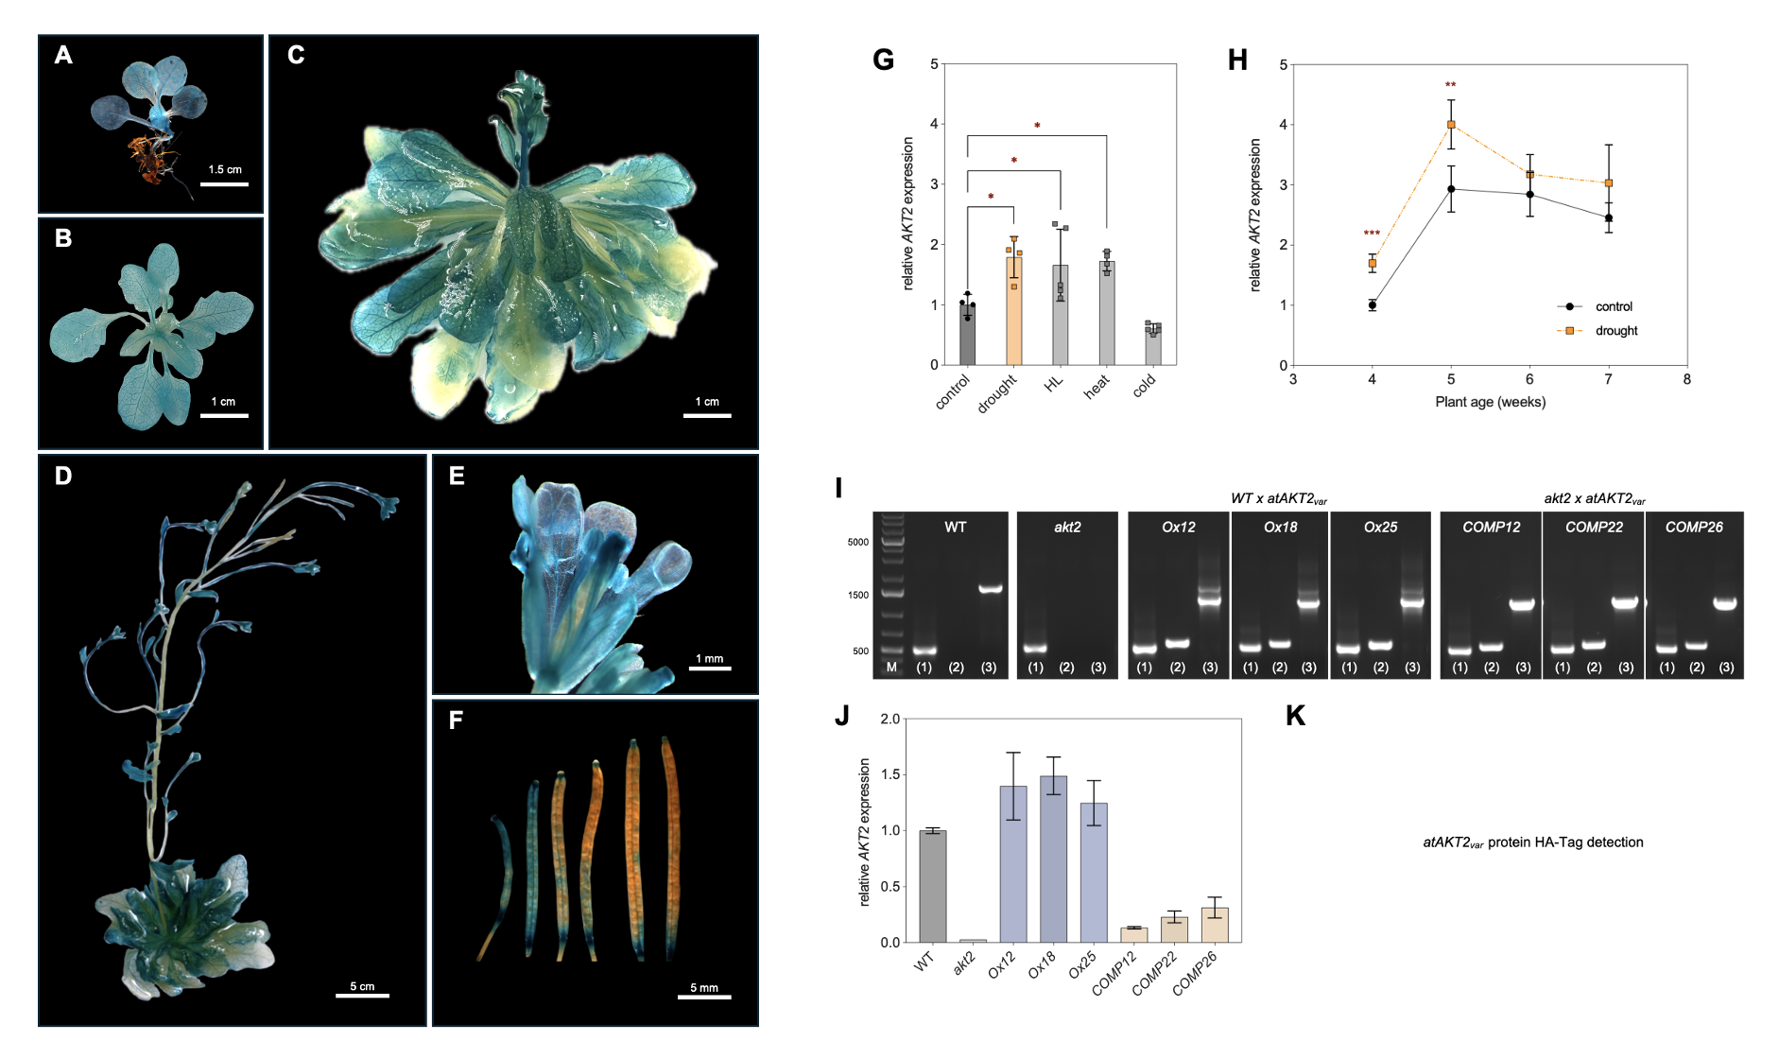
Fig. 1_ Role of AKT2_{var} in Arabidopsis thaliana. (A–F) GUS staining of AKT2_{var} expression under the native AKT2 promoter in (A) seedlings, (B) 4-week-old plants, (C) 6-week-old plants, and (D–F) 8-week-old plants, including (E) flowers and (F) siliques. (G) qRT-PCR analysis of AKT2 expression under drought, high light (HL), heat (34 °C), and cold (4 °C). (H) AKT2 expression during prolonged drought stress. (I) PCR on genomic DNA detecting (1) Ef1α, (2) hygromycin marker, and (3) AKT2 in wild type (WT), akt2 knockout, AKT2 overexpression (AKT2-Ox), and complementation lines (COMP). (J) qRT-PCR analysis of AKT2 transcript levels in the same genotypes.
(K) Western blot analysis of HA-tagged AKT2_{var} protein (ongoing).
Initial tests under controlled conditions showed enhanced rosette growth, resulting in increased fresh weight (Figure 2A), as well as improved root growth in overexpression and complementation lines (Figure 2B). Drought stress experiments were also initiated; however, due to time limitations, they are still ongoing and will be completed in Q4 2025. Preliminary observations suggest that the growth enhancement in AKT2_{var} lines persists—and may even increase—under drought conditions. These findings point to an important role of AKT2_{var} in Arabidopsis, not only under optimal growth but also under stress conditions, in line with observations made in cassava.
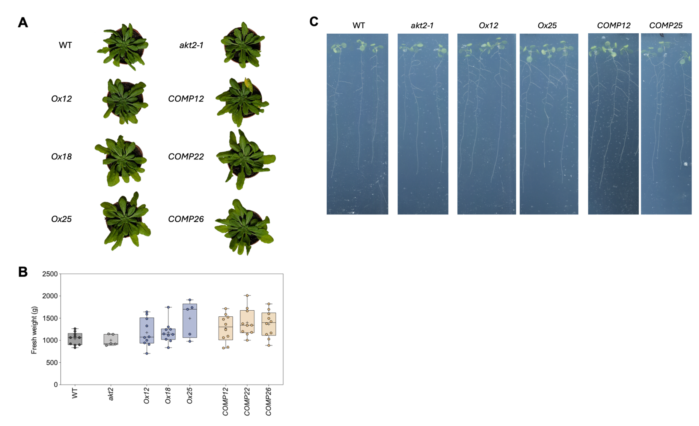
Fig. 2_ Growth performance of Arabidopsis WT, akt2 knockout, AKT2_{var} overexpression, and AKT2_{var} complementation lines. (A) Phenotype of 5-week-old plants grown on soil under controlled conditions. (B) Quantification of fresh weight of plants shown in (A). (C) Root growth of 3-week-old plants grown on ½ MS plates.

Q4 2025 – Updated results for the Arabidopsis experiments

Screening and molecular characterization of AtAKT2_{var} lines in Arabidopsis: To confirm the successful generation of AtAKT2_{var} transgenic lines either in akt2-1 knockout background or wild type, primary transformants (T0) were propagated and their progeny were screened in the T1 and T2 generations to identify homozygous lines, resulting in the selection of stable T3 lines used for further analyses. Genomic PCR analysis was then performed on these T3 plants using genotype-specific primers (Fig. 3A). Amplification of the EF1α fragment (497 bp) as reference was detected in all tested lines, confirming the integrity and quality of the extracted genomic DNA. The presence of the hygromycin resistance gene (542 bp) was observed exclusively in transgenic lines, indicating successful integration of the transgene, while no amplification was detected in wild-type (WT) and akt2-1 knockout plants. Furthermore, amplification of the AtAKT2-specific fragment allowed discrimination between WT (1571 bp) and AtAKT2_{var} lines (1258 bp), confirming the expected genotype of the selected transgenic plants. The expression levels of AtAKT2/AtAKT2_{var} transcripts were quantified in 5-week-old plants using quantitative real-time PCR (Fig. 3B). Transcript abundance was normalized to the housekeeping gene SAND. All AtAKT2_{var} lines showed detectable expression, confirming successful transcription of the introduced construct. In comparison to the akt2-1 knockout mutant, the complementation lines (#12, #22, and #26) exhibited low, but clearly detectable transcript levels. In contrast, overall AtAKT2 transcript levels in WT and WT + AtAKT2_{var} lines showed only minor alterations (Fig. 3B). To further validate transcript presence, RT-PCR analysis was conducted on total RNA isolated from 5-week-old plants (Fig. 3C). RNA integrity was verified by denaturing agarose gel electrophoresis prior to cDNA synthesis. Subsequent amplification using AtAKT2-specific primers confirmed the presence of AtAKT2/AtAKT2var transcripts in all transgenic lines, while EF1α amplification served as an internal control for cDNA quality and equal loading. These results support the quantitative PCR findings, showing that akt2-1 complementation lines produced weak but detectable signals, whereas WT + AtAKT2_{var} lines indicated that endogenous AtAKT2 transcript levels might be slightly reduced. However, integration and expression of the AtAKT2_{var} transgene compensated for this reduction, resulting in overall transcript levels comparable to WT, as observed in the previous analysis by qRT-PCR (Fig. 3C). To assess the impact of AtAKT2var expression on plant growth, fresh weight measurements were performed on 5-week-old plants grown on soil (Fig. 3D). Significant differences in biomass accumulation were observed among the analyzed genotypes. Representative images of WT and AtAKT2var plants visually support the observed differences in growth performance (Fig. 3E). Together, these results demonstrate successful generation of AtAKT2_{var} transgenic lines and reveal measurable effects on plant growth under controlled conditions.

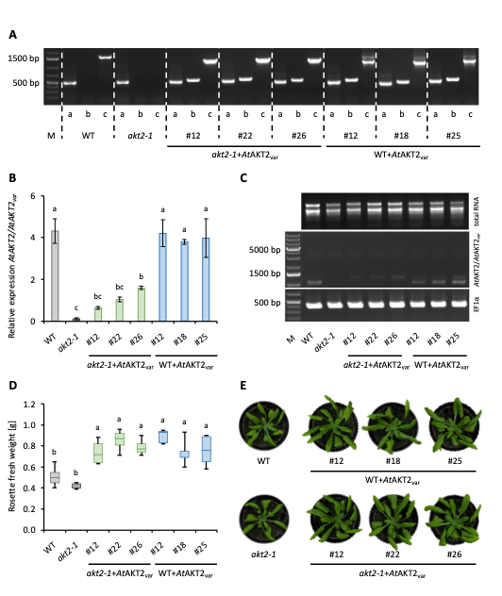
Fig. 3_ Screening of AtAKT2_{var} transgenic lines. (A) PCR products obtained from gDNA were analyzed by agarose gel electrophoresis to assess the presence or absence of specific sequences. DNA was extracted from leaf tissue and amplified using genotype-specific primers. Three primers were used: (a) EF1α (497 bp) as an internal positive control, (b) hygromycin resistance gene (542 bp) to confirm successful transformation, and (c) AtAKT2 (1571 bp) to discriminate between WT and mutant alleles. The detection of bands at the expected sizes indicates successful amplification of the respective targets. (B) Relative expression of AtAKT2/AtAKT2_{var} was analyzed by quantitative real-time PCR in 5 week-old plants (n=5). Transcript levels were normalized against the housekeeping gene SAND. (C) The presence of AtAKT2/AtAKT2_{var} transcripts in all generated AtAKT2var lines was examined using RT-PCR. Total RNA was isolated from 5-week-old plants and RNA integrity was assessed by denaturing agarose gel electrophoresis (top). Following reverse transcription into cDNA, AtAKT2 transcripts were amplified using gene-specific primers (middle). Amplification of EF1α was used as an internal reference control (bottom) to verify cDNA quality and equal loading. (D) To evaluate growth performance, 5-week-old plants were harvested, and fresh weight was measured. (E) Representative images of the plants were recorded. The boxplots show the median of 5 biological replicates. Edges of the box mark the first and third quartiles and the lower whisker represents the minimum value, and the upper whisker reaches the maximum value. Significance was calculated using the one-way analysis of variance with post hoc Tukey-Kramer test (p<0.05). Letters indicate the same level of significance.

AtAKT2_{var} lines and effects on reproductive development in Arabidopsis: To investigate the role of AtAKT2_{var} during plant development, transcript levels were monitored in WT plants across distinct developmental stages including inflorescence formation and flowering (Fig. 4A). Expression was normalized to the housekeeping gene SAND, and the onset of bolting is indicated by a vertical dashed line. Statistical comparison of transcript levels before and after bolting revealed significant increases during inflorescence development indicating stage-dependent regulation of AtAKT2 expression (Fig. 4A). To generate GUS lines expressing the introduced AtAKT2_{var} construct under its native promoter, T0 plants were transformed, and their progeny were screened in the T1 and T2 generations to identify homozygous T3 lines. Several independent lines were tested for comparison, and a representative line was selected for histochemical analysis. Histochemical GUS staining in WT plants revealed tissue- and stage-specific patterns of AtAKT2_{var} expression (Fig. 4B). Strong GUS activity was detected predominantly in vascular tissues, including leaf veins and petioles, as well as in stem tissue. In addition, pronounced staining was observed in reproductive organs, including the inflorescence and developing siliques. Expression varied with developmental stage, suggesting a regulated role of AtAKT2_{var} during plant growth and reproductive development (Fig. 4B). Representative images of 7-week-old plants grown under standard conditions illustrate overall plant morphology (Fig. 4C-F). Quantitative analysis of growth parameters at this stage revealed differences among genotypes. Rosette fresh weight (Fig. 4D), inflorescence fresh weight (Fig. 4E), and the number of siliques (Fig. 4F) were measured in five biological replicates (n=5). Thereby, both AtAKT2_{var} complementation lines and AtAKT2_{var} expression in the WT background showed an increase in rosette fresh weight by 51% and 54%, respectively, compared to WT plants (Fig. 4D). Comparable increases were observed for inflorescence fresh weight, with values of 72% and 45% relative to WT (Fig. 4E). This increase in vegetative and inflorescence biomass resulted in a higher number of siliques per plant (Fig. 4F). These observations indicate that AtAKT2_{var} expression can influence both vegetative growth and reproductive output in Arabidopsis under standard growth conditions, as has also been described in cassava (Zierer et al., 2025) and is consistent with previous work in Arabidopsis (Sandmann et al., 2011).

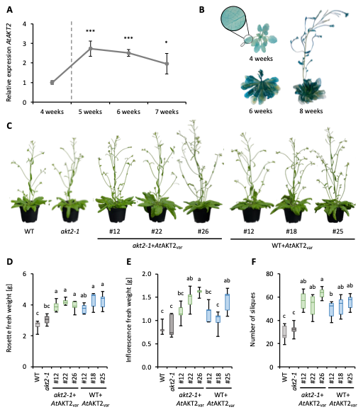
Fig. 4_Phenotypical characterization of AtAKT2_{var} lines under standard growth conditions and the effects on reproductive tissue development. (A) AtAKT2 transcript levels in WT plants were monitored across distinct developmental stages (n=3-5). Transcript levels were normalized against the housekeeping gene SAND. The vertical dashed line marks the onset of bolting. Statistical differences were assessed by comparing expression levels after the initiation of inflorescence development with pre-bolting stages using Microsoft Excel for unpaired T test (***<0,5%; **<1%; *<5%). (B) Histochemical GUS staining of wild-type plants at defined developmental stages illustrates tissue- and stage-dependent expression patterns of AtAKT2_{var}. (C) Representative images of 7-week-old plants grown under standard conditions. At this developmental stage, (D) rosette fresh weight, (E) inflorescence fresh weight, and (F) the number of siliques were recorded. The boxplots show the median of 5 biological replicates (n=5), dividing the data into two equal halves. Edges of the box mark the first and third quartiles, while the lower whisker represents the minimum value, and the upper whisker reaches the maximum value. The significance was calculated using the one-way analysis of variance with post hoc Tukey-Kramer test (p<0.05). Letters indicate the same level of significance.

Analysis of seedling development and root growth during drought stress: As AtAKT2_{var} has been implicated in enhanced drought tolerance in cassava, AtAKT2 transcript levels were analyzed in WT plants under drought stress as well as under additional abiotic stress conditions (Fig. 5A). Quantitative real-time PCR was used to determine AtAKT2 expression in soil-grown plants exposed to drought, heat (32 °C), high light (600 µEinstein compared to 120 µEinstein under control conditions), and cold stress (4 °C), in comparison to plants grown under controlled conditions. Expression levels were normalized to the reference gene SAND (n = 3-5). The analysis thereby revealed stress-dependent changes in AtAKT2 transcript abundance, indicating that AtAKT2 expression responds to multiple abiotic stress conditions (Fig. 5A). Seedling growth and root development were further examined under control and simulated drought stress conditions (PEG). Representative images of seedlings grown on ½ MS medium (control) and on PEG-supplemented medium were taken 14 days after transfer to the respective growth media (Fig. 5B). Under PEG-induced drought stress, seedlings exhibited visible alterations in root system architecture compared to control conditions. Further quantitative analysis of seedling fresh weight revealed differences between control and drought stress treatments (Fig. 5C). For each biological replicate, five plantlets were pooled (n=3). Growth on PEG-containing medium resulted in a general reduction in fresh weight compared to control conditions, reflecting the inhibitory effect of simulated drought stress on seedling biomass accumulation (Fig. 5C). Under control conditions, AtAKT2_{var} expression lines tended to display higher fresh weight compared to WT plants; however, this difference did not reach statistical significance, likely due to the limited number of biological replicates. Notably, this trend became more pronounced under drought stress conditions, where AtAKT2_{var} lines consistently maintained higher fresh weight relative to WT and akt2-1 knockout, suggesting an enhanced ability to sustain biomass accumulation under water limiting conditions (Fig. 5C). In addition, lateral root formation was quantified in seedlings grown under both conditions (Fig. 5D). A total of 16 seedlings per condition were analyzed, including individuals lacking visible lateral roots, which were scored as zero (Fig. 5D). The number of lateral roots was altered under PEG-induced drought stress compared to control conditions, indicating that drought stress affects root branching and overall root system development. A similar trend to that observed for fresh weight was detected for lateral root number: while differences between genotypes were less pronounced under control conditions, they became more apparent under drought stress, with AtAKT2_{var} expression lines showing a higher number of lateral roots compared to WT and akt2-1 knockout (Fig. 5D).

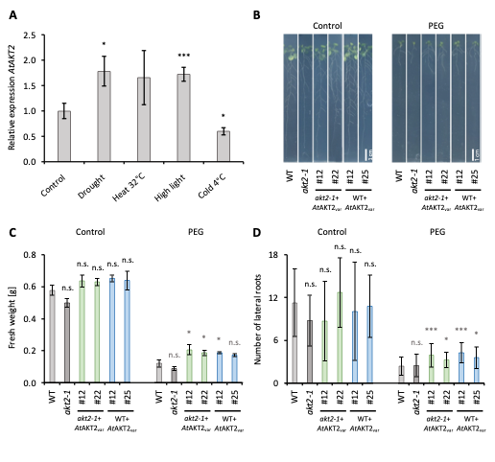
Fig. 5_Analysis of seedling development and root growth under standard and drought stress conditions. (A) Quantitative real-time PCR was used to assess AtAKT2 transcript abundance in WT plants exposed to various abiotic stress conditions. Expression levels were normalized to the reference gene SAND (n=3-5). (B) Representative images of seedlings for documentation of root growth. Seedlings grown on ½ MS medium served as controls, while plates supplemented with PEG were used to simulate drought stress conditions. Images were recorded 14 days after transfer to the respective plates. (C) Fresh weight of plantlets grown on ½ MS medium (control) and on PEG-containing medium to simulate drought stress. For each replicate, five plantlets were pooled (n=3). (D) Lateral root numbers were quantified in seedlings grown on ½ MS medium (control) and on PEG containing medium to simulate drought stress. A total of 16 seedlings per condition were analyzed (n=16), including individuals lacking visible lateral roots, which were scored as zero. Microsoft Excel was used for the standard deviation and the T-test (***<0,5%; **<1%; *<5%).
Screening and phenotypic characterization of MeAKT2 and MeAKT2_{var} transgenic lines: To assess whether the two Manihot esculenta AKT2 isoforms could confer similar effects, both native isoforms (MeAKT2a and MeAKT2b) as well as their mutagenized variants (MeAKT2a_{var} and MeAKT2b_{var}) were introduced. To verify the successful generation of transgenic lines expressing the unmodified and modified genes under their native promoters, T0 plants were transformed, and their progeny were subsequently screened in the T1 and T2 generations were used for further analyses. Genomic PCR analysis was then performed using genotype-specific primers (Fig. 6A). Amplification of the EF1α fragment as a reference (497 bp) was detected in all tested lines, confirming the quality and integrity of the extracted genomic DNA. Primer sets specific for MeAKT2a and MeAKT2b, which bind to both the native and modified alleles, produced PCR products of the expected sizes (997 bp and 937 bp, respectively) in transgenic lines, confirming successful integration of the introduced constructs. To evaluate early growth performance, the rosette diameter of 4-week-old plants was measured (Fig. 6B). Analysis of nine biological replicates per genotype (n=9) revealed differences in rosette size among the analyzed lines. Boxplots display the median and interquartile range, with whiskers indicating the minimum and maximum values. Distinct letters indicate differences between genotypes. Representative images of the transgenic and control plants visually support the observed differences in rosette growth (Fig. 6C).

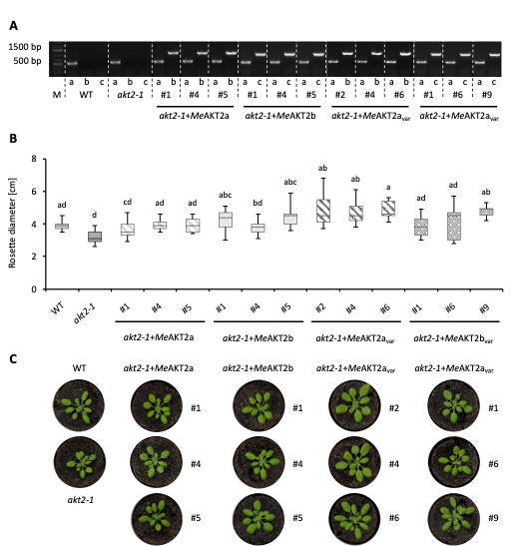
Fig. 6_Screening of MetAKT2_{var} transgenic lines. (A) PCR products obtained from gDNA were analyzed by agarose gel electrophoresis to assess the presence or absence of specific sequences. DNA was extracted from leaf tissue and amplified using genotype-specific primers. Three primer sets were used: (a) EF1α (497 bp) as an internal positive control, (b) MeAKT2a, which binds to both the native MeAKT2a and the modified MeAKT2a_{var} (997 bp), and (c) MeAKT2b which is also capable of binding both the native MeAKT2b and the modified MeAKT2b_{var} (937 bp) to confirm successful transformation. The detection of bands at the expected sizes indicates successful amplification of the respective targets. (B) To assess growth performance, the rosette diameter of 4-week-old plants was measured. The boxplots show the median of 9 biological replicates (n=9), dividing the data into two equal halves. Edges of the box mark the first and third quartiles, while the lower whisker represents the minimum value, and the upper whisker reaches the maximum value. The significance was calculated using the one-way analysis of variance with post hoc Tukey-Kramer test (p<0.05). Letters indicate the same level of significance. (C) Representative plants were documented photographically.

Q4 Summary
In this project part, a comprehensive molecular and phenotypic characterization of AKT2 variant lines was successfully established in Arabidopsis thaliana. Stable transgenic lines expressing modified AKT2 variants under their native promoters were generated through Agrobacterium-mediated transformation. Primary transformants (T0) were systematically screened through successive generations (T1 and T2) to identify homozygous T3 lines, ensuring stable transgene integration and expression. Molecular validation confirmed the presence and expression of the introduced constructs using genomic PCR, quantitative real-time PCR, and RT-PCR analyses. These approaches verified correct genotypes, transgene integration, and transcriptional activity of AKT2 and AKT2_{var} constructs across multiple independent lines. In Arabidopsis, expression analyses further revealed developmental and stress-dependent regulation of AtAKT2, supporting its functional relevance during vegetative and reproductive growth. Phenotypic analyses demonstrated that expression of AtAKT2_{var} constructs influenced plant growth, biomass accumulation, reproductive output, and root system architecture under both control and drought stress conditions. At later developmental stages, AtAKT2_{var} expression was associated with increased fresh weight, enhanced inflorescence development, and higher silique numbers. At the seedling stage, AtAKT2_{var} lines maintained higher biomass and lateral root formation under PEG-induced drought stress, indicating improved stress resilience. In parallel, transgenic lines expressing Manihot esculenta AKT2 isoforms (MeAKT2a and MeAKT2b) and their mutagenized variants were successfully generated and molecularly confirmed. Initial phenotypic screening revealed measurable effects on early rosette growth, providing a foundation for comparative functional analyses between isoforms and variant constructs. Collectively, these results establish a robust experimental platform for investigating AKT2-mediated regulation of plant growth and stress responses across species, and they provide a solid basis for subsequent functional, physiological, and mechanistic studies.

To further validate the observed phenotypic effects, growth experiments under drought stress conditions that were initially conducted on soil should be repeated using increased biological replication and more refined stress regimes. Extended and intensified drought treatments will allow a robust assessment of stress resilience, recovery capacity, and growth stability of AtAKT2_{var} lines under water-limiting conditions. In addition, seed production and overall plant yield require more comprehensive investigation to better understand the consequences of AtAKT2_{var} expression in Arabidopsis thaliana. Detailed analyses of silique development, seed number, seed size, and total seed yield per plant will be essential to determine whether the enhanced vegetative growth translates into improved reproductive performance. This is particularly relevant considering previous findings in cassava, where AtAKT2_{var} were shown to influence storage root growth and biomass accumulation. Furthermore, it may be of interest to determine carbon allocation dynamics by measuring ¹¹CO₂ labelling flow rates in Arabidopsis, enabling direct comparison with AtAKT2_{var} related effects previously observed in cassava. Such analyses would provide mechanistic insight into source-sink relationships and assimilate transport associated with AtAKT2_{var} expression. For Manihot esculenta AKT2 genes, initial growth screenings and the present analyses indicate that MeAKT2a_{var} shows particularly promising effects. Therefore, future work will focus on a reduced number of the most relevant candidate lines to allow more detailed characterization. The same experimental approaches applied to AtAKT2_{var} including growth analyses, drought stress experiments, and yield-related measurements are planned for selected MeAKT2 lines. Together, these next steps will enable a more comprehensive functional comparison of AKT2 variants across species and strengthen conclusions regarding their roles in growth regulation, stress tolerance, and yield-related traits.

Update Q1 2026
In parallel with drought stress experiments, high-light treatments were established as a promising approach to further elucidate the role of AKT2_{var} in Arabidopsis. To support upcoming drought stress experiments, a propagation phase spanning the past 2.5 months was implemented. Preliminary analyses of AKT2_{var} responses under high-light conditions were conducted in a small-scale experimental setup. As shown in Figure 5A, strong and significant alterations in expression levels were observed under these conditions, highlighting their relevance for more detailed future investigations. Therefore, plants were grown for 3 weeks in soil under standard conditions at 130 µmol m⁻² s⁻¹ light intensity and were subsequently transferred to high-light conditions at 700 µmol m⁻² s⁻¹ for an additional two weeks. Under standard conditions, complementation and overexpression lines showed an increase of approximately 20–28% in fresh weight. These differences further increased to up to 30% under high-light conditions (Figure 6A–D). In addition to the increased fresh weight observed under high-light conditions, phenotypic inspection revealed that mutant lines expressing AtAKT2var displayed pink staining on the abaxial (lower) side of leaves, indicating strong accumulation of anthocyanins. This observation may be linked to alterations in sugar partitioning in these lines (Figure 6D). Therefore, samples were collected and are currently being analyzed to determine sugar contents and anthocyanin levels. In addition these experiments will be repeated in Q2 2026 for further confirmation and validation of these results.

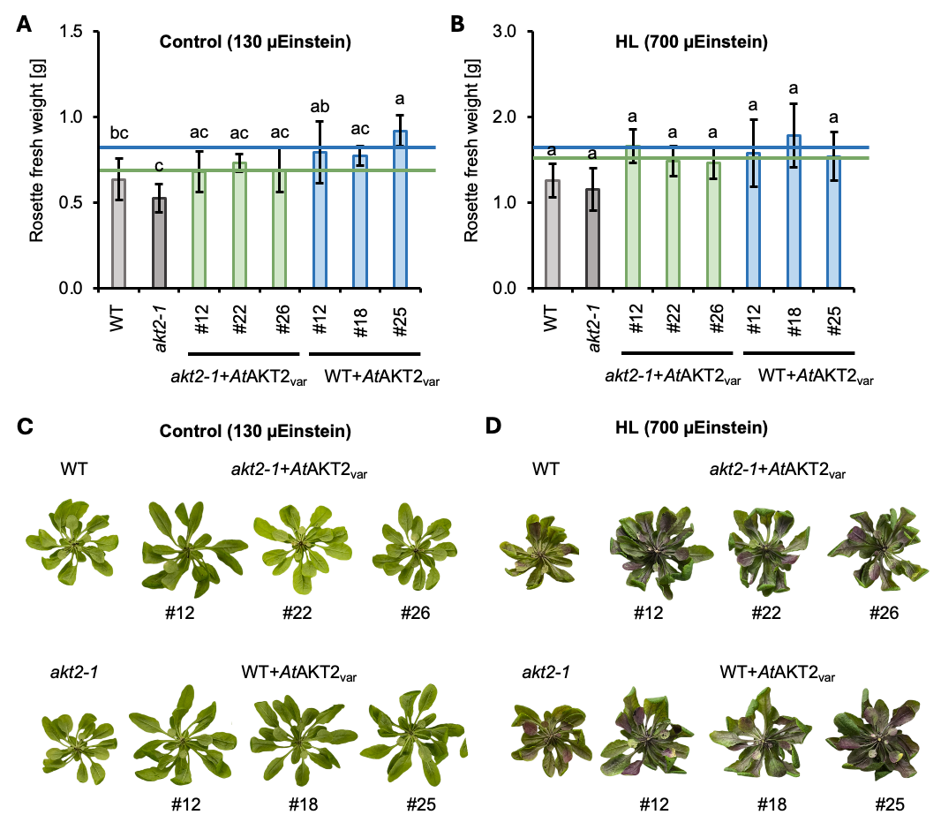
Fig. 7_ Phenotypical characterization of AtAKT2_{var} lines under standard growth conditions and high light conditions. Plants were grown for 3 weeks under standard conditions at 130 µmol m⁻² s⁻¹ light intensity before transferred to high light conditions at 700 µmol m⁻² s⁻¹. (A, B) To evaluate growth performance, plants were harvested, and fresh weight was measured (n=5). (C, D) Representative images of the plants were recorded.

Additional steps:
- Beginn screening of MeAKT2 constructs in cassava to obtain homozygous T₄ lines for inclusion in ongoing analyses. (Concluded)
- Conclude and complete drought stress experiments of atAKT2 in Arabidopsis, including metabolite profiling (Concluded).
- Comparative and detailed analysis of all the different At/MeAKT2(_{var}) lines (Ongoing).

Update Q1 2026
Analysis are still ongoing and will need more time for a final conclusion.

SUC2 project (RPTU): Investigations have not yet started, because the analysis of AKT2 cassava plants was prioritized. The current cassava greenhouse capacity at RPTU is fully-utilized to analyze the AKT2 cassava lines. The field data from Taiwan 2024 should be awaited to see whether AtSUC2 events will lead to an improvement at all. The plants from sterile culture are available and can be transferred into the growth chambers/greenhouses as soon as the comprehensive AKT2 analyses have been completed. In addition, a first round of AtSUC2 greenhouse analysis is being initiated at FAU.
A first cultivation conducted at FAU did not reveal a positive impact of SUC2 expression on cassava performance. Despite expression of the transgene, storage root fresh weight and storage root number tended to be neutral or decreased. Additionally, no positive impact on growth performance could be observed in the CFT 2024 conducted at NCHU experimental station. Due to the fact that SUC2 did not show promising results in previous trials, no further cultivations were initiated and no further experiments conducted.

As agreed during the quarterly meeting Q4 2024, work on the SUC2 construct was discontinued.

PsGPT2/AtNTT1 project (RPTU):
Existing PsGPT2/AtNTT1 constructs (C56) were analyzed in more detail. Greenhouse trials demonstrated strong potential to increase starch synthesis under optimized growth conditions, whereas field trials showed no significant changes, indicating a limitation of these constructs in natural environments (a third field trial is ongoing). Alongside qRT-PCR genotyping, multiple greenhouse cultivations were performed. These revealed enhanced storage root growth, while shoot growth appeared unaffected. More detailed metabolite quantification indicated a shift from sugar toward starch synthesis. MRI analysis together with the Jülich team further suggested earlier storage root formation, resulting in higher storage root weight and greater starch accumulation. Photosynthesis, CO₂ fixation, and the transport of assimilates to storage root tissue were not affected. As a next step, sugar contents of field-grown plants will be assessed to clarify the limitations of these constructs under challenging conditions. Material has been prepared and shipped by FAU and measurements are ongoing.

To validate the observed increases storage root starch increases for CFT 2023 and 2024, we are currently investigating the CFT 2025 field material. In parallel, untargeted and targetd proteomic experiments are performed to confirm the presence or absence of PsGPT2 and AtNTT1. Additional meatabolites are being determined from greenhouse material. Futhermore, the integrated field result analysis for 2023-2025 is ongoing. Once these experiments have concluded (projected for Q2 2026) , we should be able to draw final conclusions on the impact of PsGPT2+AtNTT1 on cassava performance.

Update Q1 2026
We are currently working to summarize the findings regarding C56 (PsGPT2/AtNTT1) in a manuscript. Briefly, the main conclusions currently are as follows:

- PsGPT2/AtNTT1 expression in cassava results in increased biomass in the greenhouse
Transgenic lines expressing C56 (PsGPT2/AtNTT1) were repeatedly tested in the greenhouse in Kaiserslautern (Fig. 1), revealing similar levels of shoot dry weight (Fig. 1B) with consistent increases in storage root dry weight (Fig. 1B) and consequently also harvest index (Fig. 1C) under these conditions.
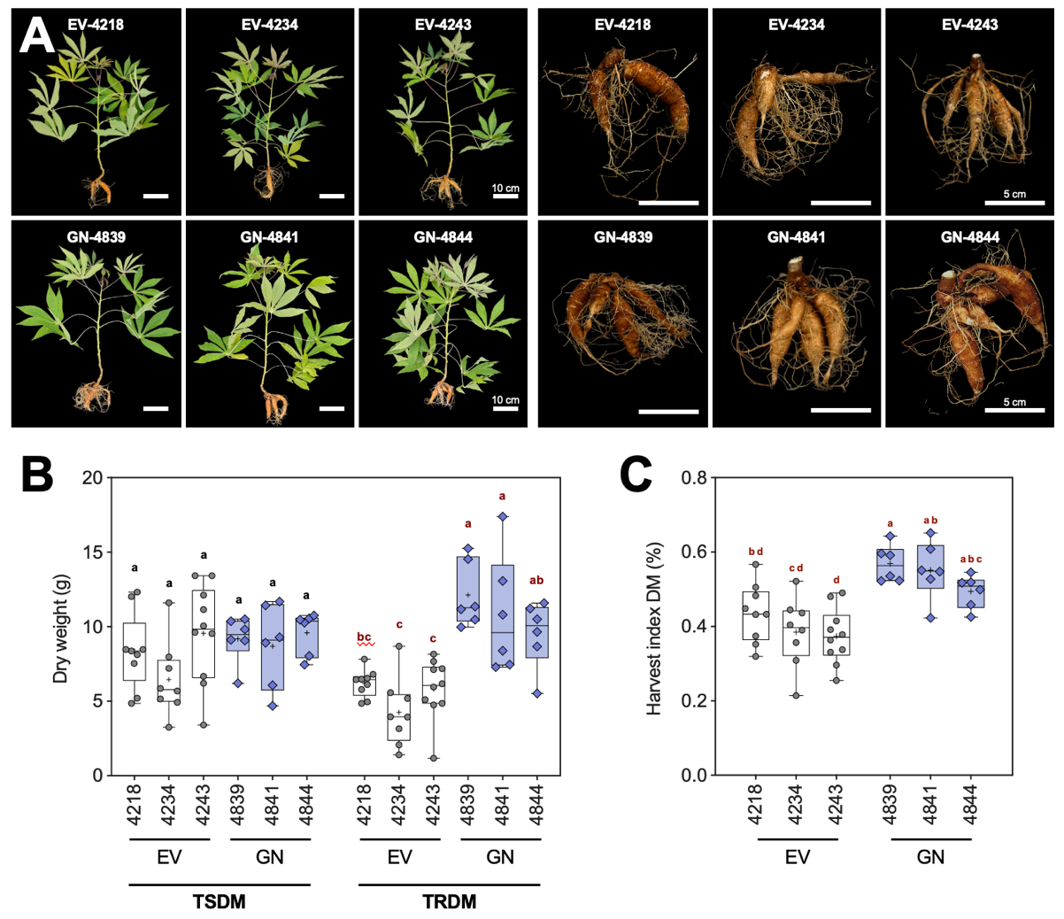
Figure 1_Results of greenhouse phenotyping. (A) Representative pictures of vector controls and C56/GN (PsGPT2/AtNTT1) transgenic lines for shoot and root. (B) Dry weight evaluation of shoot and root. (C) Harvest index calculation. Plants were approximately 19-weeks-old.

- PsGPT2/AtNTT1 expression in cassava results in increased sugar to starch conversion under greenhouse conditions
Transgenic lines expressing C56 (PsGPT2/AtNTT1) grown in the greenhouse displayed reduced monosaccharide levels (glucose and fructose), but increased starch levels (Fig. 2A). A correlation analysis demonstrates a negative correlation between sugars and starch, showing C56 transgenic lines with more favorable relations (Fig. 2B). These results suggest more efficient sugar to starch converstion in the transgenic lines. In addition, AGPase enzyme activity was found to be increased in C56 (Fig. 2C).
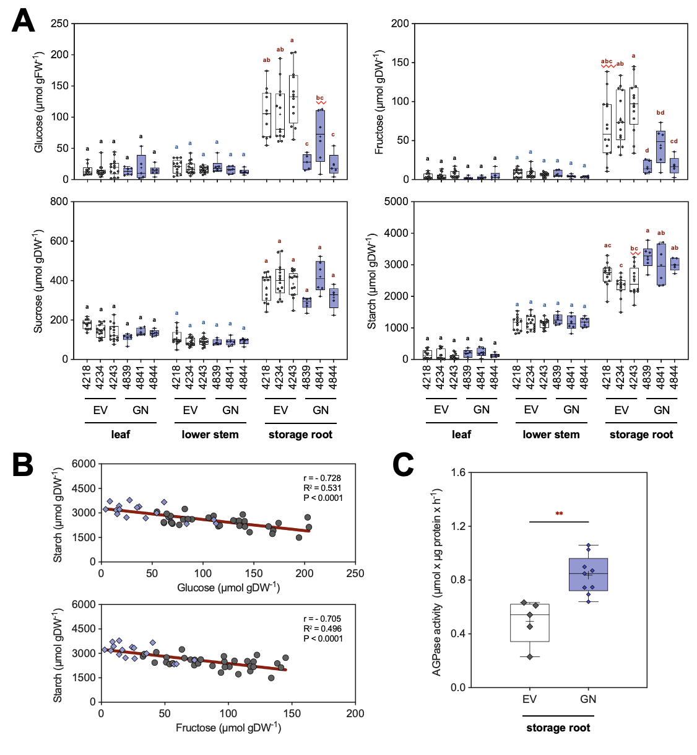
Fig. 2_ Tissue-specific carbohydrate alterations in C56/GN (PsGPT2/AtNTT1) cassava lines and alterations in starch synthesis of storage root tissue. (A) Glucose, fructose, sucrose, and starch contents measured in source leaf, lower stem, and storage root tissues of empty vector controls (EV-4218, EV-4234 and EV-4243), and transgenic lines expressing PsGPT2 and AtNTT1 (GN-4839, GN-4841, GN-4844). (B) Correlation analysis of starch–glucose and starch–fructose contents in storage roots. Correlation coefficients (r), coefficient of determination (R²) and significance levels (p) are shown. (C) AGPase enzymatic activity in storage root tissue of empty vector controls and GN lines.

- PsGPT2/AtNTT1 expression in cassava does not result in increased field performance
Growth of C56 (PsGPT2/AtNTT1) was tested in the confined field in 2023, 2024, and 2025 in Taichung, Taiwan. Overall, plant growth was similar between control plants and transgenic lines within each year, althou gh performance of transgenic plants tended to be slightly lower compared to the controls (Fig. 3A-B). A multi-year analysis indicates that most lines display performance losses in the field compared to the control lines.
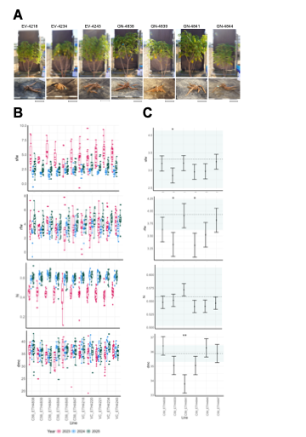
Figure 3_Growth results of C56/GN (PsGPT2/AtNTT1) in the confined field in Taichung, Taiwan in the years 2023 – 2025. (A) Representative pictures of the tested lines. (B) Shoot fresh weight (sfw), root fresh weight (rfw), harvest index (hi), and dry matter content (dmc) for 2023, 2024, and 2025. (C) Multi-year statistical evaluation using the workflow published in Zierer et al., 2025.

- Analysis of field material indicates variability in sugar to starch conversion efficiency
We measured sugar and starch from storage root field material obtained during the final harvest of CFT 2023, 2024, and 2025 in Taichung, Taiwan. In 2023, we observed an increase in sugars measured in the storage roots of transgenic lines compared to the controls. Additionally, starch levels were slightly higher in the transgenic lines. In 2024, we observed an increase in storage root sucrose levels and higher starch levels in the transgenic lines. In 2025, no increases in starch levels were observed. However, sucrose levels were again increased in the storage roots of C56 transgenic lines. Although the variation between particular lines is considereable, the overall constructs trend indicated changes in carbohydrate metabolism also under field conditions.

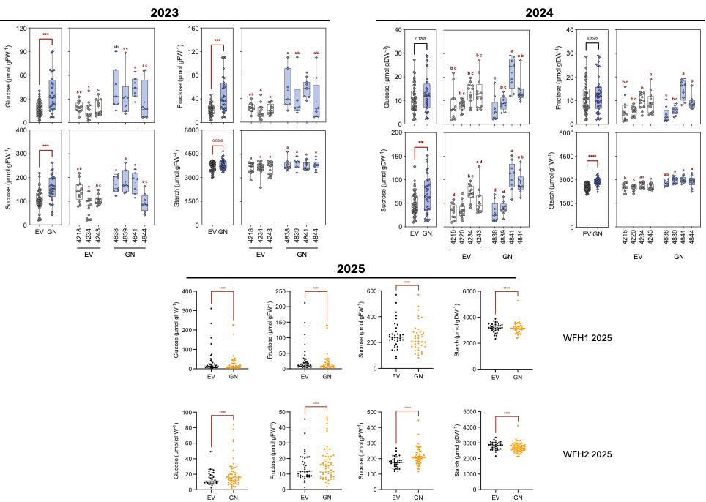
Figure 4_Sugar and starch measurements from storage root material obtained during the final harvest of CFT 2023, 2024, and 2025. EV = vector control, GN = C56 (PsGPT2/AtNTT1) transgenic cassava lines. West field 1 (WF1) was used in 2023 and 2024. Plants were grown on WF1 and West field 2 (WF2) in 2025.
Based on the current findings, we believe that the PsGPT2/AtNTT1 concept is functional and can improve storage root starch formation in cassava. The molecular data suggests that flow of carbon towards plasmids and consequentally into starch is increased. However, there clearly seems to be additional complexity and other constraints that prevent the realization of yield gains under field conditions. Therefore, we suggest to combine the concept with other target genes that can help to overcome these limitations, including source improvments (e.g. AKT2, PPase) and other sink improvements (e.g. sucrose synthase, limitation of starch break).

AAP1 project: (MPI-MPP): The agronomic and metabolic characterisation of six transgenic lines for AAP1 has been successfully completed under glasshouse (polytunnel) conditions, using a full nutrient substrate. Based on the results from the previous polytunnel experiment, the field testing in Taiwan, and the transgene expression results, the characterization has now been limited to the three most promising transgenic lines. To further assess the robustness and adaptability of these lines, they are being tested under more challenging conditions, specifically in poor nutrient soil. This aims to evaluate how well the transgenic lines perform under nutrient-limited conditions, which are more representative of field conditions in low-input agricultural systems. To ensure comprehensive data collection, a detailed harvest was conducted. Eleven distinct plant sections were harvested from each of the selected transgenic lines. These samples will be used for both metabolic profiling and qRT-PCR to assess expression levels in various tissues.
To further evaluate AAP1 transgenic lines, three selected lines (4354, 4358, and 4359) were tested under challenging conditions, specifically in nutrient-poor soil within a semi-controlled environment. Under these nutrient-limited conditions, transgenic plants displayed a similar performance to VC, showing no significant differences in growth parameters. A detailed harvest was conducted where eleven distinct plant sections were harvested. Samples have reached the final extraction phase in preparation for gas chromatography-mass spectrometry (GC-MS) analysis. Specifically, the analysis of amino acids in phloem-enriched tissues could shed light on the functionality of AAP1, an amino acid transporter expressed in the vasculature. In parallel, an additional experiment under optimal growth conditions has been initiated to serve as a comparative control to verify the composition of phloem exudates. This work has synergy with the modelling activites of EM1-3, which also require phloem metabolite composition.
To further investigate a potential nutrient-dependent effect, MPI-MPP have established communication with the International Institute of Tropical Agriculture (IITA) in Ibadan regarding the AAP1 samples collected from the most recent confined field trial (CFT, harvest Nov/Dec 2024).
The processing and extraction of AAP1 samples cultivated under nutrient-limited conditions have been successfully completed. These samples are currently queued for GC-MS analysis, pending instrument availability. Repeated cultivation of AAP1 plants under optimal growth conditions is progressing as planned. To date, no recurrence of Fusarium spp. contamination has been observed, harvest is predicted to May/June 2025. No new results are yet available.

Repeated cultivation of AAP1 transgenic plants under controlled optimal growth conditions was successfully completed. Phloem exudate samples were harvested and analysed. The results are summarized in Figure 1 below.
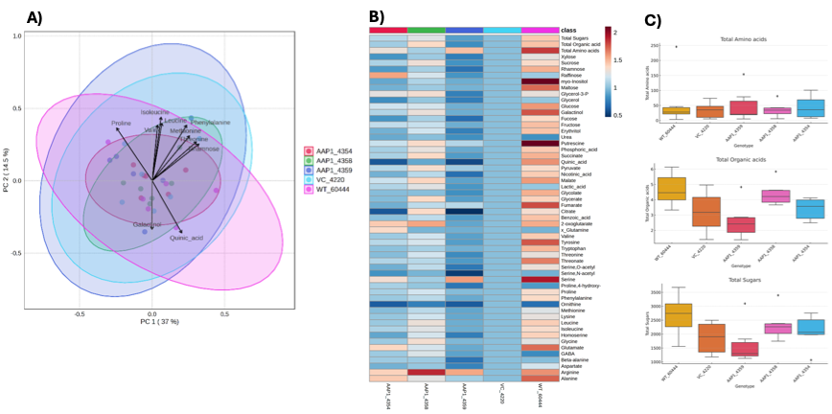
Fig. 1_Metabolic changes between select AAP1 transgenic lines and control lines. A) Principal component analysis (PCA) of metabolites in phloem exudates. Scores plot of PCA of genotypes considering individual genotypes and transformation events and loading plot showing the top ten features contributing to the observed variation. Coloured ovals indicate 95% confidence regions. The data has been normalised by median, log transformed and scaled. B) Heatmap of relative metabolites in phloem exudates. Red and blue colours represent high and low levels of metabolites using a false-colour scale, respectively. Metabolites starting with x represent estimated values. The content of each metabolite was normalised to the vector control (VC). C) Total metabolite levels (µg). Averages from the transgenic lines are compared against VC and significant differences determined by Kruskal-Wallis test are presented as asterisk (*) for p≤0.05 (n=6).
No significant differences in metabolite data were observed between genotypes. Principal Component Analysis (PCA) did not show clear separation of the genotypes, and individual metabolite analysis also revealed no statistically significant differences. These findings are consistent with previous results from semi-controlled conditions (“Polytunnel”, 2022), where no significant differences were detected in agronomic traits or metabolite levels in leaves and roots.
However, data analysis of phloem exudates proved to be challenging due to the low concentration of metabolites and high variability among replicates. Moreover, we cannot rule out the possibility of metabolite degradation during the collection process. For instance, linamarin, which is expected to be present in phloem sap, was not detected in these samples. One explanation is that linamarin becomes exposed to linamarase during the exudate collection, leading to its breakdown. In the protocol, exudates were collected by partially cutting the "leaf finger" and immersing the cut end in collection buffer for 6-8 hours. This method differs from the procedure used for other tissue samples, which were also cut but immediately flash-frozen in liquid nitrogen, minimising enzymatic activity.
Although no differences were observed in metabolite levels in the phloem sap, we cannot exclude the possibility that certain metabolites are being differentially accumulated in specific tissues. Therefore, MPI-MPP would like to conduct further analysis of metabolites of selected AAP1 transgenic lines grown under nutrient-poor soil and control conditions. Samples from these plants have already been extracted and are ready for GC-MS analysis, which is currently being planned in collaboration with a partner company.

Additionally, in collaboration with the infrastructure group Kopka within the institute, a GC-MS instrument has been configured according to our analytical requirements,
and a subset of AAP1 samples is currently undergoing measurement.

We proceed with the evaluation of AAP1 lines under challenging conditions, specifically in poor nutrient soil. As reported previously, the transgenic lines exhibited growth characteristics comparable to the vector control (VC) plants. In parallel, a subset of AAP1 samples was submitted for metabolite profiling in collaboration with the company Metasys, and this data is currently under analysis. Additionally, total protein content was quantified across eleven distinct tissue types (Fig. 2) to evaluate possible effects of the AAP1 construct on protein accumulation patterns.

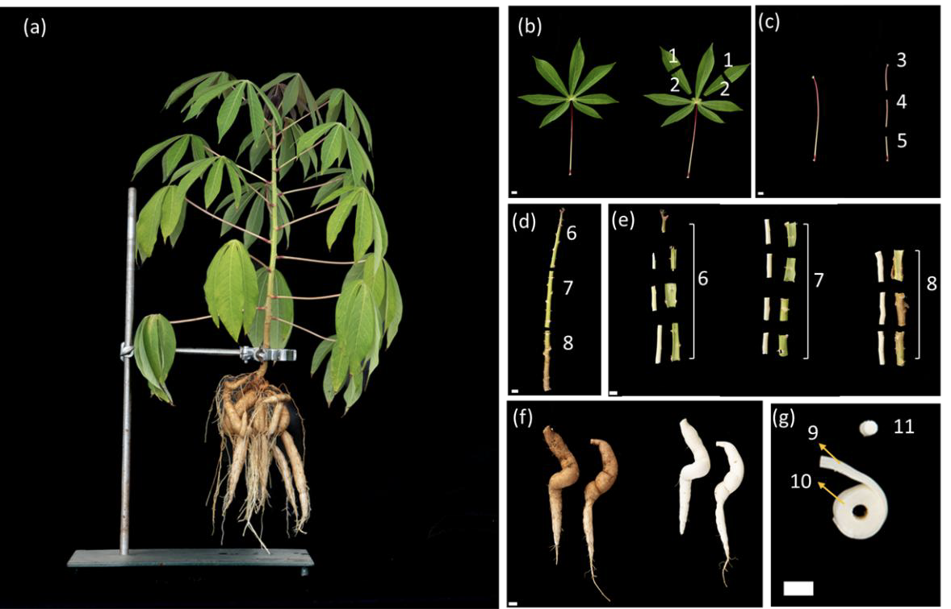
Fig. 2_ Representation of eleven different tissue/sections harvested for detailed metabolite analysis for AAP1 transgenic and control lines. Plants were grown under nutrient-poor soil within a semi-controlled environment.

Significant differences were observed only in tissues 2 (leaflet base) and tissue 6 (phloem-enriched fraction of upper stem) , where lines 4358 and 4359 showed a reduction in total protein levels compared with the control (Fig. 3). No other tissues displayed statistically significant changes, suggesting that any impact on protein accumulation may be tissue-specific and limited to particular transgenic events.

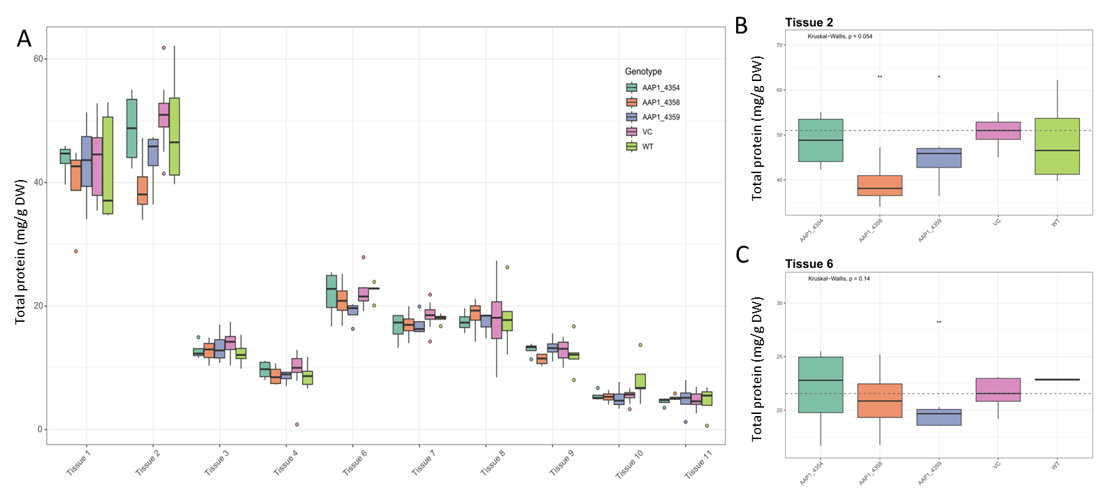
Fig. 3_Total protein content for AAP1 transgenic and control lines. (A) Overview of the eleven different tissues. (B-C) Tissues with significant differences, tissue 2 (leaflet base) and tissue 6 (phloem-enriched fraction of upper stem). Plants were grown under nutrient-poor soil within a semi-controlled environment. Averages from the transgenic lines are compared against VC and significant differences determined by Kruskal-Wallis test are presented as asterisk (*) for p≤0.05 (n=4-5).

Additionally, the results of a detailed metabolic profiling of the tissues shown in Fig. 2 is currently ongoing.

Update Q1 2026

Metabolite Profiling of 2022 Taiwan Field Trial
We continued the analysis of previously delayed samples from the 2022 Taiwan field trial, including both intermediate and final harvest time points. An overview of the metabolite distribution across tissues is presented in Figure 4, which summarises the number of detected metabolites per class. The data indicate that the majority of metabolites are shared across the analysed tissues, reflecting a largely conserved metabolic profile.
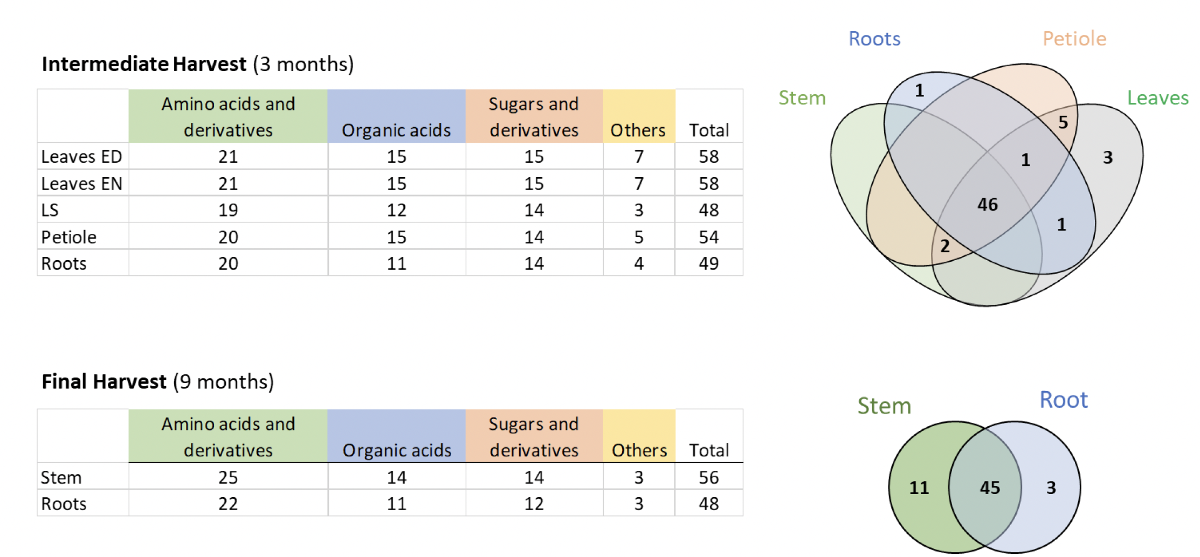
Figure 4. Summary of the number of metabolites per class across different tissues in the 2022 Taiwan field trial and respective Venn diagrams with the number of metabolites shared in different tissues.

Following statistical evaluation, no significant differences were identified between the WT_FEC and vector control (VC) lines. Based on this outcome, these control groups were combined for subsequent analyses and graphical representation to simplify data interpretation and improve clarity. At the intermediate harvest stage, only six metabolites exhibited statistically significant differences when comparing AAP1 lines to the combined control group (Figure 5). Specifically, in leaf samples collected at the end of the day, significant changes were observed for threonine, 2-oxoglutarate, pyruvate, and phosphoric acid. In petiole tissue, alanine and galactinol showed significant variation. These differences were limited in number and did not indicate a broad metabolic shift at this developmental stage.

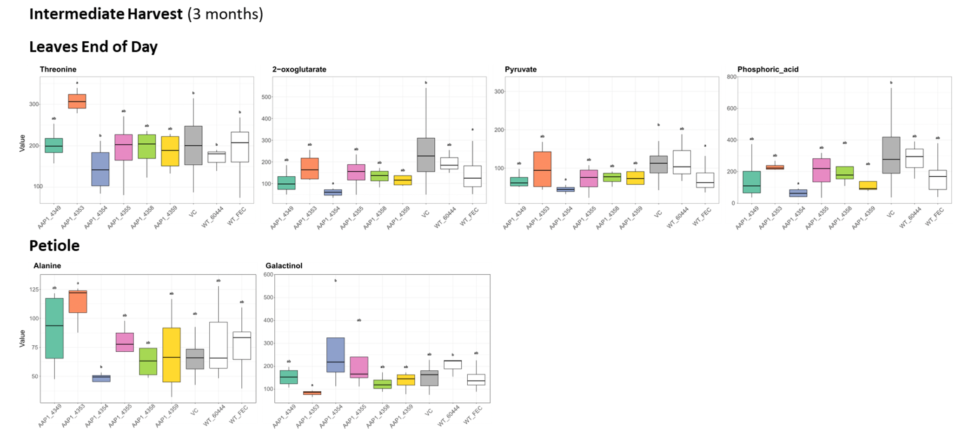

Figure 5. Significantly changed metabolites in AAP1 lines compared to combined controls (WT_FEC + VC) at the intermediate harvest stage. Statistical significance was determined using Kruskal-Wallis test followed by Dunn’s post hoc test with a threshold of p≤0.05.

In contrast, the final harvest revealed a greater number of metabolites with significant differences. However, these changes were not consistently observed across all AAP1 lines. Notably, line AAP1_4353 displayed a consistent reduction in metabolite levels, with 16 metabolites decreased in stem tissue and five in roots (Figure 6). Malate was the only metabolite exhibiting an opposite trend, showing increased levels in this line. The remaining AAP1 lines did not show consistent or significant differences when compared to at least one of the control groups.
Overall, the observed metabolic changes do not reveal a clear or consistent pattern across the AAP1 lines. This lack of uniformity is likely influenced by the relatively high variability among biological replicates, which is expected under field conditions. Furthermore, no clear correlation was identified between transgene expression levels and metabolite content. For instance, line AAP1_4353, despite exhibiting the highest expression level, showed a general reduction in several metabolites. To improve the robustness of the analysis, a re-evaluation of the dataset is planned, including the identification and potential exclusion of outliers that may disproportionately affect statistical outcomes.

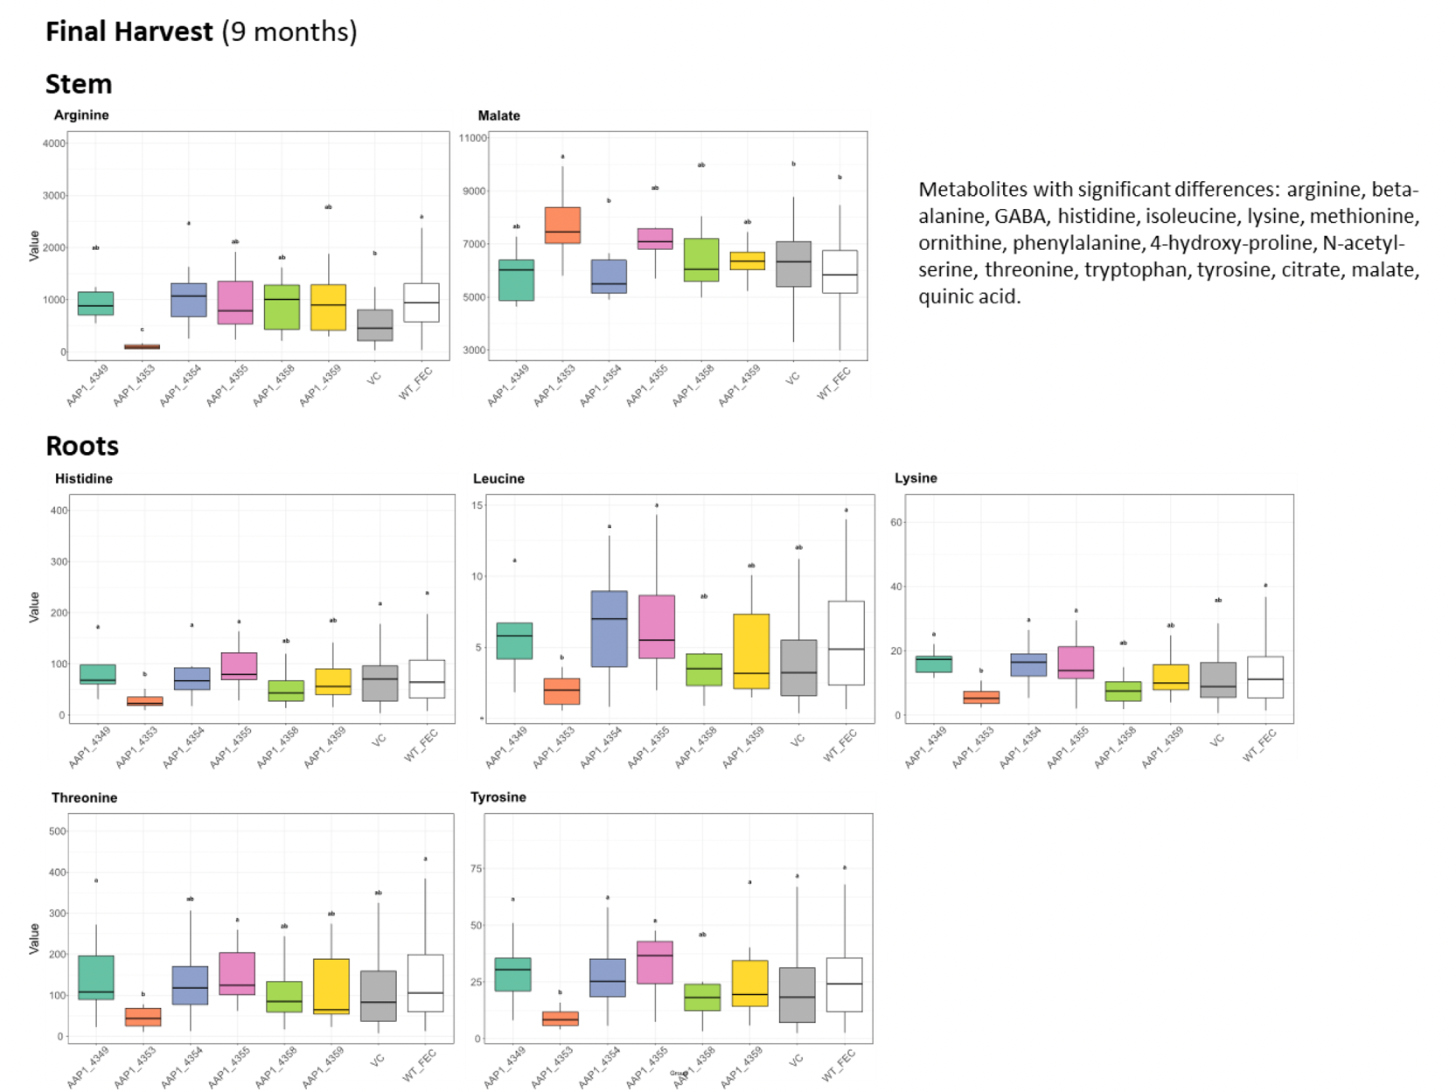
Figure 6. Significantly changed metabolites in AAP1 lines compared to combined controls (WT_FEC + VC) at the final harvest stage. For stem tissue, a representative example is shown, accompanied by a list of metabolites exhibiting significant differences. Statistical significance was determined using Kruskal-Wallis test followed by Dunn’s post hoc test with a threshold of p≤0.05.

Metabolite profiling of AAP1 transgenic and control lines across the eleven tissue types, as well as the recently collected samples from sink tissues prior to the onset of the bulking stage, is still ongoing. Further analyses are expected to provide additional insights into tissue-specific metabolic responses and developmental stage-dependent effects.

Currently, there is still no proof for AAP1 protein function and since neither yield, nor quality parameters (protein content) are improved following AAP1 overexpression, the current conclusion must still be to terminate this construct.

Construct combinations (RPTU): For the combination of AKT2/AAP1 and AKT2/AAP1/SUC2, the first sterile cultures were received in December 2024 and subsequently transferred for screening with WT and three independent vector controls. The harvested samples will be analyzed by the end of Q1 2025 to assess transcript levels, sugar/starch contents, amino acid concentrations, and ion contents in several promising lines. To ensure proper cultivation and assess morphological and physiological adaptations, a weekly documentation has been implemented as part of this screening process. However, first greenhouse results for these constructs indicate transformation defects for several lines. It is currently unclear, if enough viable lines can be isolated and if further, more detailed analysis is warrented.
As agreed during the quarterly meeting Q4 2024, the AKT2/AAP1 and AKT2/AAP1/SUC2 combination lines, especially in light of their transformation defects, will not be retransformed and will be discontinued soon. As discussed, AKT2/GPT/NTT represents a far more promising combination for transformation. The construct is complete and transformation is currently being initiated.
Transformation of the AKT2_{var}/GPT/NTT (C127) construct has been initiated and is currently ongoing at FAU.
Unfortunately, transformation has failed and needs to be re-initiated. The construct has been sent to ETH Zurich for transformation. Transformation is projected for Q2 2026.
1.2.5. Generate additional constructs centered on potassium transport
After discussions during the quarterly meeting Q4 2024 and subsequent meetings with RPTU, we decided to extend our efforts towards potassium-related constructs. We agreed on cloning and transformation of the constructs outlined in Table 2.

Table 2_Summary of EM1.2 gene constructs in preparation for cassava transformation
Construct number | Gene cassette | Database link | Current status
C2-122 | pAtSUC2::AtAKT2 CDS_S210N-S329N::Ter (companion cell-specific expression) | https://cassbase.org/stock/470120/view | Awaiting transformation
C2-124 | pMeAKT2a::AtAKT2_{var} (Endogenous AKT2a specificity) | https://cassbase.org/stock/470133/view | Transformed Feb 2026
C2-143 | pMeAKT2b::AtAKT2_{var} (Endogenous AKT2b specificity) | https://cassbase.org/stock/475426/view | Transformed Feb 2026
C127 | AKT2_{var} + GPT2 + NTT1 | https://cassbase.org/stock/470119/view | Awaiting transformation
C2-129 | pAtSUC2::OsHAK18 | https://cassbase.org/stock/471878/view | Transformed Feb 2026
C2-130 | pMeSUS1::MeSWEET10 RNAi | https://cassbase.org/stock/471879/view | Transformed Feb 2026

These constructs are currently being cloned and prepared for transformation in TMS6044. While cloning of C2-122, C2-124, and C2-127 is already finished, cloning of pMeAKT2b::AtAKT2_{var} and the pAtSUC2::OsHAK18 construct is still ongoing.
Cloning of C2-129 has been completed, while cloning of pMeAKT2b::AtAKT2_{var} is still ongoing, due to challenges with the identification and amplification of the MeAKT2b promoter from genomic DNA. Transformation of C2-122 (pAtSUC2::AtAKT2_{var}), C2-129 (pAtSUC2::OsHAK18), and C127 (AKT2_{var} + GPT + NTT) has already been initiated. In addition, we decided to create a pMeSUS1::MeSWEET10 RNAi construct (C2-130) to limit lateral assimilate loss in the stem. MeSWEET10 is a stem phloem parenchyma-localized sucrose transporter that is likely important to supply the stem with sucrose. Downregulation of MeSWEET10 in the stem, should result in reduced delivery of sucrose to the stem, and potentially more sucrose delivery to storage roots. Transformation of C2-124, pMeAKT2b::AtAKT2_{var}, and C2-130 will be initiated in the next quarter.

Cloning of all constructs outlined in Table 2 above is now complete, transformation of all constructs will be initiated soon.

Transformation has been initiated at FAU. Unfortunately, transformation has failed due to problems with the current Agrobacteria. Transformation needs to be re-initiated and constructs have been sent to ETH Zurich to be included in the next possible transformation slot.

Update Q1 2026
Transformation of new EM1-2 constructs has been initiated at ETH Zurich with the exception of C2-122 (pAtSUC2::AtAKT2_{var}) and C127 (AtAKT2_{var}+PsGPT2+AtNTT1), which will be transformed at the earliest next opportunity.

Challenges and Mitigations:
RPTU: No challenges to report in this quarter.
The only minor note at this stage is that the growing capacities (green house and chambers) are currently fully-utilized with the screening of combination constructs and cannot be expanded unless further screenings are conducted on a smaller scale. This limitation may also pose a challenge for Q1 2025. This statement remains valid as of Q1 2025. A minor, but important note is that RPTU growing capacities—both in the greenhouse and growth chambers—are currently fully-utilized. Expansion is not possible at this time unless further screenings are conducted on a smaller scale. This limitation may continue to pose challenges in Q2 2025 and beyond. Additionally, analytical capacities are also currently at full load and should be carefully considered in future planning to avoid delays in processing and data generation.

Re-initiation of new EM1.2 constructs is required, resulting in delayed delivery of new transgenic lines. Constructs will be prioritized in upcoming transformation batches.

Update Q1 2026
No new challenges this quarter

MPI-MPP: One of the key challenges encountered in the project has been the prolonged waiting time for running extracted samples on the Gas Chromatography-Mass Spectrometry (GC-MS) machines. This delay is primarily due to the high demand for equipment use across multiple projects and technical issues with the machines, which has resulted in scheduling bottlenecks. To mitigate these challenges, a new technician is currently undergoing training to operate the GC-MS machines and a consultation with a specialized technician from the manufacturer has been scheduled.
We continue to encounter technical challenges with the GC-MS instruments, including prolonged waiting times. At present, the only operational machine is also experiencing issues with the turbo pump. Efforts are underway to diagnose and resolve the problem to minimize disruptions to our analysis.
A certified technician from the instrument supplier recently conducted a verification and maintenance check on the GC-MS systems. As a result, one of the GC-MS machine has been partially restored and is currently operating under limited capacity. While this allows for the processing of smaller sample sets, it presents significant limitations and potential risks when handling large-scale sample batches, such as from the 2022 Taiwan field trials. As an alternative solution, we have initiated contact with partner laboratories to explore collaborative solutions. Discussions are underway regarding the shipment of chemical standards to ensure data comparability and maintain methodological consistency.
Ultimately, we decided to run the samples in collaboration with a partner company. It was agreed that the partner will perform the sample runs and provide the chromatograms, while the data analysis will be conducted by the Fernie group. The analysis has now been completed.

Update Q1 2026
No new challenges this quarter

Next Steps in the Action Plan:
RPTU:
- Analysis of greenhouse trials focussed on AKT2 and drought stress (Concluded)
- Analysis of intermediate harvest samples from CFT 2024 Taiwan (Concluded)
- Finalizing and submitting the AKT2_{var} manuscript (Concluded)
- Screening of Arabidopsis mutants for AtAKT2 and MeAKT2 (Concluded)
  - Isolating homozygous T₂ lines (Concluded)
  - Conducting complementation experiments (Concluded)
- Continue screening of the AKT2/AAP1/SUC2 combination constructs (Discontinued)
- Discuss a “potassium work package” (Concluded)
- FAU to complete cloning of new constructs and to initiate transformation (Cloning concluded, transformation pending)
- Detailed analysis of the different At/MeAKT2(_{var}) lines (Ongoing)
- Evaluation of AKT2_{var} control vs. drought stress RNA-Seq and design of further experiments to reveal the AKT2_{var} mechanism (Ongoing)
- Transformation of new EM1.2 constructs (Ongoing)

MPI-MPP:
- We will focus on advancing the analysis and evaluation of the AAP1 transgenic lines under nutrient-limited conditions and running samples from the Taiwan field 2022, which are currently on the GC-MS waiting list.
- Further evaluation of AAP1 transgenic lines under both nutrient-limited and optimal conditions, along with comprehensive sample analysis. Additionally, processing and analysis of samples from the 2022 Taiwan field trials.
- Priority is given to the smaller set of samples, such as modelling samples and GPT/NTT samples. Harvest of AAP1 transgenic lines under repeated optimal conditions is predicted for May/June 2025.
- Conduct an inventory and prioritisation of the remaining samples to be sent to the partner company for analysis.
- Given the lack of significant differences between AAP1 lines and the vector control (VC), no additional experiments are planned. Efforts will instead focus on finalising the analysis of samples already collected.
- Running of selected AAP1 GCMS samples with the partner company is ongoing. (Data analysis ongoing)
- Running of selected AAP1 GCMS samples with the infrastructure group is ongoing. (Completed)
- Measurement of total protein in different tissues from currently available samples is planned. (Completed)
- Support the analysis of new metabolism lines by metabolite profiling. Samples will be sent from FAU to MPI-MPP for analysis.

EM1.3_Transport and allocation modelling
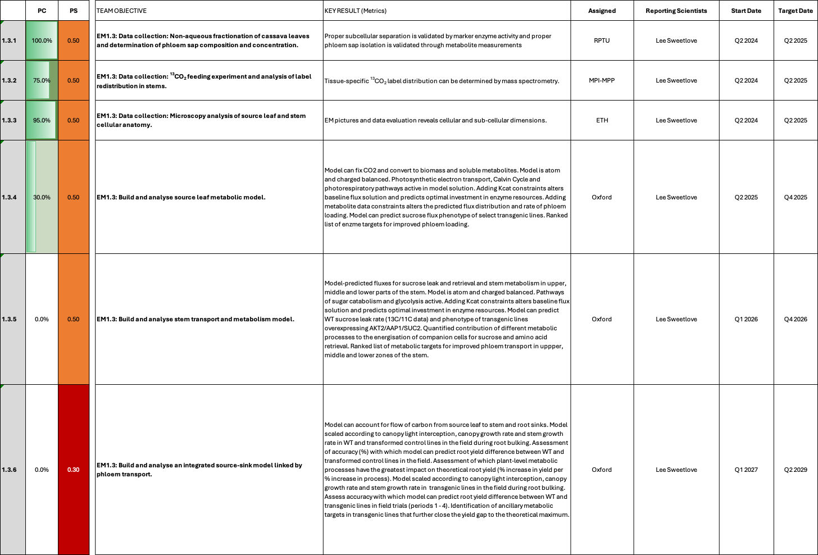

EM1.3_Transport and allocation modelling

Reporting module leader: Lee Sweetlove, UO with RPTU, MPI-MPP and ETH.

Progress Update:

1.3.1. Data collection: Non-aqueous fractionation of cassava leaves and determination of phloem sap composition and concentration.
A protocol for phloem sap extraction and analysis from leaf petioles has been developed although some further optimisation is required. Plans are in place to sample leaves at three time points over the day to calculate average phloem sap composition. The phloem exudates will be generated by RPTU. Upon generation of the samples, RPTU will determine soluble sugars and share the samples with MPI-MPP for measurement of metabolite profiles (as agreed with group Fernie).
Non-aqueous fractionation (NAF) in leaves has not been established (Please see challenges and mitigation).
NAF analysis on leaf tissue is still pending at RPTU. MPI-MPP has refined their existing GC-MS method for absolute metabolite quantification to accurately account for the expected low concentrations of metabolites in phloem exudates. The initial test, conducted using phloem exudate from vector control plants, yielded successful results. Several phloem exudate samples have been generated and are currently undergoing data analysis to validate and further refine our approach.
Non-aqueous fractionation attempts using cassava leaves were conducted twice in two independent growth experiments. However, the method and extraction procedure proved to be unreliable and did not yield results suitable for robust interpretation. Consequently, either the methodology or the experimental setup requires optimization, or this approach may not be suitable for reliably determining subcellular partitioning. However, if phloem sap composition data is available, the NAF data is not strictly required according to the modelling team.
Phloem sap samples have been taken and measured at MPI-MPP. The data is currently being processes.
The first set of data has recently been obtained and is currently undergoing further processing. Preliminary results have been shared with cooperation partners within the CASS project for joint evaluation and follow-up analysis. To obtain a more accurate representation of phloem sap composition throughout the day, further improvements in sampling protocols and increased availability of GC-MS measurements are required. These steps will help generate a more robust dataset and allow for the calculation of meaningful average values. The currently available phloem composition data can now be used to constrain the metabolic outputs of the leaf model and inputs for stem and root models.
1.3.2. Data collection: ¹³CO₂ feeding experiment and analysis of label redistribution in stems.
In order to obtain data more quickly for the establishment of the model, the decision was made to shift focus from the ¹³C experiments to tissue biomass and metabolite analysis with wild type cassava plants grown in glasshouse conditions , alongside ion analysis, proteomics and microscopy (see 1.3.3). To ensure the dataset is comprehensive and consistent, a coordinated effort has been planned across teams to meticulously harvest stem and root tissues from the same batch of plants. This synchronized harvesting approach aims to minimize variability of the samples and consequently of the data collected. The plants are currently growing at ETH and the harvest is scheduled for the first weeks of November 2024. A sampling and analysis plan has been generated and shared among the participating teams.
This experiment was carried out (although with some delays; please see EM.3.4) and samples have been sent to the analyzing laboratories at RPTU, MPI-MPP, and ETH. The samples will generate important information on cellular and metabolic composition, which is important for leaf-, stem- and storage root model parameterization.
In addition, we decided to measure total ¹³C abundance using isotope ratio mass spectrometry, following a method similar to Jiang et al. (2024). This method allows to determine the total amount of carbon delievered to the different organs (leaves, stems, storage roots), an important modeling parameter. Unfortunately, two cultivations were lost at MPI-MPP due to fungal contamination by Fusarium sp., requiring the complete removal of affected plants to prevent further spread within the growth chamber. A new batch of plants, initiated in November 2024, is currently healthy and developing well. These plants are expected to reach the required age for ¹³CO₂ feeding by the end of February 2025 (three months old) and May 2025 (five months old). After labelling, the entire plant will be harvested, tissues will be separated, and total ¹³C quantification will be outsourced for analysis.
The repeated cultivation of WT plants for ¹³C-labeling under controlled optimal growth conditions is proceeding well. To date, no recurrence of Fusarium spp. contamination has been observed. An intermediary harvest originally scheduled at three months old (February 2025) was cancelled. Upon assessment, the plants had not yet developed sufficient storage roots to justify sampling. The harvest with five-months-old (May 2025) plants is planned. This timeline also aligns better with the growth conditions in Jülich and ETH.
The labelling experiment has been completed, samples were collected and are now being processed at MPI-MPP. Sample analysis is still in progress.

1.3.3. Data collection: Microscopy analysis of source leaf and stem cellular anatomy.
As stated for 1.3.2, experimental plans has been established for plants growing at ETH for harvest in November 2024. Stems will be harvested and fixed in paraffin for microscopy analysis of cell types. At the same time, samples will be taken for bulk tissue biomass composition, metabolite, ion and proteome analysis. In the original plan, electron microscopy was stated, to allow analysis of subcellular features. However, these are not crucial for the modelling and, after extensive discussions, the decision was made to focus on light microscopy of embedded stem sections to provide the information required to paramaterise the stem model. A similar approach will be taken for the storage root model (EM 3.4.1), but also supplemented with live-cell confocal fluorescence microscopy to provide information on the relationship between cell volume and starch accumulation.
As stated in 1.3.2., this experiment was carried out and the samples were obtained in January 2025 including samples of upper, middle and lower stem. Samples will be analysed for bulk tissue biomass composition, metabolite, ion and proteome analysis similar to the root samples in EM 3.4. Samples for metabolic analyses have been prepared and distributed to the participating laboratoris at RPTU, MPI-MPP, and ETH. Stem samples were fixed and embedded for light microscopy to be conducted at FAU for analysis of cell numbers and cell types, which can be used to parameterise the stem transport model.
Anatomical analysis of stem sections has been completed and results have been provided.
Leaf model parameterisation requires information about metabolites stored and consumed during the day night cycle. Therefore, end of day and end of night leaf samples were collected during the intermediate field harvest from TMS60444-derived plants. RPTU has already analyzed sugars and ions from these samples, FAU will additionally analyze amino acids and carboxylic acids. A similar set of samples is being collected from glasshouse plants at FAU and carbohydrates, amino acids, and carboxylic acids will be determined, as well.
End of day and end of night samples from both field-grown (intermediate harvest CFT 2024) and greenhouse-grown TMS60444-derived plants have been collected and analysed. Ions (RPTU), sugars (RPTU), starch (RPTU), amino acids (FAU), and osmotic potential data (FAU) has been collected and is ready for incorporation into models. Carboxylic acid data (FAU) is currently being measured and will be available very soon. These data are critical for parameterising the leaf model and may give insights into the mechanism of phloem loading and how it can be optimised.
All data has now been collected. This includes bulk tissue biomass composition, metabolite, ion and proteome analysis for stems and metabolite analysis. End-of-day and end-of-night measures of starch, sugars and metabolites in leaves. Osmotic pressure in leaves and stems has been measured. Additionally light microscopy imaging of stem sections has been completed, but these images are still to be segmented and analysed for cell volumes.

1.3.4. Build and analyse source leaf metabolic model.
A model of a cassava source leaf has been constructed based on a core metabolic model of leaf metabolism. The model has been annotated with cassava specific gene-protein-reaction rules which allow incorporation of Kcat and protein allocation constraints. The model is able to fix CO₂, convert this to biomass and soluble metabolites and is atom and charge balanced. Photosynthetic electron transport, Calvin cycle and photorespiratory pathways are active in model solutions. Next steps involve incorporating the collected experimental data on diel metabolite profiles and osmotic potentials as well as phloem output composition. The metabolite data will constrain the model to represent cassava leaf specific metabolism.

Very little progress has been made on modelling in this quarter because Edward Smith has been on long-term leave due to illness since the 16th July 2025. The prognosis for his recovery is uncertain and it is likely that all modelling deadlines will need to be pushed back. This will be discussed in the annual meeting. The current status of the source leaf model is that it has been constructed and we have checked that it is able to fix CO₂, convert this to biomass and soluble metabolites and is atom and charge balanced. Photosynthetic electron transport, Calvin cycle and photorespiratory pathways are active in model solutions. However, work to incorporate experimental data as model constraints has not yet started.

Challenges and Mitigations:

1.3.1. Data collection: Non-aqueous fractionation of cassava leaves and determination of phloem sap composition and concentration.
The presence of inhibitory substances in cassava often complicates downstream applications involving enzyme activities. It is expected that NAF in leaves will be challenging due to the difficulty in measuring the activity of relevant subcellular marker enzymes in leaves. If NAF in leaves is found to be impossible, assumptions can be made from published data or more relaxed constraints applied to models. We still expect models to be useful and predictive if NAF leaf data is not available. The possibility of leaf NAF will be clarified until Q1 2025.
NAF experiments on leaves have not been carried out yet. Preparations for these measurements are ongoing and it should be clear until Q2 2025 latest, if these measurments are possible. NAF of leaves is important for quantifying subcellular sugar concentrations, which will impact phloem loading and osmotic constraints. To mitigate NAF not being possible in leaves, phloem sap sugar concentrations can be used as a proxy for cytosolic sugar concentrations and assumptions can be made about osmotic constraints to parameterize the leaf model.
GC-MS/MS machines at MPI-MPP are currently not functional, but phloem exudate measurements can be conducted as soon as the machines have been repaired and data will arrive in time for the modelling. One of the GC-MS instruments has been partially restored but the team is still operating under limited capacity.
Phloem sap contains high levels of sugar in the form of sucrose, glucose, and fructose. GC-MS analysis of phloem sap was overloaded with sucrose preventing reliable quantification. Fortunately, preliminary analysis of phloem sap sugars by ion chromatography was also performed by RPTU and this data can be used for constraining phloem composition for metabolic models. However, there was still a high degree of variability between samples and sensitivity analysis of final modelling conclusions will be used to determine if phloem sugar composition measurement needs to be repeated to improve reliability.

Phloem sap data can has been obtained and can be used for the model. Non-aqueous fractionation on the leaf samples seems not to be possible.

1.3.2. Data collection: ¹³CO₂ feeding experiment and analysis of label redistribution in stems.
A significant challenge is anticipated regarding the method of delivering ¹³C into the plant. One potential issue with using ¹³CO₂ for labelling at the leaf level is the extended time required for the labelled carbon to be assimilated and incorporated into the metabolites of interest in stem or root tissue. To address this, an alternative approach being considered involves the direct injection of ¹³C-labeled sucrose at the base of the stem. This method may provide more immediate insight into the carbon dynamics between the stem and the root, offering a more direct way to track the carbon flow specifically into the root tissues. Additionally, injecting ¹³C sucrose directly into the top of the stem is also being explored as a method to trace the distribution within different parts of the stem.
A fully and succesfully conducted anatomical and metabolic analysis of the stems generated in the frame of the “ETH modelling cultivation”, together with a successfully conducted analysis of total ¹³C abundance using isotope ratio mass spectrometry should provide sufficient data to properly parameterize the stem model. Data and samples from the “ETH modelling cultivation” have been generated and are being analyzed (no futher adjustments necessary). The analysis of total ¹³C abundance at MPI-MPP still needs to be conducted because two cultivations were lost due to fungal contamination by Fusarium sp., requiring the complete removal of affected plants to prevent further spread within the growth chamber. The new cultivation is developing well and experiments can likely start in May.
No new challenges. The labelling experiment has been completed, samples were collected, and are now being processed at MPI-MPP.
Experiment has been conducted, but sample measurements are still ongoing at MPI-MPP.

1.3.3. Data collection: Microscopy analysis of source leaf and stem cellular anatomy.
Microscopy analysis of leaf tissue is no longer required. This was originally planned to allow conversion of subcellular metabolite abundances from non-aqueous fractionation into concentrations. However, upon reflection, we have realised that we can parameterize the leaf model from relative proportions of metabolites in different compartments (should leaf NAF be possible) and thus, leaf microscopy is not necessary.
A fully and succesfully conducted anatomical and metabolic analysis of the stems generated in the frame of the “ETH modelling cultivation” should provide suffient data to properly parameterize the stem model. Data and samples from the “ETH modelling cultivation” have been generated and are being analyzed (no futher adjustments necessary). Analysis of stem cellular anatomy is proceeding well at FAU.
No new challenges.

1.3.4. Build and analyse source leaf metabolic model.
No current challenges identified

It is unclear when Edward Smith will be able to return to work. This work will therefore be delayed.

Edward Smith has been able to partially return to work but at a significantly reduced capacity (~20% FTE), therefore source leaf metabolic model will be delayed until completion of root modelling (EM3.4).

Update Q1 2026
No progress this quarter as focus was on finalising root model, but leaf modelling is planned for next quarter.

Challenges and Mitigations:
Root modelling is now completed and Edward Smith has been able to return to work at an increased, although still limited, capacity.

Next Steps in the Action Plan:

The primary focus will be on the successful harvest of the steady-state experiment with wild-type cassava plants currently growing at the ETH facility and the distribution of samples to the respective partners. These samples are already listed as a priority for processing and running in all groups with estimated data delivery to mid-January 2025. Additional wild type cassava plants are currently being multiplied in tissue culture at the MPI-MPP and will be grown in similar conditions as in the ETH for testing the viability of the proposed ¹³C sucrose injection method, both at the base and top of the stem.
Next steps include:
- Clarify if NAF is possible (RPTU) (Concluded) and analyze phloem sap composition (MPI-MPP) (Concluded)
- Conduct the ¹³C abundance experiment using isotope ratio mass spectrometry (MPI-MPP) (Labeling concluded, data analysis ongoing)
- Analysis of metabolites from the different tissues obtained from the modelling cultivation (RPTU/MPI-MPP/ETH) (Concluded)
- Analysis of stem anatomy (FAU) (Concluded)
- Analysis of leaf metabolic turnover and osmotiv values (FAU) (Concluded)
- Initiate and parameterise source leaf model using collected data (Now restarted as Edward Smith has increased capacity)

EM2: Increasing sink strength by optimizing xylem parenchyma cell formation in storage roots
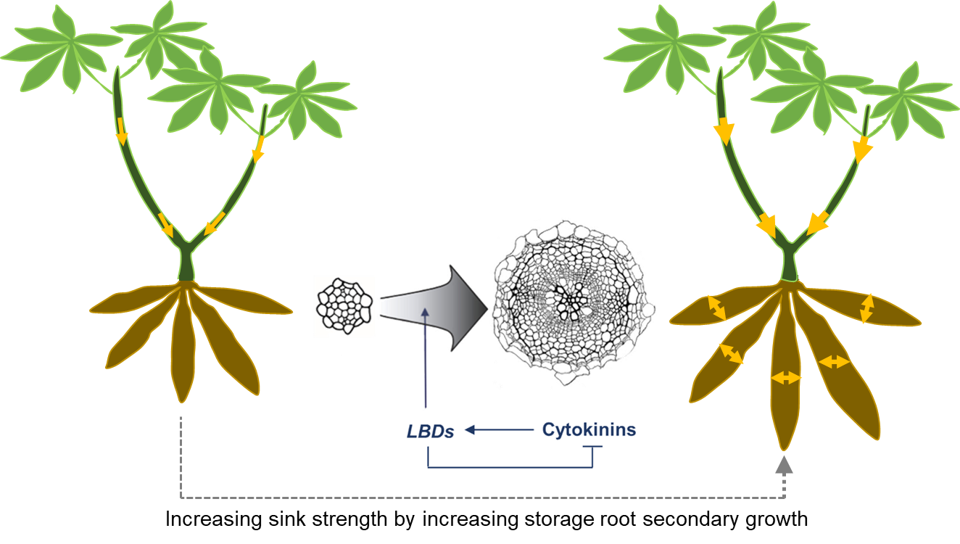

EM2.2_Manipulation of downstream factors involved in xylem parenchyma cell formation

2.2
EM2.1_Manipulation of OVAC and cytokinin metabolism or signaling
2.1
Summary of Goals and Impact
The goal of EM2 is to enhance the sink strength of cassava storage roots by promoting the formation of xylem parenchyma cells, which are crucial for starch storage. By stimulating the vascular cambium, the tissue responsible for radial growth, through targeted manipulation of cytokinin (CK) signalling pathways and other secondary growth regulators, this module aims to significantly increase the radial growth and starch-storing capacity of cassava roots.

For smallholder farmers, the impact of this research could be transformative. By boosting the storage root yield through an increase in the number of starch-storing cells, EM2 has the potential to deliver higher yields with minimal additional inputs. This approach could lead to more productive and resilient cassava plants, directly improving food security and livelihoods in regions where cassava is a staple crop. The innovative use of tissue-specific gene expression to control and enhance storage root growth could set a new standard for biotechnological interventions in root crops, offering scalable solutions for sustainable agriculture.

EM2.1_Manipulation of OVAC and cytokinin metabolism or signalling

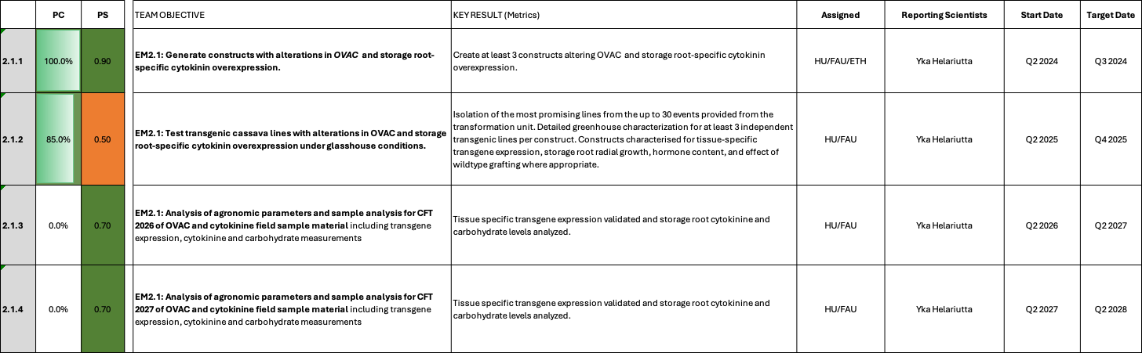

EM2.1_Manipulation of OVAC and cytokinin metabolism or signalling

Reporting module leader: Yka Helariutta, HU with FAU and ETH.

Progress Update:

2.1.1. Generate constructs with alterations in OVAC and storage root-specific cytokinin overexpression.
As outlined in the project application, constructs targeting OVAC and cytokinine synthesis were created (see Table 1). For OVAC, a constitutive overexpression construct, utilizing CaMV35S promoter and the Arabidopsis OVAC sequence, as well as a Crispr/Cas9 construct targeting endogenous cassava OVAC was created. For cytokinine synthesis, the storage root-specific promoter pStPatatin was chosen in order to avoid negative side effects for fibrous roots or other organs. The promoter controls the expression of Arabidopsis ISOPENTENYLTRANSFERASE7 (AtIPT7) and/or Arabidopsis LONELY GUY (AtLOG1).

Table 1_Summary of the gene constructs created.
Construct number | Gene cassette | Database link
C2-51 | pCaMV35S::6xHA-AtOVAC::Ter | https://cassbase.org/stock/454502/view
CC1_MeOVAC | pAtU6::gRNA OVAC1 + pAtU6::gRNA OVAC2 + pCaMV35S::Cas9-SV40NLS::Ter | https://cassbase.org/stock/462097/view
C2-59 | pStPatatin::AtIPT7::tAtuG7 | https://cassbase.org/stock/462046/view
C2-56 | pStPatatin::AtLOG1::tAtLOG1 | https://cassbase.org/stock/454161/view
C75 | pStPatatin::AtIPT7::tAtuG7 + pStPatatin::AtLOG1::tAtLOG1 | https://cassbase.org/stock/462047/view
C2-132 | pMeACL5::GUS + pMeACL5::AtBUD2 | https://cassbase.org/stock/471880/view

Construct cloning has been finished and the OVAC overexpression construct and the OVAC Crispr/Cas9 construct has already been transformed into TMS60444. FAU has shipped 10 lines of pCaMV35S::AtOVAC and 24 lines of MeOVAC Crispr/Cas9 to HU for further analysis. Transformation of the AtIPT7, AtLOG1, and AtIPT7 + AtLOG1 constructs has been initiated, but will require several month until completion.

Transformation of C2-51, CC1_MeOVAC, C2-56, C2-59, and C75 lines has been completed.

A new construct has been proposed by HU. Results from Arabidpsis thaliana suggest that parenchyma formation is positively influenced by the level of S-Adenosylmethionine Decarboxylase enzyme BUD2. BUD2 is involved in the formation of Decarboxy-S-Adenosylmethionine, which is an important precursor for polyamine biosynthesis and therefore also an important precursor for the polyamine thermospermine. Prior results from HU also indicate that thermospermine, alongside cytokinin, plays an important role in parenchyma formation. Recent HU results indicate that BUD2 overexpression causes increased numbers of parenchyma cells in Arabidopsis. We previously tested overexpression of the thermospermine synthase, ACL5, in cassava, but could not observe a beneficial effect. However, in light of the recent Arabidopsis results, it is possible that the enzyme levels of ACL5 are not actually limiting thermospermine synthesis, but rather the supply of precursor molecules is restricing thermospermine synthesis. To test this hypothesis, we will attempt to overexpress Arabdipsis BUD2 in cassava storage roots. To ensure that BUD2 is expressed in the same domains as ACL5, we selected the pMeACL5 promoter to drive BUD2 expression. Cloning of C2-132 is finished, but transformation still needs to be initiated.

2.1.1. Test transgenic cassava lines with alterations in OVAC and storage root-specific cytokinin overexpression under glasshouse conditions.
OVAC expression levels have been analysed in the pCaMV35S::OVAC lines to confirm that they are overexpressors at transcript level. For the OVAC Crispr/Cas9 lines, the insertion numbers were determined by digital PCR and for selected lines also by Southern blot. AtIPT7/AtLOG1 transgenic plants are still in transformation. The current transformation status is displayed in Table 2.

Table 2_Transformation status of EM2.1 plants
Construct number | Gene cassette | Database link | Current transformation status
C2-59 | pStPatatin::AtIPT7::tAtuG7 | https://cassbase.org/stock/462046/view | No problems reported; 40-100 shoots have passed the rooting test; 24 lines have been created and T-DNA integration numbers have been determined; Greenhouse analyses ongoing
C2-56 | pStPatatin::AtLOG1::tAtLOG1 | https://cassbase.org/stock/454161/view | Transformation finished; 13 events confirmed; Greenhouse analyses ongoing
C75 | pStPatatin::AtIPT7::tAtuG7 + pStPatatin::AtLOG1::tAtLOG1 | https://cassbase.org/stock/462047/view | No problems reported; 40-100 shoots have passed the rooting test; 25 lines have been created and T-DNA integration numbers have been determined; Greenhouse analyses ongoing
C2-132 | pMeACL5::AtBUD2 | https://cassbase.org/stock/471880/view | Transformation in Jan 2026
As described in detail in TM2.1, FAU received a large delivery of plant lines from ETH in April. Lines for EM2.1 are summarized in Table 3. Essentally, the IPT7, LOG1, IPT7/LOG1 set is now complete.

Table 3_EM2.1 events/lines available for further processing
Construct | Name | Hyg^{R} events received | Lines maintained | Next steps
C2-59 | pStPatatin::AtIPT7 | 63 (untested) + 24 (untested) | 24 (untested) + 24 (untested) | Single insertion events determined by dPCR; Transgene expression analysis ongoing; Transgene expression has been confirmed in 21 lines; Screening complete, detailed greenhouse characterization ongoing: Phenotyping, qPCR, hormone measurments, and RNA-Seq to be conducted at different root bulking stages.
C75 | pStPatatin::AtIPT7 + pStPatatin::AtLOG1 | 56 (untested) + 9 (untested) | 24 (untested) + 9 (untested) | Single insertion events determined by dPCR; Transgene expression analysis ongoing; Transgene expression has been confirmed in 13 lines; Screening complete, detailed greenhouse characterization ongoing: Phenotyping, qPCR, hormone measurments, and RNA-Seq to be conducted at different root bulking stages.
C2-56 | pStPatatin::AtLOG1::tAtLOG1 | 13 | 13 | Transgene expression has been confirmed in 11 lines; Screening complete, detailed greenhouse characterization ongoing: Phenotyping, qPCR, hormone measurments, and RNA-Seq to be conducted at different root bulking stages.

We selected 24 lines from C2-59 and C75 and transferred them (alongside the previously selected C2-56 lines) to the greenhouse. In parallel, we tested the 24 lines each for single insertion events by dPCR. At least 14 and 12 single insertion lines were identified for C2-59 and C75, respectively. C2-56, C2-59, and C75 lines are currently growing in the greenhouse in small pots to trigger an early storage root formation. Once storage roots have been formed, transgene expression will be tested by qRT-PCR.

Expression screening for C2-59, C75, C2-56 is ongoing. Leave samples and storage root samples have been collected and RNA extraction is currently ongoing. The primary screening of these lines has been concluded and several transgene expressing lines could be isolated. However, a more detailed greenhouse analysis is required. This cultivation is currently being initiated at FAU. The detailed characterization will asses changes in traits, anatomy, hormonal contents, and gene expression profiles. Results are projected for Q3 2026.

Approximately 12 preferentially single insertion lines from construct C2-59 (pStPatatin::AtIPT7), construct C2-56 (pStPatatin::AtLOG1), and C75 (AtIPT7+AtLOG1) were investigated for their transgene expression (Fig. 1) and phenotype (Fig. 2) during a first screening.

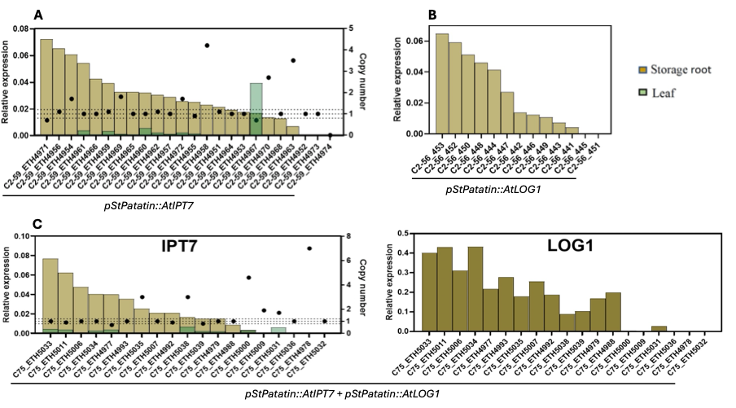
Fig. 1. Transgene expression of C2-59 (pStPatatin::AtIPT7), C2-56 (pStPatatin::AtLOG1), and C75 (AtIPT7+AtLOG1). (A) Transgene expression of C2-59 (pStPatatin::AtIPT7) in leaf (green) and storage root (braun). Dots indicate the T-DNA copy number per line. Transgene expression is normalized to the reference gene MeGAPDH. (B) Transgene expression of C2-56 (pStPatatin::AtLOG1) in leaf (green) and storage root (braun). Transgene expression is normalized to the reference gene MeGAPDH. (C) Transgene expression of C75 (AtIPT7+AtLOG1) in leaf (green) and storage root (braun). Dots indicate the T-DNA copy number per line.

Transgene expression was detected for all three constructs and was preferentially observed in storage root, matching the storage root specificity of the StPatatin promoter.

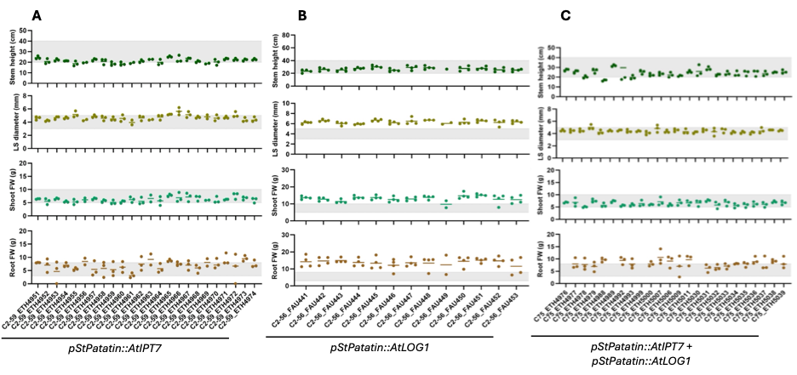
Fig. 2. Phenotypes of greenhouse-grown C2-59 (pStPatatin::AtIPT7), C2-56 (pStPatatin::AtLOG1), and C75 (AtIPT7+AtLOG1). Stem height, lower stem (LS) diameter, shoot fresh weight, and root fresh weight were determined at approx. 2 month after planting. (A) Values for C2-59 (pStPatatin::AtIPT7), (B) Values for C2-56 (pStPatatin::AtLOG1), (C) Values for C75 (AtIPT7+AtLOG1). Grey bars indicate the control plant values.

Phenotypic values were recorded approximately 2 month after planting. Lines from construct C2-59 (pStPatatin::AtIPT7) and C75 (AtIPT7+AtLOG1) appeared similar to control lines in the first screening. Lines from construct C2-56 (pStPatatin::AtLOG1) displayed higher values for lower stem diameter, shoot fresh weight, and root fresh weight for the majority of lines in the first screening.

Select lines were replanted in the greenhouse for detailed analyses (Table 4). Fifteen replicates per line were planted to enable analysis of the storage root bulking behaviour at three consequtive timepoints, 30, 38, and 60 days after planting.

Table 4_Plant lines transferred to the greenhouse for detailed analyses.
Plant lines | Construct | Pre bulking (30 dap) | Early bulking (38 dap) | During bulking (60 dap)
VC_ETH5602 | Vector control | 5 replicates - sampled | 5 replicates - sampled | 5 replicates - growing
VC_ETH5603 | Vector control | 5 replicates - sampled | 5 replicates - sampled | 5 replicates - growing
C2-56_FAU453 | pStPatatin::AtLOG1 | 5 replicates - sampled | 5 replicates - sampled | 5 replicates - growing
C2-56_FAU452 | pStPatatin::AtLOG1 | 5 replicates - sampled | 5 replicates - sampled | 5 replicates - growing
C2-56_FAU450 | pStPatatin::AtLOG1 | 5 replicates - sampled | 5 replicates - sampled | 5 replicates - growing
C2-56_FAU448 | pStPatatin::AtLOG1 | 5 replicates - sampled | 5 replicates - sampled | 5 replicates - growing
C2-59_ETH4971 | pStPatatin::AtIPT7 | 5 replicates - sampled | 5 replicates - sampled | 5 replicates - growing
C2-59_ETH4956 | pStPatatin::AtIPT7 | 5 replicates - sampled | 5 replicates - sampled | 5 replicates - growing
C2-59_ETH4961 | pStPatatin::AtIPT7 | 5 replicates - sampled | 5 replicates - sampled | 5 replicates - growing
C2-59_ETH4966 | pStPatatin::AtIPT7 | 5 replicates - sampled | 5 replicates - sampled | 5 replicates - growing
C75_ETH5033 | pStPatatin::AtLOG1 + AtIPT7 | 5 replicates - sampled | 5 replicates - sampled | 5 replicates - growing
C75_ETH5011 | pStPatatin::AtLOG1 + AtIPT7 | 5 replicates - sampled | 5 replicates - sampled | 5 replicates - growing
C75_ETH5006 | pStPatatin::AtLOG1 + AtIPT7 | 5 replicates - sampled | 5 replicates - sampled | 5 replicates - growing
C75_ETH5034 | pStPatatin::AtLOG1 + AtIPT7 | 5 replicates - sampled | 5 replicates - sampled | 5 replicates - growing
TMS60444_ETH1 | Wildtype | 5 replicates - sampled | 5 replicates - sampled | 5 replicates - growing

During growth plant height and lower stem diameter is conducted regularly (Fig. 3). No obvious differences for plant height were observed so far. Lower stem diameter is equal at 30 and 37 dap, however appears to increase over control lines at 44 dap (Fig. 3D-F). We will continue to monitor the aboveground phenotypes.
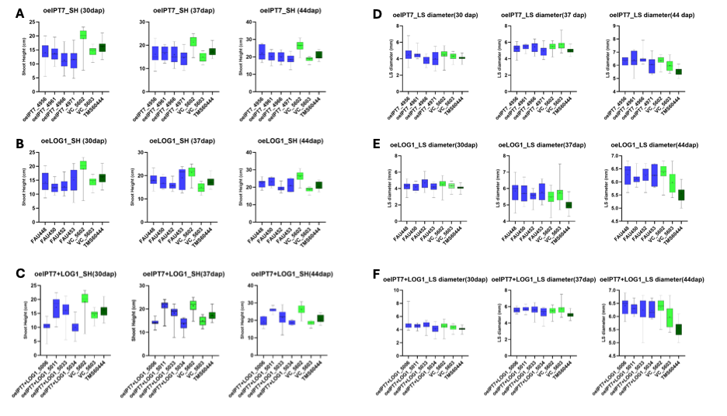
Fig. 3. Plant height and lower stem diameter of C2-59 (pStPatatin::AtIPT7), C2-56 (pStPatatin::AtLOG1), and C75 (AtIPT7+AtLOG1). (A-C) Plant height, (D-F) Lower stem diameter. (A, D) C2-59 (pStPatatin::AtIPT7), (B, E) C2-56 (pStPatatin::AtLOG1), (C-F) C75 (AtIPT7+AtLOG1). Plant height and lower stem diameter was measured at 30, 37, and 44 days after planting (dap).

Two timepoints were samples so far, the pre-bulking timepoint at 30 dap and the early bulking timepoint at 38 dap (Fig. 4). Shoot fresh weight was determined at 30dap (Fig. 4 A, C, E) and 38 dap (Fig. 4 B, D, F). Root fresh weight was determined at 38 dap (Fig. 4 G-I). Shoot fresh weight was similar between transgenic lines and vector control in these two timepoints, although C2-59 (pStPatatin::AtIPT7) tended to increase over controls at 38 dap (Fig. 4B). Interestingly, root fresh weight appeared to increase in C2-56 (pStPatatin::AtLOG1) and C75 (AtIPT7+AtLOG1) over controls starting form the early bulking timepoint 38 days after planting (Fig. 4, H-I).
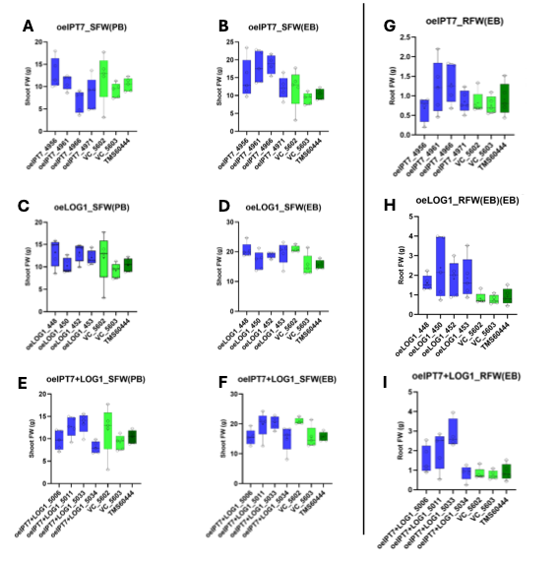
Fig. 4. Shoot and root fresh weight of C2-59 (pStPatatin::AtIPT7), C2-56 (pStPatatin::AtLOG1), and C75 (AtIPT7+AtLOG1). (A, C, E) Shoot fresh weight of C2-59 (pStPatatin::AtIPT7), C2-56 (pStPatatin::AtLOG1), and C75 (AtIPT7+AtLOG1) at pre-bulking 30 days after planting. (B, D, F) Shoot fresh weight of C2-59 (pStPatatin::AtIPT7), C2-56 (pStPatatin::AtLOG1), and C75 (AtIPT7+AtLOG1) at early bulking 38 dap. (G-I) Root fresh weight of C2-59 (pStPatatin::AtIPT7), C2-56 (pStPatatin::AtLOG1), and C75 (AtIPT7+AtLOG1) at early bulking 38 after planting.

Visual inspection of the roots at 38 days after planting indicated an earlier onset of storage root bulking in the transgenic lines (Fig. 5).
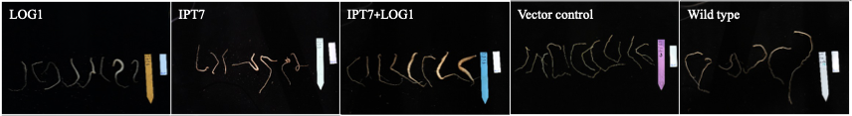
Fig. 5. Pictures from roots of C2-59 (pStPatatin::AtIPT7), C2-56 (pStPatatin::AtLOG1), and C75 (AtIPT7+AtLOG1) at 38 days after planting.

These early results indicate that AtIPT7 and particularly AtLOG1-containing lines have an improved root bulking behaviour. However, more phenotyping is necessary to properly resolve the differences. In addition, transgene expression experiments, cytokinine measurements, and RNA-Seq experiments will be initiated on these materials in the next weeks/month. The during bulking timepoint at 60 days after planting will be evaluated in the coming days.

Very recent data from the last greenhouse sampling suggest that the differences between controls and IPT7/AtLOG1 transgenic lines become even more pronounced over time. IPT7/AtLOG1 seems to accelerate storage root bulking significantly (Fig. 6).
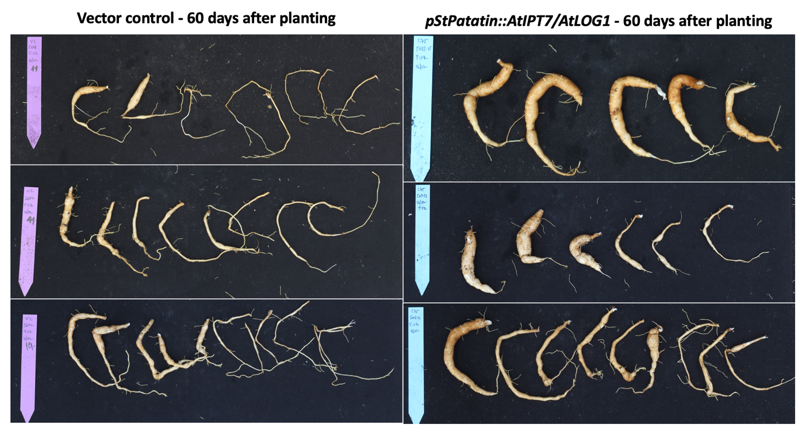

Fig. 6_Phenotypic differences between vector control and pStPatatin::AtIPT7/AtLOG1 transgenic cassava lines at 60 days after planting.

Next steps in the analysis include transgene expression (qPCR), histology, CK metabolite measurements, and RNA-Seq.

HU has analysed nine CC1_MeOVAC lines for MeOVAC editing events. Of these lines, three are currently growing in the greenhouse conditions (alongside wild type TMS60444) to monitor shoot and root phenotypes. As expected based on our observations in Arabidopsis (Y.Helariutta, unpublished), two out of the three greenhouse-grown CC1_MeOVAC lines display stunted and bushy shoot architecture, correlated with editing of the MeOVAC gene (see Figure 6 below). We envision some data on the storage roots during Q3 2025. We have also cloned the MeOVAC gene to understand the precise nature of each editing event in the selected OVAC Crispr/Cas9 lines, and started to work towards analysing transcript levels of e.g. cytokinin and thermospermine biosynthesis genes in these lines.

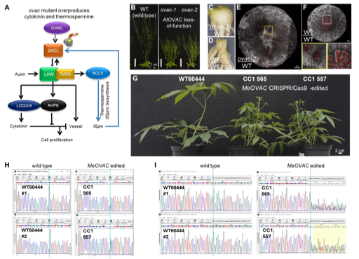
Fig. 6_The Arabidopsis storage organogenesis concept translated to cassava. (A) The pathway of OVAC-Thermospermine-SACL regulon. (B) 7-week-old Arabidopsis plants representative of each genotype. (C-F) Arabidopsis mini-tuber (C) and wild-type self-grafts (D) 11-weeks after grafting, and transverse sections of their hypocotyls (E-F). The ovac mutant overproduces cytokinins and thermospermine to adequate levels to induce storage organogenesis in Arabidopsis. The insets with or without yellow outline are magnified images of region marked with white or yellow box, respectively. Xylem vessel: red, parenchyma: grey. (G) 7-week-old cassava plants representative of each genotype. (H and I) Sanger sequencing data of MeOVAC guideRNA1 (H) and guideRNA1.2 (I) targeting regions, respectively. PCR fragments amplified from genomic DNA were sequenced. Vertical line indicates a position where an extra nucleotide (H) or a deletion/insertion (I) disrupts MeOVAC reading frame in the CRISPR/Cas9 lines, as compared to the wild type sequence (#1 and #2 represent independent samples) that is identical to the reference genome assembly M.esculenta_v8.

HU has also propagated sufficient amount of nine pCaMV35S::OVAC lines, and started rooting in vitro to transfer plants in soil for phenotypic analyses in the greenhouse conditions. We have observed storage roots of three CC1_MeOVAC lines after 8-12 weeks of growth under greenhouse conditions. Our first impression, based on cross sections of few storage roots, suggests that there may be an increased number of vessels in the MeOVAC Crispr/Cas9 edited lines as compared to wild type. Additionally, we monitor starch granule pattern differences possibly indicated by the first cross sections. However these preliminary data need to be verified. We have started to grow nine pCaMV35S::OVAC lines in the greenhouse conditions.

We performed additional phenotyping of storage roots of CC1_MeOVAC lines (see Fig. 7 below). The observations support the earlier finding that the MeOVAC Crispr/Cas9 lines can develop storage roots. However, in the MeOVAC edited lines there seems to be more xylem vessels forming clusters as compared to wild type (Fig. 7C). The altered vascular patterning is in line with our data of atovac mutant plants (Ko et al., in press), although the increase in vessel numbers seems more subtle in cassava. In this first batch of MeOVAC edited lines, the total yield of storage roots reached only about 30% of the fully established wild type grown under the same conditions (Fig. 7D). This suggest that storage root development is not simply delayed in the meovac lines but also limited with a lower yield as compared to wild type. Storage roots of this first set of meovac plants were also sampled for potential metabolomics analyses. We have recently succeeded with multiplying in vitro a third independent MeOVAC edited line (CC1_MeOVAC line 562), which will allow us to further verify the cassava meovac phenotypes.

We have optimized cassava grafting and improved on success rate after various trials. The first set of comparable grafts was performed in December 2025 and consists of the following scion/rootstock combinations: meovac/WT, WT/WT and WT/meovac. These will be analysed during Q1-Q2 2026, and appropriate graftings repeated.

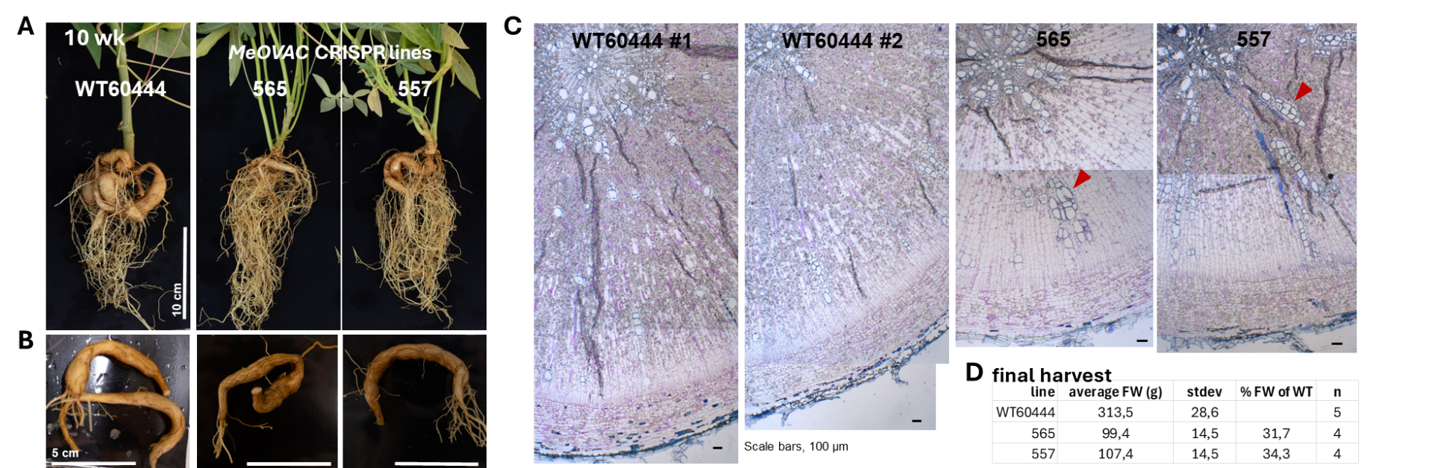
Fig.7_Preliminary characterization of storage roots of transgenic lines carrying contruct CC1_MeOVAC. (A) Overview after 10 weeks of growth in soil. (B) Roots from plants shown in (A) selected for histological analyses. (C) Histological sections stained with ruthenium red and toluidine blue. Arrowheads point at clusters of xylem vessels that appear characteristic to the MeOVAC CRISPR lines. (D) Storage root fresh weight after 6 months of growth in the greenhouse conditions.

We have measured various phenotypic parameters of the first set of transgenic lines carrying the construct C2-51 (see Fig. 8 below). This is the first set of cassava plants closely monitored in the HU greenhouse from late fall until winter, and as such may serve to understand how cassava develops in the local conditions during a naturally unfavorable growth season. Based on the shoot and root phenotyping data collected, the overall impression is that the transgenic lines over-expressing AtOVAC do not seem to outperform wild type. There is variation in storage root yield, however it seems that at best the OVAC over-expressing lines can reach up to about 85% of wild type yield during the timepoints analysed. Throughout the present time series, three lines (425, 427, 438) most consistently reached the highest storage root yield and the widest stem diameter (measured below the 6th leaf counted from the apex) among all transgenic lines. Currently we are in a process of embedding storage root samples for anatomical studies. We have also collected storage root samples of all lines for potential metabolomics analyses.

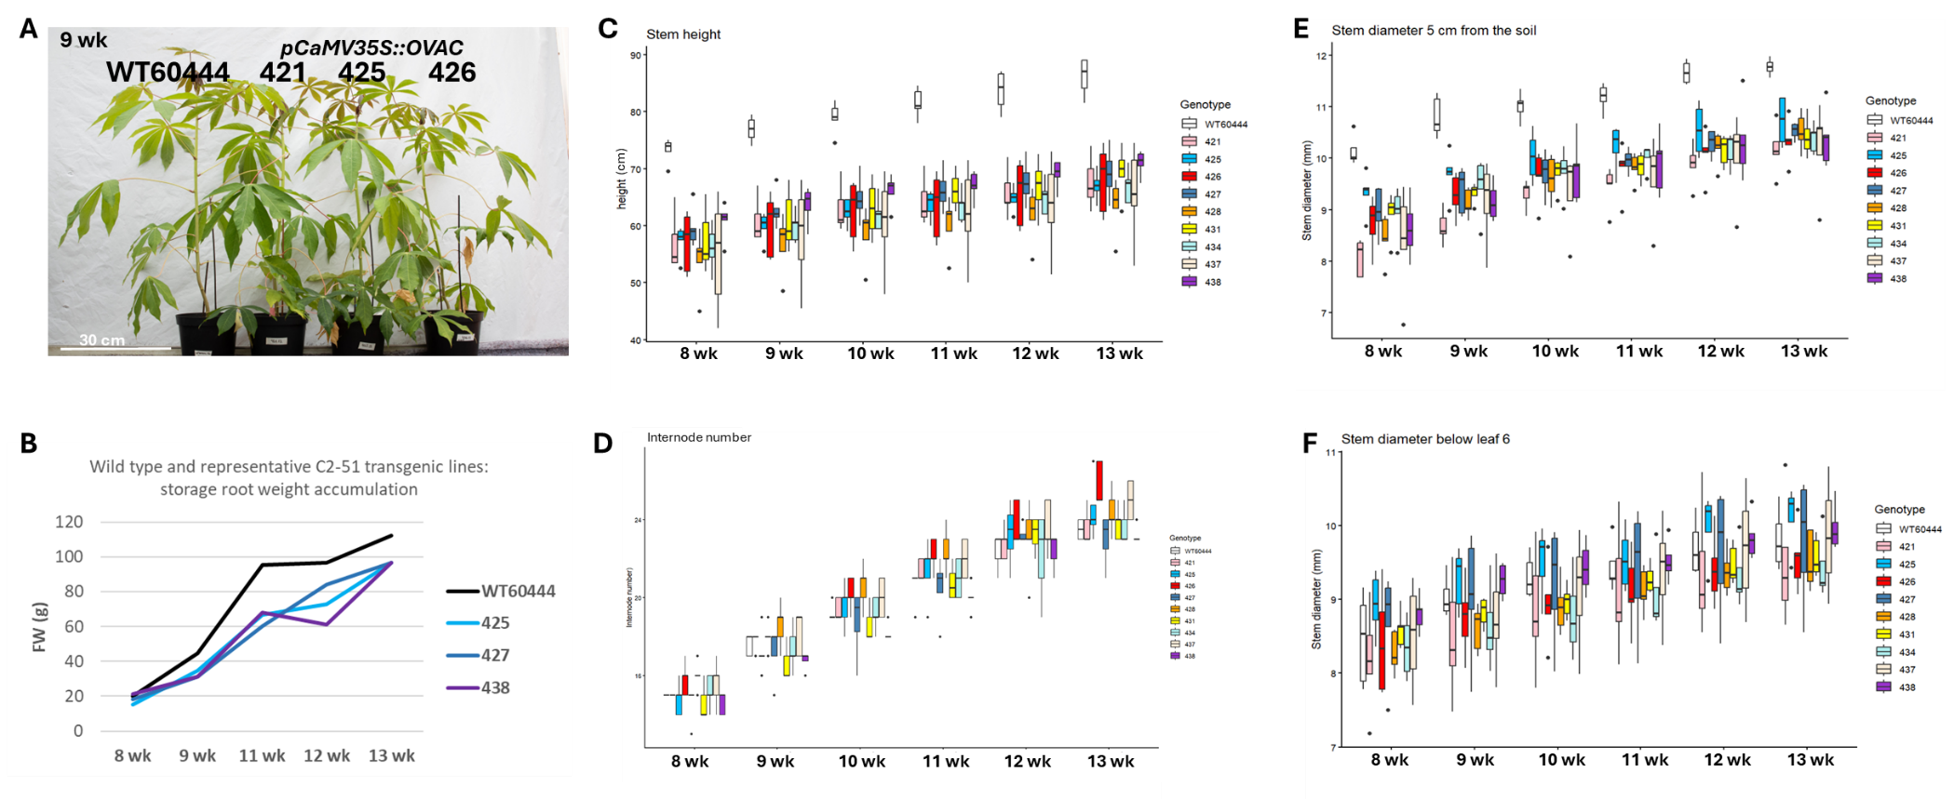
Fig. 8_Preliminary characterization of shoot and root phenotypes of transgenic lines carrying the construct C2-51 in the greenhouse conditions. (A) Overview of representative plants after 9 weeks of growh in soil. (B) Storage root weight of representative lines. (C) Stem height, (D) internode number, (E) stem diameter at 5 cm from soil, and (F) stem diameter measured below the 6th leaf from the top at one-week intervals as indicated. n=4-5 in C to F.

After consulting Gates Ag One on potential IP protection of the Brassicaceae mini-tuber concept based on grafting Arabidopsis ovac mutant (Fig. 6 A-F), we filed a provisional patent application in Helsinki to protect this invention. A preprint on the aradish Arabidopsis plants was submitted to bioarchives (https://www.biorxiv.org/content/10.64898/2026.01.29.702522v1).
While optimizing cassava grafting, we performed anatomical analyses on young stem and observed an increased vessel number in a MeOVAC CRISPR line as compared to wild type (Fig. 9). This supports a trend earlier observed in meovac storage roots (Fig. 7C).
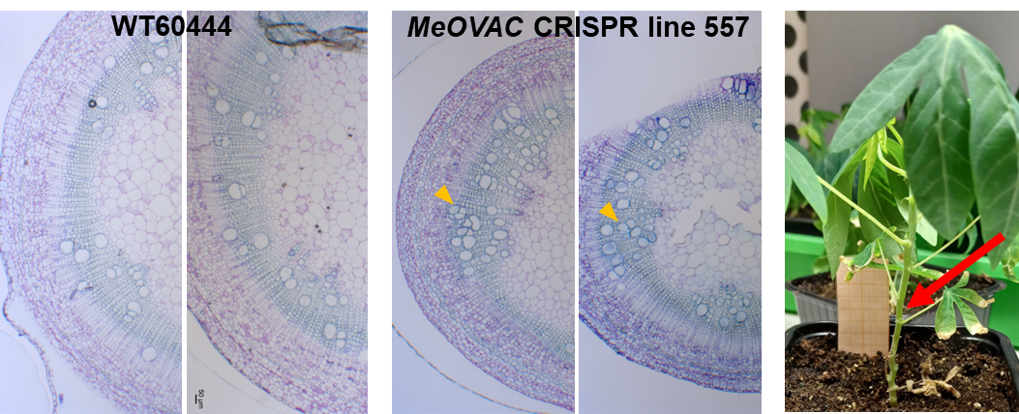
Fig. 9_Histological sections of young stems stained with ruthenium red and toluidine blue. Arrowheads point at clusters of xylem vessels that appear characteristic to the MeOVAC CRISPR line. On the image to the right, red arrow points at an approximate position on the stem that was harvested for histological analyses in each case.

Challenges and Mitigations:
We have not encountered any challenges at this stage.

Many (but not all) of the transgenic events harboring the construct CC1_MeOVAC grow poorly under the HU standard in vitro growth conditions, while we experience no issues with the wild type or other transgenic events under the same conditions. To promote development of the events with defects, we have attempted to supply the growth media with plant hormones, and test growth cabinets with different light and temperature conditions. Similarly, growth of CC1_MeOVAC in FAU tissue culture is aberrant. Several lines are shedding leaves in tissue culture jars (a so far unobserved phenomenon for any line) and are dying off. It is yet unknown if the abarant growth behavior is conncected to the editing of the MeOVAC locus (HU is currently conducting genotyping of the lines).

Our first grafting trials (WT/WT and CC1_MeOVAC/WT) resulted in very low success rates, most likely due to the fact that we attempted to perform (micro)grafting just 1-2 weeks after the plants had been transferred from in vitro to soil. We continue to experiment what would be the earliest possible timepoint for the graftings, to induce storage organogenesis from early developmental stages.

The greenhouse analysis of these lines takes longer than initially projected, due to limitations in plant multiplication and greenhouse capacity at FAU and necessary method and cassava cultivation establishment at HU. However, some of the “hormone” lines have been included in the upcoming field trial (small side trial) to get an idea about their field performance early on. Greenhouse analyses will proceed in parallel.

It is challenging to provide favourable growth conditions for cassava particularly during the winter season in Helsinki. We have purchased and installed high power led lamps in the glasshouse to help boost cassava growth when natural light is scarce, however reaching stable, high temperatures remains infeasible during the coldest months. Alternatively, in closed cabinets we can provide a strictly controlled environment, but space is more limited and light quality and direction are suboptimal, affecting plant development. Currently HU is contemplating new growth chambers that we try to ensure better suitable for cassava requirements.

Next Steps in the Action Plan:
HU will first propagate the transgenic cassava to ensure sufficient plants for phenotypic analyses. Simultaneously, we will assess OVAC expression levels in the pCaMV35S::OVAC lines and genotype the OVAC Crispr/Cas9 lines to correlate expression levels and genotypes with storage root organogenesis phenotypes. The top three lines from each group will undergo in-depth analysis, including confirmation of OVAC and target gene expression in storage roots, histological analysis, and quantification of hormones, polyamines, and starch. Additionally, meovac mutants will be grafted onto wildtype cassava to examine their ability to induce storage organogenesis, similar to Arabidopsis mini-tuber formation.
- Re-asses OVAC expression levels in the overexpression lines to ensure that no gene silencing occurred (Concluded)
- Genotype OVAC Crispr/Cas9 genome editing events and correlate gene expression with with storage root formation phenotypes (Concluded)
- HU will start grafting ovac cassava KO lines as soon as possible. (Concluded)
- Conduct further plant line selection and expression screening (Concluded).
- Detailed characterization of “hormone” lines at FAU. This includes traits, anatomy, hormonal contents, and gene expression profiles (Ongoing)
- Anatomical characterization of OVAC OE plants and detailed investigation of ovac mutants, particularly the impact of grafting ovac shoots to WT rootstocks. This combination caused root expansion in various Brassicaceae. (Ongoing)

EM2.2_Manipulation of downstream factors involved in xylem parenchyma cell formation

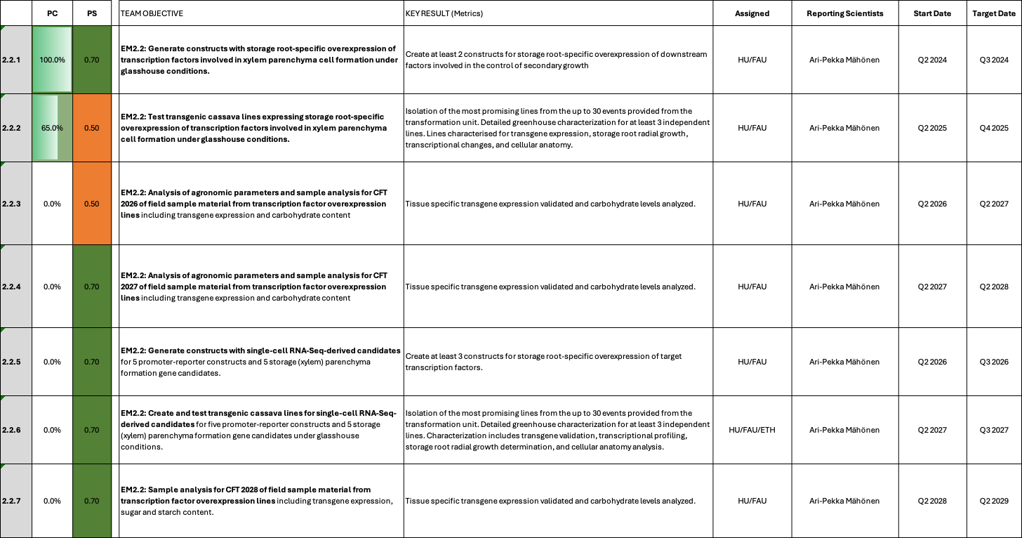

EM2.2_Manipulation of downstream factors involved in xylem parenchyma cell formation

Reporting module leader: Ari Pekka Mähönen, HU with FAU and ETH.

Progress Update:

2.2.1. Generate constructs with storage root-specific overexpression of transcription factors involved in xylem parenchyma cell formation under glasshouse conditions.

Particular LBD transcription factors were demonstrated to be involved in secondary root growth in Arabidopsis (Ye et al., 2021). To test their impact on storage root formation in cassava, two endogenous LBD genes were targeted for overexpression in their native expression domains. MeLBD11 (Manes.04G025300) was selected, because of its very strong induction during storage root bulking and its cambium/xylem localized expression pattern. In addition, AtLBD11 overexpression could already be shown to improve secondary growth in the cassava stems in an earlier construct attempt. MeLBD4 (Manes.06G173400) was selected because of its expression pattern (downregulation in stems and upregulation in storage roots) and because LBD4 is known to be a key regulator of secondary growth. To retain the native expression domains of the genes, yet still achieve overexpression, the GAL4VP16-UAS system was utilized. Table 1 shows the generated constructs.

Table 1_Summary of the gene constructs created.
Construct number | Gene cassette | Database link
C123 | pManes.06G173400 (MeLBD4)::GAL4VP16::tCaMV35S + pUAS::MeLBD4 CDS-6xHA::tMeLBD4 + pUAS::ER-GFP::Ter | https://cassbase.org/stock/462095/view
C124 | pManes.04G025300 (MeLBD11)::GAL4VP16::tCaMV35S + pUAS::MeLBD11 CDS-6xHA::tMeLBD11 + pUAS::ER-GFP::Ter | https://cassbase.org/stock/462096/view

Cloning of constructs has been finished and constructs have recently been shared with the transformation unit at ETH. Transformation of MeLBD4 and MeLBD11 constructs has been initiated at ETH Zurich.

2.2.2. Test transgenic cassava lines expressing storage root-specific overexpression of transcription factors involved in xylem parenchyma cell formation under glasshouse conditions.
Transformation of constructs is still ongoing and characterization of plant lines could not start yet. However, several shoots or events have already been isolated for the respective transformations at ETH (Table 2).

Table 2_Transformation status of EM2.2 plants
Construct number | Gene cassette | Database link | Current transformation status
C123 | pManes.06G173400 (MeLBD4)::GAL4VP16::tCaMV35S + pUAS::MeLBD4 CDS-6xHA::tMeLBD4 + pUAS::ER-GFP::Ter | https://cassbase.org/stock/462095/view | No problems reported; 30-150 emerging cotelydon embryos on shoot induction media; 24 lines were maintained; T-DNA integration numbers have been determined
C124 | pManes.04G025300 (MeLBD11)::GAL4VP16::tCaMV35S + pUAS::MeLBD11 CDS-6xHA::tMeLBD11 + pUAS::ER-GFP::Ter | https://cassbase.org/stock/462096/view | No problems reported; 30-150 emerging cotelydon embryos on shoot induction media; 21 lines were maintained; T-DNA integration numbers have been determined

Transformation is still ongoing at ETH Zurich. Between 40-80 plantlets per construct are getting established on CBM (Cassava Basic Media).

Transformation of C123 and C124 (Table 3) has concluded. Plant lines will be screened for T-DNA insertion numbers and transgene expression in the coming month. Select plant lines will be supplied to HU as soon as possible.

T-DNA integration screening was completed and plant lines are growing in the greenhouse for the transgene expression screening. Plant lines can be shared for more detailed analysis once the primary screening is completed.

Table 3_EM2.1 events/lines available for further processing
Construct | Name | Hyg^{R} events received | Lines maintained | Next steps
C123 | pManes.06G173400 (MeLBD4)::GAL4VP16::tCaMV35S + pUAS::MeLBD4 CDS-6xHA::tMeLBD4 + pUAS::ER-GFP::Ter | 36 | 36 | Single insertion events determined by dPCR; Expression screening is ongoing; Transgene expression was confirmed for 24 lines
C124 | pManes.04G025300 (MeLBD11)::GAL4VP16::tCaMV35S + pUAS::MeLBD11 CDS-6xHA::tMeLBD11 + pUAS::ER-GFP::Ter | 21 | 21 | Single insertion events determined by dPCR; Expression screening is ongoing; Transgene expression was confirmed for 19 lines

Expression screening for C123 and C124 is ongoing. Leave samples have been collected and we are currently waiting for storage root formation. The primary screening of these lines has been concluded and several transgene expressing lines could be isolated. However, a more detailed greenhouse analysis is required. This cultivation is currently being initiated at FAU. The detailed characterization will asses changes in traits, anatomy, hormonal contents, and gene expression profiles. Results are projected for Q3 2026.

Several transgenic lines from C123 (MeLBD4 OE) and C124 (MeLBD11 OE) were screened for their transgene expression and phenotype in a first greenhouse planting (Fig. 1). Both constructs show good transgene expression in storage roots (Fig. 1A, C). Preferentally, single insertion lines were used. While no obious phenotypic differences were seen for lines of C123 so far, lines from C124 could potentially have challenges in storage root formation since many lines did not form storage roots in the first screening (Fig. 1D). However, more precise phenotyping and overall analysis is required.
Currently, we are focusing on the analysis of the AtIPT7/AtLOG1 lines and will initiate more detailed analyses of C123 and C124 once there is more greenhouse space available again.
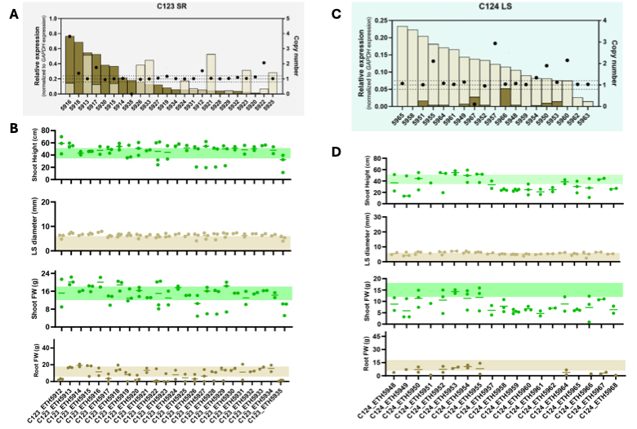
Fig. 1_Transgene expression, copy number determination, and phenotyping of the first screening planting for C123 and C124. (A) Transgene expression of C123 in lower stem (light braun) and storage roots (braun). Expression was normalized against the reference gene MeGAPDH. Copy number is indicated by the black dots. (B) Shoot height, lower stem diameter, shoot fresh weight, and root fresh weight results of C123. (C) Transgene expression of C124 in lower stem (light braun) and storage roots (braun). Expression was normalized against the reference gene MeGAPDH. Copy number is indicated by the black dots.

Since C123 and C124 utilize the GAL4/UAS expression system, an additional, but independent ER-GFP cassette was used to highlight the transgene expression domain (Fig. 2). Lines from both constructs displayed ER-GFP fluorescence over background level (vector control fluorescence). While GFP fluorescence in LBD11 was overall stronger, both constructs showed GFP fluorescence near xylem vessels. This suggests that LBD4 and LBD11 might be involved in the control of xylem vessel formation. However, more detailed analysis is required before conlusions can be drawn.

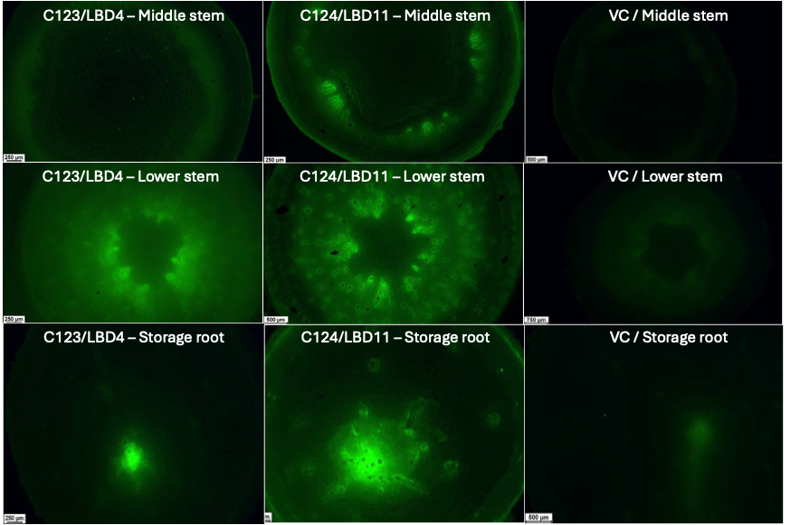
Fig. 2_GFP fluorescence in middle stem, lower stem, and storage root of select lines from C123 (MeLBD4) and C124 (MeLBD11). Vector controls serve as negative control and to determine autofluorescence levels.

Challenges and Mitigations:
We have not encountered any challenges at this stage.

Initial plans for transformation, pre-screening and subsequent field testing were made very optimistic. Currently it seems like we will be able to stick to the outlined field testing timelines only for constructs that were part of the first transformation batches (EM1.1 lines, EM2.1 lines, EM3.1 lines, EM3.2 lines, ETH lines). Unfortunately, EM2.2 constructs were not part of the first batches and are therefore are slightly behind schedule. Although the plant lines look very healthy in the greenhouse, we will not be able to complete pre-screening in time to select confirmed lines for the upcoming field trial Taichung 2026. We have a hard deadline to nominate lines for import to Taiwan (October 10), but won´t be able to harvest and analyze storage roots by this point. Therefore, the lines can only be included in the next field trial. However, detailed greenhouse characterization can still take place as planned.

The greenhouse analysis of these lines takes longer than initially projected, due to limitations in plant multiplication and greenhouse capacity at FAU. However, a new cultivation is currently being established in the greenhouse and detailed characterization results are projected for Q3 2026.

Since we have a multitude of transgenic lines, it is challenging to find enough greenhouse space to proceed with the analysis of all constructs at once. Priorities had to be defined and other constructs to be delayed.

Next Steps in the Action Plan:
- Constructs will be transformed and transgenic lines will be distributed for primary analysis. Additionally, existing cassava expression data is being mined for further ideas/concepts to improve storage root secondary growth.
- Primary characterization of transgenic events can begin once the plants are available. ETH to supply the new lines (via FAU) as soon as possible. (Concluded)
- Complete greenhouse pre-screening and line selection and supply selected lines to HU (Ongoing).
- Conduct detailed characterization of LBD lines in the greenhouse, including traits, anatomy, hormonal contents, and gene expression profiles
- Conduct detailed greenhouse characterization once growth space is available

EM3: Increasing sink strength by optimizing metabolic flux in storage roots
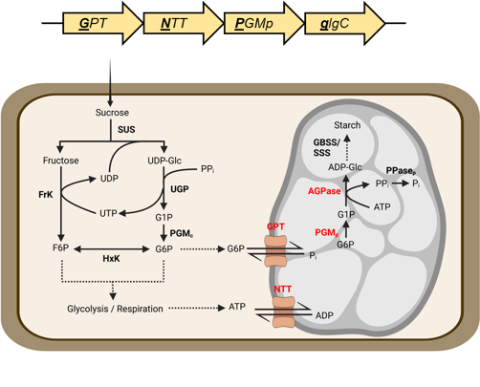
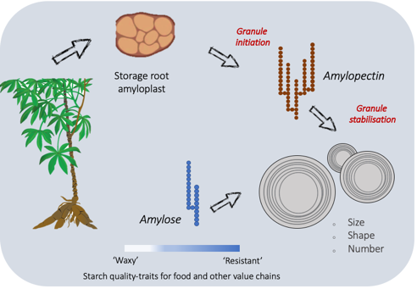
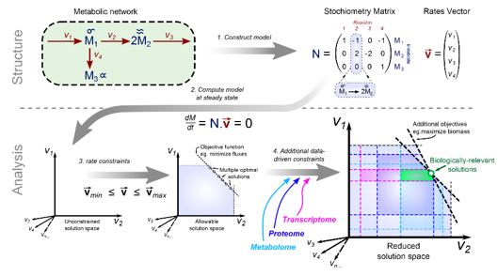
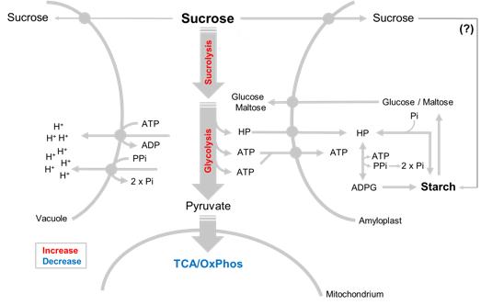
EM3.1: Optimization of sucrolytic cleavage and glycolysis
3.1
EM3.4: Model-based predictions
3.4
EM3.3: Starch granule initiation
and growth
3.3
EM3.2: Optimization of starch-precursor delivery to amyloplasts
3.2
Summary of Goals and Impact
The objective of EM3 is to enhance the sink strength of cassava storage roots by optimizing the metabolic processes that drive starch biosynthesis. Many African cassava varieties struggle with low starch production, leading to storage roots with excessive sugar and water content. This module seeks to address these limitations by focusing on key metabolic areas: sugar cleavage and glycolysis (EM3.1), the delivery of starch precursors to amyloplasts (EM3.2), and the initiation and growth of starch granules (EM3.3). Additionally, a computational model of storage root metabolism (EM3.4) will be developed to guide the engineering efforts and predict effective gene targets for improving starch synthesis.

This research holds great promise for creating tangible benefits for smallholder farmers. By boosting the starch content and overall yield of cassava, EM3 could lead to more productive crops that offer higher nutritional and economic value. The success of this module would not only increase food security but also support sustainable agricultural practices under low-input conditions, making a significant impact on the lives of farmers who rely on cassava as a staple crop.

EM3.1_Optimization of sucrolytic cleavage and glycolysis

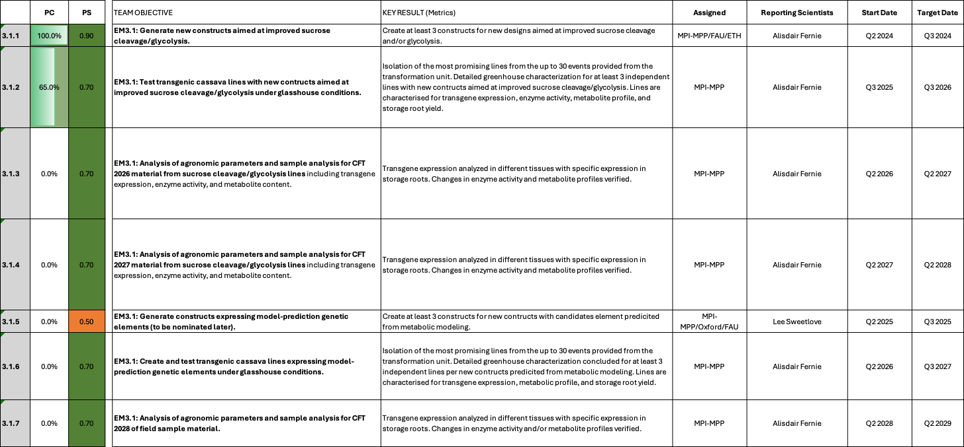

EM3.1: Optimization of sucrolytic cleavage and glycolysis

Reporting module leader: Alisdair Fernie, MPI-MPP with Oxford and FAU.

Progress Update:

3.1.1. Generate new constructs aimed at improved sucrose cleavage/glycolysis.
Prior to the availability of storage root modelling results, five targes have been selected for overexpression in this module. Targets were mostly selected based on their protein correlation with the dry matter trait, as well as other published research.

Table 1_Summary of the gene constructs.
Construct number | Gene cassette | Database link
C2-99 | pMeAPL3a::MeSUS3-HA::Ter | https://cassbase.org/stock/462048/view
C2-100 | pMeGPT2::MePFPbeta::Ter | https://cassbase.org/stock/462049/view
C2-101 | pMeGPT2::MeGAPC::Ter | https://cassbase.org/stock/462050/view
C2-112 | pMeGPT2::PGAM-ENO-PK::Ter | https://cassbase.org/stock/462061/view
C2-110 | pMeGPT2::MeFRK4/7-tdTomato::Ter | https://cassbase.org/stock/462060/view
C2-133 | pStPatatin::AtTPS1::Ter | https://cassbase.org/stock/471881/view

Apart from MeSUS3, which uses the very strong sink-specific MeAPL3 promoter, the other constructs use MeGPT2 promoter, which is also specific for sink tissues with predominant activity in the phloem- and xylem parenchyma cells of storage roots (Zierer et al., 2022). The introduction of the PGAM-ENO-PK multienzyme complex is expected to further enhance carbon partitioning and efficiency, applying insights based on Arabidopsis unpublished data in the research group of Alisdair Fernie. Cloning of all constructs was finished and constructs were sent to ETH for transformation into TMS60444.
A new construct was added to EM3.1. In the frame of the analyses for the metabolic modelling, we analysed radial sections from adult storage roots harvested from the Taiwan CFT 2024. Five to six adult storage roots were sampled, the outer cortex/phloem removed, and the xylem divided into 4 radial sections for each storage root. Metabolic profiling revealed strong metabolic gradients in the radial dimension, confirming earlier studies conducted in the CASS project (Mehdi et al., 2019). The results from TMS60444 storage roots indicate a strongly reduced sugar gradient towards the center of the root, with both glucose, fructose, and sucrose, as well as the signaling molecule trehalose-6-phosphate being strongly reduced towards the center. Overall metabolism also seems reduced towards the center. Energy molecules (ATP/ADP/AMP) all decline towards the center, as does succinate, indicating reduced mitochondrial electron transport chain activity. With both starch synthesis and starch degradation being strongly reduced, it seems like overall anabolism being strongly reduced towards the center of the root.
We want to test the possibility of stimulating storage root anabolism towards the center of the storage root by overexpressing Arabidopsis Trehalose-6-Phosphate Synthase (AtTPS1) in storage roots. Therefore, we created a pStPatatin::AtTPS1 construct (C2-133). Cloning of this construct is finished, however, we still need to initiate transformation.

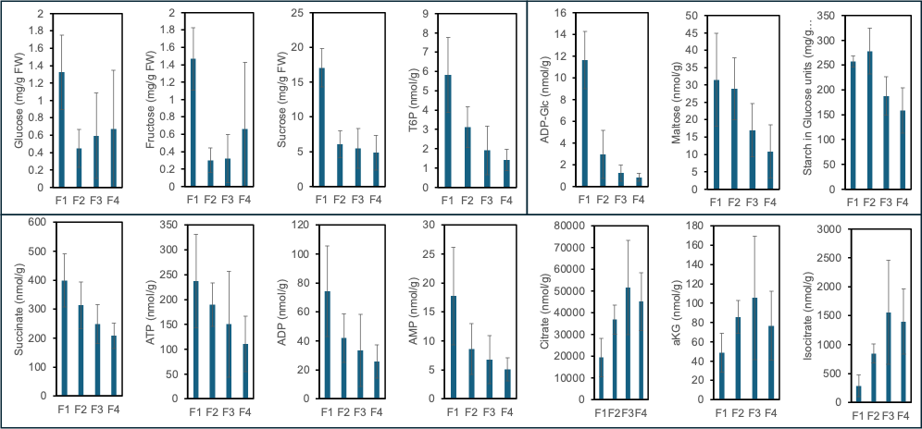
Fig.1_Select metabolites in four radial sections from field-grown TMS60444 storage roots, approximately 9 month after planting. F1 represents the outer, most youngest xylem, F4 represents the inner, most oldest xylem. T6P = Trehalose-6-Phosphate, ATP = Adenosinetriphosphate, ADP = Adenosinediphosphate, AMP = Adenosinemonophosphate, aKG = alpha-Ketogluterate

3.1.2. Test transgenic cassava lines with new constructs aimed at improved sucrose cleavage/glycolysis under glasshouse conditions.
Transformation of constructs is still ongoing and characterization of plant lines could not start yet. However, several shoots or events have already been isolated for the respective transformations at ETH (Table 2). Unfortunately, transformation of C2-99 failed due to a technical issue and needs to be reinitiated.

Table 2_Transformation status of EM3.1 plants
Construct number | Gene cassette | Database link | Current transformation status
C2-99 | pMeAPL3a::MeSUS3-HA::Ter (complete) | https://cassbase.org/stock/462048/view | Transformation has failed due to technical issues; needs to be re-initiated; 24 lines have been maintained; T-DNA integration numbers have been determined
C2-100 | pMeGPT2::MePFPbeta::Ter (complete) | https://cassbase.org/stock/462049/view | 40-100 shoots have passed the rooting test; 24 lines have been maintained; T-DNA integration numbers have been determined
C2-101 | pMeGPT2::MeGAPC::Ter (complete) | https://cassbase.org/stock/462050/view | 40-100 shoots have passed the rooting test; 24 lines have been maintained; T-DNA integration numbers have been determined
C2-112 | pMeGPT2::PGAM-ENO-PK::Ter (complete) | https://cassbase.org/stock/462061/view | 30-150 emerging cotelydon embryos on shoot induction media; 8 lines have been created, T-DNA integration numbers have been determined
C2-110 | pMeGPT2::MeFRK4/7-tdTomato::Ter (complete) | https://cassbase.org/stock/462060/view | 30-150 emerging cotelydon embryos on shoot induction media; 24 lines have been maintained; T-DNA integration numbers have been determined

As described in detail in TM2.1, FAU received a large delivery of plant lines from ETH in April. Lines for EM3.1 are summarized in Table 3. Plants need to be multiplied before shipment to MPI-MPP, which will still require several weeks.

Table 3_EM3.1 events/lines available for further processing
Construct | Name | Hyg^{R} events received | Lines maintained | Status
C2-99 | pMeAPL3a::MeSUS3 | 60 (untested) | 24 (untested) | Select single insertion events by dPCR and conduct a transgene expression screening; 24 lines were tested for transgene expression. Unfortunately, no meaningful transgene expression could be detected in all lines tested. Since another construct utilizing pMeAPL3 also did not show transgene expression, likely the promoter is not performing as expected. Transgene silencing would be another possibility resulting in lack of transgene expression.
C2-100 | pMeGPT2::MePFP1beta | 42 (untested) + 37 (untested) | 24 (untested) + 24 (untested) | Select single insertion events by dPCR and conduct a transgene expression screening; Transgene expression could be observed for 20 lines; Detailed characterization will be performed with the next cultivation
C2-101 | pMeGPT2::MeGAPC | 66 (untested) + 29 (untested) | 24 (untested) + 24 (untested) | Select single insertion events by dPCR and conduct a transgene expression screening; Transgene expression in storage root was observed in 17 lines; Detailed characterization will be performed with the next cultivation
C2-110 | pMeGPT2::MeFrk4-tdTomato | 38 (untested) | 38 (untested) | Select single insertion events by dPCR and conduct a transgene expression screening; 15 lines were tested. Unfortunately, very low transgene expression was detected. Since the pMeGPT2 promoter works well, this indicates transgene silencing.
C2-112 | pMeGPT2::PGAM-ENO-PK | 8 (untested) | 8 (untested) | Select single insertion events by dPCR and conduct a transgene expression screening; Transgene expression could be confirmed for 6 lines

We have screened constructs C2-99, C2-100, and C2-101 for T-DNA insertion numbers and obtained at least 15, 17, and 12 single insertion events, respectively. We have moved 24 lines for these constructs into the greenhouse. Plants are growing in small pots to trigger an early storage root formation. We will conduct transgene expression screening once storage root material is available.
Additionally, we recently received plant lines from ETH Zurich for the constructs C2-110 and C2-112. We will also conduct dPCR and transgene expression prescreening as soon as possible.
We have concluded T-DNA integration screening for all constructs of Table 3 and are currently growing the associated plant lines in the greenhouse. Leaf samples have been taken for all constructs, and storage root samples have been taken for C2-99, C2-100, and C2-101. We are currently extracting RNA and conducting qPCR experiments to confirm transgene expression. We aim to conclude transgene screenings before the hard nomination deadline for the Taichung 2026 field experiments. Plant lines of constructs C2-110 and C2-112 were part of a later transformation batch and have not grown to storage root formation yet. We will not be able to conclude expression screening in time to include these particular lines in the upcoming field trials. However, C2-99, C2-100, and C2-101 will likely be completed in time.

Update Q1 2026
Expression screening and line selection of C2-99 (pMeAPL3::MeSUS3), C2-100 (pMeGPT2::MePFPbeta), C2-101 (pMeGPT2::MeGAPC), and C2-112 (PGAM-ENO-PK) was completed. Transgene expression was determined in source leaves and storage roots. Selected promoters should target activity towards the storage roots. For C2-100 (pMeGPT2::MePFPbeta), C2-101 (pMeGPT2::MeGAPC), and C2-112 (PGAM-ENO-PK) we observed decent and preferential expression in storage roots., as expected (Fig. 2A-C). Several single insertion lines per construct were isolated as well (Fig. 2A-C). Several lines of C2-100 and C2-112 displayed stronger growth compared to vector controls in the initial screening population. However, due to the small pots and the dense planting in the screening experiment, these results need to be validated further.
Lines of C2-99 displayed no transgene expression (Fig. 3), dispite the confirmed activity of the pMeAPL3a promoter (see TM3.1). Likely, the transgene is silenced. Although the codon usage of MeSUS3 was altered, alterations might not have sufficient triggering transgene silencing regardless. However, we want to repeat the expression analysis to exlude technical error.

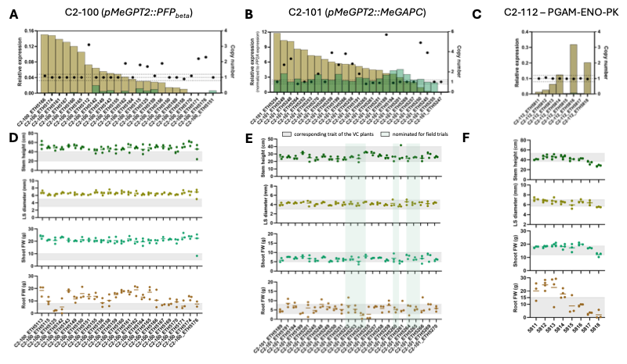
Fig. 2_Transgene expression and phenotypic results for C2-100, C2-101, and C2-112. Plants were grown in the greenhouse for approximately 90 days. Relative expression was determined using MeGAPDH as a reference gene. In the case of C2-101, PP2A was used as a reference gene. Expression in storage roots are displayed in braun, expression in leaves is indicated in green. Grey bars indicate the vector control performance in comparision.

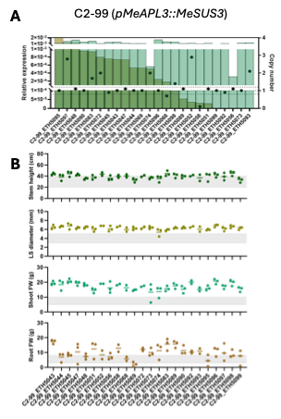
Fig. 3_ Transgene expression and phenotypic results for C2-99 (pMeAPL3::MeSUS3). Plants were grown in the greenhouse for approximately 90 days. Relative expression was determined using MeGAPDH as a reference gene. Expression in storage roots are displayed in braun/dark green, expression in leaves is indicated in green. Grey bars indicate the vector control performance in comparision.

Based on the results of the first screening, six lines each of C2-100 (pMeGPT2::MePFP1beta), C2-101 (pMeGPT2::MeGAPC), and C2-99 (pMeAPL3a::MeSUS3) were selected for a new cultivation to further confirm the transgene expression strength and tissue-specificity, validate enzyme functionality, and characterize the phenotypes. The PFP1beta and GAPC lines have a relatively good expression level in the target root tissues, in contrast, SUS3 expression was quite low, likely due to transgene silencing. Therefore, a two-stage characterization was planned, covering the pre-bulking and during-bulking stages. Plants were potted in the half-liter pots, so the two stages roughly correspond to 35 dap and 60 dap. Since the transgenes target the storage root, we would focus on the timing of storage root initiation, the potential influence on source carbon assimilation and photosynthesis, and, eventually, the biochemical and agronomic traits of the storage root. If the plants passed these checkpoints, we would conduct further metabolite profiling. The PFP1beta and GAPC act respectively at the upstream and downstream of glycolysis, enhancing these control points would lead to stronger glycolysis, potentially provide more energy and metabolic intermediates, e.g., hexose-phosphate, triose-phosphate, pyruvate, which would favor not only starch synthesis, but also cell wall synthesis, amino acid, and organic acid synthesis. In principle, this strategy should give the plant an enhanced sink demand and strength to pull and utilize more carbon.

By today, those plants are 27 dap, the first-stage characterization will start soon. Due to the limited greenhouse capacity, C2-112 (pMeGPT2::PGAM-ENO-PK) was put in the second batch for greenhouse testing once the first batch is complete. Most of the first batch plants were harvested, so cultivation of C2-112 will start soon.

3.1.5 Generate constructs expressing model-prediction genetic elements
We are waiting for the nominations by the modelling team to initiate cloning. These nominations are projected for end of February / early March.
The modelling team has introduced the storage root model and named several target genes for cassava improvement. Currently, we are running particular checks to validate certain model assumptions and are debaiting the best target genes to go forward in the testing pipeline.

Challenges and Mitigations:
Overexpression of GAPC could potentially lead to increased cytosolic acidification, to mitigate this risk, the overexpression of cytosolic malate dehydrogenase (cMDH) has been proposed, as it could help buffer the cytosolic pH by converting oxaloacetate to malate. However, due to the complexity and possible side effects associated with this strategy, this construct remains a lower priority in the current pipeline. Additionally, a construct combining the plant glycolytic enzymes PGAM-ENO-PK as a multienzyme complex has been included in the glycolysis set. Promising results have been observed in Arabidopsis, where overexpression of these enzymes as a complex led to increased biomass (unpublished data), the verification of these results under varying conditions and across multiple generations is ongoing. However, cassava’s ability to propagate vegetatively offers a significant advantage to any possible generation loss that might occur in Arabidopsis.

The SUS3 and Frk4/7 construct seem to be affected by insufficient promoters and/or transgene silencing, resulting in lack of transgene expression. Unfortunately, this requires re-cloning and re-transformation. Since nominations from the modelling team are projected for end of February / early March, we recommend to safe the transformation capacity for constructs addressing these new targets.

However, MePFP1beta, MeGAPC, and PGAM-ENO-PK constructs can still be analyzed. Currently, a repeated cultivation is being initiated to characterize these constructs in more detail.

Next Steps in the Action Plan:
Transgenic plants for each construct are expected to be ready for screening under greenhouse conditions by Q2/Q3 2025. The possibility of growing plants in different facilities is being considered at MPI-MPP to increase the number of plants that can be screened in parallel. This could not only accelerate the discovery of promising transgenic lines, but also allow us to assess how the plants perform under different environmental conditions, thereby strengthening the reliability of the results.
Primary characterization of transgenic events can begin once the plants are available.
- Detailed analyses of transgene-expressing constructs (Ongoing)
- Cloning of model-derived constructs as soon as predictions are available (Ongoing)

EM3.2: Optimization of starch-precursor delivery to amyloplasts

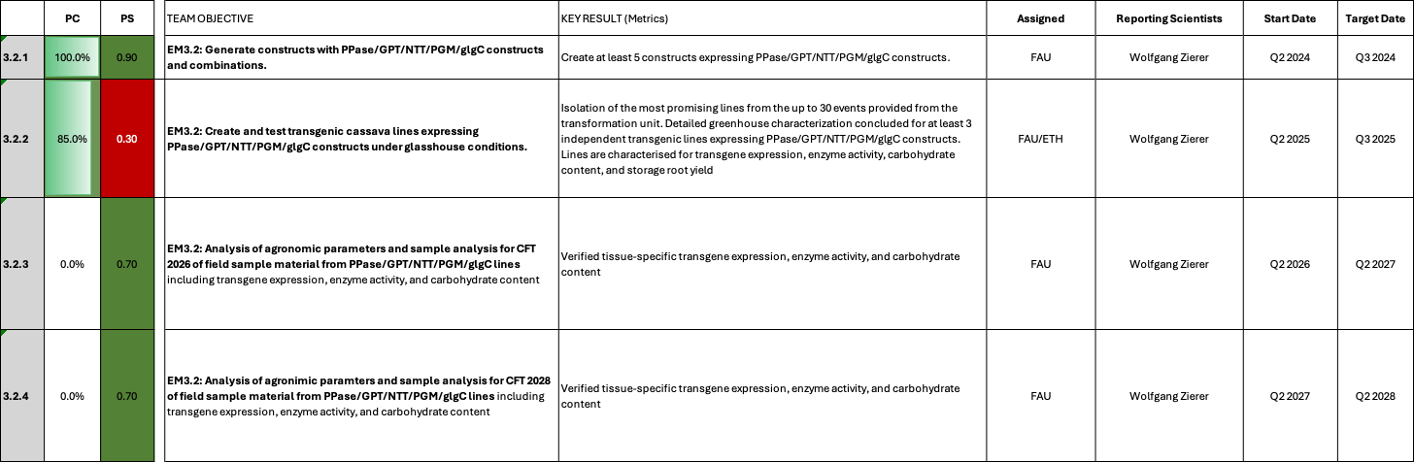

EM3.2: Optimization of starch-precursor delivery to amyloplasts

Reporting module leader: Wolfgang Zierer, FAU with ETH.

Progress Update:

3.2.1. Generate constructs with PPase/GPT/NTT/PGM/glgC constructs and combinations.
As outlined in the project application, new constructs targeting GPT/NTT/PGMp/glgC16 have been created. Table 1 outlines the created constructs. Strong, sink-specific promoters have been selected to drive transgene expression (pStGBSS1, pMeGPT2, pStPat, pMeAPL3a). Specificity for sink organs could already be demonstrated for pStGBSS, pMeGPT2, and pStPat (Zierer et al., 2022). The promoter of MeAPL3a has not yet been confirmed, but it is included in the first batch of promoter-reporter constructs created in the frame of TM3.1 (see there). However, sink-specific activity of pMeAPL3a is likely, as MeAPL3a represent the major gene variant of the large ADP-glucose phyrophosphorylase and its transcript is highly sink-specific (Expression data from Rüscher et al., 2024). In contrast to the previous construct versions, the cassava endogenous GPT/NTT/PGMp genes were used, instead of the Pisum sativum (PsGPT2) or Arabidopsis thaliana (AtNTT1) genes. The introduced cassava genes were cloned with altered codon usage to enable their distinction from the WT background. A double construct expressing MeGPT2/MeNTT1, a triple construct expressing MeGPT2/MeNTT1/MePGMp, and a quadruple construct expressing MeGPT2/MeNTT1/MePGMp/glgC16 was created. Additionally, single gene constructs expressing tdTomato-tagged versions of the individual genes were created to be able to confirm correct subcellular localization in amyloplasts.

Table 1_Current EM3.2 constructs
Construct number | Gene cassette | Database link
C2-102 | pStGBSS1::MeNTT1-tdTomato | https://cassbase.org/stock/462052/view
C2-103 | pMeGPT2::MeGPT2-tdTomato | https://cassbase.org/stock/462053/view
C2-104 | pStPat::PGMp-tdTomato | https://cassbase.org/stock/462054/view
C2-105 | pMeAPL3a::glgC16-tdTomato | https://cassbase.org/stock/462055/view
C109 | pStGBSS1::MeNTT1 + pMeGPT2::MeGPT2 | https://cassbase.org/stock/462056/view
C110 | pStGBSS1::MeNTT1 + pMeGPT2::MeGPT2 + pStPat::PGMp | https://cassbase.org/stock/462057/view
C111 | pStGBSS1::MeNTT1 + pMeGPT2::MeGPT2 + pStPat::PGMp + pMeAPL3a::glgC16 | https://cassbase.org/stock/462062/view
C2-76 | pManes.09G045900::GUS + pManes.09G045900::EcPPase-tdtomato | https://cassbase.org/stock/462058/view
C2-91 | pManes.05G118300::GUS + pManes.05G118300::EcPPase-tdtomato | https://cassbase.org/stock/462059/view

All constructs outlined in Table 1 have been sent to ETH Zurich for transformation into TMS60444 in July 2024.
Prior results obtained in the CASSII project showed that the E.coli cytosolic PPase transgene can be used to increase the sucrose concentration in various cassava tissues. However, unwanted expression in stem tissue resulted in lack of starch formation and growth defects under field condutions. We believe that a leaf-specific impelementation for this transgene would result in beneficial results for overall carbohydrates and yield. Therefore, we are testing new versions with the PPase transgene, using promoters with putative leaf specificity. Constructs C2-76 and C2-91 were sent to ETH Zurich and succesfully transformed.

EM3.2. Create and test transgenic cassava lines expressing PPase/GPT/NTT/PGM/glgC constructs under glasshouse conditions.
Transformation of constructs is still ongoing and characterization of plant lines could not start yet. However, several shoots or events have already been isolated for the respective transformations at ETH (Table 2).

Table 2_Transformation status of EM3.2 plants
Construct number | Gene cassette | Database link | Current transformation status
C2-102 (complete) | pStGBSS1::MeNTT1-tdTomato | https://cassbase.org/stock/462052/view | No problems reported; 40-100 shoots have passed the rooting test; Transformation completed; 24 lines have been maintained; T-DNA integration numbers have been determined
C2-103 (complete) | pMeGPT2::MeGPT2-tdTomato | https://cassbase.org/stock/462053/view | No problems reported; 40-100 shoots have passed the rooting test; Transformation completed; 24 lines have been maintained; T-DNA integration numbers have been determined
C2-104 (complete) | pStPat::PGMp-tdTomato | https://cassbase.org/stock/462054/view | No problems reported; 40-100 shoots have passed the rooting test; Transformation completed; 24 lines have been maintained; T-DNA integration numbers have been determined
C2-105  (complete) | pMeAPL3a::glgC16-tdTomato | https://cassbase.org/stock/462055/view | No problems reported; 40-100 shoots have passed the rooting test; Transformation completed; 24 lines have been maintained; T-DNA integration numbers have been determined
C109  (complete) | pStGBSS1::MeNTT1 + pMeGPT2::MeGPT2 | https://cassbase.org/stock/462056/view | No problems reported; 40-100 shoots have passed the rooting test; Transformation completed; 24 lines have been maintained; T-DNA integration numbers have been determined
C110 (failed) | pStGBSS1::MeNTT1 + pMeGPT2::MeGPT2 + pStPat::PGMp | https://cassbase.org/stock/462057/view | This construct is experiencing problems during transformation (low number of cotyledeons and negative rooting tests) and needs to be checked; 0 lines could be created
C111 (complete) | pStGBSS1::MeNTT1 + pMeGPT2::MeGPT2 + pStPat::PGMp + pMeAPL3a::glgC16 | https://cassbase.org/stock/462062/view | No problems reported; 30-150 emerging cotelydon embryos on shoot induction media; Transformation completed; 24 lines have been maintained; T-DNA integration numbers have been determined
C2-76 | pManes.09G045900::GUS + pManes.09G045900::EcPPase-tdtomato | https://cassbase.org/stock/462058/view | Transformation completed; 24 lines have been maintained; T-DNA integration numbers have been determined
C2-91 | pManes.05G118300::GUS + pManes.05G118300::EcPPase-tdtomato | https://cassbase.org/stock/462059/view | Transformation completed; 24 lines have been maintained; T-DNA integration numbers have been determined

As described in detail in TM2.1, FAU received a large delivery of plant lines from ETH in April. Lines for EM3.2 are summarized in Table 3. While transformation of C110 failed, and transformation of C111 is still ongoing, all other constructs were successfully transformed. With the exception of C2-105 plant lines, the lines were already characterized by dPCR and single insertion lines were identified. However, plant lines need to be first established in tissue culture and multiplied for greenhouse testing, which will require several weeks before further testing can proceed.

Table 3_EM3.2 events/lines available for further processing
Construct | Name | Hyg^{R} events received | Lines maintained | Status
C2-102 | pStGBSS1::MeNTT1-tdTomato | 27 (confirmed single insertion) + 58 (untested) | 24 (confirmed single insertion) | Multiply confirmed events for greenhouse; Conduct transgene expression screening in storage roots; Confirm subcellular localization; 24 lines were tested for transgene expression in storage roots; Unfortunately, very low expression was observed for most lines; Expression needs to be validated in an independent cultivation
C2-103 | pMeGPT2::MeGPT2-tdTomato | 37 (confirmed single insertion) + 17 (untested) | 24 (confirmed single insertion) | Multiply confirmed events for greenhouse; Conduct transgene expression screening in storage roots; Confirm subcellular localization; 24 lines were tested for transgene expression in storage roots; Unfortunately, very low expression was observed for most lines; Expression needs to be validated in an independent cultivation
C2-104 | pStPat::PGMp-tdTomato | 36 (confirmed single insertion) | 24 (confirmed single insertion) | Multiply confirmed events for greenhouse; Conduct transgene expression screening in storage roots; Confirm subcellular localization; Confirm enzymatic activity; 24 lines were tested for transgene expression in storage roots; Unfortunately, very low expression was observed for most lines; Expression needs to be validated in an independent cultivation
C2-105 | pMeAPL3a::glgC16-tdTomato | 60 (untested) | 24 (confirmed single insertion) | Select single insertion events by dPCR; Conduct transgene expression screening in storage roots; Confirm subcellular localization; Confirm enzymatic activity; 24 lines were tested for transgene expression in storage roots; Unfortunately, very low expression was observed for most lines; Expression needs to be validated in an independent cultivation
C109 | pStGBSS1::MeNTT1 + pMeGPT2::MeGPT2 | 24 (confirmed single insertion) + 37 (untested) | 24 (confirmed single insertion) | Multiply confirmed events for greenhouse; Conduct transgene expression screening in storage roots; 24 lines were analyzed for transgene expression. 20 lines displayed high expression of MeNTT1. However, none of the lines displayed expression for MeGPT2; Expression needs to be validated in an independent cultivation
C110 | pStGBSS1::MeNTT1 + pMeGPT2::MeGPT2 + pStPat::PGMp | 0 | 0 | Identify reason for lethality
VC | Empty vector control | 13 (confirmed single insertion) + 35 (untested) | 12 (confirmed single insertion) | Multiply confirmed events for greenhouse
C2-76 | pManes.09G045900::GUS + pManes.09G045900::EcPPase-tdtomato | 52 (untested) | 24 (confirmed single insertion) | Conduct dPCR screening and select single insertion lines; Multiply a select subset of lines for the greenhouse; Conduct transgene expression screening in leaves; Low level of promoter activity and transgene expression could be detected
C2-91 | pManes.05G118300::GUS + pManes.05G118300::EcPPase-tdtomato | 48 (untested) | 24 (confirmed single insertion) | Conduct dPCR screening and select single insertion lines; Multiply a select subset of lines for the greenhouse; Conduct transgene expression screening in leaves; No promoter staining and no transgene expression could be detected
C111 | pStGBSS1::MeNTT1_ACU + pMeGPT2::MeGPT2_ACU + pStPatatin::MePGMp_ACU + pMeAPL3a::glgC16 | 51 (untested) | 24 (confirmed single insertion) | Conduct dPCR screening and select single insertion lines; Conduct transgene expression screening in storage roots; Despite the recovery of many lines for construct C111, none of the tested lines showed transgene expression of any of the 4 transgenes. Since the similar construct C110 was lethal, these lines could represent escape lines. We are currently testing for the presence of the four CDS sequences on genomic DNA.

We have conducted dPCR screening to identify single insertion lines for C2-102, C2-103, C2-104, C2-105, and C109. We have identified at least 24 single insertion lines for each construct. We have transferred 24 lines per construct into the greenhouse. Plants are currently growing in small pots to facilitate storage root formation. We will proceed with transgene expression screening for theses lines.
We only received plant lines from C2-76, C2-91, and C111 a few days ago. We will conduct dPCR analysis to reduce the plant line numbers to a manageable number of 24 lines (ideally single insertion) per construct.

We have concluded dPCR for 24 transgenic lines per construct and determined copy numbers. Overall, a high number of single insertion events was found. We are currently growing the plant lines in the greenhouse to conduct an expression screening. Samples from leaves and storage roots have been taken from constructs C2-102, C2-103, C2-104, C2-105, C109. We are currently isolating RNA and conducting qPCR to confirm transgene expression. We aim to finish transgene confirmation before the hard field trial nomination deadline on October 10. We expect to finish in time for these constructs. Additionally, we can complete the leaf screening of C2-76 and C2-91 in time, which also allows us to nominate lines for the upcoming field trials. Construct 111 was part of a later transformation batch and will likely not be completed in time to be part of the Taichung 2026 trial.

Update Q1 2026
We initially selected the target genes MeNTT1, MeGPT2, MePGMp, and glgC16 for testing. Single gene constructs with tdTomato tags were constructed to be able to test the performance of the genes individually and to confirm/disconfirm correct subcellular localization in storage root amyloplasts. Twentyfour single insertion lines per construct were isolated by dPCR and tested for their transgene expression in leaves and storage roots (Fig. 1). Unfortunately, rather low expression was observed, which was not expected from promoters like pStGBSS1, pMeGPT2, pStPat, and pMeAPL3a, as they had all been confirmed for their activity in storage roots. While C2-103 (pMeGPT2::MeGPT2-tdTomato) and C2-105 (pMeAPL3a::glgC16-tdTomato) displayed expression close to zero, C2-103 (pStGBSS1::MeNTT1) and C2-104 (pStPatatin::MePGMp) displayed low, but noticeable, expression. Despite the low expression, several lines of C2-103, C2-104, and C2-105 were found to outperform the vector controls in the initial screening population. However, due to the small pots, the dense planting in the screening experiment, and also due to the lack of good transgene expression these results need to be validated further.

The combination construct C109 (MeNTT1 + MeGPT2) was analyzed as well. In line with the single insertion lines, expression of MeGPT2 was found to be close to zero, while expression of MeNTT1 was actually quite good in C109 (Fig. 2).
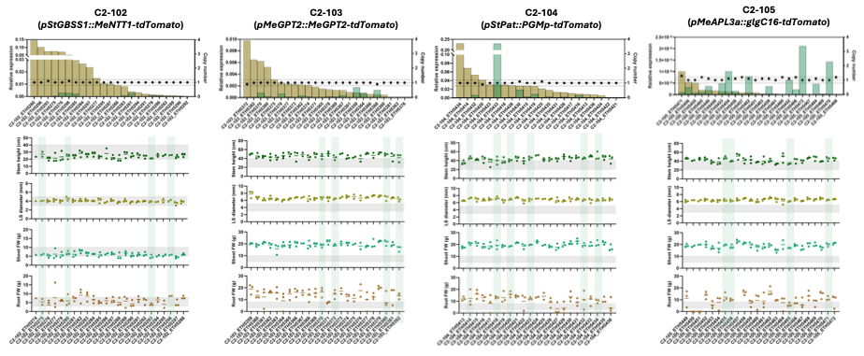
Fig. 1_Transgene expression and phenotypic results of C2-102, C2-103, C2-104, and C2-105 screening. Expression results were normalized to MeGAPDH. Dots indicate the T-DNA insertion number. Expression in storage roots is displayed in brown, expression in leaves is displayed in green. Grey bars indicate the vector control performance in comparision.

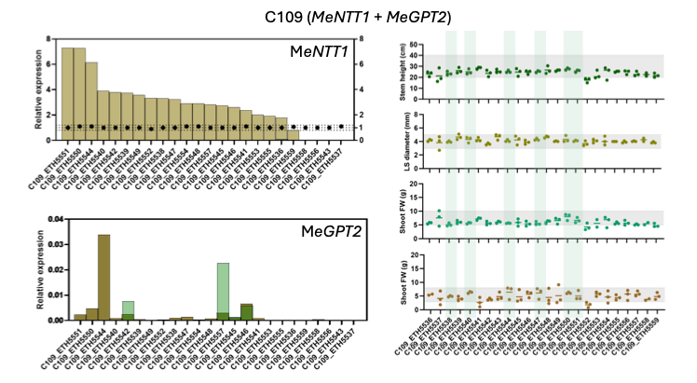
Fig. 2_Transgene expression and phenotypic results of C109 (MeNTT1 + MeGPT2). Plants were grown for approximately 90 days in the greenhouse. Expression was normalized to PP2A as a reference gene. Expression in storage roots is displayed in braun, expression in leaves is displayed in green. Dots indicate the T-DNA insertion number.

To rule out technical error, selected lines of these constructs have been replanted and transgene expression will be analyzed again. Select lines will be tested for protein abundance as well.

Challenges and Mitigations:
No unforeseen challenges have yet been encountered.
We did encounter problems during the transformation of C110 (GPT/NTT/PGMp), which is not producing rooting test positive clones. We did check the plasmid by whole plasmid sequencing prior to transformation and the sequences were correct. However, PGMp already proved difficult during E. coli transformation. Since C109 (GPT/NTT, without PGMp) seems to work fine, PGMp could be the cause. However, the PGMp-tdTomato single construct seems to be working, arguing against this interpretation. Yet again, the tdTomato-tag could have reduced the PGMp activity, reducing the impact on the bacteria. C111 (also containing PGMp) has not progressed as much as the other constructs, so its to early to say if this construct is also affected. C110 has indeed failed transformation. We suspect that this is the result of PGMp overexpression lethality. However, PGMp-tdTomato single overexpression construct has resulted in transgenic plant lines. However, it is possible that the tdTomato-Tag affects activity. We will test PGMp-tdTomato for activity. It overexpression of a functional PGMp is not lethal, transformation of slightly altered combination constructs C110/C111 can be attempted again.
A major challenge are the sheer overall numbers of plant lines we have to handle for all the different constructs. FAU serves as a central hub for plant lines. We receive transformed lines from Zurich in huge numbers, transform lines locally, and need to handle multiplications for greenhouse experiments and to prepare shipments to partner institutions. We therefore strieve to reduce plant numbers as soon as possible without being entirely arbritrary. Our current approach is to focus on single insertion lines and to conduct a first round of transgene expression screening to identify the lines with highest expression level.
Although we are handling a large number of plant lines at the moment, the team is making good progress and we will likely be able to nominate lines from the majority of constructs for field trials in Taichung 2026.

Update Q1 2026
Unfortunatly, the first wave of results indicates a lot of problems with the new GPT/NTT-centered constructs. We are struggeling with transgene expression in the constructs using cassava endogeneous sequences (despite codon alteration) and seem to have problems with transgene silencing. Although we need to further validate these findings, it is possible that codon alteration of the cassava sequences was not sufficient to circumvent transgene silencing events. In addition, constructs containing combinations of MeGPT2, MeNTT1, and pMePGMp (C110 and C111) seem to be lethal. C110 could not be transformed at all, and current data for C111 suggests that the genes are not contained in the construct.
The cassava sequences were initially selected for the new GPT/NTT constructs, since at the time of cloning, the functionality of the PsGPT2 and AtNTT1 gene variants were still unclear. We wanted to try another gene variant in case the pea and Arabidopsis gene variants were not functional in cassava. However, with the progress in the analysis of C56 (PsGPT2/AtNTT1), indicating sufficient protein level in the transgenic cassava plants, as well as metabolic phenotypes that point towards increased starch concentration (see brief update EM1.2), the new GPT/NTT constructs are no longer strictly required to validate the potential of this concept.

Two constructs for the source leaf-specific implementation of PPase were also analyzed. While C2-91 did not display promoter activity and transgene expression, a few lines of C2-76 showed weak expression. Additionally, an increase in PPase activity could be measured in source leaves. These lines deserve further investigation. Further candidates for source leaf-specific promoters have been identified and will be tested.

New transformations EM3.2
Based on the results obtained with C56, which indicates the principle functionality of the concept, we propose a range of constructs that try to increase the cell specificity of PsGPT2/AtNTT1 while also combining the concept with source improvement target genes, starch breakdown inhibition genes, and other putative sink enhancement genes. We are currently discussing combinations for cloning and transformation.

Next Steps in the Action Plan:
Upon the completion of the transformation experiments, the resulting lines will be screened and selected for detailed characterization in the glasshouse. Initial event screening will include the determination of overall growth performance, T-DNA insertion numbers, transgene expression, and subcellular localization of target proteins. Chosen events will be characterized for their enzyme activities (were possible), carbohydrate levels, photosynthetic and growth performance. Primary characterization of transgenic events will start once the plants are available. Plants need to establish in tissue culture and need to be multiplied for greenhouse testing. This will require several weeks. After plants have been multiplied, transgene expression will be analyzed in shoot, stem, and storage root tissues to identify most appropriately expressing lines for further, more detailed analysis.
- Conduct greenhouse transgene expression screenings in storage roots of C2-102, C2-103, C2-104, C2-105, and C110 cassava lines (Concluded)
- Test select lines of C2-102, C2-103, C2-104, and C2-105 for subcellular localization (Concluded)
- Test select lines of C2-104 and C2-105 for enzymatic activity (Ongoing)
- Screen C2-76, C2-91, and C111 for transgene integration numbers and select lines for greenhouse testing (Concluded)
- Nominate plant lines in time for the Taichung 2026 import permit (Concluded)
- Validate expression results in an independent planting (Ongoing)
- Clone new constructs (Ongoing)

EM3.3: Starch granule initiation and growth

EM3.3: Starch granule initiation and growth

Reporting module leader: Sam Zeeman, ETH with FAU.

Progress Update:

3.3.1. Generate first generation constructs with single and multigene constructs (PTST2, MFP1, MRC, SS4, ESV1, LESV1).
First generation constructs expressing single and multi-gene combinations of the four target genes involved in starch granule initiation (based on PTST2, MFP1, MRC and SS4) have been assembled and in Agrobacterium ready for cassava transformation. Constructs designed to knockout/knockdown two genes purportedly involved in starch granule assembly and stabilisation (ESV1 and LESV1) have also been generated and utilise CRISPR Cas9 elements. In addition, an over-expressing construct containing ESV1 was also produced. Binary constructs have been assembled and validated by Sanger sequencing to be used for transformation of cassava. Reporter (mCitrine) tagged genes of these starch pathway genes were also used in Nicotiana benthamiana leaf infiltration analyses to ensure correct localisation and expression prior to stable cassava transformation. Table 1 shows the current constructs used for cassava transformation.

Table 1_Current EM3.3 constructs
Construct number | Gene cassette | Database link | Overall status
ETH37487 | pCaMV35S::HbESV1-tCaMV35S | https://cassbase.org/stock/461505/view | Glasshouse (complete, assembling data)  CFT2024 – processing material; ongoing  CFT2025 – awaiting final harvest, leaf samples collected; limited material collected  Planned – CFT2026
ETH37488 | pStPatatin::HbPTST2-tnos | https://cassbase.org/stock/461500/view | Glasshouse (complete, assembling data)  CFT2025 – awaiting final harvest; no root material collected  Planned – CFT2026
ETH37491 | pStGBSS1::HbESV1-tCaMV35S | https://cassbase.org/stock/461506/view | Glasshouse – in progress; Discarded  CFT2025 – awaiting final harvest, leaf samples collected. No root material collected  Planned – CFT2026
ETH37493 | pStPatatin::HbPTST2-tnos + pMeGPT2::HbSS4-tHsp18.2 + pMeGBSS1::HbMRC-tHsp18.2 | https://cassbase.org/stock/461501/view | Glasshouse (complete, assembling data)  CFT2025 – awaiting final harvest  Planned – CFT2026
ETH37499 | pStPatatin::HbPTST2-tnos + pMeGPT2::HbSS4-tHsp18.2 + pMeGBSS1::HbMRC-tHsp18.2 + pStGBSS1::HbMFP1-tHsp18.2 | https://cassbase.org/stock/461502/view | Glasshouse (complete, assembling data)  CFT2025 – awaiting final harvest; no root material collected  Planned – CFT2026
ETH37501 | pMeGBSS1::HbMRC-tHsp18.2 + pStGBSS1::HbMFP1-tHsp18.2 | https://cassbase.org/stock/461503/view | Glasshouse (complete, assembling data)  CFT2025 – awaiting final harvest; no root material collected  Planned – CFT2026
ETH37502 | pMeGBSS1::HbMRC-tHsp18.2 + pStGBSS1::HbMFP1-tHsp18.2 + pStPatatin::HbPTST2-tnos | https://cassbase.org/stock/461504/view | Glasshouse (complete, assembling data)  CFT2025 – awaiting final harvest; no root material collected  Planned – CFT2026
ETH37503 | pStGBSS1::MFP1-t35S | https://cassbase.org/stock/462639/view | Transformation complete. Pre-screening for glasshouse; Plant multiplication for testing  Planned – CFT2026
ETH37505 | pMeGBSS1::MRC-tHSP18.2 + pStPatatin::PTST2-tNOS | https://cassbase.org/stock/462640/view | Transformation complete. Pre-screening for glasshouse; Plant multiplication for testing  Planned – CFT2026
ETH37508 | MeESV1 CRISPR/Cas9 | https://cassbase.org/stock/462099/view | Glasshouse-cultivated plants. Analyses ongoing.
ETH37494 | pMeGPT2::HbSS4-tHsp18.2 | https://cassbase.org/stock/471884/view | Transformation complete. Pre-screening for glasshouse; Plant multiplication for testing.  Planned : CFT2026
ETH37509 | pCaMV35S::Cas9-eGFP::tHSP + pU6::LESVsg452::tRNAPol + pCaMV35S::AtFT::tNOS | https://cassbase.org/stock/471885/view | Glasshouse – plantlet mulitiplication underway; Discarded
ETH37510 | pCaMV35S::Cas9-eGFP::tHSP + pU6::LESVsg673::tRNAPol + pCaMV35S::AtFT::tNOS | https://cassbase.org/stock/471886/view | Glasshouse – plantlet mulitiplication underway; Discarded
ETH37511 | pCaMV35S::Cas9-eGFP::tHSP + pU6::LESVsg958::tRNAPol + pCaMV35S::AtFT::tNOS | https://cassbase.org/stock/471887/view | Glasshouse – plantlet mulitiplication underway; Discarded
ETH37492 | pStPatatin::HbPTST2::tNOS + pMeGPT2::SS4::tHSP | https://cassbase.org/stock/471883/view | Transformed Q4 2025; shoots emerging
ETH37495 | pMeGPT2::HbSS4::tHSP + pMeGBSS1::HbMRC::tHSP | https://cassbase.org/stock/471888/view | Awaiting cassava transformation
ETH37489 | pMeGBSS1::HbMRC::tHSP | https://cassbase.org/stock/471882/view | Transformed Q4 2025; shoots emerging
ETH37504 | pStGBSS1::HbMFP1-tCaMV35S + pStPatatin:HbPTST2-tNOS | https://cassbase.org/stock/471889/view | Transformed Q4 2025; shoots emerging
ETH37500 | pMeGPT2::HbSS4-tHSP + pMeGBSS::HbMRC-tHSP +  pStGBSS::HbMFP1-tCaMV35S | https://cassbase.org/stock/475432/view | Transformed Q4 2025; shoots emerging
ETH37506 | pStGBSS::HbMFP1-t35S + pGPT2::HbSS4-tHSP | https://cassbase.org/stock/475433/view | Transformed Q4 2025; shoots emerging
ETH37579 | pL2B-HYG-Cas9-LESVsg958 | NA | Construct assembled
ETH37593 | pL2B-HYG-Cas9-LESVsg500 | NA | Construct assembled
ETH37581 | pL2B-HYG-Cas9-LESVsg1025 | NA | Construct assembled
ETH37580 | pL2B-HYG-Cas9-LESVsg958-LESVsg500 | NA | Construct assembled
ETH37582 | pL2B-HYG-Cas9-LESVsg958-LESVsg1025 | NA | Construct assembled
ETH37594 | pL2B-HYG-pMeGBSS-HbLESV-tHSP | NA | Construct assembled
Two additional constructs, “pStGBSS1::MFP1-t35S” (ETH37503) and “pMeGBSS1::MRC-tHSP18.2 + pStPatatin::PTST2-tNOS” (ETH37505) were created to complete the stacking approach for all the target genes. Transformation of the new constructs was initiated into TMS60444. Approximately 80-100 regenerating cotyledons have been selected and transferred to shoot induction media. Transformation appears successful and we have harvested approximately 70 plantlets/putative transgenic shoots from each of the transformations using constructs ETH37503 and ETH37505. A further construct, “pMeGPT2::HbSS4-tHsp18.2” (ETH37494) was also used to transform TMS60444 for which we have approximately 50 shoots. A few constructs are awaiting transformation (e.g. ETH37500_SS4/MRC/MFP1; ETH37489_MRC; ETH37504_MFP1/PTST2) in TMS60444.
Constructs ETH37503, ETH37505, ETH37494 were successfully analysed by rooting test and are now in the pipeline to determine transgene copy number. Of the originally identified plantlets/shoots, we have 16, 41 and 38 plantlets respectively.
In vitro plant lines were also generated with the LESV-CRISPR constructs (ETH37509, ETH37510, and ETH37511; sgRNAs were designed to target different sites in LESV) and are currently being analysed. We have 3, 8 and 14 plants respectively. Analyses will include PCRs to determine transgene presence, and ddPCR for copy number. To identify KO lines we will perform western blots (with antibody raised against Arabidopsis LESV) and sequencing of the intended target regions.

CRISPR-Cas9 mediated genome editing of LESV was detected in 16/21 plants analysed. In some cases the indels are predicted to introduce a premature stop codon/KO (Fig. 1). Indels were detected using Oxford Nanopore sequencing of amplicons. A western blot of protein extracted from in vitro leaf material and probed with an LESV antibody raised to Arabidopsis LESV was inconclusive – specificity to cassava LESV was weak and background was evident. This analysis will be repeated when freeze-dried root material becomes available as our experience suggests improved detection of starch-associated proteins. Selected lines will be propagated for glasshouse testing.

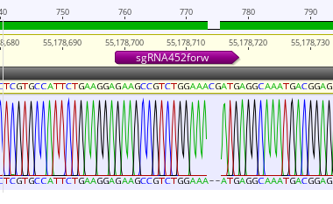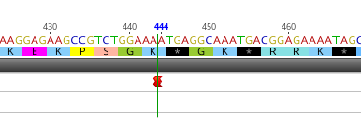

Figure 1_ CRISPR-Cas9 mediated genome editing of LESV in in vitro cassava plant (line ETH37509-6). A 2-bp deletion results in a predicted premature stop codon. Data based on 180 reads (100% of sequence). The sgRNA (sg452) targets to exon1.

Plants transformed with ETH37509, ETH37510 and ETH37511 (CRISPR constructs targeting LESV) were propagated for growing in the glasshouse. However, these plants along with the respective controls (FEC-control and VC) did not develop as usual – they had abnormally slow growth and poor root development even after 3 months. The plants were discarded. Comparing with recently collected data from CFT2025, it suggests this particular batch of FECs was compromised, and while transgenic plants could be produced and maintained in vitro, growth in soil revealed somaclonal varation. Fortunately, only few constructs were used for transformation of this FEC batch (and none from the rest of the CASS consortium) ensuring minimal loss of material. We have used this opportunity to improve the LESV constructs prior to re-transformation.

Update Q1 2026
From transformations with constructs ETH37492, ETH37504, ETH37489, ETH37500 and ETH37506 (OE of genes involved in starch granule initiation), shoots are emerging and scheduled to be screened (rooting assay) in Q2. These new constructs/plants will enable us to expand our understanding of these gene functions in starch biosynthesis in cassava and complement other constructs tested.

Modified constructs for the CRISPR LESV have been assembled and will be used for cassava transformation in Q2. The primary modification is the removal of the FLOWERING LOCUS T unit, which, due to regulatory restrictions of flowering plants in CFTs, means agronomic performance of CRISPR lines is currently limited to glasshouses only. For comparison, we have also generated a OE LESV construct (ETH37594), which we predict will result in an increase in granule number and also a reduction in amylose content, based on information from Arabidopsis-based experiments.

3.3.2. Test transgenic cassava lines expressing single and multigene constructs with PTST2, MFP1, MRC, SS4, ESV1, LESV1 under glasshouse conditions.
Cassava plant line analysis
From the constructs described above, independent lines of eight constructs (excluding controls) have been cultivated under glasshouse conditions and root and leaf material harvested for analyses (ongoing). In addition, selected lines of the respective in vitro material have been transferred to Germany for multiplication in preparation for planting in the 2025 CFT in Taiwan.
Analyses of the harvested greenhouse material from the transformants described in Table 1 above is ongoing.
Analyses of the harvested greenhouse material from the transformants described in Table 1 continues. Data such as plant height and root weight have been analysed for ETH37488 (PTST2), ETH37493 (PTST2-SS4-MRC), ETH37499 (PTST2-SS4-MRC-MFP), ETH37501 (MRC-MFP), ETH37502 (MRC-MFP-PTST2). Purified starch has also been extracted from storage roots and has been analysed for size/shape using the flow cytometer. Further analysis is underway using microscopy techniques to study granule morphology in detail. Amylose content has also been determined and while there is some statistical differences, broad variation within and between lines requires further investigation. These lines have been multiplied and are currently in the field in Taiwan for the CFT2025.
Ongoing analysis of the lines (namely, scanning electron microscopy of purified storage root starch) in lines ETH37488 (PTST2), ETH37493 (PTST2-SS4-MRC), ETH37499 (PTST2-SS4-MRC-MFP), ETH37501 (MRC-MFP), ETH37502 (MRC-MFP-PTST2) has revealed variation in granule morphology – one of the key traits targeted by our approach (see Figure 1 below).
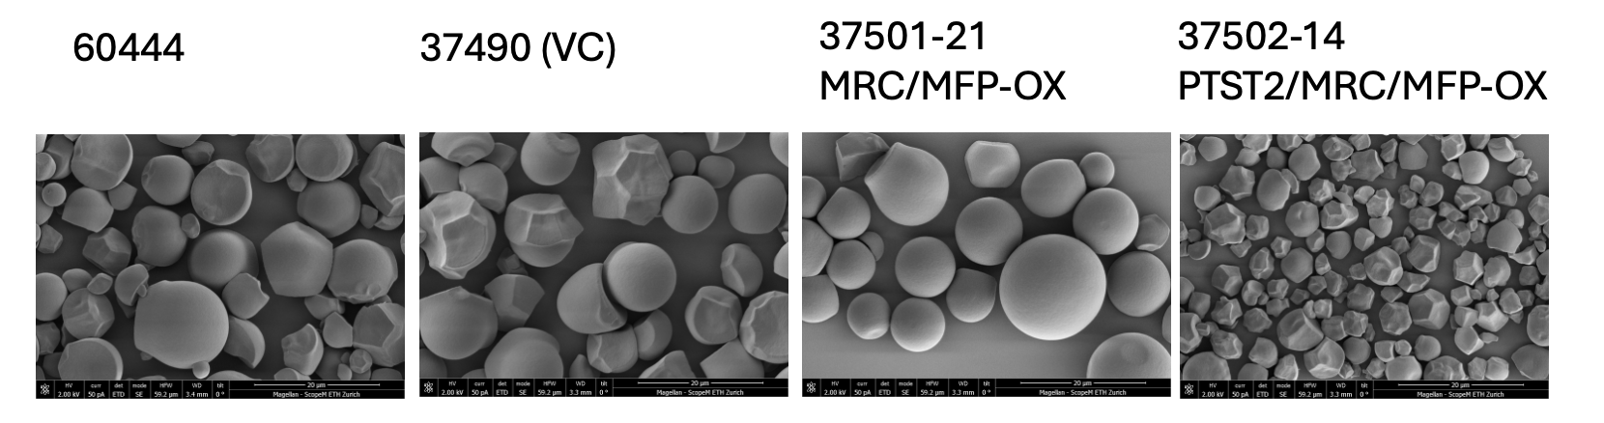
Fig. 1_Variations in starch granule morphology

For example, the granules from MRC-MFP OE lines appear different from the wild type with one having almost spherical granules. Conversely, granules from a line OE PTST2/MRC/MFP (ETH37502) had smaller, more irregular shaped granules. The significance of these phenotypes is under review.
Additionally, of constructs that have yet to be used for cassava transformation, prioritisation will be made based on current and emerging data, i.e. for gene stacks related to those already yielding the promising results. For example, priority constructs are ETH37492 (PTST2+SS4), ETH37495 (SS4+MRC), ETH37489 (MRC) and ETH37504 (MFP1+PTST2) (see Table 1). FEC material of 60444 is being prepared for transformations this year.

qPCR data for the developed transgenic lines is being collated - ETH37488 (PTST2) 6 lines, ETH37493 (PTST2-SS4-MRC) 6 lines, ETH37499 (PTST2-SS4-MRC-MFP) 4 lines, ETH37501 (MRC-MFP) 6 lines, ETH37502 (MRC-MFP-PTST2) 5 lines, controls ETH37490 (VC) and WT. The results will be used to identify possible correlations between expression profiles and gathered biochemical data (e.g. granule morphology, amylose content etc).

Arabidopsis complementation experiments
In parallel, to confirm that the transgenes used were functionally similar to their orthologs in Arabidopsis, constructs containing the transgenes (PTST2, MRC, MFP1, ESV1 and SS4) were assembled with the constitutive promoter UBQ10 from Arabidopsis and used to transform the respective mutant background of Arabidopsis (e.g. pUBQ10:ESV1:tNOS was used to transform mutant plants of esv1 Arabidopsis). We are awaiting T₁ generation.
The complementation study in Arabidopsis also continues. Transformations (floral dip) have been performed (with the exception of SS4, as a construct rearrangement was observed in the bacteria) and T1 seeds have been harvested. We are awaiting selection (RED seed) and genotyping.
Constructs with PTST2, MFP1, MRC and SS4 (used for the cassava transformations) and expressed via the UBQ10 promoter have been used to transform their respective mutant backgrounds in Arabidopsis. The T1 seed have been harvested and are ready for screening (constructs also contain the pOleosin::dsRED ‘red seed’ marker). Constructs with PTST2, MRC and SS4 have also been assembled fused with the mCitrine reporter protein to enable visualisation alongside functional restoration of the proteins in planta. The MFP1-mCitrine fusion was not assembled since previous (in-house) studies revealed an C-terminal fusion negatively interfers with MFP1 function.
Starch has been extracted from leaf samples of T₁ Arabidopsis plants transformed for complementation assays (constructs described above). WT-like phenotypes were observed and data from flow cytometry (i.e. measuring starch granule shape/size) are WT-like. These are crucial control results, providing confidence that the H. brasiliensis transgenes in cassava are functionally similar to the better-characterised Arabidopsis starch metabolism genes, and should function also in the more closely related cassava. Further assessment of the Arabidopsis plants is planned for Q3/Q4 2025, including leaf sectioning for light and transmission electron microscopy to determine granule arrangement in the chloroplasts. Additionally, plants transformed with the mCitrine-tagged transgenes will also be viewed using confocal microscopy to determine cellular localisation of the proteins.

3.3.3 Analysis of agronomic parameters and sample analysis for CFT 2024/2025 of field sample material from PTST2, MFP1, MRC, SS4, ESV1, LESV overexpression/KO lines
Good progress in the previous work modules enabled us to transfer the first starch-modified transgenic plants to the CFT in 2024 (ahead of schedule). The constitutive over-expressing ESV1 lines are currently in the field in Taiwan and material from the intermediate harvest this week (mid September 2024) arrived at ETH and are awaiting preliminary analyses.
Five independent ESV1 OE lines, together with vector controls and WT plants were grown in the frame of the CFT 2024 Taichung. Plants were harvested (intermediate harvest) and sampled in Taiwan and were processed for analysis. Samples were measured for amylose content, transgene expression, starch granule size/shape using flow cytometry and scanning electron microscopy. The data interpretation is ongoing.
The samples from the intermediate harvest were assessed as described above and no discernible differences were seen for amylose content or granule size/shape. Interestingly, some differences were observed with these experiments using glasshouse-grown material. Shoot weight, plant height, root weight, dry matter content also did not vary from WT/control lines. Approximately 6-fold increased expression of ESV1 was measured (sqPCR) in three of the four transgenic lines harvested. Recently, we also successfully received the field data and harvested material for the ESV1 OE (construct ETH37487) lines from the main 2024 field harvest. Preliminary analyses suggest no significant differences in root weight, shoot weight or dry matter content of the ESV1 OE lines vs WT/controls. Harvested root material (circa 200 biological samples) are stored in our freezer awaiting analyses. Through this material transfer, we have established a shipping process involving agents in both Taiwan and Zurich that (after two large shipments on dry ice) has proven reliable and efficient.
As mentioned above, plantlets were shipped to Taiwan for the 2025 CFT - Transformants ETH37488 (PTST2), ETH37493 (PTST2+SS4+MRC), ETH37499 (PTST2+SS4+MRC+MFP1), ETH37501 (MRC+MFP1), ETH37502 (MRC+MFP1+PTST2), ETH37491 (strong root expression ESV1), as well as a second field trial for plants transformed with ETB37487 (constitutive ESV1 OE), and control lines. This equates to approximately 1,800 plants. This objective is ahead of schedule (planned Q1 2026).
Processing of the shipped storage root material from Taiwan 2024 CFT (received Q1) commenced in Q2. Namely, line ETH37487 (ESV1 OE) plus controls have been homogenised and starch extracted from a subset of samples (4 biological replicates per line). Depending on data from these lines, further biological replicates will be processed. Leaf material collected from the Intermediate Harvest CFT 2024 is also being processed. In total, 144 leaves were collected from different lines at the end of day (EOD- when transient starch is expected to be at the maximum quantity) and also end of night (EON- when starch content is expected to be depleted). This is important since ESV OE lines are expected to have an increase in leaf starch content, based on prior knowledge from Arabidopsis. Leaves from a subset of samples (4 leaves per line, per construct, per EOD and EON) are being processed for starch/sugar analyses. Leaf material from the EOD/EON experiment for the 37487 ESV1 OE lines have been processed and analysed for starch, sugar profiles and granule size/shape. The results indicate that several lines, in particular line ETH37487-14, are performing as expected: in both glasshouse and CFT2024 leaf samples starch content is elevated both at EOD and EON relative to the controls (Figure 1 below).

Q4 2025 Update
Please see ‘Challenges and Mitigations’ for issues related to CFT2025.

EM3.3.2. – Q4 2025 - is a ‘go/no go’ juncture for this workpackage. We have made excellent progress with generating the many different OE and CRISPR constructs and have glasshouse data for the majority of the lines. Moreover, line ETH37487 has already been cultivated twice in Taiwan (CFT2024 and CFT2025). Modifying the starch-associated genes often yields interesting phenotypes (e.g. ETH37501-21) and further analyses are ongoing. While some constructs/lines have promising phenotypes (e.g. ETH37501-34), more extensive field and glasshouse testing is require to determine if material is statistically significant in terms of yield gain. This is being explored in CFT2026. Given that most lines are at least on a par with control material (i.e. no overall detriment to yield or traits by modifying starch biosynthesis genes) we are confident we should continue with this workpackage.

ESV1 Analyses

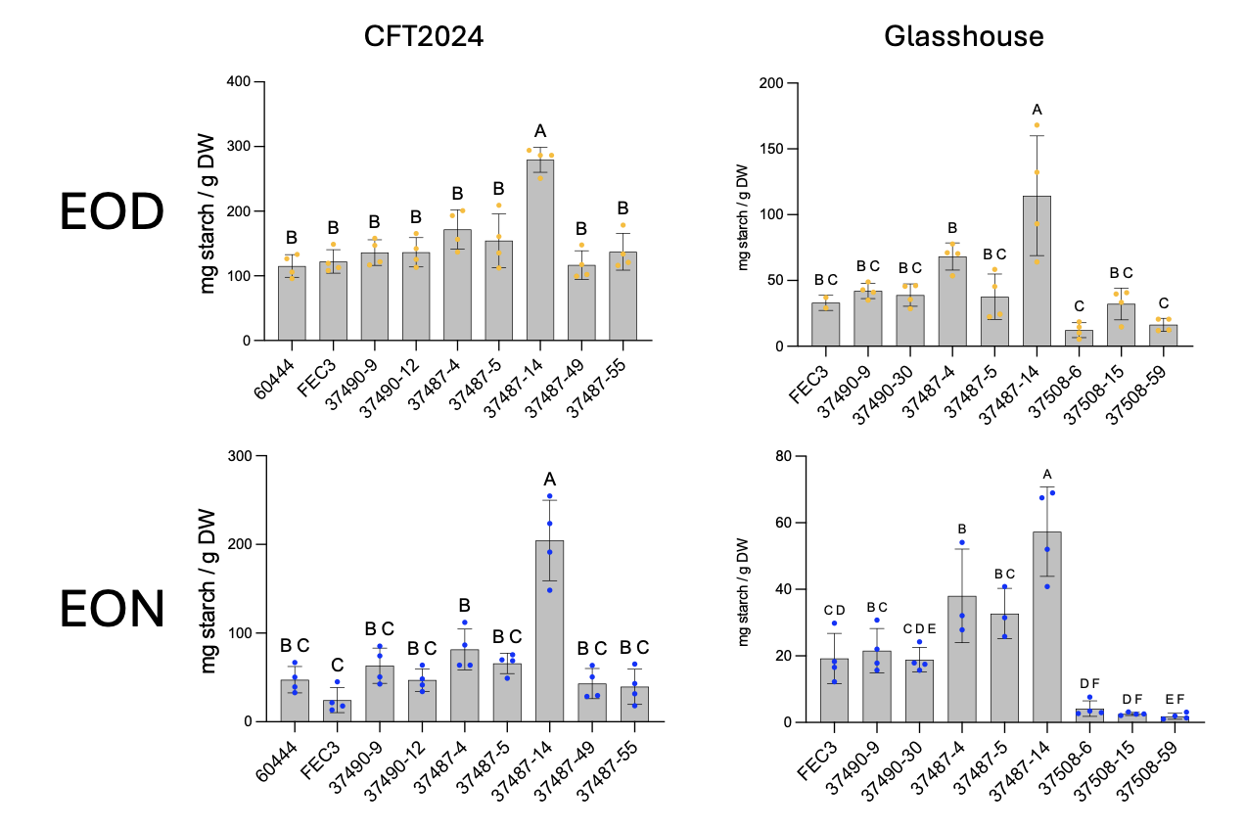
Fig. 1_ Starch content in leaves of plants grown in CFT2024 (Taiwan) and glasshouses (ETH Zurich). FEC3, WT control; 37490-9, vector control; 37487-4, 37487-5 and 37487-14, lines of p35S:ESV1; 37508-6, 37508-15 and 37508-59 lines of CRISPR-Cas9 edited ESV1. EOD, End of Day; EON, End of Night.

A phenotype is also evident at EOD/EON when purified starch is viewed using a SEM (Figure 2 below). For example, at EON in the control lines (FEC and ETH37490), what are presumably starch degradation products are visible, whereas in the ETH37487 lines (and again notably ETH37487-14) starch granules remain relatively intact.
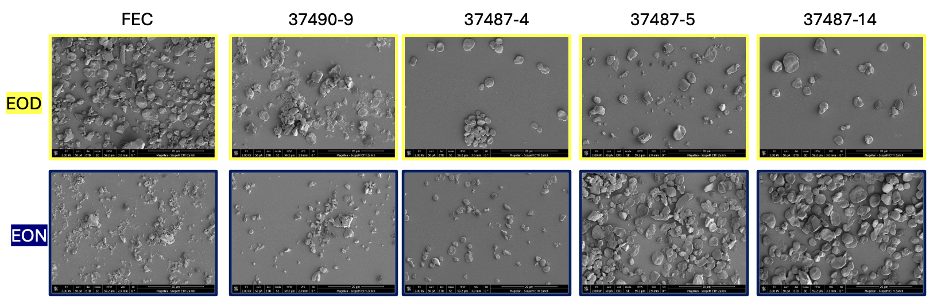
Fig. 2_ SEM of purified starch extracted from leaves from the CFT2024 Intermediate Harvest. FEC, WT control; 37490-9, vector control; 37487-4, 37487-5 and 37487-14, lines of p35S:ESV1. EOD, End of Day; EON, End of Night.

Approximately 286 leaf samples were collected at NCHU (CFT2025) from plants transformed with ETH37487 (ESV1 OE/35S promoter) and ETH37491 (ESV1 OE/GBSS promoter) (plus relevant controls) at the end of day (EOD) and end of night (EON). For the ETH37487 lines this is the second year replicate (the first was performed in CFT2024; see above) and will be processed as the CFT2024 samples to corroborate the data above. The samples were received in Q3 2025. By measuring starch content in the leaf samples, we expect to see evidence that starch breakdown has been impaired in the leaves due to the the OE of ESV1. We also expect that the impact will be less significant in the ETH37491 lines since in this the transgene is driven by the GBSS promoter and therefore more likely to be regulated than the pCaMV35S. Root samples will be analysed following final harvest of CFT2025.

Q4 2025 Update:
Starch content from roots collected from CFT2024 intermediate harvest and the final harvest was extracted and measured in lines OE ESV1. No significant differences were observed between intermediate and final harvests, nor between different lines (OE, VC and WT) (Fig. 3, left graph). Interestingly, while total starch content did not vary between lines, differences in sucrose levels were measured (Fig. 3, right graph). Overall, a decrease in sucrose content was observed between roots collected at the intermediate and final harvests. This may be explained by a reduced photosynthetic and metabolic activity during the dry season. However, in 3 of the 4 OE:ESV1 lines (ETH37487) this reduction was not evident, instead maintaining a more stable level of sucrose. This observation requires further investigation.
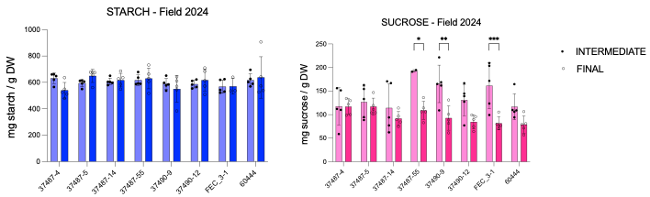
Fig. 3_Total starch (left) and sucrose content (right) in storage roots from CFT2024. FEC, WT control; 37490-9 and 37490-12 vector control; 37487-4, 37487-5, 37487-14, 37487-55 lines of p35S:ESV1. Colours: Light blue and light pink – intermediate harvest, darker blue and pink – final harvest. Lines 37487-4, 37487-5 and 37487-14 are the three most highly OE lines based on qPCR data.

No discernible differences were observed between the rheological properties of purified storage root starch from OE:ESV1 lines and controls, suggesting changes to phenotype did not alter starch physicochemical properties (Fig. 4).

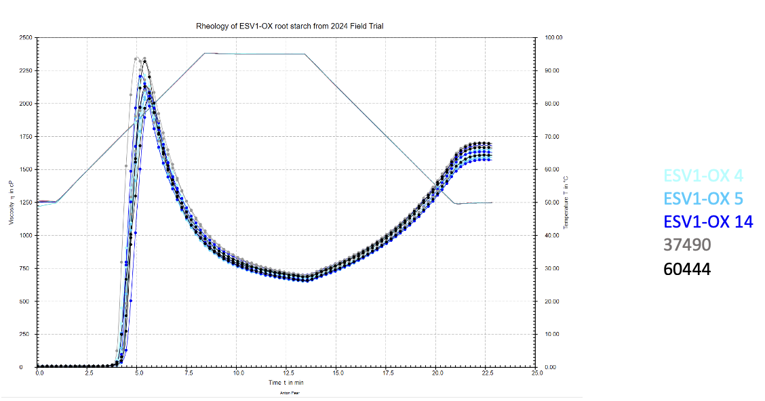
Fig. 4_Rheological profiles of cassava storage root starch from CFT2024. 60444 (WT control); 37490 (vector control); ESV1-OX4 (37487-4), ESV1-OX5 (37487-5), ESV1-OX14 (37487-14).

Analyses of starch granule initiation constructs (PTST2/MRC/MFP1/SS4)
Total root weight of lines OE genes involved in starch granule initiation was collected from CFT2025. No significant differences were calculated between the OE and VC/WT lines, with the exception of ETH37488-17 and ETH37488-34 where a significant reduction was measured (Fig. 6). Our working hypothesis is that this effect may be a consequence of the specific site of these T-DNA insertions. Though this needs to be explored further. The highest mean root weight was line ETH37501-34 at 5.0Kg compared to the mean for WT 60444 at 4.1Kg. The weight variation observed within lines highlights the need to increase sample size to allow for more robust analyses. A power analysis suggests the requirement for 80 biological replicates to determine statistical significance. For CFT2026, 80 replicates for selected lines were propagated.

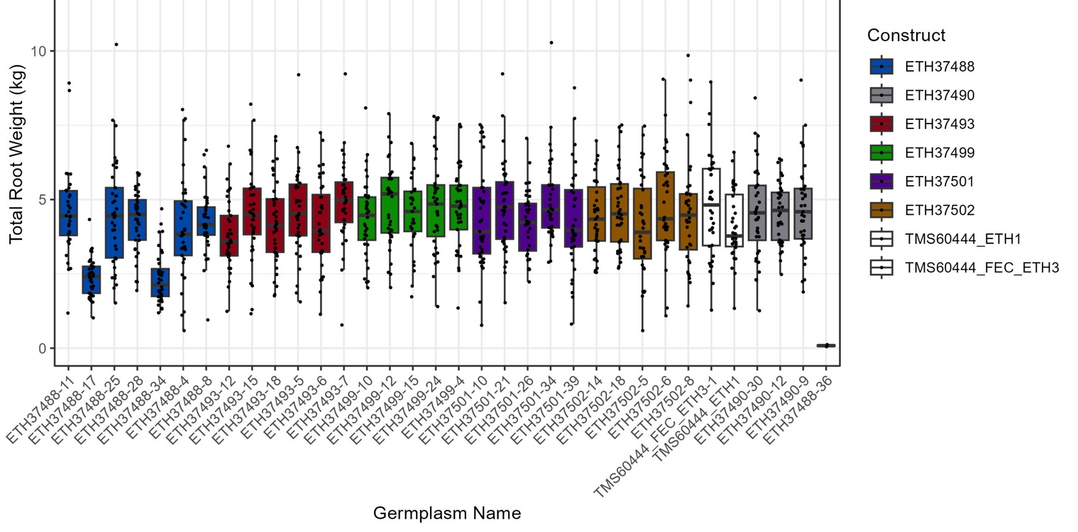
Fig. 6_Total root weight of lines OE starch initiation genes in cassava 60444 (CFT2025). ETH37488 (PTST2), ETH37490 (VC), ETH37493 (PTST2/SS4/MRC), ETH37499 (PTST2/SS4/MRC/MFP1), ETH37501 (MRC/MFP1), ETH37502 (PTST2/MRC/MFP1). n=32-37.

Update Q1 2026
Propagated material to establish glasshouse experiments of six selected lines for ETH37494 (SS4), ETH37503 (MFP) and ETH37505 (PTST2:MRC), including VCs and WT plants (total 132 plants). These plants will be harvested in Q2 2026 and analysed (e.g. plant height, root weight, storage root starch profiles). This material has also been sent to Taiwan CFT2026.

We are also exploring different microscopy approaches (including fixation, staining and embedding techniques) to improve visualisation of starch in the different storage root tissues and to distinguish amyloplast membranes/structures (Figures 7 and 8). Through this, we aim to understand more about starch granule formation, number and expansion in amyloplasts in the cassava storage root, with the ultimate aim to identify novel players that could be used for enhancing starch production.

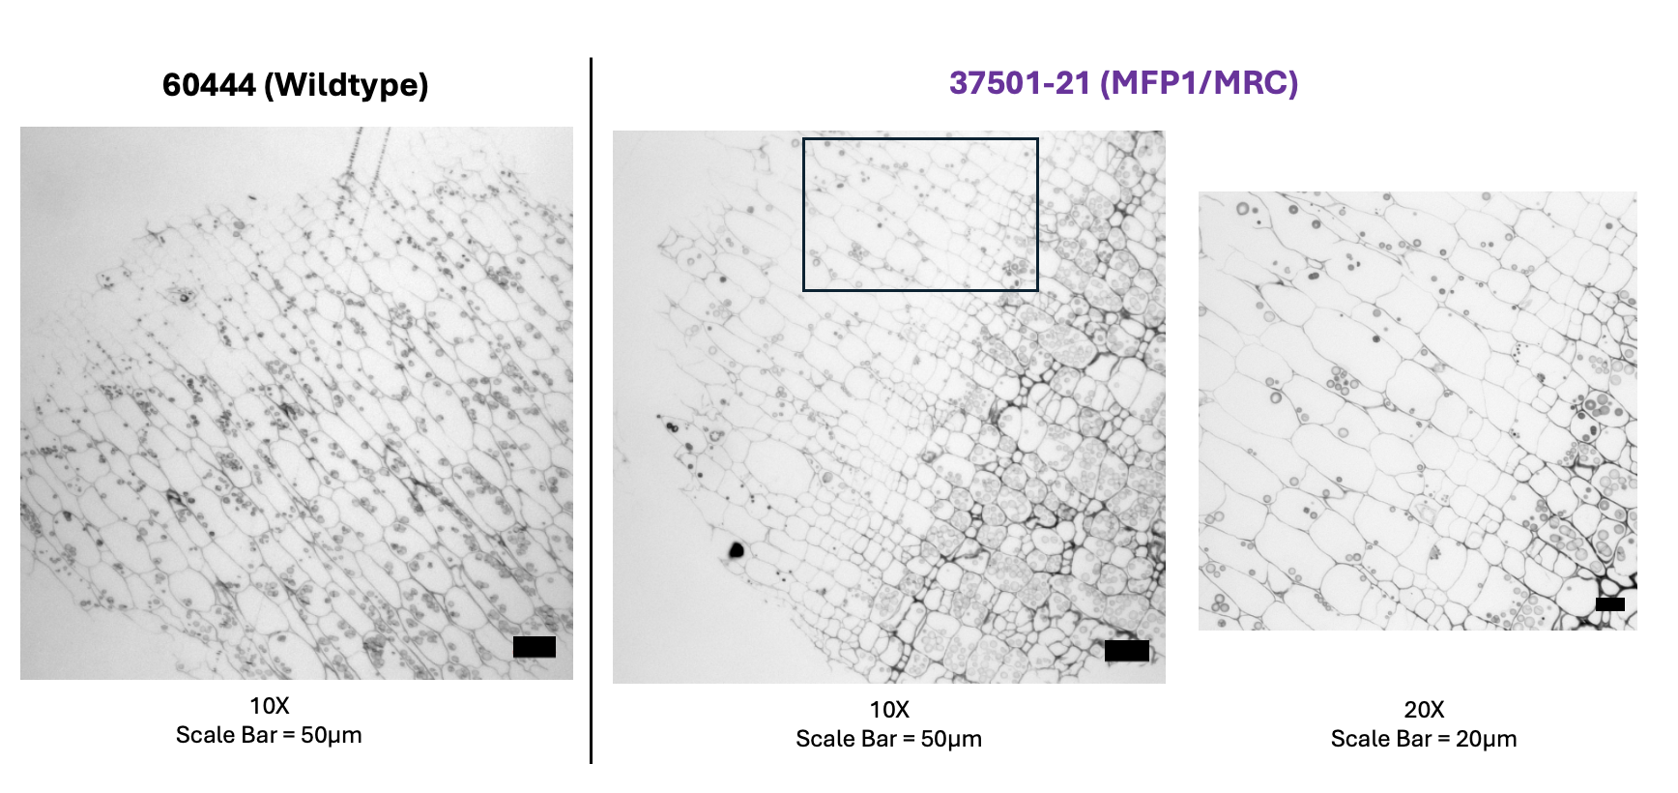
Figure 7. 0.7-µm sections from osmium-tetroxide-stained tissue embedded in durcupan. All sections stained with toludine blue post-sectioning and mounted in Eukitt’s mounting media. Imaged with a Zeiss Axio Imager Z2 light microscope.

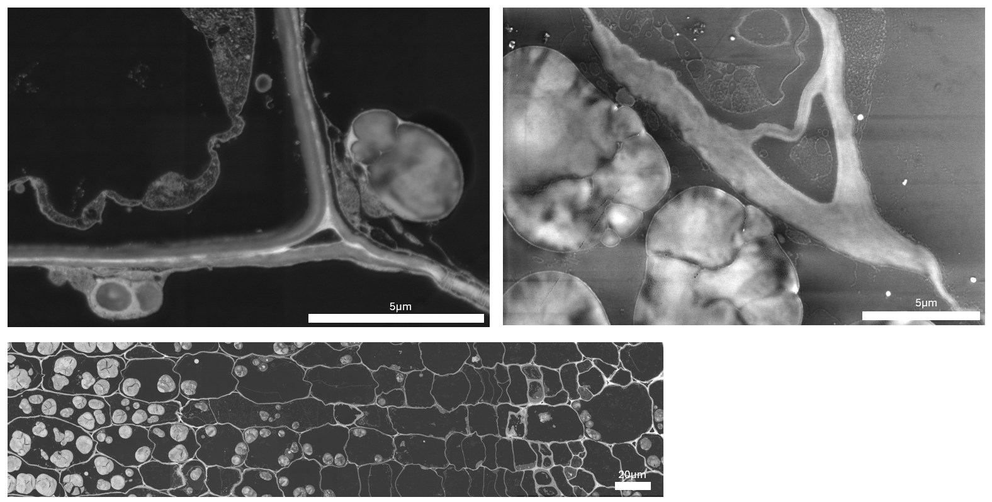
Figure 8. Embedded cassava 60444 storage root stained with osmium tetroxide. 80nm sections mounted on Si-chip and imaged with a TFS Magellan 400 scanning electron microscope. A) Concentric Backscatter (CBS) Detector; B) Through-the-Lens Detector (TLD) and C) CBS detector (126 images stitched together)

RT-qPCR of OE target lines has been performed (Figure 9) and confirms OE of transgenes. The variability measured is expected between different biological lines. Moreover, rheological analyses of the purified starch from storage roots of glasshouse-cultivated plants reveals differences in viscosity and thus altered physicochemical properties of the starch in some lines (Figure 10). Notable is line ETH37493-7 (PTST2:SS4:MRC) that has smaller granules and reduced peak viscosity, and ETH37499-12 (PTST2:SS4:MRC:MFP1) that has a reduced peak viscosity. This preliminary dataset indicates that OE lines may have altered phenotypes that could have interesting physiochchemical properties.

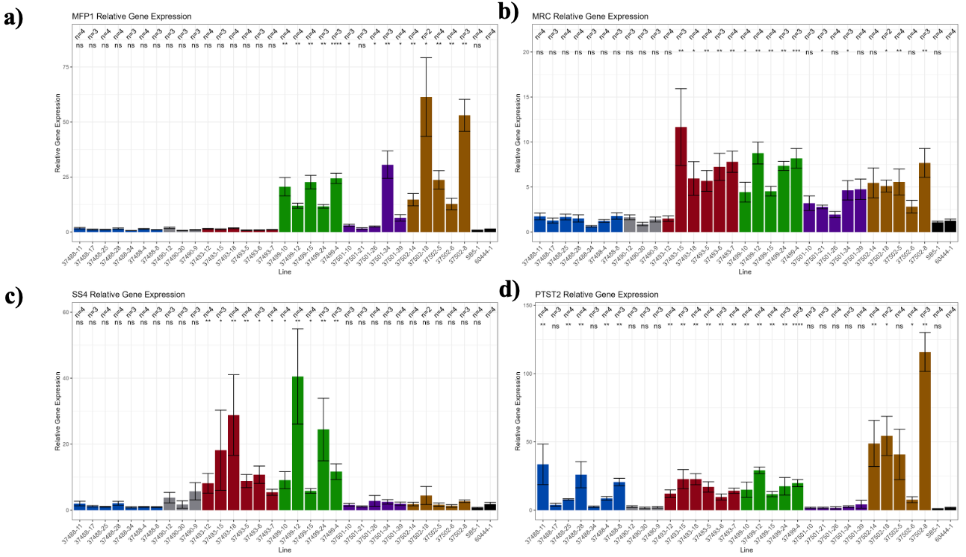
Figure 9. Relative expression of both endogenous and transgenic a) MFP1, b) MRC, c) SS4 and d) PTST2. Bars represent mean relative gene expression and error bars represent the standard error. Asterisks indicate statistically significant differences (p<0.05) from wildtype (WT) as determined by Wilcoxon Rank-Sum Test. n= the number of biological replicates. Two technical replicates were prepared for each biological sample. Reference genes PP2A and Histidinal dehydrogenase.

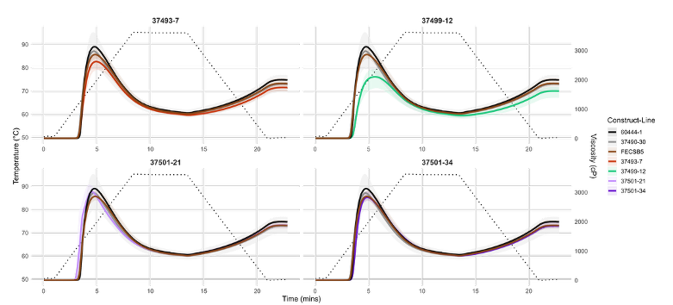
Figure 10. Rheological profiles of starch extracted from root flour of greenhouse-grown plants. Analyzed on Modular Compact Rheometer (MCR92) and plotted in RStudio. Each line represents the mean viscosity, and shaded ribbons the minimum/maximum values.

Challenges and Mitigations:
In January 2025 the Plant Biochemistry (Zeeman) group will be relocating to a new site in Zurich as part of a Departmental restructuring. Therefore, we foresee some disruption to sample analysis and work routines etc while equipment and facilities are decommissioned/transferred.
The laboratory relocation is ongoing and the tissue culture facilities are up for transfer.
The Plant Biochemistry group moved to its new site at the end of January 2025 and, while there were obvious disruptions, the CASS team was able to keep most objectives on track.
Preparations are being made for relocating to alternative glasshouses to allow refurbishment of the current cassava glasshouses. The relocation will be done in Q3 2025. While naturally disruptive, we don’t expect a negative impact on plant growth. We are currently testing conditions with WT plants. With the renovation, we are also required to test LED lamps (to replace the metal halide lamps currently fitted). These tests commenced in Q2 and are ongoing. New lamps selected and awaiting installation and further testing.
MicroPAM measurements of selected lines in CFT2025 were set-up by the Julich team, but unfortunately the data collection has been interrupted due to a breakdown of some of the equipment in Taiwan. We are being kept updated of the situation and hope to be able to gather some data prior to harvest later this year. Ongoing

Q4 Update
In the CFT2025, ETH had several constructs associated with starch granule initiation and stabilisation:
ETH37488 (PTST2): 8 lines
ETH37493 (PTST2/SS4/MRC): 6 lines
ETH37499 (PTST2/SS4/MRC/MFP1): 5 lines
ETH37501 (MRC/MFP1): 5 lines
ETH37502 (MRC/MFP1/PTST2): 5 lines
ETH37490-FEC3 (VControl): 3 lines
ETH37487 (ESV1): 5 lines

These lines constituted approximately 1,200 plants. Unfortunately, although a request was made to provide DMC data and frozen, harvested root samples, this was not performed and only plant height and total root weight data was provided. This is a set-back for ETH objectives. For almost all of the constructs, 2025 was the first time plants had been grown in Taiwan and it is our top priority to assess starch quality traits, which are currently based solely on glasshouse-propagated material. A selection of the aforementioned lines will be grown again in CFT2026, the final harvest of which will only be available for analysis in Q1/Q2 2027. This is disappointing since we were driving this workpackage ahead of schedule. However, in light of this development, we have the opportunity to bring additional, newly-developed lines into the field for a broader comparison. We will also work with our colleagues in Taiwan to obtain field samples ahead of schedule in 2026, and meanwhile use this chance to perform deeper analyses of material cultivated in the ETH glasshouses.

Next Steps in the Action Plan:
We prioritised transformation of cassava with constructs designed by CASS consortium members in Q2 & Q3 2024. With good progress on this module (please see TM2.1) other EM 3.3.1. constructs (approximately 6-8 in number) will be used for stable transformation towards the end of 2024. This should ensure we have glasshouse-cultivated plants of these lines harvested by Q4 2025. Characterisation of already harvested material is ongoing.
We continue to analyse the data collected so far from the different constructs and independent lines generated. We also expect receipt of circa 300 samples from the final harvest (ESV1 OE and controls) in Q1 2025, which will require processing and analysis.
We continue to process and analyse the data collected so far from the different constructs and independent lines generated, both from the glasshouse grown material and the recently harvested lines from Taiwan.
Regarding harvested CFT 2024 lines (ESV1 OE) – we are presently processing the leaf material to determine starch content at EOD and EON. This should provide insight into transitory starch levels – specifically whether starch content is elevated in these OE lines (as in Arabidopsis), and to what extent this might influence source-sink starch/sugars. From the final harvest root material, analyses (3 biological replicates per line) will include flow cytometry to determine granule size/shape, rheological analyses to determine pasting properties, total starch content, amylose content and amylopectin structure. These samples will be processed through Q3/Q4. In Q3 we also plan to do another leaf harvest from the CFT 2025 to corroborate data collected in CFT 2024. In Q3 2025 we also plan to establish microPAM measurements of selected lines in CFT 2025 (under discussion with Juan). This should provide preliminary insight into the photosynthetic performance of the tested lines during the growing season.

Regarding the LESV-CRISPR lines – if we are successful in identifying KO lines, in vitro material will be multiplied, along with relevant controls, for transfer to soil/glasshouse in Q3/Q4 (expected harvest Q1 2026). Discarded due to growth defects. Re-transformation using new batch of FECs planned.

Based on Oxford Nanopore sequencing of genomic sites targeted by the different sgRNAs/Cas9, we have some evidence that LESV expression has been disrupted in several plants. In Q3 we plan to multiply lines of interest (and control material) for transfer to soil/glasshouse cultivation.

Lastly, priority constructs for cassava transformation in Q3/Q4 2025 are ETH37492 (PTST2+SS4), ETH37495 (SS4+MRC), ETH37489 (MRC) and ETH37504 (MFP1+PTST2) (see Section 3.3.2, above). Selection of constructs was based on collected and emerging data from other transformation events. FEC material of 60444 is being prepared.

A review of plant material to be sent for CFT2026 is being developed and will be shared with FAU in Q3 2025. We currently envisage a second field trial of plant lines that are in Taiwan CFT2025. However, based on emerging experimental data, we plan to reduce the number of lines analysed, instead favouring a few select lines of most interest but with increased number of replicates (e.g. 80 biological replicates per line), necessary to improve statistical power/interpretation. Completed

Rheological analyses of storage root starch from CFT2024 (ETH37487, p35S:ESV1, plus controls) has recently been completed on a selection of lines and data will be reviewed in Q3 2025. Rheology provides data pertaining to the gelatinization characteristics of the starch, which is an important factor in root or starch utilisation, for example, in food preparation. Completed

Starch extraction from root samples harvested from the final harvest of CFT2024 is underway and starch-based analyses will commence Q3-Q4. This will include flow cytometry, amylose measurements, SEM, starch/sugar analyses. Ongoing

New cassava transformation experiments are also planned in Q3/Q4 with constructs for EM3.3. Ongoing

Update Q4 2025
- Modify and generate new LESV-CRISPR constructs for cassava transformation (Q2 2026)
- Microscopy of storage root material transformed with the starch granule initition constructs (OE PTST2/SS4/MRC/MFP1).
- qPCR of OE PTST2/SS4/MRC/MFP1 genes in storage root material (glasshouse-cultivated lines).
- Organise documents and necessary materials for shipping CFT2026 plantlets to Taiwan (Q1 2026).

Update Q1 2026
- Continue to develop microscopy techniques to support visualisation of starch development in storage roots.
- Molecular screening of newly emerging plants transformed with PTST2:SS4, SS4:MRC, MRC, MFP1:PTST2, SS4:MRC:MFP, MFP:SS4.
- Transform cassava with the new LESV CRISPR and OE constructs
- Harvest and analyse glasshouse lines for ETH37494 (SS4), ETH37503 (MFP) and ETH37505 (PTST2:MRC).

EM3.4: Model-based predictions

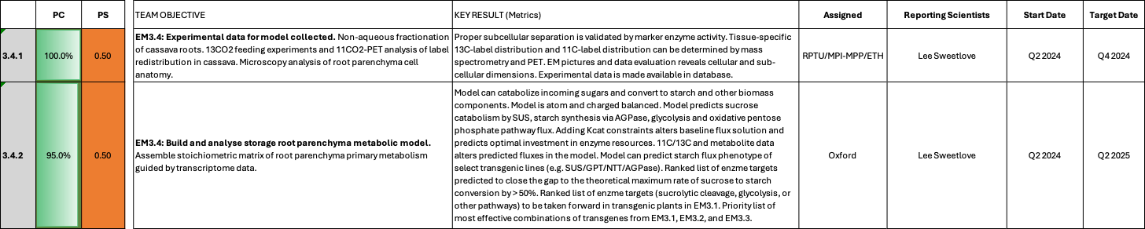

EM3.4: Model-based predictions

Reporting module leader: Lee Sweetlove, OU with RPTU, MPI-MPP and ETH.

Progress Update:

3.4.1. Experimental data for model collected.
In order to obtain data more quickly for the establishment of the model, the decision was made to shift focus from the ¹¹C and ¹³C experiments to a steady-state experiment with wild type cassava plants grown in glasshouse conditions. This experiment will provide a set of consistent, comparable data from the same plants for parameterization of the model. These data will include storage root growth rate, quantitative analysis of metabolites and ion, analysis of biomass composition and quantitative proteomics. In addition, light microscopy of embedded sections of roots using light microscopy will be done to quantify cell types, numbers and sizes. As explained in EM1.3, electron microscopy will not be done. Additional live-cell imaging using confocal microscopy of root sections will be done to ascertain the relationship between cell volume and starch content, a key constraint for parameterizing the model. A coordinated effort has been planned across teams to meticulously harvest root and stem (for EM1.3) tissues from the same batch of plants. This synchronized harvesting approach aims to minimize variability of the samples and consequently of the data collected. The plants are currently growing at ETH and the harvest is scheduled for the first weeks of November 2024. Pilot experiments have already been done to refine and test protocols, especially for new assays such as total lipids, total cell wall quantification and microscopy-based analysis of starch content and cell volumes.
TMS60444 WT plants were grown in the greenhouse at ETH and harvested in November 2024. However, plants had sub-optimal growth including smaller than expected storage roots potentially due to greenhouse repair/upgrades. This was noticed at the time of harvest and communicated to project coordination. It was decided to priorizite quality over time and not use these plants for sampling and downstream analysis and instead use a separate batch of plants grown in a different greenhouse. These plants were now harvested in January 2025 and samples have been prepared and distributed to RPTU (ions), MPI-MPP (metabolites), ETH (starch), and FAU (storage root proteomics). Microscopy-based analysis of starch content and cell volumes was successfully analyzed by ETH and first data have been shared with the modelling team. Automated imaging analysis solutions are being explored to evaluate the generated pictures in detail.
NAF analyses on storage roots has already been conducted in the frame of Rüscher et al., 2024. Further analyses have not yet been started due to time constraints. We aim to use the same plants, which will become instrumental for module 1.3.1, for NAF analysis of leaf (if possible) and storage roots.
Data from Rüscher et al., 2024 is sufficient and will be used for the model
In parallel, plants are being grown at FZJ for analysis of storage root growth rates using MRI analysis. This will provide accurate root growth rate data without destructive harvesting.
Storage roots of plants grown at FZJ were successfully analysed using MRI. Image segmentation and data processing is underway and results have been shared with the team for incorporation into root modelling. Quantifying the absolute rate of root expansion, as well as the dynamics over time will be critical to parameterising the root model.
As stated in EM1-3, we decided to measure total ¹³C abundance using isotope ratio mass spectrometry, following a method similar to Jiang et al. (2024), after a detailed discussion at the last project meeting. Unfortunately, two experiments at MPI-MPP were lost due to fungal contamination by Fusarium sp., requiring the complete removal of affected plants to prevent further spread within the growth chamber. A new batch of plants, initiated in November 2024, is currently healthy and developing well. These plants are expected to reach the required age for ¹³CO₂ feeding by the end of February 2025 (three months old) and May 2025 (five months old). After labelling, the entire plant will be harvested, tissues will be separated, and total ¹³C quantification will be outsourced for analysis.

As stated in EM 1.3, the repeated cultivation of WT plants for ¹³CO₂ feeding under controlled optimal growth conditions is proceeding well. To date, no recurrence of Fusarium spp. contamination has been observed. An intermediary harvest originally scheduled at three months old (February 2025) was cancelled. Upon assessment, the plants had not yet developed sufficient storage roots to justify sampling. The harvest is planned with five-months-old plants (May 2025). This timeline also aligns better with the growth conditions in Jülich and ETH.
The ‘model’ plants were successfully harvested in January 2025 at ETH. For each plant, samples were taken of the apex, upper, middle and lower stem sections. Each stem section was peeled, providing a core and peel. Radial and longintudinal sections of stem were sampled for paraffin embedding at FAU (EM1.3). Storage roots were also sampled – A section was isolated, peel, xylem parenchyma and xylem core were dissected. Sizes and volume of sampled sections were measured and documented. Photographs of plants were taken, as well as data including plant height and root weight. Samples were distributed to RPTU (ions), MPI-MPP (metabolites), ETH (starch), and FAU (storage root proteomics). Samples are currently being processed at ETH for starch analyses. Microscopy-based analysis of starch content and cell volumes were collected, preliminary analyzed by ETH and the data shared with the modelling team. Automated imaging analysis solutions are being explored to expedite data acquisition and depth.
Macroscopic parameters, cell microscopy, MRI growth rates, proteomics, osmotic potential and ion concentration data is now in hand ready for incorporation into modelling. Metabolomics (MPI-MPP) and total starch content data (ETH) is still pending, but expected in the next month. Once all data is available the root model can be parameterised and, along with the ability to incorporate Kcat constraints, metabolic engineering targets identified.
Total starch content and metabolomics data for soluble metabolites, ions and phloem composition has now been collected and incorporated into the model where possible. Automated image analysis was established for root microscopy sections allowing extraction of cell size and starch distributions. Together with MRI growth rate data, this information was used to fit a model of cassava root growth, providing estimates of cell division and expansion rates, as well as starch production rates over time and space. The microscopy and subsequent automated analysis was critical for establishing the link between cell expansion and starch production, as well as scaling the absolute rates of these processes which is required to make metabolic flux predictions with absolute units. The framework used here to analyse wild type storage roots could also potentially be used to quantify the results of EM2 to understand how genetic changes affect cell number, size, distribution and starch content.

All data for the root model is now collected.

3.4.2. Build and analyse storage root parenchyma metabolic model.
A core model of plant metabolism has been adapted and upgraded to represent a cassava specific metabolic network. Reactions have been annotated with cassava specific genes so transcriptome and proteome data can be incorporated into downstream analysis, such as adding Kcat constraints. Pathways for key metabolites relevant to cassava, such as linamarin, have been added to the model. A computational pipeline has been established ready to incorporate experimental data from EM3.4.1 in Jan 2025. A collection of data from the literature has been assembled for the initial paramaterization and testing of the model. Even with these preliminary constraints, the model predicts some expected flux patterns including sucrose catabolism by SUS, starch synthesis via AGPase and glycolysis and oxidative pentose phosphate pathway fluxes.
A core model of cassava storage root metabolism has been established and is awaiting additional parameterisation using data collected in EM3.4.1. Work in this reporting period has focussed on refining the reaction to protein to gene mapping rules of the model (essential for incorporating ‘omic data) and finalising methods for incorporating machine-learning-derived K_{cat} constraints into metabolic models, a generalisable approach that is also applicable to leaf, stem and whole plant models. Addition of K_{cat} constraints affects model predictions and allows additional limitations on proteome allocation to be explored.
The approach for incorporating Kcat constraints and proteome data has been refined and is now able to identify potential metabolic engineering targets. While we are awiting the final cassava root data we have been validating the approach using publicly available ¹³C-flux data from Arabidopsis, tobacco and Camelina leaves. We have demonstrated that the incorporation of machine-learning-generated Kcats result in a model that predicts fluxes that are a good match to the ¹³C-flux data and can make predictions of metabolic engineering targets that include enzymes demonstrated to increase target fluxes in transgenic plants. Once the last cassava data is available the cassava storage root model can be parameterised and metabolic engineering targets identified using the validated approach.
All currently available experimental data has now been incorporated into the root model: starch production and cell expansion rates, protein amino acid composition, osmotic potential, inorganic ion composition, phloem input composition, osmolyte composition, cell wall composition, cell membrane composition. Together these constraints allow exploration of the metabolic network at different stages of xylem parenchyma cell development. The modelling framework also allows future evaluation of whole root metabolic fluxes, which will be required for EM1.3. The final stage of storage root model analysis involves incorporation of proteome data and sensitivity analysis of enzyme levels to identify a ranked list of metabolic engineering targets. An initial list of targets will be prepared by the end of July for discussion with consortium partners to identify areas of interest or where further model refinement is required.

Very little progress has been made on modelling in this quarter because Edward Smith has been on long-term leave due to illness since the 16th July 2025. The prognosis for his recovery is uncertain and it is likely that all modelling deadlines will need to be pushed back. This will be discussed in the annual meeting. The status of the root model is that the model framework (incorporating KCATs) is complete and has been run with the constraints derived from the collected data. Preliminary model validation has been done but further tests, model inspection and analysis are required before a high-confidence list of target predictions can be generated.

Edward Smith was able to partially return to work this quarter, although at a significantly reduced capacity (~20% FTE). A more detailed mathematical treatment of the microscopy data was completed allowing a much more precise prediction of cell expansion and starch biosynthesis rates, to the benefit of the accuracy of the metabolic model. Two model validations were performed: (i) a comparison of model predicted enzyme activity with experimentally measured enzyme activity, (ii) comparison of model predicted starch production with experimentally determined measurements. The comparison with experimentally determined starch production required improvements to the mechanistic model of root growth at both the cellular and organ level. These improvements allowed better accounting for experimental uncertainty when combining data from separate whole root and cell data sources. Methods were developed for target prediction, but sensitivity analysis and further model inspection are required before the final high-confidence list of target predictions can be generated next quarter. We aim to complete the sensitivity analysis and target-list prediction by the end of February.

Update Q1 2026
Root model construction and validation is now complete and a list of enzyme targets predicted to increase starch production was presented to Uwe and Wolfgang in March. Targets were identified in sucrolysis, starch synthesis and glycolysis generally supporting the target pathways already proposed. Sensitivity analysis was applied in order to give target predictions confidence scores as well as incorporate uncertainty from experimental data and modelling assumptions. The modelling framework can now be used to explore hypotheses or integrate experimental data to gain further insights into storage root biology.
One of the current top predictions for enyzmes constraining starch synthesis is plastidic pyrophosphatase. We are currently conduction pyrophosphate measurments in oder to validate input accuracy and ensure that predicions are accurate.
Challenges and Mitigations:
A significant challenge is anticipated regarding the method of delivering ¹³C into the plant. One potential issue with using ¹³CO2 for labelling at the leaf level is the extended time required for the labelled carbon to be assimilated and incorporated into the metabolites of interest in stem or root tissue. To address this, an alternative approach being considered involves the direct injection of ¹³C-labeled sucrose at the base of the stem. This method may provide more immediate insight into the carbon dynamics between the stem and the root, offering a more direct way to track the carbon flow specifically into the root tissues. ¹³C labelling data is not directly required for construction of a root specific model in isolation and will be more important when individual tissue models are connected into a whole plant model. Therefore, the delay in availability of this ¹³C labelling data will not affect task 3.4.2.
Analysis of ¹¹C in root tissues will not be done because, following discussions with FZJ, it became apparent that ¹¹C cannot provide the key quantity (total rate of sucrose influx into the storage root) that is required for the model. Instead this will be obtained from the ¹³C labelling experiment. Should the ¹³C experiment prove to be impractical, there are workarounds in the model formulation that would allow us to proceed without this data. Note that ¹¹C experiments will be useful for the stem model (EM 1.3), as they will allow paramaterization of phloem flow rates and of phloem sucrose leak rates. These experiments are still planned, but resources at FZJ have been prioritised at this time towards the MRI analysis of root growth, since this data is more urgent for the root model. In addition, first ¹¹C measurements have been done in the frame of the AKT2 plant line analysis.
Time required for cassava greenhouse plants to grow and develop storage roots of sufficient size means plants are not available for harvest until November 2024. Allowing time for sample analysis e.g. metabolomics/proteomics/image analysis means data will not be available until mid-January 2025. This is beyond the Q4 2024 target date, but still gives suffcient time to incorporate data into the modelling pipeline with the target of producing a ranked list of enzyme targets by Q2 2025.
The failed harvest of greenhouse plants in November has delayed data collection for modelling by an additional 1.5 months. Plants were harvested and sampled in January 2025 and material distributed to partners for analysis in February 2025. We anticipate the required data will be available for incorporation into the models by April 2025 depending on available resources for the required analysis pipelines. The original timeline allocated 7 months from experimental data being available to delivering metabolic targets in May 2025. We propose to wait until all data is available before proceeding further with interpretation of root model results. Making predictions without the complete dataset is an inefficient use of time as model behaviour may radically change as new data is incorporated. Furthermore, effort for the growing and sampling of plants has already been invested and making premature model predictions without the data from these experiments would be a waste of resources.
To mitigate the delays, modelling work that does not directly require experimental data is being carried out wherever possible to reduce the time required from data collection to target generation. However, in order to rigorously analyse model predictions, we still anticipate requiring at least 4 months and therefore M2 will be delayed from May 2025 to the end of July 2025. The original planning projected a detailed greenhouse characterization and subsequent field trials in 2028 (preparations in 2027), which is still very realistic, even with the delays.
GC-MS analysis of soluble metabolites in storage roots must identify a range of compounds at both very low and very high abundance which can make sample preparation and analysis a challenge. A currently unresolved issue with GC-MS analysis makes the quantification of highly abundant metabolites unreliable (infeasibly high concentration of metabolites were identified) and therefore this data will not be used to constrain models until the issue is resolved. To mitigate this, absolute constraints on metabolite abundances can be relaxed and the model left free to identify the relative abundance of stored metabolites. The experimental data can still be incorporated in a more relaxed way by simply identifying the metabolites that are able to be stored rather than their relative amounts. Reliable data on inorganic ion content and total osmolarity also constrains the accumulated soluble metabolites and therefore the model can still be reasonably constrained, even if data is missing for the abundance of some soluble metabolites. To help avoid bias and identify key parameters, sensitivity analysis of any constraints on final model conclusions will be carried out. This will help give confidence to predictions of metabolic engineering targets or identify where further experimental data is required to validate model predictions.

See above for information about staff illness. Modelling deadlines will need to be pushed back. Edward Smith is now able to work but at significantly reduced capacity and therefore modelling deadlines will need to be pushed back.

Next Steps in the Action Plan:
The primary focus will be on the successful harvest of the steady-state experiment with wild-type cassava plants currently growing at the ETH facility and the distribution of samples to the respective partners. These samples are already listed as a priority for processing and running in all groups with estimated data delivery to mid-January 2025. As the data from these experiments becomes available it will be incorporated into the model to improve the accuracy of predictions with the focus moving from model building to validation of existing enzyme targets and identification of new targets to increase starch production in storage roots.
The priority in the next quarter is analysis of the material from the steady-state greenhouse experiment in order to generate the parameters required for modelling. We hope this data is available by the end of Q1 2025. The model will be prepared as much as possible ready to incorporate data when it is available.
Once the last remining data is available (metabolomics and starch content) all the datasets can be integrated into the model of a growing cassava storage root. Some data processing will be required for cell images to extract data on cell expansion and starch accumulation rates. Once the model is paraemterised metabolic engineering targets to maximise starch production can be identified.
Final stages of root modelling involve compiling a list of metabolic engineering targets and performing a sensitivity analysis to ensure conclusions are robust to variability in experimental data constraints. Engineering targets will be discussed with the consortium partners and adjustments to modelling or additional hypothesis explored where appropriate. The root model can be used in an ongoing way to help interpret experimental results from the consortium even after initial metabolic engineering targets have been identified.

It is unclear if Edward Smith will be able to return to work in the next quarter. Edward Smith was able to return to work at reduced capacity and will continue to monitor his condition. Workload will only be increased if it is safe to do so. Final steps of modelling are to generate and present the list of metabolic engineering targets to the consortium.
It has been agreed that Lee and Uwe will review the situation with respect to Ed’s health and workload expectations in early March. We will assess the completion of the planned work by the end of February and propose a revised plan for all future milestones.

Update Q1 2026
Rather than ceasing work on the root model as was originally planned, we will discuss a plan with the CASS leadership that would allow us to continue to explore and iterate the model throughout the remainder of the project in order to capitalise on the work already completed. The model that has been developed is highly accurate and forms a powerful tool for target identification and exploration of the underlying biochemical network of starch biosynthesis and cell expansion of xylem parenchyma. The goal would be to address key questions of storage root biology in collaboration with Uwe, Wolfgang, Ekkehard, Ally and Sam. Current questions include: The allocation / transport of PPi and how it affects sucrolysis / starch biosynthesis; the effect of sucrose concentration signals on optimal metabolic routes for sucrolysis; how do these scenarios change if we consider different developmental distances away from the cambium (cell division, vs cell expansion vs the peak of starch biosynthesis in mostly expanded cells)? The root model can also integrate with EM2 to understand the effect of increasing XP cell formation and whether additional metabolic engineering strategies could be complimentary to this. The plan would be for the work would progress via regular (monthly) meetings with Lee / Ed and Uwe / Wolfgang plus relevant experimental PIs to discuss model predictions and formulate ideas to test / explore. These would be implemented in the models by Ed and discussed at the next monthly meeting – an iterative process of model exploration and development that takes advantage of the rich collective knowledge of the PIs in the team.

TM1: Project management and central services
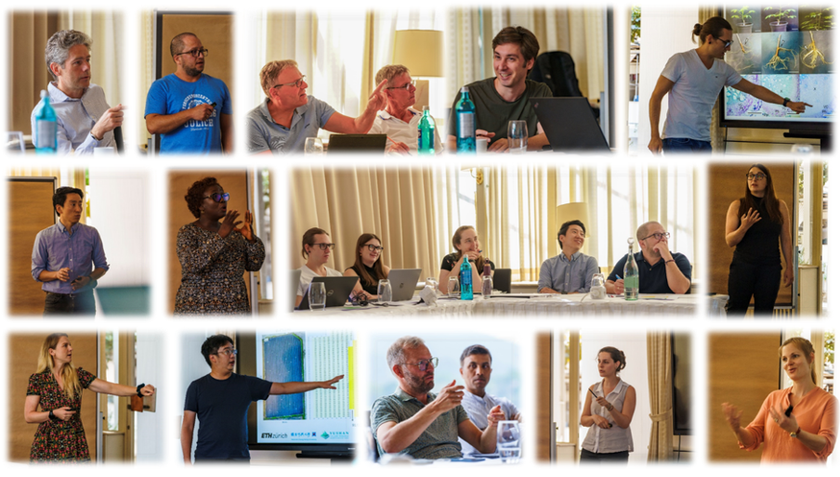
1.1

TM1_Project management and central services

Summary of Goals and Impact
The primary goal of TM1 is to ensure the efficient management and coordination of the Cassava Source-Sink Project (CASS) across all its components. This module is responsible for organizing, reporting, and communicating the progress of the project, as well as managing finances, intellectual property, and stakeholder interactions. Through regular meetings, detailed reporting, and strategic management, TM1 supports the seamless execution of the scientific and engineering goals of CASS, ensuring that all modules work in harmony towards the mission of increasing cassava yields under low-input farming conditions.

The impact of TM1 extends beyond administrative support; it facilitates the successful integration of cutting-edge research with practical agricultural applications. By ensuring that the project runs smoothly and efficiently, TM1 enables the delivery of tangible benefits to smallholder farmers, aligning with the broader goals of enhancing food security and improving livelihoods through innovative agricultural biotechnology.

TM1_Project management and central services

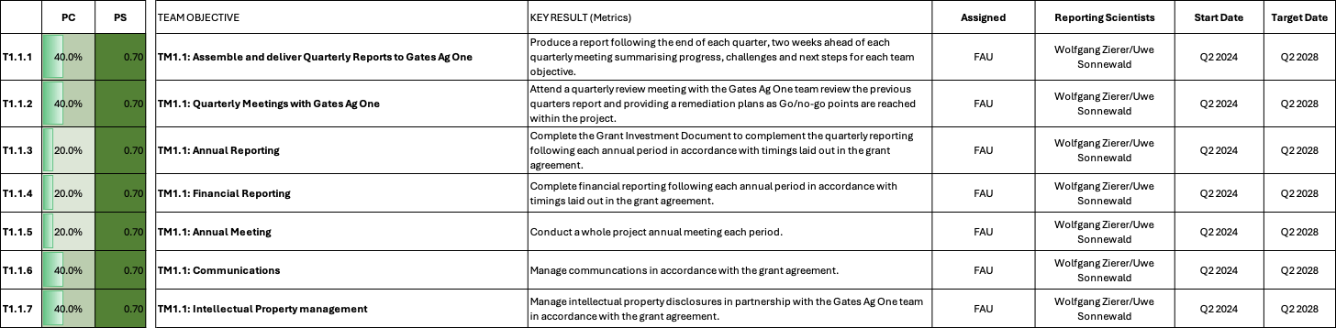

TM1: Project management and central services

Reporting module leaders: Wolfgang Zierer and Uwe Sonnewald, FAU.

Progress Update:

T1.1.1 Assembly and delivery of Quaterly Reports to Gates Ag One
With the support of Christian Rogers and Catherine Espinoza, a quarterly reporting structure similar to the ENSA project has been established. The present document represents the core of the first quarterly report (parts of Q2 and entire Q3) submitted to Gates Ag One within the agreed upon timeframe.
Q4 2024 report was submitted on February 14th 2025 as agreed.
Q1 2025 report was submitted on April 14th 2025 as agreed.
Q2 2025 report was submitted on July 18th 2025 as agreed.
Q3 2025 report was submitted on Sep 12th 2025 as agreed.
Q4 2025 report was submitted on Feb 13th 2026 as agreed.
Q1 2026 report was submitted on April 17th 2026 as agreed.

T.1.1.2 Quaterly Meetings with Gates Ag One
The first quarterly meeting for CASS Phase 3 is scheduled for September 30.
Q4 2024 quaterly meeting is scheduled for Feb 27th 2025.
Q1 2025 quaterly meeting is scheduled for May 2nd 2025.
Q2 2025 quaterly meeting is scheduled for July 25th 2025.
Q3 2025 quaterly meeting coincides with the annual meeting scheduled for Sep 24-25th at IITA, Ibadan.
Q4 2025 quarterly meeting is scheduled for Feb 26th 2026.
Q1 2026 quarterly meeting is scheduled for April 24th 2026.

T1.1.5 Annual Meeting
The CASS Phase 2/CASS Phase 3 “Kick-off” meeting was conducted in Zurich, in April 2024. A first CASS Phase 3 annual meeting is scheduled for October 6-8 2024 in Taichung Taiwan. The agenda is fixed and the meeting organized. The next annual meeting will likely be conducted in Europe or Africa around a similar time in October 2025, but is not yet organized.
The next annual meeting is scheduled for the week of 22-26. October 2025 at IITA Ibadan, Nigeria. I have contacted Ismail to begin the planning for this event. Due to the requirements for visa and specific vaccinations, it will be important to communicate meeting details in a timely manner.
No feedback from IITA so far. A meeting with Ismail Rabbi has been initiated.
Preparations for the annual meeting at IITA are under way. Participants have been asked to make travel plans and to contact IITA for invitation letters and hotel reservations. An additional planning meeting is scheduled for July 22nd 2025 to advance the meeting planning.
The annual meeting at IITA, Ibadan is organized. Let´s hope it will be a good one (it was)!
The annual meeting 2026 is scheduled for Sept 16-18 in Helsinki. Meeting planning has started.

T1.1.6 Communication
We are currently working on overhauling the CASS webpage and an updated release should be available in the next weeks. However, we are not fully satisfied with the realized design and further updates might be necessary.
Jolanda Kraner has started in February 2025 as CASS Communications Manager. Her task will be the improment of CASS public relations activities.
Jolanda Kraner and Uwe Sonnewald have started working on communication projects. For instance improvement to the CASS internet presence and a local event at the Erlangen Botanical Garden are planned).
This quarter focused on implementing a complete relaunch of the CASS Research website. The new site was redesigned and restructured to communicate research results and project activities more clearly and effectively.
To strengthen crisis communication, contact was established with an external agency to organize a training seminar for the core team. In addition, a report was compiled summarizing key communication activities and contributions from project partners.
Preparations were also made for launching dedicated social media channels, including the development of a content strategy and channel structure. A new logo for the project was designed and conceptually finalized.
The new website will go live on the existing domain within the next few days. If you would like to view it in advance, please use the following link:
https://cassresearch.wixsite.com/cass-research
Linkedin posts were published and prepared for accepted and hopefully soon to be accepted publications.
Current communication activities include, but are not limited to:
- Managing and developing the project’s LinkedIn presence (content planning, publishing, performance monitoring)
- Publishing and optimizing website content, improving articles and structure, adjusting performance settings in the back office; conducting website testing
- Developing the project Media Kit
- Creating standardized communication templates (letters, presentations, social media) and ensuring consistent corporate identity
- Supporting planning for the next Annual Meeting
- Coordinating press activities (TV filming, collaboration with internal FAU communications)
- Producing short social media video content

Katie Talf (AgOne), Jolanda Kramer (CASS), Uwe Sonnewald (CASS), and Emma Steer (ENSA) recently met at FAU Erlangen to link up and align communication strategies.

T1.1.7 Intellectual Property Management
A provisional patent application for AKT2 was submitted earlier this year. We are actively monitoring the situation around AKT2 in order to strengthen the patent application. A manuscript is currently being prepared for AKT2 and additional samples from key experiments (intermediate field samples 2024 and greenhouse drought stress experiments) are being analyzed. We will continue to share data and documents surrounding AKT2 as they become available. Additionally, we have agreed on more AKT2 work (Arabidopsis akt2 mutant complementation experiments) in order to strengthen the patent application further. We have also begun to create additional AKT2 constructs and plan to execute additional TMS60444 transformations to gain further insights into this transgene. Although the timeframe of this work is clearly beyond one year, these plant lines can still be used as post-filing evidence.
The AKT2 manuscript is close to being ready for circulation (including the IP team) and the additional Arabidopsis work is progressing as planned.
An updated version of the AKT2_{var} manuscript was recently shared. Currently no further IP activities.
The CASS IP online portal was established and is being well-received by the project members.

Project management highlights and achievements:
Despite the many challenges encountered from within FAU during the CASS Phase 2 to Phase 3 transition phase, we could properly manage this transition without losing key staff. We were also able to fill all vacant positions at FAU (3 PostDocs, 1 Technician, 1 Administrator, 1 Data Manager), with the exception of the projected Impact Manger. Training and integration of the new FAU staff is progressing well. Subgrant Agreements with all partners were created and have been signed. Projected funds for period 1 are being transferred. Overall, the projected work is progressing well and the CASS Phase 3 team seems motivated to tackle the challenges ahead.
Despite difficult circumstances, CASS conducted a successful annual meeting in Taichung, Taiwan.
We are in the process of recruiting an additional PhD student with projected start in July 2025. Srujan Kumar Talasila has joined the CASS team in July, to support the work on cassava storage root development aspects. We also recruited Johannes Schmidt as a PhD student, to support work in bioinformatics and data analysis. He is projected to start his PhD studies from October 2025 onwards. Additionally, we are in the process of hiring Ana-Marcela Florez-Rueda as a postdoc with experience in bioinformatics and data analysis.
The annual and financial report was submitted to GatesAgOne within the agreed upon timeframe.
- We had a very successful project meeting in September 2025 in Ibadan Nigeria.
- We published our AKT2_{var} manuscript in Nature Plants.
- Plant multiplication and logistics for CFT 2026 were successfully completed.

Challenges and Mitigations:
The projected Impact Manager position is yet unfilled. Initially, we planned to hire a person with both IP and communication background. However, we discovered that such a person is difficult to find for us. Since we feel that the present and expected level of IP-related work can still be handled by the involved scientists, we will be hiring a person focussed on communication. We have already identified such a person and have started negotiations.
In 2021, we outsourced plant multiplication to an external company, which facilitated the production of thousands of plants for our field trials. Plants multiplied this way were used in the CFT Taichung 2022, 2023, and 2024. While the company successfully finished also the production for the CFT 2025, we were informed of their bancrupcy. In parallel, we were exploring plant multiplication directly in Taiwan at another company. Unfortuntely, this company has also withdrawn interest in conducting this work, leaving us currently without the option for external plant multiplication. We have therefore decided to multiply plants at FAU again. Due to the massively increased scope of this work, we need more plant growing capacities and tissue culture staff. We plan to remodel an existing walk-in chamber and to hire additional staff by August 2025 latest, to not endanger the multiplication for 2026 field trial. The required budget shifts were recently approved by GatesAgOne and the order for remodeling has been placed.
Unfortunately, one of our recently hired PostDocs already left again to take a permanent research position in China. Therefore, recruitment for this or similar positions is ongoing. Recruitment for the additionally required technician is also required.
We still have open scientific positions that need to be filled.
On the current trajectory, we will have all open positions filled by October 2025.
Hiring is ongoing due to ever increasing German bureaucracy.
All positions are currently filled.

Next Steps in the Action Plan:
- We will attend the annual meeting on October 6-8 in Taichung Taiwan. After the meeting we will focus on further progressing project operations. (concluded)
- The quarterly report for Q1 2025 will soon follow the quarterly report for Q4 2024. Organization of the CASS annual meeting should start early. (concluded)
- Continue recruiting efforts and organize CASS meeting (concluded)
- Launch new CASS website (concluded)
- Continue organization of the annual meeting at IITA (concluded)
- Finalize hiring of new new employees (concluded)
- Organize CFT 2026 (concluded)

TM2: Cassava Transformation
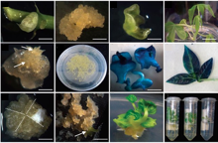
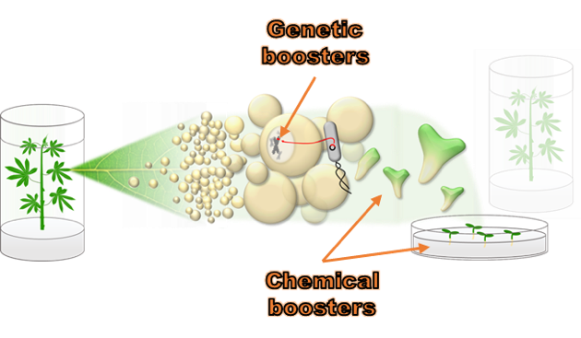
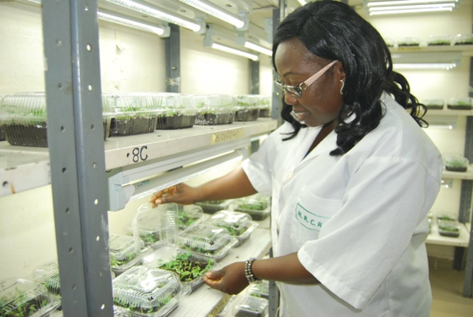
TM2.3_Transformation of farmer-preferred genotypes
2.3
TM2.2_Chemical and genetic boosters
2.2
TM2.1_Routine transformation
2.1
Summary of Goals and Impact

The primary goal of TM2 is to provide the transformation capacity essential for the success of the Cassava Source-Sink Project (CASS). This module focuses on transforming cassava genotypes, particularly the model genotype TMS60444, and optimizing transformation protocols to achieve higher efficiency, especially in farmer-preferred varieties. TM2 aims to develop genotype-independent transformation protocols, ensuring that the advances made in the engineering modules (EM1 to EM3) can be effectively applied to a range of useful cassava cultivars.

The activities within TM2 are critical for enabling the deployment of genetic innovations that can significantly boost cassava yields. By optimizing transformation protocols and ensuring the delivery of high-quality, transformed plantlets for further analysis and field testing, TM2 plays a central role in translating research into practical outcomes. This work has the potential to make a profound impact on the livelihoods of smallholder farmers by improving the productivity and resilience of cassava, a staple crop in many regions.

TM2.1_Routine transformation

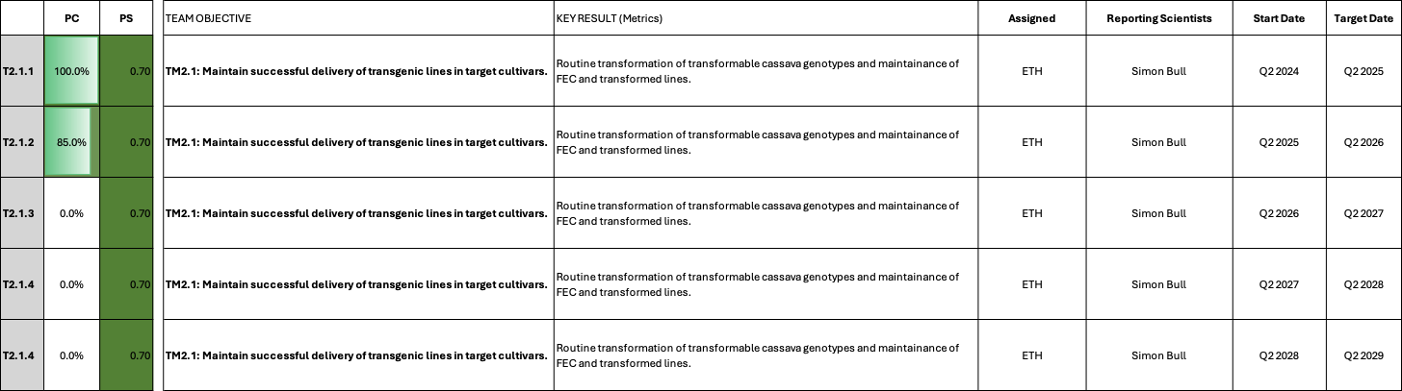

TM2.1_Routine transformation

Reporting module leader: Simon Bull, ETH.

Progress Update:

T2.1.1. Maintain successful delivery of transgenic lines in target cultivars.

Eleven constructs were received from FAU in early May 2024
EM2.1: C2-59_pStPatatin::AtIPT7 (Transformation completed)
C75_pStPatatin::AtIPT7 + pStPatatin::AtLOG1 (Transformation completed)
EM3.1: C2-99_pMeAPL3a::MeSUS3 (Transformation completed)
C2-100_pMeGPT2::MePFP1beta (Transformation completed)
C2-101pMeGPT2::MeGAPDH (Transformation completed)
EM3.2: C2-102_pStGBSS1::MeNTT1-tdTom (Transformation completed)
C2-103_pMeGPT2::MeGPT2-tdTom (Transformation completed)
C2-104_PStPatatin::MePGMp-tdTom (Transformation completed)
C2-105_pMeAPL3a::glgC16-tdTom (Transformation completed)
C109_pStGBSS1::MeNTT1-Myc + pMeGPT2::MeGPT2-HA (Transformation completed)
C110_pStGBSS1::MeNTT1-Myc + pMeGPT2::MeGPT2-HA + pStPat::PGMp-Flag (Transformation failed)

Transformation of these constructs into TMS60444 has been initiated and is currently ongoing. The material is on shoot induction medium and we are currently harvesting juvenile shoots for all constructs.
For above constructs, circa 40-100 shoots per construct have been produced and have passed the rooting test (check for HYG resistance). Plants have been propagated into new media/jars and awaiting next stage screening (i.e. PCR analysis for presence of transgenes).

Five constructs were received from FAU end of July 2024
EM3.1: C2-112_PGAM-ENO-PK (Transformation completed)
C2-110_MeFrk4 (Transformation completed)
EM3.2: C111_GPT-NTT-PGMp-glgC16 (Transformation completed)
C2-76_PPaseV2 (Transformation completed)
C2-91_PPaseV3 (Transformation completed)

For above constructs, circa 30-150 emerging cotyledonary embryos per construct have been produced and on shoot induction media. Between 50-80 plantlets per construct are getting established on CBM (Cassava Basic Media). The exception is construct C2-112-PGAM-ENO-PK from which only 20 shoots could be produced.

Three constructs were received from FAU early September 2024
EM2.2: C123_pMeLBD4::MeLBD4 (GAL4VP16-UAS) (Transformation completed)
C124_ pMeLBD11::MeLBD11 (GAL4VP16-UAS) (Transformation completed)
TM3.1: C2-118_ pManes.13G006800::GUS + pManes.13G006800::MeSWEET15-tdTomato (Transformation completed)

Transformation of these constructs is scheduled for transformation into TMS60444 end of September 2024. For above constructs, circa 50-150 emerging cotyledonary embryos per construct have been produced and on shoot induction media. Between 40-80 plantlets per construct are getting established on CBM (Cassava Basic Media).

FAU has received a lot of material from the ETH transformation pipeline. We received one plant per line in 50ml tubes, with plants being in varying conditions. Unfortunately, the material is not yet in a state that allows further work with the lines. Lines need to be cut and transferred to new jars and multiplied at least once. This results in a copy for tissue culture maintenance and a copy for greenhouse expression screening (n=1). This process alone will require several weeks, before greenhouse screening can even start.
Overall, we received more lines per construct than we can reasonably handle. Most constructs were transformed twice and yielded up to 60 lines per batch. We decided to reduce each transformation batch to a maximum of 24 events, selecting the visually better lines. Some transformation batches were already tested by digital-PCR (dPCR), identifying single insertion lines, while other batches are yet untested. We plan to prioritize the confirmed single insertion event lines in the downstream processing but will keep up to 24 untested lines per construct as a back-up for now. This is just to account for the possibility that greenhouse testing reveals defects for a given transformation batch. Lines from constructs that do not have a batch of confirmed single insertion events yet will be tested by dPCR to identify the single insertion events. Table 1 shows a summary of the current events/lines available for EM3.2.

The final shipment of plantlets were successfully transferred from ETH to FAU in Q2 2025. Plants that passed the rooting test were multiplied at ETH to expedite transfer of material to the glasshouse at FAU. The target transformations for ETH for Q2-2024 to Q2-2025 (TM2.1.1) were successfully concluded and material distributed.

Table 1_Summary of events/lines available for further processing
EM2.1
Construct | Name | Hyg^{R} events received | Lines maintained | Next steps
2-59 | pStPatatin::AtIPT7 | 63 (untested) + 24 (untested) | 24 (tested) | Determined single insertion events by dPCR; Conducting transgene expression screening; Detailed characterization required
C75 | pStPatatin::AtIPT7 + pStPatatin::AtLOG1 | 56 (untested) + 9 (untested) | 24 (tested) | Determined single insertion events by dPCR; Conducting transgene expression screening; Detailed characterization required
EM2.2
Construct | Name | Hyg^{R} events received | Lines maintained | Next steps
C123 | pManes.06G173400 (MeLBD4)::GAL4VP16::tCaMV35S + pUAS::MeLBD4 CDS-6xHA::tMeLBD4 + pUAS::ER-GFP::Ter | 36 | 24 (tested) | Determined single insertion events by dPCR; Conducting transgene expression screening; Detailed characterization required
C124 | pManes.04G025300 (MeLBD11)::GAL4VP16::tCaMV35S + pUAS::MeLBD11 CDS-6xHA::tMeLBD11 + pUAS::ER-GFP::Ter | 21 | 21 (tested) | Determined single insertion events by dPCR; Conducting transgene expression screening; Detailed characterization required
EM3.1
Construct | Name | Hyg^{R} events received | Lines maintained | Next steps
C2-99 | pMeAPL3a::MeSUS3 | 60 (untested) | 24 (tested) | Determined single insertion events by dPCR; Conducting transgene expression screening; Re-check expression (discard if negative)
C2-100 | pMeGPT2::MePFP1beta | 42 (untested) + 37 (untested) | 24 (tested) | Determined single insertion events by dPCR; Conducting transgene expression screening; Detailed characterization required
C2-101 | pMeGPT2::MeGAPC | 66 (untested) + 29 (untested) | 24 (tested) | Determined single insertion events by dPCR; Conducting transgene expression screening; Detailed characterization required
C2-110 | pMeGPT2::MeFrk4-tdTomato | 38 (untested) | 24 (tested) | Determined single insertion events by dPCR; Conducting transgene expression screening; Re-check expression (discard if negative)
C2-112 | pMeGPT2::PGAM-ENO-PK | 8 (untested) | 8 (untested) | Determined single insertion events by dPCR; Conducting transgene expression screening; Detailed characterization required
EM3.2
Construct | Name | Hyg^{R} events received | Lines maintained | Next steps
C2-102 | pStGBSS1::MeNTT1-tdTomato | 27 (confirmed single insertion) + 58 (untested) | 24 (tested) | Determined single insertion events by dPCR; Conducting transgene expression screening; Re-check expression (discard if negative)
C2-103 | pMeGPT2::MeGPT2-tdTomato | 37 (confirmed single insertion) + 17 (untested) | 24 (tested) | Determined single insertion events by dPCR; Conducting transgene expression screening; Re-check expression (discard if negative)
C2-104 | pStPat::PGMp-tdTomato | 36 (confirmed single insertion) | 24 (tested) | Determined single insertion events by dPCR; Conducting transgene expression screening; Re-check expression (discard if negative)
C2-105 | pMeAPL3a::glgC16-tdTomato | 60 (untested) | 24 (tested) | Determined single insertion events by dPCR; Conducting transgene expression screening; Re-check expression (discard if negative)
C109 | pStGBSS1::MeNTT1 + pMeGPT2::MeGPT2 | 24 (confirmed single insertion) + 37 (untested) | 24 (tested) | Determined single insertion events by dPCR; Conducting transgene expression screening; Re-check expression (discard if negative)
C110 | pStGBSS1::MeNTT1 + pMeGPT2::MeGPT2 + pStPat::PGMp | 0 | 0 | Identify reason for lethality
C2-76 | pManes.09G045900::GUS + pManes.09G045900::EcPPase-tdtomato | 52 (untested) | 24 (tested) | Determined single insertion events by dPCR; Conducting transgene expression screening; Detailed characterization required
C2-91 | pManes.05G118300::GUS + pManes.05G118300::EcPPase-tdtomato | 48 (untested) | 24 (tested) | Determined single insertion events by dPCR; Conducting transgene expression screening; Re-check expression (discard if negative)
C111 | pStGBSS1::MeNTT1_ACU + pMeGPT2::MeGPT2_ACU + pStPatatin::MePGMp_ACU + pMeAPL3a::glgC16 | 51 (untested) | 24 (tested) | Determined single insertion events by dPCR; Conducting transgene expression screening; Re-check expression (discard if negative)
All
Construct | Name | Hyg^{R} events received | Lines maintained | Next steps
VC | Empty vector control Batch1 | 13 (confirmed single insertion) + 35 (untested) | 12 (tested) | Multiply confirmed events for greenhouse and field experiments
VC | Empty vector control Batch2 | 28 (untested) | 12 (tested) | Multiply confirmed events for greenhouse and field experiments

The shipment of another 11 constructs (Table 2) from FAU to ETH is being prepared at the moment. Another four constructs will be transformed at FAU (Table 3).

Table 2_Constructs awaiting transformation at ETH
Construct number | Gene cassette | Database link | Next steps
C2-132 | pMeACL5::GUS + pMeACL5::AtBUD2 | https://cassbase.org/stock/471880/view | Transformed in January 2026
C2-133 | pStPat::AtTPS1 | https://cassbase.org/stock/471881/view | Transformed in January 2026
C2-134 | pSlRBCS2::GUS + pSlRBCS2::IntronGA2ox1 | https://cassbase.org/stock/471877/view | Transformed in January 2026
C2-136 | pSlRBCS2::GUS + pSlRBCS2::AtGAIdelta17 | https://cassbase.org/stock/475422/view | Transformed in January 2026
C2-139 | pMe01g239100::GUS + pMe01g239100::PPase | https://cassbase.org/stock/475427/view | Emerging shoots
C2-140 | pMe15g171200::GUS + pMe15g171200::PPase | https://cassbase.org/stock/475428/view | Emerging shoots
C2-144 | pCaMV35S::GUS + pCaMV35S::IntronGA2ox1 | https://cassbase.org/stock/475429/view | Emerging shoots
C126 | pKNAT1::GUS + pKNAT1::GAL4 + UAS::KNAT1 + UAS::ER-GFP | https://cassbase.org/stock/475430/view | Transformed in January 2026
C2-141 | pKS1::GUS + pKS1::IntronGA2ox1 | https://cassbase.org/stock/475424/view | Emerging shoots
C2-142 | pKS1::GUS + pKS1::AtGAIdelta17 | https://cassbase.org/stock/475429/view | Emerging shoots
C2-129 | pAtSUC2::OsHAK18 | https://cassbase.org/stock/471878/view | Transformed in February 2026
C2-130 | pMeSUS1::MeSWEET10 RNAi | https://cassbase.org/stock/471879/view | Transformed in February 2026
C2-131 | pMeAKT2a::AtAKT2var | https://cassbase.org/stock/475431/view | Transformed in February 2026
C2-143 | pMeAKT2b::AtAKT2var | https://cassbase.org/stock/475426/view | Transformed in February 2026
C2-96 | bZIP-TF11 |  | Transformed in February 2026
C2-97 | bZIP-TF53 |  | Transformed in February 2026
C2-122 | pAtSUC2::AtAKT2 CDS_S210N-S329N::Ter (companion cell-specific expression) | https://cassbase.org/stock/470120/view | Awaiting transformation
C127 | PsGPT2 + AtNTT1 + AtAKT2_{var} | https://cassbase.org/stock/470119/view | Awaiting transformation

As discussed between FAU and ETH Zurich, fewer plants will be generated per construct in future transformation cycles to help alleviate over-burdening resources at FAU with space requirements and processing. About 25 – 30 plantlets will be sufficient.

Update Q4 2025
Constructs (Table 2) were received 19th September 2025 (Q3). Priority constructs (defined by FAU) were used for transformation in November 2025. The FAU vector control plasmid (VC220) was included in this round of transformations.

Update Q1 2026
For the transformation batch that was initiated in November (i.e. C2-139, C2-140, C2-144, C2-141 and C2-142, including VC), we now have shoots emerging for all constructs. We envisage that selected plantlets will be sent to FAU in Q2 2026.

A further set of transformations with FAU/CASS constructs was initiated in January (see Table 2 above) and currently on regeneration (MSN) media.

Challenges and Mitigations:
Construct C110 failed to give expected numbers of regenerating embryos/shoots, both in the first transformation and in a repetition, indicating a deleterious impact of this construct on growth. C110 has indeed failed transformation. We suspect that this is the result of PGMp overexpression lethality. However, PGMp-tdTomato single overexpression construct has resulted in transgenic plant lines. However, it is possible that the tdTomato-Tag affects activity. We will test PGMp-tdTomato for activity. It overexpression of a functional PGMp is not lethal, transformation of slightly altered combination constructs C110/C111 can be attempted again.
No challenges so far. The transformation plattfrom of ETH Zurich remains a reliable source of high quality transgenic cassava material.

Transformations outlined in Table 3 failed at FAU due to problems with Agrobacteria and need to be re-initiated. Constructs have been sent to ETH Zurich to be prioritized for transformation.

Q4 2025 Update
No technical challenges. However, due to contractual restrictions at ETH Zurich, unfortunately we are unable to renew the employment contract of Mr. Kai Kirchhoff (Technician) beyond December 2025. As such, we are seeking to recruit a new member of the CASS team. We envisage there will be a period (Q1-Q3 2026) during which high-output will reduce slightly while training a new staff member.

Update Q1 2026
A new research assistant has been appointed (Dr Fabienne Bürki), who started in the ETH cassava team in February 2026.

Next Steps in the Action Plan:
Continue as planned – the harvested shoots from the first round of transformations (11 constructs) will be used in rooting test analysis in the next couple of months. Constructs from the second and third batch of transformations (7 constructs) will be used for cassava transformation by end of September, thus we expect shoots early 2025. In vitro plantlet material will be transferred to Erlangen when available.
Transformations and regenerating embryos/shoots continues as planned. The plantlets that passed the rooting test (from first round of transformations) will be used for further selection/assessment in early 2025. The material from the second and third round of transformations, we expect to have shoots for pre-screening early 2025. Once these materials are checked and verified, we will send to FAU for further coordination/analysis.

- ETH to complete ongoing transformation
- FAU to supply a new set of plasmid to ETH in Q3 2025 (current plan is to send a larger set of promoter-reporter constructs)
- FAU to complete dPCR characterization of received lines (Table 1)
- FAU to maintain and multiply material for distribution and greenhouse experiments
- Provide new transformation constructs to the ETH Zurich pipeline
- Schedule transformations for Q1 2026 in collaboration with the project manager
- Discuss next batch of constructs to be sent to ETH

TM2.2_Chemical and genetic boosters

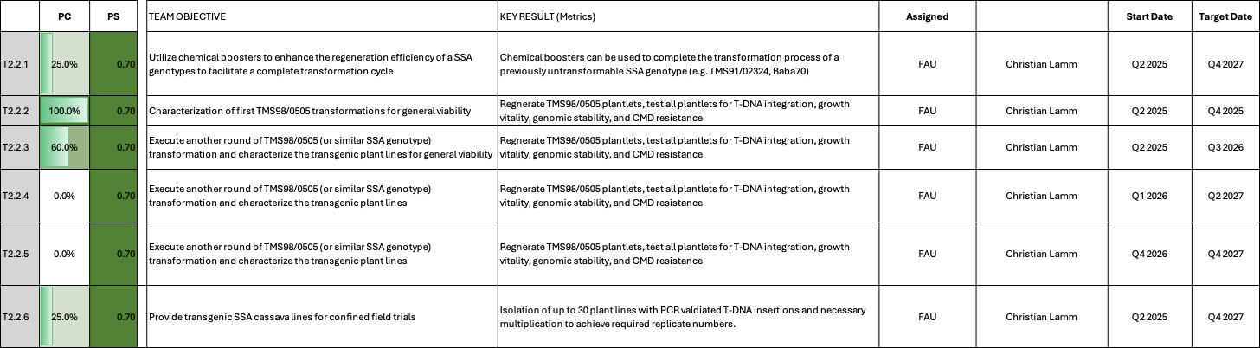

TM2.2_Chemical and genetic boosters
Reporting module leader: Christian Lamm, FAU.

Progress Update:

Following the Q4 2024 change requests and the subsequent Q1 2025 discussions, we agreed to stop work on genetic boosters and to restructure the work packages. The work packages displayed in slight grey below have been retired:

Determining optimal concentration and timing of chemical boosters to enhance transformation
Preliminary experiments with chemical boosters were conducted with untransformed TMS60444 wildtype friable embryogenic calli at the stage of somatic embryogenesis/regeneration. Here, the chemicals could indeed improve shoot regeneration efficiency. To assess the effect of the hyperphyllin and sodium butyrate on regeneration efficiency in a complete transformation experiment, a fluorescent reporter construct was used for conventional transformation of TMS60444 friable embryogenic callus. Cells are currently in selection and will be treated with chemical boosters during upcoming regeneration. To assess the utility of chemical agents such as hyperphyllin and sodium butyrate at earlier timepoints in the transformation procedure, i.e. on generation of transformable calli, leaf explants of genotypes TMS60444 and TME419 were subjected to different callus induction media with or without the chemicals. No beneficial effects could be observed 4 weeks after continuous treatment. Hence, tested chemical boosters seem to have a beneficial effect on shoot regeneration, but seem not suitable to induce callus production in cassava.
The experiment intended to assess effects of hyperphyllin and sodium butyrate on regeneration efficiency of transformed callus was continued as planned. Unfortunately, a persisting contamination with Agrobacteria during regeneration made it necessary to discard several of the replicate petri dishes over the course of the experiment. Ultimately, the lack of replicates led to the premature termination of the experiment. However, quantitiation of the emerging shoots on the remaining replicates over a regeneration period of seven weeks showed significant positive effects of treatment with 200µM sodium butyrate when compared to regular regeneration medium, confirming previous experiments.
As discussed during the Q4 2024 quarterly meeting, the repetition of the above mentioned experiment still showed no conclusive result. However, previous data indicates that SB at a concentration of 200 µM and HP at 40 µM can improve regeneration. We further hypothesize that TMS60444, the genotype we used so far, may not necessarily benefit from chemical booster treatment, as regeneration is very efficient even without supplementing booster chemicals. Since we now can obtain FEC from several farmer-preferred genotypes, we will apply the chemical boosters to those rather than the model genotype, as outlined in task 2.2.2.

Challenges and Mitigations:
None to report in this quarter.
In line with previous work, our experiment confirmed that addition of 200µM sodium butyrate enhances regeneration efficiency. Hence, experiments with farmer-preferred genotypes will commence as planned. However, since the experiment was unable to deliver the desired statistical power throughout the complete regeneration procedure, a repetition of the experiment (still using TMS60444) was initiated in Dec. 2024. As of now, transformed callus is on regeneration medium with or without chemical boosters and final results are expected until March. The repetition of the experiment will not affect the projected timelines of TM2.2.2, as first application of chemical boosters to FEC of farmer-preferred genotypes is scheduled for March-April. Hence, no mitigations are necessary at the moment.

Next Steps in the Action Plan:
After recovery and selection phase, reporter-transformed cells will be subjected to regeneration media including variable concentrations of hyperphyllin and/or sodium butyrate. Emerging plantlets will be quantified. Results are to be expected towards the end of the year.
After obtaining complete data for chemical booster performance, regenerating FEC derived from farmer-preferred varieties will be treated with suitable amounts of HP/SB according to T2.2.2.
As outlined above, we conclude our activities in TMS60444 and move to the application of chemical boosters in farmer-preferred genotypes.

Identification of morphogenic genes suitable as transformation boosters in cassava TMS60444.
Several morphogenic genes were selected based on literature research, molecular cloning is finished or underway.
Of these, LEAFY COTYLEDON2 and WUSCHEL (Manes.17G047000 and Manes.02G104000, respectively) were already stably expressed in TMS60444 under the control of a viral rolling circle expression system to achieve high expression strength. Golden gate constructs additionally included a GFP-reporter gene, making it possible to observe transformed cells. An empty vector control as well as a viral rolling circle-driven GFP reporter served as controls. Emerging cotyledons were quantified during regeneration.
Both LEC2 and WUS yielded no higher regeneration potential as compared to the controls. Quite the contrary, the rolling circle system seemed to suppress regeneration, as GFP control performed worse than empty vector control. Despite this, the LEC2 construct still achieved regeneration efficiency comparable to empty vector controls, making LEC2 a promising candidate under control of a different promoter system.
TMS60444 was transformed using a new set of morphogenic genes. Expression is controlled by a NOS promoter, genes include LEC2 (Manes.17G047000), WOX5 (Manes.07G126200), AGL15 (Manes.10G135400) and PLT5 (Manes.14G154900), regeneration and quantitation is ongoing at the moment.
As stated in the Q4 2024 quarterly meeting, we concluded the work on morphogenic genes in favor of the more promising transformation of TMS98/0505 (and potentially other genotypes) using improved transformation protocols.

Challenges and Mitigations:
Viral rolling circle replication potentially harmful during regeneration of plantlets – drop this system and use NOS promoter instead (Selection marker uses same promoter, which confirms promoter activity during regeneration on Hyg-containing medium). Molecular cloning of constructs is finished.
The transformation experiment with AGL15 was contaminated with mold and had to be discontinued. The construct will be included in the next regular transformation experiment, regeneration of all other constructs continues as planned. Although we are slightly behind schedule here, we are confident that we can conclude T2.2.3 at target date Q2 2025 by sampling regenerating plantlets for subsequent analyses earlier than usual.

Next Steps in the Action Plan:
Use more suitable promoter system (NOS) for expression of at least 6 morphogenic genes in total. Repeat transformation of pNOS::LEC2 as promising candidate.
- Quantitation of the regenerating cotyledons from the recent pNOS::LEC2/WOX5/AGL15/PLT5 transformations.
- Regeneration of plantlets and confirmation of T-DNA insertion.
TM2.2.1. Utilize chemical boosters to enhance the regeneration efficiency of a SSA genotypes to facilitate a complete transformation cycle
So far, we have obtained suitable FEC for TMS98/0505, TMS91/02324 and Baba70. While FECs from TMS98/0505 could be used for regeneration/full transformation of plants (see below), TMS91/02324 stopped at the regenerate stage using our usual protocol and appeared overall slow growing. Application of the chemical boosters to TMS91/02324 is of special interest to us, because it could trigger shoot regeneration in this genotype.
A first transformation experiment with Baba70 (https://www.nextgencassava.org/next-generation-varieties-details/) was initiated. FEC are on selection medium at the moment. Generation of FEC of other genotypes like TMS91/02324 is ongoing at the moment.
Baba70 FEC transformed with C2-8 were subjected to treatment with 200µM sodium butyrate during regeneration. While the experiment is ongoing, it is already obvious that regeneration efficiency of Baba70 is generally inferior to TMS60444 (slower, fewer shoots). First cotyledons could be isolated after three weeks on regeneration medium, as of today, after 8 weeks of regeneration, the sodium butyrate treated FECs yielded 13 cotyledons (derived from 4/15 petri dishes), while the empty vector control on regular medium yielded 10 cotyledons (derived from 2/15 petri dishes. No cotyledons could be isolated for C2-8 on regular regeneration medium so far.
After 11 weeks of regeneration, the BABA70 transformation experiment was terminated. Although additional shoots could be obtained, none of them survived a rooting test on hygromycin-containing medium after regeneration. This indicates unwanted recovery of non-transgenic escape lines, independent of the regeneration medium type (+/- sodium butyrate). Since no transgenic lines could be obtained, the experiment could not yield reliable information on chemical transformation booster efficiency.
However, BABA70 FEC was obtained rather easily and emerging shoots of escape lines regenerated readily.
Since we were only able to recover lines lacking T-DNA/hygromycin resistance cassette, we suspect that transgene delivery by Agrobacteria failed in this experiment/for this particular genotype. As a new batch of BABA70 FEC is already available, the transformation experiment will be repeated using adapted coculture conditions.

Confirming our first attempt, generation of a second BABA70 FEC batch occurred very efficiently with our standard workflow. However, recent BABA70 and TMS60444 transformation experiments yielded no transgenic plants, hence we suspected issues with our Agrobacterium stock. Consequently, a newly purchased stock of Agrobacterium tumefaciens strain LBA4404 was used for transformation of the second batch of BABA70 FEC as well as all other upcoming transformation experiments.
To investigate effects of chemical boosters during BABA70 regeneration, regeneration medium was supplemented with hyperphyllin and sodium butyrate in varying concentrations. Over a period of 9 weeks, emerging shoots were isolated and counted from 11-12 plates per treatment. While the experiment yielded very high numbers of emerging plantlets throughout all conditions, statistical analysis (Kruskal-Wallis test) showed no significant differences between group means, presumably due to high variability within treatment groups (Fig. 1A). Nevertheless, treatment led to a tendency to have more well-performing plates (increased median) and a generally higher number of emerging plantlets over all plates (Fig. 1B). This corroborates previous observations, indicating that (i) BABA70 callus readily undergoes somatic embryogenesis and (ii) chemical boosters have the potential to aid in transformation.
In contrast to the first failed experiment, some first plants showed viability in medium containing high concentrations of hygromycin, suggesting successful T-DNA transfer. A more detailed assessment of these plants (PCR-based transgene confirmation, general viability of fully grown plants, etc.) remains to be done.
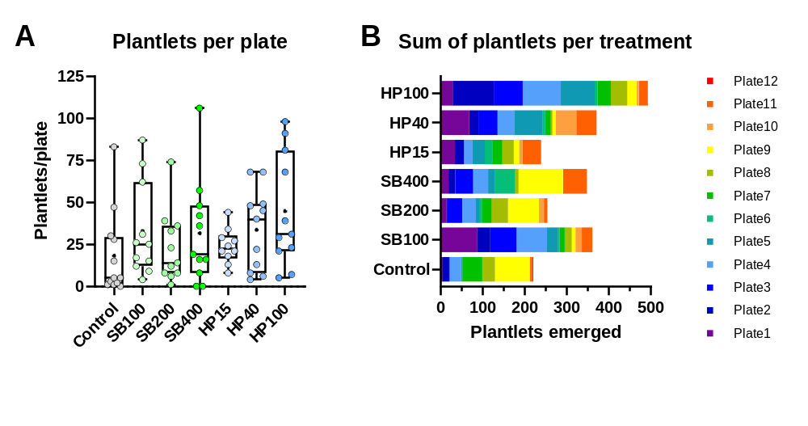
Fig. 1_(A) Quantification of emerging plantlets after 9 weeks of regeneration. Each datapoint represents the number of plantlets derived from one plate.
(B) Sum of all emerging plantlets after 9 weeks of regeneration.

Update Q1 2026
For each of the tested treatments, we selected a set of plants that have passed the rooting test for further characterization. To date, 40 regenerants have been established and are being propagated for subsequent multiplication and greenhouse evaluation. At this stage, many plantlets exhibit atypical leaf phenotypes. Given our lack of prior experience with this genotype post-transformation, we cannot specifiy whether these traits are transient and reflect recovery from recent exposure to phytohormone-supplemented culture media, or whether the atypic phenotypes remain.

Challenges and Mitigations:
None to report
Transgene delivery by Agrobacteria problematic in first transformation of BABA70, use adapted conditions, e.g. higher oD of bacterial culture.
Previous issues with transgene delivery were mitigated by purchasing a fresh Agrobacterium stock.
Possibly atypical leaf phenotype. Evaluation only reliably possible after prolonged growth in regular medium.

Next Steps in the Action Plan:
Production of suitable amounts of FEC for transformation experiments.
Treatment of transformed FEC of farmer-preferred genotypes with chemical boosters, quantitation of regenerating shoots.
Baba70 regeneration will continue until cotyledons cease to emerge. FEC of other genotypes will be successively subjected to similar experiments.
Repeat transformation experiment as described above.
Regenerated lines will be analyzed by PCR-based methods and transferred to the greenhouse to evaluate overall viability.
dPCR and propagation for greenhouse transfer ongoing.

TM2.2.2. Characterization of first TMS98/0505 transformations for general viability
In addition to the task outlined in the project application, FAU has been working on the implementation of protocols for the transformation of farmer-preferred genotypes. Here, the generation of quality FEC is considered a major bottleneck. To assess it's suitability for non-TMS60444 FEC prduction, we subjected several farmer-preferred varieties (obtained via DSMZ Braunschweig) to our routine pipeline with small alterations in medium composition according to Segatto et al. 2022. We were unable to produce FEC from TME419 and Gamechanger, but succeeded for 91/02324 and 98/0505, although with low FEC yield. Once isolated, FEC propagated readily and were multiplied for transformation experiments using our routine protocol. FEC from both genotypes were recently transformed using a fluorescent reporter construct, as well as C2-8 (AKT2) and are currently on resting medium / in selection. Transformation efficiency will be compared to a TMS60444 control experiment. We will also attempt to repeat the generation of 91/02324 and 98/0505 FECs and further optimize (low FEC yield) the implementation of these protocols at FAU. Depending on the outcome of the first transformation experiments with 91/02324 and 98/0505 FECs, as well as on the repetition experiment for the induction of the respective FECs, this route could prove a faster way towards the generation of virus-resistant, farmer-preferred genotypes for the project.
Our previous efforts to obtain FEC from farmer-preferred varieties were successful for genotypes TMS98/0505 and TMS91/02324, and transformation experiments were initiated. In both cases, transformed callus yielded a solid number of cotyledons, that were subsequently put on regeneration medium. In case of TMS91/02324, regeneration failed for all cotyledons. For TMS98/0505 however, we were able to readily regenerate plantlets. While regeneration occurred slightly slower, the overall number of regenerated plants was comparable to our benchmark TMS60444. A first PCR analysis on a small subset of plants showed successful integration of our test construct C2-8, proving our general ability to transform this farmer-preferred genotype with slightly adapted standard procedures. TMS98/0505 represents a CMV-resistent genotype with CMD3-type resistance, which should enable us to test transgenic cassava plants in Sub-Saharan Africa (SSA). We will continue isolation of AKT2_{var} lines and vector control lines (was transformed in parallel) and test their viability (growth and WGS). Potentially, AKT2_{var} and vector control lines in the TMS98/0505 backgrounds can be used for a first field trial in SSA starting 2025/2026, way ahead of schedule.
Additionally, farmer-preferred cultivars TMS98/0505 and TMS91/02324 were shared with ETH Zurich, which re-introduced them into their tissue culture to test their capacity to produce FECs. Both cultivars are currently on GD-based media (to induce FEC) and will be reviewed in Q1/Q2 2025.
Following transformation of TMS98/0505 with construct C2-8 (AKT2_{var}), we regenerated aprox. 60 plantlets. Of those, 40 plants survived a rooting test on hygromycin-containing medium, T-DNA insertion was confirmed by PCR for approx. 30 plants so far, and a small subset was also tested by Southern blotting, showing that lines are independent (single as well as multiple T-DNA insertions detected). Having arranged a WGS strategy with the service provider to enables a suitable evaluation of genomic stability, we are now preparing genomic DNA samples for sequencing.
A new, larger batch of TMS98/0505 FEC, as well as newly obtained Baba70 FEC, were transformed with constructs C2-8 (AKT2_{var}) at the beginning of April. Transformed FEC of both genotypes are on selection medium at the moment.
Finally, routine FEC production for TMS98/0505 was initiated to ensure a constant supply with FEC for further experiments/transformations.
We isolated the 30 most healthy looking lines of AKT2_{var} in TMS98/0505 and could move 10 lines into the greenhouse so far. We confirmed T-DNA integtration for these lines by digital PCR and discovered single insertion lines, as well as double- and multiple insertion lines. Line 900 was discovered to be an escape line, which will be used as a control. We are currently conducting an aboveground screening (plant height and stem diameter) and photographic documentation. In addition, we tested AKT2_{var} transgene expression in petiole tissue. Since we expext phloem expression for this transgene, the observed qRT-PCR values are typically very low, due to the tissue dilution effect. Fig. 2 below shows that that the AKT2_{var} negative line and the WT control don´t show AKT2_{var} expression as expected. Line 904, a AKT2_{var} positive line, also does not show expression in petiole tissue. However, it could be that this line has a deviating tissue specific expression and expression nees to be tested in stem tissue, once distructive sampling for these lines is current. All other lines tested express the AKT2var transgene. It is interesting to note that AKT2_{var} expressing lines tended to be taller, but also thinner compared to WT or non-expressing plant lines. Also their leaf form appeared more irregular compared to controls. Since the escape line 900, which experienced all the same treatment as the transgenic lines, does not show this behaviour, it is likely an AKT2_{var} in TMS980505 phenotype. However, further analysis is required.

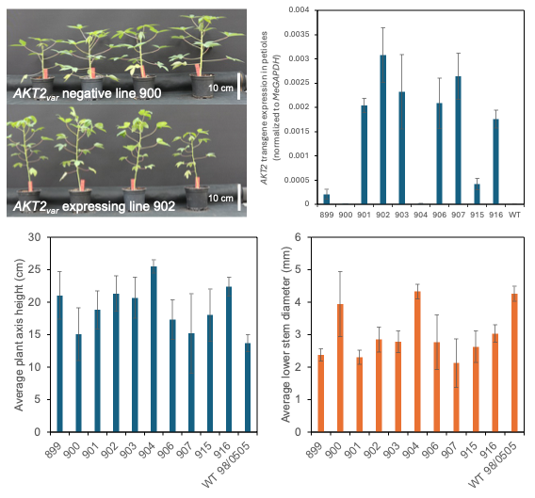
Fig. 2_First results from greenhouse screening for AKT2_{var} in TMS980505

We also conducted whole genome sequencing (WGS) of 4 transgenic and 1 wildtype plant to investigate potential somaclonal variation/large-scale genome rearrangements. While SNPs and InDels were detected as expected, no major chromosome losses or other major deviations were found between transgenic lines and WT plants, suggesting an overall intact TMS980505 genome.

By now, from a total of 51 recovered lines, we concluded dPCR analysis of 40 lines, revealing 15 single insertion events. Of the ten lines previously transferred to the greenhouse, only one contained a single insertion (line 904, no expression detectable in petiole, other tissues will be harvested in the upcoming weeks).
As suspected before, the leaf distortion phenotype manifested for most of the 10 initially cultivated lines also 15 weeks after planting. Of note, while escape line 900 does not show any phenotype, the drastic effects showcased by other lines is mitigated in line 904 (single T-DNA insertion, no expression in petioles detectable). This could also be replicated in a second planting containing a large part of the remaining lines. Similar to the initial cultivation, many of the lines show drastic phenotypes such as leaf distortion and bendy shoots at 4 weeks after planting. Conversely, ca. 10 lines were found to exhibit milder symptoms (i.e. slightly distorted leaves, lanceolate leaves) and should be followed upon.
To evaluate whether the off-type effects are a consequence of AKT2_{mut} expression in TMS98/0505, or whether they can be attributed to the general transformation procedure, further experiments are needed.
It is currently unclear if we will be able to provide healthy AKT2_{var} TMS98/0505 lines from this first round of transformation for field trials. If symptom severity persists in stake plantings or increases over time, the current material might not be viable.
To assess general viability of recovered plants, a set of ca. 40 C2-8 AKT_{var}TMS98/0505 lines was transferred to the greenhouse from tissue culture. In line with the previous experiment, transgenic lines maintained higher shoots with thinner stems throughout the growing period of ca. 10 weeks. At harvest, most of the transgenic lines had higher shoot weight, which was oftentimes accompanied by drastical reductions in root freshweight (Fig. 3). Only one transgenic line, line 944, exhibited slightly increased harvest data over the wildtype and non-transgenic escape line 900. Overall, most of the plants suffered from more or less pronounced transformation defects, as was observed before. Unsurprinsingly, lines with more severe defects tended to have lower yield, while more intact lines showed better results. For most lines, expression of AKT2_{var} could be confirmed. Notably, the highest-yielding line 944 showed expression levels comparable to those of other lines, suggesting that transgene expression is unlikely to be responsible for the observed defects.

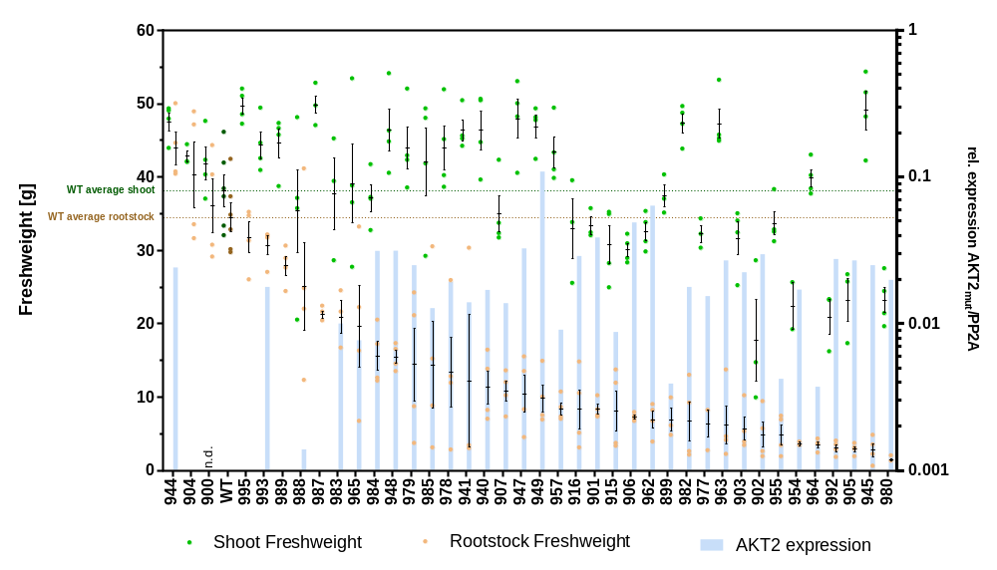
Fig. 3_ Screening of AKT2var-TMS98/0505 lines illustrating root and shoot weight as well as transgene expression in stem tissue.
After harvest, we replanted some of the best performing transgenic lines from stakes. While the experiment is still ongoing, it is already obvious that stake-grown plants still retain some transformation defects, albeit not as strong as observed previously (Fig. 4). While it is evident that results from the second transformation batch of TMS98/0505 are necessary to answer obvious questions about the general viability of these plants after transformation, the stake-grown plants from this experiment will still be used to test for ACMV resistance. Having acquired all necessary permits from the local authorities, we obtained ACMV inoculum from DSMZ Braunschweig towards the end of last year and will now commence to establish a ELISA-based testing system using bud grafts according to Wagaba et al. 2013 (10.1186/1756-0500-6-516).

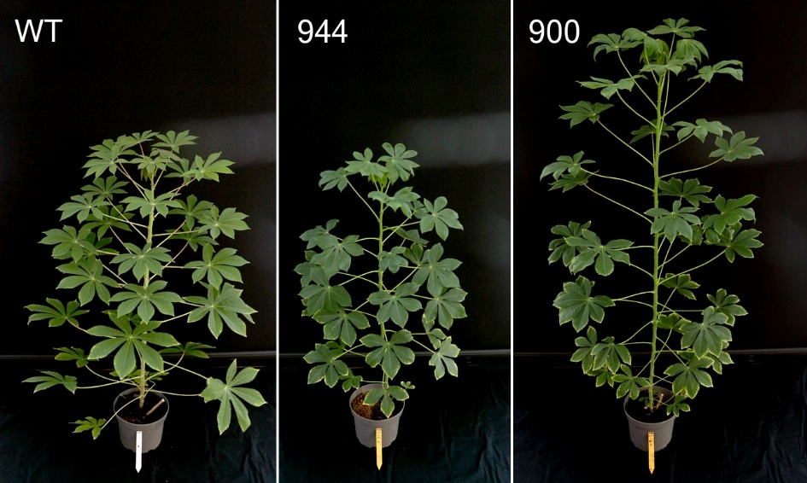
Fig. 4_ Stake-grown AKT2var plants at 12-weeks after planting.

Challenges and Mitigations:
While some of the generated C2-8_TMS98/0505 lines look healthy, many others exhibit transformation defects after growing some time. Since we used only a small set of FEC, which was then propagated on callus level, it is reasonable that these defects can be mitigated by preparing a larger and fresher set of FEC, as was done in the recent transformation experiment mentioned above. This should increase the ratio of healty looking plants to defective looking plants. Furthermore, transformation experiments on other genotypes like Baba70 are ongoing.
Our initial concern about off-type effects could be mitigated by some propagation cuttings, which let to mostly healthy plants. However, as noted above, leaves of transgenics still show some distortion. The reasons for this are unclear so far. While WGS indicates overall intact genomes, more experiments are needed to assess the vitality of the generated plant lines.
Off-type phenotypes of transgenic 98/0505 plants remain present also after prolonged growth in the greenhouse across most of the cultivated lines. While this seems to be an issue throughout most of the transformation batch, there are some lines showing milder symptoms than others. It will be necessary to screen the second set of plants in the greenhouse, hopefully identifying viable lines. Most promising lines will also be planted from stakes to assess the phenotype when not grown from in vitro plantlets. Finally, a repetition of the transformation with the same and other constructs will give us information on transformation batch effects as well as transgene-mediated effects.

Stake-planted AKT2var lines still retain off-typic effects, albeit somewhat mitigated. It will be necessary to analyze the second TMS98/0505 transformation batch to obtain information on the nature of the defects (i.e. the observed defects can be pinpointed to FEC-batch, transgene construct, or genetic transformation in general).
Due to regulatory difficulties in obtaining ACMV inoculum, CMD resistance testing is still outstanding. While we are behind schedule with this last remaining experiment, we are confident to conclude this activity in the upcoming weeks.

Update Q1 2026
First mechanical ACMV inoculations in Nicotiana benthamiana were initiated to obtain more infectious plant material for the actual virus resistance assays. Unfortunately, we failed at infecting the model plant and had to switch to a different method. We ordered plasmids containing the viral genomes and are now using a particle gun-based method to infect plants. This activity is still ongoing.

Next Steps in the Action Plan:
Repetition of FEC production for 91/02324 and 98/0505. Further genotypes will be fed in the FEC pipeline.
Although not part of the initial action plan for TM2.2, we are planning further (greenhouse) experiments in the upcoming 4-5 months to characterize the putative TMS98/0505-transgenics. We will determine T-DNA insertion, genomic stability, overall plant integrity, as well as CMD-resistance.
C2-8 TMS98/0505 plants are currently being propagated for greenhouse evaluation. Genomic DNA of representative lines will be sent to WGS to check for genomic stability after transformation.
- Continue greenhouse analysis of the present plant lines and add the remaining lines to the screening
- Analyse transgene expression in other tissues and replant plant lines from stakes to evaluate the phenotype again
- We plan to conduct a CMD virus resistance screening in the near future (likely via external collaborators)
The first round of greenhouse screening will be concluded for all lines, most promising ones will be planted from stakes. C2-8 / AKT2_{var} will again be used in the upcoming TMS98/0505 transformation experiment, furthermore unrelated constructs will be transformed.

- Virus resistance tests will be initiated in-house using stake grown plants.
- New constructs have been transformed (see TM2.2.3).

Using a particle gun-based method, plants will be infected with ACMV for resistance assays.

TM2.2.3. Execute another round of TMS98/0505 (or similar SSA genotype) transformation and characterize the transgenic plant lines for general viability
While Baba70 transformation is still ongoing and first cotyledons are emerging (compare TM2.2.1), the second transformation of TMS98/0505 was unfortunately affected by contamination with Agrobacteria. While measures to control the contamination have been taken, it seems likely that the infection has had some negative effect on the viability of cells. Regneration is nevertheless ongoing. New batches of FEC from 98/0505 are currently in preparation.
As a consequence of the contamination of the previous TMS98/0505 transformation experiment with Agrobacteria, regeneration did not lead to recovery of quality shoots, hence the experiment had to be terminated. We included a TMS98/0505 FEC production pipeline into our routine workflow to ensure regular supply of target tissue for transformation.
Repetition of the transformation experiment was initiated in Oct. 2025 using a new batch of FEC as well as the newly obtained strain of Agrobacteria. Constructs C56 (GPT/NTT), C2-8 (AKT2_{var}) and an empty vector control were chosen for this experiment. At the moment, we are regenerating plantlets, and first plants have passed the rooting test in hygromycin-containing medium for all constructs. While indicating successful transformation, it is not possible to evaluate viability of plants at this early stage.
Similarly, plants derived from the Baba70 transformation successfully passed the rooting test (Compare TM2.2.1).
At the moment we are still recovering Hygromycin-resistant plantlets for all conducted transformations. We are aiming to obtain 15-20 positive lines per construct, a number that we nearly reached for most of the constructs.
Challenges and Mitigation:
Repetition of TMS98/0505 transformation necessary, FEC will be ready for cocultivation towards the end of September.

Next Steps in the Action Plan:
- Repetition of C2-8 / AKT2_{var} transformation (together with additional unrelated constructs) (Ongoing)
- Grow and multiply plants for dPCR and greenhouse testing (Ongoing)

TM2.2.4 Execute another round of TMS98/0505 (or similar SSA genotype) transformation and characterize the transgenic plant lines for general viability
A new batch of TMS98/0505 FEC is ready and will be used for transformation in the upcoming weeks.

A total of five constructs were used to transform the latest batch of TMS98/0505 FEC on March 26:
- Empty Vector p134GG
- C1-70 (pManes09G047609::GUS)
- C1-71 ( pManes.17G027300::GUS)
- C2-92 (pManes09G047609::AtGAI_delta17)
- C2-93 (pManes17G027300::AtGAI_delta17)
To date, the FEC are undergoing selection.

Challenges and Mitigation:
None to report.

Next Steps in the Action Plan:
Selection and regeneration of plantlets.

Challenges and Mitigation:
None to report.

Next Steps in the Action Plan:
Transforming Agrobacterium with desired constructs, initiate genetic transformation.

TM2.3_Transformation of farmer-preferred genotypes

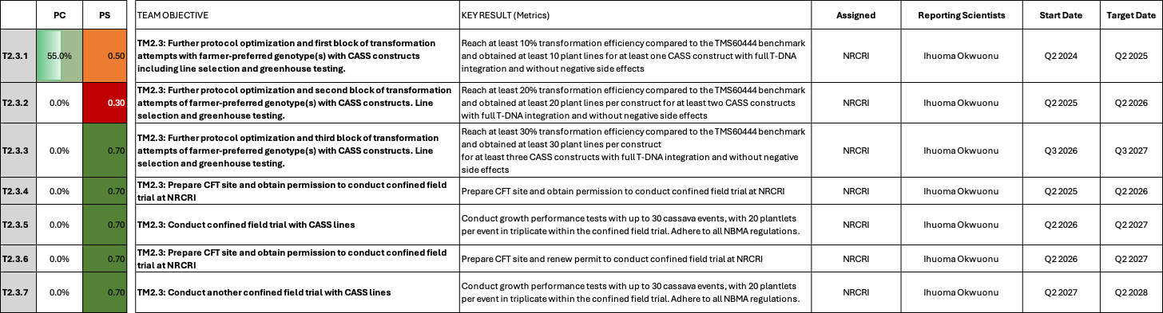

TM2.3_Transformation of farmer-preferred genotypes

Reporting module leader: Ihuoma Okwuonu, NRCRI.

Progress Update:

Following our Q4 2024 change request and subsequent discussion during the Q1 2025 quarterly meeting, we agreed to add field testing activities to this work package.

T2.3.1. Further protocol optimization and first block of transformation attempts with farmer-preferred genotype(s) with CASS constructs including line selection and greenhouse testing.
Working towards achieving at least 10% transformation efficiency in three farmer preferred cultivars in comparison to TMS 60444, fresh Agrobacterium cultures harbouring CASS constructs C2-8 (AKT2) and C46 were made and confirmed by restriction digestion and sequencing. Construct C2-8 is being used for transformation of target cultivars using the friable embryogenic callus (FEC) transformation protocol and the alternative transformation protocol. FEC pipeline production is also in progress with the possibility of producing quality FEC at 4th quarter to commence transformation with FEC target tissues.
Continuous attempt to induce FEC from target cultivars were carried out through media and protocol modification. Six batches of OES were produced from TMS60444, TMS98/0505 and IBA070536 from which six batches of FEC were derived for TMS60444 and 1 batch of FEC-derived for TMS98/0505 and IBA070356, respectively. The induced FEC were multiplied and use for transformation experiments. Three sets of transformation experiments using CASS construct C2-8 (AKT2) were carried out and are currently on selection and regeneration media. More tissues are in the pipeline for the induction of FEC from TMS60444 (6 lines), TMS98/0505 (2 lines), IBA070536 (5 lines) and CR 36-5 (5 lines) currently at different cycles on GD plate. Different concentrations of hormones including picloram and tyrosine, as well as culture environment are being evaluated to enhance FEC yield from these cultivars.
Experiment on the higher concentration of picloram and tyrosine yielded a positive response to the induction of FEC in TMS98/0505, IBA070536 and CR 36-5 thereby ensuring a continuous production of FEC, which will enhance our capability of producing transgenic lines. Putative cotelydonary embryos were recovered from the transformed genotypes TMS98/0505 and IBA070356 and have been transferred to germination medium for shoot induction. Clone confirmation will be carried out to ascertain gene integration once we are able to harvest leaves from the recovered lines. New FEC lines are being generated to help us transform more tissues to generate more transgenic lines from these cultivars. We explored transformation with alternative explants in other farmer preferred cultivars and have recovered putative transgenic shoots which will be confirmed for transgene integrations by June.
FEC induction from TMS98/0505, IBA070356, CR36-5 has greatly improved with production of FECs at GD1 which initially was a big hurdle. Various experiments were carried out to improve FEC induction and multiplication including use of higher concentrations of picloram and tyrosine which yielded a positive response. However, considering that higher concentrations of these hormones might hinder regeneration, we then considered other sources of these chemicals, particularly picloram, and discovered actually that the delay in FEC induction and slow mulitiplication was as a result of the source of our picloram. Change in picloram source resulted to rapid FEC induction and multiplication not only in target cultivars mentioned above, but in other important farmer preferred cultivars being evaluated. Large batches of FEC from TMS98/0505 and CR36-5 are in production pipeline for subsequent transformation experiments.
Ten putative transgenic lines of IBA070356 were recovered from putative embryos recovered in shoot induction medium in Q1 and are presently in rooting medium. Molecular confirmation will be carried out early August with the receipt of primers from the vendor and installation of our newly aquired PCR machine. Regeneration from 980505 was a bit slower and was moved from regeneration 1 medium to 2 which is showing some positive response. New batches of CR36-5 and IBA 070536 were transformed with construct C2-8 (AKT2_{var}) alongside 60444 in June and are currently on selection medium.

Preliminary PCR analysis of putative transgenic events derived from IBA070536 and UMUCASS48 showed the expected amplification in five of the IBA070536 events and one event of UMUCASS48. The amplicon will be sent for sequencing for further confirmation. At the same time DNA are being extracted from additional lines derived from CR 24-16, TMS98/0505 and UMUCASS48 via explant transformation for confirmation of gene integration.
We also have nine FEC transformation experiments on regeneration and selection media for five cultivars: CR 24-16, IBA070536, TMS98/0505, CR 24-3, and CR 36-5. Lines from CR 24-16 are beginning to show signs of embryo regeneration while the remaining cultivars are yet to produce embryos. However, regeneration experiment conducted on non-transformed tissues has shown that IBA070536, CR 24-16, TMS98/0505 and CR 24-3 produce over 50 embyros from one regeneration experiment. We are therefore anticipating a good yield of embryos from the transformed lines. Several lines of target FEC tissues for transformation are at different production stages in the production pipeline; starting from leaflobes, OES induction, GD plates inducing FECs and FEC multiplication on GD for future transformation. FEC availability has greatly improved and is no longer a challenge.

Molecular confirmation of 12 transgenic lines recovered using real-time PCR confirmed transgene integration in six of the events mostly in CR 24-16 (2) and TMS 980505(4) background. The amplicon was excised and sent for sequencing alongside those confirmed from IBA070536 and UMUCASS 48. These lines are being propagated for phenotypic evaluation in the screenhouse. Four lines derived from #2-8 AKT2 in CR 24-16 background and IBA070536 are presently in MS BAP for cotyledon regeneration. New constructs C2-124-pAtAKT2_A, C127-PsGPT2_AtNT and Empty vector received from FAU was transformed into E. coli and subsequently in Agrobacterium and are ready for new sets of transformation. Continued production of FEC from seven cultivars TMS 980505, CR 36-5, CR 24-3, CR 27-20, CR 24-16, IBA070536 are on-going for the new sets of transformation with the new constructs while FEC induction from ten other newly released farmer preferred cultivars including Game changer, Poundable, Dixon, Obasanjo-2, No hunger, Headmaster, Hope and renewed Hope and Baba 70 have been established with all cultivars showing excellent OES production and promising FEC induction.

Nine of the putative transgenic lines regenerated in the background of 980505(6 lines) and CR 24-16 (3 lines) were confirmed positive with integration of AKT2 gene both by PCR and sequencing. Two of these lines 2-8/985/L1T5 and 2-8/985/L1T8 showed retarded growth and development and were thus discarded while the remaining lines are being propagated in tissue culture. At moment, we have few cultures of these lines and are hoping to have a substantial number by May/June for phenotypic evaluation in the screenhouse. We do not see any strange phenotypes now in tissue culture in the remaining lines. New lines in the background of CR 36-5, CR 27-20, CR 24-16 and IBA 07035 have also been regeneration in MS2 media and are being evaluated for transgene integration. New transformation of 2-8 are currently at Stage 1 regeneration and on resting media. Unfortunately, all new transformation done with the new construct C2-124-pAtAKT2_A and empty vector were affected with Agrobacterium overgrowth. We are currently troubleshooting to circumvent this occurrence.

Challenges and Mitigations:
Molecular analysis of previous recovered lines did not show integration of expected target genes, which led to resequencing of the construct which showed rearrangement of the constructs in LBA 40444. To mitigate this challenge, fresh Agrobacterium transformation was made in LBA 4044 and AGL1 Agrobacterium strain. The transformants were confirmed by restriction digest and sequencing. There is a need to increase the volume of target FEC tissue used for transformation.
Low and inconsistent yield of FECs from TMS98/0505 and IBA070536 remains a limiting step for continuous production of target tissues. To mitigate this we are evaluating different concentrations of hormones and cultures to enhance FEC yield.
Preservation of constructs in Agrobacterium was initially a challenge due to inconsistent power supply resulting to contamination of our transformation experiments. However, this has been handled with the provision of new solar and inverter system and a table-top minus 80°C freezer for culture preservation through the intervention of the Executive Director.
Frequency of embryo regeneration seems slower than expected in the last set of regeneration. We are trying out different concentration of NAA to improve embryo regeneration.
We are experiencing Agrobacterium overgrowth with the new constructs C2-124-pAtAKT2_A, C127-PsGPT2_AtNT and Empty vector. We have done fresh Agrobacterium transformation with new strains of Agrobacterium and are optimizing the Agrobacterium concentrations used for transformation.

Next Steps in the Action Plan:
The freshly made Agrobacterium cultures harbouring the constructs are now being used to transform the target tissues. A couple of protocols are being tested to increase the volume of target tissue used for transformation.
The goal is to generate more FEC lines from TMS98/0505 and IBA070536 for subsequent transformation with the aim of achieving the target for year 1.
Next steps is to maximize the production of FEC from TMS98/0505, IBA070536 and CR 36-5 to increase the volume of transgenic events to be recovered and to continue the transformation and regeneration of the putative transgenic event which will be confirmed by molecular analysis.
- Transformation and regeneration of more transgenic events from the targeted cultivars
- Molecular confirmation of the recovered events

Next steps include molecular confirmation of lines derived from the cultivars mentioned above. Regeneration of the transformed experiments outlined above and production of new lines from available target tissues.

Set up new transformation with C2-124_AtAKT2_{var} and empty vector using the six cultivars already in our FEC production pipeline. Achieve FEC induction in the newly released farmer preferred cultivars and set them up with transformation using AtAKT2_{var} gene.
Next steps include troubleshooting agrobacterium overgrowth and optimizing transformation with the new constructs, micropropagation and weaning of the confirmed transgenic lines for screenhouse evaluation. Molecular confirmation of the newly regenerated lines and recovery of the new transformation experiments.

T.2.3.4. Prepare CFT site and obtain permission to conduct confined field trial at NRCRI
In preparation for confined field trials early next year, application for CFT permit is currently underway and will likely be completed in August and subsequently submitted to NBMA.

Viable lines need to be obtained by either FAU or NRCRI before field testing can proceed.
Deliberation on budgets and activities for CFT is ongoing to determine next steps on this activity.

Challenges and Mitigations:
None so far.

Next Steps in the Action Plan:
- Complete the NBMA application
- Conclude plans to carry out CFT in 2027

TM3_Expanding the cassava expression toolbox

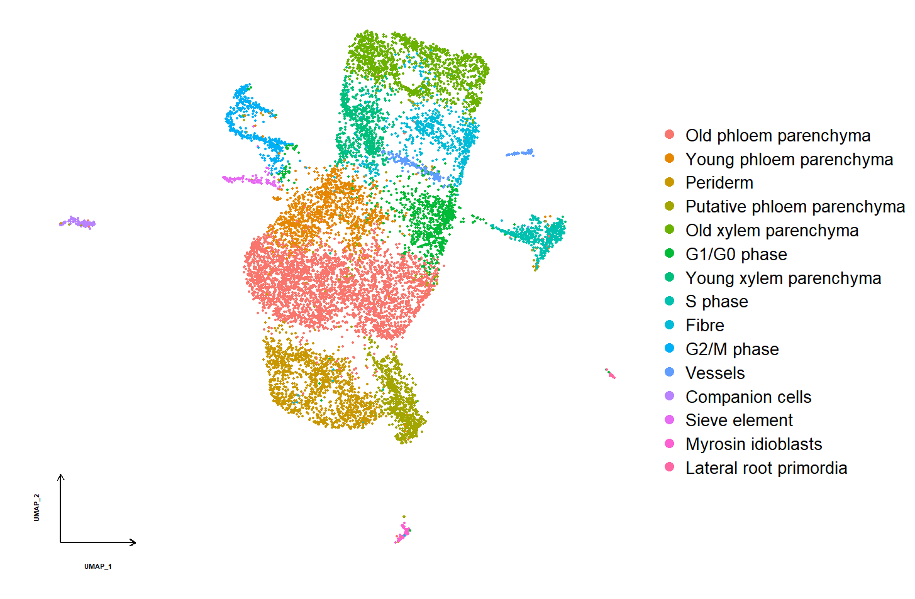
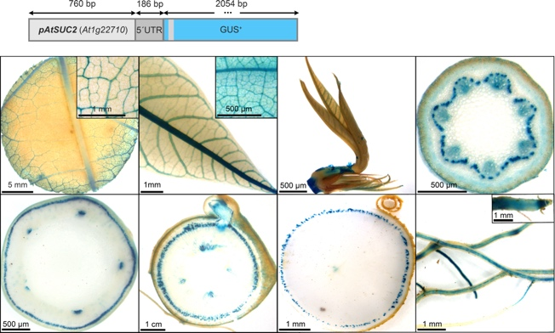
TM3.2_Identification of genes and promoter candidates involved in formation of xylem parenchyma
3.2
TM3.1_Testing of already identified tissue-specific promoter candidates

3.1
Summary of Goals and Impact
The primary goal of TM3 is to develop a robust and versatile promoter toolbox that allows for tissue- and cell-specific expression of target genes in cassava. By expanding the range of available promoters, TM3 aims to enable more precise control over gene expression, which is crucial for optimizing the physiological traits of cassava plants. This module will leverage RNA sequencing and single-cell transcriptomics to identify and validate promoters that can drive expression in specific tissues or cells, particularly those involved in storage root development and growth.

The activities in TM3 are pivotal for enhancing the effectiveness of genetic engineering efforts across the CASS project. By enabling targeted gene expression, TM3 supports the development of cassava varieties with improved yield, resilience, and overall productivity. This work is essential for creating cassava plants that can meet the needs of smallholder farmers in diverse environments, ultimately contributing to food security and economic stability in regions where cassava is a key crop.

TM3.1_Testing of already identified tissue-specific promoter candidates

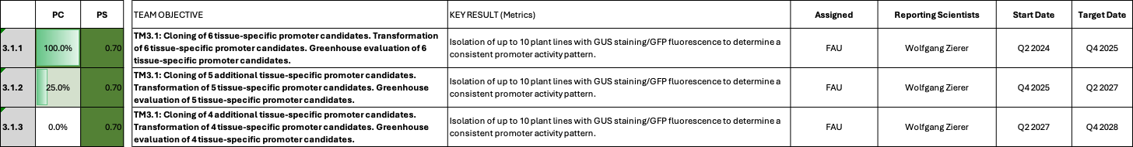

TM3.1_Testing of already identified tissue-specific promoter candidates

Reporting module leader: Wolfgang Zierer, FAU.

Progress Update:

T3.1.1. Cloning, transformation and greenhouse testing of 6 tissue-specific promoter candidates.
Cassava expression data was use to select tissue-specific transcripts and to infer putate tissue-specific promoters. Organ-specific expression data was generated in the frame of Rüscher et al., 2024 and tissue-specific expression data was generated by cryosectioning of stems and storage roots (Rüscher et al., in preparation). All constructs were cloned with the promoter candidate driving the expression of the GUS transgene, as well as an independent expression cassette controling the expression of tdTomato, enabling both GUS staining and live-cell imaging. In addition to the putative stem-specific promoters being tested as part of EM1.1 (pManes.09G047609 and pManes.17G027300), putative leaf-, storage root-, and fibrous root-specific promoter candidates were chosen.
pManes.03G182100, pManes.05G118300, and pManes.09G045900 were chosen as putative leaf-specific promoter candidates. The Manes.03G182100 transcript encodes a large subunit of the ADP-glucose phyrophosphorylase and displays a very leaf-specific expression pattern. Manes.05G118300 and Manes.09G045900 both display a very leaf-specific expression pattern and their transcript is induced from timepoint 1 and 2 to timepoint 3 in the Rüscher et al., 2024 dataset, which indicates activation in source leaves. This expression pattern is desirable for the implementation of the E.coli PPase transgene, an approach that seems to be able to improve sucrose export from the leaves, but was so far hindered by its unspecific and untimely expression. To save time and transformations, the PPase transgene was already included in these two particular constructs (C2-27 and C2-91).
pManes.11G085500, pManes.05G048400, pManes.037900, pManes.09G126100, and pManes.13G006800 were chosen as largely storage root-specific promoter candidates. The Manes.11G085500 transcript encodes a large subunit of the ADP-glucose phyrophosphorylase and displays a very sink-specific expression pattern. With close to 100.000 normalized counts (DESeq2), the transcript of MeAPL3a is among the most abundant transcripts in the storage roots overall. Similar to other sugar- and starch-related transcripts/promoters, MeAPL3a has expression in lower stem tissue. Despite the lower stem activity, pMeAPL3a should still be excellent to overexpress target genes aimed at altered sink organ metabolism. Both Manes.05G048400, Manes.037900, and Manes.09G126100 display a very storage root-specific expression pattern, with induction during the storage root bulking phase. The sectioning expression data indicates that the expression peak of Manes.05G048400 and Manes.037900 is in the cambium and xylem. Promoters with an activity pattern in cambium and xylem would be well-suited for the implementation of target genes trying to stimulate xylem parenchyma formation (e.g. EM2.1 and EM2.2). According to the sectioning expression data, the expression peak of Manes.09G126100 is in the cambium. Promoters with an activity pattern in the cambium would be well-suited for the implementation of target genes addressing the stimulation of cell division (e.g. EM2.1 and EM2.2). pManes.13G006800 (MeSWEET15) displays a largely storage root-specific expression pattern with its main expression in the phloem parenchyma region.
One putative fibrous root-specific promoter, pManes.03G057900 (CCD1), is also being tested. Fibrous root-specific promoters could enable the implementation of new target genes stimulating the uptake of water and nutrients.

Table 1_Current TM3.1 Constructs

Construct number | Gene cassette | Database link
C1-65 | pManes.03G182100-GUS | https://cassbase.org/stock/462063/view
C1-67 | pManes.05G048400::GUS | https://cassbase.org/stock/462064/view
C1-68 | pManes.09G126100::GUS | https://cassbase.org/stock/462065/view
C1-69 | pManes.03G057900::GUS | https://cassbase.org/stock/462066/view
C1-72 | pManes.11G085500::GUS | https://cassbase.org/stock/462067/view
C1-73 | pManes.12G037900::GUS | https://cassbase.org/stock/462068/view
C2-76 | pManes.09G045900::GUS + pManes.09G045900::EcPPase-tdtomato | https://cassbase.org/stock/462058/view
C2-91 | pManes.05G118300::GUS + pManes.05G118300::EcPPase-tdtomato | https://cassbase.org/stock/462059/view
C2-118 | pManes.13G006800::GUS + pManes.13G00680::Manes.13G00680-tdtomato | https://cassbase.org/stock/462098/view

All constructs outlined in Table 1 are being transformed into TMS60444 at FAU Erlangen (C2-118 was sent to ETH). All transformations have been initiated and are currently in shoot regeneration. The first lines have already been picked, but more time is needed to conclude transformation.
We isolated 15 transgenic events each for the 6 promoter-reporter constructs C1-65, C1-67, C1-68, C1-69, C1-72, C1-73 (Table 2). Plants from these 6 constructs are currently growing in the greenhouse in preparation for GUS staining analyses. Constructs C2-76, C2-91, and C2-118 are still in transformation, but have a high number of cotyledons emerging.

Table 2_Transformation status of TM3.1 plants
Construct number | Gene cassette | Database link | Current transformation status
C1-65 | pManes.03G182100::GUS | https://cassbase.org/stock/462063/view | Transformation concluded; 15 events isolated and multiplied
C1-67 | pManes.05G048400::GUS | https://cassbase.org/stock/462064/view | Transformation concluded; 15 events isolated and multiplied
C1-68 | pManes.09G126100::GUS | https://cassbase.org/stock/462065/view | Transformation concluded; 15 events isolated and multiplied
C1-69 | pManes.03G057900::GUS | https://cassbase.org/stock/462066/view | Transformation concluded; 15 events isolated and multiplied
C1-72 | pManes.11G085500::GUS | https://cassbase.org/stock/462067/view | Transformation concluded; 15 events isolated and multiplied
C1-73 | pManes.12G037900::GUS | https://cassbase.org/stock/462068/view | Transformation concluded; 15 events isolated and multiplied
C2-76 | pManes.09G045900::GUS + pManes.09G045900::EcPPase-tdtomato | https://cassbase.org/stock/462058/view | 30-150 cotyledons growing on shoot induction medium
C2-91 | pManes.05G118300::GUS + pManes.05G118300::EcPPase-tdtomato | https://cassbase.org/stock/462059/view | 30-150 cotyledons growing on shoot induction medium
C2-118 | pManes.13G006800::GUS + pManes.13G00680::Manes.13G00680-tdtomato | https://cassbase.org/stock/462098/view | 50-150 cotyledons growing on shoot induction medium

As of Q1 2025, 8 promoter-reporter constructs are now available for characterization (Table 3). Three additional promoter-reporter lines are still in transformation (Table 4).

Table 3_Promoter-reporter lines available for analysis as of Q1 2025
Construct number | Gene cassette | Expectation | Database link
C1-65 | pManes.03G182100-GUS | Photosynthetic tissues | https://cassbase.org/stock/462063/view
C1-67 | pManes.05G048400::GUS | Storage root (cambium) | https://cassbase.org/stock/462064/view
C1-68 | pManes.09G126100::GUS | Storage root (cambium) | https://cassbase.org/stock/462065/view
C1-69 | pManes.03G057900::GUS | Fibrous root | https://cassbase.org/stock/462066/view
C1-70 | pManes.09G047609::GUS | Stem | https://cassbase.org/stock/462039/view
C1-71 | pManes.17G027300::GUS | Stem | https://cassbase.org/stock/462040/view
C1-72 | pManes.11G085500::GUS | Storage root | https://cassbase.org/stock/462067/view
C1-73 | pManes.12G037900::GUS | Storage root (cambium) | https://cassbase.org/stock/462068/view

Table 4_Promoter-reporter lines still in transformation as of Q1 2025
Construct number | Gene cassette | Expectation | Database link
C2-76 | pManes.09G045900::GUS + pManes.09G045900::EcPPase-tdtomato | Leaf | https://cassbase.org/stock/462058/view
C2-91 | pManes.05G118300::GUS + pManes.05G118300::EcPPase-tdtomato | Leaf | https://cassbase.org/stock/462059/view
C2-118 | pManes.13G006800::GUS + pManes.13G00680::Manes.13G00680-tdtomato | Storage root (phloem) | https://cassbase.org/stock/462098/view

A first round of GUS staining analysis could be performed for at least four lines each for 8 promoter-reporter constructs. Table 5 summarizes the outcome of the first analysis.

Table 5_Current conclusions and next steps on the 8 analyzed constructs
Construct number | Expectation | Observed activity | Next steps | Figure
C1-65 | Photosynthetic tissues | No mesophyll activity; Low activity overall; unspecific | Test more lines to obtain a consistent pattern | Figure 1
C1-67 | Storage root (cambium) | No consistent storage root activity; No storage root specificity; localized staining (potential auxin regulation); | Discard; Test other candidates for storage root cambium | Figure 2
C1-68 | Storage root (cambium) | High storage root specificity in phloem/cambium areas; interesting candidate | Analyze mor lines and test cell type | Figure 3
C1-69 | Fibrous root | Fibrous root activity, but also active in the outer parts of other tissues | Could potentially be optimized by testing other sequence versions; Currently not a priority | Figure 4
C1-70 | Stem | Largely stem-specific, but only active in the outer parts of petiole/stem; Might not be sufficiently active to implement GA approach | Test other stem-specific candidates (Ent-kaurene synthase B is a good candidate) | See EM1.1 for Figure
C1-71 | Stem | Stem activity, but unspecific; Might result in undesired effects for the GA concept | Test other stem-specific candidates (Ent-kaurene synthase B is a good candidate) | See EM1.1 for Figure
C1-72 | Storage root | High storage root specificity; Surprisingly not a homogenous activity across the storage root, but seems to be mostly active close to cambium/phloem | Test cell type | Figure 5
C1-73 | Storage root (cambium) | Extremely high storage root activity in phloem/cambium area, but off-target expression in other tissues | Test cell type; Test other sequence variants of this promoter | Figure 6

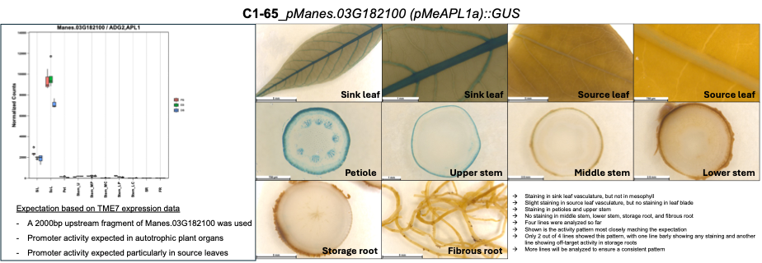
Fig. 1_GUS staining pattern of C1-65 (pManes.03G182100::GUS). Tissue-specific expression pattern on the left. Promoter-GUS staining results on the right.

Additional stainings have to be performed, but the conclusion has not changed. pManes.03G18200 is not suitable as a source promoter. A summary has been uploaded to cassbase (https://cassbase.org/stock/462063/view; see “Upload Data File”).
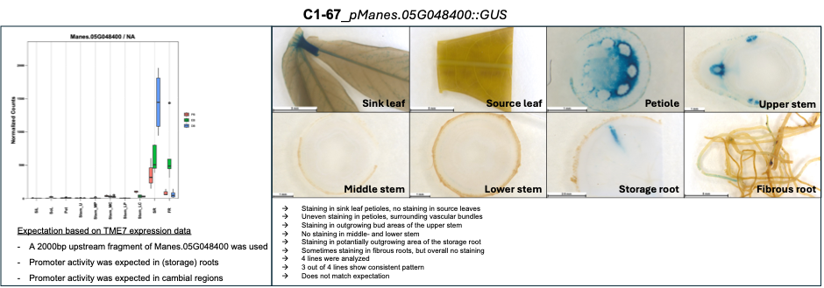
Fig. 2_GUS staining pattern of C1-67 (pManes.05G048400::GUS). Tissue-specific expression pattern on the left. Promoter-GUS staining results on the right.

Additional stainings have to be performed, but the conclusion has not changed. pManes.05G048400 is not suitable as a storage root cambium promoter. A summary has been uploaded to cassbase (https://cassbase.org/stock/462064/view; see “Upload Data File”).

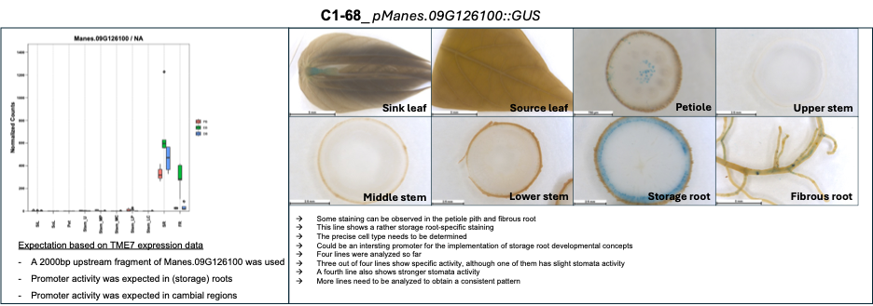
Fig. 3_GUS staining pattern of C1-68 (pManes.09G126100::GUS). Tissue-specific expression pattern on the left. Promoter-GUS staining results on the right.

Additional stainings have to be performed. pManes.05G048400 still displays a very storage root-specific staining pattern with a specificity for a specifiy, yet unknown cell type. Once the cell type can be clarified, the promoter has potential for useful applications. A summary has been uploaded to cassbase (https://cassbase.org/stock/462065/view; see “Upload Data File”).
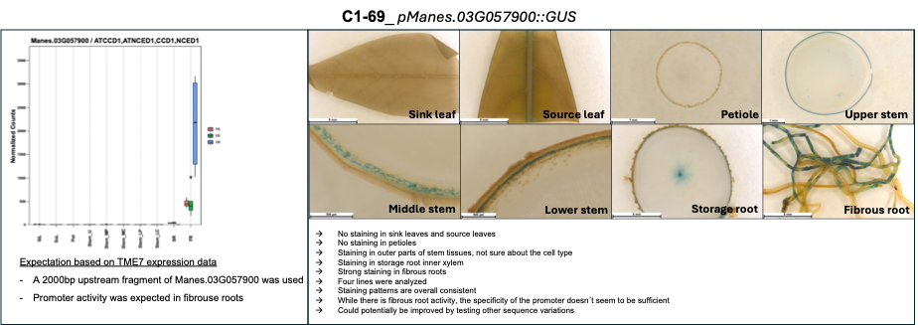
Fig. 4_GUS staining pattern of C1-69 (pManes.03G057900::GUS). Tissue-specific expression pattern on the left. Promoter-GUS staining results on the right.

Additional stainings have been performed, which revealed that pManes.03G057900 is more fibrous root-specific than initially thought. A shorter staining with less substrate revealed a very specific fibrous root staining, indicating that the initial result might be the result of an overstaining. Off-target stainings seem to be weak and only appear in longer stainings, while staining for 1h revealed the main activity domain in fibrous root. This makes this promoter usable for biotechnological applications targeting, for instance, nutrient uptake or nodule engineering. A summary has been uploaded to cassbase (https://cassbase.org/stock/462066/view; see “Upload Data File”).

Fig. 5_GUS staining pattern of C1-72 (pManes.11G085500::GUS). Tissue-specific expression pattern on the left. Promoter-GUS staining results on the right.

Additional stainings have been performed. Manes.11G085500 represents the main APL subunit in cassava. Therefore, the expectation was to observe a homogeneous storage root staining. Surprisingly, pManes.11G085500 has specific activity close to the cambium, particularly in phloem daughter cells and in vascular rays, which might make the promoter interesting for developmental manipulations. A summary has been uploaded to cassbase (https://cassbase.org/stock/462067/view; see “Upload Data File”).

Fig. 6_GUS staining pattern of C1-73 (pManes.12G037900::GUS). Tissue-specific expression pattern on the left. Promoter-GUS staining results on the right.

Additional stainings have been performed. The overall activity seems to be in cambial tissues. However, the promoter seems to be active in all tissue parts and different forms of cambia/procambia, limiting its usefulness. Sequence length variation might improve the pattern. A summary has been uploaded to cassbase (https://cassbase.org/stock/462068/view; see “Upload Data File”).

Current conclusions from this first round of promoter-reporter analysis:
While further analysis is required to determine the cell type of several promoter-reporter plant lines, first conclusions can already be drawn:
- The stem candidates (C1-70 and C1-71) do not seem to produce the desired activity pattern, which is broad activity in stem tissues, without activity in leaf and root tissues. While C1-71 (pManes.17G027300) is not stem-specific, C1-70 (pManes.09G047609) only shows activity in the outermost tissue layers. This activity pattern might not be enough to sufficiently express genes targeting gibberellin metabolism/signalling. New candidates for stem-specific expression should be tested. We identified a good candidate by analysing endogenous GA genes. Transcripts of Manes.16G068951 (Ent-kaurene synthase B) display a rather middle- and lower stem-specific expression pattern, which are the tissues where internode elongation happens. We will clone and transform pManes.16G068951 for further testing.
- Some of the storage root cambium candidates, which are required to implement developmental concepts more specifically, show interesting activity patterns. However, we still need to determine the specific cell type. C1-68 for instance shows a storage root specific activity in the phloem/cambium area. C1-73 for instance, shows extremely strong storage root activity in the phloem/cambium area (it essentially turned blue the second we added the staining buffer), but also displayed activity in petiole and parts of the stem. Some new transformations with an altered sequence length might be required to further reduce off-target activity and increase target tissue specificity.
- Further candidates for leaf-specific promoters will be tested. Two candidates (C2-76 and C2-91) are still in transformation and further candidates have been identified for future cloning/transformation.
- Although a fibrous root specific promoter is currently not a priority, pManes.03G057900 could potentially be made more specific by testing different sequences of this promoter.
The second batch of promoter-reporter construct transformations will be initiated as soon as transformation capacity allows. This second batch will include new versions of already analyzed promoter candidates, which showed the potential for high tissue-specificity and activity in target tissues. It will also include new candidates for stem-specific activity, leaf-specific activity, and storage root cambium activity.

The analysis of the current GUS lines has been completed. It seems like pManes.05G048400 (SR; specific phloem cells), pManes.03G057900 (FR; elongation/adult root zone), and pManes.11G085500 (SR, close to cambium, phloem derivatives and vascular rays) have specific activity patterns that could be useful for new engineering approaches.

Update Q1 2026
We tested the source leaf specificity of two promoter candidates, pManes.09G045900 (C2-76) and pManes.05G118300 (C2-91). pManes.09G045900 did display low level source-leaf activity (Fig. 7), but also low level staining in other tissues. Our current judgement is that the expression strength and specificity will not be sufficient to properly implement the PPase concept, however, we are testing the C2-76 construct in the greenhouse to be sure.

Fig. 7_GUS staining of C2-76 (pManes.09G045900::GUS + pManes.09G045900::PPase) in source leaf (SoL), sink leaf (SiL), petiole (Pet), lower stem, storage root, and fibrous root. Staining was observed preferentially in source leaves, but low level staining was also observed in a spotted manner in other organs.

C2-91 (pManes.05G118300::GUS + pManes.05G118300::PPase) did show not GUS staining in neither tissue, indicating that the promoter is not functional. Matching this observation, no transgene expression could be detected for this construct.

New sequencing data
To extend our options for promoter discovery and to complement our tissue-specific mRNA datasets, we decided to also sequence tissue-specific long non-coding RNAs, as well as small RNAs. We collected new plant material from 2-month old TME7 plants. Source leaf, sink leave, petiole, shoot apex, upper stem, middle stem peel, middle stem core, lower stem peel, lower stem core, storage root peel, storage root core, and fibrous root samples were taken. LncRNAs and sRNAs are currently being determined by an external company.
Data was obtained and is currently being evaluated. There are several highly tissue-specific mRNA candidates, some tissue-specific lncRNA candidates, and some tissue-specific miRNAs. These candidates are currently being evaluated in the wet lab. Confirmed candidates will be integrated in the promoter testing modules and will be part of the next batch of GUS constructs.
Two source-leaf specific mRNAs (Manes.01G013100 and Manes.05G159200) could be confirmed by qPCR and acrosse multiple other datasets, making them strong candidates for obtaining a purely SoL-specific promoter. In addition, a leaf-specific lncRNA was identified and confirmed by qPCR. We are currently isolating the corresponding promoter candidate. Validation of tissue-specific small RNAs is ongoing. However, two small RNAs seem to display a pattern of being absent from source leaves and present in other green tissues, making them potential candidates as negative regulators able to fine-tune other photosynthesis-related promoters. This is important for the correct implementation of the PPase concept, which strictly requires source leaf-specific expression to avoid undesired effects on sugar to starch conversion.

Additionally, a putative storage root cambium-specific promoter candidate has been identified, by searching the Rüscher et al., 2025 cryosectioning dataset for transcripts specific for the storage root cambium (Fig. 8).
Fig. 8_Expression of Manes.02G156700 (MeFANTA4) in different tissues at different timepoints. Tissues: Sink leaf (SiL), Sourc leaf (SoL), Petiole (Pet), Upper stem part including SAM (Stem_U), Middle stem peel (Stem_MP), Middle stem core (Stem_MC), Lower stem peel (Stem_LP), Lower stem core (Stem_LC), Storage root (SR), Fibrous root); Timepoints: PB (30 days after planting), represents a primary root anatomy, EB (38 days after planting), represents a secondary root anatomy, but without visible thickening, DB (60 days after planting), represents a visible thickend storage root

The gene corresponds to FANTA4 (Manes.02G156700), a developmental regulator that is known to interact with WUSCHEL in the shoot apical meristem. Interestingly, the FANTA4 gene is specifically expressed in the cambium and upregulated during storage root bulking in cassava according to RNA-Seq data. If the isolated promoter can indeed mediate storage root cambium-specific expression, the promoter can be used to implement various developmental approaches aimed at increasing cell division rates in storage root cambium.

Most urgent promoter requirements as of Q4 2025:
With the apparent success of the C2-93 construct and additional GA/DELLA construct versions in the pipeline, the need for stem-specific promoters has decreased. However, source leaf-specific promoters with decent activity are still highly desirable to potentially facilitate the implementation of the PPase concept in cassava. Several candidates have been identified and are currently being validated. In addition, we are persuing a second strategy in which off-target expression could potentially be removed through the use of endogenous miRNAs. We are currently validating miRNA candidates, which are present in all tissues with the exception of leaves. Such miRNAs could be used to suppress undesired expression outside of source leaves. Likewise, storage root cambium promoters would be particularly valuable to facilite approaches of vascular cambium stimulation. By comparing an RNA-Seq dataset with tissue dimensions (Rüscher et al., 2024) with a cryosectioning RNA-Seq dataset from stem and storage roots (Rüscher et al., 2025), we identified a few mRNAs that display apparent storage root cambium expression. We are currently trying to amplify the putative promoters of these targets for testing with stable promoter-GUS cassava lines.

Cloning of new tissue-specific candidates is currently ongoing (Table 6).
Construct number | Gene cassette | Expectation | Status
NA | pMeAPL3a::GAL4-VP16 + UAS::PsGPT2 + UAS::AtNTT1 + pSOL1::PPase + pSOL1 (Manes.01G013100)::GUS | Testing will be done in the frame of the new EM3.2 constructs. PPase will immediately be combined with PsGPT2/AtNTT1 to create a source-sink improvement concept. The expectation is that pManes.01G013100 can mediated source leaf-specific expression, thereby increasing sucrose export from leaves | Promoter cloning ongoing
NA | pMeAPL3a::GAL4-VP16 + UAS::PsGPT2 + UAS::AtNTT1 + pSOL2::PPase + pSOL2 (Manes.05G159200)::GUS | Testing will be done in the frame of the new EM3.2 constructs. PPase will immediately be combined with PsGPT2/AtNTT1 to create a source-sink improvement concept. The expectation is that pManes.05G159200 can mediated source leaf-specific expression, thereby increasing sucrose export from leaves | Promoter cloning finished
NA | pFANTA4::GUS + pFANTA4::Target gene (TBD; i.e. WOX4, CYCD3;1) | Testing storage root cambium specificity of the promoter candidate and combining it with an overexpression of a key cambial regulator, which should result in increased cambial proliferation | Promoter cloning finished

Challenges and Mitigations:
No unforeseen challenges have yet been encountered.

Recent promoter-GUS activities have shown that it is difficult to predict promoter performance from transcript data. Often the promoters match the predition to some extent, but often not precisely. Promoter regulation is complex and it is unclear how to select the exact promoter with the desired activity.
We are still looking for a strictely source leaf-specific promoter allowing the proper implementation of the PPase concept and we are still looking for truly storage root (cambium) specific expression tools.

Next Steps in the Action Plan:
Upon completion of the transformation experiments, the resulting plant lines will be transferred to the glasshouse and grown to maturity. Source leaves (SoL), sink leaves (SiL), petioles (Pet), upper stem (US), lower stem (LS), storage roots (SR) and fibrous root (FR) material from several independent lines per construct will be analyzed via GUS staining to identify positive events and a consistent staining pattern. If the cellular specificity is unclear after GUS staining experiments, additional live cell imaging will be conducted. Further transcript analyses will be conducted to identify additional tissue specific promoter candidates for the next batch of promoter-reporter constructs.
Once the plants currently growing in the greenhouse have built storage roots, GUS staining will be performed and promoter activity patterns visualized.
- Determine cell specificity for interesting promoter-reporter lines (Concluded)
- Stain additional lines in case of unclear patterns (Concluded)
- Generate additional sequencing data on non-coding RNAs (Concluded)
- Generate new promoter-reporter constructs with new candidates

Update Q1 2026
- Validate small RNA candidates for negative regulation of photosynthesis promoters to achieve a source-leaf specific promoter
- Isolate lncRNA promoter candidate
- Finish cloning of 3 new mRNA candidates for promoters
- Build constructs

TM3.2_Identification of genes and promoter candidates involved in formation of xylem parenchyma

TM3.2_Identification of genes and promoter candidates involved in formation of xylem parenchyma

Reporting module leader: Ari Pekka Mähönen, HU

Progress Update:

T3.2.1. Establishing cassava storage root protoplast isolation for three developmental stages
The isolation and purification of protoplasts from cassava storage roots was successfully achieved. We are currently assessing the quality of the protoplasts.
While the isolation works in principle, the protoplast quality needs further improvement.
HU has made further progress in optimizing protoplast isolation. As it became obvious that the transport time during the protoplasting is an issue, we have just been able to finalize an infrastructure for the optimal set-up in the Meilahti campus (medical campus) of the University of Helsinki. During this first round of experimentation we were able to establish a clear vision on the order of events to make this happen in the best possible manner. Although we were already somewhat successful on three different developmental stages, it has become clear that we should first focus the optimizaiton on one stage all the way until the results of the single-cell transcriptome and after that perform the analysis on the remaining two stages.
The local cell extraction lab on the medical campus is now in use. We have been conducting tests on both protoplast and nuclei extraction, the nuclei extraction appears to be better to acquire a clean cell/nuclei suspension without starch granules (see Figure 1 below). Consequently, we are now considering shifting the single-cell RNA sequencing to single-nuclei RNA sequencing. Besides, we are in discussions to upgrade the equipment—such as acquiring a low-temperature centrifuge.
We have focused on optimizing the nuclei extraction protocol and refining the gating strategy during sorting, as well as confirming the successful isolation of nuclei after sorting, for example through DNA extraction.
We have been focusing on optimizing both the protoplast and nuclei extraction protocol and refining the gating strategy during sorting, as well as confirming the successful isolation of protoplasts and nuclei after sorting.

Fig. 1_Comparision of results obtained for protoplast isolation and nuclei isolation.

Challenges and Mitigations:
The concentration of protoplasts needs to be increased, and their quality requires further verification.
We are currently optimizing the protoplasting protocol to ensure the stable production of healthy protoplasts and improving methods for assessing their quality. The concentration of protoplasts needs to be increased, and the cell purification step still needs to be optimized.
HU successfully isolated a sufficient number of protoplasts; however, transport time and technical variations in each trial has affected the sequencing quality. Cassava grows slowly during winter under our conditions, but as temperature rise, we are currently preparing materials for intensive single-cell RNA sequencing trials.
HU has been contacting frequently, and promoted, the establishment of the local cell extraction lab in medical campus, to save the sample transporting time. This lab should be in use in May. Although there has been some delays concerning the optimization of protoplasting at three distinct stages, on the other hand, concerning the single-cell transcriptome analysis, we have progressed faster than anticipated. HU feels confident that we are able to meet the final goal of this work-package in a timely manner.
Currently, we are addressing the issue of high starch granule content by exploring solutions including density-based levitation, cell sorting techniques, and optimization of the gating strategy during sorting. The facilities in the medical campus will not be in use during July, but we plan to resume our efforts in August.
During nuclei extraction, a considerable amount of small debris is generated. Additionally, when sorting nuclei with DAPI staining, starch granules also become stained, making it challenging to define an accurate sorting gate.
The starch granules released in the extraction solution has been the major issue to solve. We start to test different gradient method to remove starch granules. At the same time, we have been optimizing protocols to extract protoplasts more efficiently. Low speed centrifuge (100G) can remove most of the starch granules, later, the Percoll gradient can separate starch granules and nuclei in different gradient layers. Besides, we found increasing the enzyme concentration can increase the yield of protoplasts.
We are still testing different nuclei extraction protocols to get clean and sufficient number of nuclei. So far, the low speed centrifuge (100G) can stably remove most of the starch granules. We are now testing different OptiPrep gradients to separate nuclei, since it is recommended to protect the nuclei better. From the sorting result, we still need to test different gradient to get nuclei with clear DAPI signal.

Next Steps in the Action Plan:
The specific details of the materials, including developmental stages, genotypes, and the part of the storage root to be used, need to be determined. Concurrently, we will continue to optimize the quality and concentration of the protoplasts before processing the samples on the single-cell platform. To increase protoplast concentration, we will simply increase the amount of starting material. For quality and concentration assessment, we will utilize trypan blue staining and an automated cell counter.
A local cell extraction laboratory has been established for the purpose of single-cell RNA sequencing. We are working to develop a stable protoplast extraction pipeline there and plan to conduct another trial soon.
Preform new isolations and sequencing attempts in the newly established lab.
Keep optimizing the workflow in the newly established lab in August and confirm the quality of protoplasts/nuclei.
For nuclei extraction, we aim to minimize small debris by incorporating an additional filtration step and using various strainers, such as Miracloth and 20 µm filters. We also plan to introduce a step specifically designed to remove starch granules from the nuclei preparation. During sorting, we will evaluate different staining methods and use starch-less species as controls to enhance separation efficiency. DNA extraction and microscopic observation of sorted nuclei will provide the most reliable measures of nuclei enrichment.
We had a meeting with Stig Uggerhøj Andersen’s lab (ENSA) to troubleshoot the challenges with sc/snRNAseq work with tissues of high starch content, such as cassava storage root. This meeting was very helpful, and Uggerhøj Andersen’s team gave us suggsetions of both protoplast isolation and nuclei extraction. Especially, they suggested to use OptiPrep to reduce starch content during nuclei extraction. Besides, they have also addressed the importance of species and tissue-specific optimization of the protocol, including the the most optimal gradient composition, the ratio of several reagents, technical details et al. We have been taking the suggestions and test the most optimal experiment condition for cassava storage root, to gurantee the yield of high quality protoplasts and/or nuclei.
For nuclei extraction, different protocols need to be tested, including different OptiPrep gradient, centrifuge speed, detergent choice et al. We can proceed further until we see the clear group of nuclei with clear DAPI signal using flow cytometry.

For protoplasting, we have been contacting the researchers who created the FX-Cell technique (Ming et al. 2025), we might try fix the plant first and then extract protoplasts with higher temperature, with higher enzyme efficiency.

TM4_Cassava confined field testing

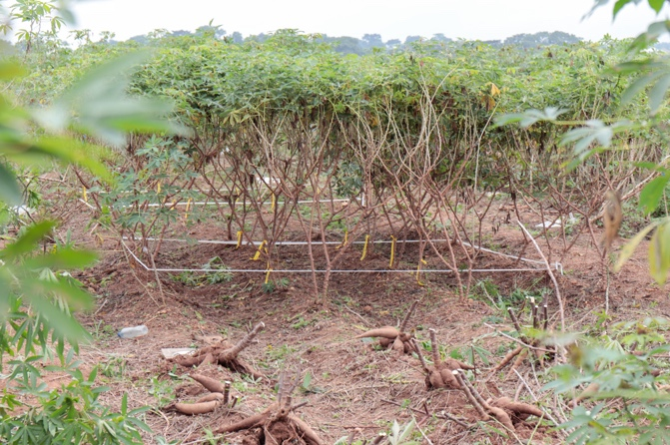
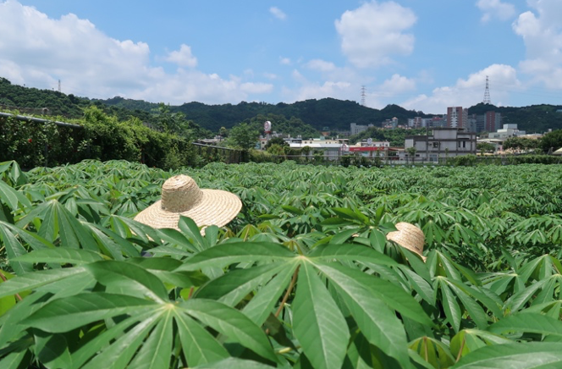
TM4.2_Testing of transgenic lines in Africa and transgenic crossing activities
4.2
TM4.1_Pre-testing of transgenic lines outside Africa
4.1
Summary of Goals and Impact
The goal of TM4 is to conduct confined field tests (CFTs) of transgenic cassava plants, crucial for evaluating the agronomic performance of the genetically modified plants developed in the CASS project. This module includes field testing in Taiwan and Nigeria, focusing on generating reliable data on the performance of transgenic cassava lines. These tests are essential for validating the strategies developed in the engineering modules (EM1-3) aimed at increasing storage root yield.

TM4 also involves ensuring regulatory compliance in Nigeria, conducting pilot crossing experiments with farmer-preferred genotypes, and phenotypically validating transgenic plants in these backgrounds. By expanding field testing capacity and validating transgenic lines in real-world agricultural settings, TM4 directly contributes to the development of high-yielding, resilient cassava varieties that can significantly benefit smallholder farmers. The outcomes from this module will be pivotal in advancing cassava as a staple crop, enhancing food security, and supporting sustainable agricultural practices in regions dependent on cassava cultivation.

TM4.1_Pre-testing of transgenic lines outside Africa

TM4.1_Pre-testing of transgenic lines outside Africa

Reporting module leader: Wilhelm Gruissem, NCHU with FAU and FZJ.

Progress Update:

4.1.1. Preparations for confined field-testing at NCHU season 2024.

- The import permit for 4,500 cassava in vitro transgenic (16 different DNA constructs) and control (wild type, FEC, vector) plantlets produced at ETH Zurich and FAU was obtained from the Taiwan Animal and Plant Health Inspection Agency of the Ministry of Agriculutre on November 8, 2023. The 4,500 in vitro plantlets were multiplied by an external service provider and shipped from ETH Zurich to Taiwan on January 16, 2024, and received at NCHU on January 19, 2024. The in vitro plantlets were subsequently labeled (bar-coded), transferred to soil, and hardened in the greenhouse before transplanting into the field in March 2024. The survival rate of the in vitro plantlets in soil for most transgenic lines was 85% or higher.

- Four new field sites were prepared in February 2024 for testing the transgenic cassava plants with the different DNA constructs (west field 2 / WF2) and transgenic cassava selected for different DNA constructs to be regrown from stakes (20-25 cm cuttings from harvested 2023 stems; EF1, EF2, EF3). The soils of the field sites were analyzed using several samples (600 g of soil each for a depth of 20 cm) collected from selected sites in the fields (soil data are available). The fields were conditioned with sugarcane residues (Taisugar no. 11, 10 t/ha) and fertilizer (Taiwan Fertilizer Co. #4 “Hey Won” nitrophosphate organic compound fertilizer, 400 kg/ha) that were ploughed into the soils. Ridges were built and covered with black pastic tarp to reduce weed growth. The field site WF1 had been used for growing CASS cassava lines during 2019-2023 and was therefore replanted with soybean to regenerate the soil.

4.1.2. Confined field-testing at NCHU season 2024.

- The greenhouse-hardened plants (2,200 plants) were transplanted into the WF2 field during the second half of March 2024 and subsequently watered twice per week until the start of the rainy season in May. The stakes cut from the stems of cassava DNA construct lines and control plants harvested in 2023 were submerged in water for 2-3 days to activate sprouting and the basal ends were dipped into auxin powder (4-indol-3-ylbutyric acid, 0.5%, Phytorgan S.A.) before planting into soil into the EF1, EF2 and EF3 fields (1,500 stakes). The planted stakes were also watered regularly until the start of the rainy season. Meteorological data are routinely collected from a certified weather station at the Taiwan Agricultural Research Institute located 5.5 km from the NCHU field sites. To control spider mite and scale infestations, plants are treated as needed with clofentezine + fenbutatin-oxide (2.5 l/ha) for spider mites and thiamethoxam (500 g/ha) for scales once a week for 2-3 weeks.

- Regular bi-weekly UAV-based RGB and multispectral images of the WF2, EF1, EF2 and EF3 fields were successfully started and are ongoing using an external service company, which delivers several thousand RGB images of whole field site for every measurement timepoint. Until mid-September images were acquired at four field sites and measurement points, namely WF2, EF1, EF2, and EF3 (supervised by NCHU). Image data are transferred to FZJ and data quality and data completeness are currently evaluated by scientists at FZJ (joint activity between NCHU and FZJ). Quality checked RGB imagery is processed using the structure-of-motion approach and a georeferenced 3D crop surface is calculated for each field site. The 3D surface model is of high quality with a resolution of 2 cm in xyz direction (FZJ). Bi-weekly height measurements of each plant is conducted manually until plant canopy closure.

- Four transgenic cassava replica plants for each independent event of DNA constructs were harvested during the week of July 22, 2024 (intermediate harvest) for leaf and storage root (SR) sample collection. For independent events of selected DNA constructs also fibrous roots (FR) and leaves at end of day (EOD) and end of night (EON) were collected for analysis. Shoots and SRs of the harvested plants were weighed (fresh weight analysis) and photographed. All samples were frozen in liquid nitrogen. For each plant, 100 g of peeled SR material was collected and dried in the oven for SR dry weight analysis. Frozen samples were shipped to FAU and ETH Zurich for molecular and biochemical analysis. Agronomic data from the intermediate harvest have been analyzed and are available.

- All cassava plants from WF2 (grown from micro-propagated in vitro plantlets received at NCHU in January 2024), EF1, EF2, and EF3 (grown from stakes of stems harvested in 2024) were harvested from November 25 to December 11, 2024. The above-ground portions of each plant (stems and leaves) were harvested first, labeled and photographed, and the fresh weight biomass was recorded. Storage roots were then excavated, labeled and photographed, and the fresh weight of the storage root biomass was recorded. Storage root and stem tissues were collected from plants with selected DNA construct genetic traits and snap-frozen in liquid nitrogen. These tissue samples were subsequently shipped to FAU and ETH on dry ice for biochemical and molecular analysis. To measure the storage root dry mass, 100 g of storage root per plant was collected from the harvested storage roots, dried in a greenhouse and drying oven, and weighed. Monitoring PAM measurements were recorded for several weeks from selected AKT2 DNA construct and vector control plants before harvesting to analyze the photosynthesis parameters, and the data were reported to FZJ. Stems from 570 plants, including wild type cassava and transgenic cassava lines, were collected and stored in the greenhouse for 2025 planting in the field. Multiple soil samples were collected from the WF1, WF2, EF1, EF2, and EF3 fields for mass spectrometric analysis of several parameters, including organic matter content, pH, electrical conductivity, NH⁺⁴, NO³⁻, phosphorus, potassium, and cation exchange.

4.1.3. Preparations for confined field-testing at NCHU season 2025

- To accommodate approximately 4,000 in-vitro cassava plants, three fields—West Field 1 (WF1), West Field 2 (WF2), and East Field 1 (EF1)—were prepared. Initial land preparation involved ploughing and conditioning with sugarcane residue (Taisugar No. 11) applied at 10 t/ha. The fields were then fine-ploughed, and ridges were built 1.2 m apart. Plastic tarps were used to cover the ridges to suppress weed emergence. To allow better drainage of excess water and avaoid water logging after heavy rainfalls, two additional drainage trenches were constructed in the WF2 field and one in the WF1 field that drain into the side trenches running along the fields. Water pumps were installed at the corners of each field to facilitate efficient drainage during heavy rainfall events. Similarly, East Field 2 (EF2) and East Field 3 (EF3) were also prepared for transplanting the stakes harvested in 2024.

- The import permit for 7,500 in-vitro cassava plantlets—comprising 17 transgenic lines, two vector controls, two FEC lines, two wild types, and border lines—developed by ETH Zurich and FAU was obtained from the Taiwan Animal and Plant Health Inspection Agency of the Ministry of Agriculture on November 6, 2024. On January 16, 2025, we received 7,364 in-vitro plants from ETH Zurich, of which 7,362 were labeled (barcoded) and transplanted into pots between January 20-23, 2025, for hardening in the greenhouse. During the first month, the plants were maintained at a regulated temperature of 25°C during the day and 22°C at night. In the second month, they were gradually acclimatized to environmental conditions by turning off the temperature regulator in the greenhouse. After nearly two months of regular monitoring for mold, dehydration, and temperature stress, the in-vitro cassava plants were planted into the field at 1.2 m apart in a random snake design.
4.1.4. Confined field-testing at NCHU season 2025

- A total of 2,100 greenhouse-hardened in-vitro cassava plants were transplanted into WF2 with 21 replicates between March 4–5, 2025 in a random snake design and were watered regularly after transplanting. Similarly, 1,600 plants were transplanted into WF1 with 16 replicates between March 24–25, 2025. Damaged plants in both fields were replaced approximately two weeks post-transplanting to maintain uniform stand density. In-vitro cassava plants that remained after transplanting into WF1 and WF2 were planted in EF1 in a random block design. These serve as supplementary data points for transgenic lines in WF1 and WF2. Notably, cassava growth heterogeneity was observed in 2024, especially in EF1. However, comprehensive soil chemistry analysis showed only minimal variation in soil composition, pH, and chemical components among the soil samples collected from WF1, WF2, EF1, EF2, and EF3. Therefore, observation from 2025 in this field is expected to clarify whether the observed variability is driven by environmental factors or small differences in soil properties. This will inform future decisions regarding continued use of EF1.

- In parallel, about 900 cassava stakes (20-30 cm length) from both transgenic, wild-type, and border lines harvested in 2024 were planted in EF2 and EF3 on February 14, 2025. Prior to planting, stakes were pre-conditioned by submerging in water for 24 hours to stimulate sprouting. Basal ends were treated with auxin powder (4-indol-3-ylbutyric acid, 0.5%, Phytorgan S.A.) to enhance root initiation. Planting followed a randomized snake design, and stakes were irrigated regularly. Meteorological data were continuously collected from the certified TARI weather station located 5.5 km from the field sites, ensuring reliable tracking of environmental conditions.

- The growth of cassava in WF1, WF2, and EF1 is being regularly monitored using UAV-based remote sensing at 15-day intervals since April 28, 2025. Images captured after each flight were shared with the consortium for analysing plant growth, canopy development and other agronomic parameters. In parallel, CO₂ response curve (AC_{i}) were measured for three selected lines: C2-8 (AKT2_{var}), C56 (, pStGBSS1::PsGPT2 + pStB33::AtNTT1), and C-16 (pOsAnt::HvAlaAt ), using the LICOR-6800 infrared gas analyzer (IRGA). For comparison, WT lines from ETH and FAU were also evaluated under the same conditions. AC_{i} measurments take approximately 60 – 70 minutes per plant, limiting us to seven plants per day – five transgenic and two wildtype. Constructs C2-16 and C2-8 each have five independent lines, while C56 has six. To select five lines for C56, we reviewed previous agronomic data. As no significant differences were observed among the lines, we randomly selected C56_ETH4838, C56_ETH4839, C56_ETH4844, C56_ETH4845, and C56_ETH4847. Healthy plants from each line were chosen, and measurements were distributed over seven days per construct to capture gas exchange data across all time points between 8:30 a.m. and 5:00 p.m (Table 1).
Table 1_To capture overall photosynthesis performance of each AKT2_{var} line between 8:30 AM and 5 PM, measurements were spread over seven days. Due to heavy rain on Day 4-1, measurement after the fifth plant was halted, so the cycle was repeated on Day 4-2. However, measurements for the first two plants on Day 4-2 were also missed due to rain. Blue boxes in the table indicate periods of rainfall during measurement.
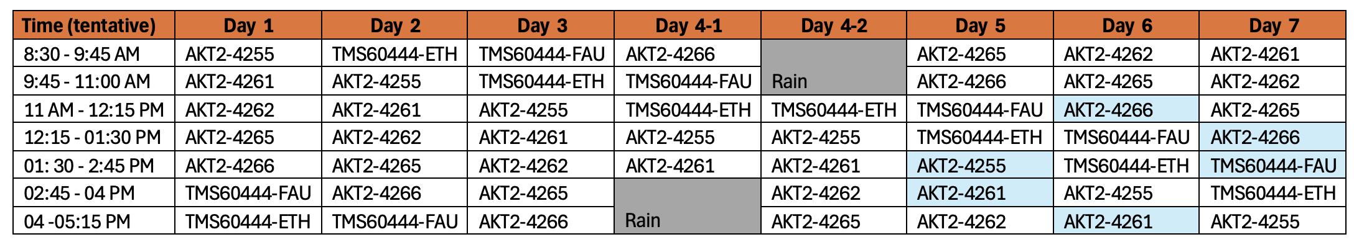
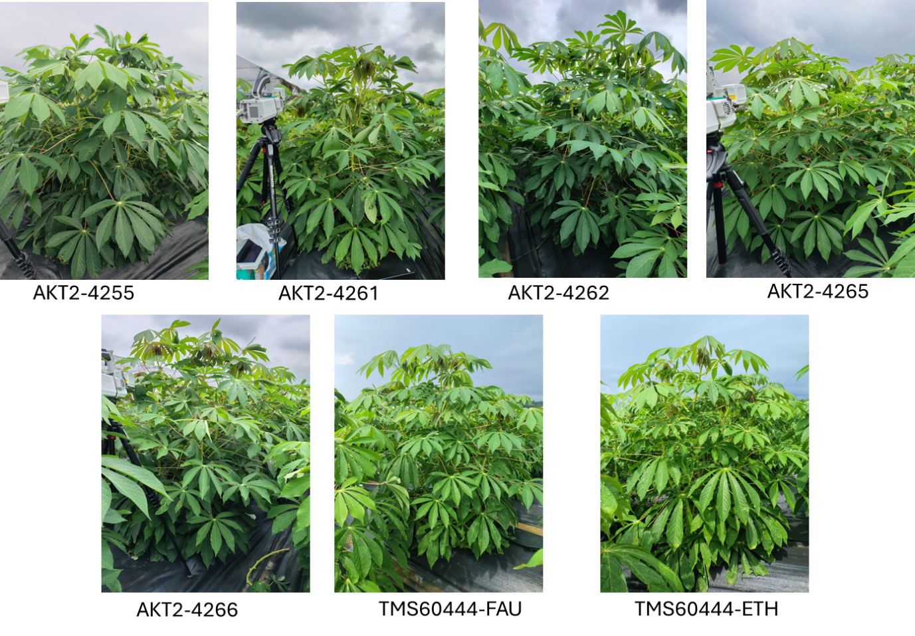
Figure 1_AKT2_{var}, TMS60444-FAU, and TMS60444-ETH plants for measuring the gas exchange.
The AKT2_{var} lines, which grew best, along with TMS60444-FAU and TMS60444-ETH, were randomly selected from replicates 2, 3, 4, and 5 in WF2. Gas exchange measurements will be conducted on these plants throughout the growing season to track changes in photosynthesis during the vegetative and reproductive stages. Similarly, plants from the C56 and C2-16 lines will be selected from WF2 for gas exchange measurement. As previously mentioned, gas exchange measurements for each construct will be spread over seven days. After completing the first cycle for C2-8, measurements will proceed with C56, followed by C2-16. These cycles will continue until harvest or until the IRGA light sensor can no longer reach the 4th or 5th leaf of the plant.
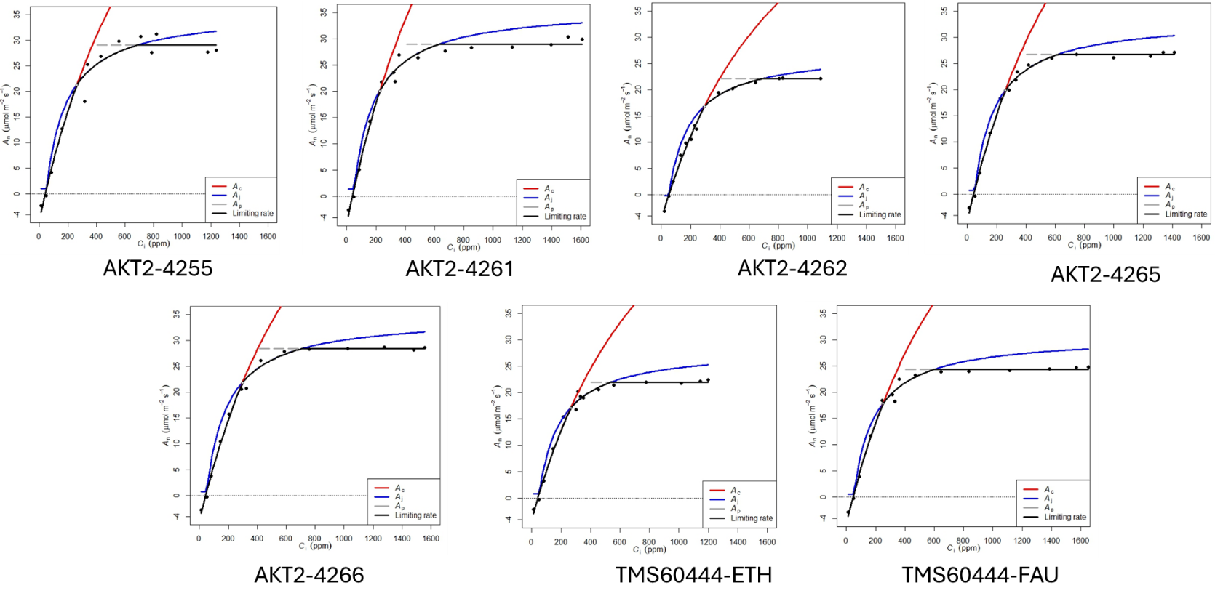
Figure 2_Representative AC_{i} curve from AKT2_{var} lines and WT from ETH and FAU: Using “plantecophys”, an R-package for analysing and modelling leaf gas echange, AC_{i} curve was drawn and the value for Vcmax, Jmax, Rd, Gamma star, and TPU were calculated.
Despite the rain and cloudy weather on some days, AC_{i} curves were successfully measured from five independent AKT2_{var} lines and two wild types (TMS60444-ETH and TMS60444-FAU; Figure 3). Among them, AKT2_{var}-4255, AKT2_{var}-4261, and AKT2_{var}-4262 showed higher VC_{max}, J_{max}, and TPU than the vector controls and wild types. This indicates enhanced RuBisCO activity, RuBP regeneration and triose phosphate utilization, as well as an increased overall photosynthetic capacity, under saturating light and non-limiting CO₂ conditions. In contrast, AKT2-4265 and 4266 exhibited comparable or lower values for these parameters compared to the vector controls and wild types.
Lines AKT2_{var}-4255, AKT2_{var}-4261 and AKT2_{var}-4265 lines exhibited lower day respiration (Rd) than the vector control, suggesting reduced mitochondrial CO₂ release during carbohydrate breakdown for ATP and NADH supply, and potentially improved CO₂ utilization efficiency. Under varying CO₂ levels and saturating light, the AKT2 lines also exhibited lower Γ* (gamma star), indicating reduced photorespiration and a lower CO₂ compensation point.
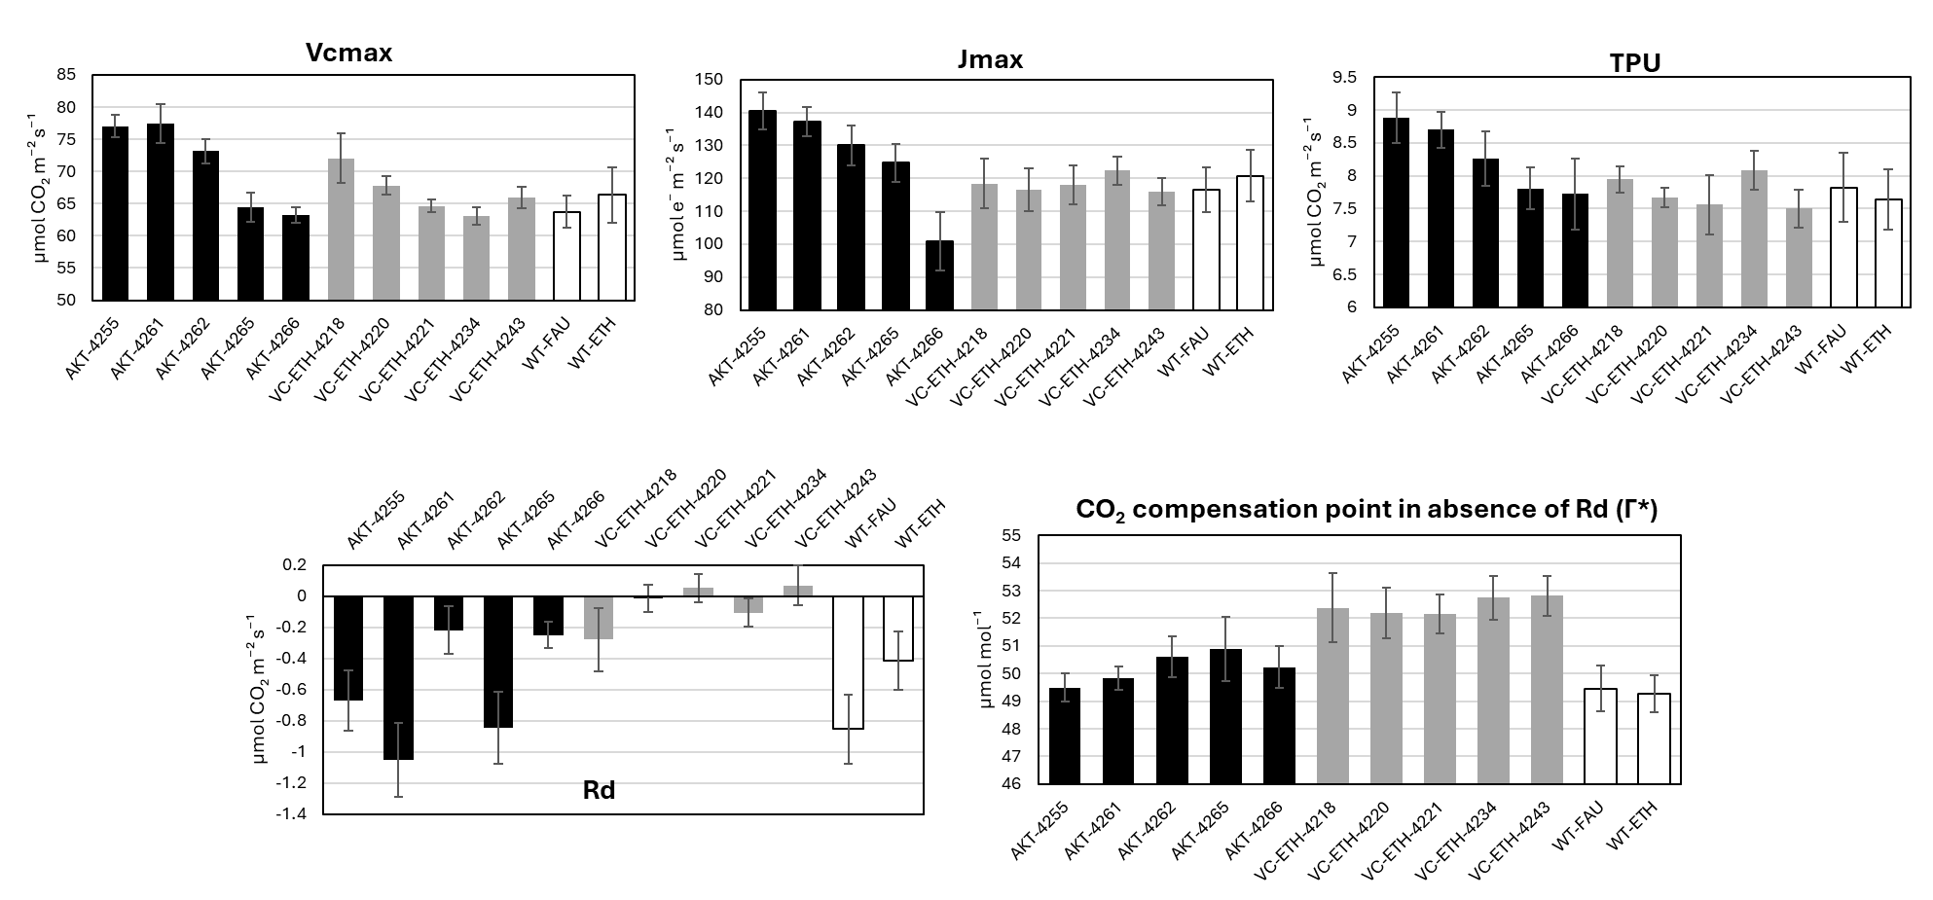
Figure 3_Vcmax, Jmax, TPU, Rd, and Γ* for AKT2_{var} construct lines, vector control, and wild type in WF2 after seven days of measurements at different time points: The values for Vcmax and Rd, along with their standard errors, are presented as weighted means, accounting for the varying precision of individual estimates. Gas exchange measurements for the vector control were conducted one week prior to those for the AKT2_{var} lines and wild type.
Similar to the AKT2_{var} plants, visually healthy plants of C56 (pStGBSS1::PsGPT2 + pStB33::AtNTT1), and C2-16 (pOsAnt::HvAlaAt), lines were randomly selected from replicates 2, 3, 4, and 5 in the WF2 field (Fig. 4). The same wildtype plants from plot 2070 for TMS60444 ETH and plot 3061 for TMS60444 that were used for the AKT2_{var} photosynthesis measurements were also used for both the GTP-NTT and AlaAT plants.
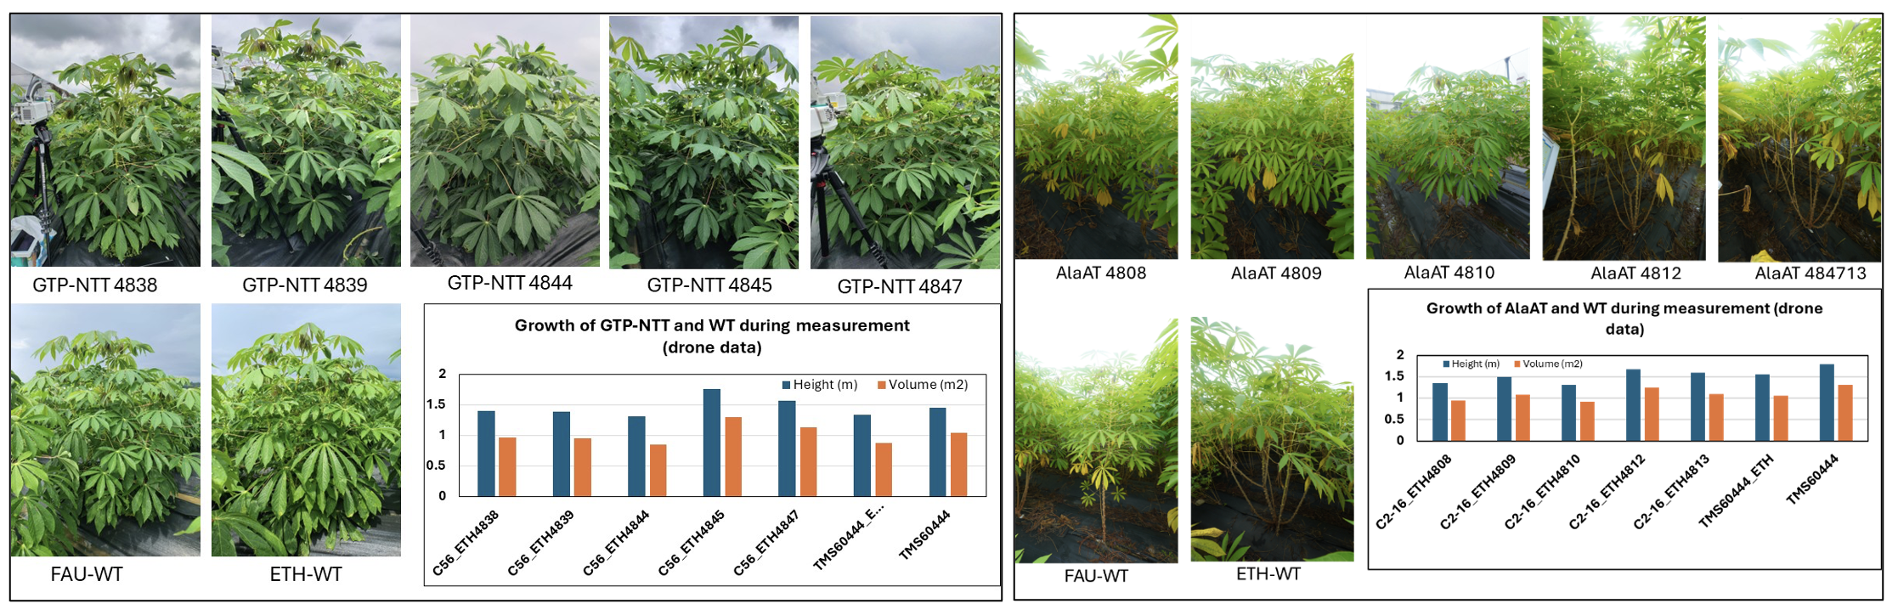
Figure 4_Left panel: GTP-NTT, TMS60444-FAU, and TMS60444-ETH plants used for measuring the gas exchange. Plant height and volume were measured using UAV. Right panel: AlaAT, TMS60444-FAU, and TMS60444-ETH plants used for measuring the gas exchange. Plant height and volume were measured using UAV.

The growth parameters for all plants during the time of measurement were captured by UAV. As explained previously, gas exchange from the 4th or 5th leaf of the plant were measured for each construct over seven days (see Table 2 and 3).
Table 2_Photosynthesis measurements scheduled over seven days to capture photosynthesis performance of each C56 line between 8:30 AM and 5 PM. Prior to Day 7, the field was sprayed with insecticides leading to stomatal closure. Therefore, after two days, the measurement was retaken. Blue boxes in the table indicate periods of rainfall during the measurements.
Time (tentative) | Day 1 | Day 2 | Day 3 | Day 4 | Day 5 | Day 6 | Day 7.1 | Day 7.2
8:30 - 9:45 AM | GTP-NTT-4844 | TMS60444-ETH | TMS60444-FAU | GTP-NTT-4839 | GTP-NTT-4847 | GTP-NTT- 4845 | GTP-NTT- 4838 | GTP-NTT- 4838
9:45 - 11:00 AM | GTP-NTT- 4838 | GTP-NTT-4844 | TMS60444-ETH | TMS60444-FAU | GTP-NTT-4839 | GTP-NTT-4847 | GTP-NTT- 4845 | GTP-NTT- 4845
11 AM - 12:15 PM | GTP-NTT- 4845 | GTP-NTT- 4838 | GTP-NTT-4844 | TMS60444-ETH | TMS60444-FAU | GTP-NTT-4839 | GTP-NTT-4847 | GTP-NTT-4847
12:15 - 01:30 PM | GTP-NTT-4847 | GTP-NTT- 4845 | GTP-NTT- 4838 | GTP-NTT-4844 | TMS60444-ETH | TMS60444-FAU | GTP-NTT-4839 | GTP-NTT-4839
01: 30 - 2:45 PM | GTP-NTT-4839 | GTP-NTT-4847 | GTP-NTT- 4845 | GTP-NTT- 4838 | GTP-NTT-4844 | TMS60444-ETH | TMS60444-FAU | TMS60444-FAU
02:45 - 04 PM | TMS60444-FAU | GTP-NTT-4839 | GTP-NTT-4847 | GTP-NTT- 4845 | GTP-NTT- 4838 | GTP-NTT-4844 | TMS60444-ETH | TMS60444-ETH
04 -05:15 PM | TMS60444-ETH | TMS60444-FAU | GTP-NTT-4839 | GTP-NTT-4847 | GTP-NTT- 4845 | GTP-NTT- 4838 | GTP-NTT-4844 | GTP-NTT-4844
Table 3_Photosynthesis measurements scheduled over seven days to capture photosynthesis performance of each AlaAT line between 8:30 AM and 5 PM.
Time (tentative) | Day 1 | Day 2 | Day 3 | Day 4 | Day 5 | Day 6 | Day 7
8:30 - 9:45 AM | AlaAT-4808 | TMS60444 ETH | TMS60444 FAU | AlaAT- 4813 | AlaAT- 4812 | AlaAT- 4810 | AlaAT- 4809
9:45 - 11:00 AM | AlaAT-4809 | AlaAT- 4808 | TMS60444 ETH | TMS60444 FAU | AlaAT- 4813 | AlaAT- 4812 | AlaAT- 4810
11 AM - 12:15 PM | AlaAT-4810 | AlaAT- 4809 | AlaAT- 4808 | TMS60444 ETH | TMS60444 FAU | AlaAT- 4813 | AlaAT- 4812
12:15 - 01:30 PM | AlaAT- 4812 | AlaAT- 4810 | AlaAT- 4809 | AlaAT- 4808 | TMS60444 ETH | TMS60444 FAU | AlaAT- 4813
01: 30 - 2:45 PM | AlaAT- 4813 | AlaAT- 4812 | AlaAT- 4810 | AlaAT- 4809 | AlaAT- 4808 | TMS60444 ETH | TMS60444 FAU
02:45 - 04 PM | TMS60444 FAU | AlaAT- 4813 | AlaAT- 4812 | AlaAT- 4810 | AlaAT- 4809 | AlaAT- 4808 | TMS60444 ETH
04 -05:15 PM | TMS60444 ETH | TMS60444 FAU | AlaAT- 4813 | AlaAT- 4812 | AlaAT- 4810 | AlaAT- 4809 | AlaAT- 4808
Gas exchange of five independent lines of C56 (PsGPT2/AtNTT1) and C2-16 (HvAlaAT), along with two wild types (TMS60444-ETH and TMS60444-FAU), was successfully measured using the LI-6800 system (Fig. 5 and 6).
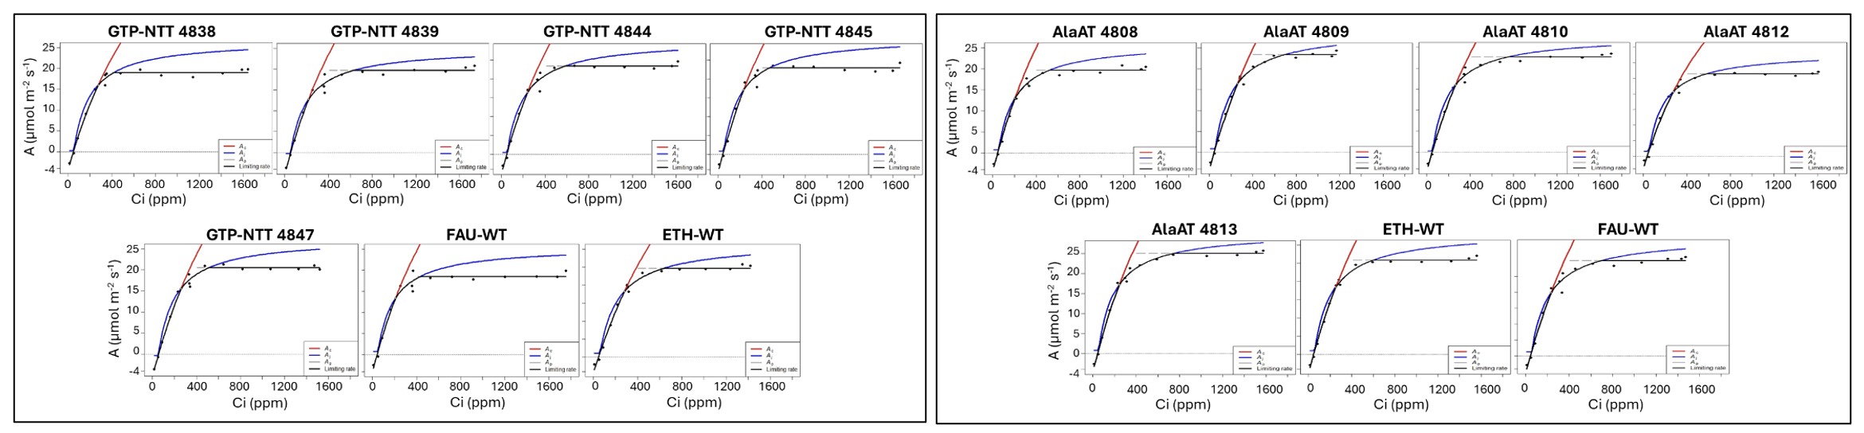
Figure 5_Left panel: Representative AC_{i} curves from WT (ETH, FAU) and GTP-NTT lines. Right panel: Representative AC_{i} curves from WT (ETH, FAU) and AlaAT lines. The AC_{i} curves were drawn and the values for VC_{max}, J_{max}, Rd, Gamma star, and TPU were calculated using “plantecophys”, an R-package for analysing and modelling leaf gas echange.

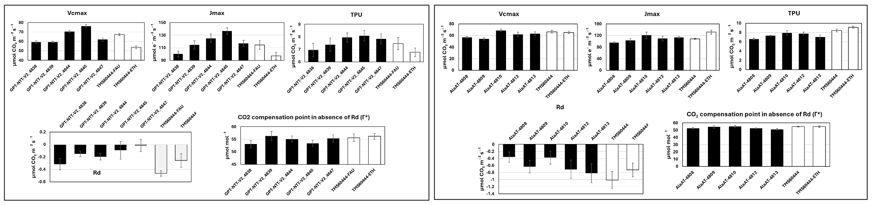
Figure 6_Left panel: VC_{max}, J_{max}, TPU, Rd, and Γ* were measured for GTP-NTT, vector control, and wild type plants in WF2. Right panel: VC_{max}, J_{max}, TPU, Rd, and Γ* were measured for AlaAT, vector control, and wild type plants in WF2. The values for VC_{max} and Rd, along with their standard errors, are presented as weighted means, accounting for the varying precision of individual estimates.
Compared to wild type plants, plants of C56 lines 4844 and 4845 were found to exhibited higher VC_{max}, J_{max}, and TPU, indicating enhanced RuBisCO activity, RuBP regeneration, and triose phosphate utilization, and thus an overall increase in photosynthetic capacity under saturating light and non-limiting CO₂ conditions. In contrast, plants of GTP-NTT lines 4838, 4839, and 4847 performed comparably to the wild type. All plants from C56 lines except plants from line 4838 showed lower day respiration (Rd) than the wild type plants, suggesting reduced mitochondrial CO₂ release during carbohydrate oxidation and potentially improved CO₂ utilization efficiency. Furthermore, under varying CO₂ levels with saturating light, plants of GTP-NTT lines 4848 and 4845 exhibited lower Γ* (gamma star), indicating reduced photorespiration and a lower CO₂ compensation point.
All plants from HvAlaAT lines performed similarly to the wild type plants, indicating no significant change in photosynthetic parameters with the expression of barley AlaAT gene in cassava.
- Three replicate plants from each of the C2-16 construct line, VC_ETH4220 line, and wildtype were harvested from the WF1 and WF2 fields (intermediate harvest) on June 30 and July 1, 2025, to evaluate line performance. From each plant, leaf, upper stem, lower stem, fibrous root (FR), and storage root (SR) samples were collected and snap-frozen in liquid nitrogen for AlaAT expression analysis. Fresh and dry weights of total root and shoot were measured and documented photographically.
- Additionally, replicate plants 6 to 10 of all the five independent lines of the C2-8 construct and vector controls were harvested from the WF2 field on July 15-17, 2025. Leaf, petiole, upper stem, lower stem, storage root peel, inner storage root, and fibrous root samples were snap-frozen in liquid nitrogen. Frozen samples were shipped to FAU for molecular and biochemical analysis. Agronomic data, including plant height and fresh and dry weights of root and shoot, were also recorded and shared with the consortium.
- Leaflets and petiole from the fourth leaf were harvested from plants of the five independent lines of the C2-8 construct and vector control (VC) plants from the WF2 field at the end of night (EON) and the end of day (EOD). At EON, only the leaf was collected, while at EOD both leaf and petiole were collected. Samples were snap-frozen in liquid nitrogen and shipped to FAU for molecular and biochemical analysis. Similarly, two unshaded leaflets from the fifth leaf and two from the sixth leaf were harvested at EOD and EON, respectively, from nine independent lines of construct 37491 (StGBSS:ESV1), five of 37487 (35S:ESV1), two vector controls (37490-9, 37490-12), FEC control, and TMS60444-ETH1 from the WF2 field. These samples were also snap-frozen in liquid nitrogen and shipped to ETH Zurich for molecular and biochemical analysis.
- To regularly monitor plant growth, UAV images were captured at 15-day intervals (twice per month) to measure plant height and volume. From April 29, 2025 to the end of August 2025, nine imaging sessions have been conducted, with the most recent on August 25, 2025. The images have been shared with the consortium. Monitoring will continue until the end of October or until the final harvest, tentatively scheduled starting the last week of November 2025.
- As reported earlier, the 2025 experiments of clonally propagated cassava in the EF2 and EF3 fields were discontinued due to the low germination rate of stakes as the result of the cold weather conditions in February and March 2025. To facilitate nutrient replenishing of the fields, soybean will be cultivated in EF2 and EF3.
- For seasonal PAM-based photosynthesis measurements, the FAU team selected plants based on growth parameters derived from UAV data. To ensure data quality, the measurements require regular monitoring of the clamps, as they may loosen or slide off during heavy rain and windy conditions. Measurements are conducted in 10–15 day cycles, with clamps repositioned to new selected plants after each cycle. The recorded MicroPAM data are regularly shared with the CASS team for further analysis.
- Soil samples were collected from six locations in WF1 and twelve locations in WF2 to assess nutrient content and evaluate whether soil properties contribute to the heterogeneous growth of cassava. The data were compared with the average soil nutrient levels of Taichung City over the past five years. No significant differences were found that could explain the observed heterogeneity in cassava growth. However, nitrogen availability was higher in WF1 than in WF2, where less heterogeneity was also observed. This is likely due to previous soybean cultivation in WF1. Hence, conditioning WF2 with soybean for one year is being considered, and the proposal will be discussed on a larger platform.
- Regular growth monitoring of the cassava lines was continued using UAV-based imaging at 15-day intervals until November 17, 2025, one week prior to the final harvest. The collected data were subsequently shared with the consortium for further analysis.
- The final harvest of approximately 4100 cassava plants was conducted from November 24 to December 16, 2025 across all fields (WF2, WF1, and EF1, in that order). Total fresh shoot and storage root weight were measured for all plants. Data were recorded digitally using the Field Book V6 App and uploaded daily to CASSBASE for consortium access. In addition, approximately 100 mg of storage root tissue from each genotype was collected, oven-dried under hot air, and used for dry weight determination. These data were also recorded in the Field Book App V6 and uploaded to CASSBASE. Photographs of shoots and storage roots were taken during harvest using specially constructed imaging setups. All images have been shared with the digital team, who will rename them according to the QR codes imbeded in the photos and upload them to CASSBASE. Data for the fresh shoot and storage root weight harvested during 2025 is discussed in annexure 1 attached below the report.
- To obtain high-quality images of shoots and roots, dedicated photobooths with a blue background were constructed for color correction (representative images of a shoot and storage root taken during the harvest are shown in Figure 7 below). The shoot photobooth consisted of a steel frame measuring 2.5 m in height and 1.5 m in width. The root photobooth was designed in Germany and included a top slot for camera mounting (image attached below). To minimize shadow formation, the inner walls were lined with waterproof white fabric, which also allowed easy cleaning after harvest. The two photobooths significantly improved image quality compared with previous years.
- For molecular analysis, peel and core tissues from the lower shoot stem (collected separately and in some cases combined), as well as peel and core tissues from storage roots, were sampled from six independent C56 lines (PsGPT2/AtNTT1), five vector control (VC) lines, and wild types (WT) from WF1 and WF2. All samples were snap-frozen in liquid nitrogen and shipped to FAU, Germany. In addition, for lines ETH37487-4, -5, and -14 from WF1, a 1 cm transverse slice of storage root including the peel, and a 1 cm oblong section of storage root without peel, were collected. These samples were also snap-frozen in liquid nitrogen and shipped to ETH for further analysis.
- Stakes of approximately 1 m length from five lines each of C2_8 (AKT), C2_16 (AlaAT), VC, and WT were harvested from WF1. These stakes will be planted in one of the EF fields in 2026 for agronomic evaluation. This approach follows standard farmer practice and was adopted to ensure that the experimental setup reflects real field conditions.
- After the final harvest, soil samples were collected at 30 cm depth from nine locations in WF1, ten in WF2, and five in EF1 to evaluate whether variation in mineral content, soil texture, or soil chemistry could explain the observed heterogeneity in cassava growth. The sampling covered areas representing low, medium, and high growth. Except for higher soil organic matter content and cation exchange capacity, and a lower proportion of sandy soil and exchangeable Fe in the low-growth areas, no other soil parameters showed clear differences. A brief summary of the soil analysis is provided in Annexure 1.
- After completion of the harvest, all fields were planted with a legume until the end of January 2026 to improve soil nitrogen and organic matter status.
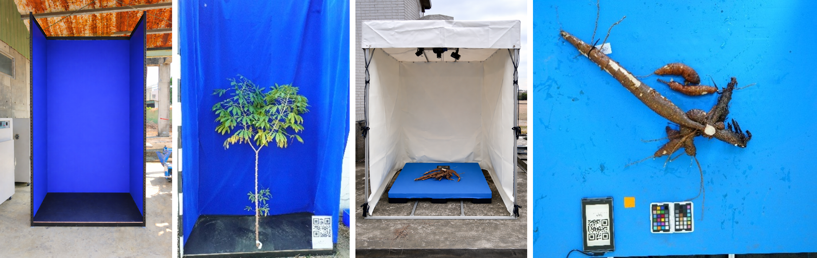
Figure 7: Photobooths for shoot and root imaging used during the final harvest: representative shoot and storage root images captured during the final 2025 harvest using custom-built photobooths. Each image was linked to a unique QR code assigned to individual plants. The root photobooth was equipped with a top-mounted camera and flash lighting to minimize external light interference and reduce shadow formation.
Challenges and Mitigations – Season 2024:

- The cassava plants in the field trials are growing well, although there is some unevenness in the plant growth patterns in WF1 that has been recorded and is currently being analyzed. Data acquisition is ongoing, and data are of good quality (see TM5.1.4 for trait data extraction). The cassava fields were challenged during the week of July 22, 2024, when typhoon Gaemi hit Taiwan and Taichung received 400 mm rain during a three-day period. The installation of pumps in the WF2, EF1, EF2, and EF3 fields prevented the accumulation of excessive water. Some remaining water in the trenches between the ridges eventually evaporated. There was a loss of two cassava plants that had been broken by the typhoon. Several other cassava plants were leaning from the wind and1 soaked soil but could be straightend up again. Although the total amount of precipitation (1061 mm) during the April to August 2024 period was not significantly different from 2023, rain was often intermittent and heavy at times.

- In addition to typhoon Gaemi in Q3 (see above), Taichung experienced another two typhoons in Q4, Krathons on October 3 and Kong-rey on November 1. Although typhoons are normal seasonal weather events in Taiwan, Taichung is usually sheltered from typhoons arriving on the Taiwan island from the East. The typhoons during Q4 were unusual because they approached Taiwan from the South and then travelled up the Taiwan Strait, which can also impact Taichung. Typhoon Krathons dissipated before reaching Taichung, but typhoon Kong-rey caused some damage to cassava fields, particularly in the EF2 and EF3 stake fields. EF1 and WF2 plants, however, remained largely unaffected. The immediate impact included uprooting, breakage, and leaning of some plants, and water accumulating in the trenches from the heavy rain. Leaning plants were straightened up again using a support system and water was pumped out from the field. Despite these challenges, most of the impacted plants could be harvested successfully and quality data and samples for analysis collected during the final harvest.

To prevent water standing in the trenches for extended periods after heavy rains, we already installed water pumps at the corner of the field in early 2024. To further facilitate excess water drainage, one or two trenches will be constructed across the middle of the larger WF1 and WF2 fields to channel water to the pumps. While adding trenches will slightly reduce the number of plants that can grow in the fields, it will more effectively remove excess water from the fields. Alves et al. (2024; https://doi.org/10.1590/0034-737X2024710016) reported yield penalties for cassava plants during early growth under waterlogged conditions, therefore minimizing waterlogging will significantly improve agronomic performance of the cassava plants, outweighing the small reduction in planting area.
Variable plant growth performance has been observed across the fields independent of DNA construct or transgenic events. For example, in WF2 vigorous canopy growth was observed on the North side of the field, while in the central and southern part of the field plant growth was more variable. Plants in the EF3 field were growing well on the East side, but growth was more variable on the West side. Similarly, plant growth was variable in the EF1 field. No growth variability was observed in EF2. Analysed soil chemistry post-harvest to check for macro- or micronutrient deficiencies in areas with poor growth did not reveal significant differences in the soil data except for small differences in pH and all fields, including EF2, shared similar soil chemistry.
With soil nutrient deficiencies ruled out, water accumulation in the trenches after heavy rain may be a contributing factor to the uneven growth. As mentioned, in addition to trenches across the fields, additional water pumps will be installed in WF1 and WF2 to drain excess water, and cross-trenches will help channel water out of the fields. Additionally, PVC pipes about 5 cm in diameter with holes will be installed across the fields to monitor whether the soil retains maximum water capacity instead of allowing infiltration. Previously, manual preparation of the fields might have resulted in uneven application of organic material and fertilizer. A purchased tractor now evenly sprays sugarcane residues (Taisugar no. 12 t/ha) and fertilizer across the fields before transplanting the cassava stakes and plants from the greenhouse. WF1 has been kept fallow in 2024 for nutrient recharge.
One challenge during data analysis was the lack of statistical power with 12 replicates for each independent event on average. Field conditions introduce multiple factors that contribute to variability in agronomic performance. Additionally, variable plant growth may have impacted the results. Focusing on increasing the number of replicates for the best-performing independent events, rather than maximizing the number of DNA constructs that are tested, could be a more effective and robust approach.

Next Steps in the Action Plan – Season 2024:

- The 2024 cassava field experiments in WF2, EF1, EF2, and EF3 will continue until the final harvest in late November to early December. Agronomic data will be collected until the cassava plant canopy closes and it becomes difficult to take measurements in the field. UAV-based data acquisition will continue as planned to obtain a complete data set of the 2024 vegetation period. It is also planned that NCHU and FZJ researchers will perform photosynthetic measurements on plants in the fields. Data flow between NCHU (data acquisition) and FZJ (data processing) is well established, and the teams will continue working in this manner until the end of the vegetation period.

- In 2025, we expect to receive around 7,500 micro-propagated wildtype and transgenic plants from our FAU partners. In addition to WF2, the WF1 field, which was left fallow in 2024, will be used for planting these. As in previous years, EF2 and EF3 will be used to grow stakes harvested in 2024, while EF1 will accommodate additional micro-propagated plants. EF2 and EF3 are preferred for vegetative propagation due to their uniformity, as shown in Fig. 4. The micro-propagated plants in EF1 will support data collection for WF1 and WF2 but not serve as the primary focus of the study. Installation of additional water pumps, fertilizer spraying, and re-levelling the field before planting will help reduce heterogeneity. A 26-horsepower tractor has been purchased for ploughing, levelling, and fertilizer application, and the NCHU team will standardize its use to minimize cassava growth variability in the fields.

- A detailed biostatistics evaluation of the field data is required (internally and/or externally) to develop recommandations for further field testing. Data has been shared with AgOne and we are currently working on it internally.

Challenges and Mitigations – Season 2025:

Challenges
- The first three months of 2025, Taichung arguably experienced one of the most erratic weather patterns recorded over the past five years. Temperature fluctuations during February and March were unusually high, with frequent shifts between rainfall and cold nights. This period also marked one of the wettest early growing seasons, with significant challenges for cassava field operations. A total of 56 mm of rainfall was recorded during a single event on February 12–13. This sudden and intense rainfall delayed ridge building in WF2 until the soil had dried sufficiently to allow working with the heavy equipment. Another heavy rain event on March 4, 2025, impacted ridges that had already been built in WF1. After the soil in WF1 had dried out enough again, the filed had to be reploughed and ridges had to be rebuilt, delaying transplanting for two weeks. While cumulative rainfall in 2022 was higher both in February and March, it was spread across multiple events with less immediate water management problems. In contrast, the 2025 season was marked by intense, concentrated rain coupled with abrupt temperature drops and wind—creating a high-risk environment for newly planted cassava plants and stakes.

- On March 4–5, in-vitro cassava plants were transplanted into WF2. Shortly after, a heavy rainfall event was followed by a sharp drop in night temperatures. The resulting cold stress led to physiological damage in some of the transplanted cassava plants, including wilting and chlorophyll loss. Cold stress also weakened some of the newly transplanted cassava plants making the more vulnerable to mechanical damage during strong or even mild wind.

- The most severe damage was observed in the cassava stake fields, EF2 and EF3, which were transplanted on February 14, 2025. Prolonged waterlogging, followed by successive cold waves in early and mid-March, significantly reduced sprouting rates. In many cases, emerging buds failed to survive, leading to a current survival rate of only 17% for construct lines and 56% for wild-type border lines. Given the poor establishment and low sprouting success, the stake fields may be discontinued for the 2025 season. Resources will instead be prioritized for monitoring and managing the in-vitro cassava populations in WF1, WF2, and EF1.

- A few spider mites were observed in the WF2 field. To prevent their spread, three insecticides- Diafenthiuron (1.1 L/ha), Spiromesifen (0.83 L/ha), and Cyenopyrafen (0.66 L/ha) – were immediately applied across all fields.
- During gas exchange measurements, it was not possible to maintain constant values for leaf temperature (Tleaf) and relative humidity (RH) in the measuring head could not be maintained at constant values throughout the seven-day cycle, due to fluctuations in ambient conditions. RH ranged from 60 to 100%, and air temperature ranged from 28 to 40 °C. Drierite, which is essential for humidity control, was only effective for up to two days. Although sourcing Drierite directly from LICOR involved long lead times and higher costs, we found a reliable local supplier who can deliver high-quality material within a day at a significantly lower cost. This ensures uninterrupted measurements while maintaining experimental standards.
- A low level scales infestation was observed in the WF1 and WF2 fields after the monsoon. To prevent their spread, the insecticide thiamethoxam was sprayed at 1:4000 ratio on August 28, 2025.
- The high humidity in the field caused a defect in the Licor 6800 humidity controller since the mid week of July. The engineer from Licor is trying to repair the instrument as soon as possible. However, it is unlikely that the cassava gas exchange can be recorded further this growing season as most of the plants are now above 2 meters tall, which is beyond the reach for measurement of the top leaves.
- Taichung experienced heavy rainfall in July due to typhoon Danas, with a total precipitation of 1013 mm. In August, typhoon Podul brought an additional 282 mm of rainfall. Despite the heavy rains, no damage occurred to the cassava plants, as the trenches and pumps installed in all corners of WF1 and WF2 effectively drained excess water from the fields.
- The final harvest of 4100 cassava plants in 2025 was the largest harvest, data and sample collection performed so far by the NCHU team and presented logistical, scheduling and personnel management challenges over a three-week period. As the result of a misunderstanding of instructions from the ETH team, the NCHU team did not collect storage root samples from all of the ETH lines. This misunderstanding was not realized until shipment of the samples to FAU in January 2026.
- In addition to collecting storage root samples from all ETH lines, the ETH team gave instructions to also collect a 1 cm transverse slice of storage root including the peel, and a 1 cm oblong section of storage root without peel, from lines ETH37487-4, -5, -14, ETH37491-10, -12, and -17. However, during the final harvest at WF2, roots from ETH37491-10, -12, and -17 were found to be very small (average ~0.9 kg). Following consultation with the ETH team, these lines were therefore excluded from sampling for molecular analysis.

Mitigations
- Waterlogging in the experimental fields before they were prepared for effective water drainage and planting was addressed using portable water pumps. Although muddy conditions caused repeated clogging and mechanical issues, the pumps were serviced multiple times, allowing for effective drainage.
- To take advantage of the limited planting window after the rain events, additional part-time labor was mobilized to expedite field preparation and cassava transplanting, especially in WF1 and WF2.
- Following the cold wave and wind-induced damage, most affected plants were replaced using the same constructs plants that were maintained in the greenhouse, which is our normal operational practice for field management. For constructs that were no longer available, alternatives such as Construct 46 and Construct 23 that were not included in the planting plan were used for replanting to maintain a uniform plant density.
- The use of the Field Book App (v6) has been challenging over the years. Two weeks prior to the final harvest, the CASS digital and data management team (Dr. Lukas Müller from Cornell University and Dr. Mercedes Thieme from FAU), visited the experimental fields to assist with app setup and configuration. They continued to monitor its performance during the harvest period and resolved several technical issues. The use of the Field Book App enabled daily data collection and facilitated timely data sharing with the consortium, improving data accessibility and coordination across teams.
- For the 2026 field experiment, the NCHU team will confirm all sampling instructions from FAU and ETH to avoid possible misunderstandings. The NCHU team will also discuss with the FAU and ETH teams that for future field experiments only strictly necessary data and samples will be collected at the final harvest. This will avoid overburdening the NCHU team and also keep the final harvest to a minimum time window for improving data comparison between plants harvested early an late.
- To mitigate the problem with the missed ETH storage root samples, the NCHU team has proposed to the ETH team to collect plant material during the 2026 field season in several intermediate harvests of selected ETH lines followed by immediate shipment of the samples to ETH. The ETH team believes that collecting multiple samples during the field season might actually be preferable to single samples from the final harvest.

Next Steps in the Action Plan – Season 2025:

- The 2025 cassava field experiments in WF1, WF2, and EF1 will continue to the final harvest, which is expected between late November and early December. Photosynthetic parameters, including gas exchange and chlorophyll fluorescence, will be assessed during the vegetative phase using the LI-COR 6800 infrared gas analyzer (IRGA). Key agronomic observations such as branching date, leaf yellowing (senescence, which is typical when plant grow taller), and lower leaf drop will be recorded prior to harvest. UAV-based remote sensing will start on April 28, 2025, and continue every two weeks to ensure comprehensive monitoring and data collection for crop development throughout the 2025 growing season.
- Gas exchange measurements in the three selected constructs will continue throughout the season to capture responses across different growth stages. From mid-July onwards, one vector control line developed at ETH will be used for comparison instead of the FAU wildtype. In addition to gas exchange, chlorophyll a fluorescence and other photosynthetic parameters will be recorded using MicroPAM for the same lines starting in July. UAV-based growth monitoring will also continue at 15-day intervals for the duration of the season.
- An intermediate harvest is planned for mid-July, targeting five independent lines of C2-8 carrying pAtAKT2::AtAKT2_{var} and five vector control lines developed at ETH. Additionally, leaf samples from selected constructs developed at FAU will be collected at end-of-day and end-of-night timepoints.
- UAV flight to monitor the growth of cassava will continue after every 15 days until the final harvest.
- The team is in constant contact with the other CASS teams in preparation for the final harvest that is scheduled to begin at the last week of November. A new photobooth stand is being constructed that can help us to capture better images of the shoot and the root. The device used for capturing photos is also being discussed to make image capturing more efficient during the harvest without compromising the quality of the images.
- To include Chlorophyll a fluorescence measurements along with the gas exchange measurements recorded with Licor 6800, the NCHU team is currently procuring HandyPEA from Hansatech Instruments Ltd.

4.1.5. Preparations for confined field-testing at NCHU season 2026
- To accommodate approximately 4,680 in-vitro cassava plants and 500 stakes from 2025, the West Field 1 (WF1), West Field 2 (WF2), East Field 2 (EF2) and East Field 3 (EF3) were prepared. Initial soil preparation involved ploughing and conditioning with sugarcane residue (Taisugar No. 11) applied at 10 t/ha. The fields were then fine-ploughed, and ridges were built 1.2 m apart. Plastic tarps were used to cover the ridges to suppress weed emergence. To allow better drainage of excess water and avoid water logging after heavy rainfalls, two additional drainage trenches were constructed in WF2 field and one in WF1 field that drain into the side trenches running along the fields, similar to the previous year. Water pumps installed at the corners of each field to facilitate efficient drainage during heavy rainfall events are still kept in its place.
- The import permit for 8,000 in-vitro cassava plantlets comprising 24 transgenic lines, two vector controls, two FEC lines and two wild types developed by ETH Zurich and FAU was obtained from the Taiwan Animal and Plant Health Inspection Agency of the Ministry of Agriculture on November 17, 2025. On January 16, 2026, we received 6,468 in-vitro plantlets from ETH Zurich, which were labeled (barcoded) and transplanted into pots containing a 2:1:1 mixture of peat moss, vermiculite, and perlite between January 19-21, 2026, for hardening in the greenhouse. To reduce excess light exposure and maintain humidity, the pots were placed on trays and covered with a translucent lid and a black net for approximately two weeks. After this period, the covers were removed, and after one month the pots were spaced out on greenhouse benches to ensure adequate room for growth of the plantlets. In the second month, they were gradually acclimatized to environmental conditions by turning off the temperature regulation in the greenhouse. From the time of transplanting, plants were regularly monitored for mold development, wilting, and water status to ensure healthy establishment.

After one month of hardening, the survival rate was recorded. In addition, three representative plants from each line were photographed and shared with the consortium. This information was used by the teams at ETH and FAU to design the field map based on the number of plants available. After nearly two months of regular monitoring for mold, dehydration, and temperature stress, the cassava plants were planted into the field at 1.2 m apart.

4.1.6. Confined field-testing at NCHU season 2026

- The 2026 field experiment is organized based on the source of the plant materials. Field layouts for WF1, WF2 and EF2 were created and deposited in CASSBASE. Lines from FAU were planted in WF1 and EF2, while those from ETH were planted in WF2. This arrangement was necessary because some FAU-derived lines (DELLA constructs) are expected to exhibit dwarf and semi-dwarf phenotypes. Planting them alongside normal-height lines could result in shading, affecting their growth and accurate phenotypic assessment. WF1 is divided into three sections. The first section consists of DELLA constructs arranged in a block design of 4 X 4 plants. The second section includes metabolic lines planted in a random serpentine arrangement for final harvest, and the third section contains metabolic lines in a random serpentine arrangement for intermediate harvest. Similarly, WF2 is divided into three sections: the first small section for intermediate harvest, the second section for final harvest, and third small section with DELLA lines for intermediate harvest. All plants in WF2 and EF2 are planted in a random serpentine arrangement. All planting activities were completed within four days: EF2 on March 16, 2026; WF2 on March 17, 2026; WF1 on March 18, 2026; and EF3 (stakes from 2025) on March 19, 2026. The planting dates were kept close across all fields to ensure uniform crop establishment and synchronized growth, enabling consistent comparison and analysis. EF1, which was used for growing in vitro plants in 2025, will be conditioned with soybean to improve nutrient status.

Figure 8_(A) In vitro plants as received from FAU via Zurich. (B) Jars containing in vitro plants maintained under controlled conditions for 3–4 days for acclimatization. (C) In vitro plants after transfer to pots. (D) Potted plants covered with lids to reduce dehydration and limit excess light exposure. (E) Hardened plants arranged across greenhouse tables to ensure adequate spacing for growth.

- The first round of replacing dead plants was carried out on March 30, 2026 across all fields (EF2, WF2, and WF1). In EF2, two plants of the same original construct were replaced. In WF2, a total of 22 plants were replaced, including two with the same construct and 20 with different lines. In WF1, 10 plants were replaced, of which six were from the same construct lines and four from different constructs. As agreed, all plants from this first round of replacement will be included in the study, as their planting time remains close to the main batch. A second round of replacement is planned for mid-April. These plants will not be included in any analysis because they will be nearly one month behind than the rest, which could affect comparability. The purpose of this second replacement is to maintain a similar plant density and crowding effect across the field, ensuring consistent field conditions. All replaced constructs have been shared with the CASS data manager for updating in CASSBASE. For the stake field (EF3), about 75% of the stakes have sprouted. Stakes that have not sprouted by mid-April will be replaced.
Early phenotype assessment
- In the greenhouse, most plants showed a similar growth phenotype at approximately one month of age. However, one construct, C2-93 carrying the AtGAI_Δ17 gene under control of the pManes17G027300 promoter, showed a distinct phenotype even at this early stage. Among the seven independent lines, C2-93_FAU865, C2-93_FAU827, C2-93_FAU868, C2-93_FAU834, C2-93_FAU867, and C2-93_FAU833 exhibited a dwarf phenotype, while lines C2-93_FAU838 and C2-93_FAU826 appeared similar to the wild type.

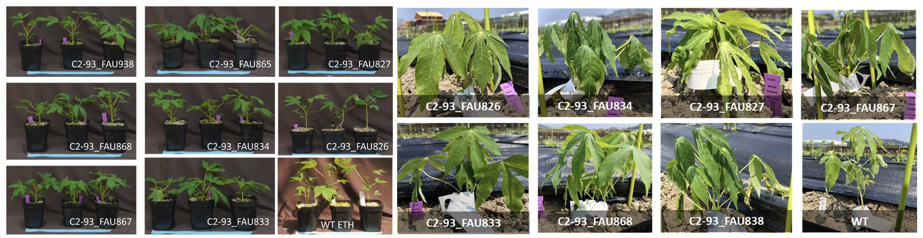

Figure 9_ Phenotype of C2-93 construct in the greenhouse and after one week of planting them in the field

The dwarf phenotype was also observed in the field after transplantation. To prevent these shorter plants from being shaded by lines with normal growth height, the WF1 field was designed in blocks, allowing better exposure and more accurate phenotypic assessment.
Challenges and Mitigations - Season 2026:

- After reporting the survival rate and receiving the field map from the CASS team, all plants were tagged prior to planting to ensure proper identification and tracking. However, due to damage and loss of replicas of some constructs, replacements were required. In some cases, replicas from different lines of the same constructs were used for replacement, while in others cases replicas from different constructs were used for replacement. All changes were communicated to the CASS data manager for updating in CASSBASE.
- In WF1, the construction of a single vertical trench caused a shift in planting positions relative to the original field map. This was reported to the FAU team, and a revised map was prepared to avoid confusion during field monitoring and data collection, particularly for aerial drone imaging where spatial accuracy is critical.
- Following planting, the weather in Taiwan has been predominantly hot and dry, which is not ideal for the transplanted in vitro plants due to their sensitivity to water stress. To support establishment and reduce transplant shock, the team has been regularly irrigating the plants using hoses, including during weekends. This consistent watering is important to maintain plant survival and ensure uniform early growth across the field.

Next Steps in the Action Plan – Season 2026:
- To train the NCHU team in gas exchange measurements using the LI-6800 instrument in the field, the postdoctoral researcher Silas Wungrampha will visit Forschungszentrum Jülich, Germany, for one month starting January 10, 2026. This hands-on training will provide practical experience in instrument handling, experimental design, and data interpretation. The training will also help in optimizing gas exchange protocols for future experiments and in improving the integration of gas exchange data with chlorophyll fluorescence measurements obtained from the MicroPAM. This combined approach will enhance the physiological interpretation of photosynthetic performance and strengthen the robustness of our experimental analyses.
- Immediately after harvest, WF1, WF2 and EF1 were ploughed and sown with a legume cover crop to increase soil nitrogen and organic matter (the EF2 and EF3 fields were planted with soybean earlier in 2025). In early February 2026, the fields will be ploughed again and flooded in preparation for fine ploughing in the second half of February 2026. This will be followed ridge building and covering of the fields with black tarpaulin in early March, prior to layout and mapping for cassava planting. In addition, digital soil mapping is planned after field preparation to assess spatial variation in soil properties. In particular, soil electrical conductivity will be evaluated to determine whether it contributes to the observed heterogeneity in cassava growth across the fields.
- To monitor plant growth, UAV-based RGB and multispectral imaging of WF1, WF2, EF2, and EF3 will be conducted twice per month until final harvest. The first UAV flight is scheduled for April 8, 2026, followed by the second on April 23, 2026. Thereafter, subsequent flights will be conducted at 15-day intervals.
- To better understand the heterogeneity in plant growth, particularly in WF1 and WF2, soil electromagnetic induction (EMI) is being measured using the EM38 (Genomics) instrument by Dr. Juan Quiros. In addition, field topography is being mapped using GPS coordinate points. These datasets will be integrated to examine potential correlations between EMI and soil topography. Based on the analysis, detailed soil sampling will be conducted at locations showing the highest and lowest EMI values. This will help determine whether variations in soil properties are contributing to the observed differences in plant growth across the field.

TM4.2_Testing of transgenic lines in Africa and transgenic crossing activities

TM4.2_Testing of transgenic lines in Africa and transgenic crossing activities

Reporting module leader: Ismail Rabbi, IITA.

Progress Update:

4.2.1. Nominate best performing construct for a pilot crossing experiment. Apply for permission to conduct the transgenic crossing experiment at IITA.
CFT permit application for construct C2-8 (AKT2) was submitted to National Biosafety Management Agency (NBMA) in June 2024. The review process is currently ongoing, with the agency conducting a thorough risk assessment. As part of the process, there is also a public consultation to gather input from stakeholders. We expect the permit to be issued before the end of the month. Following its approval, we will immediately proceed with the request for an import permit to facilitate the next steps in the trial.
New CFT permit (NBMA /CFT/016) was issued to IITA by NBMA in November 2024. The permit is valid from November 2024 to November 2026.

4.2.2. Obtain plant import permit. Transplant and pre-harden planting material. Conducting crossing experiment in screenhouses at IITA CFT site.
This component has not commenced, because we are yet to receive the permit approval from NBMA. However, we have started preparation for the activities by multiplying and planting adapted cassava varieties that will be crossed with transgenic lines to develop experimental hybrids. Simultaneously, AKT2 construct lines are being multiplied at FAU to be able to speedily ship lines upon reception of the import permit to avoid further delay. We have also doubled the space of our CFT by adding 2800 m² adjacent land.
Import permit was obtained from the Plant Quarantine Department of the Nigeria Agricultural Quarantine Services. We have also received new AKT2 transgenic tissue culture plantlets on 24th January 2025. The plants are presently undergoing acclimatication and hardening at the Biosafety Containment Screenhouse at IITA Ibadan. A total of 300 plantlets are presently being acclimatized. Their multiplication using Semi-Autotrophic Hydroponic will be carried to increase the number of plants two to three fold to allow for simultaneous large plot field testing and hybridization. Expansion of the CFT space (by adding 2800 m² adjacent land) was completed.
Following the issuance of the CFT permit, a plant import permit was secured from the Nigeria Agricultural Quarantine Services. This enabled the legal and biosafety-compliant shipment of transgenic material. A batch of 300 AKT2 transgenic cassava plantlets was received at IITA Ibadan in late January 2025. Acclimatization was conducted in February 2025. During this period, the plantlets were carefully removed from culture vessels, washed to eliminate residual media, and transferred into soil substrates under controlled humidity. Survival rate exceeded 90%, with most plantlets exhibiting successful root establishment and vegetative recovery.
In order to expand the starting material and ensure sufficient plants for field testing and crossing experiments, a semi-autotrophic hydroponic (SAH) multiplication system was initiated. The first round of SAH cuttings began on 27 February 2025. Cuttings were made from actively growing plantlets and placed in transparent boxes to facilitate rooting under high-humidity conditions. Each box was labeled with a barcode to ensure full traceability of each line under the biosafety protocol. After two weeks, the boxes were opened and rooting success was assessed. Multiplication efficiency ranged between two- to three-fold, resulting in the generation of approximately 800–900 additional plantlets from the initial 300.
Currently, the first batches of SAH-derived plantlets were planted in soil bags for further growth hardening. This secondary hardening phase is necessary for physiological stabilization prior to field planting. All plants are being monitored regularly for nutrient, and stress status under confined, clean conditions.
IITA continued its efforts to multiply and pre-harden plants for the planned field trials and crossing activities. So far, a total of 2502 transgenic plantlets were succesfully multiplied across 5 genotypes using the SAH system, with over 90% of cuttings rooting successfully. Resulting plantlets showed healty root systems, uniform shoot development, and high survival rates, making them suitable for further hardening or field transfer. No contaminations or physical abnormalities were observed. Table 1 shows the current multiplication status and Figure 1 illustrates the plantlets. More rounds of multiplication will be done.

Table 1. Current multiplication status
Genotypes | Number of plants received | Number of plants end of June
C2-8_ETH4261 | 80 | 500
C2-8_ETH4262 | 76 | 315
C2-8_ETH4266 | 80 | 369
VC_ETH4234 | 80 | 268
TMS60444 | 80 | 291
Total | 396 | 1743

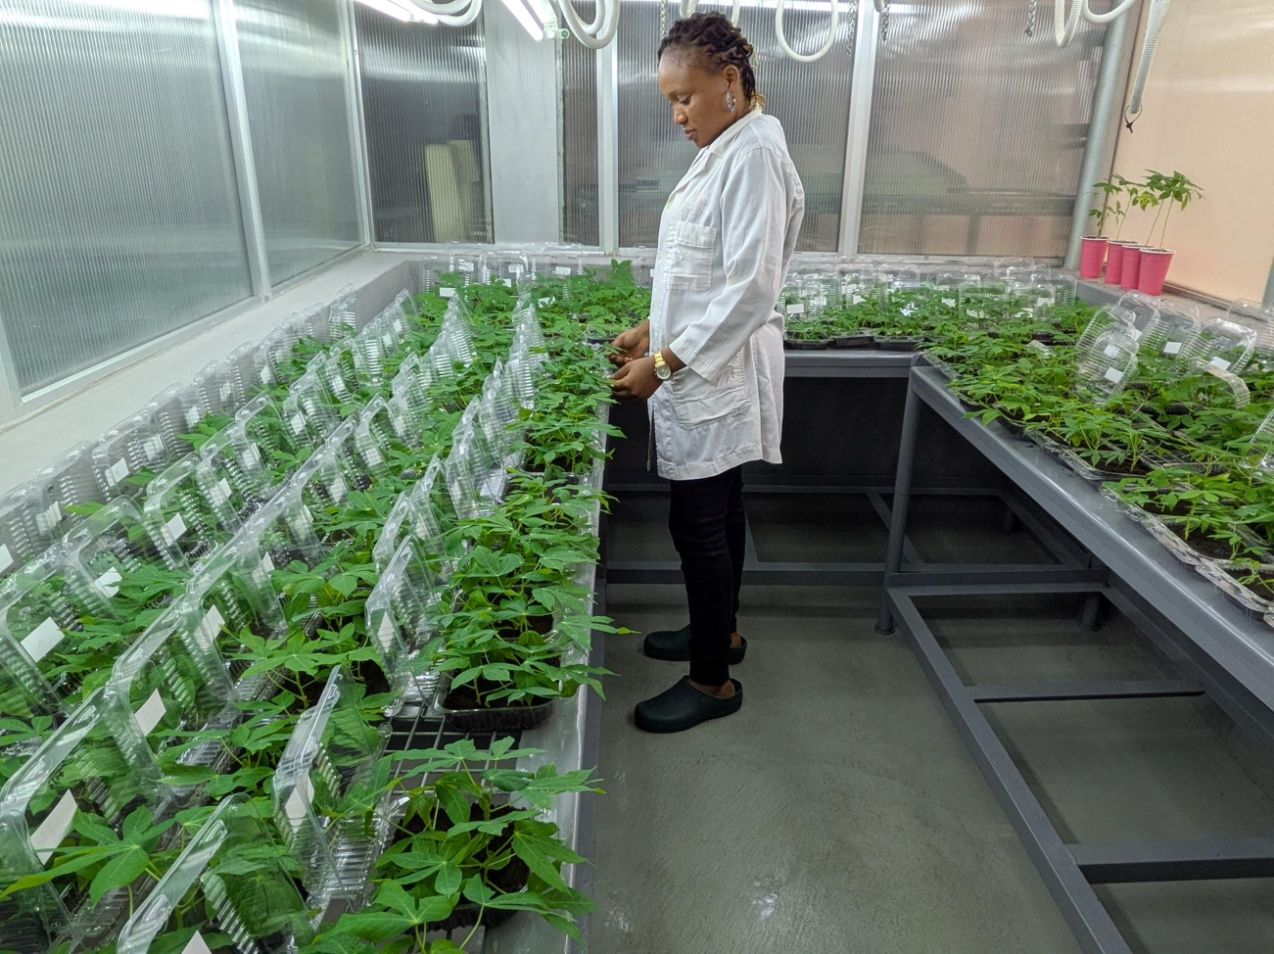
Figure 1_Plantlets being multiplied in SAH containers at IITA Ibadan.
Selected healthy and uniform transgenic lines were prepared and transplanted to the confined field site on June 5, 2025, following two rounds of SAH multiplication and final hardening in nursery bags. Field preparation, including mowing, harrowing, and ridging, was completed by May 30, 2025, in accordance with NBMA biosafety guidelines (fencing, isolation distance, and signage). Plantlets were moved to the site on June 4, 2025 for acclimatization, and transplanting was timed to coincide with favorable weather conditions to reduce stress and improve establishment. A total of 200 hardned, transgenic plantlets, representing 5 lines, were successfully transplanted to the confined field trial site on June 5, 2025. Another 180 plantlets were also successfully transplanted on July 7, 2025. Table 2 shows the current and planned transplanting status.

Table 2. Current and planned transplanting status
Batch number | Field Transplanting Date | Number plants (total) | Design
1 | 5/6/2025 | 200 | 5 genotypes, 20 plants / plot, 2 replications
2 | 8/7/2025 | 180 | 5 genotypes, 30 plants / plot, 1 replications
3 | Expected for early August | 400 | Can give us 4 reps of 20 plants/plot
4 | Expected for late August | 300 | Can give us another 3 reps of 20 plants/plot

A total of 405 plantlets have been transplanted to nursery bags for further hardening prior to field transplanting (see Figure 2 for impressions). Post-transplanting survival rate after two weeks was 100%, with plants exhibiting healthy establishment and minimal transplant shock. All transplanted lines met the required phenotypic uniformity and biosafety compliance standards. Field layout was successfully implemented according to the approved trial map, including proper labeling, GPS-tagged plots, and adherence to isolation distances. No incidences of pest infestation, mechanical injury, or erosion-related damage were recorded in the immediate post-transplant period. Environmental conditions on the transplant day were optimal (e.g., moderate temperature), which supported good initial field establishment.

Fig.2_Impressions from IITA. A) Pre-hardened cassava plant in planting bag. B) Field planting of cassava plants. C) Freshly planted cassava plants. D) Further improvements being made to the confined field site.

As part of ongoing regulatory compliance and monitoring, officials from the National Biosafety Management Agency (NBMA) conducted a visit to the confined field trial site on May 9, 2025. The purpose of the visit was to assess adherence to biosafety guidelines during the preparation, handling, and transplantation of transgenic plantlets. The inspection covered key aspects including field layout, fencing, isolation distance, signage, recordkeeping, and containment procedures. NBMA officials also evaluated plant health, environmental conditions, and documentation related to the SAH multiplication, hardening, and transplanting processes. The visit was successful, with no major non-compliance issues reported. Officials expressed satisfaction with the implementation of biosafety measures and the overall condition of the confined trial site. Their feedback reinforced the importance of continued diligence in line with national biosafety regulations.

In this quarter, progress accelerated as plantlets became available from successive rounds of SAH multiplication. Importantly, the initial 396 tissue culture plantlets received were multiplied into more than 4,158 plants by the end of August 2025, ensuring more than enough material to fully cover the CFT site and sustain experimental continuity.

Field trial and crossing block establishment
In Q3, a total of 1,200 plants were transplanted, comprising 840 established in field plots and 180 in screenhouses. When combined with the June–July batches, the overall number of plants established reached 1,400 across 161 plots. Post-transplant survival was very high, with plants showing vigorous establishment and only minimal signs of transplant shock.

Table 3. Field and Screenhouse Transplanting Summary (June–September 2025)
Batch | Date | Plants (total) | Plots | Design
1 | 5/6/2025 | 200 | 10 | 5 genotypes, 20 plants/plot, 2 reps
2 | 8/7/2025 | 180 | 5 | 5 genotypes, 30 plants/plot, 1 rep
3 | 1/8/2025 | 840 | 56 | 5 genotypes + 2 checks, 15 plants/plot, 8 reps
4 | 2/9/2025 | 180 | 90 | 5 genotypes, 1 plant/plot, 18 plots/genotype (2 screenhouses)

Regulatory Oversight and Biosafety Compliance
As part of ongoing regulatory compliance and monitoring, officials from the National Biosafety Management Agency (NBMA) visited the confined field trial site twice during the reporting period.

- On May 9, 2025, NBMA assessed site readiness during the early stages of plantlet hardening and transplanting. The inspection covered field layout, fencing, isolation distance, signage, recordkeeping, and containment procedures, as well as evaluation of plant health, environmental conditions, and SAH multiplication processes. The visit was successful, with no major non-compliance issues reported. Officials expressed satisfaction with biosafety implementation and reinforced the importance of continued diligence.
- A follow-up inspection was conducted on July 29, 2025, once larger-scale transplanting to the field and screenhouses was underway. NBMA reviewed field layout, fencing, isolation, signage, recordkeeping, containment, SAH multiplication, hardening, and transplanting procedures. The visit again confirmed full compliance, with no non-compliance issues identified. NBMA expressed satisfaction with the overall management of the confined trial site and the robustness of biosafety measures in place.

In addition to these inspections, IITA submitted a comprehensive regulatory report to NBMA documenting the implementation and results of previous confined field trials conducted under permits NBMA-008 and NBMA-010, thereby ensuring continuity of compliance and transparent communication with the agency.

Ongoing Regulatory Oversight and Biosafety Compliance
Regulatory engagement remained a priority during Q4. Officials from the NBMA conducted a formal inspection of the confined field trial and screenhouse facilities on 9–10 December 2025.

The inspection covered all aspects of biosafety compliance, including:
- Field layout and isolation distances
- Fencing, signage, and access control
- Recordkeeping and traceability systems
- SAH multiplication, hardening, and transplanting procedures
- Plant health and environmental management

The visit concluded with no major non-compliance issues reported. NBMA officials expressed satisfaction with the overall management of the confined trial site, the condition of the plants, and the robustness of biosafety measures in place. Their feedback reinforced the importance of continued diligence and documentation as trials progress.

Ongoing Confined Field Trials and Screenhouse Evaluations
During Quarter 4, the focus shifted from large-scale establishment to continued management, evaluation, and stabilization of transgenic cassava plants under confined conditions. Transgenic lines previously transplanted to the confined field site and two dedicated screenhouses remained in good condition throughout the reporting period (Fig. 3). In the open confined field, plants representing the lines (ETH4261, ETH4262, ETH4266, EV4234, and TMS60444) continued to show healthy establishment, uniform growth, and no abnormal phenotypes. Routine agronomic management, including weeding and pest monitoring, was conducted. Monthly observations focused on general vigor, plant height, and early expression of key traits, as well as monitoring for cassava mosaic disease (CMD), cassava bacterial blight (CBB), and cassava green mite (CGM). Supplemental once-a-week irrigation during the dry season which started in October 2025.

Parallel evaluations were maintained in two confined screenhouses, where selected plants were grown under more controlled conditions to support crossing activities and detailed phenotypic observations. Clear genotypic differences in vegetative vigor were observed, with ETH4262 consistently exhibiting superior growth performance across environments. Plants in Screenhouse 1 generally showed greater mean plant height than those in Screenhouse 2, highlighting environmental effects on early growth expression. No biosafety incidents, pest outbreaks, or containment breaches were recorded during the quarter.

These ongoing field and screenhouse evaluations ensure continuity of phenotypic data generation and provide a stable platform for downstream crossing and trait assessment activities.
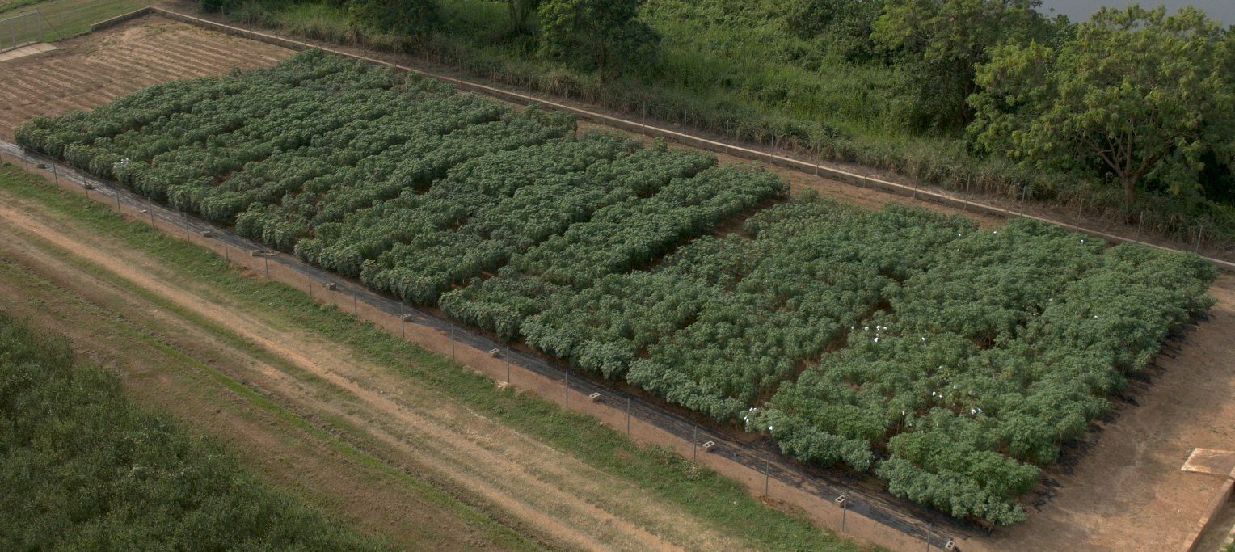
Fig. 3_CFT plant growth as at December 2025

Update Q1 2026
No symptoms of cassava mosaic disease (CMD) or cassava bacterial blight (CBB) were observed across all the genotypes. This indicates that the plants remained healthy under the screen house conditions, with no visible signs of disease infection. This also ensured that plant growth and performance were not affected by disease stress, allowing for reliable assessment of the measured traits.
Across both screenhouse 1 and screenhouse 2, a similar trend was observed among the genotypes. ETH4262 consistently performed best, recording the highest plant height and largest stem diameter, indicating strong overall growth. ETH4261 also showed good performance in both traits. ETH4266 had a relatively thick stem, but only moderate plant height, while TMS-IBA60444 showed average performance. In contrast, EV4234 recorded the lowest plant height and stem diameter in both screenhouses, indicating weaker growth compared to the other genotypes.
For open field stem diameter varied among the seven cassava genotypes evaluated across eight replicates, indicating differences in stem thickness and overall plant vigor.
Although ETH4261 recorded the highest mean stem diameter, indicating superior overall performance, observations across replicates revealed that ETH4262 and ETH4266 consistently produced relatively high stem diameter values. This suggests that these genotypes possess good vigor and adaptability under the given conditions. There is clear variability in stem diameter among the seven genotypes. Genotypes such as ETH4262 and ETH4266 showed superior stem development, indicating strong vigor and good potential for propagation. ETH4261 and IITA-TMS-IBA60444 also performed reliably across replicates. In contrast, TMEB419 and IITA-TMS-IBA000070 showed inconsistent performance, suggesting sensitivity to environmental conditions or lower stability.
Harvest of the CFT has started and harvest data will be available for the Q2 2026 report latest.

Maintenance of Transgenic Plantlets in SAH Facilities
In Q4, IITA continued the maintenance and conservation of transgenic cassava plantlets using the Semi-Autotrophic Hydroponics (SAH) system, which remains central to sustaining clean, uniform planting material.

A total of 3,120 transgenic plantlets across five genotypes were actively maintained in SAH facilities located within the confined field site. Routine management practices included nutrient adjustment, irrigation, sanitation, removal of weak plantlets, and strict labeling and barcoding to ensure full traceability. Plantlets remained vigorous, with high survival rates and no observed contamination or physiological abnormalities.

The SAH system allowed efficient space use and rapid regeneration capacity, ensuring that sufficient plant material remains available for continued confined field trials, replacement planting if required, and future experimental needs (Figure 4). Maintenance of these plantlets safeguards the long-term continuity of the transgenic research pipeline beyond the current trial cycle.
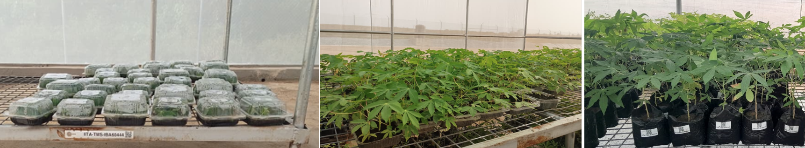
Figure 4_Healthy plantlets maintained in CFT screen house

Update Q1 2026
Maintenance of Transgenic plantlets in SAH facilities (SAH Plantlets in boxes and Nursery bags)
In Q1 2026, a total of 4,487 plantlets across five genotypes were maintained in the SAH facilities within the confined field trial. The plantlets were regularly monitored throughout the quarter to ensure optimal growth and development. Routine management practices (watering, weeding, and general maintenance) were carried out accordingly. All plantlets were properly labeled and carefully conserved to maintain genetic identity, ensure traceability, and prevent mix-ups among the genotypes. These measures contributed to the overall health and integrity of the planting materials during the study period.
Plantlets established in nursery bags (1250; Figure 5) will be use for the subsequent planting season and be utilized for the establishment of crossing blocks for controlled pollination. These plantlets were carefully managed to ensure uniform growth, optimal vigor, and genetic integrity prior to field establishment. Upon transplanting, they will serve as parental lines which will be cross with improved variety in hybridization programs, facilitating uniform flowering, effective pollen transfer, and successful seed set under controlled crossing conditions.

Genotypes | No of plantlets received | No of plantlets as of end of March at the SAH facility inside the confined field | No plantlets in Nursery bags | 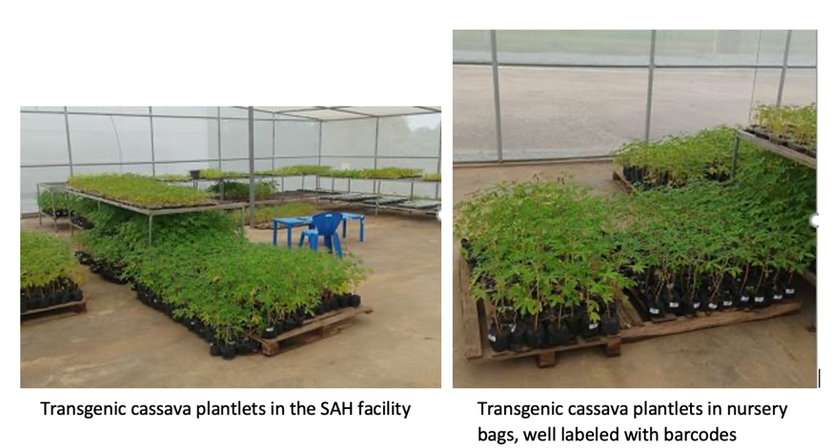  Figure 5_Transgenic cassava plantlets in reserve
ETH 4261 | 80 | 1050 | 250
ETH 4262 | 76 | 742 | 250
ETH 4266 | 80 | 975 | 250
EV 4234 | 80 | 840 | 250
TMS60444 | 80 | 880 | 250
Total | 396 | 4487 | 1250

Controlled Crosses with Improved Cassava Variety TMS13F1343P0022
Quarter 4 marked a significant phase of active crossing between transgenic lines and an elite, farmer-preferred cassava variety, TMS13F1343P0022 (Obasanjo 2). Controlled pollination activities were conducted under confined screenhouse conditions, following standard cassava crossing protocols and strict biosafety procedures.
Flower induction, identification of receptive female flowers, pollen collection, and manual pollination were carried out across multiple transgenic genotypes. All pollinated inflorescences were properly tagged, documented, and protected using pollination bags to prevent unintended gene flow and fruit shattering. Both direct and reciprocal crosses were performed to maximize hybrid seed production and assess cross-compatibility.
By the end of Q4, over 3,400 flowers had been pollinated, resulting in 123 confirmed fruit sets and approximately 252 seeds across the various cross combinations (Table 4). These seeds represent foundational material for future evaluation of trait inheritance, hybrid vigor, and integration of transgenic traits into elite genetic backgrounds. Crossing activities are ongoing and will continue into the next reporting period.
Table 4_Crosses Between Transgenic and Improved Cassava
Female | Male | Flowers | fruits | seeds
ETH4261 | TMS13F1343P0022 | 385 | 20 | 40
ETH4262 | TMS13F1343P0022 | 543 | 17 | 34
ETH4266 | TMS13F1343P0022 | 133 | 16 | 35
EV 4234 | TMS13F1343P0022 | 905 | 44 | 92
TMS60444 | TMS13F1343P0022 | 460 | 7 | 12
TMS13F1343P0022 | ETH4261 | 334 | 8 | 19
TMS13F1343P0022 | ETH4262 | 320 | 1 | 3
TMS13F1343P0022 | ETH4266 | 212 | 6 | 8
TMS13F1343P0022 | EV 4234 | 40 | 3 | 6
TMS13F1343P0022 | TMS60444 | 94 | 0 | 0
TMS17F1387P0008 | ETH4266 | 1 | 1 | 3
 | TOTAL | 3427 | 123 | 252

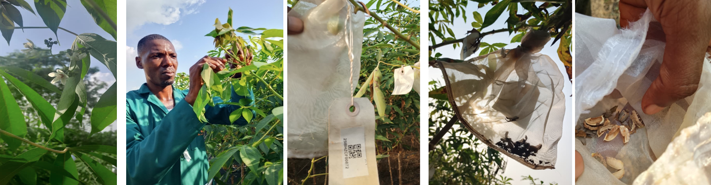
Hosting and participation in the CASS III Annual Project Meeting
IITA actively participated in and hosted the CASS III Annual Project Meeting, held in Ibadan from 21–23 September 2025. Although the meeting took place toward the end of Q3, its outcomes and follow-up actions were implemented during Q4 and are therefore reported here.
The meeting brought together partners from Africa, Europe, Asia, and North America, including Gates Agricultural Innovations (Gates Ag One) and multiple academic institutions. Participants visited the Biosafety Level 2 laboratory, confined field trial sites, screenhouses, and breeding plots, gaining first-hand exposure to IITA’s transgenic cassava research platforms (see attached detailed meeting report).
IITA presented updates on confined field trials, SAH multiplication, and crossing activities, while discussions focused on integrating source–sink biology with breeding, high-risk/high-reward research strategies, and pathways to translate discovery science into improved cassava varieties. Feedback from partners and Gates Ag One helped refine priorities for the next phase of experimental evaluation and trait deployment.

4.2.3. F₁ seedling nursery (multiplication of planting material)
This activity has not started for the AKT2 construct since we could just received the plants and they are now undergoing hardening. However, experimental crosses were conducted using transgenic lines from permit number NBMA-CFT-010, with 2,952 flowers produced across all lines, resulting in 266 seeds (approx 10% success rate). It should be noted that the crosses were carried out during the hot, dry season (with supplemented irrigation), which is not ideal for cassava.
Seed set efficiency varied widely among the transgenic lines (Table 3). Some lines, such as AAP1_4358 (315 flowers, 32 seeds) and VC_4243 (291 flowers, 45 seeds), exhibited relatively high seed conversion, while others, like AAP1_4355 and mitoGS_4277, failed to set seeds, despite producing flowers. Vector control lines generally had higher seed set efficiency, with VC_4243 producing the most seeds (45). Among the mitoGS lines, mitoGS_4275 (385 flowers, 27 seeds) and mitoGS_4267 (206 flowers, 22 seeds) performed better than others. The TMS60444 control line (83 flowers, 5 seeds) showed moderate reproductive performance. These results highlight differences in reproductive efficiency among transgenic lines, which may influence pollination success and seed viability. Further analysis will help optimize breeding strategies and controlled crossing efforts in cassava improvement.

Table 3. Conducted experimental crosses and seed set efficiency
Female parent | Male parent | Number of crosses | Number of seeds obtained
AAP1_4349 | TMS13F1343P0022 | 145 | 11
AAP1_4353 | TMS13F1343P0022 | 7 | 0
AAP1_4354 | TMS13F1343P0022 | 227 | 6
AAP1_4355 | TMS13F1343P0022 | 212 | 0
AAP1_4358 | TMS13F1343P0022 | 315 | 32
AAP1_4359 | TMS13F1343P0022 | 20 | 4
mitoGS_4267 | TMS13F1343P0022 | 206 | 22
mitoGS_4268 | TMS13F1343P0022 | 53 | 5
mitoGS_4269 | TMS13F1343P0022 | 114 | 4
mitoGS_4272 | TMS13F1343P0022 | 145 | 11
mitoGS_4275 | TMS13F1343P0022 | 385 | 27
mitoGS_4277 | TMS13F1343P0022 | 39 | 0
mitoGS+AAP1_4455 | TMS13F1343P0022 | 25 | 1
TMS60444 | TMS13F1343P0022 | 83 | 5
VC_4218 | TMS13F1343P0022 | 185 | 12
VC_4220 | TMS13F1343P0022 | 132 | 26
VC_4221 | TMS13F1343P0022 | 265 | 35
VC_4234 | TMS13F1343P0022 | 92 | 20
VC_4239 | TMS13F1343P0022 | 11 | 0
VC_4243 | TMS13F1343P0022 | 291 | 45
Total |  | 2952 | 266

In this quarter, we advanced from seed collection to early seedling establishment, focusing on germination and transplantation outcomes of seeds obtained from Q4 2024 crosses. Out of the 266 seeds harvested, a total of 132 seeds successfully sprouted, reflecting a germination rate of approximately 50%. From these, 95 seedlings were transplantedto the field or nursery for further growth and evaluation, representing about 72% transplant success from sprouted seeds. Sprouting and transplanting performance varied markedly by transgenic line. Notably, AAP1_4358 led among the aap1constructs, with 20 seeds sprouting and 16 successfully transplanted, demonstrating both high germination and field establishment potential. In contrast, other aap1 lines such as AAP1_4355 and AAP1_4353 showed limited or no germination success. Among the mitoGS constructs, mitoGS_4275 had the best performance, with 11 sprouts and 11 transplants from 27 seeds, indicating excellent vigor and survival. mitoGS_4267 followed with 10 sprouts and six transplants, while other mitoGS lines contributed modestly or showed no germination. Vector control lines consistently showed strong performance. Vector_control_4243, which had the highest seed set in Q4, produced 22 sprouts and 12 transplants. Similarly, Vector_control_4221 yielded 20 sprouts, of which 17 were successfully transplanted, confirming its high conversion efficiency from seed to established seedling. Vector_control_4220 also performed well, with 21 sprouts and 17 transplants, making it one of the most efficient lines for early establishment.
In addition to the ongoing multiplication and field evaluation of newly developed events, previously generated transgenic cassava lines are being maintained through the Semi-Autotrophic Hydroponics (SAH) system to ensure continuity and availability for future use.
Crosses with old transgenic lines like AAP1 or mitGS were only performed as an establishment exersize and to asses the general crossing behaviour and seed set rate. Now that the actual AKT2_{var} material has been crossed, F1 seedling nurseries will be established as soon as possible with the newely generate material specified in Table 4.
Update Q1 2026
Seeds from crosses were sown on 26 February 2026. Sowing was carried out according to the different crosses within each family, with seeds placed individually in jiffy cups filled with topsoil. Each family were carefully labeled to ensure proper identification and traceability of the crosses. The seeds were watered twice daily to maintain adequate moisture for germination and early seedling establishment. Table 4 summarizes the germination count and number of available plants.

Table 4_Germination of crosses
Female | Male | Flowers | fruits | Seeds | Germination count as April 1st 2026
ETH4261 | TMS13F1343P0022 | 385 | 20 | 40 | 27
ETH4262 | TMS13F1343P0022 | 543 | 17 | 47 | 30
ETH4266 | TMS13F1343P0022 | 133 | 16 | 35 | 18
EV 4234 | TMS13F1343P0022 | 905 | 44 | 92 | 45
TMS60444 | TMS13F1343P0022 | 460 | 7 | 12 | 7
TMS13F1343P0022 | ETH4261 | 334 | 8 | 21 | 13
TMS13F1343P0022 | ETH4262 | 320 | 1 | 3 | 3
TMS13F1343P0022 | ETH4266 | 212 | 6 | 12 | 9
TMS13F1343P0022 | EV 4234 | 40 | 3 | 6 | 6
TMS17F1387P0008 | ETH4266 | 1 | 1 | 3 | 2
 | TOTAL | 3427 | 123 | 271 | 160
Resulting plants are currently establishing in the seedling nursery (Fig. 6). We need to discuss the genotyping and subsequent steps in the analyses.
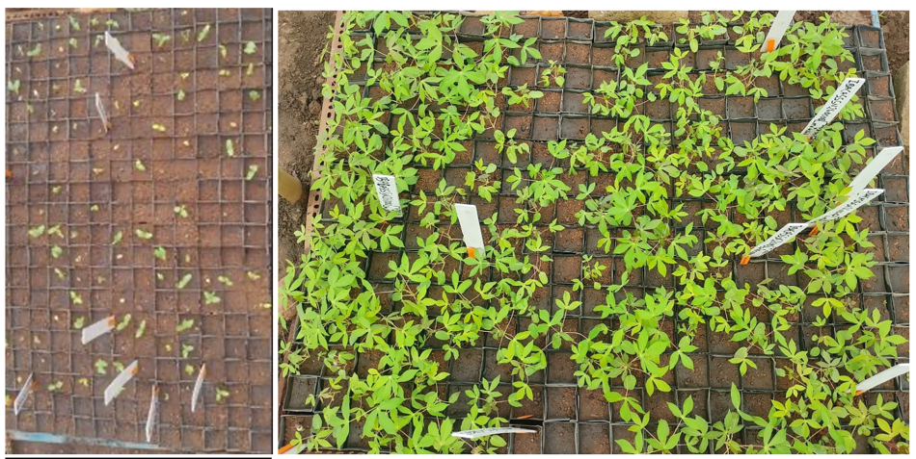
Figure 6_Crosses germinating and growing in the seedling nursery
Challenges and Mitigations:
One of the primary challenges faced is the delay in obtaining the CFT permit approval from the National Biosafety Management Agency (NBMA), which has slowed down the initiation of the trial. To mitigate this, I have proactively reached out to the NBMA to request an expedited review of the permit application. In the meantime, preparations are ongoing to ensure that once the permit is granted, the trial can commence without further delays.
One of the primary challenges faced is the delay in obtaining the CFT permit approval from the National Biosafety Management Agency (NBMA), which has slowed down the initiation of the trial. The permit was finally obtained and the transgenic plants are already in Ibadan undergoing hardening and acclimatisation. Meanwhile we run pilot hybridization between previous set of transgenic constructs (AAP1, mitoGS) and a previously released variety (TMS13F1343P0022). This was carried out to test the ability of the GM plats to successfully hybridize and produce seeds.

Next Steps in the Action Plan:
Once the CFT permit is approved, the immediate next step will be to submit the application for the import permit to facilitate the introduction of the transgenic materials required for the trial. Simultaneously, we will continue scaling up the planting of adapted cassava varieties and finalize preparations for crossing with the transgenic lines. This will ensure that the trial progresses swiftly upon approval, minimizing any further delays to the project timeline.
We will carry out AKT2, VC, and TMS60444 multiplication using SAH technology to have suffient plants for crossing and testing. (Concluded)
- Continuing to conduct the transgenic field trial
- Establishment of F1 nursery

Additional noteworthy updates:
- The expanded CFT area at IITA, covering an additional 2,800 m², was fully fenced in the previous quarter. This space will be used for both large plot field testing and hybridization between transgenic lines and elite African cassava genotypes. The first round of hardened plantlets will be transplanted to the field in Q2 2025, and crossing experiments will commence in parallel. Additional cycles of SAH propagation are planned to increase plantlet numbers to 2,000–2,500 to support replicated field trials and hybrid development. All activities continue to comply strictly with national biosafety regulations, including event tracking, documentation, and biosafety monitoring.

- IITA has also embarked on renovation of the CFT site in preparation for field plantings and long-term infrastructure use. As part of this, a range of structural and civil works have been initiated to improve the functionality, safety, and regulatory compliance of the field site. The activities include the construction of proper drainage systems across the confined field to reduce erosion impact; removal of old nets for three screenhouses; installation of additional tanks to expand the existing water reservoir; leveling of topsoil to improve soil uniformity; and stabilization of sloped areas using granite to prevent erosion. These will require budgetary adjustments and be spread across the first and second year of the project.

- Further improvements were made to the confined field site to strengthen its functionality and compliance. Erosion control measures were implemented through the construction of earth bunds and reinforced drainage channels to reduce runoff and prevent soil washout. Screenhouse infrastructure was also upgraded, with complete net replacement to enhance pest exclusion and acclimatization capacity. In addition, a new Semi-Autotrophic Hydroponics (SAH) facility was established within the confined field to support ongoing plantlet multiplication and ensure a sustainable supply of high-quality material.

TM5_Cassava plant and field phenotyping

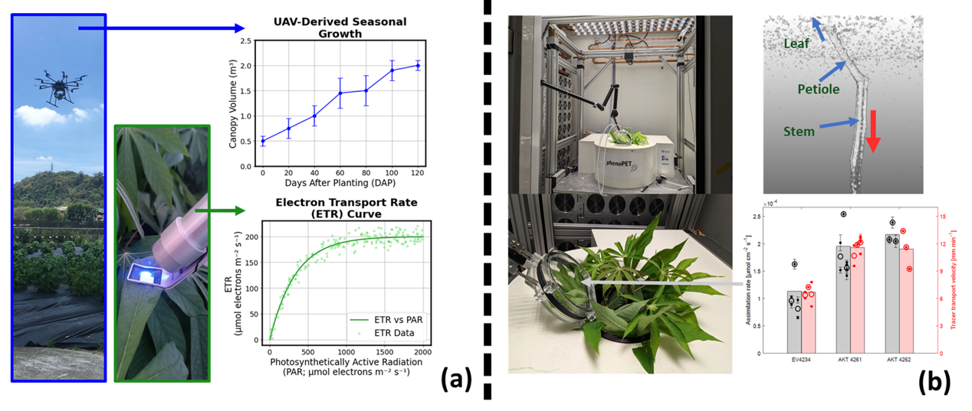
TM5.1_Cassava plant and field phenotyping
5.1
Summary of Goals and Impact
The goal of TM5 is to conduct comprehensive phenotyping of cassava plants, both in controlled environments and in the field, to assess the impact of genetic modifications on plant performance and yield. This module employs advanced techniques, including ¹¹CO₂-PET measurements, UAV-based imaging, and ground-based sensor systems, to monitor carbon transport, photosynthesis, and growth dynamics in both wild-type and transgenic cassava plants. By gathering detailed quantitative data on these physiological traits, TM5 aims to identify the most promising genetic lines for increased storage root yield and overall plant performance.

The activities in TM5 are critical for translating genetic modifications into tangible agronomic improvements. By providing precise and high-resolution data on how transgenic cassava plants grow and function in real-world conditions, this module ensures that only the most effective traits are carried forward into large-scale testing and deployment. The insights gained from TM5 will guide the development of cassava varieties that are more productive and resilient, directly benefiting smallholder farmers by enhancing food security and agricultural sustainability.

TM5_Cassava plant and field phenotyping

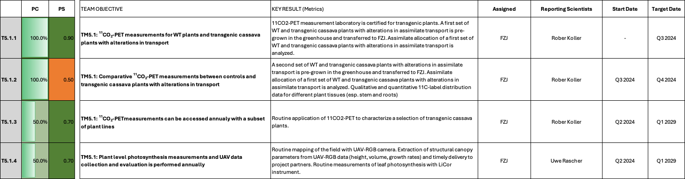

TM5.1: Cassava plant and field phenotyping

Reporting module leader: Uwe Rascher, FZJ.

Progress Update:

5.1.1. ¹¹CO₂-PET measurements for WT plants and transgenic cassava plants with alterations in transport
- Certification of the MRI and PET lab for transgenic plants was successfully finished.
- First set of cassava plants (WT and AKT2) was received from RPTU and characterized for gas exchange and assimilate flow velocities in the stem using ¹¹C-PET, successfully concluding this workpackage. Data is currently being integrated into a manuscript on AKT2.
- Concluded

5.1.2. Comparative ¹¹CO₂-PET measurements between controls and transgenic cassava plants with alterations in transport
- A second batch of AKT2 plants was successfully measured and data was analysed according to the first set.
- Quantitative tracer distribution in the stems is currently being analysed.
- Quantitative tracer distribution and flow in the storage roots has been successfully demonstrated in a pilot experiment.
- Quantitative tracer distribution in the stems of WT and AKT2 was analysed. Parallel transport from a single leaf along different vascular strands could be documented for the first time in cassava. Tracer flow velocity showed no marked differences between strands.
- Measurement of the first batch of cassava plants for tracer distribution and flow in the storage roots had to be postponed to Q1 2025, to allow for short-term measurement of storage root development with MRI and provide data for EM 3.4 (as agreed with project coordination). Storage root growth rate data and weekly 3D MRI datasets for 18 plants were provided to OU.
- The first batch of cassava plants with altered storage root properties (two C56_GPT/NTT lines) was analyzed with ¹¹C-PET at FZJ. The development of the plants was slower than expected. Therefore, we included an MRI measurement series that provided additional data on storage root formation, guiding the start of the ¹¹C-PET experiments. The measurement series was conducted during March and April 2025 and data analysis is ongoing. Preliminary results indicate that a direct quantification of flow velocity in the storage roots was not possible in this experimental series. Contrastingly, flow velocity in the stems and in combination with MRI storage root formation data was achieved and is expected to yield valuable data for characterizing the constructs. Data analysis will be concluded in Q2 2025.
- Data analysis for the first batch of Cassava plants with alternating storage root properties (two GPT/NPP lines) was finished. Data on flow velocities in the stems of the plants could be provided to RPTU and FAU to further characterize the constructs. Flow velocities in the storage roots directly could not be measured within the timeframe of the experiment, probably due to the slower-than-expected development of the storage roots that was documented by a series of MRI measurements for each plant. However, the experimental conditions required for a successful measurement of flow in storage roots as demonstrated in a preliminary experiment could now be narrowed down. Therefore, we expect that we will be able to supply data on flow in storage roots in future experiments, should this be required in routine PET measurements of other GT.
- The GPT/NPP line work is the second characterization of transport dynamics in Cassava with the high spatial and temporal resolution of PET with data supplied to RPTU for the manuscript on these lines. The first one was the work on the AKT2_{var} lines in 2024 that are now included in the manuscript by Zierer et al. (submitted) that is currently under review. That one was to our knowledge also the first study on in vivo carbon allocation dynamics in cassava in general and with genetically modified lines for transport characteristics.
- The additional data from MRI measurements of the storage root development on the GPT/NPP lines was also provided as quantitative local growth of the storage roots over a period of several weeks to RPTU. This along with the MRI study on storage root development in vivo done in our lab in Q4/2024 may also help to further characterize the dynamics of cassava storage root development in wild types and constructs, based on quantitative differences in temporal and spatial development of the storage roots.
- Concluded

5.1.3. ¹¹CO₂-PET measurements can be accessed annually with a subset of plant lines
After several pilot experiments, a cassava specific protocol for routine work with cassava (workflow for cultivation, measurement and data analysis) at the MRI and PET facilities was established and applied for a second batch of plants,
- Measurement and analysis pipeline for future transgenic cassava lines is ready and can be applied as suggested.
- Measurement of the root development with MRI on 18 plants from FAU allowed for a better establishment of cultivation and handling procedures for cassava
- Measurement of an additional construct (C56) and focussing on storage root development and its effects on transport velocity will allow for a better assessment of future constructs.
- Ongoing discussion with FAU and RPTU revealed that more testing on current lines was required before efficient PET measurements are possible, so the next PET measurements are planned for 2026
- The installation of a new PET/CT system has started in Q4 2025 and is expected to be finished in Q1 2026. This will improve also the data quality and measurement options for CASS III and will be available for all future Cassava measurements.
- The installation of a new PET/CT system was finished in Q1 2026. First tests of the CT component with cassava plants are planned for Q2 2026 to see if storage root imaging is feasible and provides more information on storage root formations.
- Planning for the next ¹¹CO₂-PET measurements with plants from FAU was concluded. New plants will be shipped in Q2 2026.
5.1.4. Plant level photosynthesis measurements and UAV data collection and evaluation is performed annually
Season 2024
- Shape files defining the layout of the field experiment and the exact location of every single individual plant is produced taking the planting information and UAV data (from TM4.1.2) into account. The shape file contains the genetic label of every single plant in the field
- Data (shape files & 3-D surface maps) are geo-registered and included in a novel real time GIS system, which allows the users the real time selection of canopy structure from single plants.
- 3D information of single plants is converted into canopy height and canopy volume for every individual plant.
- Canopy height and canopy volume information is extracted for every single plant and data are delivered as easy to handle cvs file to Cassbase. By Sept 16th, data from measurements collected until August 2nd have been processed.
- 2 weeks visit of scientist from FZJ (Juan Quiros) to BTI in September to discuss and optimize data flow into the project data base. In the past, we experienced delays in data provision to the CASS database, which was partly related to incompatibilities between data formats and database standard. Experts from FZJ and BTI jointly worked in Ithaca towards resolving these issues and towards finding smooth workflows for a timely data delivery. During the visit, UAV-derived data from Nigeria (2018-2021) and Taiwan (2020-2024) was uploaded to Cassbase (a total of about 90k data points) in a “clean” format. “Clean” format means data points with timestamps and associated to the “observationunit_name”, which is the same identification linked to the QR codes.
- UAV-based whole-field measurements: UAV data collection and processing for the 2024 season was completed. UAV data processing workflow improved by: (i) automating the processing from the orthomosaics and digital elevation models, (ii) expanding documentation for each code sub-block within the Jupyter Notebook, and (iii) developing the foundation of a method to enhance the accuracy of UAV-derived volume estimations.
In total, flights at 11 time points during the vegetation cycle were conducted, plant-level height, volume, and relative growth rate information extracted and analyzed. Data from the years 2022-2024 was delivered to the CASS database. Multi-year (2022–2024) seasonal plots of plant height and volume for AKT2 and VC were provided, contributing to the AKT2 performance manuscript, which is currently in development under the lead of RPTU/FAU.
- Photosynthesis measurements at selected lines of interest: PAM-based photosynthesis data from nine locations (measured between October 6th and November 22nd) processed. A permanent communication channel was established to provide support on PAM instrument usage. Improvements on the PAM data processing workflow by: (i) automating the pipeline from raw instrument data to plotting key parameters, including the pre-dawn maximum quantum efficiency of photosystem II (Fv/Fm) and the maximum electron transport rate (ETRmax) at the accession level; and (ii) implementing quality flags to identify plants with insufficient data for reliable ETR curve fitting.
- Data provision / publication: Materials and methods sections for a UAV- and PAM-based data collection and processing publication drafted. Contribution for the AKT2 performance manuscript. Reprocessing of previous IITA data (growth, weather and agronomic), to revisit the joint publication with colleagues from IITA. With the support of colleagues from the Boyce Thompson Institute (BTI), two new traits were added to the Cassbase ontology: relative growth rate, and ETR.
Season 2025
- UAV-based whole-field measurments: As of the date of this report, UAV field data collection for CFT 2025 has not yet started. Once data collection begins, we will proceed with data processing according to the standard workflow.
  - In coordination with Mercedes Thieme and Lukas Müller, a new standardized format for UAV data reporting fully compatible with Cassbase has been implemented. The updated structure organizes plant-level UAV data by year (or trial) rather than by individual DAP-based events, significantly improving data management and usability within Cassbase. Priority datasets from Taiwan (2022, 2023, and 2024) have been reformatted and delivered, and remaining historical datasets are being progressively updated to follow the same structure.
  - All UAV 2025 datasets collected up to the date of this report (0429, 0512, 0523, 0609, and 0628) have been processed using the updated Python pipeline. The code was specifically modified to accommodate this year’s data structure, which differs from previous years by including two WF (West Field) blocks and one EF (East Field) block. This required adjustments in how plot-level traits are extracted and mapped to their respective field positions. The processed datasets include detailed canopy structural parameters such as plant height, canopy volume, and relative growth rates. These outputs have supported the selection of plants PAM-based photosynthesis measurements, focusing on the genotypes of interest: C2-8, C2-16, C56, and VC. The latest UAV results have also informed ongoing discussions with NCHU colleagues regarding ways to address potential causes and analysis of field spatial variability.
  - In addition, UAV data from 2024 was revisited and analyzed with a focus on ETH starchy genotypes to support their genotype selection for PAM measurements within the current year’s seasonal protocol. A combined trait analysis was conducted, integrating final harvest data with UAV-derived metrics. Constructs were evaluated through a single composite visualization incorporating root yield, root:shoot ratio, canopy volume, and RGR to gain insight into genotype performance. The aim is to capture more dynamic aspects of source-sink relationships, rather than relying solely on plant size. This approach remains in an exploratory phase and has not yet been formalized as a standard method; its broader applicability to other research objectives will be assessed based on the outcomes of the ongoing evaluation with ETH genotypes.
  - Dataset processing: All UAV 2025 datasets collected to date (0429, 0512, 0523, 0609, 0628, 0712, 0721, and 0811) have been fully processed using the updated Python pipeline to extract plant-level height, volume, and relative growth rate traits.
  - Data sharing with collaborators: The most recent UAV data package has been delivered to NCHU, supporting their ongoing analyses and facilitating alignment with complementary datasets.
  - Preparation for upcoming meeting: A consolidated set of seasonal UAV-derived traits has been prepared and structured for the forthcoming discussions at IITA, ensuring readiness for genotype-level comparisons.
  - Spatial heterogeneity analysis: A multi-year spatial heterogeneity assessment of WF1 has been completed, showing stable spatial patterns between 2023 and 2025 and a marked deviation in 2022. These results are being incorporated into the broader evaluation of side effects and trial comparability.

Update Q4 2025
  - Dataset processing and sharing: All UAV datasets acquired in 2025 were fully processed. Plant height, canopy volume, and derived relative growth rates were extracted from raw imagery and formatted for direct ingestion into Cassbase. Resulting time-series outputs were visualized as seasonal growth curves, race plots, and animated growth maps. Processed datasets and visual outputs were shared with collaborators at Eidgenössische Technische Hochschule (ETH), Friedrich Alexander Universität (FAU), and National Chung Hsing University (NCHU), and final deliverables are to be uploaded to Cassbase (within two weeks after the delivery of this report) for centralized access and long-term traceability.
  - Further improvement of processing pipelines: Year-specific processing scripts were consolidated into a single standardized pipeline with interactive pop-up inputs, enabling consistent processing of data from any year (including future campaigns) using identical steps and parameters. This improves reproducibility, cross-seasonal consistency, and traceability of UAV derived traits.
Season 2026

Update Q1 2026
- In 2026 we aim to characterize the spatial heterogeneity within the experimental fields in more detail, aiming to enable a more precise disentanglement of environmental and genetic effects in the phenotyping data. Therefore, before planting, the digital soil mapping was performed at NCHU experimental fields, from March 15th to April 10th. Digital soil mapping was done by FZJ with a electromagnetic induction method (EMI, using an EM38 sensor from Geonics).

In addition:
- 80% of the Ground Control Points (GCPs) were recorded with a low cost GNSS-RTK system.
- A dedicated MicroPAM experiment was established to assess photosynthetic activity at early developmental stages. This experiment addresses a current gap in the dataset, as initial growth stages have not previously been characterized in terms of photosynthetic performance, and aims to evaluate whether genotypic differences in key traits (such as electron transport rate, ETR) are more pronounced during this period.
- Due to the fragility of plants in the main field trial during early development, 16 plants that remained in the greenhouse after field planting were used to avoid potential damage from PAM measurements on the primary trial material. These plants were transplanted into larger pots filled with field soil and subsequently placed within the trial area to approximate field conditions following transplanting. A total of 16 plants were selected, corresponding to the number of available MicroPAM sensor heads, including 4 plants from each of two Della lines (8 plants in total), 4 plants from the C2-16 line, and 4 plants from the VC line.
- Photosynthesis measurements of selected lines of interest: The new, compact version of the PAM system was received at our facilities in Jülich. The equipment is shipped to NCHU 10 April , following the completion of initial testing and shipment documentation.
  - The new MicroPAM system has been installed and is currently collecting data in the WF1 field as part of the seasonal measurement campaign. Landmarks for the plants designated for the next measurement phase in WF2 have already been placed and are color-labeled to ensure traceability and alignment with the protocol. During initial deployment, troubleshooting was required on one of the two central measurement stations due to erratic sensor behavior; the issue has been addressed, and the system is now operating.
  - A detailed seasonal plan guides the rotation of the MicroPAM system across three field locations in a fixed monthly cycle (e.g., day 10 to Location 2, day 20 to Location 3, and end or start of the month back to Location 1). Measurements capture diurnal photosynthetic patterns using 2-hour intervals at night, 10-minute intervals at predawn, and 15-minute intervals during the day. Monthly batch files adjust for changing sunrise and sunset times. Plant selection was based on spatial coverage, cable reach, and trait-based criteria, prioritizing individuals within the upper interquartile range while avoiding statistical outliers. The selected genotypes (C2-8, C2-16, C56, and VC) are distributed across WF1 and WF2. Full details are provided in the document “seasonal_ps_meas_instructions_2025.pdf.”
  - A wireless modem for real-time data transfer from the central working stations in the field to cloud platforms is currently being tested. This setup aims to simplify field activities by reducing the need for manual data retrieval, while ensuring a continuous and secure flow of information. The approach is being evaluated not only for its technical reliability but also for its potential to support long-term implementation, particularly if seasonal photosynthesis measurements are to be continued in subsequent years.
  - Data acquisition: Photosynthesis measurements were collected in the month July on 36 plants across six priority constructs, providing the basis for construct-level comparisons. A malfunctioning MoniDA workstation limited further collection photosynthesis data from August a new device is ordered and sent to NCHU in the first week of September.
  - Technical support and planning: Supported NCHU in troubleshooting the malfunctioning MoniDA workstation. When local fixes proved unsuccessful, coordinated directly with the factory for a replacement unit and updated the plan for photosynthesis measurements to ensure continuity of PAM-based data collection.
  - Data processing: Photosynthesis datasets have been processed and organized in preparation for the upcoming IITA meeting. The processed variables are electron transport rate (ETR) and the maximum quantum efficiency of PSII measured in dark-adapted leaves at early morning (Fv/Fm). These variables were compiled at construct level, enabling genotype-level comparisons.

Q4 2025 Updates
  - Data acquisition, processing and sharing: Photosynthesis measurements were collected both in person (July) and in collaboration with colleagues from NCHU during August, October, and November. Measurements were conducted using the newly acquired MicroPAM instruments. All datasets were fully processed and shared with collaborators at ETH, FAU, and NCHU.
  - Further improvement of processing pipelines: Similar to the UAV workflows, year-specific photosynthesis processing scripts were consolidated into a single standardized pipeline with interactive pop-up inputs, enabling consistent processing of data from any year (including future campaigns) using identical steps, equations, etc. This improves reproducibility, cross-seasonal consistency, and traceability of photosynthesis-derived traits.
  - Training and capacity building: Silas Wungrampha (from NCHU) was hosted for one month in the Shoot Dynamics Group (IBG-2), Forschungszentrum Jülich, co-led by Onno Muller and Uwe Rascher. During this period, he received hands-on training in the operation of LI-COR gas exchange systems from three experts in the group. Additionally, Silas Wungrampha was engaged in scientific discussion concerning the use of different photosynthesis tools that were made available for him during the training.

- Data provision / publication: Ongoing communication has been maintained with the valuable support of the data manager. As the 'repetitive data branch' within the database is not yet developed, we are currently discussing: (i) the possibility of reverting to the classical UAV data upload approach, which involves using individual CSV files containing information for specific dates ('cass_days'); and (ii) the inclusion of additional information in those files, such as row and column identifiers. Concerning publications: (i) Provided data to and review of 'AKT2 manuscript' b (ii) First draft of the manuscript addressing repeatability and heritability estimations of UAV-derived canopy traits in the breeding trials cultivated in IITA, Nigeria (2018-2021). Some more internal iterations are needed before this manuscript is sent to all the involved co-authors within the consortium.
  - Data provision:
A dedicated meeting with Mercedes Thieme and Lukas Müller was held to define the optimal UAV file format for integration into Cassbase. The revised structure organizes UAV-derived plant-level data (observationunit_name) by year (trial), replacing the previous format that stored each UAV acquisition as a separate file by DAP. Column headers now include trait name and ID, cass day, and a composite trait identifier, preserving DAP-level granularity. Additionally, all values are timestamped in alignment with Cassbase requirements. The UAV data processing pipeline was updated to automatically generate output in this standardized format upon receipt of new datasets.
  - Publications:
- Support was provided for the submission of the AKT2_{var} manuscript to Nature Plants, including the delivery of UAV and photosynthesis data processing code. Year-specific UAV pipelines (Python Jupyter notebooks) were shared with the scientific coordinator and manuscript lead to meet journal data availability standards.
- A revised draft of the manuscript on the repeatability and heritability of UAV-derived canopy traits from breeding trials conducted at IITA, Nigeria (2018–2021), was shared with collaborators at FAU and IITA. Constructive feedback has been received and is currently being addressed. Further internal revisions are planned prior to circulation among all consortium co-authors.
A revised draft of the manuscript on the repeatability and heritability of UAV-derived canopy traits from cassava breeding trials conducted at IITA, Nigeria (2018–2021), was shared with Prof. Hans-Peter Piepho (University of Hohenheim, Biostatistics), whose expertise in mixed models and genotype-environment interaction analyses provides valuable external input. Further internal revisions are also planned prior to circulation among all consortium co-authors.
- An abstract titled “Cassava Phenotyping: Challenges and Opportunities” was submitted to the European Plant Phenotyping Symposium (EPPS). A corresponding poster, which will focus on improved volume estimation through side-view UAV imagery and individual plants canopy segmentation, is under preparation and scheduled for completion by the end of July. It will be shared with FAU before submission to AgOne for formal approval.
A poster was prepared to be presented at the European Plant Phenomics Symposium (EPPS ) – 2025. The poster is titled “Growth Dynamics Phenotyping in Cassava Breeding Trials: Challenges and Opportunities of Aerial Information”, and poster synthesizes stablished methods in UAV-based trait extraction (height, volume, RGRs), highlights challenges in canopy volume estimation after closure, and presents new insights on repeatability (R) and heritability (H²) relevant for cassava breeding applications.
Q4 2025 Update
- A final version of the manuscript entitled “Repeatability and Heritability of UAV-Derived Canopy Traits in a Cassava Breeding Population Using Time-Series Data from Two Consecutive Growing Seasons” was completed after incorporating revisions from an external expert reviewer (University of Hohenheim). The manuscript is currently with the IITA co-author and will subsequently be shared with the scientific manager (Wolfgang Zierer) and the CASS head (Uwe Sonnewald, FAU) prior to submission.
- Contributions in terms of field photosynthesis and growth (from the field trials in Taiwan) information for a study being conducted by Leo Bellin, Rheinland-Pfälzische Technische Universität (RPTU), on the overexpression GPT/NTT (C56) in cassava lines.

Challenges and Mitigations:
- TM 5.1.2: The data analysis for altered storage root properties (C56) is delayed to Q2 2025.
- TM 5.1.3: In order to support the modelling approach (EM 3.4) with data on dynamic storage root formation an additional batch of WT plants will be measured regularly by MRI. The goal is to extract axial and longitudinal growth rates of the storage roots in the soil. These were considered vital data for the model and are very difficult to obtain with other methods available. To allow this new experiment within the given budget frame, the number of projected ¹¹C-PET measurements within T5.1.3 will be reduced accordingly (as agreed with project management).
The tracer measurements on the storage roots had to be delayed to Q1 2025 in favour of providing urgently needed data for the modelling partners in EM 3.4 (as agreed with project coordination). Data on storage root elongation and expansion was provided to the modelling team at OU.
- TM 5.1.4: Currently no challenges. Data acquisition is ongoing (see TM 4.1.2), data are of sufficient quality and quantitative trait extraction is routinely ongoing. We currently expect a good time series of from the 2024 field trail
  - Challenges
  - Field deployment of PAM fluorometry involved several technical and operational challenges, which required careful handling to ensure reliable data acquisition. These challenges were effectively addressed in a timely manner through close collaboration of Tzu Jui Chiu (NCHU).
  - In the small, uniformly managed CASS field trials, spatially structured field heterogeneity (likely driven by soil variability and interacting with the randomized snake design) can complicate the interpretation of UAV- and PAM-based phenotyping data by obscuring the separation of genetic effects from environmentally driven variation across years.
  - Mitigation
  - Maintain and further strengthen close and fluent communication with NCHU, combined with increased on-site presence during critical measurement periods, to enable rapid identification and resolution of PAM instrument-related issues and to support consistent, high-quality data acquisition under field conditions.
  - Implement digital soil mapping as a targeted strategy to address spatial environmental heterogeneity. This approach has been formally proposed to the consortium leadership at FAU. Its objective is to provide high spatial resolution soil information that can be integrated into field-level analyses to improve the separation of genetic and environmental effects. The planned implementation will rely on an instrument provided on loan by collaborators from the Institute of Biosciences and Geosciences (IBG), Agrosphere (IBG-3; Forschungszentrum Jülich), who will also provide dedicated operational training. No additional costs are anticipated beyond shipment of the instrument.

- The photosynthesis data exhibits high variability, likely influenced by differences in leaf position during measurements. To address this, the next field visit, likely in June 2025, will be extended to allow for one week of preliminary experiments before the main data collection. These experiments aim to determine whether the observed variability is indeed associated with the specific leaves sampled. If confirmed, adjustments to the field measurement protocol will be implemented accordingly.
- Conducting seasonal photosynthesis (PS) measurements in coordination with NCHU for the first time represents a significant logistical and operational challenge. Aligning schedules, standardizing protocols, and ensuring consistent data quality across teams working in parallel adds complexity to an already demanding field campaign. These challenges are heightened by the need for timely measurements under changing environmental conditions and the physical constraints of working with equipment in open-field settings. To mitigate these issues, a detailed measurement protocol was developed and shared in advance, and active communication with NCHU is maintained to ensure ongoing alignment and responsiveness throughout the season.
- The implementation of the EMI-based soil sensor for digital soil mapping represented a valuable opportunity to engage with new instrumentation. Initially, in coordination with the sensor specialist from the partner institute owning the equipment, data collection was planned in manual mode due to the datalogger being out of service for some time. However, under the specific conditions of the experiment in Taichung, manual operation proved impractical, demanding troubleshooting and restoration of the datalogger. Once the datalogger was recovered, the system was transitioned to automatic mode, enabling continuous and efficient data acquisition and ensuring consistent measurements.

Next Steps in the Action Plan:
- TM 5.1.2
  - A new batch of cassava plants will be measured with ¹¹C-PET focussing on cassava roots in Q4 2024. The data will be analysed for flow velocity and assimilate allocation. Depending on the quality of the data gained for C56 storage roots during the measurments in Q1 2025, C56 will be repeated or another construct can be measured in Q3 2025.
  - WT plants will be measured with MRI over several weeks focussing on quantifying storage root formation in the soil in Q4 2024. The data will be analyzed for radial and longitudinal growth rates of the storage root to support modelling efforts in EM 3.4. (Concluded)
- TM 5.1.3
  - The next batch of transgenic cassava plants with alterations in root metabolism from RPTU will be grown in Q4 2024 at RPTU and analysed with ¹¹C-PET in Q1 2025. (Concluded)
  - Based on data analysis from the quantitative shoot and root tracer measurements and construct development at FAU and RPTU a measurements schedule will be established for 2025 in Q1 2025. A measurements schedule will be established for 2025 in Q2 2025 as root data were not available in Q1 2025.
  - Based on ongoing discussion and construct development at FAU and RPTU and focus of the project a measurements schedule will be established for 2025 and 2026 in Q3 2025 .
  - Measurements on the next promising cassava lines from FAU/RPTU are scheduled for Q2 2026
- Measurements on the next cassava lines altered in carbon allocation from FAU are scheduled for Q2 2026
- TM 5.1.4
  - Intensive field campaign for photosynthesis measurements before intermediate harvest are prepared and measurement campaign will be executed beginning of October. Instruments are calibrated and prepared at FZJ and will be ready to be shipped to Taiwan. (Concluded)
  - Data processing of 2024 field trail is currently smooth, but we expect that quantitative trait extraction will be more challenging, when the canopy is fully closed as the identification of single plants will become more challenging in closed canopies. Routines and approaches to address this are in preparation and the manual shape files will help. (Concluded)
  - Intensive field campaign will be executed in October, where photosynthesis data are acquired from a larger number of plants in the field. We will use the established measurement protocols from CASS2, to measure cardinal points of photosynthesis from the selected lines. (Concluded)
  - Data from 2024 field trail will be statistically analysed to identify patterns of improved growth and altered carbon fixation in the different lines. (Ongoing)
  - Establishment of the field photosynthesis data collection to be held in June. This involves taking care of necessary administrative and logistic processes to obtain and employ the new MicroPAMs system in time for the new vegetation period. (Concluded)
  - FZJ is planning a visit for early to mid-May, subject to the delivery of the MicroPAMs. (ii) UAV Data Processing: Similarly, stay in close contact with NCHU to initiate data processing as soon as UAV data collection begins. (iii) Data Provision: Continue close coordination with the data manager (especially during her visit to BTI) to address and resolve the remaining open discussion points. (iv) Manuscript Development: Continue working on the manuscript focused on repeatability and heritability estimates of UAV-derived canopy traits from the breeding trials conducted at IITA, Nigeria (2018–2021).
  - Photosynthesis Data Acquisition: Maintain close coordination with the NCHU team to ensure the continuity of seasonal measurements following the established monthly cycling protocol.
  - UAV Data Processing: Continue collaborating with NCHU for timely UAV data transfer and processing. Regularly update the current year’s dataset in the agreed Cassbase format, while remaining responsive to data and analysis requests from other consortium partners.
  - Manuscript Development: Advance the preparation of the manuscript focused on the repeatability and heritability of UAV-derived canopy traits from IITA breeding trials (2018–2021).
  - EPPS Poster: Finalize the poster for the European Plant Phenotyping Symposium (EPPS), highlighting advances in volume estimation using side-view imagery and machine learning.
  - Manuscript submission: Submit the manuscript “Repeatability and Heritability of UAV-Derived Canopy Traits in a Cassava Breeding Population Using Time-Series Data from Two Consecutive Growing Seasons”.
  - Targeted field visits: Conduct dedicated field visits to implement digital soil mapping and to ensure proper installation, operation, and quality control of photosynthesis (PAM) instrumentation under field conditions, supporting robust and reliable data acquisition.
  - Digital soil mapping: Implement high-resolution, geophysics-based digital soil mapping within the CASS field trials to explicitly quantify spatial soil heterogeneity, support the disentanglement of genetic and environmental effects, and enhance mechanistic interpretation of source–sink relationships.
  - Further development integrating photosynthesis and growth: Continue advancing analytical frameworks that jointly integrate PAM-derived photosynthesis data and UAV-derived growth traits across multiple seasons, with the aim of enabling a more coherent interpretation of shoot growth dynamics and genotype-specific responses under field conditions.
  - Continued contributions with RPTU: Maintain and strengthen ongoing scientific collaboration with Rheinland-Pfälzische Technische Universität (RPTU) through continued provision, integration, and joint interpretation of field-based growth and photosynthesis data for the GPT/NTT (C56) study, ensuring alignment between phenotyping activities and downstream biological analyses.
  - Prospective publication on soil-informed phenotyping: Depending on the successful implementation of digital soil mapping and the insights obtained, initiate a new publication addressing how high-resolution soil information can improve the interpretation of field phenotyping data and the disentanglement of genetic and environmental effects.
- The UAV data processing will start in the week following the submission of this report. The updated experimental setup (combining block structures with randomized snake designs, as well as the presence of intermediate harvest subsections) will require adjustments to the existing processing pipeline to ensure proper handling of the 2026 dataset. Regarding photosynthesis, data from the experiment assessing early-stage photosynthetic performance will be processed in April, ahead of the initiation of the official seasonal measurements in the main field trial.

In addition, the following actions are planned:
  - Submit the manuscript on repeatability and heritability of cassava canopy traits as soon as confirmation from IITA is received.
  - Complete the post-processing of digital soil mapping data, including steps such as georectification, interpolation, delineation of homogeneous soil zones, and their integration with field observations and soil sampling to assess how spatial variability influences phenotypic traits. This work is currently in progress and, subject to promising stepwise results, is expected to progressively evolve into a dedicated publication pathway.

TM6_Research data management
6.1
TM6.1_Research data management

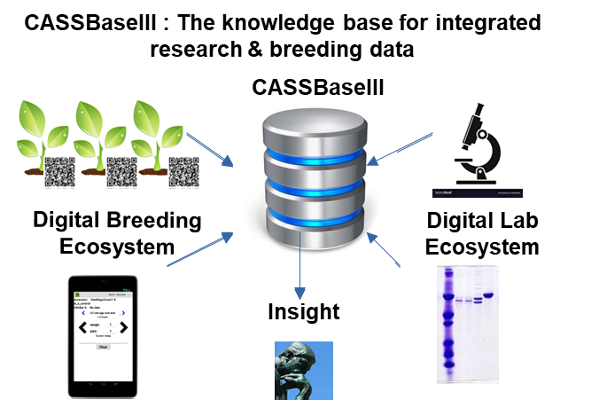
Summary of Goals and Impact
The goal of TM6 is to facilitate the data management of the project and is therefore an important component for success of the CASS program.

By instituting the use of a modern central digital ecosystem for breeding and scientific data on the project level through the use of CASSbase, the module will result in high quality, comprehensive, queryable, and actionable information, generating feedback loops for new queries and hypotheses, that will help produce a higher impact and improved outcomes for the project and the farmer.

TM6_Research data management

Progress Update: TM6_Research data management

Reporting module leader: Lukas Mueller, BTI.

6.1.1. Period 1 data captured and workshop on system usage conducted. Improve the implementation of features related to lab results. Improve the visibility and accessibility of OMICS datasets for users.

- The current period was characterized by a lot of exchanges, workshops, and travel between the different institutions to facilitate the use of the project database. Training sessions were organized in Erlangen from August 22 – 23, 2024, and feedback gathered for implementing improved tools for the transformation tracking in the project. Lukas Mueller travelled to Erlangen and met with Wolfgang Zierer, Christian Lamm, Yannick Schnauhuber and colleagues, as well as Mercedes Thieme who just started to work for the project and is playing a pivotal role as the main data manager of the project. Discussions revealed that user interfaces related to transformation tracking in the database can be improved. BTI is working on further optimizations with the transformation units. Discussions also revealed that the upload of greenhouse and laboratory phenotypes is currently hindered by the lack of suitable trait definitions. On August 27, 2024, Mueller and Thieme traveled to ETH Zurich to talk to Christine Muller about data integration of their research results, and actively added data from the program. A meeting with Simon Bull expanded on tracking infrastructure needs in the database. From Sept 2-14, 2024, BTI hosted Juan Quiros from the Jülich Breeding Center to talk more about their data and start integrating results from that program.
- Several data from CASS Phase2 have been uploaded including a full clean up of the transformation plasmids and accessions, as well as field data upload, UAV phenotyping data and several pieces of expression and promoter data.

In the Q4 2024 reporting period, the primary focus was on the following activities:
- Implementation of the transformation tracking process in the CASSbase database
- Improvement of the expression data presentation in the Expression Atlas tool
- CASSbase workshop at the annual meeting in Taiwan in October 2024
- Addition of missing traits to CASSbase
- Meetings and visits between labs
- Data upload summary

- Implementation of transformation tracking: Generating large numbers of transformants requires the tracking of regenerating tissue, as well as transformation dates, parental lines, vectors, medium changes, and other events. In the reporting period, the system for sample tracking was improved so that tracking experiments can be set up, barcodes printed, and the progress followed using a special webpage on CASSbase that can directly read the barcodes and add information to a tracked sample based on a customizable tracking ontology. The tracking system and the ontology of terms have been created in close collaboration with the team in Erlangen. The new transformation tracking system was very well received.
- Improvement of the expression data presentation in the Expression Atlas Tool: Currently, two expression atlases are available for Cassava: The Cassava Expression Atlas linked from Cassavabase, as well as a CASS-centric CASSEA atlas, which contains the older CASS1 and CASS2 data. A new expression atlas, CASSEA-test, has been set up to accommodate all the CASS3 data. A standardized and improved expression data pipeline has been defined by Mercedes Thieme, and will eventually be used to upload all the CASS3 generated data. As a test data set, RNA-Seq data generated by Wolfgang Zierer will be used. This dataset, named Trans_2024_C2-37(AtLBD11_OE)_GH-FAU_root-shoot_CASS3 compares the greenhouse-grown AtLBD11 OE (C2-37) plants with WT 60444 and VC 60444. The dataset contains stem and storage root information.
- CASSbase workshop at the annual meeting in Taichung: A workshop about CASSbase was held at the CASS annual meeting in Taichung, Taiwan. The workshop demonstrated the use of CASSbase for designing, managing, and analyzing trials in CASSbase, as well as the use of the Fieldbook data collection tablet-app. The workshop was presented by Mercedes Thieme and Lukas Mueller.
- Addition of missing traits to CASSbase: New traits and variables were added to the CASSbase trait ontology to reflect the traits used by the CASS project. The new traits were related to the drone-based measurement of plant canopy and plant volume. We have opted for a flexible model of trait addition; the traits added have a special trait identifier range that will not conflict with the official Crop Ontology that the traits in CASSbase are based on, and we will be able to submit them at a later point to the official ontology. In order to add traits quickly we will use this method for all the traits requested by members of the CASS team.
- Meetings and visits between labs: As reported previously, Lukas Mueller traveled to Erlangen in August 2024, and intends to visit Erlangen and Zurich regularly during the project. Plans for Mercedes Thieme to visit Ithaca in early 2025 have also been initiated. In January 2025, members of the Mueller lab (Mueller, Nyaga, Powell) and members of the Sonnewald lab (Thieme) attended the PAG meeting in San Diego, CA, where they met informally to discuss CASS issues, and gave presentations and posters.
- Data upload summary: Ten new trials were generated during the reporting period, all were of the tracking type, and all were generated under the CASS breeding program. 410 new stocks were generated, of which 89% were accessions and the rest consisted of vector_constructs and other types. 3619 new phenotypic measurements were uploaded. In addition, a big dataset of drone-based data is being prepared for upload, but there is still some discussion about how these data should be parsed.

In the Q1 2025 reporting period, the primary focus was on the following activities:
- Results from 2 trials including 3619 trait measurements have been uploaded since 12/2024.
- Addition of missing traits to CASSbase: New traits and variables were added to the CASSbase trait ontology to reflect the traits used by the CASS project. The new traits were related to the drone-based measurement of plant canopy and plant volume. We have opted for a flexible model of trait addition; the traits added have a special trait identifier range that will not conflict with the official Crop Ontology that the traits in CASSbase are based on, and we will be able to submit them at a later point to the official ontology. In order to add traits quickly we will use this method for all the traits requested by members of the CASS team.
- BTI continues to work on new features and optimizations related to the transformation protocols that the CASS project relies upon. CASSbase allows transformation processes to be tracked using special identifiers created for transformation experiments, which can be printed as barcode labels. The barcodes can be scanned directly with a tablet and the status of the tracked samples adjusted on a special CASSbase webpage. In the reporting period, improvements to the system were made, for example, how certain samples can be obsoleted, with obsoleted lines being listed in supplementary table from which they can be un-obsoleted if necessary (see pull request #5316, https://github.com/solgenomics/sgn/pull/5316). Another ticket asked for the inclusion of an obsoletion note (implemented in pull request #5267, https://github.com/solgenomics/sgn/pull/5267), as well as many other improvements and extensive testing in the lab. These features are developed in close collaboration with the transformation teams.
- The connections between expression data and breeding data were improved. Expression data is currently stored in the Expression Atlas (https://cassea.sgn.cornell.edu/) and the CASS Breedbase instance (https://cassbase.org/). A special page was designed on CASSbase to interface with expression data (pull request https://github.com/solgenomics/sgn/pull/5381/files). Currently, two expression atlases are available for Cassava: The Cassava Expression Atlas linked from Cassavabase, as well as a CASS-centric CASSEA atlas, which contains the older CASS1 and CASS2 data. A new expression atlas, CASSEA-test, has been set up to accommodate all the CASS3 data. A standardized and improved expression data pipeline has been defined by Mercedes Thieme, and will be used to upload all the CASS3 generated data.
In the Q2 2025 reporting period, the primary focus was on the following activities:
- Further improvements to the transformation tracking system have been made:
The system can now create the accessions and automatically assign a standard name using a user-definable naming scheme to the new accessions. With each transformation, a transformation negative control can be linked, which In the reporting period, the system for sample tracking was improved so that tracking experiments can be set up, barcodes printed, and the progress followed using a special webpage on CASSbase that can directly scan the barcodes, which will bring up the data collection screen for that specific item. Information can then be added to that item through a customizable tracking ontology with a simple point and click web interface. The tracking system and the ontology of terms have been created in close collaboration with the team in Erlangen. BTI continues to work on new features and optimizations related to the transformation protocols that the CASS project relies upon. In the reporting period, improvements to the system were made, for example, how certain samples can be obsoleted, with obsoleted lines being listed in supplementary table from which they can be un-obsoleted if necessary (see pull request #5316, https://github.com/solgenomics/sgn/pull/5316). Tracking obsoleted lines can be important for reporting on biosafety. Another ticket asked for the inclusion of an obsoletion note (implemented in pull request #5267, https://github.com/solgenomics/sgn/pull/5267), as well as many other improvements and extensive testing in the lab. These features are developed in close collaboration with the transformation teams. Currently, we are working on improved tools to visualize vector sequences, with the development of a d3-based vectorviewer app by summer student intern Milo Burke.
- Further improvements to the expression data viewer have been made:
A new expression atlas, CASSEA-test, has been established to incorporate CASS3 data. This new instance was established in response to user feedback with the objective of enhancing the tool, including an improved landing page for more intuitive queries and the ability to export query results as images. Additionally, we plan to integrate publicly accessible data, such as that from Becky Barts' lab for instance. A standardized expression data pipeline for the CASS3 data was developed by Thieme. As part of the testing phase, data generated by Zierer will be utilized. This dataset, Trans2024C2- 37(AtLBD11OE)GH-FAUroot-shootCASS3, compares greenhouse-grown AtLBD11 OE (C2-37) plants with the WT 60444 and VC 60444 lines, providing detailed stem and storage root information. Additionally, there is an effort to link and store the data of the expression atlas as high-dimensional phenotype (HDP) in CASSbase. While the Expression Atlas serves as a platform for visualization and gene or tissue queries of the processed and normalized data, the raw expression data (feature counts) are stored in the HDP section of CASSbase. This enables users to download the raw data and apply a normalization approach based on their scientific question, whether for comparisons within or between samples, or for differential expression analysis. In the future, more transcriptomic data sets (project-based and publicly available) will be added, and the tools improved successively. Proteome and metabolome data will be implemented as well.
- Addition of missing traits to CASSbase
New traits and variables were added to the CASSbase trait ontology to reflect the traits used by the CASS project, and trait definitions were refined and in some cases, trait names were changed for clarity. The new traits were related to the drone-based measurement of plant canopy and plant volume. We have opted for a flexible model of trait addition; as we use the CropOntology ontology, the traits added have a special trait identifier range that will not conflict with the official CropOntology that the traits in CASSbase are based on, and we will be able to submit them at a later point to the official ontology. In order to add traits quickly we will use this method for all the traits requested by members of the CASS team.
- Meetings between labs
Thieme visited Ithaca in April 2025 for three weeks, in which she gained more hands-on experience with the database, both on the user interface level and the backend. These regular exchanges and meetings allow further development of the tools thanks to user feedback, while users are supported in the handling and uploading of data.
- Data upload summary
12 new tracking trials were generated during the reporting period, generated under the CASS breeding program. Six phenotyping trials were added, and 9393 new stocks were created, of which 6% were new accessions (mostly transgenics), where most objects represent observation units in field layouts, , and the rest consisted of vector_constructs and other types. For two field trials, 69,210 new phenotypic measurements were uploaded, mostly for remote sensing type traits. The data upload summary can be viewed on the page: https://cassbase.org/breeders/dbstats. The data range of the data to be displayed can be set to any start and end date to obtain the created objects in that range. Some older data (before 2017) may not have create dates associated with them; if they should be included, click the “include items without a date” checkbox.
- Other improvements made to the database
  - Spatial corrections in field trials
As a recently introduced feature, on the trial detail page, spatial corrections can be applied directly in the trial layout section. If the the spatial correction was run, the trait overlay menu will have additional positions for the corrected traits, which can be overlaid on the trial map to generate a “heat map”. The corrected data is stored in the database in an analysis data structure, and can be used further for downstream analyses, such as the selection index tool.
  - Improved repetitive measurements
The handling of repetitive measurements has been improved in the codebase and will be released shortly to the live site. A new trait variable attribute, trait_repeat_type, has been defined which can be used to define a trait as single, multiple, or time_series measurement. A multiple repeat time means that a trait is measured many times over a period of time, such as yield in certain crops that are harvested over long periods of time, whereas time_series is used for measurements such as growth curves over time. Results display differently depending on the trait_repeat_type defined for the trait in question, and phenotypic data can be queried by date ranges on the site.

In the Q3 2025 reporting period, the primary focus was on the following activities:
- In the reporting period, further improvements to the system were made. One of the improvements provides the option to add metadata and observations about the transformation, including the number of potential insertion into the genome as determined by PCR and the expression level of the transgene. In pull request #5686 (https://github.com/solgenomics/sgn/pull/5686), the ability to add insertion counts has been implemented. The expression level use case is currently being worked on and a pull request should be ready next week.
- The connections between expression data and breeding data is being improved. Expression data is currently stored in the Expression Atlas (https://cassea.sgn.cornell.edu/) and the CASS Breedbase instance (https://cassbase.org/). Mercedes Thieme at FAU and Adrian Powell at BTI are working to upload CASS3 generated data and also work on storing the data directly in Breedbase.
- A perennial problem with taking pictures in the field is the question how the images can be assigned the their proper observation unit in the database. When using the Fieldbook app, this problem had been initially solved by a naming scheme for the image filename, which included the observation unit name and some other metadata. However, this scheme caused issues because there are few restrictions on the names of observation units or trait names, with special characters, such as the slash or pipe symbol, leading to issues in different types of file systems (Windows vs UNIX etc). A better way has been implemented by storing the metadata (observation unit and trait information observed on the image) in an EXIF data structure, which is a standard data structure available in almost all image file formats, including jpg and png. In this scheme, the Fieldbook app stores the information in BrAPI-like JSON data structure in the UserComment field of the EXIF data structure. When an image is uploaded to CASSbase, the systems checks for the presence of the EXIF data and if available, uses it to connect the image to the respective observation unit and trait. The relevant pull request, which has been merged, is #5680 (see https://github.com/solgenomics/sgn/pull/5680). Note that with the BrAPI enabled data exchange, the metadata is provided by the BrAPI call and the EXIF data is not necessary.
- What about images that have not been taken by Fieldbook? These image files will not have the EXIF data and therefore won’t be able to automatically assign linkages in the database. For this purpose, we are implementing an automated barcode reading system that checks the image for QRCode -type 2D barcodes, and extracts the information, which will be used to make the connections in the database. The relevant pull request, #5699 (see https://github.com/solgenomics/sgn/pull/5699), is currently being reviewed.
- Spatial correction in field trials can now be run from the trial detail page directly and visualized on the fieldmap view, as implemented in pull request #5478 (see https://github.com/solgenomics/sgn/pull/5478). Additional “spatial corrected traits” become available in the fieldmap view, with the option to see the new absolute values or the differences to the uncorrected values.
- A plasmid vector viewer has been implemented that shows the structure of a vector, including its genes and restriction sites in a dynamic graphic viewer. The viewer can parse Genbank records to produce vector views, and allows for limited editing of the vector structure on-line, as well as zooming in, highlighting section of the vector, searching for genes and restriction sites, and other features. See https://github.com/solgenomics/vectorviewer.
- Many other smaller improvements and bug fixes were implemented. See https://github.com/solgenomics/sgn/pulls?q=is%3Apr+
Q4 2025 Updates
- For the first time, CASSbase has been used as intended with data collection based on tablets running the Field Book app and connecting directly to the CASSbase using BrAPI (https://brapi.org/). This is a much less painful process than the data collection by hand on paper, followed by manual transcription, and upload to the database without some important metadata that the apps automatically collects. The new process was a success.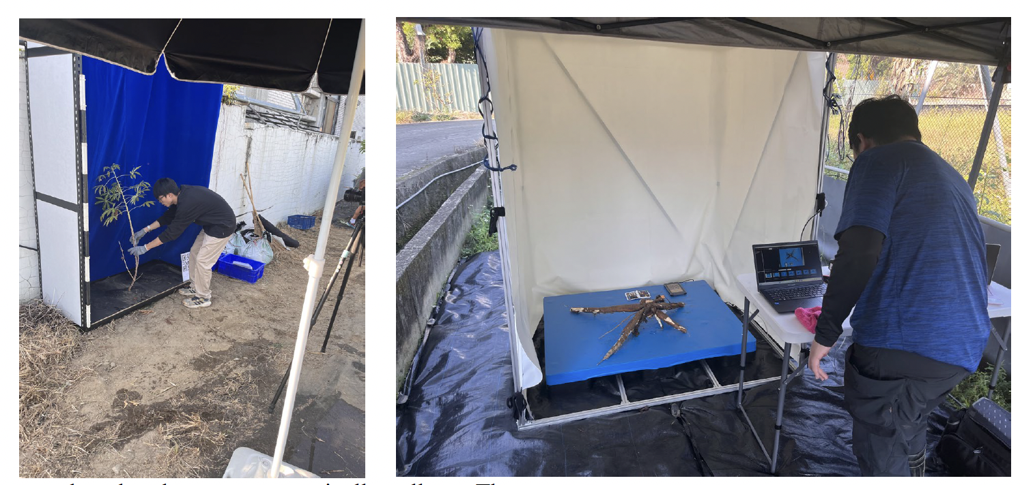
Image capture in the field using embedded QRCode in purpose-built booths with standardized backgrounds. In the root imaging, the QRCode was displayed using a tablet.

- The image loading has been improved, with several methods added to match images with their observation units in the database. At present, three methods are implemented to match images: 1) by name; the image name matches the observation unit. 2) using EXIF data; tools such as Field Book embed metadata in the image using the User Comments field in the EXIF data structure that is present in all image formats, and Breedbase can parse that information. 3) Embedded QRcode; A specially formatted QRcode in the image itself can be parsed by Breedbase and used to associate the image with its observation unit.
- BTI continues to work on new features and optimizations related to the transformation protocols that the CASS project relies upon. CASSbase allows transformation processes to be tracked using special identifiers created for transformation experiments, which can be printed as barcode labels. The barcodes can be scanned directly with a tablet and the status of the tracked samples adjusted on a special CASSbase webpage. In the previous reporting period, improvements to the system were made, for example, how certain samples can be obsoleted, with obsoleted lines being listed in supplementary table from which they can be un-obsoleted if necessary. The system was refined in the reporting period by implementing a more generic propagation workflow that borrows many features of the tracking workflow.
- The field layout overview has been sped up considerably, adding to the ease of use of the trial detail page.
- Vectors can now be visualized using the vector viewer on the vector detail page, although it currently support only strict Genbank versioned files. We are working on supporting the Geneious software version of the Genbank format. These features are developed in close collaboration with the CASS teams.
- The interface for trial treatments was revamped as the old implementation had limitations. The new implementation has treatments implemented as an ontology, similar to traits, with new user interfaces for specifying treatments for different plots, subplots and plants. Treatments can also be visualized on the field layout viewer on the trial detail page.

Meetings and visits between labs
- The CASS group met at the very productive annual meeting in Ibadan, Nigeria, in September, with field visits, presentations, and discussions.
- Thieme and Mueller went to Taiwan to support the group with the data collection effort. The tablets with the Fieldbook app were used to directly collect the data in the field, with data uploads back to the database every evening. Only a few minor glitches happened, which were all fixed.

Data upload summary
- Data from the 2025 Taiwan experiments were uploaded directly to the database using the BrAPI connection method. In total, 20 new projects were entered into the database, of which 8 were field trials, 6 were transformation projects, and 6 were tracking trials. 2774 stocks were created in the database, and 33,670 new phenotypes were recorded.

Update Q1 2026

- New 2026 trials have been designed for Taiwan and are tracked in the system.
- BTI continues to work on new features and optimizations related to the transformation protocols that the CASS project relies upon. CASSbase allows transformation processes to be tracked using special identifiers created for transformation experiments, which can be printed as barcode labels. The barcodes can be scanned directly with a tablet and the status of the tracked samples adjusted on a special CASSbase webpage. In the previous reporting periods, improvements to the system were made, for example, how certain samples can be obsoleted, with obsoleted lines being listed in supplementary table from which they can be un-obsoleted if necessary. In the current reporting period, improvements were made in how data can be associated with obsoleted materials, which is sometimes required during the workflow.
- The tracking data about the transgenic plants complies now with the requirements of the official GMO reporting, as the creation date and obsoletion tracking can be output according to their specifications.
- The Breedbase ordering system has been applied to the FAU ordering of transgenic lines. The system allows users to log in and generate lists of stock requests, which can then be processed and managed by the FAU transformation lab.
- An SSO login system was added to Breedbase, so that third party logins could potentially be used with Cassbase, such as Google or ORCID.
- A wiki system was implemented to replace the Confluence system that was used previously but deemed to pricey for the service. Pages have been migrated to the new system (https://cassbase.org/wiki ).

Data upload summary
- At FAU, experiments now get routinely designed in Cassbase, with labels printed and data collected using tablets (Field Book). In total, FAU designed 6 greenhouse trials in the quarter ending March 31, while ETH made 3 and MPI-MP entered 2. Digital collection tools are now also routinely used, with almost 20,000 phenotypic observations being added.
- In total, 85 new transgenic accessions were tracked in the system, which are being tracked in regeneration using the Cassbase tracking tool.
- New trait variables were added to the CASS trait ontology for soluble and insoluble sugar concentrations in roots.

Challenges and Mitigations:
Interest and momentum is building to use the database and this has to be accelerated and maintained. The meeting in Taiwan will be key to train more people on the database and a brief workshop is planned there. Further interactions with Mercedes Thieme and the project partners will be key in establishing the right SOPs to integrate data in the database. BTI is supporting transformation activities by expanding tracking infrastructure in the database.
Communication between project members is a big challenge in large projects such as CASS. In August 2024, Mercedes Thieme was hired as central data manager for the project, and a great working relationship with CASSbase has been established, with regular, weekly meetings, and a planned in person visit for early 2025 in Ithaca.

The field data collection had been a sticky issue in the CASS project, as data was provided to the database curators in Excel files. It is therefore a major advance that the direct data upload from the data collection tablets has been used in the latest trials, which has been a success.

- Participation in the digital ecosystem of Cassbase has vastly improved since the beginning of the project, especially at FAU and is being improved at other sites as well.
Next Steps in the Action Plan:
A further workshop is planned (Taiwan in October) and key people have been signed up on Slack for easy communication. Certain database interfaces are being adapted to the suggestions made by Lamm and Bull. Feedback on the new transformation feature is very positive so far. Missing trait definitions will be added to the project database to enable the upload of greenhouse and lab phenotypes. Mercedes Thieme will visit BTI in the next quarter to train on database best practices and SOPs.
The tracking process as implemented for Erlangen should also be implemented in Zurich. A new type of experiment, grouping images such as in situ images, will be added to the system. A new code branch that implements repetitive measurements with a new framework will be merged soon, enabling a simpler and more refined approach to repetitive measurements. A spatial correction feature is almost ready in the code base, and would benefit the CASS field experiments. The CASS trait ontology will be further updated. Data from field experiments will be uploaded as quickly as possible. The user experience of the Expression Atlas will be further improved and new data types, e.g. metabolomic data sets will be uploaded. Mercedes Thieme and Wolfgang Zierer are planning to visit Ithaca in the spring.

- The tracking process as implemented for Erlangen will also be implemented in Zurich (Ongoing)
- A new feature will be added that will allow to create image collections, to group images such as in situ images. (Ongoing
- A new code branch that implements improved repetitive measurements is currently in testing phase and wil be merged soon. (Concluded)
- A spatial correction feature is also being readied, and will benefit the CASS field experiments data analysis. (Concluded)
- Further additions and improvements will be implemented in the CASS trait ontology. (Concluded)
- Data from field experiments will be uploaded as quickly as possible. (Concluded)
- The user experience of the Expression Atlas will be further improved and new data types, e.g. metabolomic data sets will be uploaded. (Ongoing)
- Reciprocal visits are being planned for 2025, starting with the visit of Mercedes Thieme in April 2025. (Concluded)
- Storage of raw gene expression data as high dimensional phenotypes in CASSbase will be improved, and already available datasets uploaded (Ongoing)
- Improve the plasmid vector visualization on the vector detail pages (Ongoing)
- Provide digital assistance during final harvest in 2025 in Taiwan (Concluded)
- Mueller will go on a sabbatical at ETH Zurich in spring 2026 and work hands-on on software to improve use cases identified in the Zeeman lab. During the time in Zurich, Mueller will also visit Erlangen and other CASS sites in Europe.
- Further additions and improvements will be implemented in the CASS trait ontology.
- Data from field experiments will continue to be uploaded using the new methodology tested in Taiwan in the fall of 2025, which is direct upload from the tablet to the database using the BrAPI method. This works for trait data as well as images collected with the Field Book app.
- To improve the data and sample collection procedure, tags will be exported to Field Book to guide the experimenter which type of samples have to be extracted from the observation unit.
- The user experience of the Expression Atlas will be further improved and new data types, e.g. metabolomic data sets will be uploaded.
- A wiki page system will be included in Breedbase for easier project management.
- An authorization system with finer grained permissions is almost ready for merging.
- An authentication system with single sign on support is in review.
- Mueller started a sabbatical ETH Zurich at the end of March 2026 and work hands-on on software to improve use cases identified in the Zeeman lab. During the time in Zurich, Mueller intends to also visit Erlangen and other CASS sites in Europe.
- Software improvements are being made to the transformation tracking tool, especially with a focus on tracking media changes and other features.
- An authorization system with finer grained permissions is still being worked on and gets closer to merging.

CASS Reporting and Quarterly Meeting timetable 2024-2029

Reporting Period | Start | End | DEADLINE: Report from Partners | DEADLINE: Report to Gates Ag One | CASS Quarterly Meeting
Q3 2024 | July 1, 2024 | September 30, 2045 | September 16, 2024 | September 20, 2024 | September 30th, 2024
Q4 2024 | Oct 1, 2024 | Dec 31, 2024 | February 10th, 2025 | February 14, 2025 | February 27th, 2025
Q1 2025 | January 1, 2025 | March 30, 2025 | April 11, 2025 | April 18, 2025 | April 25, 2025
Q2 2025 | April 1, 2025 | June 30, 2025 | July 11, 2025 | July 18, 2025 (Annual Report) | July 25, 2025
Q3 2025 | July 1, 2025 | September 30, 2025 | September 15, 2025 | September 19, 2025 | September 29th, 2025
Q4 2025 | Oct 1, 2025 | Dec 31, 2025 | February 9th, 2026 | February 13, 2026 | February 26th, 2026
Q1 2026 | January 1, 2026 | March 30, 2026 | April 10, 2026 | April 17, 2026 | April 24, 2026
Q2 2026 | April 1, 2026 | June 30, 2026 | July 17, 2026 | July 24, 2025 (Annual Report) | July 31, 2026
Q3 2026 | July 1, 2026 | September 30, 2026 | September 14, 2026 | September 18, 2026 | September 28th, 2026
Q4 2026 | Oct 1, 2026 | Dec 31, 2026 | February 8th, 2027 | February 12, 2027 | February 25th, 2027
Q1 2027 | January 1, 2027 | March 30, 2027 | April 16, 2027 | April 23, 2027 | April 30, 2027
Q2 2027 | April 1, 2027 | June 30, 2027 | July 16, 2027 | July 23, 2025 (Annual Report) | July 30, 2027
Q3 2027 | July 1, 2027 | September 30, 2027 | September 13, 2027 | September 17, 2027 | September 27th, 2027
Q4 2027 | Oct 1, 2027 | Dec 31, 2027 | February 7th, 2028 | February 11, 2028 | February 24th, 2028
Q1 2028 | January 1, 2028 | March 30, 2028 | April 14, 2028 | April 21, 2028 | April 28, 2028
Q2 2028 | April 1, 2028 | June 30, 2028 | July 14, 2028 | July 21, 2025 (Annual Report) | July 28, 2028
Q3 2028 | July 1, 2028 | September 30, 2028 | September 12, 2028 | September 16, 2028 | September 26th, 2028
Q4 2028 | Oct 1, 2028 | Dec 31, 2028 | February 6th, 2029 | February 10, 2029 | February 23th, 2029
Q1 2029 | January 1, 2029 | March 30, 2029 | April 13, 2026 | April 20, 2029 | April 27, 2029

Module reporting leader | CASS Module
 | EM1: Optimizing assimilate allocation to storage roots
Uwe Sonnewald, FAU | EM1.1_Manipulating shoot architecture
Ekkehardt Neuhaus, RPTU with MPI-MPP. | EM1.2_Limiting lateral transport losses through active phloem (re-)loading
Lee Sweetlove, UO with RPTU, MPI-MPP and ETH. | EM1.3_Transport and allocation modelling
 | EM2: Increasing sink strength by optimizing xylem parenchyma cell formation in storage roots
Yka Helariutta, HU with FAU and ETH. | EM2.1_Manipulation of OVAC and cytokinin metabolism or signalling
Ari Pekka Mähönen, HU with FAU and ETH. | EM2.2_Manipulation of downstream factors involved in xylem parenchyma cell formation
 | EM3_Increasing sink strength by optimizing metabolic flux in storage roots
Alisdair Fernie, MPI-MPP with Oxford and FAU | EM3.1_Optimization of sucrolytic cleavage and glycolysis
Wolfgang Zierer, FAU with ETH. | EM3.2_Optimization of starch-precursor delivery to amyloplasts
Sam Zeeman, ETH with FAU. | EM3.3_Starch granule initiation and growth
Lee Sweetlove, OU with RPTU, MPI-MPP and ETH. | EM3.4_Model-based predictions
Wolfgang Zierer and Uwe Sonnewald, FAU | TM1_Project management and central services
 | TM2_Cassava transformation
Simon Bull, ETH | TM2.1_Routine transformation
Christian Lamm, FAU. | TM2.2_Chemical and genetic boosters
Ihuoma Okwuonu, NRCRI. | TM2.3_Transformation of farmer-preferred genotypes
 | Objective TM3_Expanding the cassava expression toolbox
Wolfgang Zierer, FAU. | TM3.1_Testing of already identified tissue-specific promoter candidates
Ari Pekka Mähönen, HU | TM3.2_Identification of genes and promoter candidates involved in formation of xylem parenchyma
 | Objective TM4_Cassava confined field testing
Wilhelm Gruissem, NCHU with FAU and FZJ. | TM4.1_Pre-testing of transgenic lines outside Africa
Ismail Rabbi, IITA. | TM4.2_Testing of transgenic lines in Africa and transgenic crossing activities
Robert Koller, FZJ | TM5_Cassava plant and field phenotyping
Lukas Mueller, BTI. | TM6_Research data management

